BREWORA
Prometheus Complete Query Evidence
Modular Monolith vs. Microservices | Screenshots and exact outputs
This document records the Prometheus query expressions and numeric outputs visible in the screenshots supplied for this project. Values are transcribed from the result tables; latency values are converted from seconds to milliseconds for easier comparison.

1. Actual results summary
Metric | Microservices | Modular Monolith | Unit / note
Resident memory | 435,150,848 | 29,597,696 | Bytes; direct Prometheus output
Resident memory (converted) | 414.90 | 28.23 | MiB; bytes ÷ 1,048,576
CPU rate × 100 | 2.502319 | 0.341887 | Percentage of one CPU core, summed by architecture
HTTP request rate | 3.637091 | 1.818546 | Requests/second
P50 latency | 4.545455 | 2.525253 | Milliseconds; original result in seconds
P95 latency | 22.589288 | 4.797980 | Milliseconds; original result in seconds
P90 latency | 19.910710 | 4.545455 | Milliseconds; query explicitly multiplies by 1000

HTTP status counter output:
HTTP status | Counter value
200 | 916
404 | 1

2. Prometheus queries and screenshot evidence

2.1 Resident memory by architecture
sum by (architecture) (brewora_process_resident_memory_bytes)
Actual output: microservices = 435150848 bytes; modular_monolith = 29597696 bytes.
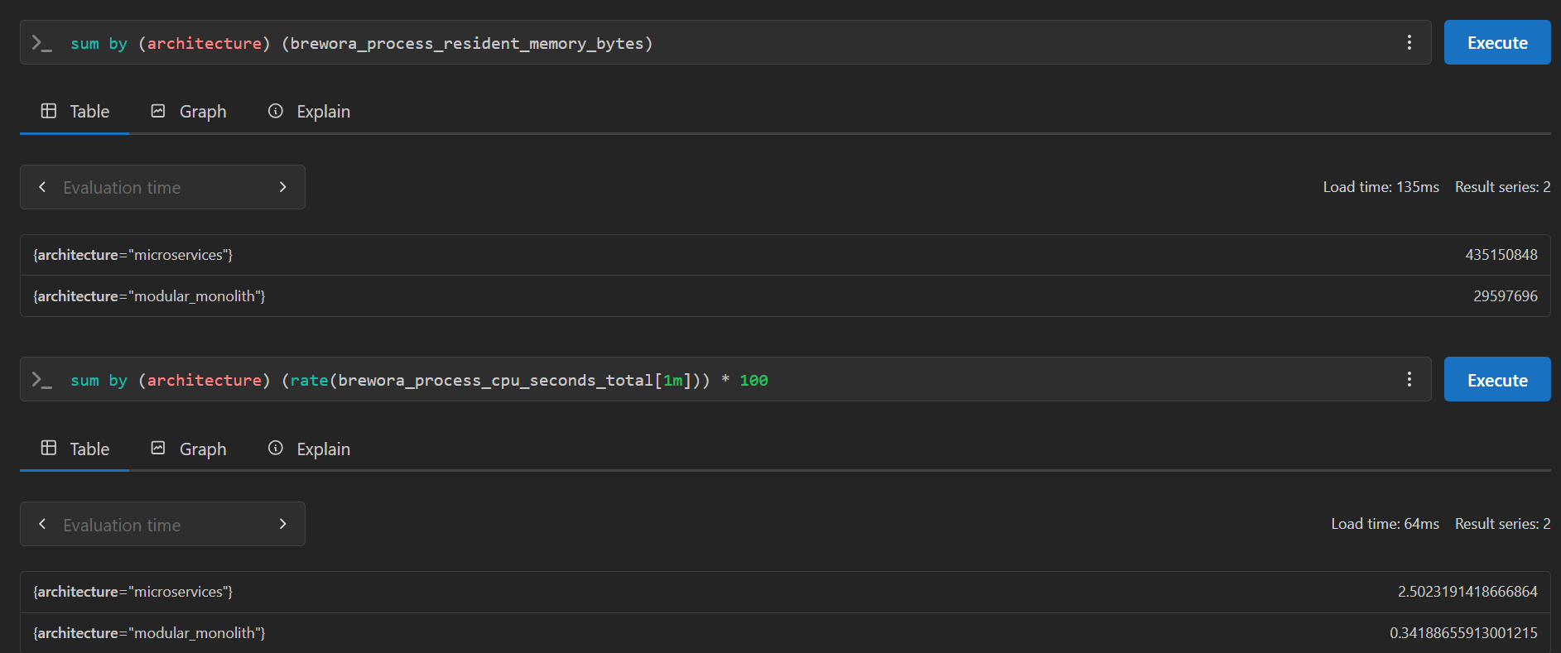
Prometheus memory and CPU query results

2.2 CPU usage estimate
sum by (architecture) (rate(brewora_process_cpu_seconds_total[1m])) * 100
Actual output: microservices = 2.5023191418666864; modular_monolith = 0.34188655913001215. This is rate of CPU-seconds multiplied by 100, not necessarily total machine CPU utilization.

2.3 HTTP request rate
sum by (architecture) (rate(brewora_http_requests_total[1m]))
Actual output: microservices = 3.637091054574551; modular_monolith = 1.8185455272872755 requests/second.
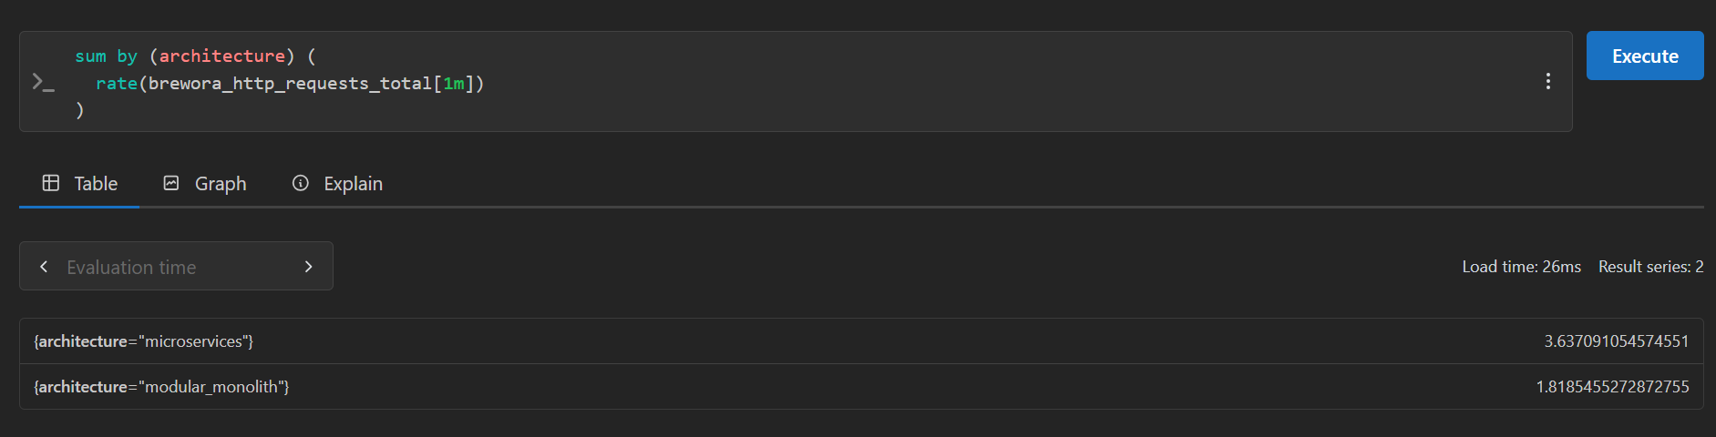
Prometheus HTTP request-rate query result

2.4 P50 HTTP latency
histogram_quantile(
0.50,
sum by (le, architecture) (
rate(brewora_http_request_duration_seconds_bucket[5m])
)
)
Actual output: microservices = 0.0045454483807659376 seconds (≈4.545448 ms); modular_monolith = 0.0025252525252525255 seconds (≈2.525253 ms).
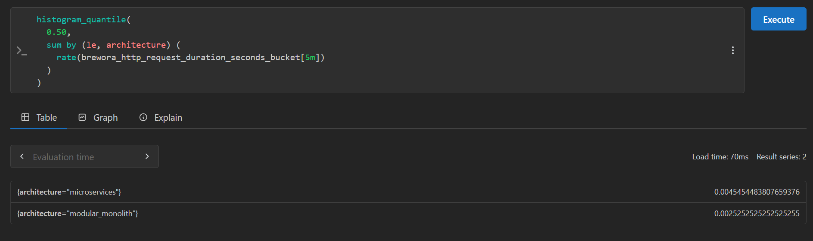
Prometheus P50 latency query result

2.5 P95 HTTP latency
histogram_quantile(
0.95,
sum by (le, architecture) (
rate(brewora_http_request_duration_seconds_bucket[5m])
)
)
Actual output: microservices = 0.022589287838802728 seconds (≈22.589288 ms); modular_monolith = 0.0047979797979797985 seconds (≈4.797980 ms).
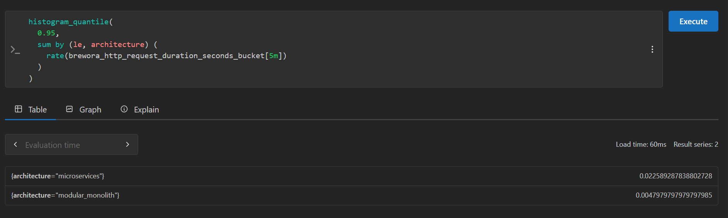
Prometheus P95 latency query result

2.6 HTTP status counts
sum by (status) (brewora_http_requests_total)
Actual output: status 200 = 916; status 404 = 1. These are counter values at the query evaluation time.
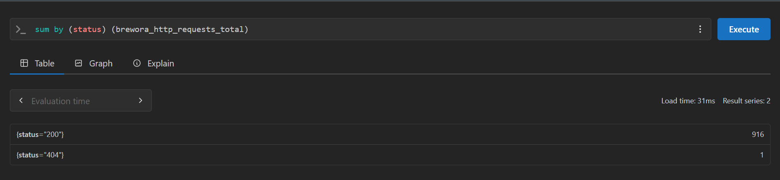
Prometheus HTTP status-count query result

2.7 P90 HTTP latency
histogram_quantile(
0.90,
sum by (le, architecture) (
rate(brewora_http_request_duration_seconds_bucket[5m])
)
) * 1000
Actual output: microservices = 19.91071005286976 ms; modular_monolith = 4.545454545454546 ms.
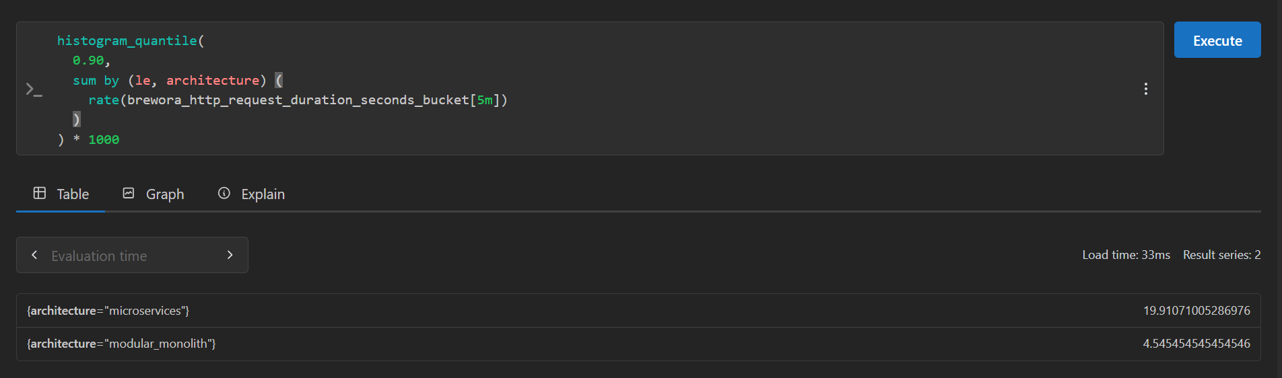
Prometheus P90 latency query result

3. Important interpretation notes
- Memory is reported as bytes by Prometheus. The MiB conversion in the summary uses 1 MiB = 1,048,576 bytes.
- The CPU expression is rate(process CPU seconds) × 100. Interpret it as percentage of one CPU core, summed by architecture, rather than a guaranteed percentage of the whole computer.
- The request-rate query aggregates all matching series by architecture. In a microservices setup, it may include gateway and internal-service requests, so compare carefully with monolith external requests.
- P50, P90 and P95 are histogram quantile estimates. The P50 and P95 screenshots show values in seconds because those expressions do not multiply by 1000. P90 includes ×1000 and therefore returns milliseconds.
- HTTP status values 916 and 1 are cumulative counter values at that evaluation time, not rates.
- All values are snapshots from the screenshots. Re-running the queries later can produce different values.

4. Note about the separate dashboard screenshots
The earlier Grafana dashboard screenshots show heap usage, event-loop lag, request rate, latency panels, HTTP 2xx rate and scrape-target health. Those chart-only screenshots do not show exact hover values for every point. This document focuses on the additional Prometheus table screenshots where exact numeric outputs are visible.

