Contents

- Overview of Microprocessor
- RISC vs CISC Processor
- RISC processor Implementation—Single Cycle and Multi Cycle processor.
- Processor—top level entity
  - Instruction Format
  - Control unit
  - Datapath
    - ALU
    - ALU controller
    - Memory
    - Register file
    - Mux-32
    - Mux-5
    - Mux_sel
    - Pc Register
    - Instruction Register
    - Instruction split
    - Extender
- Cyclone EP1C6 devices

Overview of Microprocessor:

The circuit for the microprocessor can be divided into two parts: the datapath and the
control unit as shown in the figure.

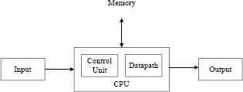

The datapath is responsible for the actual execution of all operations performed by the microprocessor such as the addition inside the arithmetic logic unit (ALU). The datapath also includes the registers for the temporary storage of your data. The functional units inside the datapath (ALU, shifter, etc.) and the registers are connected together with multiplexers and buses to form one unit, the datapath.

Even though the datapath is capable of performing all the operations of the microprocessor, it cannot, however, do it on its own. In order for the datapath to execute the operations automatically, the control unit is required. The control unit, also known as the controller, controls the operations of the datapath, and therefore, the operations of the entire microprocessor. The controller is a finite state machine (FSM) because it is a machine that executes by going from one state to another, and the fact that there are only a finite number of states for the machine to go to. The controller is made up of three parts: the next-state logic, the state memory, and the output logic. The purpose of the state memory is to remember the current state that the FSM is in. The next-state logic is the circuit for determining what the next state ought to be for the machine. And the output logic is the circuit for generating the actual control signals for controlling the

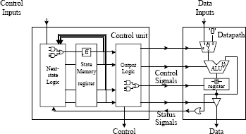
datapath.

Every digital logic circuit, regardless of whether it is part of the control unit or the datapath, is categorized as either a combinational circuit or a sequential circuit. A combinational circuit is one where the output of the circuit is dependent only on the current inputs to the circuit. For example, an adder circuit is a combinational circuit. It takes two numbers as inputs. When given the two inputs, the adder outputs the sum of the two numbers as the output. A sequential circuit, on the other hand, is dependent not only on the current inputs but also on all the previous inputs. In other words, a sequential circuit has to remember its past history.

Design:
Digital circuits can be designed at any one of several abstraction levels. Designing at the transistor level, which is the lowest level, we would be dealing with discrete transistors and connecting them together to form the circuit. The next level up in the abstraction is the gate level. At this level we are working with logic gates to build the circuit. At the gate level, we can also specify the circuit using either a truth table or a Boolean equation. Using logic gates, a designer usually creates combinational and sequential components to be used in building larger circuits. In this way a very large circuit such as a microprocessor can be built in a hierarchical fashion. Design methodologies have shown that solving a problem hierarchically is always easier than trying to solve the entire problem as a whole. These combinational and sequential components are used at the register-transfer level in building the datapath and the control unit in the microprocessor. At the register-transfer level, we are concerned about how the data is transferred between the various registers and functional units to realize or solve the problem at hand. Finally, at the highest level, which is the behavioral level, we construct the circuit by describing the behavior or operation of the circuit using a hardware description language.
Here we would be using VHDL to describe the circuit, at Register-level.

RISC vs CISC
A Complex Instruction Set Computer (CISC) provides a large and powerful range of instructions, which is less flexible to implement. For example, the 8086 microprocessor family has these instructions:
JA Jump if Above
JAE Jump if Above or Equal JB Jump if Below
...
JPO Jump if Parity Odd JS Jump if Sign
JZ Jump if Zero
There are 32 jump instructions in the 8086, and the 80386 adds more. The primary goal of CISC architecture is to complete a task in as few lines of assembly as possible. This is achieved by building processor hardware that is capable of understanding and executing a series of operations.
Reduced Instruction Set Computer (RISC) only use simple instructions. As these are much simpler, they can be implemented directly in silicon, so will run at the maximum possible speed. There are only two Jump instructions in the ARM processor - Branch and Branch with Link.

Most modern CISC processors, such as the Pentium, uses a fast RISC core with an interpreter sitting between the core and the instruction.

Advantages of RISC processor:

- It has fewer instructions, and the design will be less complicated.
- RISC processor requires fewer transistors than comparable CISC processors.
- Faster execution of the instructions.
In spite of above advantages RISC processor has the disadvantage that the program would be lengthy. Software for RISC processors must handle more operations than traditional CISC [Complex Instruction Set Computer] processors.

RISC processor Implementation—Single Cycle and Multi Cycle processor

RISC processor can be implemented in any of the following ways
- Single-Cycle processor
- Multi-Cycle processor

In Single cycle processor execution of any instruction takes only one clock cycle. Though, this is easy to implement, it has a primary disadvantage that cycle time is decided by instruction that takes longest time to execute.

In Multi cycle processor, each instruction is divided to number of small parts, each of which is executed in one clock cycle. Datapath is portioned in to equal size chuncks, to minimize the cycle time.It has advantage that each instruction doesn’t require to take same amount of time. So, cycle time is decided by datapath and control path combinational delay.

In the following pages, we would develop a Multi cycle 32 bit RISC processor. Here we would be using top-down approach.

Processor:

It is the top level design entity which comprises of datapath and control unit. It structurally combines controller and datapath.

Entity:

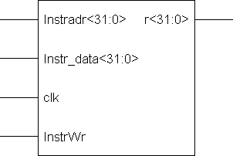

Here InstrWr is active high signal that is used to write instructions and data into the memory asynchronously. Instr_data<31:0> is data or instruction to be written, and Instradr<31:0> is address of the location.

VHDL Code:
--The following package code is given in appendix.
use work.cpu_lib.ALL;--this includes a package, which defines various data types used in
--the program

library IEEE;
use IEEE.STD_LOGIC_1164.ALL; use IEEE.STD_LOGIC_ARITH.ALL;
use IEEE.STD_LOGIC_UNSIGNED.ALL;

entity processor is port(clk:in std_logic;
InstrWr:in std_logic;
Instradr:in std_logic_vector(size downto 0);
Instr_data:in std_logic_vector(size downto 0);
r:out std_logic_vector(size downto 0));--defining the ports end processor;

architecture Behavioral of processor is

--Including the Control unit component control_unit is
port(opcode:in std_logic_vector(5 downto 0);
equal:in std_logic;
clk: in std_logic;
IorD : out std_logic;
MemWr : out std_logic;
MemRd : out std_logic;
IRwr : out std_logic;
RegDst :out std_logic;
RegWr : out std_logic;
ExtOp : out std_logic;
MemtoReg :out std_logic;
ALUSelA :out std_logic;
ALUSelB : out std_logic_vector(1 downto 0);
ALUOp : out std_logic_vector(2 downto 0);
PCSrc: out std_logic
);
end component;
--Datapath component datapath is
Port ( IorD : in std_logic;
MemWr : in std_logic;
MemRd : in std_logic;
InstrWr:in std_logic;
IRwr : in std_logic;
RegDst : in std_logic;
RegWr : in std_logic;
ExtOp : in std_logic;
MemtoReg : in std_logic;

ALUSelA : in std_logic;
ALUSelB : in std_logic_vector(1 downto 0);
ALUOp : in std_logic_vector(2 downto 0);
PCSrc: in std_logic;
clock: in std_logic;
Instradr:in std_logic_vector(size downto 0);
Instr_data:in std_logic_vector(size downto 0);
op:out std_logic_vector(5 downto 0);
Eq:out std_logic;
result:out std_logic_vector(size downto 0)); end component;

--Declaring the signals to connect Control unit and Datapath Structurally

signal IorD : std_logic;--to select the read address for memory signal MemWr :std_logic; --Memory write signal
signal MemRd : std_logic;--Memory read signal signal IRwr : std_logic; --Instruction reg write
signal RegDst : std_logic; --To select from Rt and Rd signal RegWr : std_logic; --Register write signal
signal ExtOp : std_logic; --to select the type of extension
signal MemtoReg : std_logic;--select whether to write from memory or from ALu_out signal ALUSelA : std_logic; --select the type of input to alu (pc or from regfile) signal ALUSelB :std_logic_vector(1 downto 0);--select the second input to ALU signal ALUOp : std_logic_vector(2 downto 0);
--input to alu controller to generate necessary controll signal signal PCSrc: std_logic;--to indicate when to write to the pcreg signal op:std_logic_vector(5 downto 0);--opcode
signal Eq: std_logic;--goes high when both inputs of alu are equalbegin
--Giving proper signals to Control unit a0:datapath port map(
IorD,MemWr,MemRd,InstrWr,IRwr,RegDst,RegWr,Extop,MemtoReg,ALUSelA,ALUS elB,ALUOp,PCSRc,clk,Instradr,Instr_data,op,Eq,r
);

--Generating signals for Datapath, Takes status signals from datapath as input a1:control_unit port map( op,Eq,clk,IorD,MemWr,MemRd,IRwr,RegDst,REgWr,Extop,MemtoReg,ALUSelA,ALU SelB,ALUop,PCSrc
);
end Behavioral;

Schematic:
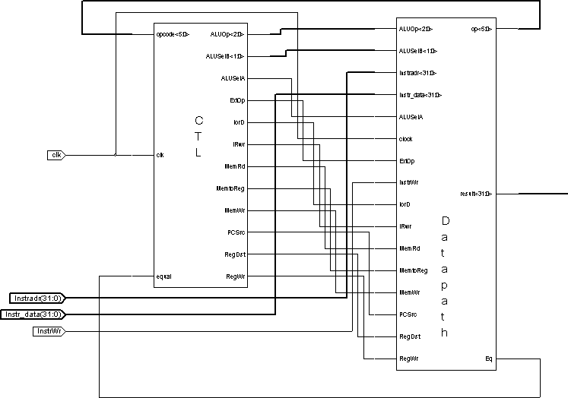

Instruction Format:

One of the important things that we must decide before starting the processor design is the instruction format and the number of instruction. For RISC processors the number of instructions is less.

Here, 32 bit instruction format is being considered.

The Instruction Format can be divided into 3 categories, as follows.
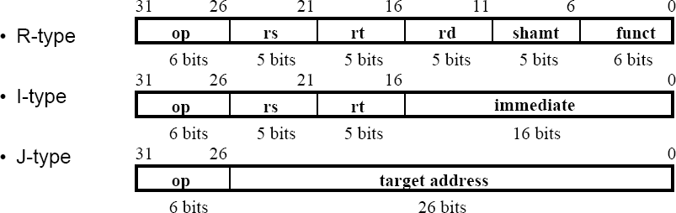

The different fields are
- op: operation of the instruction
- rs,rt,rd: the source and destination register specifiers.
- shamt: the shift amount.
- funct:selects the variant of the operation in the op field
- addres/immediate:address offset or immediate value
- target address:target address of the jump instruction

The following table indicates the decoding logic for the various opcodes.

Opcode | Instruction operation
000000 | R-type
101101 | Or-immediate
100011 | Load word
101011 | Store word
000100 | Branch instruction
For R-type instruction the type of instruction operation depends on the last 6-bits that is on funct bits. The type of operation is as indicated below.

Funct<5:0> | Instruction operation
100000 | Add
100010 | Subtract
100100 | And
100101 | Or

The immediate value or address offset is either sign extended or zero-extended as required. Most often immediate value is zero-extended, where as address is sign-extended.

Control Unit:

The control unit is a sequential circuit in which its outputs are dependent on both its current and past inputs. This history of past inputs is stored in the state memory and is said to represent the state of the circuit. Thus, the circuit changes from one state to the next when the content of the memory changes. Depending on the current state of the circuit and the input signals, the next-state logic will determine what the next state ought

to be by changing the content of the state memory. Hence, a sequential circuit executes by going through a sequence of states. Since the state memory is finite, therefore the total number of different states that the circuit can go to is also finite. This is not to be confused with the fact that the sequence length can be infinitely long. However, because of the reason of having only a finite number of states, a sequential circuit is also referred to as a finite-state machine (FSM).

Control unit takes inputs opcode and equal from datapath and generates required control signals to the datapath.

State Diagram:
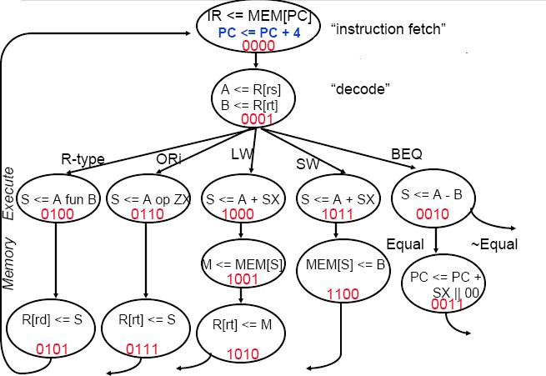

Entity:

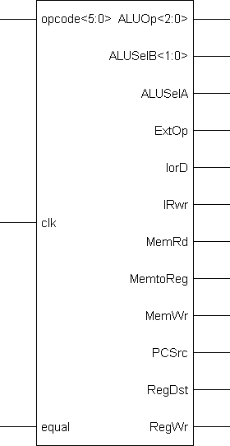

VHDL Code:

use work.cpu_lib.ALL; library IEEE;
use IEEE.STD_LOGIC_1164.ALL; use IEEE.STD_LOGIC_ARITH.ALL;
use IEEE.STD_LOGIC_UNSIGNED.ALL;

entity control_unit is
port(opcode:in std_logic_vector(5 downto 0);

equal:in std_logic;
clk: in std_logic;
IorD : out std_logic;
MemWr : out std_logic;
MemRd : out std_logic;
IRwr : out std_logic;
RegDst :out std_logic;
RegWr : out std_logic;
ExtOp : out std_logic;
MemtoReg :out std_logic;
ALUSelA :out std_logic;
ALUSelB : out std_logic_vector(1 downto 0);
ALUOp : out std_logic_vector(2 downto 0);
PCSrc: out std_logic
);
end control_unit;
architecture Behavioral of control_unit is

signal st:std_logic_vector(3 downto 0):="0000"; begin
process(clk) begin

if clk'event and clk='1' then

case st is
--Fetch the instruction

when "0000" =>
IorD<='0'; MemRd<='1'; MemWr<='0'; IRWr<='1';
RegDst<='0'; RegWr<='0';
Extop<='0'; MemtoReg<='0'; ALUSelA<='0'; ALUSelB<="00"; ALUop<="000"; PCSrc<='1';

st<="0001";
--decode the instruction
when "0001" =>

--generate the next state depending on the opcode
IorD<='0'; MemRd<='0'; MemWr<='0'; IRWr<='0';
RegDst<='0'; RegWr<='0';
Extop<='0'; MemtoReg<='0'; ALUSelA<='1'; ALUSelB<="01"; ALUop<="111"; PCSrc<='0';

case opcode is
when "000000" =>
st<="0100"; when "101101" =>
st<="1101"; when "001101" =>
st<="0110"; when "100011" =>
st<="1000"; when "101011" =>
st<="1011"; when "000100" =>
st<="0010";
when others =>
st<="0000";

end case;

--branch instruction

--check if both operands are equal
when "0010" =>
IorD<='0'; MemRd<='0'; MemWr<='0'; IRWr<='0';
RegDst<='0'; RegWr<='0';
Extop<='0'; MemtoReg<='0'; ALUSelA<='1'; ALUSelB<="01"; ALUop<="001"; PCSrc<='0';

if equal='1' then

st<="0011";
else
st<="0000";
end if;
--Beq increment the pc by the immediate value
when "0011" =>
IorD<='0'; MemRd<='0'; MemWr<='0'; IRWr<='0';
RegDst<='0'; RegWr<='0';
Extop<='1'; MemtoReg<='0'; ALUSelA<='0'; ALUSelB<="01"; ALUop<="000"; PCSrc<='1';

st<="0000";
--R-type instruction
when "0100" =>
IorD<='0'; MemRd<='0'; MemWr<='0'; IRWr<='0';
RegDst<='1'; RegWr<='0';
Extop<='0'; MemtoReg<='0'; ALUSelA<='1'; ALUSelB<="01"; ALUop<="100"; PCSrc<='0';

st<="0101";
--store the result of the R-type in regfile R[Rd]
when "0101" =>
IorD<='0'; MemRd<='0'; MemWr<='0'; IRWr<='0';
RegDst<='1'; RegWr<='1';
Extop<='0'; MemtoReg<='0';

ALUSelA<='1'; ALUSelB<="01"; ALUop<="111"; PCSrc<='0';

st<="0000";
--Or immediate instruction
--zero extend the immediate value and perform or operation
when "0110" =>
IorD<='0'; MemRd<='0'; MemWr<='0'; IRWr<='0';
RegDst<='0'; RegWr<='0';
Extop<='0'; MemtoReg<='0'; ALUSelA<='1'; ALUSelB<="11"; ALUop<="010"; PCSrc<='0';

st<="0111";
--store the result in regfile

when "0111" =>
IorD<='0'; MemRd<='0'; MemWr<='0'; IRWr<='0';
RegDst<='0'; RegWr<='1';
Extop<='0'; MemtoReg<='0'; ALUSelA<='1'; ALUSelB<="01"; ALUop<="111"; PCSrc<='0';

st<="0000";
--Load word instruction
--calucalate the memory location address
when "1000" =>
IorD<='1'; MemRd<='1'; MemWr<='0';

IRWr<='0';
RegDst<='0'; RegWr<='0';
Extop<='1'; MemtoReg<='0'; ALUSelA<='1'; ALUSelB<="11"; ALUop<="000"; PCSrc<='0';

st<="1001";
--Fetch the data from the memory location
when "1001" =>
IorD<='1'; MemRd<='0'; MemWr<='0'; IRWr<='0';
RegDst<='0'; RegWr<='0';
Extop<='0'; MemtoReg<='1'; ALUSelA<='1'; ALUSelB<="01"; ALUop<="111"; PCSrc<='0';

--write the data to the regfile
st<="1010";

when "1010" =>
IorD<='1'; MemRd<='0'; MemWr<='0'; IRWr<='0';
RegDst<='0'; RegWr<='1';
Extop<='0'; MemtoReg<='1'; ALUSelA<='1'; ALUSelB<="01"; ALUop<="111"; PCSrc<='0';

--store word instruction
--calucalate the memory location address
st<="0000";

when "1011" =>

IorD<='0'; MemRd<='0'; MemWr<='1'; IRWr<='0';
RegDst<='0'; RegWr<='0';
Extop<='1'; MemtoReg<='0'; ALUSelA<='1'; ALUSelB<="10"; ALUop<="000"; PCSrc<='0';

st<="1100";
--write the value from busB to the memory
when "1100" =>
IorD<='1'; MemRd<='0'; MemWr<='1'; IRWr<='0';
RegDst<='0'; RegWr<='0';
Extop<='0'; MemtoReg<='0'; ALUSelA<='1'; ALUSelB<="01"; ALUop<="111"; PCSrc<='0';

st<="0000";
when others =>
IorD<='1'; MemRd<='1'; MemWr<='0'; IRWr<='1';
RegDst<='0'; RegWr<='0';
Extop<='0'; MemtoReg<='0'; ALUSelA<='0'; ALUSelB<="00"; ALUop<="000"; PCSrc<='1'; st<="0001";

end case; end if;
end process; end Behavioral;

Schematic:
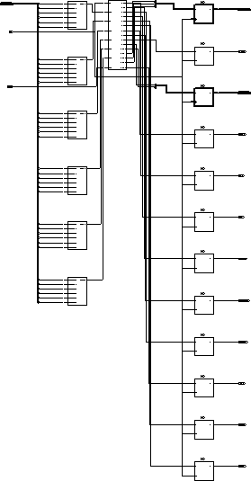

Datapath:

The datapath is responsible for the manipulation of data. It includes (1) functional units such as adders, shifters, multipliers, ALUs, and comparators, (2) registers and other memory elements for the temporary storage of data, and (3) buses and multiplexers for the transfer of data between the different components in the datapath. External data can be entered into the datapath through the data input lines.

In order for the datapath to function correctly, appropriate control signals must be asserted at the right time. Control signals are needed for all the select and control lines for all the components used in the datapath. This includes all the select lines for multiplexers, ALU and other functional units having multiple operations, all the read/write enable signals for registers and register files, address lines for register files, and memory. The operation of the datapath is determined by which control signals are asserted and at what time. In a microprocessor, these control signals are generated by the control unit.

In return, the datapath needs to supply status signals back to the control unit in order for it to operate correctly. These status signals are usually from the output of comparators. The comparator tests for a given logical condition between two values. These values can be obtained either from memory elements, directly from the output of functional units, or hardwired as constants. These status signals provide input information for the control unit to determine what operation to perform next. For example, in a branch equal instruction, the status signal will tell the control unit whether jumps or not. Since the datapath performs all the functional operations of a microprocessor, and the microprocessor is for solving problems, therefore the datapath must be able to perform all the operations required to solve the given problem. Datapath design is also referred to as the register-transfer level (RTL) design.

Datapath is structural combination of the following components.

- ALU
- Multiplexer (32 bit and 5 bit) of 2 input,1 output
- Multiplexer (32 bit ) – 4 input ,1 output
- Register-file which consist of 32 registers, each of 32 bits.
- Memory—which consists of 32 locations, each of 32 bits long.
- Extender which does either sign-extension or zero-extension
- Some registers to store temporary data
  - Instruction register—to store the instruction
  - ALU_out –to store the output of alu.
  - Pcreg—to store the program counter.

In the following pages, we would take up each and discuss.

Block Diagram:
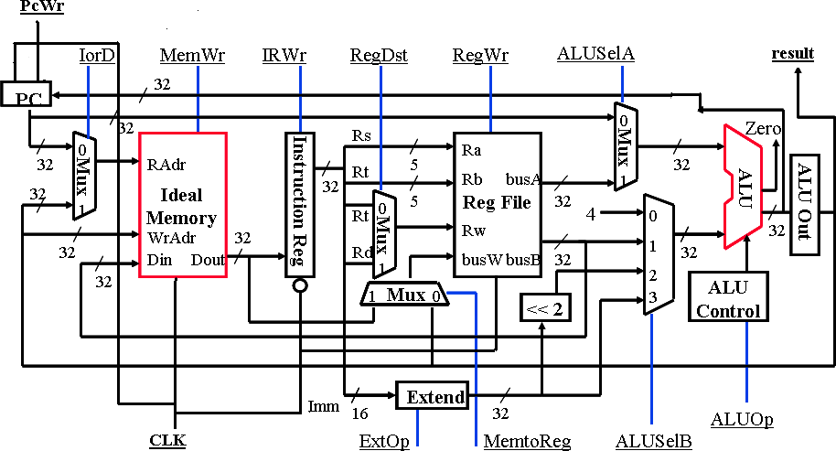

Entity:

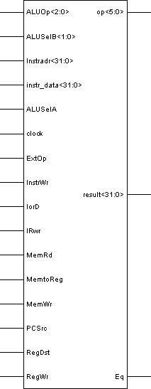

VHDL Code:

use work.cpu_lib.ALL; library IEEE;
use IEEE.STD_LOGIC_1164.ALL; use IEEE.STD_LOGIC_ARITH.ALL;
use IEEE.STD_LOGIC_UNSIGNED.ALL;

--Entity for datapath entity datapath is

Port ( IorD : in std_logic;
MemWr : in std_logic;
MemRd : in std_logic;
InstrWr:in std_logic;
IRwr : in std_logic;
RegDst : in std_logic;
RegWr : in std_logic;
ExtOp : in std_logic;
MemtoReg : in std_logic;
ALUSelA : in std_logic;
ALUSelB : in std_logic_vector(1 downto 0);
ALUOp : in std_logic_vector(2 downto 0);
PCSrc: in std_logic;
clock: in std_logic;
Instradr:in std_logic_vector(size downto 0);
instr_data:in std_logic_vector(size downto 0);
op:out std_logic_vector(5 downto 0);
Eq:out std_logic;
result:out std_logic_vector(size downto 0)); end datapath;
architecture Behavioral of datapath is

--The following would include the necessary components
--32x32 Register file component regfile is
Port ( Ra : in std_logic_vector(raddr downto 0);
Rb : in std_logic_vector(raddr downto 0);
Rw : in std_logic_vector(raddr downto 0);
RegWr : in std_logic;
clk : in std_logic;
busW:in std_logic_vector(size downto 0);
busA : out std_logic_vector(size downto 0);
busB : out std_logic_vector(size downto 0)); end component;

--Extender

component extender is
Port ( imm : in std_logic_vector(bsize downto 0);
extop : in std_logic;
y : out std_logic_vector(size downto 0)); end component;
--32 bit ALU

component alu is
Port ( a : in std_logic_vector(size downto 0);
b : in std_logic_vector(size downto 0);
aluctr : in std_logic_vector(2 downto 0);
equal : out std_logic;
result : out std_logic_vector(size downto 0)); end component;

component mux32 is
Port ( a : in std_logic_vector(size downto 0);
b : in std_logic_vector(size downto 0);
s : in std_logic;
y : out std_logic_vector(size downto 0)); end component;

--mux to select between Rt and Rd

component mux5 is
Port ( a : in std_logic_vector(raddr downto 0);
b : in std_logic_vector(raddr downto 0);
s : in std_logic;
y : out std_logic_vector(raddr downto 0)); end component;

--mux to select the type of input toALU

component mux_sel is
Port ( b : in std_logic_vector(size downto 0);
c : in std_logic_vector(size downto 0);
d : in std_logic_vector(size downto 0);
s : in std_logic_vector(1 downto 0);
q : out std_logic_vector(size downto 0)); end component;
--Memory

component memory is
Port ( Memwr : in std_logic;
Memrd : in std_logic;
InstWr: in std_logic;
clk : in std_logic;
Radr : in std_logic_vector(size downto 0);
Wradr : in std_logic_vector(size downto 0);
Instradr: in std_logic_vector(size downto 0);
instr_data:in std_logic_vector(size downto 0);
data_in : in std_logic_vector(size downto 0);

data_out : out std_logic_vector(size downto 0)); end component;

--Instruction Register

component instr_reg is
Port ( a : in std_logic_vector(size downto 0);
IRWr:in std_logic;
clk : in std_logic;
inst : out std_logic_vector(size downto 0)); end component;

component shft is
Port ( a : in std_logic_vector(31 downto 0);
q : out std_logic_vector(31 downto 0)); end component;

component ALUout is
Port ( a : in std_logic_vector(size downto 0);
q : out std_logic_vector(size downto 0)); end component;

component instr_spilt is
Port ( instr : in std_logic_vector(31 downto 0);
op:out std_logic_vector(5 downto 0);
Rs : out std_logic_vector(4 downto 0);
Rt : out std_logic_vector(4 downto 0);
Rd : out std_logic_vector(4 downto 0);
func:out std_logic_vector(5 downto 0);
imm16 : out std_logic_vector(15 downto 0)); end component;

component ALU_control is
Port ( func : in std_logic_vector(5 downto 0);
ALU_op : in std_logic_vector(2 downto 0);
ALU_ctr : out std_logic_vector(2 downto 0)); end component;

component pcreg is
port( pcin :in std_logic_vector(size downto 0);
PcSrc: in std_logic;
clk: in std_logic;

pcout : out std_logic_vector(size downto 0)); end component;

signal m1:std_logic_vector(size downto 0);
signal dout:std_logic_vector(size downto 0);--output from memory
signal instr:std_logic_vector(size downto 0);--output from instruction register signal Rs,Rt,Rdd,Rd:std_logic_vector(4 downto 0);
signal busA,busB,busW:std_logic_vector(size downto 0); --busA,busB outputs from regfile
--busW is input to the regfile
signal ext_out:std_logic_vector(size downto 0);--output from extender signal alu_ina,alu_inb:std_logic_vector(size downto 0);--inputs to alu signal ext_s_out:std_logic_vector(size downto 0);--output from shifter signal alu_out,aluout_r:std_logic_vector(size downto 0);
signal aluctr:std_logic_vector(2 downto 0);--input to the alu
signal imm16:std_logic_vector(15 downto 0);--immediate value or address signal func:std_logic_vector(5 downto 0); --Function bits
signal pc:std_logic_vector(size downto 0):="00000000000000000000000000000000";
--program counter

--aluout_r is the output of the alu_out register
--aluout is the input to the aluout register
--Extender 1 for sign ext and 0 for zero ext

begin
a:pcreg port map (alu_out,PcSrc,clock,pc); s0:mux32 port map(pc,aluout_r,IorD,m1); s1: memory port
map(Memwr,MemRd,InstrWr,clock,m1,aluout_r,Instradr,Instr_data,busB,dout); s2: instr_reg port map(dout,IRWr,clock,instr);
s3: instr_spilt port map(instr,op,Rs,Rt,Rd,func,imm16); s4: mux5 port map(Rt,Rd,RegDst,Rdd);
s5: regfile port map (Rs,Rt,Rdd,Regwr,clock,busW,busA,busB); s6: mux32 port map (aluout_r,dout,MemtoReg,busW);
s9: extender port map(imm16,ExtOp,ext_out); s10: mux32 port map(pc,busA,ALUSelA,alu_ina); s11: shft port map(ext_out,ext_s_out);
s12: mux_sel port map(busB,ext_s_out,ext_out,ALUSelB,alu_inb); s13: ALU_control port map(func,ALUop,aluctr);
s14: alu port map(alu_ina,alu_inb,aluctr,Eq,alu_out); s15: aluout port map (alu_out,aluout_r); s18:result<=aluout_r;
end Behavioral;

Schematic of Datapath:
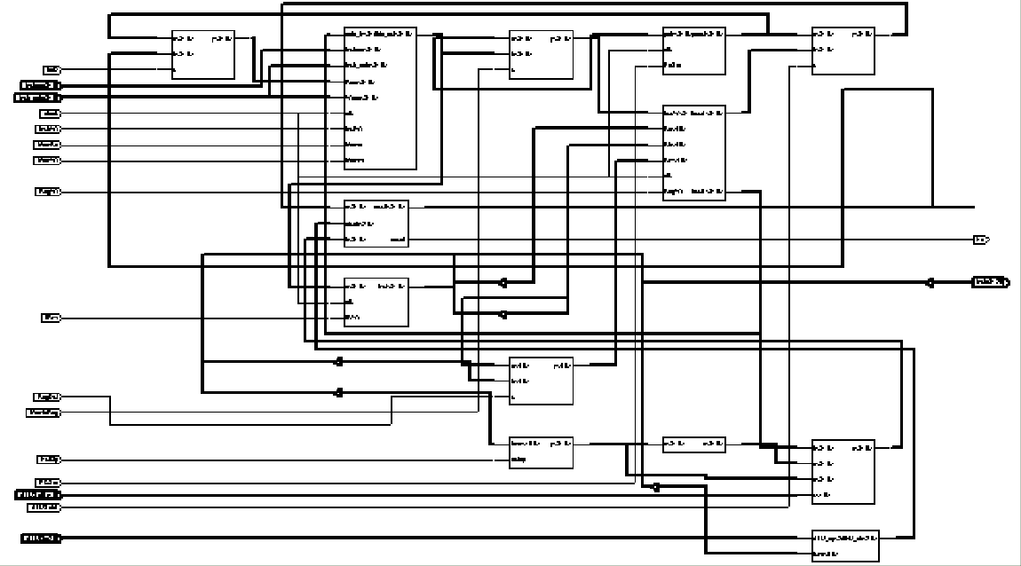

Simulation:

The following is simulation for
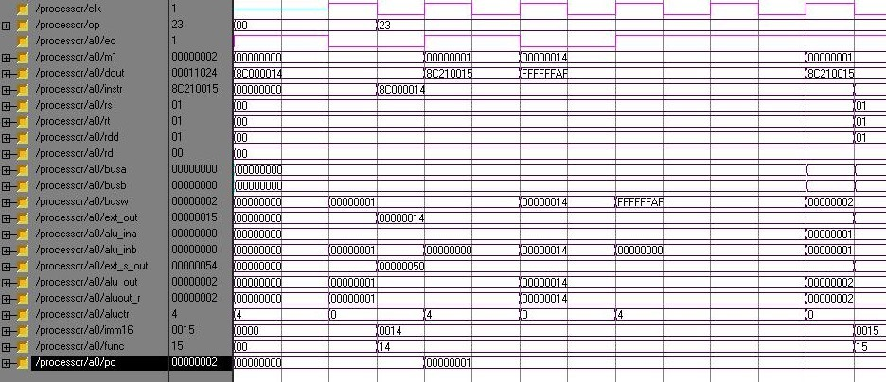

ALU

ALU is the major block in the datapath that performs all the required operations.

ALUctr | Operation
000 | Add
001 | Subtract
010 | Or
011 | And
100 | Nop
In implementing the ALU, we are using VHDL functions. ALU works without any clock.

Entity:
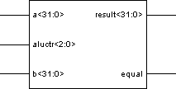

VHDL Code:

use work.cpu_lib.ALL; library IEEE;
use IEEE.STD_LOGIC_1164.ALL; use IEEE.STD_LOGIC_ARITH.ALL;
use IEEE.STD_LOGIC_UNSIGNED.ALL;

entity alu is
Port ( a : in std_logic_vector(size downto 0);
b : in std_logic_vector(size downto 0);
aluctr : in std_logic_vector(2 downto 0);
equal : out std_logic;
result : out std_logic_vector(size downto 0)); end alu;

architecture Behavioral of alu is

begin
process(a,b,aluctr)
variable t:std_logic_vector(size downto 0); --temporary variable
variable r :std_logic_vector(size downto 0);--result
begin
t:=a-b;
case t is
when "00000000000000000000000000000000" =>
equal<='1'; when others =>
equal<='0';

end case;

case aluctr is
when "000" => --Addition r:=a+b;
when "001" => --Subtraction r:=a-b;
when "010" => --Or
r:=a or b; when "011" => --And
r:= a and b;
when "100" => --Noperatoin result<=r;
when others =>
r:="00000000000000000000000000000000";
end case; result<=r; end process;

end Behavioral;

Schematic:
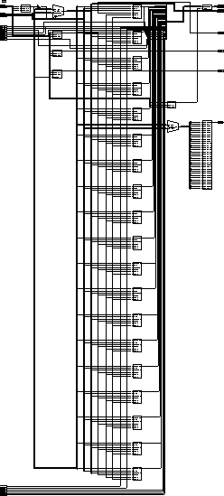

Simulation:
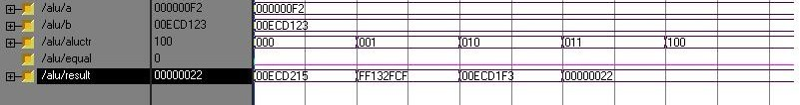

ALU Controller:
It generates the control signals for ALU depending on ALU-op. It works without the clock.

Entity:

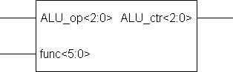

VHDL Code:

use work.cpu_lib.ALL; library IEEE;
use IEEE.STD_LOGIC_1164.ALL; use IEEE.STD_LOGIC_ARITH.ALL;
use IEEE.STD_LOGIC_UNSIGNED.ALL;

entity ALU_control is
Port ( func : in std_logic_vector(5 downto 0);
ALU_op : in std_logic_vector(2 downto 0);
ALU_ctr : out std_logic_vector(2 downto 0)); end ALU_control;

architecture Behavioral of ALU_control is
begin
process(func,ALU_op) begin
case ALU_op is
when "000" =>--add
ALU_ctr<="000";
when "001" =>--subtract
ALU_ctr<= "001";
when "010" =>--or
ALU_ctr<="010";
when "011" =>--and

ALU_ctr<="011";
when "100" =>--R-type instruction
case func is
when "100000" =>--add
ALU_ctr<="000";
when "100010" =>--subtract
ALU_ctr<="001";
when "100100" =>--or
ALU_ctr<="011";
when "100101" =>--and
ALU_ctr<="010";
when others=>--nop
ALU_ctr<="100";
end case;
when "111" =>--nop
ALU_ctr<="100";
when others =>
ALU_ctr<="100";
end case;
end process;

end Behavioral;

Schematic:

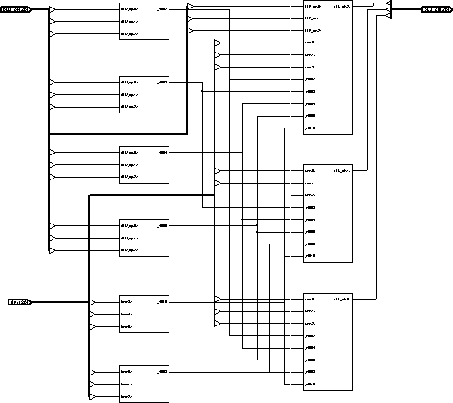

Memory:

Memory here is consisting of 32 locations and each is of 32 bit long. It has both read and write signals. There are other signals for writing instructions into the memory. Memory read operation doesn’t require any clock edge while memory write requires an active clock edge.

Entity:

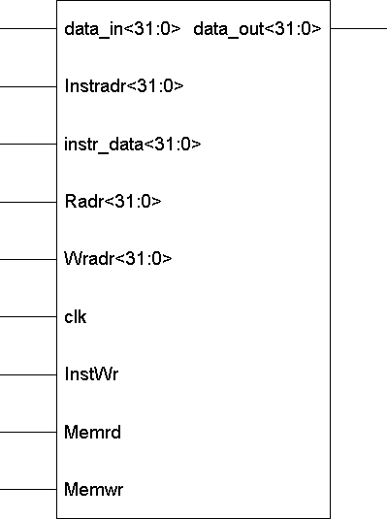

VHDL Code:

use work.cpu_lib.ALL; library IEEE;
use IEEE.STD_LOGIC_1164.ALL; use IEEE.STD_LOGIC_ARITH.ALL;
use IEEE.STD_LOGIC_UNSIGNED.ALL;

entity memory is
Port ( Memwr : in std_logic;

Memrd : in std_logic;
InstWr: in std_logic;
clk : in std_logic;
Radr : in std_logic_vector(size downto 0);
Wradr : in std_logic_vector(size downto 0);
Instradr: in std_logic_vector(size downto 0); --address to write the instruction
instr_data:in std_logic_vector(size downto 0);--Instruction or data to be written
data_in : in std_logic_vector(size downto 0); --Data input to memory
data_out : out std_logic_vector(size downto 0));--data out from memory end memory;

architecture Behavioral of memory is

type memory is array (size downto 0) of std_logic_vector(size downto 0); signal ram:mem:=--Initializing memory by default values

(x"00000000",x"00000000",x"00000000",x"00000000",x"00000000",x"00000000",x"00 000000",x"00000000",x"00000000",x"00000000",x"00000000",x"00000000",x"0000000
0",x"00000000",x"00000000",x"00000000",x"00000000",x"00000000",x"00000000",x"0
0000000",x"00000000",x"00000000",x"00000000",x"00000000",x"00000000",x"000000
00",x"00000000",x"00000000",x"00000000",x"00000000",x"00000000",x"00000000");
begin
process(clk,InstWr,Instradr,Instr_data,Radr)
begin

if clk'event and clk='1' then –check for active clock edge
if Memwr='1' then
ram(CONV_INTEGER(Wradr(mem_size-1 downto 0)))<=data_in;
data_out<="00000000000000000000000000000000";
end if;

end if;

If InstWr='1' then—write the instructions asynchronously
ram(CONV_INTEGER(Instradr(mem_size-1 downto 0)))<=instr_data; end if;

data_out<=ram(CONV_INTEGER(Radr(mem_size-1 downto 0)));
end process; end Behavioral;

Schematic:

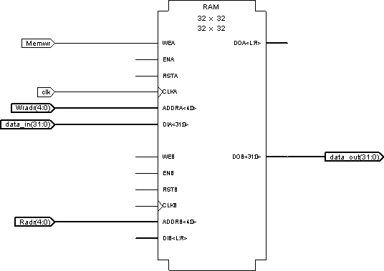
In the above schematic “Instradr” and “Instr_data” are omitted as, it gives synthesis problem because of two clocks.

Regfile:

Like, memory it also doesn’t require clock to read, but requires clock to write to the register. Here Regfile of 32 register, each of 32 bits long is implemented. Regwr should be high, when writing to the register.

Ra—Source register….its value will be output on busA Rb—Source register….its value will be output on busB
Rw—Destination Register…the value on busW will be written to it on active clock edge and when Regwr=’1’;

Entity:

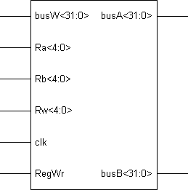

VHDL Code:

use work.cpu_lib.all; library IEEE;
use IEEE.STD_LOGIC_1164.ALL; use IEEE.STD_LOGIC_ARITH.ALL;
use IEEE.STD_LOGIC_UNSIGNED.ALL;

entity regfile is
Port ( Ra : in std_logic_vector(4 downto 0);
Rb : in std_logic_vector(4 downto 0);
Rw : in std_logic_vector(4 downto 0);
RegWr : in std_logic;
clk : in std_logic;
busW:in std_logic_vector(size downto 0);
busA : out std_logic_vector(size downto 0);
busB : out std_logic_vector(size downto 0)); end regfile;

architecture Behavioral of regfile is

signal regarray:reg_file:=--Initializing the ram with default values

(x"00000000",x"00000000",x"00000000",x"00000000",x"00000000",x"00000000",x"00 000000",x"00000000",x"00000000",x"00000000",x"00000000",x"00000000",x"0000000
0",x"00000000",x"00000000",x"00000000",x"00000000",x"00000000",x"00000000",x"0
0000000",x"00000000",x"00000000",x"00000000",x"00000000",x"00000000",x"000000
00",x"00000000",x"00000000",x"00000000",x"00000000",x"00000000",x"00000000");

begin
process(Ra,Rb,Rw,RegWr,clk,busW)
variable addr_a,addr_b,addr_w:integer;

begin

addr_a:=CONV_INTEGER(Ra); addr_b:=CONV_INTEGER(Rb); addr_w:=CONV_INTEGER(Rw); busA<=regarray(addr_a); --Read R[Ra] busB<=regarray(addr_b);--Read R[Rb]

if clk'event and clk='1' then—wait for active clock edge
if Regwr='1' then—see if write signal is active
regarray(addr_w)<=busW;--write the data
end if;
end if;
end process;

end Behavioral;

Schematic:
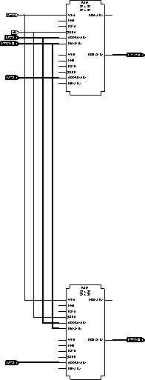

Here two rams are resulted because we are using three address to address 32 register.

Mux-32:

Mux-32 has two 32 bit input and one select line, to output one of them. This doesn’t require any clock edge.
Entity:
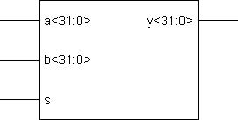

VHDL Code:

use work.cpu_lib.ALL; library IEEE;
use IEEE.STD_LOGIC_1164.ALL; use IEEE.STD_LOGIC_ARITH.ALL;
use IEEE.STD_LOGIC_UNSIGNED.ALL;

entity mux32 is
Port ( a : in std_logic_vector(size downto 0);
b : in std_logic_vector(size downto 0);
s : in std_logic;
y : out std_logic_vector(size downto 0)); end mux32;

architecture Behavioral of mux32 is

begin
process(a,b,s)
begin
case s is
when '0' =>--select a input y<=a;
when '1' =>--select b input y<=b;
when others =>

y<="00000000000000000000000000000000";
end case;
end process;

end Behavioral;

Schematic:
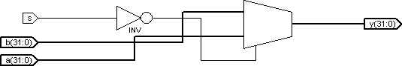

Mux 5:
It has two 5 bit inputs and one select line, to select the output. It works without any clock edge.

Entity:

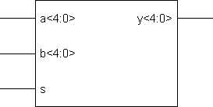
VHDL Code:

library IEEE;
use IEEE.STD_LOGIC_1164.ALL; use IEEE.STD_LOGIC_ARITH.ALL;
use IEEE.STD_LOGIC_UNSIGNED.ALL;

entity mux5 is
Port ( a : in std_logic_vector(4 downto 0);
b : in std_logic_vector(4 downto 0);
s : in std_logic;
y : out std_logic_vector(4 downto 0)); end mux5;

architecture Behavioral of mux5 is
begin process(a,b,s) begin
case s is
when '0' =>
y<=a; when '1' =>
y<=b; when others =>
y<="00000";
end case; end process;
end Behavioral;

Schematic:

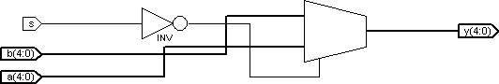

Mux_sel:

It takes four input and two select lines(ALUSelB) and outputs one of them. It doesn’t require any clock edge. One input is the default value of ‘1’ required to increment pc.

Entity:

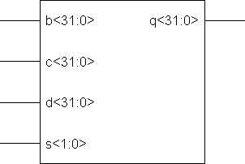

VHDL Code:

use work.cpu_lib.ALL; library IEEE;
use IEEE.STD_LOGIC_1164.ALL; use IEEE.STD_LOGIC_ARITH.ALL;
use IEEE.STD_LOGIC_UNSIGNED.ALL;

entity mux_sel is
Port (
b : in std_logic_vector(size downto 0);
c : in std_logic_vector(size downto 0);
d : in std_logic_vector(size downto 0);
s : in std_logic_vector(1 downto 0);
q : out std_logic_vector(size downto 0)); end mux_sel;
architecture Behavioral of mux_sel is

begin
process(b,c,d,s)
begin
case s is
when "00" =>--output the value 1—required to increment pc
q<="00000000000000000000000000000001";
when "01" =>--output the value b—value on busB
q<=b;
when "10" =>--output the value c—connected to the output of shifter.
q<=c;

--output the value d—connected to the output of extender
q<=d;
when "11" =>
when others =>
q<="00000000000000000000000000000000";
end case;
end process;

end Behavioral;

Schematic:

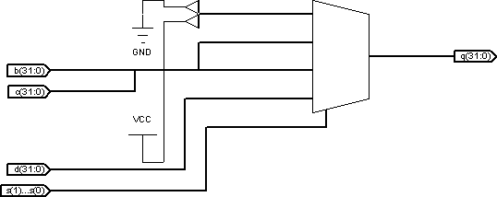

PC Register:

It is used to hold the value of pc (program counter). PcSrc, signal is used to indicate when to write the next value of pc. It works on rising edge of the clock.
Entity:

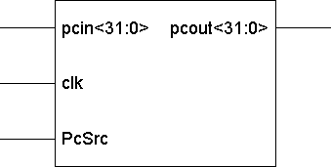
VHDL Code:

use work.cpu_lib.ALL; library IEEE;
use IEEE.STD_LOGIC_1164.ALL; use IEEE.STD_LOGIC_ARITH.ALL;
use IEEE.STD_LOGIC_UNSIGNED.ALL;

entity pcreg is
port(pcin:in std_logic_vector(size downto 0);
PcSrc: in std_logic;
clk: in std_logic;
pcout: out std_logic_vector(size downto 0)); end pcreg;

architecture Behavioral of pcreg is
--load pc with the initialize value of 0
signal pc:std_logic_vector(size downto 0):="00000000000000000000000000000000";

begin
process(clk)
begin
if clk'event and clk='1' then—wait for rising clock edge
if PcSrc='1' then—to know when to load next pc value
pc<=pcin;
end if;
end if;

end process;
pcout<=pc;--continuously output the value present in pc

end Behavioral;

Schematic:

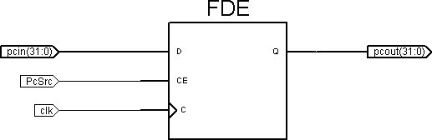

Instruction Register:

The instruction fetched during the begging of the instruction execution must be held until the execution of the instruction is completed. This is done by instruction register. This writes the value from memory when IRwr=’1’ and on the falling clock edge.

Entity:

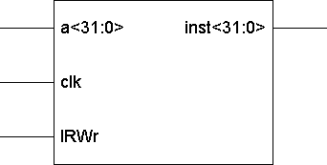

VHDL Code:

use work.cpu_lib.ALL; library IEEE;
use IEEE.STD_LOGIC_1164.ALL; use IEEE.STD_LOGIC_ARITH.ALL;
use IEEE.STD_LOGIC_UNSIGNED.ALL;

entity instr_reg is
Port ( a : in std_logic_vector(size downto 0);
IRWr:in std_logic;
clk : in std_logic;
inst : out std_logic_vector(size downto 0)); end instr_reg;

architecture Behavioral of instr_reg is
--load instr_reg with the default value.
signal instrreg:std_logic_vector(size downto 0 )
:=”0000000000000000000000000000000”;
begin
process(clk)

begin
if clk'event and clk='0' then –check for falling clock edge.
If IRWr='1' then—condition for writing to the register
instrreg<=a;
end if; end if;
end process;
inst<=instrreg;--output the value present in the register. end Behavioral;
Schematic:

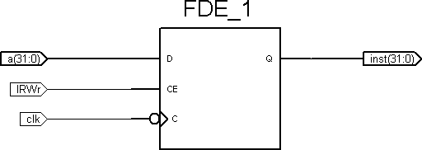

Instruction spilt:

It continuously takes the instruction from instruction register and splits them to various parts as given in the instruction format. It doesn’t require a clock.

Entity:
op<=instr(31 downto 26);
Rs<=instr(25 downto 21);
Rt<=instr(20 downto 16);
Rd<=instr(15 downto 11);
func<=instr(5 downto 0);
imm16<=instr(15 downto 0);

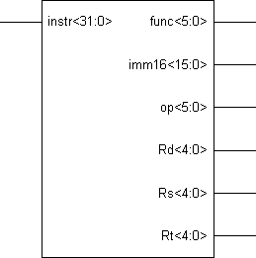

VHDL Code:

library IEEE;
use IEEE.STD_LOGIC_1164.ALL; use IEEE.STD_LOGIC_ARITH.ALL;
use IEEE.STD_LOGIC_UNSIGNED.ALL;

entity instr_spilt is
Port ( instr : in std_logic_vector(31 downto 0);
op:out std_logic_vector(5 downto 0);
Rs : out std_logic_vector(4 downto 0);
Rt : out std_logic_vector(4 downto 0);
Rd : out std_logic_vector(4 downto 0);

func:out std_logic_vector(5 downto 0);
imm16 : out std_logic_vector(15 downto 0)); end instr_spilt;

architecture Behavioral of instr_spilt is

begin
op<=instr(31 downto 26);
Rs<=instr(25 downto 21);
Rt<=instr(20 downto 16);
Rd<=instr(15 downto 11);
func<=instr(5 downto 0);
imm16<=instr(15 downto 0);

end Behavioral;
Schematic:
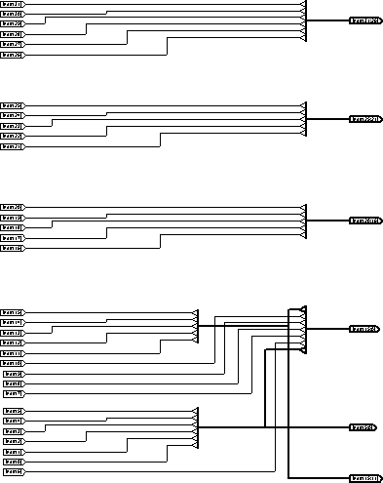

Extender:

This extenders either the given immediate 16 bit value to 32 bit either as sign extension or as zero extension depending on the value of Extop (1—for sign extension and 0 –for zero extension). It works without any clock. The output from extender goes as input to mux_sel and to the shifter.

Entity:

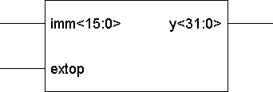

VHDL Code:

use work.cpu_lib.ALL; library IEEE;
use IEEE.STD_LOGIC_1164.ALL; use IEEE.STD_LOGIC_ARITH.ALL;
use IEEE.STD_LOGIC_UNSIGNED.ALL;

entity extender is
Port ( imm : in std_logic_vector(bsize downto 0);
extop : in std_logic;
y : out std_logic_vector(size downto 0)); end extender;

architecture Behavioral of extender is

begin
process(imm,extop)
variable sign:std_logic;--sign of the given input
variable t:std_logic_vector(size downto 0);--temporary variable
begin

case extop is
when '0' =>--zero extension
y(size downto bsize+1)<="0000000000000000";
y(bsize downto 0)<=imm;

when '1' => --sign extension
sign:=imm(bsize);

for i in bsize+1 to size loop
t(i):=sign;
end loop;

t(bsize downto 0):=imm;
y<=t; when others =>
y<="00000000000000000000000000000000";
end case;

end process;
end Behavioral;

Schematic:

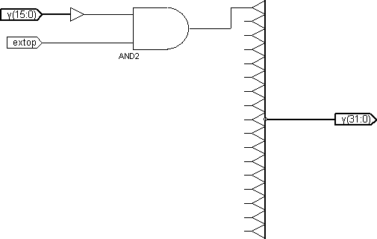

Implementation(Cyclone EP1C6):

The processor designed above is implemented on cyclone (EP1C6) board. The following would discuss this device.

EP1C6 Devices:

The EP1C6, a member of the Cyclone device family, provides 6,523 registers; 92,160 memory bits; and 5,980 logic elements. The Cyclone device meets the low-voltage requirements of 1.5-V applications and supports multiple I/O standards including LVDS (low-voltage differential signaling), LVTTL, LVCMOS, PCI, SSTL-3 Class I & II, and SSTL-2 Class I & II.

The EP1C6 is available in 144-pin TQFP packages with 92 I/O pins, 240-pin QFP packages with 181 I/O pins, and 256-pin FineLine BGA packages (See Note (12)). The device has 5,980 logic elements grouped into 598 LABs. These LABs are arranged into 20 rows and 32 columns. The embedded memory consists of one column of M4K memory blocks, containing a total of 92,160 RAM bits. Each M4K block can implement shift registers and various types of memory with or without parity bits, including dual-port, true dual-port, and single-port RAM, ROM, FIFO buffers, and shift registers.
Each I/O element contains a bidirectional I/O buffer and three registers for complete embedded bidirectional single data rate transfer. The I/O element contains individual input, output, and output enable registers. The input register provides fast setup times, the output register provides fast clock-to-output times, and the output enable register provides fast clock-to-output enable times. The EP1C6 also contains four dedicated clock pins and eight dual-purpose clock pins for large fan-out control signals. In addition, the EP1C6 contains two phase-locked loops (PLLs), which provide general purpose clocking with clock multiplication and phase shifting as well as high-speed outputs for high-speed differential I/O support.

The EP1C6 also supports ICR and JTAG BST. The EP1C6 JTAG Instruction Register length is 10; the Boundary-Scan Register length is 582; and the JTAG ID code is 0x020820DD.

The following table displays the pin-out information for EP1C6 devices:

Function PadSecondary
VRefI/O
Pad
256-Pin
240-
144- 25

No.Function
Pad
BankLocation
FineLinePin
Pin D

PQFPTQFP

Row I/O | 0 | LVDS14p/INIT_DONE | 4 | 1 | IOC_X0_Y20_N0 | D4 | 1 | 1
Row I/O | 1 | LVDS14n | 4 | 1 | IOC_X0_Y20_N1 | C3 | 2 | 2
Row I/O | 2 | LVDS13p/CLKUSR | 4 | 1 | IOC_X0_Y19_N0 | C2 | 3 | 3

Row I/O | 3 | LVDS13n | 4 | 1 | IOC_X0_Y19_N1 | B1 | 4 | 4
X0Y19SUB_LOC2 | 4 | VREF0B1 | - | 1 | IOC_X0_Y19_N2 | G5 | 5 | 5
Row I/O | 5 | - | 4 | 1 | IOC_X0_Y18_N0 | F4 | 6 | 6
Row I/O | 6 | LVDS12p/DQ0L0 | 4 | 1 | IOC_X0_Y18_N1 | D3 | 7 | 7 | D
Row I/O | 7 | LVDS12n/DQ0L1 | 4 | 1 | IOC_X0_Y18_N2 | E4 | 8 | - | D
Row I/O | 8 | DPCLK1/DQS0L | 4 | 1 | IOC_X0_Y17_N0 | F5 | 11 | 10 | D
Row I/O | 9 | LVDS11p/DQ0L2 | 4 | 1 | IOC_X0_Y17_N1 | E3 | 12 | - | D
Row I/O | 10 | LVDS11n/DQ0L3 | 4 | 1 | IOC_X0_Y17_N2 | D2 | 13 | - | D
Row I/O | 11 | LVDS10p | 4 | 1 | IOC_X0_Y16_N0 | E2 | 14 | -
Row I/O | 12 | LVDS10n | 4 | 1 | IOC_X0_Y16_N1 | D1 | 15 | -
Row I/O | 13 | LVDS9p | 4 | 1 | IOC_X0_Y16_N2 | F3 | 16 | -
Row I/O | 14 | LVDS9n | 4 | 1 | IOC_X0_Y15_N0 | G3 | 17 | -
Row I/O | 15 | LVDS8p | 4 | 1 | IOC_X0_Y15_N1 | F2 | 18 | -
Row I/O | 16 | LVDS8n | 4 | 1 | IOC_X0_Y14_N0 | E1 | 19 | -
Row I/O | 17 | LVDS7p | 4 | 1 | IOC_X0_Y14_N1 | G2 | 20 | -
Row I/O | 18 | LVDS7n/DM0L | 4 | 1 | IOC_X0_Y14_N2 | F1 | 21 | - | D
X0Y13SUB_LOC0 | 19 | VREF1B1 | - | 1 | IOC_X0_Y13_N0 | H5 | 23 | 11
Row I/O | 20 | nCSO | 19 | 1 | IOC_X0_Y13_N1 | G4 | 24 | 12

Dedicated Programming
21 DATA0 - 1 IOC_X0_Y12_N0 H2 25 13

Dedicated  Programming | 22 | nCONFIG | - | 1 | IOC_X0_Y12_N1 | H3 | 26 | 14
Dedicated Clock | 23 | CLK0/LVDSCLK1p | 19 | 1 | IOC_X0_Y12_N2 | G1 | 28 | 16
Dedicated Clock | 24 | CLK1/LVDSCLK1n | 19 | 1 | IOC_X0_Y11_N0 | H1 | 29 | 17

Function PadSecondary
VRefI/O
Pad
256-Pin
240-
144- 25

No.Function
Pad
BankLocation
FineLinePin
Pin D

Dedicated Programming Dedicated Programming Dedicated Programming Dedicated Programming Dedicated Programming Row I/O Row I/O Row I/O Row I/O Row I/O Row I/O Row I/O
25 nCEO | - | 1 | IOC_X0_Y11_N1 | H4 | 32 | 20
26 nCE | - | 1 | IOC_X0_Y11_N2 | J4 | 33 | 21
27 MSEL0 | - | 1 | IOC_X0_Y10_N0 | J3 | 34 | 22
28 MSEL1 | - | 1 | IOC_X0_Y10_N1 | J2 | 35 | 23
29 DCLK | - | 1 | IOC_X0_Y10_N2 | K4 | 36 | 24
30 ASDO | 19 | 1 | IOC_X0_Y9_N0 | K3 | 37 | 25
31 PLL1_OUTp | 19 | 1 | IOC_X0_Y8_N0 | J1 | 38 | 26
32 PLL1_OUTn | 19 | 1 | IOC_X0_Y8_N1 | K2 | 39 | 27
33 - | 45 | 1 | IOC_X0_Y7_N0 | L3 | 41 | -
34 LVDS6p | 45 | 1 | IOC_X0_Y7_N1 | K1 | 42 | -
35 LVDS6n | 45 | 1 | IOC_X0_Y7_N2 | L1 | 43 | -
36 LVDS5p | 45 | 1 | IOC_X0_Y6_N0 | L2 | 44 | -

PQFPTQFP

Row I/O | 37 | LVDS5n | 45 | 1 | IOC_X0_Y6_N1 | M1 | 45 | -
Row I/O | 38 | LVDS4p | 45 | 1 | IOC_X0_Y5_N0 | N1 | 46 | -
Row I/O | 39 | LVDS4n | 45 | 1 | IOC_X0_Y5_N1 | M2 | 47 | -
Row I/O | 40 | LVDS3p/DQ0L4 | 45 | 1 | IOC_X0_Y4_N0 | N2 | 48 | - | D
Row I/O | 41 | LVDS3n/DQ0L5 | 45 | 1 | IOC_X0_Y4_N1 | M3 | 49 | - | D
Row I/O | 42 | DPCLK0/DQS1L | 45 | 1 | IOC_X0_Y4_N2 | L5 | 50 | 28
Row I/O | 43 | LVDS2p/DQ0L6 | 45 | 1 | IOC_X0_Y3_N0 | M4 | 53 | - | D
Row I/O | 44 | LVDS2n/DQ0L7 | 45 | 1 | IOC_X0_Y3_N1 | N3 | 54 | - | D
X0Y3SUB_LOC2 | 45 | VREF2B1 | - | 1 | IOC_X0_Y3_N2 | K5 | 55 | 31
Row I/O | 46 | - | 45 | 1 | IOC_X0_Y2_N0 | L4 | 56 | 32
Row I/O | 47 | LVDS1p | 45 | 1 | IOC_X0_Y2_N1 | R1 | 57 | 33
Row I/O | 48 | LVDS1n | 45 | 1 | IOC_X0_Y2_N2 | P2 | 58 | 34
Row I/O | 49 | LVDS0p | 45 | 1 | IOC_X0_Y1_N0 | P3 | 59 | 35
Row I/O | 50 | LVDS0n | 45 | 1 | IOC_X0_Y1_N1 | N4 | 60 | 36

Function PadSecondary
VRefI/O
Pad
256-Pin
240-
144- 25

No.Function
Pad
BankLocation
FineLinePin
Pin D

PQFPTQFP

Column I/O | 51 | LVDS71p | 60 | 4 | IOC_X2_Y0_N2 | R2 | 61 | 37
Column I/O | 52 | LVDS71n | 60 | 4 | IOC_X2_Y0_N1 | T2 | 62 | 38
Column I/O | 53 | LVDS70p | 60 | 4 | IOC_X2_Y0_N0 | R3 | 63 | -
Column I/O | 54 | LVDS70n | 60 | 4 | IOC_X4_Y0_N2 | P4 | 64 | -
Column I/O | 55 | LVDS69p | 60 | 4 | IOC_X4_Y0_N1 | R4 | 65 | 39
Column I/O | 56 | LVDS69n | 60 | 4 | IOC_X4_Y0_N0 | T4 | 66 | 40
Column I/O | 57 | LVDS68p/DQ1B7 | 60 | 4 | IOC_X6_Y0_N2 | R5 | 67 | 41 | D
Column I/O | 58 | LVDS68n/DQ1B6 | 60 | 4 | IOC_X6_Y0_N1 | P5 | 68 | 42 | D
Column I/O | 59 | DPCLK7/DQS1B | 60 | 4 | IOC_X6_Y0_N0 | M5 | 73 | 47 | D
X8Y0SUB_LOC2 | 60 | VREF2B4 | - | 4 | IOC_X8_Y0_N2 | M6 | 74 | 48
Column I/O | 61 | LVDS67p | 60 | 4 | IOC_X8_Y0_N1 | N5 | 75 | 49
Column I/O | 62 | LVDS67n/DQ1B5 | 60 | 4 | IOC_X8_Y0_N0 | N6 | 76 | - | D
Column I/O | 63 | LVDS66p/DQ1B4 | 60 | 4 | IOC_X10_Y0_N2 | P6 | 77 | - | D
Column I/O | 64 | LVDS66n | 60 | 4 | IOC_X10_Y0_N1 | R6 | 78 | -
Column I/O | 65 | - | 60 | 4 | IOC_X10_Y0_N0 | M7 | 79 | -
Column I/O | 66 | LVDS65p | 60 | 4 | IOC_X12_Y0_N2 | T6 | 80 | -
Column I/O | 67 | LVDS65n | 60 | 4 | IOC_X12_Y0_N1 | R7 | 81 | -
Column I/O | 68 | LVDS64p | 60 | 4 | IOC_X12_Y0_N0 | P7 | 82 | -
Column I/O | 69 | LVDS64n | 60 | 4 | IOC_X14_Y0_N2 | N7 | 83 | -
Column I/O | 70 | LVDS63p | 60 | 4 | IOC_X14_Y0_N1 | R8 | 84 | 50
Column I/O | 71 | LVDS63n | 60 | 4 | IOC_X14_Y0_N0 | T8 | 85 | 51
Column I/O | 72 | LVDS62p | 75 | 4 | IOC_X16_Y0_N2 | N8 | 86 | 52
Column I/O | 73 | LVDS62n | 75 | 4 | IOC_X16_Y0_N1 | P8 | 87 | 53
Column I/O | 74 | - | 75 | 4 | IOC_X16_Y0_N0 | M8 | 88 | -
X20Y0SUB_LOC2 | 75 | VREF1B4 | - | 4 | IOC_X20_Y0_N2 | M10 | 93 | 56
Column I/O | 76 | LVDS61p/DM1B | 75 | 4 | IOC_X20_Y0_N1 | R9 | 94 | 57 | D

Function PadSecondary
VRefI/O
Pad
256-Pin
240-
144- 25

No.Function
Pad
BankLocation
FineLinePin
Pin D

PQFPTQFP

Column I/O | 77 | LVDS61n | 75 | 4 | IOC_X20_Y0_N0 | T9 | 95 | 58
Column I/O | 78 | LVDS60p | 75 | 4 | IOC_X22_Y0_N2 | P9 | 96 | -
Column I/O | 79 | LVDS60n | 75 | 4 | IOC_X22_Y0_N1 | N9 | 97 | -
Column I/O | 80 | LVDS59p | 75 | 4 | IOC_X22_Y0_N0 | R10 | 98 | -
Column I/O | 81 | LVDS59n | 75 | 4 | IOC_X24_Y0_N2 | T11 | 99 | 59
Column I/O | 82 | LVDS58p | 75 | 4 | IOC_X24_Y0_N1 | N10 | 100 | -
Column I/O | 83 | LVDS58n | 75 | 4 | IOC_X24_Y0_N0 | P10 | 101 | -
Column I/O | 84 | LVDS57p | 89 | 4 | IOC_X26_Y0_N2 | R11 | 102 | -
Column I/O | 85 | LVDS57n | 89 | 4 | IOC_X26_Y0_N1 | P11 | 103 | -
Column I/O | 86 | LVDS56p | 89 | 4 | IOC_X26_Y0_N0 | N11 | 104 | -
Column I/O | 87 | LVDS56n | 89 | 4 | IOC_X28_Y0_N2 | N12 | 105 | -
Column I/O | 88 | - | 89 | 4 | IOC_X28_Y0_N1 | M9 | 106 | 60
X28Y0SUB_LOC0 | 89 | VREF0B4 | - | 4 | IOC_X28_Y0_N0 | M11 | 107 | 61
Column I/O | 90 | DPCLK6/DQS0B | 89 | 4 | IOC_X30_Y0_N2 | M12 | 108 | 62
Column I/O | 91 | LVDS55p/DQ1B3 | 89 | 4 | IOC_X30_Y0_N1 | P12 | 113 | 67 | D
Column I/O | 92 | LVDS55n/DQ1B2 | 89 | 4 | IOC_X30_Y0_N0 | R12 | 114 | 68 | D
Column I/O | 93 | LVDS54p/DQ1B1 | 89 | 4 | IOC_X32_Y0_N2 | T13 | 115 | 69 | D
Column I/O | 94 | LVDS54n/DQ1B0 | 89 | 4 | IOC_X32_Y0_N1 | R13 | 116 | 70 | D
Column I/O | 95 | LVDS53p | 89 | 4 | IOC_X32_Y0_N0 | R14 | 117 | -
Column I/O | 96 | LVDS53n | 89 | 4 | IOC_X34_Y0_N2 | P13 | 118 | -
Column I/O | 97 | LVDS52p | 89 | 4 | IOC_X34_Y0_N1 | T15 | 119 | 71
Column I/O | 98 | LVDS52n | 89 | 4 | IOC_X34_Y0_N0 | R15 | 120 | 72
Row I/O | 99 | LVDS51n | 105 | 3 | IOC_X35_Y1_N1 | N13 | 121 | 73
Row I/O | 100 | LVDS51p | 105 | 3 | IOC_X35_Y1_N0 | P14 | 122 | 74
Row I/O | 101 | LVDS50n | 105 | 3 | IOC_X35_Y2_N2 | P15 | 123 | 75
Row I/O | 102 | LVDS50p | 105 | 3 | IOC_X35_Y2_N1 | R16 | 124 | 76

Function PadSecondary
VRefI/O
Pad
256-Pin
240-
144- 25

No.Function
Pad
BankLocation
FineLinePin
Pin D

PQFPTQFP

Row I/O | 103LVDS49n/DQ1R7 | 105 | 3 | IOC_X35_Y2_N0 | N15 | 125 | 77 | D
Row I/O | 104LVDS49p | 105 | 3 | IOC_X35_Y3_N2 | N16 | 126 | 78
X35Y3SUB_LOC1 | 105VREF2B3 | - | 3 | IOC_X35_Y3_N1 | K12 | 127 | 79
Row I/O | 106DQ1R6 | 105 | 3 | IOC_X35_Y3_N0 | K14 | 128 | - | D
Row I/O | 107DPCLK5/DQS1R | 105 | 3 | IOC_X35_Y4_N2 | L12 | 131 | 82 | D
Row I/O | 108LVDS48n/DQ1R5 | 105 | 3 | IOC_X35_Y4_N1 | N14 | 132 | DQ1R5 | D
Row I/O | 109LVDS48p/DQ1R4 | 105 | 3 | IOC_X35_Y4_N0 | M13 | 133 | 84 | D
Row I/O | 110LVDS47n | 105 | 3 | IOC_X35_Y5_N1 | M14 | 134 | 85
Row I/O | 111LVDS47p | 105 | 3 | IOC_X35_Y5_N0 | L13 | 135 | -

Row I/O | 112LVDS46n | 105 | 3 | IOC_X35_Y6_N1 | M15 | 136 | -
Row I/O | 113LVDS46p | 105 | 3 | IOC_X35_Y6_N0 | M16 | 137 | -
Row I/O | 114LVDS45n | 105 | 3 | IOC_X35_Y7_N1 | L14 | 138 | -
Row I/O | 115LVDS45p | 105 | 3 | IOC_X35_Y7_N0 | L15 | 139 | -
Row I/O | 116LVDS44n | 105 | 3 | IOC_X35_Y8_N1 | L16 | 140 | -
Row I/O | 117LVDS44p | 105 | 3 | IOC_X35_Y8_N0 | K16 | 141 | -
Row I/O | 118PLL2_OUTn | 128 | 3 | IOC_X35_Y9_N1 | K15 | 143 | -
Row I/O | 119PLL2_OUTp | 128 | 3 | IOC_X35_Y9_N0 | J16 | 144 | -

Dedicated Programming Dedicated
IOC_X35_Y10_N2K13 145 86
IOC_X35_Y10_N1J13 146 87
Programming
JTAG | 122TCK | - | 3 | IOC_X35_Y10_N0J14 | 147 | 88
JTAG | 123TMS | - | 3 | IOC_X35_Y11_N1J15 | 148 | 89
JTAG | 124TDO | - | 3 | IOC_X35_Y11_N0H15 | 149 | 90
Dedicated Clock | 125CLK3/LVDSCLK2n | 128 | 3 | IOC_X35_Y12_N2H16 | 152 | 92
Dedicated Clock | 126CLK2/LVDSCLK2p | 128 | 3 | IOC_X35_Y12_N1G16 | 153 | 93
JTAG | 127TDI | - | 3 | IOC_X35_Y12_N0H14 | 155 | 95
X35Y13SUB_LOC2 | 128VREF1B3 | - | 3 | IOC_X35_Y13_N2H12 | 156 | 96

120CONF_DONE | - | 3
121nSTATUS | - | 3

Function PadSecondary
VRefI/O
Pad
256-Pin
240-
144- 25

No.Function
Pad
BankLocation
FineLinePin
Pin D

PQFPTQFP

Row I/O | 129LVDS43n/DM1R | 145 | 3 | IOC_X35_Y13_N1G14 | 158 | - | D
Row I/O | 130LVDS43p | 145 | 3 | IOC_X35_Y13_N0G13 | 159 | -
Row I/O | 131LVDS42n | 145 | 3 | IOC_X35_Y14_N1G15 | 160 | -
Row I/O | 132LVDS42p | 145 | 3 | IOC_X35_Y14_N0F16 | 161 | -
Row I/O | 133LVDS41n | 145 | 3 | IOC_X35_Y15_N2F14 | 162 | -
Row I/O | 134LVDS41p | 145 | 3 | IOC_X35_Y15_N1F13 | 163 | -
Row I/O | 135LVDS40n | 145 | 3 | IOC_X35_Y15_N0F15 | 164 | -
Row I/O | 136LVDS40p | 145 | 3 | IOC_X35_Y16_N2E16 | 165 | -
Row I/O | 137LVDS39n | 145 | 3 | IOC_X35_Y16_N1E15 | 166 | -
Row I/O | 138LVDS39p | 145 | 3 | IOC_X35_Y16_N0D16 | 167 | 97
Row I/O | 139LVDS38n | 145 | 3 | IOC_X35_Y17_N2D15 | 168 | 98
Row I/O | 140LVDS38p/DQ1R3 | 145 | 3 | IOC_X35_Y17_N1E14 | 169 | 99 | D
Row I/O | 141DPCLK4/DQS0R | 145 | 3 | IOC_X35_Y17_N0F12 | 170 | 100
Row I/O | 142LVDS37n/DQ1R2 | 145 | 3 | IOC_X35_Y18_N2E13 | 173 | - | D
Row I/O | 143LVDS37p/DQ1R1 | 145 | 3 | IOC_X35_Y18_N1D14 | 174 | - | D
Row I/O | 144DQ1R0 | 145 | 3 | IOC_X35_Y18_N0H13 | 175 | 103 | D
X35Y19SUB_LOC2 | 145VREF0B3 | - | 3 | IOC_X35_Y19_N2G12 | 176 | 104
Row I/O | 146LVDS36n | 145 | 3 | IOC_X35_Y19_N1B16 | 177 | 105
Row I/O | 147LVDS36p | 145 | 3 | IOC_X35_Y19_N0C15 | 178 | 106
Row I/O | 148LVDS35n | 145 | 3 | IOC_X35_Y20_N1C14 | 179 | 107
Row I/O | 149LVDS35p | 145 | 3 | IOC_X35_Y20_N0D13 | 180 | 108
Column I/O | 150LVDS34n | 159 | 2 | IOC_X34_Y21_N0B15 | 181 | 109

Column I/O | 151LVDS34p | 159 2 | IOC_X34_Y21_N1A15 | 182 | 110
Column I/O | 152LVDS33n | 159 2 | IOC_X34_Y21_N2B14 | 183 | -
Column I/O | 153LVDS33p | 159 2 | IOC_X32_Y21_N0C13 | 184 | -
Column I/O | 154LVDS32n/DQ0T0 | 159 2 | IOC_X32_Y21_N1B13 | 185 | 111 | D

Function PadSecondary
VRefI/O
Pad
256-Pin
240-
144- 25

No.Function
Pad
BankLocation
FineLinePin
Pin D

PQFPTQFP

Column I/O | 155LVDS32p/DQ0T1 | 159 | 2 | IOC_X32_Y21_N2A13 | 186 | 112 | D
Column I/O | 156LVDS31n/DQ0T2 | 159 | 2 | IOC_X30_Y21_N0B12 | 187 | DQ0T2 | D
Column I/O | 157LVDS31p/DQ0T3 | 159 | 2 | IOC_X30_Y21_N1C12 | 188 | 114 | D
Column I/O | 158DPCLK3/DQS0T | 159 | 2 | IOC_X30_Y21_N2E12 | 193 | 119 | D
X28Y21SUB_LOC0 | 159VREF0B2 | - | 2 | IOC_X28_Y21_N0E11 | 194 | 120
Column I/O | 160- | 159 | 2 | IOC_X28_Y21_N1E9 | 195 | 121
Column I/O | 161LVDS30n | 159 | 2 | IOC_X28_Y21_N2D12 | 196 | -
Column I/O | 162LVDS30p | 159 | 2 | IOC_X26_Y21_N0D11 | 197 | -
Column I/O | 163LVDS29n | 159 | 2 | IOC_X26_Y21_N1C11 | 198 | -
Column I/O | 164LVDS29p | 159 | 2 | IOC_X26_Y21_N2B11 | 199 | -
Column I/O | 165LVDS28n | 173 | 2 | IOC_X24_Y21_N0A11 | 200 | -
Column I/O | 166LVDS28p | 173 | 2 | IOC_X24_Y21_N1B10 | 201 | -
Column I/O | 167LVDS27n | 173 | 2 | IOC_X24_Y21_N2C10 | 202 | 122
Column I/O | 168LVDS27p | 173 | 2 | IOC_X22_Y21_N0D10 | 203 | -
Column I/O | 169LVDS26n | 173 | 2 | IOC_X22_Y21_N1A9 | 204 | -
Column I/O | 170LVDS26p | 173 | 2 | IOC_X22_Y21_N2B9 | 205 | -
Column I/O | 171LVDS25n/DM0T | 173 | 2 | IOC_X20_Y21_N0D9 | 206 | 123 | D
Column I/O | 172LVDS25p | 173 | 2 | IOC_X20_Y21_N1C9 | 207 | 124
X20Y21SUB_LOC2 | 173VREF1B2 | - | 2 | IOC_X20_Y21_N2E10 | 208 | 125
Column I/O | 174- | 173 | 2 | IOC_X16_Y21_N0E8 | 213 | -
Column I/O | 175LVDS24n | 173 | 2 | IOC_X16_Y21_N1C8 | 214 | 128
Column I/O | 176LVDS24p | 173 | 2 | IOC_X16_Y21_N2D8 | 215 | 129
Column I/O | 177LVDS23n | 188 | 2 | IOC_X14_Y21_N0A8 | 216 | 130
Column I/O | 178LVDS23p | 188 | 2 | IOC_X14_Y21_N1B8 | 217 | 131
Column I/O | 179LVDS22n | 188 | 2 | IOC_X14_Y21_N2D7 | 218 | -
Column I/O | 180LVDS22p | 188 | 2 | IOC_X12_Y21_N0C7 | 219 | -

Function PadSecondary
VRefI/O
Pad
256-Pin
240-
144- 25

No.Function
Pad
BankLocation
FineLinePin
Pin D

PQFPTQFP

Column I/O | 181LVDS21n | 188 | 2 | IOC_X12_Y21_N1B7 | 220 | -
Column I/O | 182LVDS21p | 188 | 2 | IOC_X12_Y21_N2A6 | 221 | -
Column I/O | 183- | 188 | 2 | IOC_X10_Y21_N0E7 | 222 | -
Column I/O | 184LVDS20n | 188 | 2 | IOC_X10_Y21_N1B6 | 223 | -
Column I/O | 185LVDS20p | 188 | 2 | IOC_X10_Y21_N2C6 | 224 | -

Column I/O | 186LVDS19n | 188 | 2 | IOC_X8_Y21_N0 | D6 | 225 | -
Column I/O | 187LVDS19p | 188 | 2 | IOC_X8_Y21_N1 | D5 | 226 | 132
X8Y21SUB_LOC2 | 188VREF2B2 | - | 2 | IOC_X8_Y21_N2 | E6 | 227 | 133
Column I/O | 189DPCLK2/DQS1T | 188 | 2 | IOC_X6_Y21_N0 | E5 | 228 | 134
Column I/O | 190LVDS18n/DQ0T4 | 188 | 2 | IOC_X6_Y21_N1 | C5 | 233 | 139 | D
Column I/O | 191LVDS18p/DQ0T5 | 188 | 2 | IOC_X6_Y21_N2 | B5 | 234 | 140 | D
Column I/O | 192LVDS17n/DQ0T6 | 188 | 2 | IOC_X4_Y21_N0 | A4 | 235 | 141 | D
Column I/O | 193LVDS17p/DQ0T7 | 188 | 2 | IOC_X4_Y21_N1 | B4 | 236 | 142 | D
Column I/O | 194LVDS16n | 188 | 2 | IOC_X4_Y21_N2 | C4 | 237 | -
Column I/O | 195LVDS16p | 188 | 2 | IOC_X2_Y21_N0 | B3 | 238 | -
Column I/O | 196LVDS15n/DEV_OE | 188 | 2 | IOC_X2_Y21_N1 | A2 | 239 | 143
Column I/O | 197LVDS15p/DEV_CLRn | 188 | 2 | IOC_X2_Y21_N2 | B2 | 240 | 144

Power, Ground, and No-Connect Pins for 256-Pin FineLine

Function Pin Name (I/O Bank)

VCCIO4 L7(3) L10(3) T3(3) T14(3)
VCCIO3 C16(2) K11(2) P16(2)
VCCIO2 A3(1) A14(1) F7(1) F10(1)
VCCIO1 C1 G6 P1
VCCINT A7 A10 G8 G10 H7 H9 T7 T10
VCCA_PLL2 H11
VCCA_PLL1 H6
GNDG_PLL2 J12
GNDG_PLL1 J5
GNDA_PLL2 J11
GNDA_PLL1 J6
GND A1 A5 A12 A16 F6 F8 G11 H8 H10 J7 J9 K6 L9 L11 T1 T5 T12 T16

Power, Ground, and No-Connect Pins for 240-Pin PQFP

Function Pin Name (I/O Bank)

VCCIO4 70(3) 92(3) 112(3)

Power, Ground, and No-Connect Pins for 144-Pin TQFP
VCCIO3 | 130(2) | 157(2) | 172(2)
VCCIO2 | 189(1) | 209(1) | 231(1)
VCCIO1 | 9 | 22 | 51
VCCINT | 72 | 90 | 110 | 191 | 211 | 229
VCCA_PLL2 | 154
VCCA_PLL1 | 27
GNDG_PLL2 | 150
GNDG_PLL1 | 31
GNDA_PLL2 | 151
GNDA_PLL1 | 30
GND | 10 | 40 | 52 | 69 | 71 | 89 | 91
 | 142 | 171 | 190 | 192 | 210 | 212 | 23

Function Pin Name (I/O Bank)

VCCIO4 | 44(3) | 66(3)
VCCIO3 | 81(2) | 102(2)
VCCIO2 | 115(1) | 137(1)
VCCIO1 | 8 | 29
VCCINT | 46 | 55 | 64 | 117 | 126 | 135
VCCA_PLL2 | 94
VCCA_PLL1 | 15
GNDG_PLL2 | 91
GNDG_PLL1 | 19
GNDA_PLL2 | -
GNDA_PLL1 | 18
GND | 9 | 30 | 43 | 45 | 54 | 63
 | 118 | 127 | 136 | 138

