

KGISL - IAS

This document prepared on behalf of KGISL and the client. Whatever the corrections while doing implementation will be noted and circulate to the development team to incorporate in project. Every changes and correction in the projects should be recorded in this and same will be verified by the concern heads. Once the delivery is made to the customer we should get signed in individual pages and File in project folder.

ERP Overview:

KGISL-ERP is a totally integrated and customized multi-user multi-location [Web based] ERP system for meeting the information needs of any organisation engaged in construction business. It has several integrated modules, including core module focusing on Remote Site Project Planning & Execution.

KGISL-ERP is a comprehensive, integrated and integrative, modularized, customizable, and user-friendly management system for construction industry, ideal for organisations engaged in construction projects and businesses. Owing to its highly customizable feature, it can be configured suitably and implemented quickly, and also the time to gain the benefits in terms of productivity and profitability.

**Table of Contents**

Table of Contents ................................................................................................................... 2

PROJECT ............................................................................................................................... .16

1. LOGIN SCREEN ..........................................................................................................................................……… 18

2. PROJECT MODULE ............................................................................................................................................ 20

2.1 PROJECT MASTER ENTRY ................................................................................................................................... 21

2.2. PROJECT MASTER APPROVAL ........................................................................................................................... 26

2.3. PROJECT BANK .................................................................................................................................................. 30

3. ACCESS RIGHTS: ................................................................................................................................................ 32

4. PROJECT STRUCTURE ........................................................................................................................................ 32

4.1 TOWER CREATION: .............................................................................................................................................. 33

4.2 FLOOR CREATION: ............................................................................................................................................... 34

4.3 APARTMENT CREATION: ............................................................................................................................. ........ 34

5. Bay number ....................................................................................................................................................... 35

SALES ..................................................................................................................................... 37

Data Flow Diagram ................................................................................................................ 38

1. Login Screen ....................................................................................................................... 43

Objective of the Sale Module: .......................................................................................................................... 43

2. Sales Module Screen ......................................................................................................... 44

3. Apartment Category .......................................................................................................... 44

4. Price List Entry ................................................................................................................... 45

4.1 General Information ............................................................................................................................................ 46

4.2 Price Details ................................................................................................................................................. 46

4.3 Remarks ....................................................................................................................................................... 46

5. Price List Approval ............................................................................................................. 47

6. Payment Schedule Stage ................................................................................................... 47

7. Payment Schedule Entry .................................................................................................... 48

7.1 Payment Schedule Stage ……….................................................................................................................... 48

8. Payment Schedule Approval …........................................................................................... 49

9. Flat Allotment Entry ........................................................................................................... 49

9.1 Allotment Selection .................................................................................................................................... 50

9.1 Documentation Details ............................................................................................................................... 50

9.1 Car Parking Type .......................................................................................................................................... 50

10. Flat Allotment Entry Approval ........................................................................................ 51

11. Demand Generation ....................................................................................................... 51

12. Customer Receipt for Demand ....................................................................................... 53

12.1 Demand Generation Details ..................................................................................................................... 54

13. Flat Cancellation Entry .................................................................................................... 54

13.1 Allotment Details: .................................................................................................................................... 55

13.1.1 General Information ................................................................................................................................. 55

13.1.2 Payment Summary: ................................................................................................................................... 55

13.2 Cancellation Details ................................................................................................................................. 55

14. Flat Cancellation Approval ............................................................................................. 55

15. Flat Transfer Entry .......................................................................................................... 56

15.1 Transfer From Details ............................................................................................................................... 57

15.1.1 General Info ............................................................................................................................................... 57

15.1.2 Payment Summary: .................................................................................................................................... 57

15.1 Transfer To Details .................................................................................................................................... 57

16. Flat Transfer Approval .................................................................................................... 58

17. Customer Receipt for Transfer charges ......................................................................... 58

17.1 Transfer Charge Details ............................................................................................................................ 59

18. Flat Exchange Entry ........................................................................................................ 60

18.1 Apartment-1 Details ................................................................................................................................. 60

18.1.1 General Information .................................................................................................................................. 60

18.1.2 Payment Summary: ................................................................................................................................... 61

18.2 Apartment-2 Details ................................................................................................................................. 61

18.2.1 General Information .................................................................................................................................. 61

18.2.2 Payment Summary: ................................................................................................................................... 61

19. Flat Exchange Approval Entry......................................................................................................................... 62

20. Flat Reallocation Entry ................................................................................................... 63

20.1 Apartment Details .................................................................................................................................... 63

20.1.1 General Information .................................................................................................................................. 63

20.1.2 Payment Summary: .................................................................................................................................... 63

21. Flat Reallocation Approval Entry .................................................................................... 64

22. Flat Customization .......................................................................................................... 64

22.1 Request .................................................................................................................................................... 65

22.1.1 Area of Work Master ................................................................................................................................ 66

22.1.2 Request Details ......................................................................................................................................... 67

22.2 Feasibility Check ....................................................................................................................................... 67

22.3 Cost Estimation ......................................................................................................................................... 68

22.3.1 Cost Estimation Details ............................................................................................................................. 68

22.3.2 Service Taxes ............................................................................................................................................. 69

22.4 Cost Estimation Approval ......................................................................................................................... 69

22.5 Cost Estimation Customer Approval ......................................................................................................... 70



**Data Flow Diagram:**

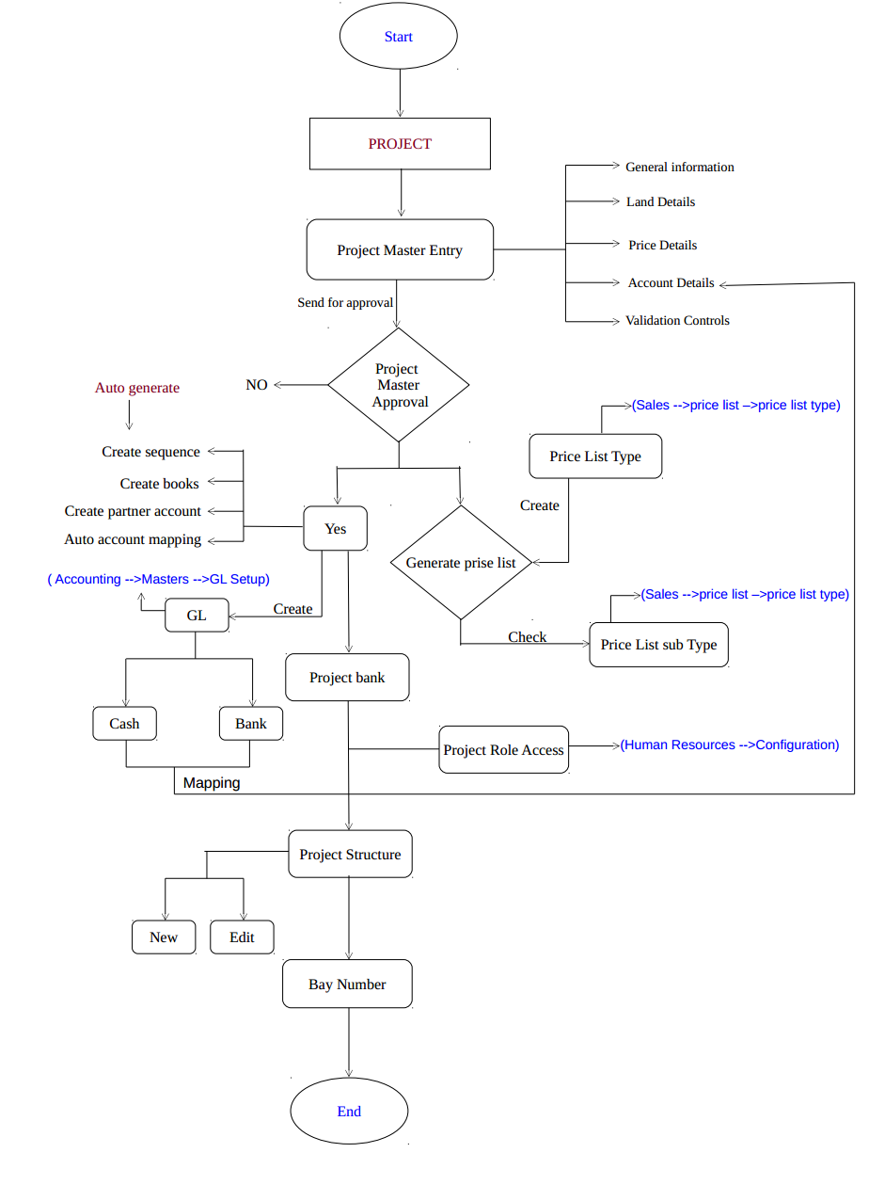

## 1. LOGIN SCREEN

## 

* Users can login to their home page by giving appropriate username and password assigned to the

Individual.

* System will take user to home page once after the successive login.

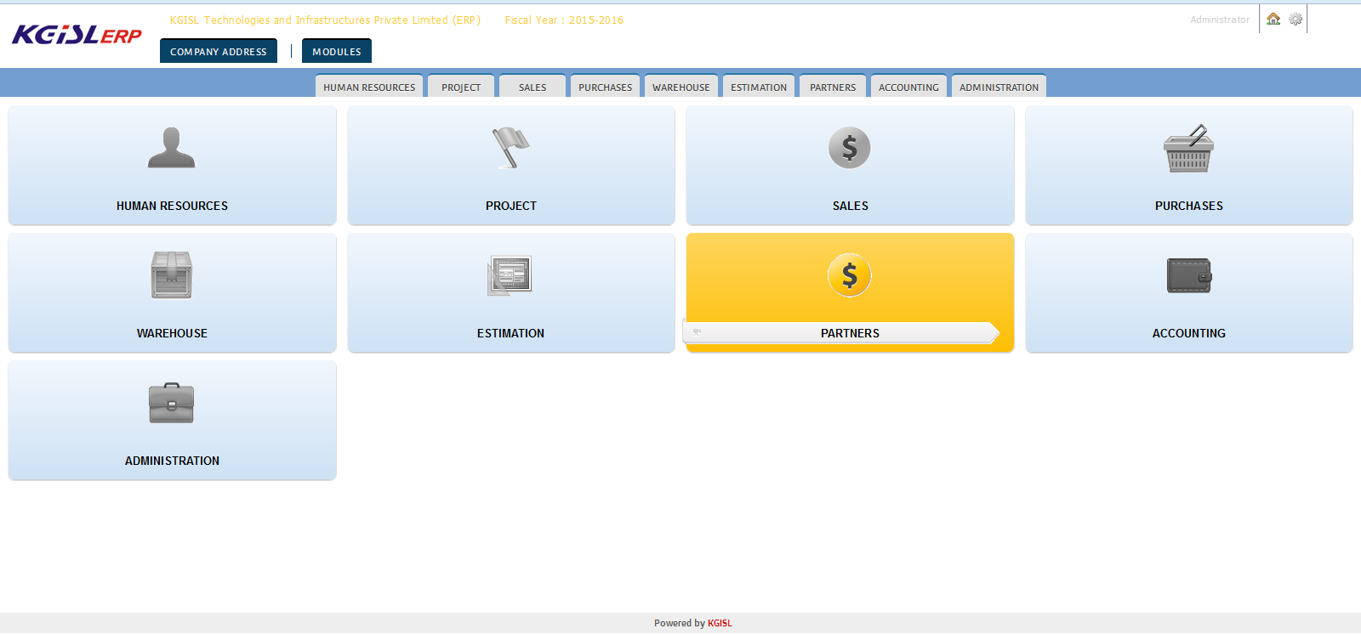

* Respective modules will be listed in home page based on the provisions assigned according to user roles and responsibilities.
* User can find their respective login name, home page link button and settings button to change company, fiscal year, mail ID, change of language and password on right top corner.

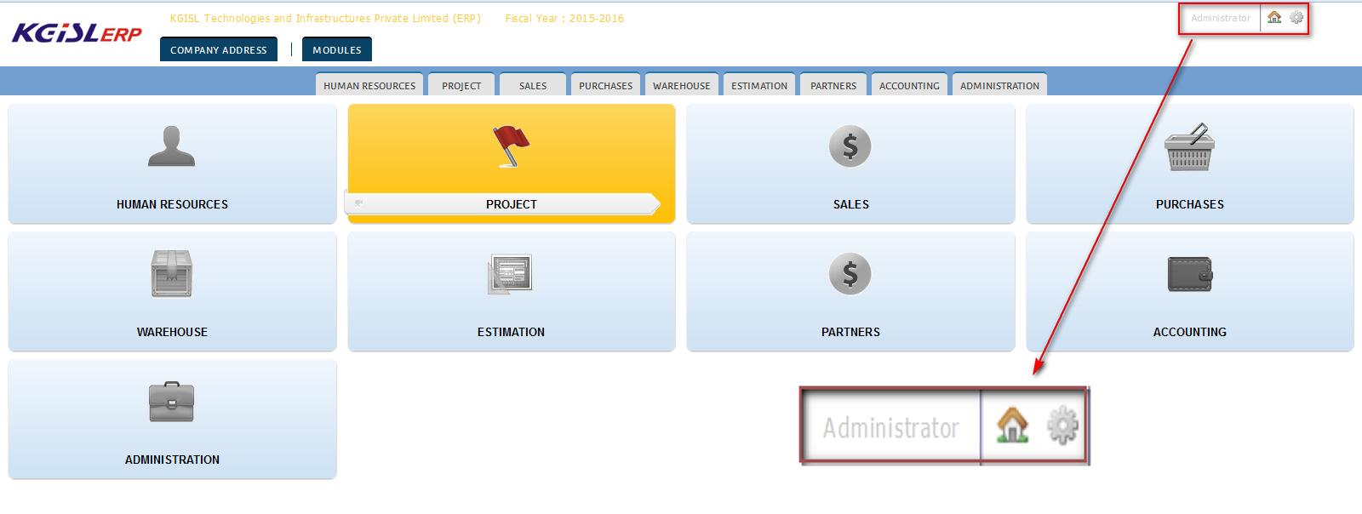

* User can select the module accordingly.

#### Objective of the Project Module:

Project module will capture the necessary and additional data against the particular project with the sense of preparing data history for future.

This module aims to get and provide details of the project like project name, type of project, project manager, description and other basic details like project start and end date, location, contact info, Land details in measures and value, Account details and remarks.

Ultimately, project module will have enough data for the project which is going to be started

## 2. PROJECT MODULE

The Project module consists of the following entry and approval forms,

1. Project Master Entry
2. Project Master Approval
3. Project Bank
4. Project Structure
5. Bay Number

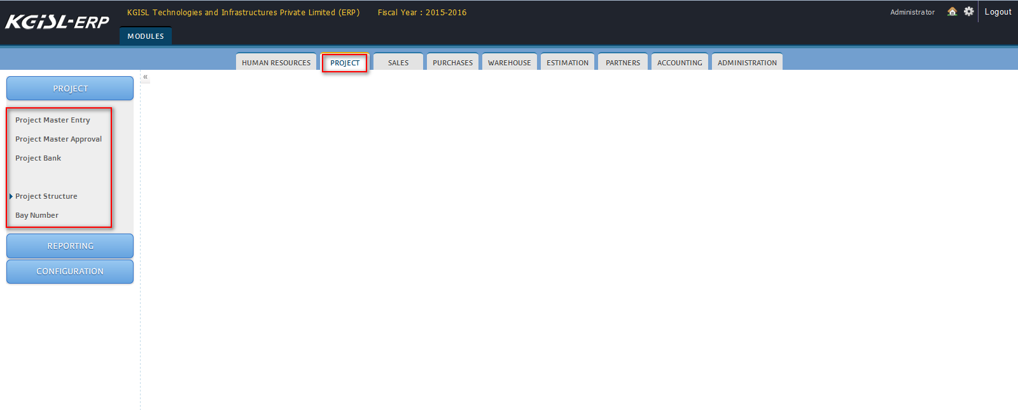

### 2.1 PROJECT MASTER ENTRY

This form is used to create new project. Based on the project only, further transactions will be carried out. Project is mandatory for every form. It contains the following details,

1. General Info
2. Land Details
3. Account Details
4. Price Details
5. Validation Controls
6. Approve/Reject Remarks

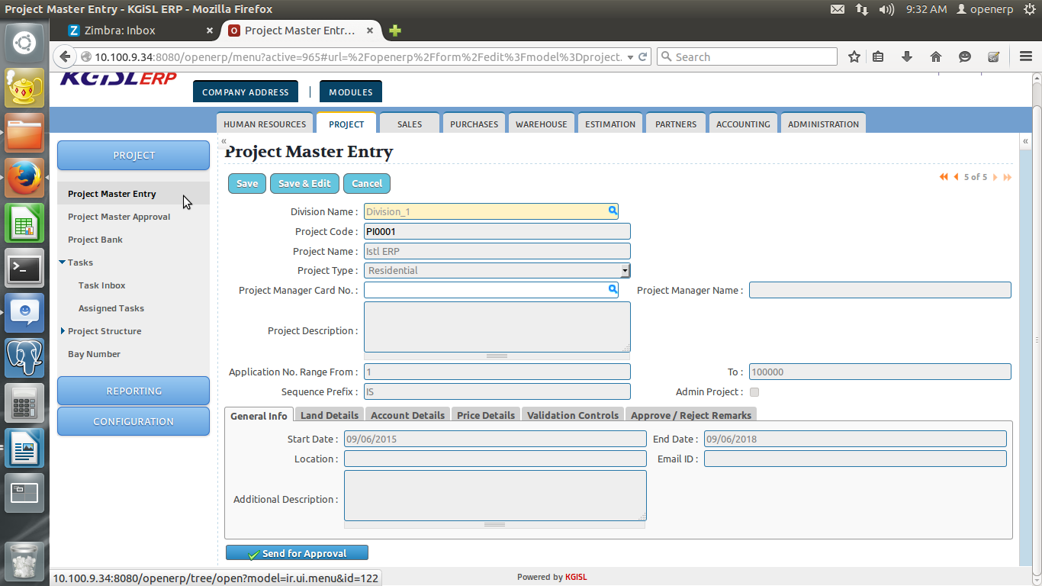

* To create a new project, go to the menu Project -> Project ->Projects Master Entry and click New.

|  |  |
| --- | --- |
| Division Name | Name of the division |
| Project Code | Unique code will be auto generated by system along with prefix entered |
| Project Name | Name of the Project |
| Application No. Range from and To | The application no. range From and To has to be entered. |
| Sequence Prefix | 2 digit prefix ( Ex: KG) |
| Admin project | Denotes Own project (Once selected, Project will not be loaded in sales) |

#### 2.1.1 General Info Tab

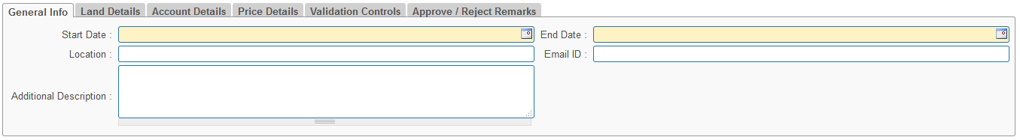

|  |  |
| --- | --- |
| Start Date | Expected starting date of the project |
| End Date | Expected end date of the project |
| Location | Name of the building location |
| Email Id | Email Id for the project |
| Additional Description | Additional information about the project if needed |

#### 2.1.2 Land Details:

This tab is used to define the Land related details for a project.

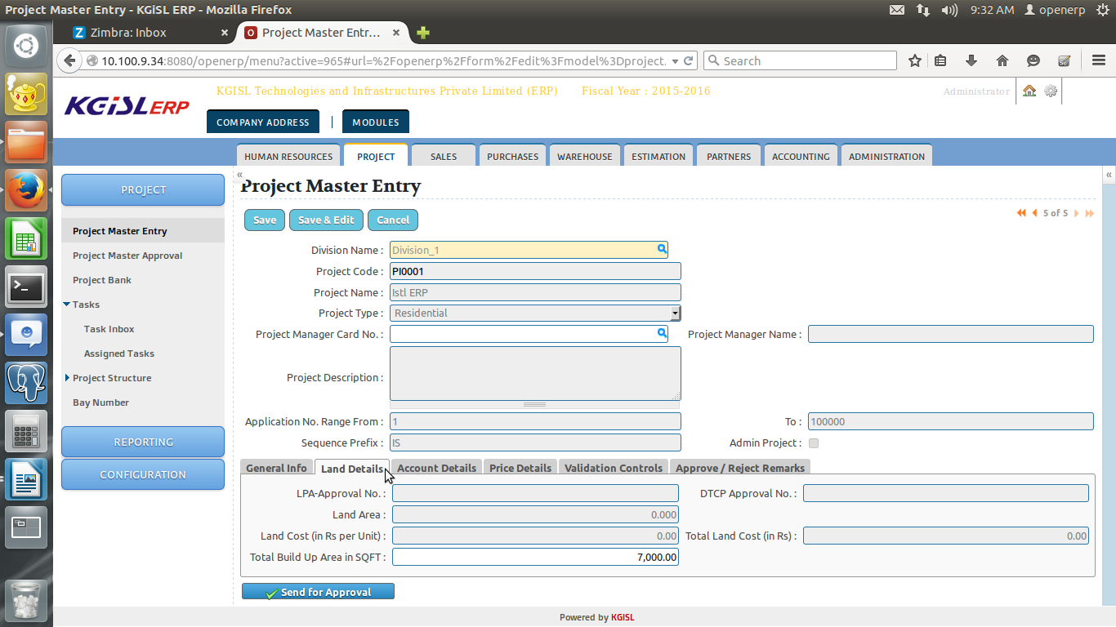

### 4.2 FLOOR CREATION:

To create floor click on the project🡪tower, for which user want to create floor and the following screen will pop up,

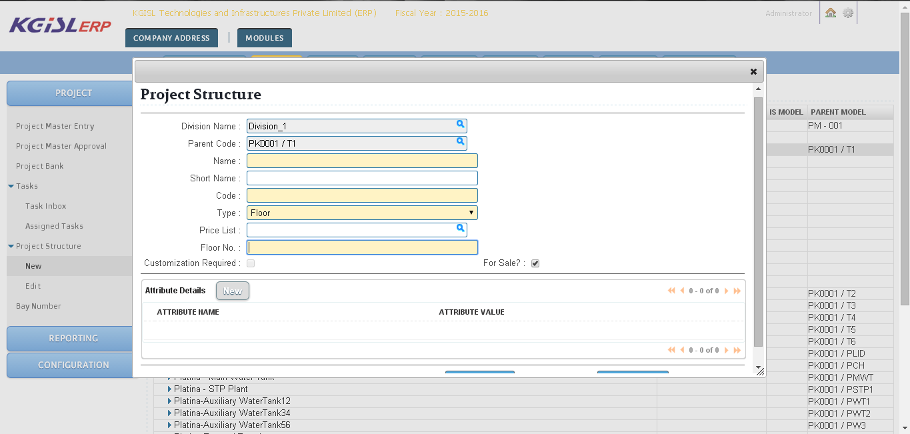

|  |  |
| --- | --- |
| Division Name | Name of the division. |
| Parent Code | This will be auto generated by the system |
| Name | Name of the Floor (Ex: T1-F1-Floor1) |
| Code | Identification code for Floor (Ex: T1-F1) |
| Type | This field helps the user to select type of structure.   1. Tower 2. Floor 3. Apartment   Select Tower for Floor creation. |
| Price List | Price List type (Optional for Floor) |
| Floor No | Number for created floor. |
| Customization Required? | Indicate whether customization is possible (Optional for Floor). |
| For Sale? | Helps to specify the purpose of floor creation |

### 4.3 APARTMENT CREATION:

To create apartment click on the project🡪tower🡪floor, which user want to create apartment and the following screen will pop up,

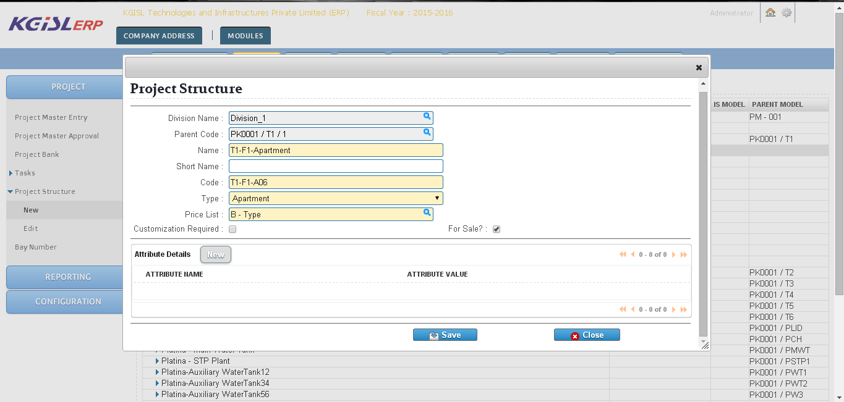

|  |  |
| --- | --- |
| Division Name | Name of the division. |
| Parent Code | This will be auto generated by the system |
| Name | Name of the Floor (Ex: T1-F1- Apartment 1) |
| Code | Identification code for Apartment (Ex: T1-F1-A1) |
| Type | This field helps the user to select type of structure.   1. Tower 2. Floor 3. Apartment   Select Apartment from list. |
| Price List | Price list type for this apartment (Listed based on price List sub type) |
| Customization Required? | Indicate whether customization is possible (Optional for Apartment). |
| For Sale? | Helps to specify the purpose of Apartment creation |
| Attribute Name | Attribute can be selected (Ex. View, Facing) |
| Attribute Value | Attribute value for the attribute (Ex: North, South, East, West) |

## 5. Bay number

Bay number is used to create number of available bays for that particular project.

Two type of parking is

1. Covered and
2. Uncovered.

