Blogging Platforms

A blogging platform allows the user to create, organize, and publish written and visual content online in a blog.

The primary thing that distinguishes a blog from other websites is that the content that is published onto a blog is shown in reverse chronological order, meaning that the most frequent additions to the website are shown first.

Blogging platforms allow the user to publish a post, display the date that the post was published, and assign a specific author assigned to the post. These software or web-based services also allow users to tag content with specific categories, making it easier to search for all posts on topic within the blog. These platforms also allow users to tag posts with multiple keywords as another way to search for specific topics.

**E R Diagram for Blogging Platform**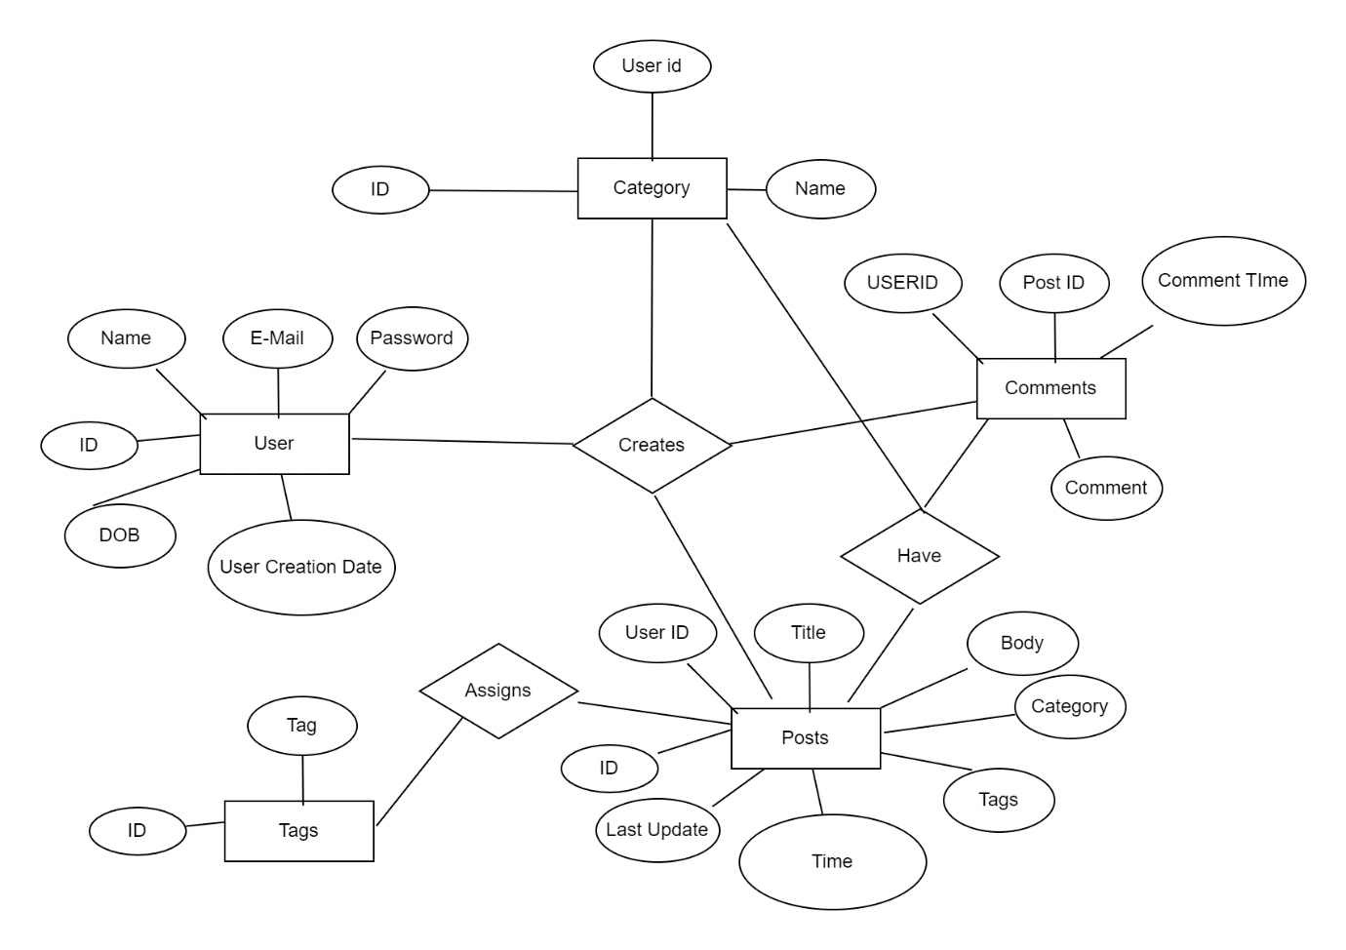

**User:** User Entity captures the basic information regarding the user’s name, email id, password for the user account, Date of birth, Date of creation of user, and ID

**Posts:** Post Entity contains the details such as title of the post, User Id from which created the post, body, category, tags, time of creation of post, time at which the post was updated at last and Post Id

**Comments:** The comments entity helps us to store details about comments on a particular post by different users in the platform. It contains Comment, comment date, user id of the user who commented and finally the Post Id

**Category:** Categories help us to classify the posts into different groups. The Category Entity contains ID, name, User ID.

**Tags:** This entity holds data regarding tags which can be used to search for the blog in a search engine or in the platform. It has attributes such as Tag and Tag Id