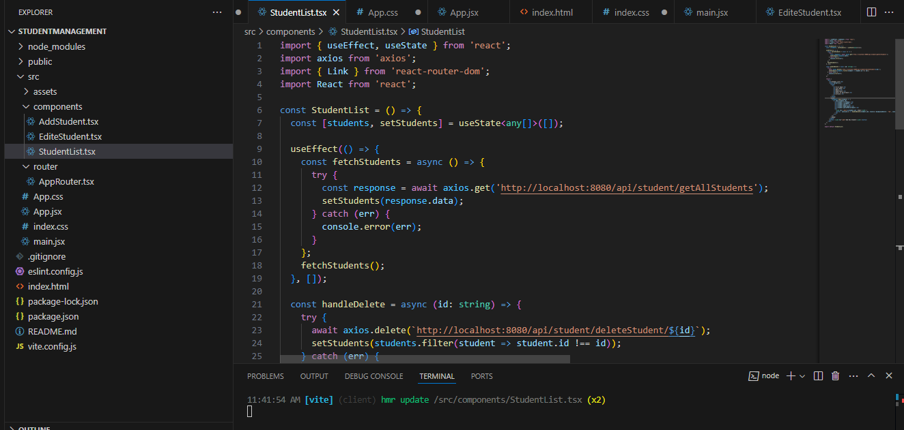

**AddStudent.tsx**

import React, { useState } from 'react';

import axios from 'axios';

import { useNavigate } from 'react-router-dom';

const AddStudent = () => {

  const [student, setStudent] = useState({

    firstName: '',

    lastName: '',

    email: '',

    department: 'Computer Science',

    yearsOfEnrollment: 1,

  });

  const navigate = useNavigate();

  const handleChange = (e: React.ChangeEvent<HTMLInputElement | HTMLSelectElement>) => {

    const { name, value } = e.target;

    setStudent({ ...student, [name]: value });

  };

  const handleSubmit = async (e: React.FormEvent) => {

    e.preventDefault();

    try {

      await axios.post('http://localhost:8080/api/student/addStudent', student);

      alert('Student added successfully');

    } catch (err) {

      console.error(err);

      alert('Error adding student');

    }

  };

  return (

    <div>

        <></>

      <h2>Add Student</h2>

      <form onSubmit={handleSubmit}>

        <input

          type="text"

          name="firstName"

          value={student.firstName}

          onChange={handleChange}

          placeholder="First Name"

          required

        />

        <input

          type="text"

          name="lastName"

          value={student.lastName}

          onChange={handleChange}

          placeholder="Last Name"

          required

        />

        <input

          type="email"

          name="email"

          value={student.email}

          onChange={handleChange}

          placeholder="Email"

          required

        />

        <select

          name="department"

          value={student.department}

          onChange={handleChange}

        >

          <option value="Computer Science">Computer Science</option>

          <option value="Statistics">Statistics</option>

          <option value="Mathametics">Mathamatics</option>

          <option value="Physics">Physics</option>

          <option value="Chemistry">Chemistry</option>

          <option value="Biology">Biology</option>

          <option value="Geology">Geology</option>

        </select>

        <input

          type="number"

          name="yearsOfEnrollment"

          value={student.yearsOfEnrollment}

          onChange={handleChange}

          placeholder="Years of Enrollment"

          required

        />

        <button type="submit">Add Student</button>

      </form>

      <button onClick={() => navigate('/')}>Back to Student List</button>

      </div>

  );

};

export default AddStudent;

**EditeStudent.tsx**

import React, { useEffect, useState } from 'react';

import axios from 'axios';

import { useParams, useNavigate } from 'react-router-dom';

const EditStudent = () => {

  const { id } = useParams<{ id: string }>();

  const [student, setStudent] = useState<any>({

    firstName: '',

    lastName: '',

    email: '',

    department: 'Computer Science',

    yearsOfEnrollment: 1,

  });

  const navigate = useNavigate();

  useEffect(() => {

    const fetchStudent = async () => {

      try {

        const response = await axios.get(`http://localhost:8080/api/student/getStudentById/${id}`);

        setStudent(response.data);

      } catch (err) {

        console.error(err);

      }

    };

    fetchStudent();

  }, [id]);

  const handleChange = (e: React.ChangeEvent<HTMLInputElement | HTMLSelectElement>) => {

    const { name, value } = e.target;

    setStudent({ ...student, [name]: value });

  };

  const handleSubmit = async (e: React.FormEvent) => {

    e.preventDefault();

    try {

      await axios.put(`http://localhost:8080/api/student/updateStudent/${id}`, student);

      navigate('/');

    } catch (err) {

      console.error(err);

      alert('Error updating student');

    }

  };

  return (

    <div>

      <h2>Edit Student</h2>

      <form onSubmit={handleSubmit}>

        <input

          type="text"

          name="firstName"

          value={student.firstName}

          onChange={handleChange}

          required

        />

        <input

          type="text"

          name="lastName"

          value={student.lastName}

          onChange={handleChange}

          required

        />

        <input

          type="email"

          name="email"

          value={student.email}

          onChange={handleChange}

          required

        />

        <select

          name="department"

          value={student.department}

          onChange={handleChange}

        >

          <option value="Computer Science">Computer Science</option>

          <option value="Statistics">Statistics</option>

          <option value="Mathametics">Mathamatics</option>

          <option value="Physics">Physics</option>

          <option value="Chemistry">Chemistry</option>

          <option value="Biology">Biology</option>

          <option value="Geology">Geology</option>

        </select>

        <input

          type="number"

          name="yearsOfEnrollment"

          value={student.yearsOfEnrollment}

          onChange={handleChange}

          required

        />

        <button type="submit">Update Student</button>

      </form>

      <button onClick={() => navigate('/')}>Back to Student List</button>

    </div>

  );

};

export default EditStudent;

**StudentList.tsx**

import { useEffect, useState } from 'react';

import axios from 'axios';

import { Link } from 'react-router-dom';

import React from 'react';

const StudentList = () => {

  const [students, setStudents] = useState<any[]>([]);

  useEffect(() => {

    const fetchStudents = async () => {

      try {

        const response = await axios.get('http://localhost:8080/api/student/getAllStudents');

        setStudents(response.data);

      } catch (err) {

        console.error(err);

      }

    };

    fetchStudents();

  }, []);

  const handleDelete = async (id: string) => {

    try {

      await axios.delete(`http://localhost:8080/api/student/deleteStudent/${id}`);

      setStudents(students.filter(student => student.id !== id));

    } catch (err) {

      console.error(err);

    }

  };

  return (

    <div>

      <h2>Student List</h2>

      <table border={1}>

        <thead>

          <tr>

            <th>First Name</th>

            <th>Last Name</th>

            <th>Email</th>

            <th>Department</th>

            <th>Years of Enrollment</th>

            <th>Actions</th>

          </tr>

        </thead>

        <tbody>

          {students.map((student) => (

            <tr key={student.id}>

              <td>{student.firstName}</td>

              <td>{student.lastName}</td>

              <td>{student.email}</td>

              <td>{student.department}</td>

              <td>{student.yearsOfEnrollment}</td>

              <td>

                <Link to={`/edit/${student.id}`}>Edit</Link> |

                <button  onClick={() => handleDelete(student.id)} style={{ backgroundColor: 'red', color: 'white', border: 'none', padding: '5px 10px', cursor: 'pointer' }}>Delete</button>

              </td>

            </tr>

          ))}

        </tbody>

      </table>

      <button ><Link to="/add">Add New Student</Link></button>

    </div>

  );

};

export default StudentList;

**AppRouter.tsx**

import { BrowserRouter as Router, Routes, Route } from 'react-router-dom';

import StudentList from '../components/StudentList';

import AddStudent from '../components/AddStudent';

import EditStudent from '../components/EditeStudent';

import React from 'react';

const AppRouter = () => (

  <Router>

    <Routes>

      <Route path="/" element={<StudentList />} />

      <Route path="/add" element={<AddStudent />} />

      <Route path="/edit/:id" element={<EditStudent />} />

    </Routes>

  </Router>

);

export default AppRouter;

**GITHUB link :**