Dear Students,

Those who are going to do an internship should follow these steps. This document contains samples, bring offer letter documents as how you received (mail or any other format) in printout.

1. Show your offer Letter to Dr. Karumuri Sri Rama Murthy sir @9848093395 or Mrs. Ch. Sandhya Rani Madam @9849745284

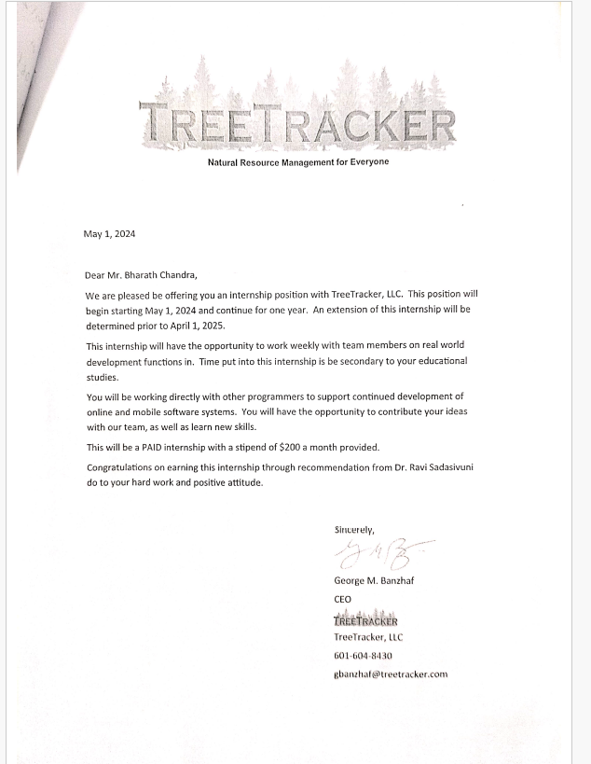

**Figure 1 Offer Letter Sampl**

Step 2: Write a letter and show it to Dr. Sri Rama Murthy Sir / Mrs. Sandya Rani Madam and get endorsed as per the template given in the following link.

[VNR Internship NOC - Application Template](https://docs.google.com/document/d/1wJxg2653o-dlxFYtZepMenNc2FAYDXR9SqY48Sd5Qz4/edit?usp=sharing)

Step-3: Obtain NOC from HOD on Letter head and also on the prescribed format from your company if needed.

[VNR Internship NOC Template](https://docs.google.com/document/d/1rad1Oni8rr8jW8AxniMG4v5_w8ypTthdS04rkFBkv-s/edit?usp=sharing)

Step 4. Fill the following form submitting pdfs of the following with **proper naming conventions** in the following link.

<https://forms.gle/MfVDFsEgVHXa6FK8A>

The form contains the following fields.

| Roll No. |
| --- |
| Name of the Student |
| Branch |
| Semester |
| Section |
| Email-id of student |
| Mobile Number of Student |
| Role of student in Company |
| Name of the Organization for Internship |
| email-id of point of contact in the organization of internship |
| Mobile Number of point of contact in the organization of internship |
| Starting Date |
| Ending Date |
| Duration of Internship - Ex: 1 Month, 2 Months, 1.5 Months, 2.5 Months |
| Internship Offer Letter - RollNo_ol.pdf Example - **22071A0508_ol.pdf** |
| Application to HoD by student Letter - RollNo_iapp.pdf Example - **22071A0508_iapp.pdf(sample)** |
| NOC by HoD to student - RollNo_inoc.pdf Example - **22071A0508_inoc.pdf** |
| Pay Package per month Eg: 15000, 20000 etc. |
| HR-Name or Name of the Point of Contact |

Step 5. Finally follow this.

Important Note: Fill the above google form and submit hard copies mentioned in the college to Dr. Sri Rama Murthy Sir / Mrs. Sandhya Rani Madam from CSE Department.

1. Offer Letter
2. Application to HOD for NOC
3. No Objection Certificate from HOD.
4. **Important Note: After completion of internship you should obtain an internship completion certificate with performance and submit it to the college.**

Dr. Karumuri Sri Rama Murthy,

Asst. Professor,

Department of CSE, VNR VJIET.