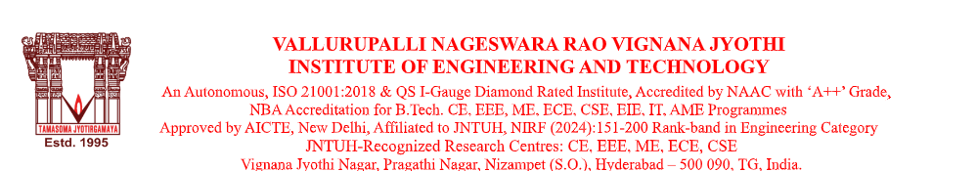

#### **BONAFIDE CERTIFICATE**

This is to certify that **Ms. Kumbala Lasya Bhasker**, daughter of **Mr. Kumbala Bhasker**, is a bonafide student of **VNR Vignana Jyothi Institute of Engineering and Technology**, pursuing **Bachelor of Technology (B.Tech)** in **Computer Science and Business Systems.**

She has been studying in this institution from **May, 2022** and is currently in the  **VII Semester** for the academic year **2025–2026** under the **R22 Regulation**.

This certificate is issued upon the request of the student for the purpose of  **Internship at Research Centre Imarat(RCI)-Defence R&D Organisation, Vignyana kancha, Hyderabad-500069.**

We wish her all the best in future endeavors.

Date: 07/07/2025  
Place: Hyderabad

**Dr. V. BABY**

Head of the Department,

Department of Computer Science and Engineering,

VNR Vignana Jyothi Institute of Engineering & Technology,

Pragathi Nagar, Nizampet-500090.

Hyderabad, Telangana.

[csehod@vnrvjiet.in](mailto:csehod@vnrvjiet.in) [9160141117].