**Practical No:02**

**Aim:Create an android app with Interactive User Interface using Layouts.**

**Code:**

**XML CODE:**

<?**xml version="1.0" encoding="utf-8"**?>  
<**LinearLayout xmlns:android ="http://schemas.android.com/apk/res/android"  
 xmlns:app="http://schemas.android.com/apk/res-auto"  
 xmlns:tools="http://schemas.android.com/tools"  
 android:layout_width="match_parent"  
 android:layout_height="match_parent"  
 tools:context="com.example.cs12.hellotoast.MainActivity"  
 android:orientation="vertical"  
 android:weightSum="1"**>  
  
  
 <**Button  
 android:onClick="showToast"  
 android:id="@+id/button_toast"  
 android:layout_width="match_parent"  
 android:layout_height="wrap_content"  
 android:background="#2288ff"  
 android:layout_gravity="center_horizontal"  
 android:text="hello toast"** />  
  
 <**TextView  
 android:id="@+id/show_count"  
 android:layout_height="wrap_content"  
 android:text="0"  
 android:layout_gravity="center_horizontal"  
 android:background="#00afa5"  
 android:layout_width="match_parent"  
 android:layout_weight="1.02"** />  
  
 <**Button  
 android:onClick="countUp"  
 android:id="@+id/button_count"  
 android:layout_gravity="center_horizontal"  
 android:layout_width="match_parent"  
 android:layout_height="wrap_content"  
 android:background="#8800ff"  
 android:text="count"** />  
</**LinearLayout**>

JAVA CODE:

**package** com.example.cs12.hellotoast;  
  
**import** android.support.v7.app.AppCompatActivity;  
**import** android.os.Bundle;  
**import** android.view.View;  
**import** android.widget.TextView;  
**import** android.widget.Toast;  
  
**public class** MainActivity **extends** AppCompatActivity {  
 **int count**;  
 TextView **txt1**;  
  
  
  
 @Override  
 **protected void** onCreate(Bundle savedInstanceState) {  
 **super**.onCreate(savedInstanceState);  
 setContentView(R.layout.**activity_main**);  
 **txt1**=(TextView)findViewById(R.id.**show_count**);  
  
  
 }  
 **public void** showToast(View view) {  
 Toast.makeText(**this**, **"goooooooood morninggggggggggggg"**, Toast.**LENGTH_LONG**).show();  
 }  
 **public void** countUp(View view){  
 **count** ++;  
 **txt1**.setText(Integer.toString(**count**));  
  
  
  
 }  
}

**Output:**

========================================================================

**Practical No:03**

**Aim:Create an android app that demonstrates working with TextView Elements**

Code:

*<?***xml version="1.0" encoding="utf-8"***?>*

<**RelativeLayout xmlns:android="http://schemas.android.com/apk/res/android"**

**xmlns:app="http://schemas.android.com/apk/res-auto"**

**xmlns:tools="http://schemas.android.com/tools"**

**android:layout_width="match_parent"**

**android:layout_height="match_parent"**

**tools:context=".MainActivity"**>

<**TextView**

**android:id="@+id/tv2"**

**android:layout_width="wrap_content"**

**android:layout_height="wrap_content"**

**android:text="@string/hello"**

**android:textColor="#11ffff"**

**android:textSize="25sp"**

**android:textStyle="italic|bold"**

**android:padding="10dp"**

**android:textAppearance="@android:style/TextAppearance.DeviceDefault.Medium"**

**android:background="#111451"**

/>

<**TextView**

**android:id="@+id/tv1"**

**android:layout_toRightOf="@+id/tv2"**

**android:layout_width="wrap_content"**

**android:layout_height="wrap_content"**

**android:text="@string/zhoha"**

**android:textColor="#11aaff"**

**android:textSize="14sp"**

**android:textStyle="bold"**

**android:padding="10dp"**

/>

</**RelativeLayout**>

mainactivity.java

**package** com.example.za.helloworld;

**import** android.support.v7.app.AppCompatActivity;

**import** android.os.Bundle;

**import** android.widget.TextView;

**public class** MainActivity **extends** AppCompatActivity {

TextView **name**;

@Override

**protected void** onCreate(Bundle savedInstanceState) {

**super**.onCreate(savedInstanceState);

setContentView(R.layout.***activity_main***);

**name**=(TextView)findViewById(R.id.***tv1*** );

**name**.setText(**"User"**);

}

}

Output:

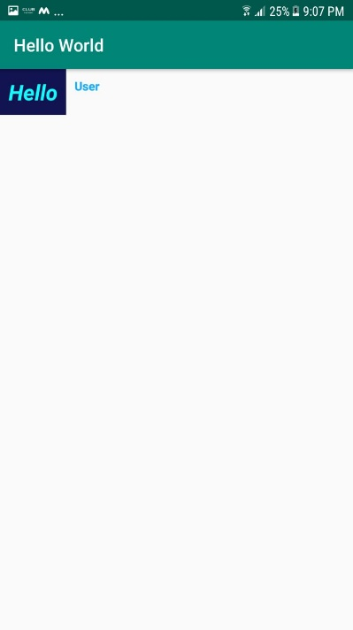

**Practical No: 4**

**Aim: Create an android app that demonstrates Activity Lifecycle and Instance State**

**Activity Lifecycle**

**Activity_main.xml**

<?xml version="1.0" encoding="utf-8"?>

<LinearLayout xmlns:android="http://schemas.android.com/apk/res/android"

xmlns:app="http://schemas.android.com/apk/res-auto"

xmlns:tools="http://schemas.android.com/tools"

android:layout_width="match_parent"

android:layout_height="match_parent"

tools:context=".MainActivity">

android:orientation="vertical"

<TextView

android:layout_width="wrap_content"

android:layout_height="wrap_content"sssss

android:text="Hello World!"

app:layout_constraintBottom_toBottomOf="parent"

app:layout_constraintLeft_toLeftOf="parent"

app:layout_constraintRight_toRightOf="parent"

app:layout_constraintTop_toTopOf="parent" />

</LinearLayout>

**MainActivity.java**

package com.example.activitylifecycle;

import android.support.v7.app.AppCompatActivity;

import android.os.Bundle;

import android.util.Log;

public class MainActivity extends AppCompatActivity {

@Override

protected void onCreate(Bundle savedInstanceState) {

super.onCreate(savedInstanceState);

setContentView(R.layout.activity_main);

Log.d(String.valueOf(this), "");

Log.d(String.valueOf(this), "onCreate");

}

@Override

protected void onStart(){

super.onStart();

Log.d(String.valueOf(this), "onStart");

}

@Override

protected void onPause(){

super.onPause();

Log.d(String.valueOf(this), "onPause");

}

@Override

protected void onRestart(){

super.onRestart();

Log.d(String.valueOf(this), "onRestart");

}

@Override

protected void onResume(){

super.onResume();

Log.d(String.valueOf(this),"onResume");

}

@Override

protected void onStop(){

super.onStop();

Log.d(String.valueOf(this), "onStop");

}

@Override

protected void onDestroy(){

super.onDestroy();

Log.d(String.valueOf(this), "onDestroy");

}

}

**Output:**

onStart()

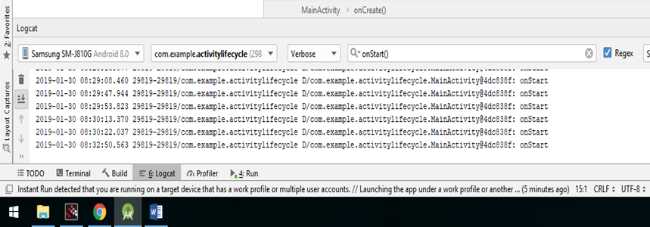

onPause()

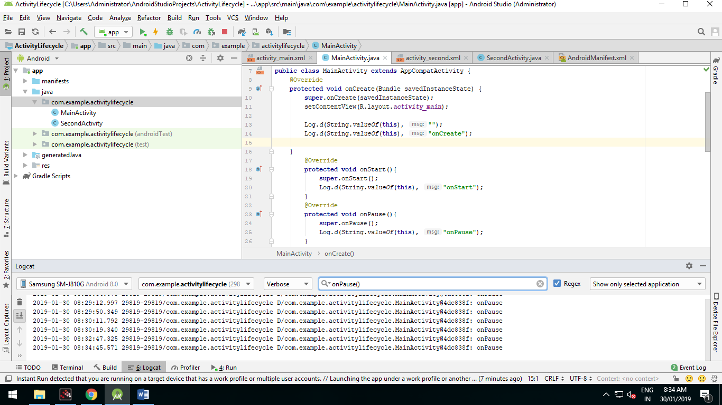

onRestart()

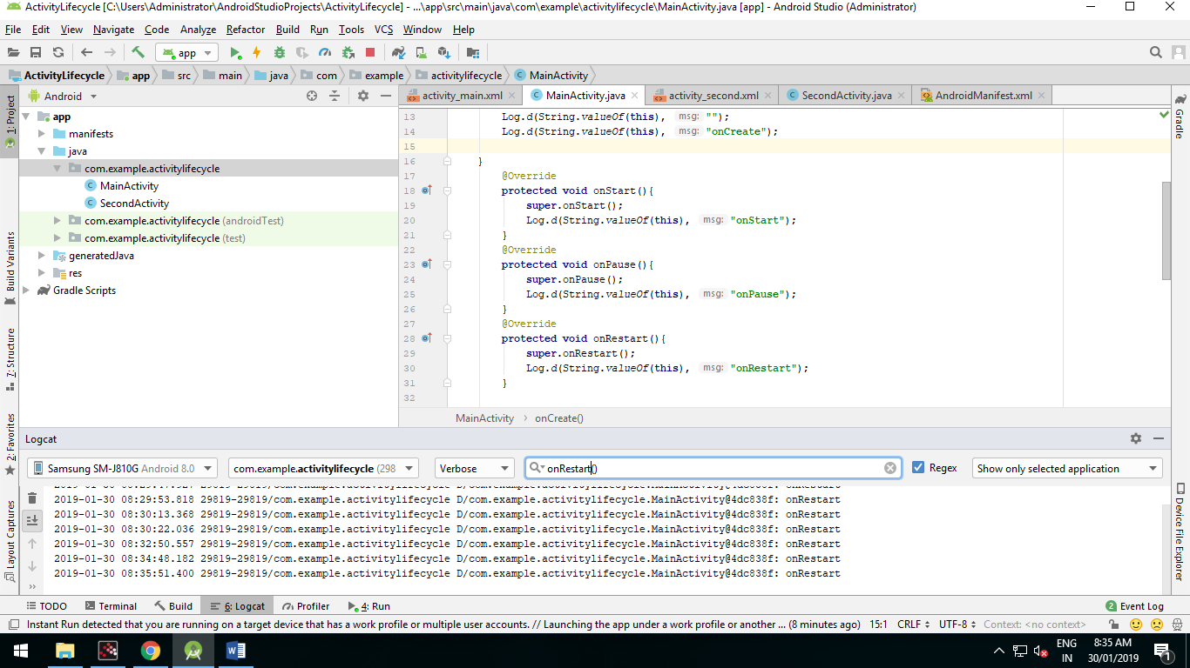

onResume()

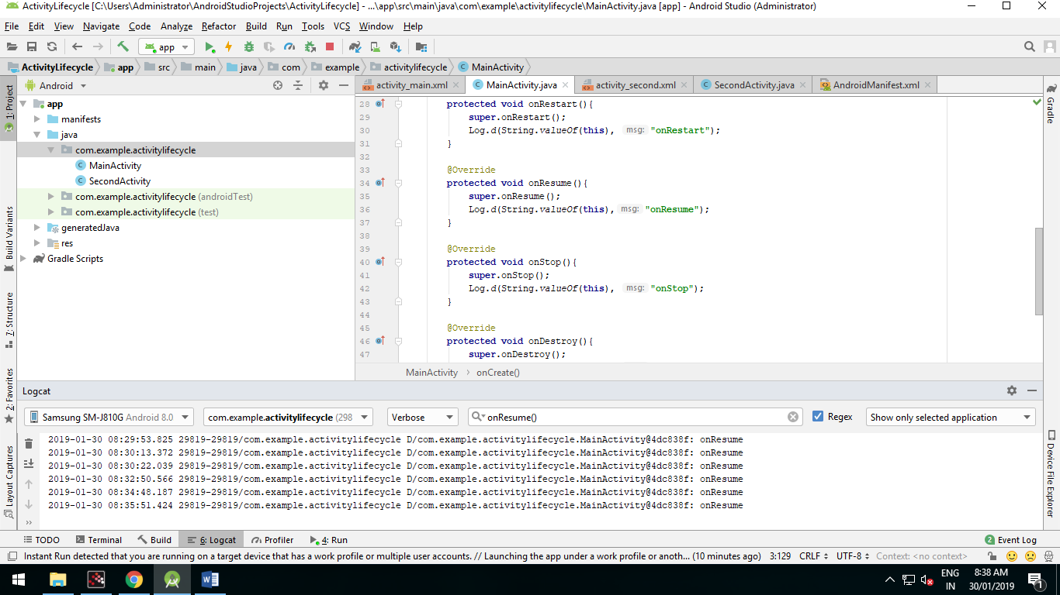

onStop()

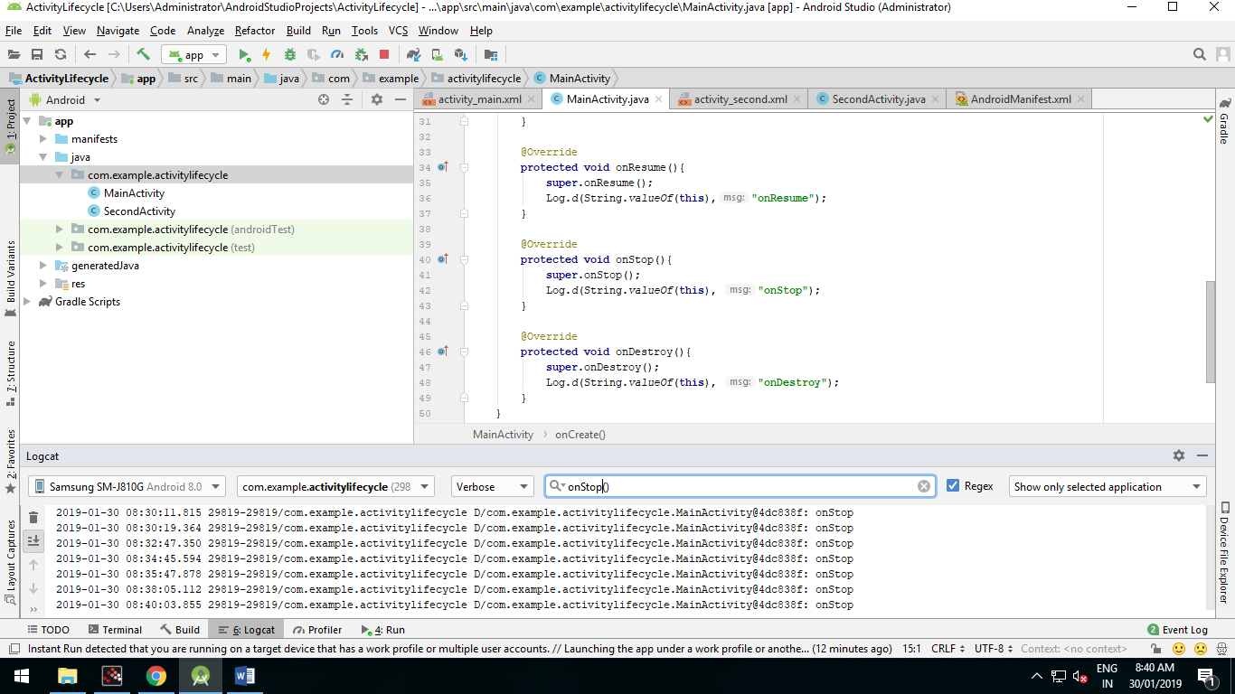

onDestroy()

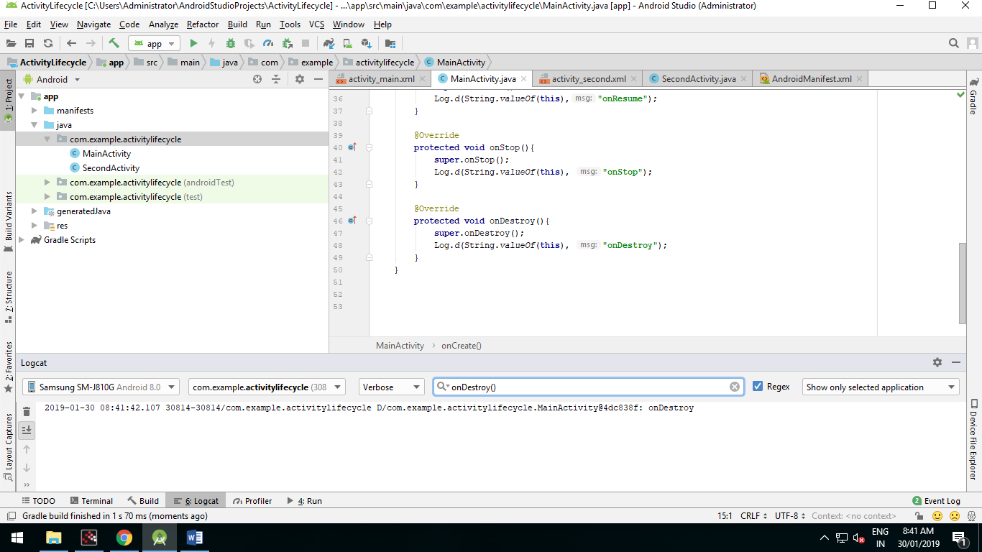

**Practical No: 5**

**Two Activities.**

Activity_main.xml

*<?***xml version="1.0" encoding="utf-8"***?>*

<**android.support.constraint.ConstraintLayout**

**xmlns:android="http://schemas.android.com/apk/res/android"**

**xmlns:app="http://schemas.android.com/apk/res-auto"**

**xmlns:tools="http://schemas.android.com/tools"**

**android:layout_width="match_parent"**

**android:layout_height="match_parent"**

**tools:context="com.example.android.twoactivities.MainActivity"**>

<**TextView**

**android:id="@+id/text_header_reply"**

**android:layout_width="wrap_content"**

**android:layout_height="wrap_content"**

**android:layout_marginStart="8dp"**

**android:layout_marginLeft="8dp"**

**android:layout_marginTop="16dp"**

**android:text="@string/text_header_reply"**

**android:textAppearance="@style/TextAppearance.AppCompat.Medium"**

**android:textStyle="bold"**

**android:visibility="invisible"**

**app:layout_constraintStart_toStartOf="parent"**

**app:layout_constraintTop_toTopOf="parent"** />

<**TextView**

**android:id="@+id/text_message_reply"**

**android:layout_width="wrap_content"**

**android:layout_height="wrap_content"**

**android:layout_marginStart="8dp"**

**android:layout_marginLeft="8dp"**

**android:layout_marginTop="8dp"**

**android:visibility="invisible"**

**app:layout_constraintStart_toStartOf="parent"**

**app:layout_constraintTop_toBottomOf="@+id/text_header_reply"** />

<**Button**

**android:id="@+id/button_main"**

**android:layout_width="wrap_content"**

**android:layout_height="wrap_content"**

**android:layout_marginBottom="16dp"**

**android:layout_marginRight="16dp"**

**android:text="@string/button_main"**

**android:onClick="launchSecondActivity"**

**app:layout_constraintBottom_toBottomOf="parent"**

**app:layout_constraintRight_toRightOf="parent"** />

<**EditText**

**android:id="@+id/editText_main"**

**android:layout_width="0dp"**

**android:layout_height="wrap_content"**

**android:layout_marginBottom="16dp"**

**android:layout_marginEnd="8dp"**

**android:layout_marginStart="8dp"**

**android:ems="10"**

**android:hint="@string/editText_main"**

**android:inputType="textLongMessage"**

**app:layout_constraintBottom_toBottomOf="parent"**

**app:layout_constraintEnd_toStartOf="@+id/button_main"**

**app:layout_constraintStart_toStartOf="parent"** />

</**android.support.constraint.ConstraintLayout**>

Activity_second.xml

*<?***xml version="1.0" encoding="utf-8"***?>*

<**android.support.constraint.ConstraintLayout**

**xmlns:android="http://schemas.android.com/apk/res/android"**

**xmlns:app="http://schemas.android.com/apk/res-auto"**

**xmlns:tools="http://schemas.android.com/tools"**

**android:layout_width="match_parent"**

**android:layout_height="match_parent"**

**tools:context="com.example.android.twoactivities.SecondActivity"**>

<**TextView**

**android:id="@+id/text_header"**

**android:layout_width="wrap_content"**

**android:layout_height="wrap_content"**

**android:layout_marginStart="8dp"**

**android:layout_marginLeft="8dp"**

**android:layout_marginTop="16dp"**

**android:text="@string/text_header"**

**android:textAppearance="@style/TextAppearance.AppCompat.Medium"**

**android:textStyle="bold"**

**app:layout_constraintStart_toStartOf="parent"**

**app:layout_constraintTop_toTopOf="parent"** />

<**TextView**

**android:id="@+id/text_message"**

**android:layout_width="wrap_content"**

**android:layout_height="wrap_content"**

**android:layout_marginStart="8dp"**

**android:layout_marginLeft="8dp"**

**android:layout_marginTop="8dp"**

**app:layout_constraintStart_toStartOf="parent"**

**app:layout_constraintTop_toBottomOf="@+id/text_header"** />

<**Button**

**android:id="@+id/button_second"**

**android:layout_width="wrap_content"**

**android:layout_height="wrap_content"**

**android:layout_marginBottom="16dp"**

**android:layout_marginRight="16dp"**

**android:text="@string/button_second"**

**android:onClick="returnReply"**

**app:layout_constraintBottom_toBottomOf="parent"**

**app:layout_constraintRight_toRightOf="parent"** />

<**EditText**

**android:id="@+id/editText_second"**

**android:layout_width="0dp"**

**android:layout_height="wrap_content"**

**android:layout_marginBottom="16dp"**

**android:layout_marginEnd="8dp"**

**android:layout_marginStart="8dp"**

**android:ems="10"**

**android:hint="@string/editText_second"**

**android:inputType="textLongMessage"**

**app:layout_constraintBottom_toBottomOf="parent"**

**app:layout_constraintEnd_toStartOf="@+id/button_second"**

**app:layout_constraintStart_toStartOf="parent"** />

</**android.support.constraint.ConstraintLayout**>

Mainactivity.java

**package** com.example.android.twoactivities;

**import** android.content.Intent;

**import** android.os.Bundle;

**import** android.support.v7.app.AppCompatActivity;

**import** android.util.Log;

**import** android.view.View;

**import** android.widget.EditText;

**import** android.widget.TextView;

**public class** MainActivity **extends** AppCompatActivity {

**private static final** String ***LOG_TAG*** = MainActivity.**class**.getSimpleName();

**public static final** String ***EXTRA_MESSAGE***

= **"com.example.android.twoactivities.extra.MESSAGE"**;

**public static final int *TEXT_REQUEST*** = 1;

**private** EditText **mMessageEditText**;

**private** TextView **mReplyHeadTextView**;

**private** TextView **mReplyTextView**;

@Override

**protected void** onCreate(Bundle savedInstanceState) {

**super**.onCreate(savedInstanceState);

setContentView(R.layout.***activity_main***);

**mMessageEditText** = findViewById(R.id.***editText_main***);

**mReplyHeadTextView** = findViewById(R.id.***text_header_reply***);

**mReplyTextView** = findViewById(R.id.***text_message_reply***);

}

**public void** launchSecondActivity(View view) {

Log.*d*(***LOG_TAG***, **"Button clicked!"**);

Intent intent = **new** Intent(**this**, SecondActivity.**class**);

String message = **mMessageEditText**.getText().toString();

intent.putExtra(***EXTRA_MESSAGE***, message);

startActivityForResult(intent, ***TEXT_REQUEST***);

}

@Override

**public void** onActivityResult(**int** requestCode, **int** resultCode, Intent data) {

**super**.onActivityResult(requestCode, resultCode, data);

**if** (requestCode == ***TEXT_REQUEST***) {

**if** (resultCode == ***RESULT_OK***) {

String reply = data.getStringExtra(SecondActivity.***EXTRA_REPLY***);

**mReplyHeadTextView**.setVisibility(View.***VISIBLE***);

**mReplyTextView**.setText(reply);

**mReplyTextView**.setVisibility(View.***VISIBLE***);

}

}

}

}

SecondActivity.java

**package** com.example.android.twoactivities;

**import** android.content.Intent;

**import** android.os.Bundle;

**import** android.support.v7.app.AppCompatActivity;

**import** android.view.View;

**import** android.widget.EditText;

**import** android.widget.TextView;

**public class** SecondActivity **extends** AppCompatActivity {

**public static final** String ***EXTRA_REPLY*** =

**"com.example.android.twoactivities.extra.REPLY"**;

**private** EditText **mReply**;

@Override

**protected void** onCreate(Bundle savedInstanceState) {

**super**.onCreate(savedInstanceState);

setContentView(R.layout.***activity_second***);

**mReply** = findViewById(R.id.***editText_second***);

Intent intent = getIntent();

String message = intent.getStringExtra(MainActivity.***EXTRA_MESSAGE***);

TextView textView = findViewById(R.id.***text_message***);

textView.setText(message);

}

**public void** returnReply(View view) {

String reply = **mReply**.getText().toString();

Intent replyIntent = **new** Intent();

replyIntent.putExtra(***EXTRA_REPLY***, reply);

setResult(***RESULT_OK***, replyIntent);

finish();

}

}

Output:

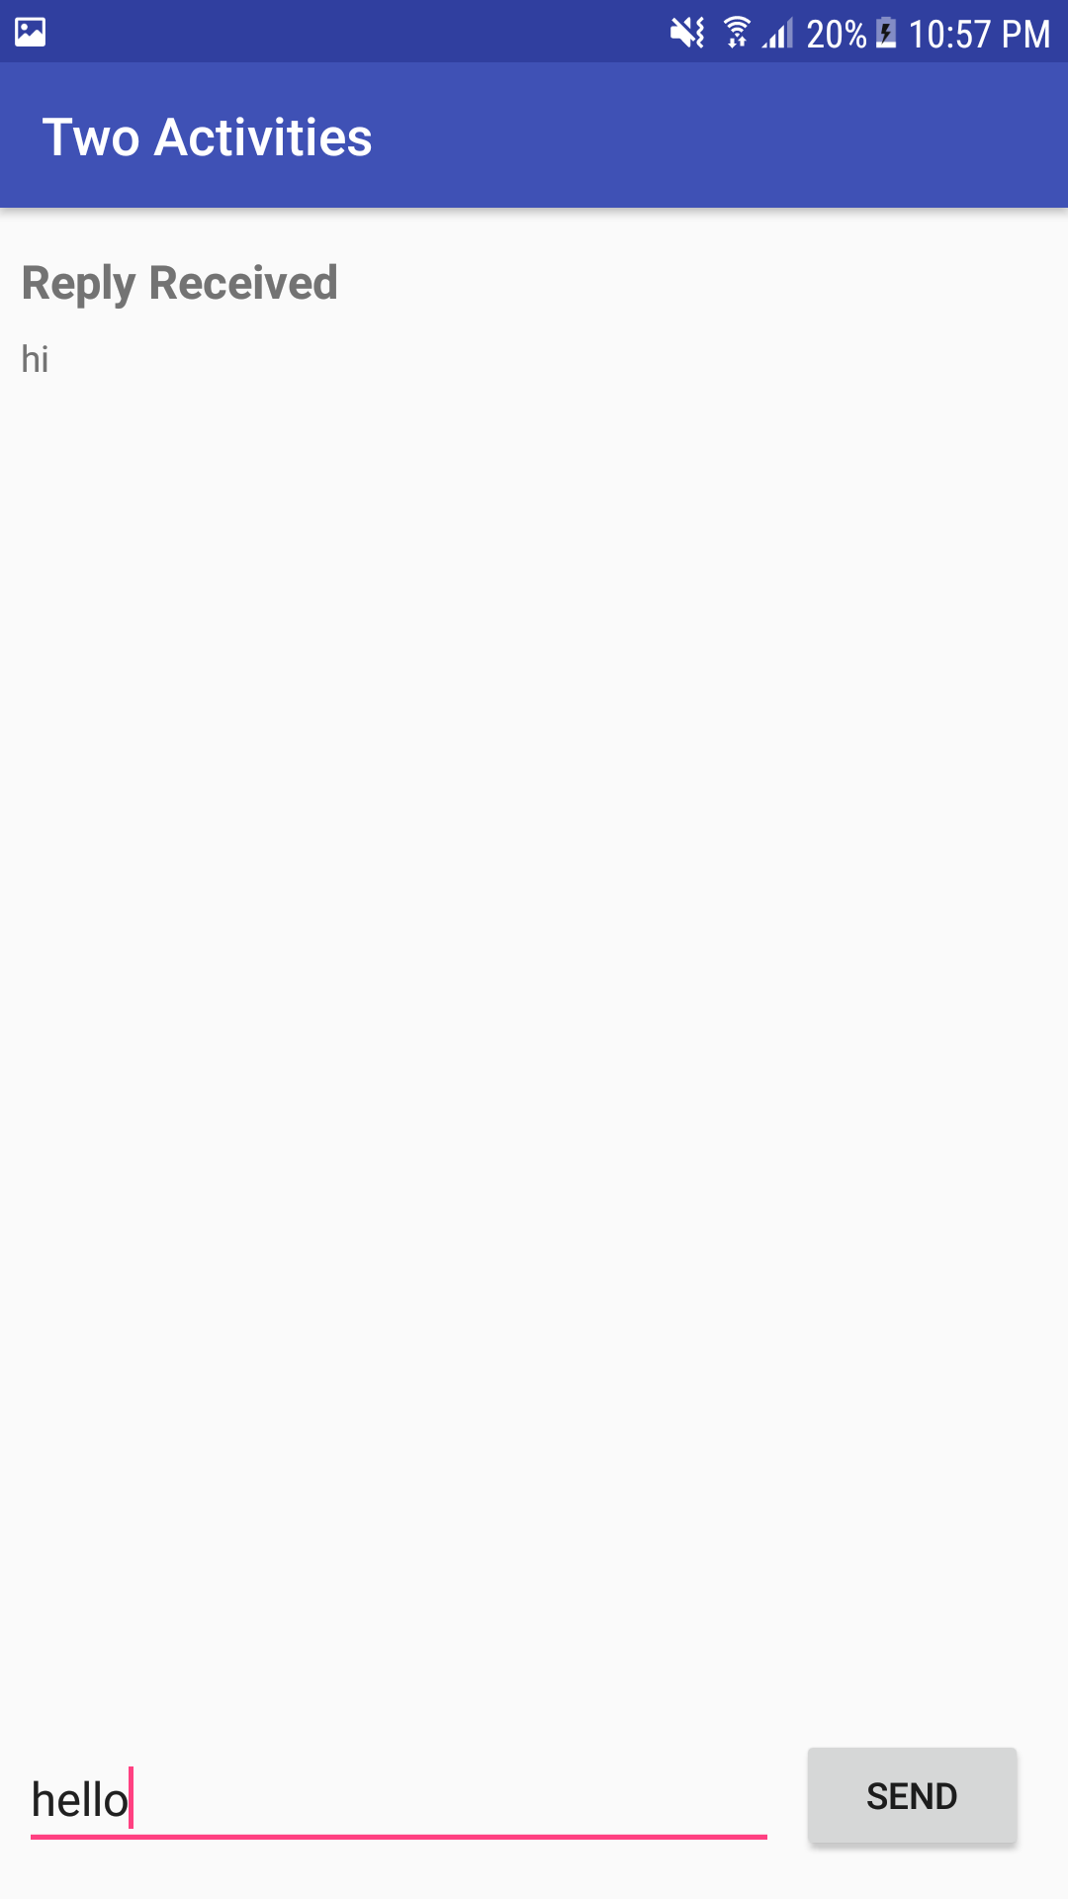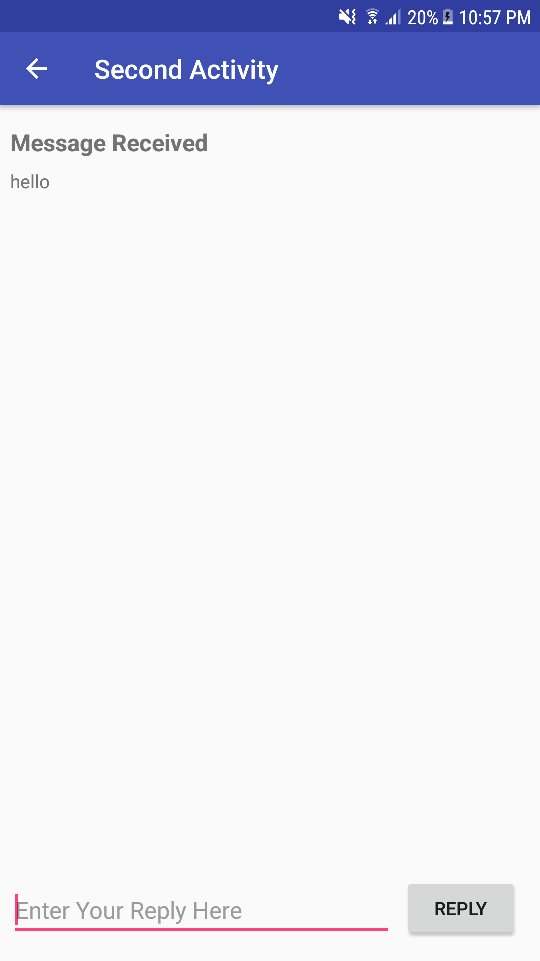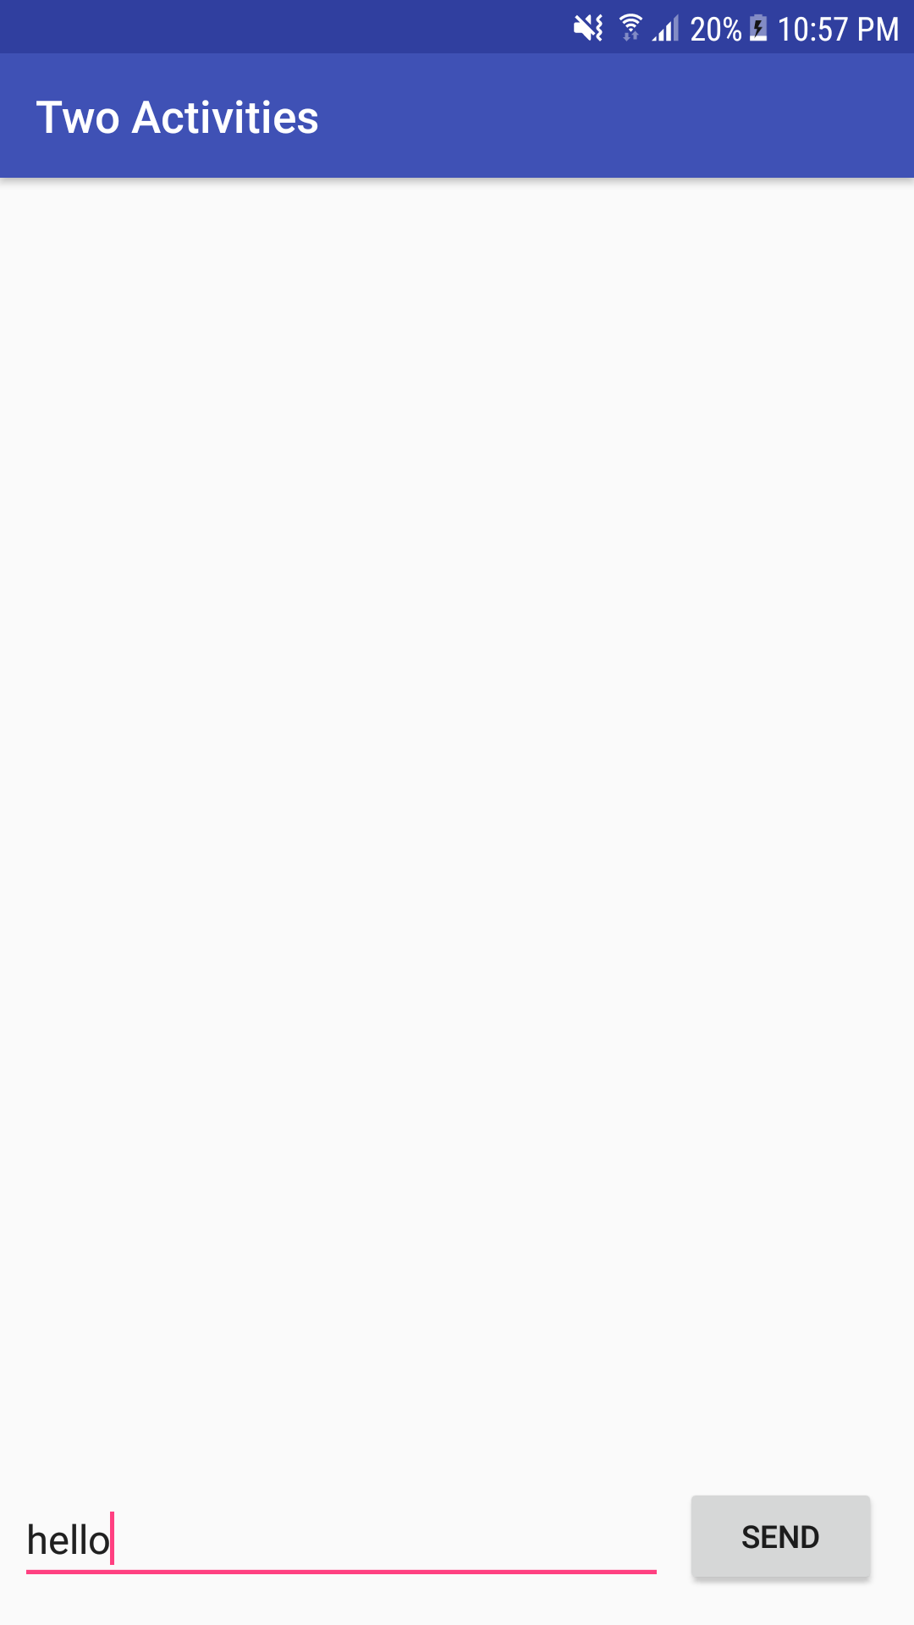

**Practical 6**

**Aim: Create an android app that demonstrates the use of Keyboards, Input Controls, Alerts, and Pickers**

**Orderactivity.java**

**package** com.example.dell.droidcafe;  
  
**import** android.content.Intent;  
**import** android.net.Uri;  
**import** android.support.v7.app.AppCompatActivity;  
**import** android.os.Bundle;  
**import** android.util.Log;  
**import** android.view.KeyEvent;  
**import** android.view.View;  
**import** android.view.inputmethod.EditorInfo;  
**import** android.widget.AdapterView;  
**import** android.widget.ArrayAdapter;  
**import** android.widget.EditText;  
**import** android.widget.RadioButton;  
**import** android.widget.Spinner;  
**import** android.widget.TextView;  
**import** android.widget.Toast;  
  
**public class** OrderActivity **extends** AppCompatActivity **implements** AdapterView.OnItemSelectedListener {  
  
 **private static final** String ***TAG*** = MainActivity.**class**.getSimpleName();  
 @Override  
 **protected void** onCreate(Bundle savedInstanceState) {  
 **super**.onCreate(savedInstanceState);  
 setContentView(R.layout.***activity_order***);  
 Intent intent = getIntent();  
 String message = intent.getStringExtra(MainActivity.***EXTRA_MESSAGE***);  
 TextView textView = (TextView) findViewById(R.id.***order_textview***);  
 textView.setText(message);  
 *// Create the spinner.* Spinner spinner = (Spinner) findViewById(R.id.***label_spinner***);  
 **if** (spinner != **null**) {  
 spinner.setOnItemSelectedListener(**this**);  
 *// Create ArrayAdapter using the string array and default spinner layout.* ArrayAdapter<CharSequence> adapter = ArrayAdapter.*createFromResource*(**this**,  
 R.array.***labels_array***, android.R.layout.***simple_spinner_dropdown_item***);  
 *// Specify the layout to use when the list of choices appears.* adapter.setDropDownViewResource  
 (android.R.layout.***simple_spinner_dropdown_item***);  
 *// Apply the adapter to the spinner.* **if** (spinner != **null**) {  
 spinner.setAdapter(adapter);  
 }  
 }  
 EditText editText =(EditText) findViewById(R.id.***phone_text***);  
 **if** (editText != **null**)  
 editText.setOnEditorActionListener(**new** TextView.OnEditorActionListener() {  
 *// If view is found, set the listener for editText.* @Override  
 **public boolean** onEditorAction(TextView textView, **int** actionId, KeyEvent keyEvent) {  
 **boolean** handled = **false**;  
 **if** (actionId == EditorInfo.***IME_ACTION_SEND***) {  
 dialNumber();  
 handled = **true**;  
 }  
 **return** handled;  
 }  
 });  
 }  
 **private void** dialNumber() {  
 *// Find the editText_main view.* EditText editText = (EditText) findViewById(R.id.***phone_text***);  
 String phoneNum = **null**;  
 *// If the editText field is not null,  
 // concatenate "tel: " with the phone number string.* **if** (editText != **null**) phoneNum = **"tel:"** +  
 editText.getText().toString();  
 *// Optional: Log the concatenated phone number for dialing.* Log.*d*(***TAG***, **"dialNumber: "** + phoneNum);  
 *// Specify the intent.* Intent intent = **new** Intent(Intent.***ACTION_DIAL***);  
 *// Set the data for the intent as the phone number.* intent.setData(Uri.*parse*(phoneNum));  
 *// If the intent resolves to a package (app),  
 // start the activity with the intent.* **if** (intent.resolveActivity(getPackageManager()) != **null**) {  
 startActivity(intent);  
 } **else** {  
 Log.*d*(**"ImplicitIntents"**, **"Can't handle this!"**);  
 }  
 }  
 **public void** displayToast(String message) {  
 Toast.*makeText*(getApplicationContext(), message,  
 Toast.***LENGTH_SHORT***).show();  
 }  
  
 **public void** onRadioButtonClicked(View view) {  
 *// Is the button now checked?* **boolean** checked = ((RadioButton) view).isChecked();  
 *// Check which radio button was clicked.* **switch** (view.getId()) {  
 **case** R.id.***sameday***:  
 **if** (checked)  
 *// Same day service* displayToast(getString(R.string.***same_day_messenger_service***));  
 **break**;  
 **case** R.id.***nextday***:  
 **if** (checked)  
 *// Next day delivery* displayToast(getString(R.string.***next_day_ground_delivery***));  
 **break**;  
 **case** R.id.***pickup***:  
 **if** (checked)  
 *// Pick up* displayToast(getString(R.string.***pick_up***));  
 **break**;  
 **default**:  
 *// Do nothing.* **break**;  
 }  
 }  
  
 @Override  
 **public void** onItemSelected(AdapterView<?> adapterView, View view, **int** i, **long** l) {  
 String spinnerLabel = adapterView.getItemAtPosition(i).toString();  
 displayToast(spinnerLabel);  
 }  
  
  
 @Override  
 **public void** onNothingSelected(AdapterView<?> adapterView) {  
  
 }  
  
}

**activity_order.xml**

*<?***xml version="1.0" encoding="utf-8"***?>*<**android.support.constraint.ConstraintLayout xmlns:android="http://schemas.android.com/apk/res/android"  
 xmlns:app="http://schemas.android.com/apk/res-auto"  
 xmlns:tools="http://schemas.android.com/tools"  
 android:layout_width="match_parent"  
 android:layout_height="match_parent"  
 tools:context=".OrderActivity"**>  
  
 <**TextView  
 android:id="@+id/order_textview"  
 android:layout_width="368dp"  
 android:layout_height="wrap_content"  
 android:textStyle="bold"  
 android:textSize="20dp"  
 app:layout_constraintLeft_toLeftOf="parent"  
 app:layout_constraintRight_toRightOf="parent"  
 app:layout_constraintTop_toTopOf="parent"** />  
  
 <**TextView  
  
 android:id="@+id/name_label"  
 android:layout_width="wrap_content"  
 android:layout_height="wrap_content"  
 android:layout_marginLeft="24dp"  
 android:layout_marginRight="24dp"  
 android:layout_marginTop="32dp"  
 android:text="Name :"  
 app:layout_constraintStart_toStartOf="parent"  
 app:layout_constraintTop_toBottomOf="@id/order_textview"**/>  
  
 <**EditText  
 android:id="@+id/name_text"  
 android:layout_width="wrap_content"  
 android:layout_height="wrap_content"  
 android:layout_marginStart="8dp"  
 android:layout_marginLeft="8dp"  
 android:ems="10"  
 android:inputType="textPersonName"  
 android:hint="@string/enter_name_hint"  
 app:layout_constraintStart_toEndOf="@id/name_label"  
 app:layout_constraintBaseline_toBaselineOf="@id/name_label"** />  
  
 <**TextView  
 android:id="@+id/address_label"  
 android:layout_width="wrap_content"  
 android:layout_height="wrap_content"  
 android:layout_marginLeft="24dp"  
 android:layout_marginStart="24dp"  
 android:layout_marginTop="24dp"  
 android:text="Address :"  
 app:layout_constraintStart_toStartOf="parent"  
 app:layout_constraintTop_toBottomOf="@+id/name_label"** />  
  
 <**EditText  
 android:id="@+id/address_text"  
 android:layout_width="wrap_content"  
 android:layout_height="wrap_content"  
 android:layout_marginLeft="8dp"  
 android:layout_marginStart="8dp"  
 android:ems="10"  
 android:hint="@string/enter_address_hint"  
 android:inputType="textMultiLine"  
 app:layout_constraintBaseline_toBaselineOf="@+id/address_label"  
 app:layout_constraintStart_toEndOf="@+id/address_label"** />  
  
 <**TextView  
 android:id="@+id/phone_label"  
 android:layout_width="wrap_content"  
 android:layout_height="wrap_content"  
 android:layout_marginLeft="24dp"  
 android:layout_marginStart="24dp"  
 android:layout_marginTop="24dp"  
 android:text="Phone No :"  
 app:layout_constraintStart_toStartOf="parent"  
 app:layout_constraintTop_toBottomOf="@+id/address_text"** />  
  
 <**EditText  
 android:id="@+id/phone_text"  
 android:layout_width="134dp"  
 android:layout_height="wrap_content"  
 android:layout_marginLeft="8dp"  
 android:layout_marginStart="8dp"  
 android:ems="10"  
 android:hint="@string/enter_phone_hint"  
 android:inputType="phone"  
 android:imeOptions="actionSend"  
 app:layout_constraintBaseline_toBaselineOf="@+id/phone_label"  
 app:layout_constraintStart_toEndOf="@+id/phone_label"** />  
  
 <**TextView  
 android:id="@+id/note_label"  
 android:layout_width="wrap_content"  
 android:layout_height="wrap_content"  
 android:layout_marginLeft="24dp"  
 android:layout_marginStart="24dp"  
 android:layout_marginTop="24dp"  
 android:text="Note :"  
 app:layout_constraintStart_toStartOf="parent"  
 app:layout_constraintTop_toBottomOf="@+id/phone_label"** />  
  
 <**EditText  
 android:id="@+id/note_text"  
 android:layout_width="wrap_content"  
 android:layout_height="wrap_content"  
 android:layout_marginLeft="8dp"  
 android:layout_marginStart="8dp"  
 android:ems="10"  
 android:hint="@string/enter_note_hint"  
 android:inputType="textCapSentences|textMultiLine"  
 app:layout_constraintBaseline_toBaselineOf="@+id/note_label"  
 app:layout_constraintStart_toEndOf="@+id/note_label"** />  
  
 <**TextView  
 android:id="@+id/delivery_label"  
 android:layout_width="wrap_content"  
 android:layout_height="wrap_content"  
 android:layout_marginLeft="24dp"  
 android:layout_marginStart="24dp"  
 android:layout_marginTop="24dp"  
 android:text="@string/choose_delivery_method"  
 android:textSize="18sp"  
 app:layout_constraintStart_toStartOf="parent"  
 app:layout_constraintTop_toBottomOf="@+id/note_text"** />  
  
 <**RadioGroup  
 android:layout_width="wrap_content"  
 android:layout_height="wrap_content"  
 android:layout_marginLeft="24dp"  
 android:layout_marginStart="24dp"  
 android:orientation="vertical"  
 app:layout_constraintStart_toStartOf="parent"  
 app:layout_constraintTop_toBottomOf="@id/delivery_label"**>  
  
 <**RadioButton  
 android:id="@+id/sameday"  
 android:layout_width="wrap_content"  
 android:layout_height="wrap_content"  
 android:onClick="onRadioButtonClicked"  
 android:text="same day messenger service"** />  
  
 <**RadioButton  
 android:id="@+id/nextday"  
 android:layout_width="wrap_content"  
 android:layout_height="wrap_content"  
 android:onClick="onRadioButtonClicked"  
 android:text="next day ground delivery"** />  
  
 <**RadioButton  
 android:id="@+id/pickup"  
 android:layout_width="wrap_content"  
 android:layout_height="wrap_content"  
 android:onClick="onRadioButtonClicked"  
 android:text="pick up"** />  
 </**RadioGroup**>  
  
 <**Spinner  
 android:id="@+id/label_spinner"  
 android:layout_width="0dp"  
 android:layout_height="wrap_content"  
 android:layout_marginEnd="24dp"  
 android:layout_marginRight="24dp"  
 android:layout_marginStart="8dp"  
 android:layout_marginLeft="8dp"  
 android:layout_marginTop="24dp"  
 app:layout_constraintEnd_toEndOf="parent"  
 app:layout_constraintStart_toEndOf="@+id/phone_text"  
 app:layout_constraintTop_toBottomOf="@+id/address_text"** />  
</**android.support.constraint.ConstraintLayout**>

**Strings.xml**

*<?***xml version="1.0" encoding="utf-8"***?>*<**android.support.constraint.ConstraintLayout xmlns:android="http://schemas.android.com/apk/res/android"  
 xmlns:app="http://schemas.android.com/apk/res-auto"  
 xmlns:tools="http://schemas.android.com/tools"  
 android:layout_width="match_parent"  
 android:layout_height="match_parent"  
 tools:context=".OrderActivity"**>  
  
 <**TextView  
 android:id="@+id/order_textview"  
 android:layout_width="368dp"  
 android:layout_height="wrap_content"  
 android:textStyle="bold"  
 android:textSize="20dp"  
 app:layout_constraintLeft_toLeftOf="parent"  
 app:layout_constraintRight_toRightOf="parent"  
 app:layout_constraintTop_toTopOf="parent"** />  
  
 <**TextView  
  
 android:id="@+id/name_label"  
 android:layout_width="wrap_content"  
 android:layout_height="wrap_content"  
 android:layout_marginLeft="24dp"  
 android:layout_marginRight="24dp"  
 android:layout_marginTop="32dp"  
 android:text="Name :"  
 app:layout_constraintStart_toStartOf="parent"  
 app:layout_constraintTop_toBottomOf="@id/order_textview"**/>  
  
 <**EditText  
 android:id="@+id/name_text"  
 android:layout_width="wrap_content"  
 android:layout_height="wrap_content"  
 android:layout_marginStart="8dp"  
 android:layout_marginLeft="8dp"  
 android:ems="10"  
 android:inputType="textPersonName"  
 android:hint="@string/enter_name_hint"  
 app:layout_constraintStart_toEndOf="@id/name_label"  
 app:layout_constraintBaseline_toBaselineOf="@id/name_label"** />  
  
 <**TextView  
 android:id="@+id/address_label"  
 android:layout_width="wrap_content"  
 android:layout_height="wrap_content"  
 android:layout_marginLeft="24dp"  
 android:layout_marginStart="24dp"  
 android:layout_marginTop="24dp"  
 android:text="Address :"  
 app:layout_constraintStart_toStartOf="parent"  
 app:layout_constraintTop_toBottomOf="@+id/name_label"** />  
  
 <**EditText  
 android:id="@+id/address_text"  
 android:layout_width="wrap_content"  
 android:layout_height="wrap_content"  
 android:layout_marginLeft="8dp"  
 android:layout_marginStart="8dp"  
 android:ems="10"  
 android:hint="@string/enter_address_hint"  
 android:inputType="textMultiLine"  
 app:layout_constraintBaseline_toBaselineOf="@+id/address_label"  
 app:layout_constraintStart_toEndOf="@+id/address_label"** />  
  
 <**TextView  
 android:id="@+id/phone_label"  
 android:layout_width="wrap_content"  
 android:layout_height="wrap_content"  
 android:layout_marginLeft="24dp"  
 android:layout_marginStart="24dp"  
 android:layout_marginTop="24dp"  
 android:text="Phone No :"  
 app:layout_constraintStart_toStartOf="parent"  
 app:layout_constraintTop_toBottomOf="@+id/address_text"** />  
  
 <**EditText  
 android:id="@+id/phone_text"  
 android:layout_width="134dp"  
 android:layout_height="wrap_content"  
 android:layout_marginLeft="8dp"  
 android:layout_marginStart="8dp"  
 android:ems="10"  
 android:hint="@string/enter_phone_hint"  
 android:inputType="phone"  
 android:imeOptions="actionSend"  
 app:layout_constraintBaseline_toBaselineOf="@+id/phone_label"  
 app:layout_constraintStart_toEndOf="@+id/phone_label"** />  
  
 <**TextView  
 android:id="@+id/note_label"  
 android:layout_width="wrap_content"  
 android:layout_height="wrap_content"  
 android:layout_marginLeft="24dp"  
 android:layout_marginStart="24dp"  
 android:layout_marginTop="24dp"  
 android:text="Note :"  
 app:layout_constraintStart_toStartOf="parent"  
 app:layout_constraintTop_toBottomOf="@+id/phone_label"** />  
  
 <**EditText  
 android:id="@+id/note_text"  
 android:layout_width="wrap_content"  
 android:layout_height="wrap_content"  
 android:layout_marginLeft="8dp"  
 android:layout_marginStart="8dp"  
 android:ems="10"  
 android:hint="@string/enter_note_hint"  
 android:inputType="textCapSentences|textMultiLine"  
 app:layout_constraintBaseline_toBaselineOf="@+id/note_label"  
 app:layout_constraintStart_toEndOf="@+id/note_label"** />  
  
 <**TextView  
 android:id="@+id/delivery_label"  
 android:layout_width="wrap_content"  
 android:layout_height="wrap_content"  
 android:layout_marginLeft="24dp"  
 android:layout_marginStart="24dp"  
 android:layout_marginTop="24dp"  
 android:text="@string/choose_delivery_method"  
 android:textSize="18sp"  
 app:layout_constraintStart_toStartOf="parent"  
 app:layout_constraintTop_toBottomOf="@+id/note_text"** />  
  
 <**RadioGroup  
 android:layout_width="wrap_content"  
 android:layout_height="wrap_content"  
 android:layout_marginLeft="24dp"  
 android:layout_marginStart="24dp"  
 android:orientation="vertical"  
 app:layout_constraintStart_toStartOf="parent"  
 app:layout_constraintTop_toBottomOf="@id/delivery_label"**>  
  
 <**RadioButton  
 android:id="@+id/sameday"  
 android:layout_width="wrap_content"  
 android:layout_height="wrap_content"  
 android:onClick="onRadioButtonClicked"  
 android:text="same day messenger service"** />  
  
 <**RadioButton  
 android:id="@+id/nextday"  
 android:layout_width="wrap_content"  
 android:layout_height="wrap_content"  
 android:onClick="onRadioButtonClicked"  
 android:text="next day ground delivery"** />  
  
 <**RadioButton  
 android:id="@+id/pickup"  
 android:layout_width="wrap_content"  
 android:layout_height="wrap_content"  
 android:onClick="onRadioButtonClicked"  
 android:text="pick up"** />  
 </**RadioGroup**>  
  
 <**Spinner  
 android:id="@+id/label_spinner"  
 android:layout_width="0dp"  
 android:layout_height="wrap_content"  
 android:layout_marginEnd="24dp"  
 android:layout_marginRight="24dp"  
 android:layout_marginStart="8dp"  
 android:layout_marginLeft="8dp"  
 android:layout_marginTop="24dp"  
 app:layout_constraintEnd_toEndOf="parent"  
 app:layout_constraintStart_toEndOf="@+id/phone_text"  
 app:layout_constraintTop_toBottomOf="@+id/address_text"** />  
</**android.support.constraint.ConstraintLayout**>

**Output:**

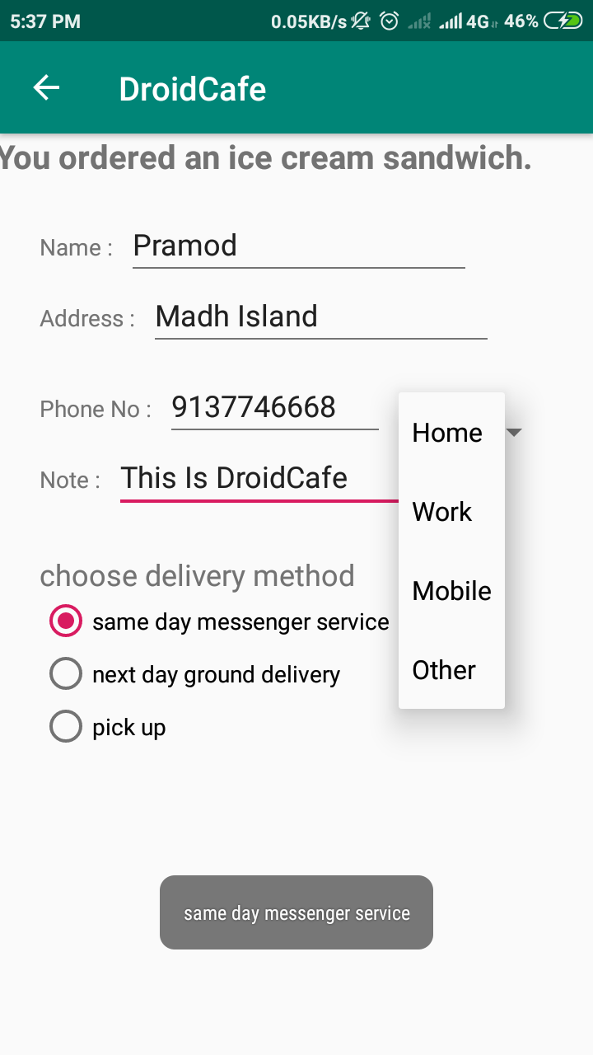 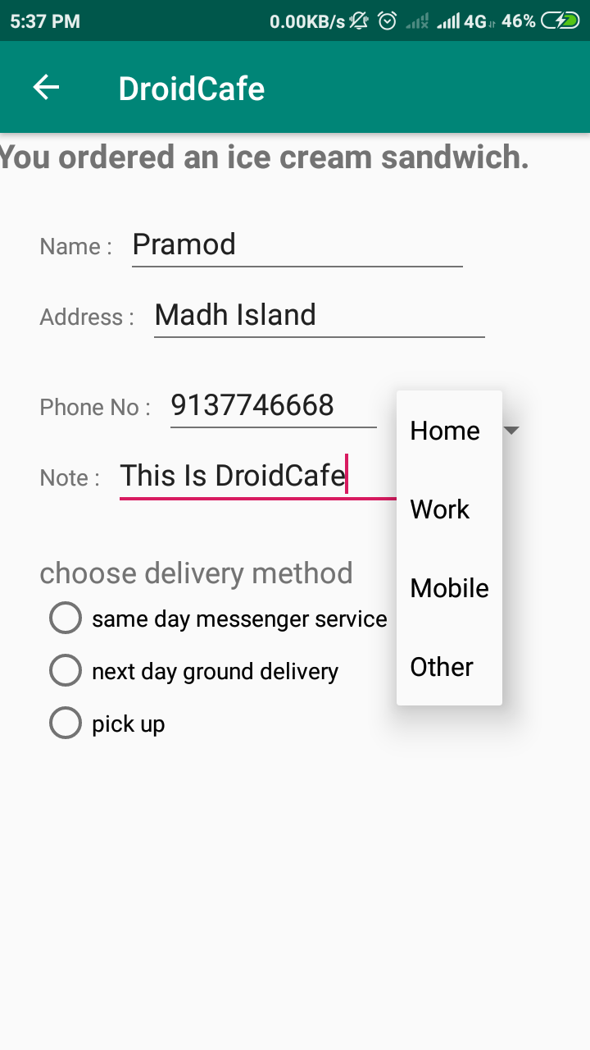

**Practical No: 7**

**Aim: Create an android app that demonstrates the use of an Options Menu**

**MainActivity.java**

**package** com.example.dell.droidcafe;  
**import** android.content.Intent;  
**import** android.os.Bundle;  
**import** android.support.design.widget.FloatingActionButton;  
**import** android.support.design.widget.Snackbar;  
**import** android.support.v7.app.AppCompatActivity;  
**import** android.support.v7.widget.Toolbar;  
**import** android.view.View;  
**import** android.view.Menu;  
**import** android.view.MenuItem;  
**import** android.widget.Toast;  
  
**public class** MainActivity **extends** AppCompatActivity {  
  
 **public** String **mOrderMessage**;  
 **public static final** String ***EXTRA_MESSAGE*** =  
 **"com.example.dell.droidcafe.MainActivity.extra.MESSAGE"**;  
 @Override  
 **protected void** onCreate(Bundle savedInstanceState) {  
 **super**.onCreate(savedInstanceState);  
 setContentView(R.layout.***activity_main***);  
 Toolbar toolbar = (Toolbar) findViewById(R.id.***toolbar***);  
 setSupportActionBar(toolbar);  
  
 FloatingActionButton fab = (FloatingActionButton) findViewById(R.id.***fab***);  
 fab.setOnClickListener(**new** View.OnClickListener() {  
 **public void** onClick(View view) {  
 Intent intent =  
 **new** Intent(MainActivity.**this**, OrderActivity.**class**);  
  
 intent.putExtra(***EXTRA_MESSAGE***, **mOrderMessage**);  
 startActivity(intent);  
 }  
 });  
 }  
  
 @Override  
 **public boolean** onCreateOptionsMenu(Menu menu) {  
 *// Inflate the menu; this adds items to the action bar if it is present.* getMenuInflater().inflate(R.menu.***menu_main***, menu);  
 **return true**;  
 }  
  
 @Override  
 **public boolean** onOptionsItemSelected(MenuItem item) {  
 *// Handle action bar item clicks here. The action bar will  
 // automatically handle clicks on the Home/Up button, so long  
 // as you specify a parent activity in AndroidManifest.xml.* **int** id = item.getItemId();  
  
 *//noinspection SimplifiableIfStatement* **if** (id == R.id.***action_order***) {  
 **return true**;  
 }  
  
 **return super**.onOptionsItemSelected(item);  
 }  
 **public void** displayToast(String message) {  
 Toast.*makeText*(getApplicationContext(), message,  
 Toast.***LENGTH_SHORT***).show();  
 }  
 **public void** showDonutOrder(View view) {  
 *//displayToast(getString(R.string.donut_order_message));* **mOrderMessage** = getString(R.string.***donut_order_message***);  
 displayToast(**mOrderMessage**);  
 }  
 **public void** showIceCreamOrder(View view) {  
 *//displayToast(getString(R.string.ice_cream_order_message));* **mOrderMessage** = getString(R.string.***ice_cream_order_message***);  
 displayToast(**mOrderMessage**);  
 }  
 **public void** showFroyoOrder(View view) {  
 *//displayToast(getString(R.string.froyo_order_message));* **mOrderMessage** = getString(R.string.***froyo_order_message***);  
 displayToast(**mOrderMessage**);  
 }  
}

**Activity_main.xml**

*<?***xml version="1.0" encoding="utf-8"***?>*<**android.support.design.widget.CoordinatorLayout xmlns:android="http://schemas.android.com/apk/res/android"  
 xmlns:app="http://schemas.android.com/apk/res-auto"  
 xmlns:tools="http://schemas.android.com/tools"  
 android:layout_width="match_parent"  
 android:layout_height="match_parent"  
 tools:context=".MainActivity"**>  
  
 <**android.support.design.widget.AppBarLayout  
 android:layout_width="match_parent"  
 android:layout_height="wrap_content"  
 android:theme="@style/AppTheme.AppBarOverlay"**>  
  
 <**android.support.v7.widget.Toolbar  
 android:id="@+id/toolbar"  
 android:layout_width="match_parent"  
 android:layout_height="?attr/actionBarSize"  
 android:background="?attr/colorPrimary"  
 app:popupTheme="@style/AppTheme.PopupOverlay"** />  
  
 </**android.support.design.widget.AppBarLayout**>  
  
 <**include layout="@layout/content_main"** />  
  
 <**android.support.design.widget.FloatingActionButton  
 android:id="@+id/fab"  
 android:layout_width="wrap_content"  
 android:layout_height="wrap_content"  
 android:layout_gravity="bottom|end"  
 android:layout_margin="@dimen/fab_margin"  
 app:srcCompat="@drawable/ic_shopping"** />  
  
</**android.support.design.widget.CoordinatorLayout**>

**Menu_main.xml**

<**menu xmlns:android="http://schemas.android.com/apk/res/android"  
 xmlns:app="http://schemas.android.com/apk/res-auto"  
 xmlns:tools="http://schemas.android.com/tools"  
 tools:context="com.example.dell.droidcafe.MainActivity"**>  
 <**item  
 android:id="@+id/action_order"  
 android:orderInCategory="10"  
 android:title="@string/action_order_message"  
 app:showAsAction="never"** />  
 <**item  
 android:id="@+id/action_status"  
 android:orderInCategory="20"  
 android:title="@string/action_status_message"  
 app:showAsAction="never"** />  
 <**item  
 android:id="@+id/action_favourites"  
 android:orderInCategory="30"  
 android:title="@string/action_favorites_message"  
 app:showAsAction="never"** />  
 <**item  
 android:id="@+id/action_contact"  
 android:orderInCategory="100"  
 android:title="@string/action_contact_message"  
 app:showAsAction="never"** />  
</**menu**>

**Content_main.xml**

*<?***xml version="1.0" encoding="utf-8"***?>*<**android.support.constraint.ConstraintLayout xmlns:android="http://schemas.android.com/apk/res/android"  
 xmlns:app="http://schemas.android.com/apk/res-auto"  
 xmlns:tools="http://schemas.android.com/tools"  
 android:layout_width="match_parent"  
 android:layout_height="match_parent"  
 app:layout_behavior="@string/appbar_scrolling_view_behavior"  
 tools:context=".MainActivity"  
 tools:showIn="@layout/activity_main"**>  
  
 <**TextView  
 android:id="@+id/textintro"  
 android:layout_width="wrap_content"  
 android:layout_height="wrap_content"  
 android:text="@string/droid_desserts"  
 android:textStyle="bold"  
 android:textSize="24sp"  
 app:layout_constraintLeft_toLeftOf="parent"  
 app:layout_constraintRight_toRightOf="parent"  
 app:layout_constraintTop_toTopOf="parent"** />  
  
 <**ImageView  
 android:id="@+id/Donut"  
 android:layout_width="wrap_content"  
 android:layout_height="wrap_content"  
 android:layout_marginLeft="24dp"  
 android:layout_marginTop="24dp"  
 android:contentDescription="@string/donut"  
 app:layout_constraintLeft_toLeftOf="parent"  
 app:layout_constraintTop_toBottomOf="@+id/textintro"  
 app:srcCompat="@drawable/donut_circle"  
 android:onClick="showDonutOrder"**/>  
  
 <**ImageView  
 android:id="@+id/ice_creame"  
 android:layout_width="wrap_content"  
 android:layout_height="wrap_content"  
 android:layout_marginLeft="24dp"  
 android:layout_marginTop="24dp"  
 android:contentDescription="@string/ice_cream_sandwiches"  
 app:layout_constraintLeft_toLeftOf="parent"  
 app:layout_constraintTop_toBottomOf="@+id/Donut"  
 app:srcCompat="@drawable/icecream_circle"  
 android:onClick="showIceCreamOrder"**/>  
  
 <**ImageView  
 android:id="@+id/froyo"  
 android:layout_width="wrap_content"  
 android:layout_height="wrap_content"  
 android:layout_marginLeft="24dp"  
 android:layout_marginTop="24dp"  
 android:contentDescription="@string/froyo"  
 app:layout_constraintLeft_toLeftOf="parent"  
 app:layout_constraintTop_toBottomOf="@+id/ice_creame"  
 app:srcCompat="@drawable/froyo_circle"  
 android:onClick="showFroyoOrder"**/>  
  
 <**TextView  
 android:id="@+id/donut_description"  
 android:layout_width="0dp"  
 android:layout_height="wrap_content"  
 android:layout_marginLeft="24dp"  
 android:layout_marginRight="24dp"  
 android:layout_marginTop="24dp"  
 android:text="@string/donut"  
 app:layout_constraintHorizontal_bias="0.503"  
 app:layout_constraintLeft_toRightOf="@+id/Donut"  
 app:layout_constraintRight_toRightOf="parent"  
 app:layout_constraintTop_toTopOf="@+id/Donut"** />  
  
 <**TextView  
 android:id="@+id/ice_cream_description"  
 android:layout_width="0dp"  
 android:layout_height="wrap_content"  
 android:layout_marginLeft="24dp"  
 android:layout_marginRight="24dp"  
 android:layout_marginTop="24dp"  
 android:text="@string/ice_cream_sandwiches"  
 app:layout_constraintLeft_toRightOf="@+id/ice_creame"  
 app:layout_constraintRight_toRightOf="parent"  
 app:layout_constraintTop_toTopOf="@+id/ice_creame"** />  
  
 <**TextView  
 android:id="@+id/froyo_description"  
 android:layout_width="0dp"  
 android:layout_height="wrap_content"  
 android:layout_marginLeft="24dp"  
 android:layout_marginRight="24dp"  
 android:layout_marginTop="24dp"  
 android:text="@string/froyo"  
 app:layout_constraintLeft_toRightOf="@+id/froyo"  
 app:layout_constraintRight_toRightOf="parent"  
 app:layout_constraintTop_toTopOf="@+id/froyo"** />  
  
</**android.support.constraint.ConstraintLayout**>

Strings_main.xml

<**resources**>  
 <**string name="app_name"**>DroidCafe</**string**>  
 <**string name="action_settings"**>Settings</**string**>  
 <**string name="donut"**>Donuts are glazed and sprinkled with candy.</**string**>  
 <**string name="froyo"**>FroYo is premium self-serve frozen yogurt.</**string**>  
 <**string name="ice_cream_sandwiches"**>Ice cream sandwiches have chocolate wafers and vanilla filling.</**string**>  
 <**string name="droid_desserts"**>Droid Desserts</**string**>  
 <**string name="donut_order_message"**>You ordered a donut.</**string**>  
 <**string name="ice_cream_order_message"**>You ordered an ice cream sandwich.</**string**>  
 <**string name="froyo_order_message"**>You ordered a FroYo.</**string**>  
 <**string name="enter_name_hint"**>enter name...</**string**>  
 <**string name="pick_up"**>pick_up</**string**>  
 <**string name="next_day_ground_delivery"**>next day ground delivery</**string**>  
 <**string name="same_day_messenger_service"**>same day messenger service</**string**>  
 <**string name="choose_delivery_method"**>choose delivery method</**string**>  
 <**string name="enter_note_hint"**>enter note...</**string**>  
 <**string name="note_label_text"**>note_label_text</**string**>  
 <**string name="enter_phone_hint"**>enter phone...</**string**>  
 <**string name="phone_label_string"**>phone_label_string</**string**>  
 <**string name="enter_address_hint"**>enter address...</**string**>  
 <**string name="address_label_text"**>address_label_text</**string**>  
 <**string name="action_order_message"**>Order.</**string**>  
 <**string name="action_status_message"**>Status.</**string**>  
 <**string name="action_favorites_message"**>Favorites.</**string**>  
 <**string name="action_contact_message"**>Contact.</**string**>  
 <**string-array name="labels_array"**>  
 <**item**>Home</**item**>  
 <**item**>Work</**item**>  
 <**item**>Mobile</**item**>  
 <**item**>Other</**item**>  
 </**string-array**>  
  
</**resources**>

**Output:**

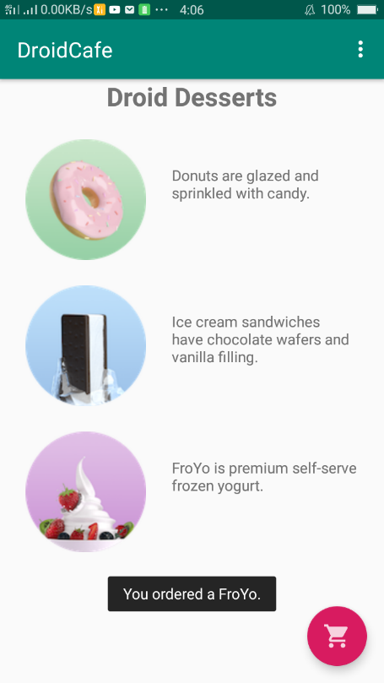 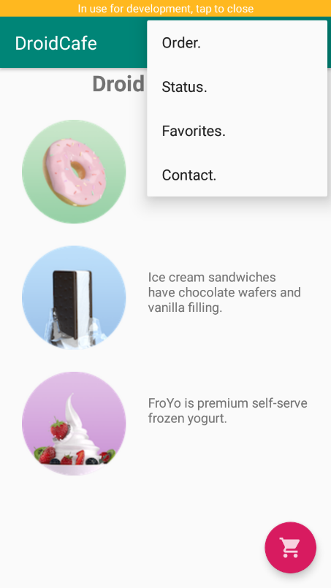

**Practical No: 8**

**Create an android app that demonstrate Screen Navigation Using the App Bar and Tabs**

**OrderActivity.java**

**package** com.example.dell.droidcafe;  
  
**import** android.content.Intent;  
**import** android.net.Uri;  
**import** android.support.v7.app.AppCompatActivity;  
**import** android.os.Bundle;  
**import** android.util.Log;  
**import** android.view.KeyEvent;  
**import** android.view.View;  
**import** android.view.inputmethod.EditorInfo;  
**import** android.widget.AdapterView;  
**import** android.widget.ArrayAdapter;  
**import** android.widget.EditText;  
**import** android.widget.RadioButton;  
**import** android.widget.Spinner;  
**import** android.widget.TextView;  
**import** android.widget.Toast;  
  
**public class** OrderActivity **extends** AppCompatActivity **implements** AdapterView.OnItemSelectedListener {  
  
 **private static final** String ***TAG*** = MainActivity.**class**.getSimpleName();  
 @Override  
 **protected void** onCreate(Bundle savedInstanceState) {  
 **super**.onCreate(savedInstanceState);  
 setContentView(R.layout.***activity_order***);  
 Intent intent = getIntent();  
 String message = intent.getStringExtra(MainActivity.***EXTRA_MESSAGE***);  
 TextView textView = (TextView) findViewById(R.id.***order_textview***);  
 textView.setText(message);  
 *// Create the spinner.* Spinner spinner = (Spinner) findViewById(R.id.***label_spinner***);  
 **if** (spinner != **null**) {  
 spinner.setOnItemSelectedListener(**this**);  
 *// Create ArrayAdapter using the string array and default spinner layout.* ArrayAdapter<CharSequence> adapter = ArrayAdapter.*createFromResource*(**this**,  
 R.array.***labels_array***, android.R.layout.***simple_spinner_dropdown_item***);  
 *// Specify the layout to use when the list of choices appears.* adapter.setDropDownViewResource  
 (android.R.layout.***simple_spinner_dropdown_item***);  
 *// Apply the adapter to the spinner.* **if** (spinner != **null**) {  
 spinner.setAdapter(adapter);  
 }  
 }  
 EditText editText =(EditText) findViewById(R.id.***phone_text***);  
 **if** (editText != **null**)  
 editText.setOnEditorActionListener(**new** TextView.OnEditorActionListener() {  
 *// If view is found, set the listener for editText.* @Override  
 **public boolean** onEditorAction(TextView textView, **int** actionId, KeyEvent keyEvent) {  
 **boolean** handled = **false**;  
 **if** (actionId == EditorInfo.***IME_ACTION_SEND***) {  
 dialNumber();  
 handled = **true**;  
 }  
 **return** handled;  
 }  
 });  
 }  
 **private void** dialNumber() {  
 *// Find the editText_main view.* EditText editText = (EditText) findViewById(R.id.***phone_text***);  
 String phoneNum = **null**;  
 *// If the editText field is not null,  
 // concatenate "tel: " with the phone number string.* **if** (editText != **null**) phoneNum = **"tel:"** +  
 editText.getText().toString();  
 *// Optional: Log the concatenated phone number for dialing.* Log.*d*(***TAG***, **"dialNumber: "** + phoneNum);  
 *// Specify the intent.* Intent intent = **new** Intent(Intent.***ACTION_DIAL***);  
 *// Set the data for the intent as the phone number.* intent.setData(Uri.*parse*(phoneNum));  
 *// If the intent resolves to a package (app),  
 // start the activity with the intent.* **if** (intent.resolveActivity(getPackageManager()) != **null**) {  
 startActivity(intent);  
 } **else** {  
 Log.*d*(**"ImplicitIntents"**, **"Can't handle this!"**);  
 }  
 }  
 **public void** displayToast(String message) {  
 Toast.*makeText*(getApplicationContext(), message,  
 Toast.***LENGTH_SHORT***).show();  
 }  
  
 **public void** onRadioButtonClicked(View view) {  
 *// Is the button now checked?* **boolean** checked = ((RadioButton) view).isChecked();  
 *// Check which radio button was clicked.* **switch** (view.getId()) {  
 **case** R.id.***sameday***:  
 **if** (checked)  
 *// Same day service* displayToast(getString(R.string.***same_day_messenger_service***));  
 **break**;  
 **case** R.id.***nextday***:  
 **if** (checked)  
 *// Next day delivery* displayToast(getString(R.string.***next_day_ground_delivery***));  
 **break**;  
 **case** R.id.***pickup***:  
 **if** (checked)  
 *// Pick up* displayToast(getString(R.string.***pick_up***));  
 **break**;  
 **default**:  
 *// Do nothing.* **break**;  
 }  
 }  
  
 @Override  
 **public void** onItemSelected(AdapterView<?> adapterView, View view, **int** i, **long** l) {  
 String spinnerLabel = adapterView.getItemAtPosition(i).toString();  
 displayToast(spinnerLabel);  
 }  
  
  
 @Override  
 **public void** onNothingSelected(AdapterView<?> adapterView) {  
  
 }  
  
}

Activity_order.xml

*<?***xml version="1.0" encoding="utf-8"***?>*<**android.support.constraint.ConstraintLayout xmlns:android="http://schemas.android.com/apk/res/android"  
 xmlns:app="http://schemas.android.com/apk/res-auto"  
 xmlns:tools="http://schemas.android.com/tools"  
 android:layout_width="match_parent"  
 android:layout_height="match_parent"  
 tools:context=".OrderActivity"**>  
  
 <**TextView  
 android:id="@+id/order_textview"  
 android:layout_width="368dp"  
 android:layout_height="wrap_content"  
 android:textStyle="bold"  
 android:textSize="20dp"  
 app:layout_constraintLeft_toLeftOf="parent"  
 app:layout_constraintRight_toRightOf="parent"  
 app:layout_constraintTop_toTopOf="parent"** />  
  
 <**TextView  
  
 android:id="@+id/name_label"  
 android:layout_width="wrap_content"  
 android:layout_height="wrap_content"  
 android:layout_marginLeft="24dp"  
 android:layout_marginRight="24dp"  
 android:layout_marginTop="32dp"  
 android:text="Name :"  
 app:layout_constraintStart_toStartOf="parent"  
 app:layout_constraintTop_toBottomOf="@id/order_textview"**/>  
  
 <**EditText  
 android:id="@+id/name_text"  
 android:layout_width="wrap_content"  
 android:layout_height="wrap_content"  
 android:layout_marginStart="8dp"  
 android:layout_marginLeft="8dp"  
 android:ems="10"  
 android:inputType="textPersonName"  
 android:hint="@string/enter_name_hint"  
 app:layout_constraintStart_toEndOf="@id/name_label"  
 app:layout_constraintBaseline_toBaselineOf="@id/name_label"** />  
  
 <**TextView  
 android:id="@+id/address_label"  
 android:layout_width="wrap_content"  
 android:layout_height="wrap_content"  
 android:layout_marginLeft="24dp"  
 android:layout_marginStart="24dp"  
 android:layout_marginTop="24dp"  
 android:text="Address :"  
 app:layout_constraintStart_toStartOf="parent"  
 app:layout_constraintTop_toBottomOf="@+id/name_label"** />  
  
 <**EditText  
 android:id="@+id/address_text"  
 android:layout_width="wrap_content"  
 android:layout_height="wrap_content"  
 android:layout_marginLeft="8dp"  
 android:layout_marginStart="8dp"  
 android:ems="10"  
 android:hint="@string/enter_address_hint"  
 android:inputType="textMultiLine"  
 app:layout_constraintBaseline_toBaselineOf="@+id/address_label"  
 app:layout_constraintStart_toEndOf="@+id/address_label"** />  
  
 <**TextView  
 android:id="@+id/phone_label"  
 android:layout_width="wrap_content"  
 android:layout_height="wrap_content"  
 android:layout_marginLeft="24dp"  
 android:layout_marginStart="24dp"  
 android:layout_marginTop="24dp"  
 android:text="Phone No :"  
 app:layout_constraintStart_toStartOf="parent"  
 app:layout_constraintTop_toBottomOf="@+id/address_text"** />  
  
 <**EditText  
 android:id="@+id/phone_text"  
 android:layout_width="134dp"  
 android:layout_height="wrap_content"  
 android:layout_marginLeft="8dp"  
 android:layout_marginStart="8dp"  
 android:ems="10"  
 android:hint="@string/enter_phone_hint"  
 android:inputType="phone"  
 android:imeOptions="actionSend"  
 app:layout_constraintBaseline_toBaselineOf="@+id/phone_label"  
 app:layout_constraintStart_toEndOf="@+id/phone_label"** />  
  
 <**TextView  
 android:id="@+id/note_label"  
 android:layout_width="wrap_content"  
 android:layout_height="wrap_content"  
 android:layout_marginLeft="24dp"  
 android:layout_marginStart="24dp"  
 android:layout_marginTop="24dp"  
 android:text="Note :"  
 app:layout_constraintStart_toStartOf="parent"  
 app:layout_constraintTop_toBottomOf="@+id/phone_label"** />  
  
 <**EditText  
 android:id="@+id/note_text"  
 android:layout_width="wrap_content"  
 android:layout_height="wrap_content"  
 android:layout_marginLeft="8dp"  
 android:layout_marginStart="8dp"  
 android:ems="10"  
 android:hint="@string/enter_note_hint"  
 android:inputType="textCapSentences|textMultiLine"  
 app:layout_constraintBaseline_toBaselineOf="@+id/note_label"  
 app:layout_constraintStart_toEndOf="@+id/note_label"** />  
  
 <**TextView  
 android:id="@+id/delivery_label"  
 android:layout_width="wrap_content"  
 android:layout_height="wrap_content"  
 android:layout_marginLeft="24dp"  
 android:layout_marginStart="24dp"  
 android:layout_marginTop="24dp"  
 android:text="@string/choose_delivery_method"  
 android:textSize="18sp"  
 app:layout_constraintStart_toStartOf="parent"  
 app:layout_constraintTop_toBottomOf="@+id/note_text"** />  
  
 <**RadioGroup  
 android:layout_width="wrap_content"  
 android:layout_height="wrap_content"  
 android:layout_marginLeft="24dp"  
 android:layout_marginStart="24dp"  
 android:orientation="vertical"  
 app:layout_constraintStart_toStartOf="parent"  
 app:layout_constraintTop_toBottomOf="@id/delivery_label"**>  
  
 <**RadioButton  
 android:id="@+id/sameday"  
 android:layout_width="wrap_content"  
 android:layout_height="wrap_content"  
 android:onClick="onRadioButtonClicked"  
 android:text="same day messenger service"** />  
  
 <**RadioButton  
 android:id="@+id/nextday"  
 android:layout_width="wrap_content"  
 android:layout_height="wrap_content"  
 android:onClick="onRadioButtonClicked"  
 android:text="next day ground delivery"** />  
  
 <**RadioButton  
 android:id="@+id/pickup"  
 android:layout_width="wrap_content"  
 android:layout_height="wrap_content"  
 android:onClick="onRadioButtonClicked"  
 android:text="pick up"** />  
 </**RadioGroup**>  
  
 <**Spinner  
 android:id="@+id/label_spinner"  
 android:layout_width="0dp"  
 android:layout_height="wrap_content"  
 android:layout_marginEnd="24dp"  
 android:layout_marginRight="24dp"  
 android:layout_marginStart="8dp"  
 android:layout_marginLeft="8dp"  
 android:layout_marginTop="24dp"  
 app:layout_constraintEnd_toEndOf="parent"  
 app:layout_constraintStart_toEndOf="@+id/phone_text"  
 app:layout_constraintTop_toBottomOf="@+id/address_text"** />  
</**android.support.constraint.ConstraintLayout**>

AndroiMAnifest.xml

*<?***xml version="1.0" encoding="utf-8"***?>*<**manifest xmlns:android="http://schemas.android.com/apk/res/android"  
 package="com.example.dell.droidcafe"**>  
  
 <**application  
 android:allowBackup="true"  
 android:icon="@mipmap/ic_launcher"  
 android:label="@string/app_name"  
 android:roundIcon="@mipmap/ic_launcher_round"  
 android:supportsRtl="true"  
 android:theme="@style/AppTheme"**>  
 <**activity  
 android:name=".MainActivity"  
 android:label="@string/app_name"  
 android:theme="@style/AppTheme.NoActionBar"**>  
 <**intent-filter**>  
 <**action android:name="android.intent.action.MAIN"** />  
  
 <**category android:name="android.intent.category.LAUNCHER"** />  
 </**intent-filter**>  
 </**activity**>  
 <**activity android:name="com.example.dell.droidcafe.OrderActivity"  
  
 android:parentActivityName=".MainActivity"**>  
 <**meta-data android:name="android.support.PARENT_ACTIVITY"  
 android:value=".MainActivity"**/>  
 </**activity**>  
 </**application**>  
  
</**manifest**>

Strings.xml

<**resources**>  
 <**string name="app_name"**>DroidCafe</**string**>  
 <**string name="action_settings"**>Settings</**string**>  
 <**string name="donut"**>Donuts are glazed and sprinkled with candy.</**string**>  
 <**string name="froyo"**>FroYo is premium self-serve frozen yogurt.</**string**>  
 <**string name="ice_cream_sandwiches"**>Ice cream sandwiches have chocolate wafers and vanilla filling.</**string**>  
 <**string name="droid_desserts"**>Droid Desserts</**string**>  
 <**string name="donut_order_message"**>You ordered a donut.</**string**>  
 <**string name="ice_cream_order_message"**>You ordered an ice cream sandwich.</**string**>  
 <**string name="froyo_order_message"**>You ordered a FroYo.</**string**>  
 <**string name="enter_name_hint"**>enter name...</**string**>  
 <**string name="pick_up"**>pick_up</**string**>  
 <**string name="next_day_ground_delivery"**>next day ground delivery</**string**>  
 <**string name="same_day_messenger_service"**>same day messenger service</**string**>  
 <**string name="choose_delivery_method"**>choose delivery method</**string**>  
 <**string name="enter_note_hint"**>enter note...</**string**>  
 <**string name="note_label_text"**>note_label_text</**string**>  
 <**string name="enter_phone_hint"**>enter phone...</**string**>  
 <**string name="phone_label_string"**>phone_label_string</**string**>  
 <**string name="enter_address_hint"**>enter address...</**string**>  
 <**string name="address_label_text"**>address_label_text</**string**>  
 <**string name="action_order_message"**>Order.</**string**>  
 <**string name="action_status_message"**>Status.</**string**>  
 <**string name="action_favorites_message"**>Favorites.</**string**>  
 <**string name="action_contact_message"**>Contact.</**string**>  
 <**string-array name="labels_array"**>  
 <**item**>Home</**item**>  
 <**item**>Work</**item**>  
 <**item**>Mobile</**item**>  
 <**item**>Other</**item**>  
 </**string-array**>  
  
</**resources**>

**Output:**

 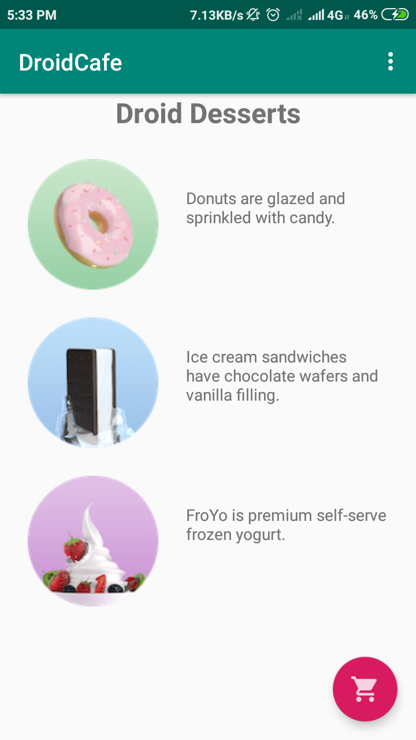

**Practical No: 9**

**Aim: Create an android app to Connect to the Internet and use BroadcastReceiver.**

**Activity_main.xml**

<?xml version="1.0" encoding="utf-8"?>

<android.support.constraint.ConstraintLayout xmlns:android="http://schemas.android.com/apk/res/android"

xmlns:app="http://schemas.android.com/apk/res-auto"

xmlns:tools="http://schemas.android.com/tools"

android:layout_width="match_parent"

android:layout_height="match_parent"

tools:context=".MainActivity">

<Button

android:id = "@+id/sendBroadcast"

android:layout_width="wrap_content"

android:layout_height="wrap_content"

android:text="Send Custom Broadcast"

android:onClick="sendCustomBroadcast"

app:layout_constraintBottom_toBottomOf="parent"

app:layout_constraintLeft_toLeftOf="parent"

app:layout_constraintRight_toRightOf="parent"

app:layout_constraintTop_toTopOf="parent" />

</android.support.constraint.ConstraintLayout>

**Mainactivity.java**

package com.example.powerreciever;

import android.content.Intent;

import android.content.IntentFilter;

import android.support.v4.content.LocalBroadcastManager;

import android.support.v7.app.AppCompatActivity;

import android.os.Bundle;

import android.view.View;

public class MainActivity extends AppCompatActivity {

private MyReceiver mReceiver = new MyReceiver();

private static final String ACTION_CUSTOM_BROADCAST =

BuildConfig.APPLICATION_ID + ".ACTION_CUSTOM_BROADCAST";

@Override

protected void onCreate(Bundle savedInstanceState) {

super.onCreate(savedInstanceState);

setContentView(R.layout.activity_main);

IntentFilter filter = new IntentFilter();

filter.addAction(Intent.ACTION_POWER_DISCONNECTED);

filter.addAction(Intent.ACTION_POWER_CONNECTED);

this.registerReceiver(mReceiver, filter);

LocalBroadcastManager.getInstance(this)

.registerReceiver(mReceiver,

new IntentFilter(ACTION_CUSTOM_BROADCAST));

}

protected void onDestroy() {

//Unregister the receiver

this.unregisterReceiver(mReceiver);

super.onDestroy();

LocalBroadcastManager.getInstance(this)

.unregisterReceiver(mReceiver);

}

public void sendCustomBroadcast(View view) {

Intent customBroadcastIntent = new Intent(ACTION_CUSTOM_BROADCAST);

LocalBroadcastManager.getInstance(this).sendBroadcast(customBroadcastIntent);

}}

**MyReceiver.java**

package com.example.powerreciever;

import android.content.BroadcastReceiver;

import android.content.Context;

import android.content.Intent;

import android.widget.Toast;

public class MyReceiver extends BroadcastReceiver {

private static final String ACTION_CUSTOM_BROADCAST =

BuildConfig.APPLICATION_ID + ".ACTION_CUSTOM_BROADCAST";

public void onReceive(Context context, Intent intent) {

String intentAction = intent.getAction();

if (intentAction != null) {

String toastMessage = "unknown intent action";

switch (intentAction){

case Intent.ACTION_POWER_CONNECTED:

toastMessage = "Power connected!";

break;

case Intent.ACTION_POWER_DISCONNECTED:

toastMessage = "Power disconnected!";

break;

case ACTION_CUSTOM_BROADCAST:

toastMessage = "Custom Broadcast Received";

break;

}

Toast.makeText(context, toastMessage, Toast.LENGTH_SHORT).show()

//Display the toast.

}

}

}

Output:

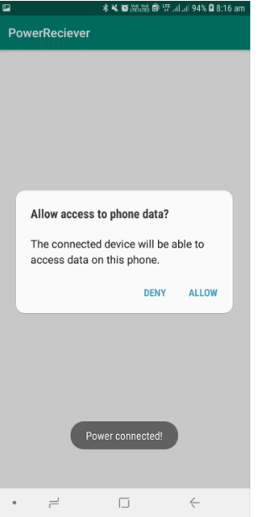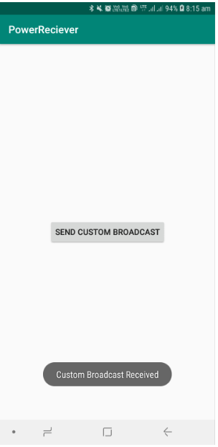

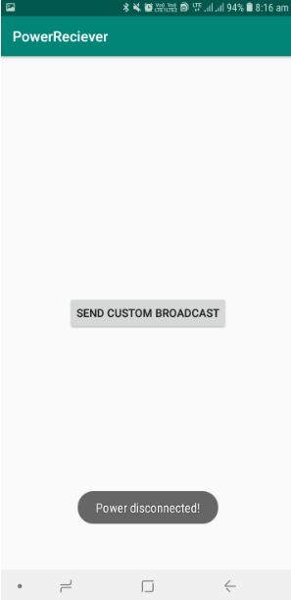

**Practical No: 10**

**Aim: Create an android app to show Notifications and Alarm manager.**

**Practical 10-A**

**Notify me**

**MainActivity.java**

package com.example.notifyme;  
  
import android.app.NotificationChannel;  
import android.app.NotificationManager;  
import android.app.PendingIntent;  
import android.content.Intent;  
import android.graphics.Color;  
import android.support.v4.app.NotificationCompat;  
import android.support.v7.app.AppCompatActivity;  
import android.os.Bundle;  
import android.view.View;  
import android.widget.Button;  
  
public class MainActivity extends AppCompatActivity {  
  
 private Button button_notify;  
 private static final String PRIMARY_CHANNEL_ID = "primary_notification_channel";  
 private NotificationManager mNotifyManager;  
 private static final int NOTIFICATION_ID = 0;  
  
 @Override  
 protected void onCreate(Bundle savedInstanceState) {  
 super.onCreate(savedInstanceState);  
 setContentView(R.layout.activity_main);  
  
 button_notify = findViewById(R.id.notify);  
 button_notify.setOnClickListener(new View.OnClickListener() {  
 @Override  
 public void onClick(View view) {  
 sendNotification();  
 }  
 });  
 createNotificationChannel();  
 }  
 public void sendNotification() {  
  
 NotificationCompat.Builder notifyBuilder = getNotificationBuilder();  
 mNotifyManager.notify(NOTIFICATION_ID, notifyBuilder.build());  
 }  
  
 public void createNotificationChannel()  
 {  
 mNotifyManager = (NotificationManager)  
 getSystemService(NOTIFICATION_SERVICE);  
 getSystemService(NOTIFICATION_SERVICE);  
 if (android.os.Build.VERSION.SDK_INT >=  
 android.os.Build.VERSION_CODES.O) {  
 // Create a NotificationChannel  
 NotificationChannel notificationChannel = new NotificationChannel(PRIMARY_CHANNEL_ID,  
 "Mascot Notification", NotificationManager  
 .IMPORTANCE_HIGH);  
  
 notificationChannel.enableLights(true);  
 notificationChannel.setLightColor(Color.RED);  
 notificationChannel.enableVibration(true);  
 notificationChannel.setDescription("Notification from Mascot");  
 mNotifyManager.createNotificationChannel(notificationChannel);  
  
  
 }  
 }  
 private NotificationCompat.Builder getNotificationBuilder(){  
 Intent notificationIntent = new Intent(this, MainActivity.class);  
 PendingIntent notificationPendingIntent = PendingIntent.getActivity(this,  
 NOTIFICATION_ID, notificationIntent, PendingIntent.FLAG_UPDATE_CURRENT);  
  
 NotificationCompat.Builder notifyBuilder = new NotificationCompat.Builder(this, PRIMARY_CHANNEL_ID)  
 .setContentTitle("You've been notified!")  
 .setContentText("This is your notification text.")  
 .setContentIntent(notificationPendingIntent)  
 .setAutoCancel(true)  
 .setSmallIcon(R.drawable.ic_android);  
 return notifyBuilder;  
 }  
}

**activity_main.xml**

<?xml version="1.0" encoding="utf-8"?>  
<android.support.constraint.ConstraintLayout xmlns:android="http://schemas.android.com/apk/res/android"  
 xmlns:app="http://schemas.android.com/apk/res-auto"  
 xmlns:tools="http://schemas.android.com/tools"  
 android:layout_width="match_parent"  
 android:layout_height="match_parent"  
 tools:context=".MainActivity">  
  
  
 <Button  
 android:id="@+id/notify"  
 android:layout_width="wrap_content"  
 android:layout_height="wrap_content"  
 android:text="Notify Me!"  
 app:layout_constraintBottom_toBottomOf="parent"  
 app:layout_constraintLeft_toLeftOf="parent"  
 app:layout_constraintRight_toRightOf="parent"  
 app:layout_constraintTop_toTopOf="parent" />  
  
</android.support.constraint.ConstraintLayout>

Output:

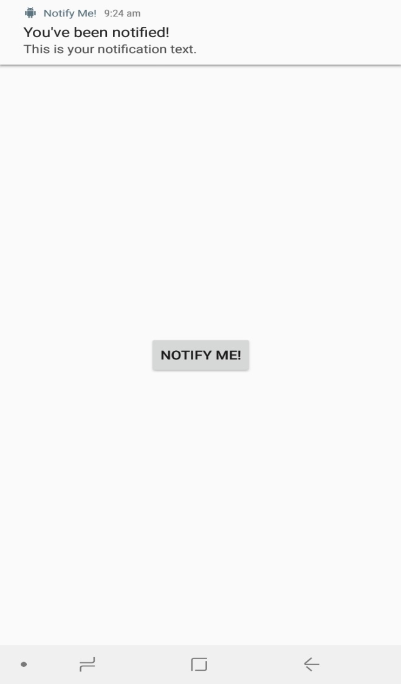

**B)ALARM MANAGER:**

**\*activity_main.xml*:**

<?xml version="1.0" encoding="utf-8"?>  
<android.support.constraint.ConstraintLayout xmlns:android="http://schemas.android.com/apk/res/android"  
 xmlns:app="http://schemas.android.com/apk/res-auto"  
 xmlns:tools="http://schemas.android.com/tools"  
 android:layout_width="match_parent"  
 android:orientation="vertical"  
 android:layout_height="match_parent"  
 tools:context=".MainActivity">  
  
 <ToggleButton  
 android:id="@+id/alarm_Toggle"  
 android:layout_width="match_parent"  
 android:layout_height="100dp"  
 android:gravity="center"  
 android:textOff="Alarm Off"  
 android:textOn="Alarm On"  
 android:textStyle="bold"  
 android:textSize="30dp"  
 app:layout_constraintBottom_toBottomOf="parent"  
 app:layout_constraintEnd_toEndOf="parent"  
 app:layout_constraintStart_toStartOf="parent"  
 app:layout_constraintTop_toTopOf="parent" />  
</android.support.constraint.ConstraintLayout>

**\*MainActivity.java*:**

package com.example.alarm_manager;  
  
import android.app.AlarmManager;  
import android.app.NotificationChannel;  
import android.app.NotificationManager;  
import android.app.PendingIntent;  
import android.content.Context;  
import android.content.Intent;  
import android.graphics.Color;  
import android.os.SystemClock;  
import android.support.v4.app.NotificationCompat;  
import android.support.v7.app.AppCompatActivity;  
import android.os.Bundle;  
import android.widget.CompoundButton;  
import android.widget.Toast;  
import android.widget.ToggleButton;  
  
public class MainActivity<isChecked> extends AppCompatActivity {  
 private NotificationManager mNotificationManager;  
 private static final int NOTIFICATION_ID = 0;  
 private static final String PRIMARY_CHANNEL_ID =  
 "primary_notification_channel";  
   
 @Override  
 protected void onCreate(Bundle savedInstanceState) {  
 super.onCreate(savedInstanceState);  
 setContentView(R.layout.activity_main);  
 ToggleButton alarmToggle = findViewById(R.id.alarm_Toggle);  
  
 alarmToggle.setOnCheckedChangeListener(  
 new CompoundButton.OnCheckedChangeListener() {  
 @Override  
 public void onCheckedChanged(CompoundButton compoundButton,  
 boolean isChecked) {  
 String toastMessage;  
 if(isChecked){  
 //Set the toast message for the "on" case.  
 deliverNotification(MainActivity.this);  
 toastMessage = "Stand Up Alarm On!";  
 } else {  
 //Set the toast message for the "off" case.  
 mNotificationManager.cancelAll();  
 toastMessage = "Stand Up Alarm Off!";  
 }  
  
 //Show a toast to say the alarm is turned on or off.  
 Toast.makeText(MainActivity.this, toastMessage,Toast.LENGTH_SHORT)  
 .show();  
 }  
 });  
  
 mNotificationManager = (NotificationManager)  
 getSystemService(NOTIFICATION_SERVICE);  
  
 createNotificationChannel();  
  
 }  
  
 public void createNotificationChannel() {  
  
 // Create a notification manager object.  
 mNotificationManager =  
 (NotificationManager) getSystemService(NOTIFICATION_SERVICE);  
  
 // Notification channels are only available in OREO and higher.  
 // So, add a check on SDK version.  
 if (android.os.Build.VERSION.SDK_INT >=  
 android.os.Build.VERSION_CODES.O) {  
  
 // Create the NotificationChannel with all the parameters.  
 NotificationChannel notificationChannel = new NotificationChannel  
 (PRIMARY_CHANNEL_ID,  
 "Stand up notification",  
 NotificationManager.IMPORTANCE_HIGH);  
  
 notificationChannel.enableLights(true);  
 notificationChannel.setLightColor(Color.RED);  
 notificationChannel.enableVibration(true);  
 notificationChannel.setDescription  
 ("Notifies every 15 minutes to stand up and walk");  
 mNotificationManager.createNotificationChannel(notificationChannel);  
 }  
 }  
  
 private void deliverNotification(Context context) {  
 Intent contentIntent = new Intent(context, MainActivity.class);  
 PendingIntent contentPendingIntent = PendingIntent.getActivity  
 (context, NOTIFICATION_ID, contentIntent, PendingIntent.FLAG_UPDATE_CURRENT);  
 NotificationCompat.Builder builder = new NotificationCompat.Builder(context, PRIMARY_CHANNEL_ID)  
 .setSmallIcon(R.mipmap.ic_stand_up)  
 .setContentTitle("Stand Up Alert")  
 .setContentText("You should stand up and walk around now!")  
 .setContentIntent(contentPendingIntent)  
 .setPriority(NotificationCompat.PRIORITY_HIGH)  
 .setAutoCancel(true)  
 .setDefaults(NotificationCompat.DEFAULT_ALL);  
  
 mNotificationManager.notify(NOTIFICATION_ID, builder.build());  
 }  
}

**Output:**

