Program 1:

#include <iostream>

class Rectangle {

private:

double length;

double breadth;

public:

Rectangle() : length(0), breadth(0) {}

Rectangle(double len, double brd) : length(len), breadth(brd) {}

Rectangle(double side) : length(side), breadth(side) {}

double calculateArea() {

return length \* breadth;

}

};

int main() {

Rectangle rect1;

Rectangle rect2(5, 4);

Rectangle rect3(6);

std::cout << "Area of Rectangle 1: " << rect1.calculateArea() << std::endl;

std::cout << "Area of Rectangle 2: " << rect2.calculateArea() << std::endl;

std::cout << "Area of Rectangle 3: " << rect3.calculateArea() << std::endl;

return 0;

}

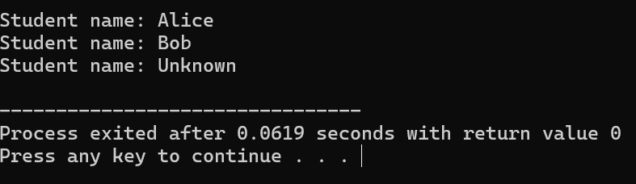

Program 2:

#include <iostream>

class AddAmount {

private:

double amount;

public:

AddAmount() : amount(50) {}

AddAmount(double addedAmount) : amount(50 + addedAmount) {}

void displayAmount() {

std::cout << "Final amount in the Piggy Bank: $" << amount << std::endl;

}

};

int main() {

AddAmount piggyBank1;

AddAmount piggyBank2(20);

piggyBank1.displayAmount();

piggyBank2.displayAmount();

return 0;

}

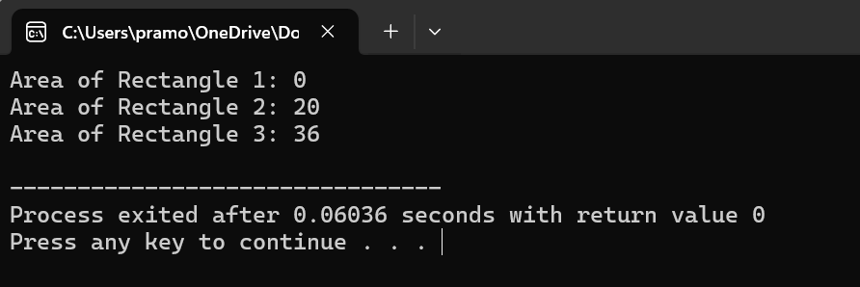

Program 3:

#include <iostream>

class AreaCalculator {

public:

void calculateArea(double length, double breadth) {

double area = length \* breadth;

std::cout << "Area of Rectangle: " << area << std::endl;

}

void calculateArea(double side) {

double area = side \* side;

std::cout << "Area of Square: " << area << std::endl;

}

};

int main() {

AreaCalculator calculator;

calculator.calculateArea(5, 6);

calculator.calculateArea(4);

return 0;

}

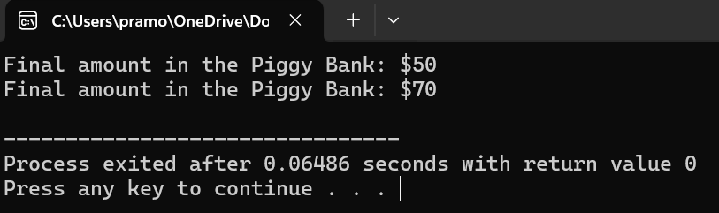

Program 4:

#include <iostream>

class Add {

private:

int num1;

int num2;

public:

Add(int n1, int n2) : num1(n1), num2(n2) {}

Add operator+(const Add& other) {

int sum1 = this->num1 + other.num1;

int sum2 = this->num2 + other.num2;

return Add(sum1, sum2);

}

void displaySum() {

std::cout << "Sum: " << num1 << " + " << num2 << " = " << num1 + num2 << std::endl;

}

};

int main() {

Add obj1(10, 20);

Add obj2(30, 40);

Add result = obj1 + obj2;

result.displaySum();

return 0;

}

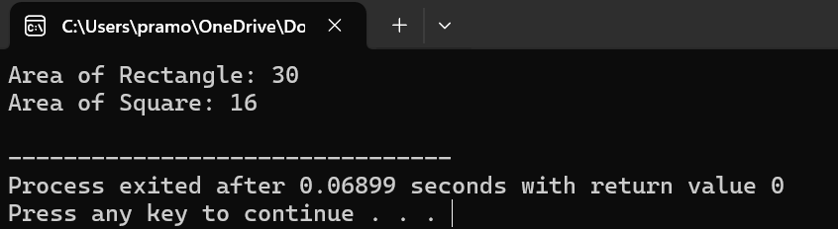

Program 5:

#include <iostream>

#include <string>

class Student {

private:

std::string name;

public:

Student(std::string studentName = "Unknown") : name(studentName) {}

void displayName() {

std::cout << "Student name: " << name << std::endl;

}

};

int main() {

Student student1("Alice");

Student student2("Bob");

Student student3;

student1.displayName();

student2.displayName();

student3.displayName();

return 0;

}

