Program 1:

#include <iostream>

class CubeCalculator {

private:

int maxNumber;

public:

CubeCalculator(int max) : maxNumber(max) {}

~CubeCalculator() {

std::cout << "Destructor called. Memory released." << std::endl;

}

void displayCubes() {

for (int i = 1; i <= maxNumber; ++i) {

std::cout << "Cube of " << i << " is: " << (i \* i \* i) << std::endl;

}

}

};

int main() {

int maxNum;

std::cout << "Enter the maximum number: ";

std::cin >> maxNum;

CubeCalculator cubeCalculator(maxNum);

cubeCalculator.displayCubes();

return 0;

}

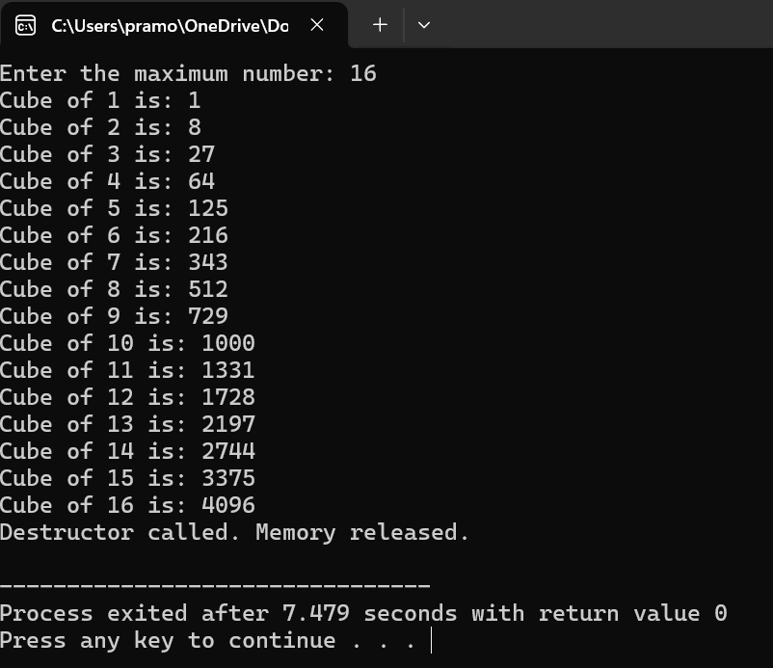

Program 2:

#include <iostream>

class CubeCalculator {

private:

int maxNumber;

public:

CubeCalculator() : maxNumber(0) {}

CubeCalculator(int max) : maxNumber(max) {}

void setMaxNumber(int max) {

maxNumber = max;

}

void displayCubes() {

for (int i = 1; i <= maxNumber; ++i) {

std::cout << "Cube of " << i << " is: " << (i \* i \* i) << std::endl;

}

}

};

int main() {

int maxNum;

std::cout << "Enter the maximum number: ";

std::cin >> maxNum;

CubeCalculator cubeCalculator(maxNum);

cubeCalculator.displayCubes();

return 0;

}

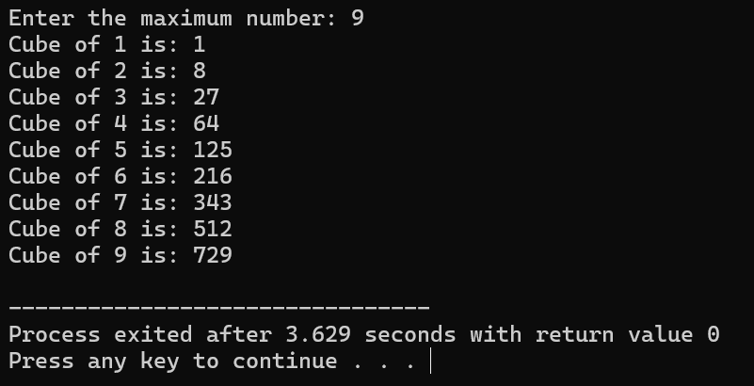

Program 3:

#include <iostream>

class SeriesSum {

private:

int n;

double sum;

public:

SeriesSum() : n(0), sum(0) {}

SeriesSum(int num) : n(num) {

sum = calculateSum();

}

double calculateSum() {

double s = 0;

for (int i = 1; i <= n; ++i) {

s += 1.0 / i;

}

return s;

}

void displaySum() {

std::cout << "Sum of the series up to " << n << " terms is: " << sum << std::endl;

}

};

int main() {

int terms;

std::cout << "Enter the number of terms in the series: ";

std::cin >> terms;

SeriesSum series(terms);

series.displaySum();

return 0;

}

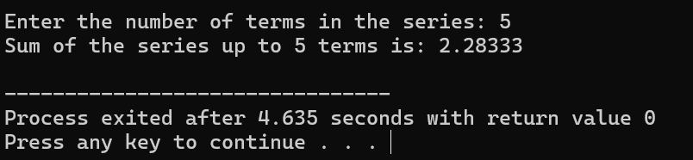

Program 4:

#include <iostream>

class RightAngleTriangle {

private:

int size;

int number;

public:

RightAngleTriangle() : size(0), number(0) {}

RightAngleTriangle(int s, int num) : size(s), number(num) {}

void printPattern() {

for (int i = 1; i <= size; ++i) {

for (int j = 1; j <= i; ++j) {

std::cout << number << " ";

}

std::cout << std::endl;

}

}

};

int main() {

int triangleSize, repeatNumber;

std::cout << "Enter the size of the right-angle triangle: ";

std::cin >> triangleSize;

std::cout << "Enter the number to repeat in each row: ";

std::cin >> repeatNumber;

RightAngleTriangle triangle(triangleSize, repeatNumber);

triangle.printPattern();

return 0;

}

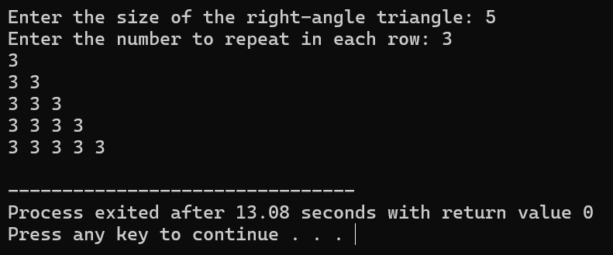

Program 5:

#include <iostream>

class ReverseNumber {

private:

int originalNumber;

int reversedNumber;

public:

ReverseNumber() : originalNumber(0), reversedNumber(0) {}

ReverseNumber(int num) : originalNumber(num) {

reversedNumber = reverse();

}

int reverse() {

int num = originalNumber;

int reversed = 0;

while (num != 0) {

int digit = num % 10;

reversed = reversed \* 10 + digit;

num /= 10;

}

return reversed;

}

void displayReverse() {

std::cout << "Reverse of " << originalNumber << " is: " << reversedNumber << std::endl;

}

};

int main() {

int num;

std::cout << "Enter a number: ";

std::cin >> num;

ReverseNumber reversed(num);

reversed.displayReverse();

return 0;

}

