Program 1:

#include <iostream>

int main() {

const int myConstant = 10;

std::cout << "The value of the constant integer is: " << myConstant << std::endl;

return 0;

}

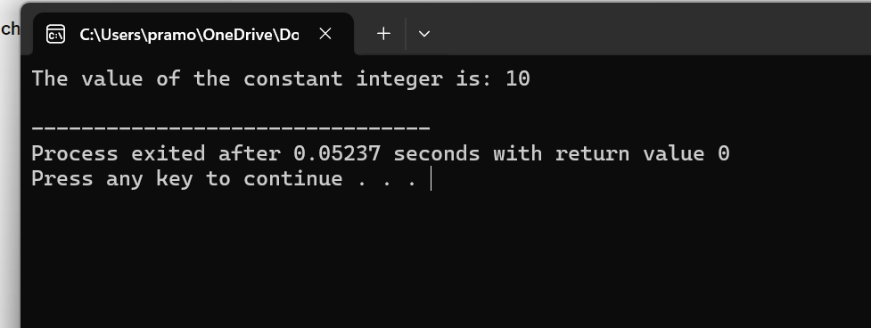

Program 2:

#include <iostream>

int main() {

int myInteger = 10;

float myFloat = 3.14;

char myCharacter = 'A';

std::cout << "Integer: " << myInteger << std::endl;

std::cout << "Float: " << myFloat << std::endl;

std::cout << "Character: " << myCharacter << std::endl;

return 0;

}

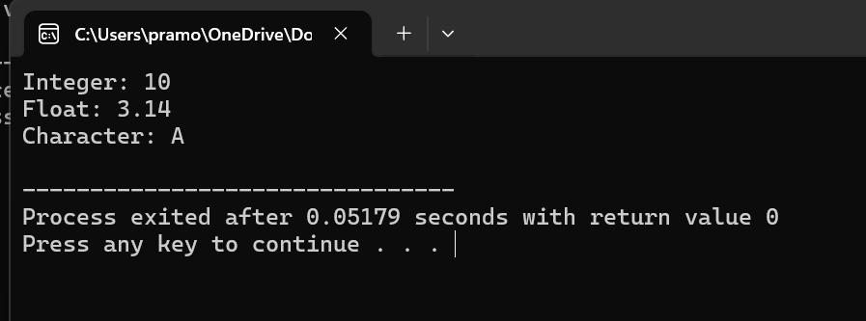

Program 3:

#include <iostream>

int main() {

int myInteger = 25;

float myFloat;

myFloat = myInteger;

std::cout << "Integer: " << myInteger << std::endl;

std::cout << "Float: " << myFloat << std::endl;

return 0;

}

Program 4:

#include <iostream>

int main() {

int myInteger = 25;

float myFloat;

myFloat = myInteger;

std::cout << "Integer: " << myInteger << std::endl;

std::cout << "Float: " << myFloat << std::endl;

return 0;

}

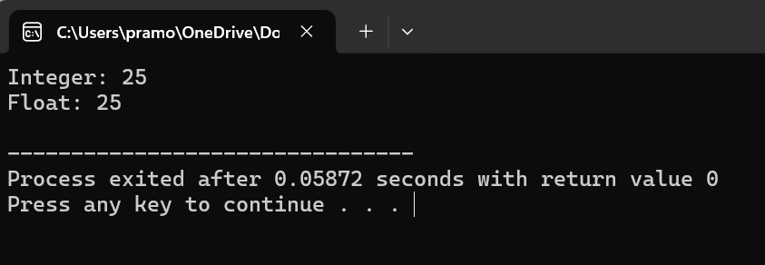

Program 5:

#include <iostream>

int main() {

int num1 = 10;

int num2 = 20;

int sum = num1 + num2;

std::cout << "The sum of " << num1 << " and " << num2 << " is: " << sum << std::endl;

return 0;

}

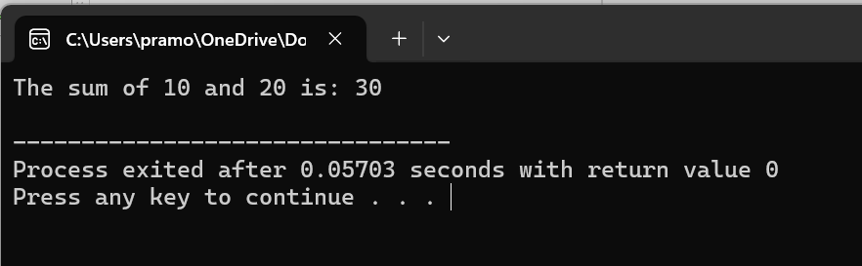

Program 6:

#include <iostream>

int main() {

int number;

std::cout << "Enter a number: ";

std::cin >> number;

if (number % 2 == 0) {

std::cout << number << " is even." << std::endl;

} else {

std::cout << number << " is odd." << std::endl;

}

return 0;

}

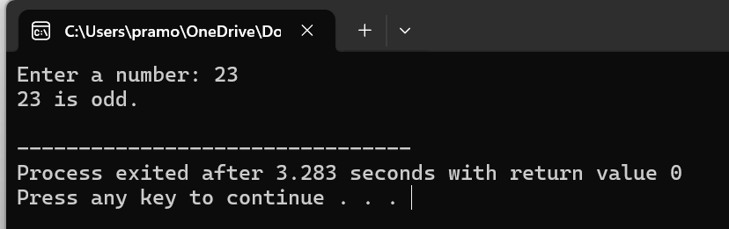

Program 7:

#include <iostream>

int main() {

int myArray[] = {1, 2, 3, 4, 5};

int arraySize = sizeof(myArray) / sizeof(myArray[0]);

std::cout << "Elements of the array:" << std::endl;

for (int i = 0; i < arraySize; ++i) {

std::cout << myArray[i] << " ";

}

std::cout << std::endl;

return 0;

}

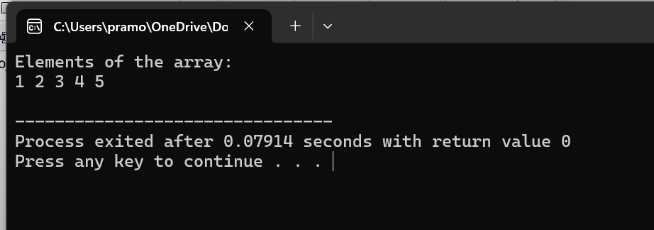

Program 8:

#include <iostream>

int main() {

int dayNumber;

std::cout << "Enter a number (1-7): ";

std::cin >> dayNumber;

switch (dayNumber) {

case 1:

std::cout << "Monday" << std::endl;

break;

case 2:

std::cout << "Tuesday" << std::endl;

break;

case 3:

std::cout << "Wednesday" << std::endl;

break;

case 4:

std::cout << "Thursday" << std::endl;

break;

case 5:

std::cout << "Friday" << std::endl;

break;

case 6:

std::cout << "Saturday" << std::endl;

break;

case 7:

std::cout << "Sunday" << std::endl;

break;

default:

std::cout << "Invalid input! Please enter a number between 1 and 7." << std::endl;

break;

}

return 0;

}

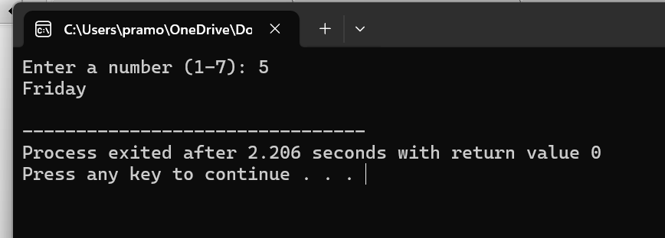

Program 9:

#include <iostream>

int main() {

double length, width, area;

std::cout << "Enter the length of the rectangle: ";

std::cin >> length;

std::cout << "Enter the width of the rectangle: ";

std::cin >> width;

area = length \* width;

std::cout << "The area of the rectangle with length " << length << " and width " << width << " is: " << area << std::endl;

return 0;

}

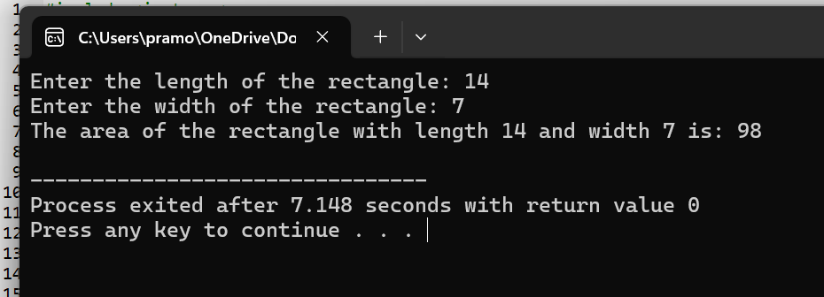

Program 10:

#include <iostream>

int main() {

int num1, num2, num3;

std::cout << "Enter three numbers: ";

std::cin >> num1 >> num2 >> num3;

int maxNumber;

if (num1 >= num2 && num1 >= num3) {

maxNumber = num1;

} else if (num2 >= num1 && num2 >= num3) {

maxNumber = num2;

} else {

maxNumber = num3;

}

std::cout << "The maximum of the three numbers is: " << maxNumber << std::endl;

return 0;

}

