Program 1:

#include <iostream>

using namespace std;

void printMessage(string message = "Hello, World!") {

cout << message << endl;

}

int main() {

printMessage();

printMessage("Greetings!");

return 0;

}

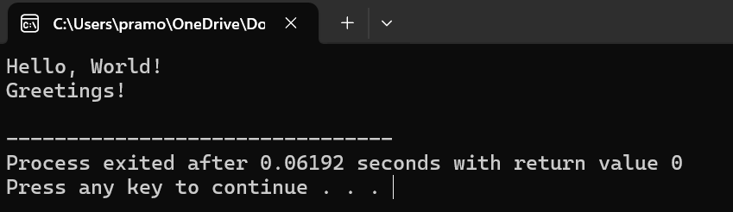

Program 2:

#include <iostream>

#include <string>

#include <cctype>

using namespace std;

bool isValidUsername(const string& username) {

if (username.empty()) {

return false;

}

if (username.length() < 5 || username.length() > 15) {

return false;

}

for (char ch : username) {

if (!isalnum(ch)) {

return false;

}

}

return true;

}

int main() {

string username;

cout << "Enter a username: ";

getline(cin, username);

if (isValidUsername(username)) {

cout << "Username is valid." << endl;

} else {

cout << "Invalid username. Username must be between 5 and 15 characters long and consist only of alphanumeric characters." << endl;

}

return 0;

}

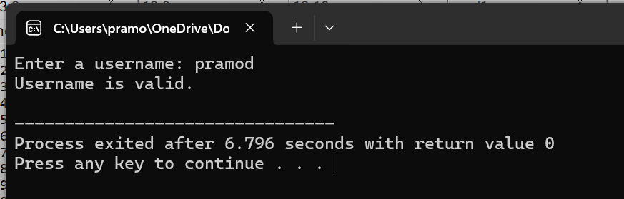

Program 3:

#include <iostream>

using namespace std;

void checkEligibility(int age) {

const int VOTING_AGE = 18;

if (age >= VOTING_AGE) {

cout << "You are eligible to vote." << endl;

} else {

int yearsLeft = VOTING_AGE - age;

cout << "You are not eligible to vote yet. ";

cout << "You need to wait for " << yearsLeft;

if (yearsLeft == 1) {

cout << " year to be eligible." << endl;

} else {

cout << " years to be eligible." << endl;

}

}

}

int main() {

int age;

cout << "Enter your age: ";

cin >> age;

checkEligibility(age);

return 0;

}

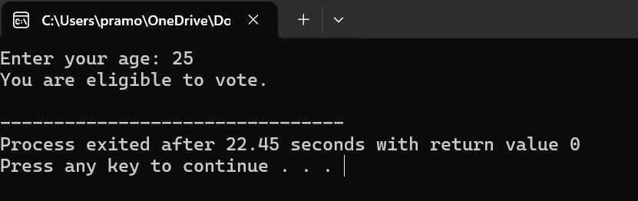

Program 4:

#include <iostream>

using namespace std;

double calculateInterestSenior(double principal, double rate, double time) {

return (principal * rate * time) / 100;

}

double calculateInterestRegular(double principal, double rate, double time) {

return (principal * rate * time) / 100;

}

int main() {

double principal, time;

char customerType;

const double seniorRate = 12.0;

const double regularRate = 10.0;

cout << "Enter principal amount: ";

cin >> principal;

cout << "Enter time (in years): ";

cin >> time;

cout << "Are you a senior citizen? (Y/N): ";

cin >> customerType;

double interest;

if (customerType == 'Y' || customerType == 'y') {

interest = calculateInterestSenior(principal, seniorRate, time);

} else {

interest = calculateInterestRegular(principal, regularRate, time);

}

cout << "Simple interest: " << interest << endl;

return 0;

}

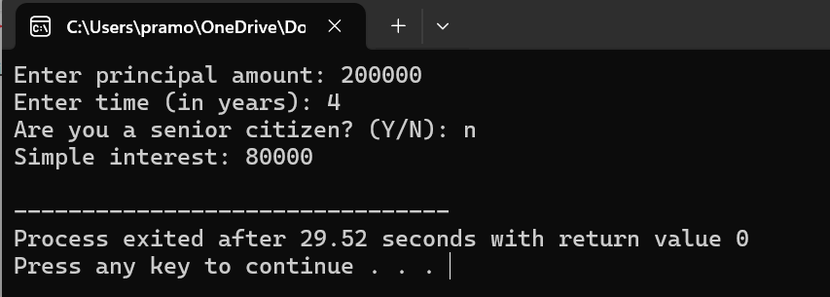

Program 5:

#include <iostream>

#include <string>

#include <algorithm>

using namespace std;

inline bool isPalindrome(const string& str) {

string reversed = str;

reverse(reversed.begin(), reversed.end());

return str == reversed;

}

int main() {

char choice;

string input;

do {

cout << "Enter a string: ";

cin >> input;

if (isPalindrome(input)) {

cout << "\"" << input << "\" is a palindrome." << endl;

} else {

cout << "\"" << input << "\" is not a palindrome." << endl;

}

cout << "Do you want to check another string? (Y/N): ";

cin >> choice;

} while (choice == 'Y' || choice == 'y');

cout << "Program exited." << endl;

return 0;

}

