Program 1:

#include <iostream>

using namespace std;

void swapByValue(int a, int b) {

int temp = a;

a = b;

b = temp;

}

void swapByReference(int &a, int &b) {

int temp = a;

a = b;

b = temp;

}

int main() {

int num1 = 5, num2 = 10;

cout << "Before swapping:" << endl;

cout << "num1: " << num1 << endl;

cout << "num2: " << num2 << endl;

swapByValue(num1, num2);

cout << "After swapping using call by value:" << endl;

cout << "num1: " << num1 << endl;

cout << "num2: " << num2 << endl;

swapByReference(num1, num2);

cout << "After swapping using call by reference:" << endl;

cout << "num1: " << num1 << endl;

cout << "num2: " << num2 << endl;

return 0;

}

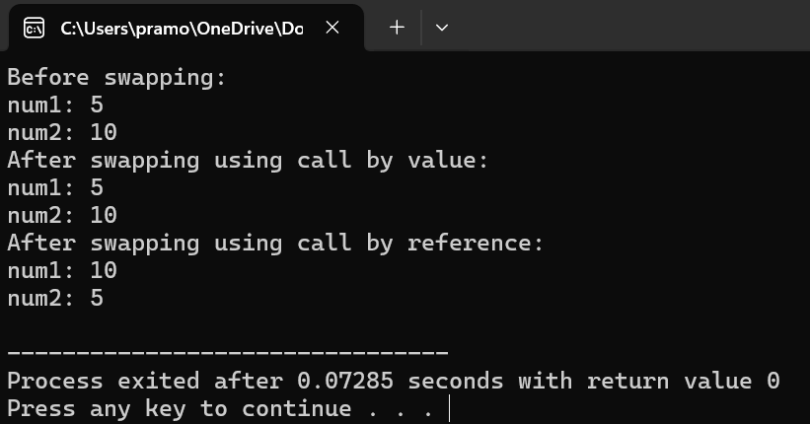

Program 2:

#include <iostream>

using namespace std;

class Series {

private:

int num;

void fibonacci(int n) {

int first = 0, second = 1, next;

cout << "Fibonacci Series up to " << n << " terms:" << endl;

for (int i = 0; i < n; ++i) {

if (i <= 1)

next = i;

else {

next = first + second;

first = second;

second = next;

}

cout << next << " ";

}

cout << endl;

}

public:

void input() {

cout << "Enter the number of terms for Fibonacci series: ";

cin >> num;

}

void show() {

fibonacci(num);

}

};

int main() {

Series seriesObj;

seriesObj.input();

seriesObj.show();

return 0;

}

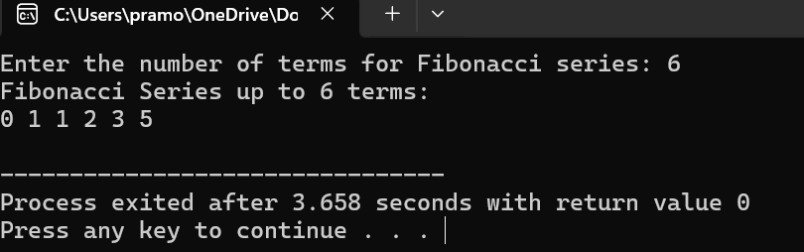

Program 4:

#include <iostream>

using namespace std;

class Complex {

private:

float real;

float imag;

public:

Complex(float r = 0.0, float i = 0.0) : real(r), imag(i) {}

Complex operator+(const Complex &other) const {

Complex temp;

temp.real = real + other.real;

temp.imag = imag + other.imag;

return temp;

}

void display() const {

cout << "Real Part: " << real << ", Imaginary Part: " << imag << endl;

}

};

int main() {

Complex c1(2.3, 4.5);

Complex c2(1.6, 7.8);

Complex result = c1 + c2;

cout << "Result of addition:" << endl;

result.display();

return 0;

}

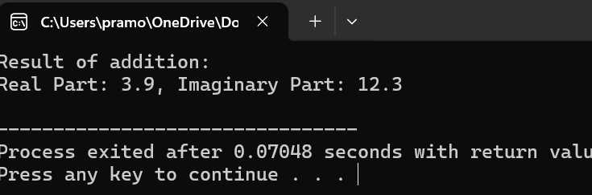

Program 5:

#include <iostream>

using namespace std;

class Employee {

private:

float taxableIncome;

float tax;

public:

Employee(float income) : taxableIncome(income), tax(0.0) {}

void calculateTax() {

if (taxableIncome <= 60000)

tax = 0;

else if (taxableIncome > 60000 && taxableIncome <= 150000)

tax = taxableIncome \* 0.05;

else if (taxableIncome > 150000 && taxableIncome <= 500000)

tax = taxableIncome \* 0.1;

else

tax = taxableIncome \* 0.15;

}

void displayTax() const {

cout << "Taxable Income: " << taxableIncome << endl;

cout << "Tax Amount: " << tax << endl;

}

};

int main() {

float income;

cout << "Enter the taxable income for the employee: ";

cin >> income;

Employee emp(income);

emp.calculateTax();

emp.displayTax();

return 0;

}

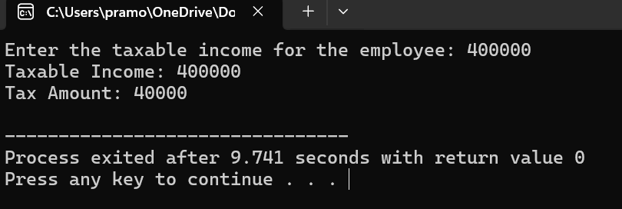

Program 3:

#include <iostream>

#include <string>

using namespace std;

class Student {

private:

string name;

int regNo;

float mark1, mark2, mark3;

float average;

char grade;

public:

void readDetails() {

cout << "Enter student name: ";

cin.ignore();

getline(cin, name);

cout << "Enter student registration number: ";

cin >> regNo;

cout << "Enter marks for three subjects (mark1 mark2 mark3): ";

cin >> mark1 >> mark2 >> mark3;

}

void calculate() {

average = (mark1 + mark2 + mark3) / 3.0;

if (average > 90)

grade = 'S';

else if (average > 80)

grade = 'A';

else if (average > 70)

grade = 'C';

else if (average > 60)

grade = 'D';

else if (average > 50)

grade = 'E';

else

grade = 'F';

}

void display() {

cout << "Student Name: " << name << endl;

cout << "Registration Number: " << regNo << endl;

cout << "Marks: " << mark1 << ", " << mark2 << ", " << mark3 << endl;

cout << "Average Marks: " << average << endl;

cout << "Grade: " << grade << endl;

}

};

int main() {

Student students[10];

for (int i = 0; i < 10; ++i) {

cout << "\nEnter details for student " << i + 1 << ":" << endl;

students[i].readDetails();

students[i].calculate();

}

for (int i = 0; i < 10; ++i) {

cout << "\nDetails for student " << i + 1 << ":" << endl;

students[i].display();

}

return 0;

}

