Program 1:

#include <iostream>

using namespace std;

void printMessage(string message = "Hello, World!") {

cout << message << endl;

}

int main() {

printMessage();

printMessage("Greetings!");

return 0;

}

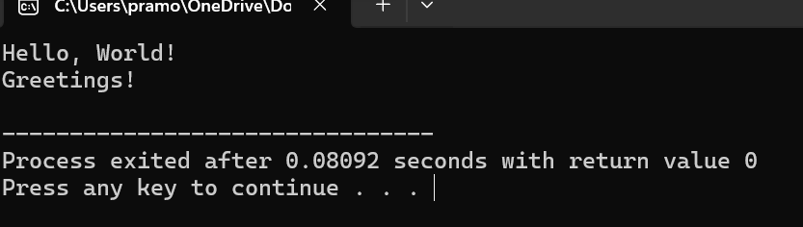

Program 2:

#include <iostream>

using namespace std;

int add(int a, int b) {

return a + b;

}

float add(float a, float b) {

return a + b;

}

float add(int a, float b) {

return a + b;

}

float add(float a, int b) {

return a + b;

}

int main() {

int num1_int = 5, num2_int = 7;

float num1_float = 3.5, num2_float = 2.7;

cout << "Sum of " << num1_int << " and " << num2_int << " is: " << add(num1_int, num2_int) << endl;

cout << "Sum of " << num1_float << " and " << num2_float << " is: " << add(num1_float, num2_float) << endl;

cout << "Sum of " << num1_int << " and " << num2_float << " is: " << add(num1_int, num2_float) << endl;

cout << "Sum of " << num1_float << " and " << num2_int << " is: " << add(num1_float, num2_int) << endl;

return 0;

}

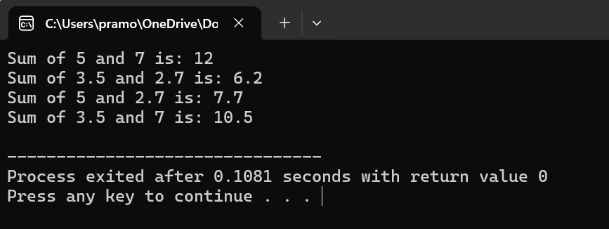

Program 3:

#include <iostream>

using namespace std;

class Box {

private:

double width;

public:

double length;

void setWidth(double w) {

width = w;

}

double getWidth() {

return width;

}

};

int main() {

Box myBox;

myBox.length = 10.0;

myBox.setWidth(5.0);

cout << "Length: " << myBox.length << endl;

cout << "Width: " << myBox.getWidth() << endl;

return 0;

}

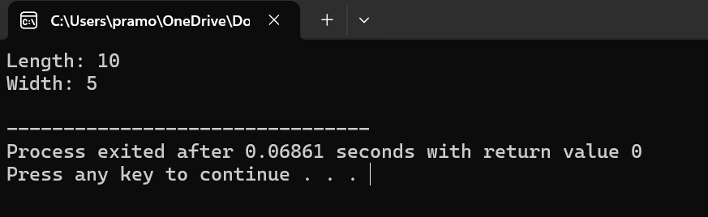

Program 4:

#include <iostream>

using namespace std;

const int MAX_SIZE = 100;

void multiplyMatrices(int mat1[][MAX_SIZE], int mat2[][MAX_SIZE], int result[][MAX_SIZE], int rows1, int cols1, int cols2) {

for (int i = 0; i < rows1; ++i) {

for (int j = 0; j < cols2; ++j) {

result[i][j] = 0;

for (int k = 0; k < cols1; ++k) {

result[i][j] += mat1[i][k] * mat2[k][j];

}

}

}

}

void displayMatrix(int matrix[][MAX_SIZE], int rows, int cols) {

for (int i = 0; i < rows; ++i) {

for (int j = 0; j < cols; ++j) {

cout << matrix[i][j] << " ";

}

cout << endl;

}

}

int main() {

int mat1[MAX_SIZE][MAX_SIZE], mat2[MAX_SIZE][MAX_SIZE], result[MAX_SIZE][MAX_SIZE];

int rows1, cols1, rows2, cols2;

cout << "Enter the number of rows and columns of the first matrix: ";

cin >> rows1 >> cols1;

cout << "Enter the elements of the first matrix: " << endl;

for (int i = 0; i < rows1; ++i) {

for (int j = 0; j < cols1; ++j) {

cin >> mat1[i][j];

}

}

cout << "Enter the number of rows and columns of the second matrix: ";

cin >> rows2 >> cols2;

cout << "Enter the elements of the second matrix: " << endl;

for (int i = 0; i < rows2; ++i) {

for (int j = 0; j < cols2; ++j) {

cin >> mat2[i][j];

}

}

if (cols1 != rows2) {

cout << "Matrix multiplication not possible: Number of columns of the first matrix must be equal to the number of rows of the second matrix." << endl;

return 0;

}

multiplyMatrices(mat1, mat2, result, rows1, cols1, cols2);

cout << "Result of matrix multiplication:" << endl;

displayMatrix(result, rows1, cols2);

return 0;

}

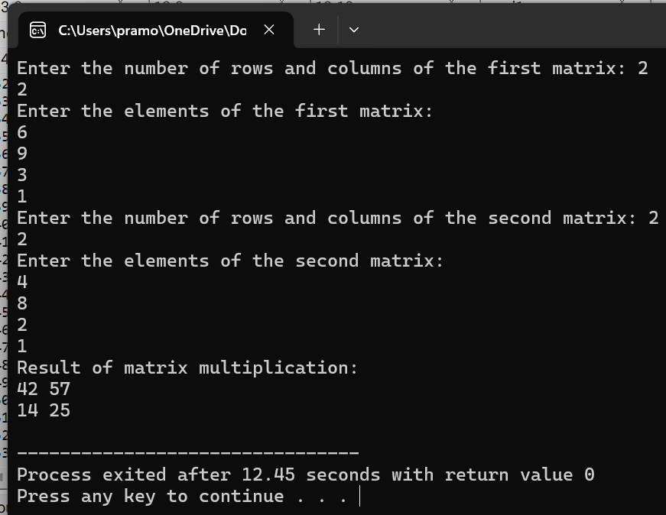

Program 5:

#include <iostream>

using namespace std;

class MyClass {

private:

static int count;

public:

MyClass() {

count++;

}

static int getCount() {

return count;

}

};

int MyClass::count = 0;

int main() {

MyClass obj1;

MyClass obj2;

MyClass obj3;

cout << "Number of objects created: " << MyClass::getCount() << endl;

return 0;

}

