Program 1:

#include <iostream>

int main() {

const double pi = 3.14159265359;

double radius, area;

std::cout << "Enter the radius of the circle: ";

std::cin >> radius;

area = pi * radius * radius;

std::cout << "The area of the circle with radius " << radius << " is: " << area << std::endl;

return 0;

}

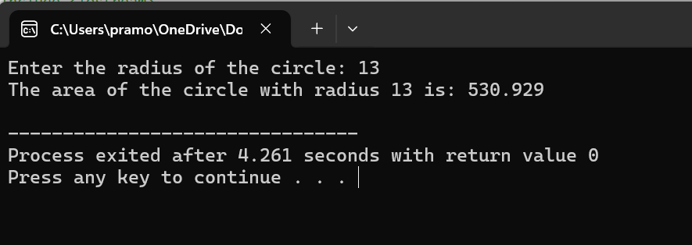

Program 2:

#include <iostream>

int main() {

int integerNumber;

float floatNumber;

std::cout << "Enter an integer: ";

std::cin >> integerNumber;

std::cout << "Enter a float: ";

std::cin >> floatNumber;

float result = floatNumber / integerNumber;

std::cout << "Result of float divided by integer: " << result << std::endl;

return 0;

}

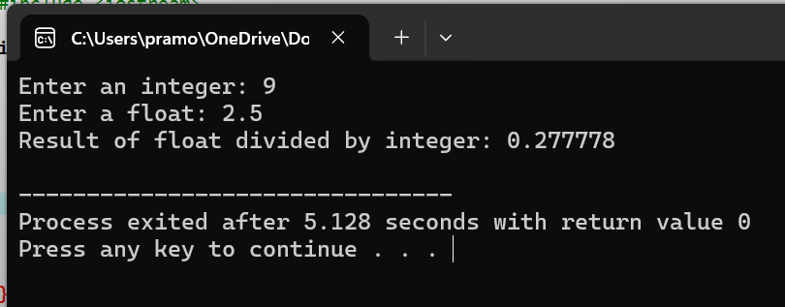

Program 3:

#include <iostream>

int main() {

int year;

std::cout << "Enter a year: ";

std::cin >> year;

if ((year % 4 == 0 && year % 100 != 0) || (year % 400 == 0)) {

std::cout << year << " is a leap year." << std::endl;

} else {

std::cout << year << " is not a leap year." << std::endl;

}

return 0;

}

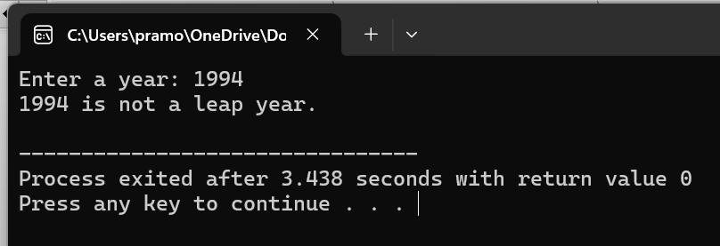

Program 4:

#include <iostream>

int main() {

double length, width, area;

std::cout << "Enter the length of the rectangle: ";

std::cin >> length;

std::cout << "Enter the width of the rectangle: ";

std::cin >> width;

area = length * width;

std::cout << "The area of the rectangle with length " << length << " and width " << width << " is: " << area << std::endl;

return 0;

}

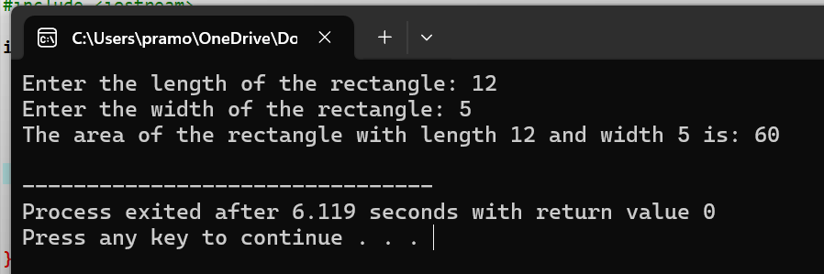

Program 5:

#include <iostream>

int main() {

int number;

std::cout << "Enter an integer: ";

std::cin >> number;

if (number & 1) {

std::cout << number << " is an odd number." << std::endl;

} else {

std::cout << number << " is not an odd number." << std::endl;

}

return 0;

}

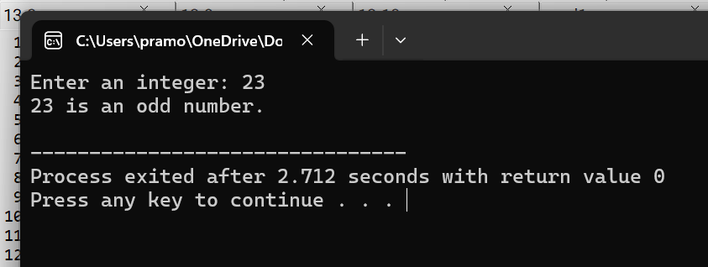

Program 6:

#include <iostream>

int main() {

int monthNumber;

// Prompt the user to enter a month number

std::cout << "Enter a month number (1-12): ";

std::cin >> monthNumber;

// Display the corresponding month name using switch-case

switch (monthNumber) {

case 1:

std::cout << "January" << std::endl;

break;

case 2:

std::cout << "February" << std::endl;

break;

case 3:

std::cout << "March" << std::endl;

break;

case 4:

std::cout << "April" << std::endl;

break;

case 5:

std::cout << "May" << std::endl;

break;

case 6:

std::cout << "June" << std::endl;

break;

case 7:

std::cout << "July" << std::endl;

break;

case 8:

std::cout << "August" << std::endl;

break;

case 9:

std::cout << "September" << std::endl;

break;

case 10:

std::cout << "October" << std::endl;

break;

case 11:

std::cout << "November" << std::endl;

break;

case 12:

std::cout << "December" << std::endl;

break;

default:

std::cout << "Invalid month number! Please enter a number between 1 and 12." << std::endl;

break;

}

return 0;

}

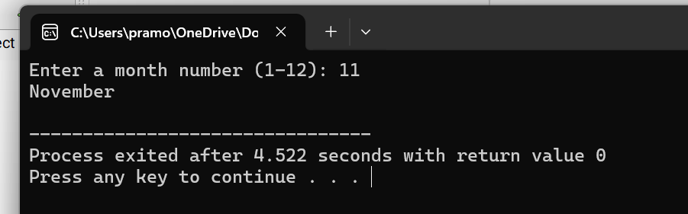

Program 7:

#include <iostream>

int main() {

const double pi = 3.14159265359;

double radius, volume;

std::cout << "Enter the radius of the sphere: ";

std::cin >> radius;

volume = (4.0 / 3.0) * pi * radius * radius * radius;

std::cout << "The volume of the sphere with radius " << radius << " is: " << volume << std::endl;

return 0;

}

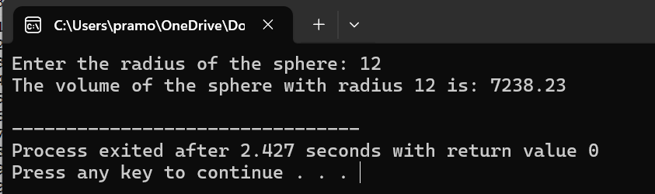

Program 8:

#include <iostream>

int main() {

int numerator, denominator;

// Prompt the user to enter the numerator and denominator

std::cout << "Enter the numerator: ";

std::cin >> numerator;

std::cout << "Enter the denominator: ";

std::cin >> denominator;

// Check if the denominator is zero

if (denominator == 0) {

std::cout << "Error: Division by zero is undefined." << std::endl;

} else {

// Perform division if the denominator is not zero

double result = static_cast<double>(numerator) / denominator;

std::cout << "Result of division: " << result << std::endl;

}

return 0;

}

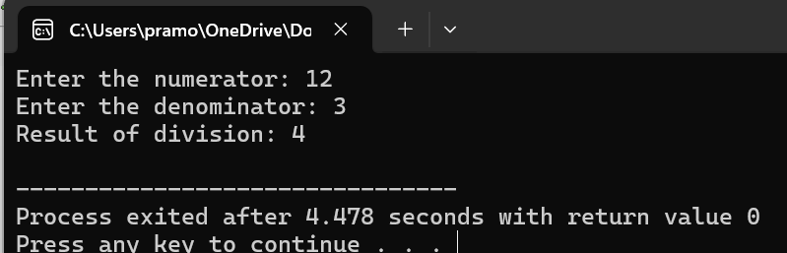

Program 9:

#include <iostream>

class Complex {

private:

double real;

double imaginary;

public:

Complex(double r = 0, double i = 0) : real(r), imaginary(i) {}

Complex operator+(const Complex& other) const {

return Complex(real + other.real, imaginary + other.imaginary);

}

Complex operator-(const Complex& other) const {

return Complex(real - other.real, imaginary - other.imaginary);

}

void display() const {

std::cout << real << " + " << imaginary << "i" << std::endl;

}

};

int main() {

Complex c1(2.0, 3.0);

Complex c2(1.0, 2.0);

Complex sum = c1 + c2;

std::cout << "Sum: ";

sum.display();

Complex difference = c1 - c2;

std::cout << "Difference: ";

difference.display();

return 0;

}

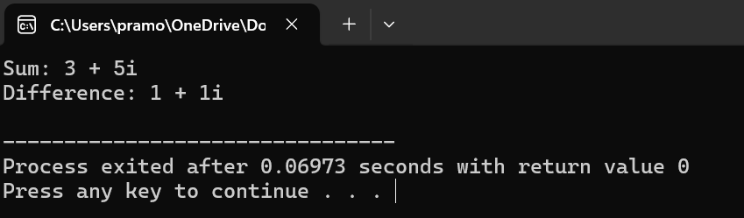

Program 10:

#include <iostream>

int main() {

int number;

unsigned long long factorial = 1;

std::cout << "Enter a number: ";

std::cin >> number;

for (int i = 1; i <= number; ++i) {

factorial *= i;

}

std::cout << "Factorial of " << number << " is: " << factorial << std::endl;

return 0;

}

