Predicting Which Recommended Content Users Click

Pramod Varma (github@**pramodv79** )

# Abstract

*In this paper, I explore application of data science to build an advertisement prediction engine. Using curated data provided Outbrain’s as part of kaggle competition I provide my findings on data exploration, feature selection, model selection, prediction and evaluation. I compare two machine learning techniques and provide results from them. Finally, I conclude with learnings and future work for this analysis.*

# Introduction

The internet is a stimulating treasure trove of possibility. Every day we stumble on news stories relevant to our communities or experience the serendipity of finding an article covering our next travel destination. [Outbrain](http://www.outbrain.com/), the web’s leading content discovery platform, delivers these moments while we surf our favorite sites.

Currently, Outbrain pairs relevant content with curious readers in about 250 billion personalized recommendations every month across many thousands of sites. In this paper, I explore to predict which pieces of content outbrain’s global base of users are likely to click on. Improving Outbrain’s recommendation algorithm will mean more users uncover stories that satisfy their individual tastes.[1]

# Data Exploration

The dataset for this project was provided by Outbrain as part of a Kaggle competition. It contains a sample of users’ page views and clicks, as observed on multiple publisher sites in the United States between 14-June-2016 and 28-June-2016. Each viewed page or clicked recommendation is further accompanied by some semantic attributes of those documents. For full details, see data specifications below.

The dataset contains numerous sets of content recommendations served to a specific user in a specific context. Each context (i.e. a set of recommendations) is given a display_id. In each such set, the user has clicked on at least one recommendation. The identities of the clicked recommendations in the test set are not revealed. The task is to rank the recommendations in each group by decreasing predicted likelihood of being clicked.

## Exploration and Pre-processing of data

Outbrain provided total of eight datasets as described below

page_views: describes features of all viewed pages, regardless of an advertisement being clicked.

events: consists of features of pages viewed when one displayed advertisement was clicked.

promoted content: provides information on advertised content.

clicks_train/clicks_Test: provides examples with labels to be used for training and examples without labels to be used for testing.

documents_meta: describes documents’ metadata.

documents_entities, documents_topic, and documents_categories provide mentioned entities (person, place, or location), topic, and taxonomy of categories of the documents, respectively.

Since the data was normalized it was necessary to join them to form a fact table. I decided to load all the individual raw files into a PostgreSQL. After loading all the data the size of the db was close to 9GB. This did not include full set of page_view log file which was uncompressed about 100GB.

 table         | table_size | related_objects_size | total_table_size | live_rows

----------------------+------------+----------------------+------------------+-----------

 promoted_content     | 32 MB      | 32 kB                | 32 MB            |    559583

 documents_meta       | 164 MB     | 64 kB                | 164 MB           |   2999334

 documents_categories | 273 MB     | 88 kB                | 273 MB           |   5481471

 documents_entities   | 446 MB     | 136 kB               | 446 MB           |   5537633

 page_views_sample    | 726 MB     | 200 kB               | 726 MB           |  10000008

 documents_topics     | 564 MB     | 160 kB               | 564 MB           |  11325980

 events               | 1822 MB    | 480 kB               | 1822 MB          |  23121858

 clicks_test          | 1361 MB    | 360 kB               | 1361 MB          |  32225335

 clicks_train         | 4336 MB    | 1112 kB              | 4337 MB          |  87141751

 TOTAL                | 9724 MB    | 2632 kB              | 9726 MB          | 178392953

Figure 1

Due to the size of the data and scope the exercise to be completely timely I decided to exclude examples found in Page Views (2B of rows) and only consider the 87 million examples contained in Events. Events contains the examples of page views that resulted in a click for one of the featured advertisements contain useful information to make click predictions.

After exploring each of the data set individually (except page_view) , following information was learnt from the data sets ( details of this exploration is provided in notebook [2]).

|  |  |  |  |  |  |
| --- | --- | --- | --- | --- | --- |
| **Dataset** | **Column** | **Cardinality** | **Missing** | **%Missing** | **Total Rows** |
| clicks_train | display_id | 16,874,593 | 0 | 0.00000 | 87,141,731 |
| clicks_train | ad_id | 478,950 | 0 | 0.00000 | 87,141,731 |
| clicks_train | clicked | 2 | 0 | 0.00000 | 87,141,731 |
|  |  |  |  |  |  |
| events | platform | 4 | 0 | 0.00000 | 23,120,126 |
| events | display_id | 23,120,126 | 0 | 0.00000 | 23,120,126 |
| events | document_id | 894,060 | 0 | 0.00000 | 23,120,126 |
| events | uuid | 19,794,967 | 0 | 0.00000 | 23,120,126 |
| events | geo_location | 2,989 | 340 | 0.00001 | 23,120,126 |
| events | timestamp | 22,896,622 | 0 | 0.00000 | 23,120,126 |
|  |  |  |  |  |  |
| document_meta | document_id |  |  |  | 2,999,334 |
| document_meta | source_id | 14,395 | 2,518 | 0.00084 | 2,999,334 |
| document_meta | publisher_id | 1,260 | 64,024 | 0.02135 | 2,999,334 |
| document_meta | publish_time | 49,914 | 1,011,118 | 0.33711 | 2,999,334 |
|  |  |  |  |  |  |
| document_topics | document_id | 2,495,423 | 0 | 0.00000 | 11,325,960 |
| document_topics | topic_id | 300 | 0 | 0.00000 | 11,325,960 |
| document_topics | confidence_level | 10,124,758 | 0 | 0.00000 | 11,325,960 |
|  |  |  |  |  |  |
| documents_categories | document_id | 2,828,649 | 0 | 0.00000 | 5,481,475 |
| documents_categories | category_id | 97 | 0 | 0.00000 | 5,481,475 |
| documents_categories | confidence_level | 21,900 | 0 | 0.00000 | 5,481,475 |
|  |  |  |  |  |  |
| documents_entities | document_id | 1,791,420 | 0 | 0.00000 | 5,537,552 |
| documents_entities | entity_id | 1,326,009 | 0 | 0.00000 | 5,537,552 |
| documents_entities | confidence_level | 2,678,533 | 0 | 0.00000 | 5,537,552 |
|  |  |  |  |  |  |
| promoted_content | document_id | 185,709 | 0 | 0.00000 | 559,583 |
| promoted_content | ad_id | 559,583 | 0 | 0.00000 | 559,583 |
| promoted_content | campaign_id | 34,675 | 0 | 0.00000 | 559,583 |
| promoted_content | advertiser_id | 4,385 | 0 | 0.00000 | 559,583 |

Figure 2

As a first step, I decided to create a de- normalized fact table. Given the amount of data only picked categories, topics and entities of the document with highest confidence_level. Additional tables were created. Below are the intermediate tables created using sql.

 table        | table_size | related_objects_size | total_table_size | live_rows

--------------------------+------------+----------------------+------------------+-----------

 clicks_train_fact_limit  | 169 MB     | 8192 bytes           | 169 MB           |   1000000

 documents_entities_top   | 144 MB     | 38 MB                | 183 MB           |   1791420

 documents_topics_top     | 124 MB     | 53 MB                | 178 MB           |   2495423

 documents_categories_top | 141 MB     | 61 MB                | 201 MB           |   2828649

 clicks_test_fact         | 5247 MB    | 2071 MB              | 7318 MB          |  32224999

 clicks_train_fact        | 14 GB      | 5600 MB              | 20 GB            |  87147369

Figure 3

# Feature Selection

For the first pass columns highlighted in green were considered as features. Columns highlighted in red uuid, timestamps and publish_time were not considered. Cardinality of uuid was very high to provide any meaningful information. Since I was not planning to do time series modeling timestamp and publish_timestamp was ignored. Below were the 14 features that were used for the first model.

|  |  |
| --- | --- |
| **Category** | **Features** |
| User | uuid, geo_location, platform |
| Display | display_id, document_id, source_id, publisher_id, publish_time, topic_id, (topic)confidence, category_id, (category)confidence_level, entity_id, (entity)confidence_level |
| Ad | ad_id, document_id, campaign_id, advertiser_id |

Figure 4

# Deciding on estimator

Response variable is a 0 and 1 which make us believe it is a classification problem but the outbrain submission file is expecting the ads to be ranked by probability due to which it becomes a prediction problem. I plan to use a classification model and calculate probability of the response variable to rank the ads

# Model Training

After I created a de-normalized fact tables with above feature the size of the table is ~20GB which is unmanageable on local computer. To move forward I reduced the scope of the dataset to first 10M out of 87M (> 10% of the training population).

For ease of iteration I explored a data science environment H20. Once the data is loaded into the H2O data frame it provides easy way to change the data type, build models, predict and compute score.

*[ Below are the results of a sample 1M split into train (0.7), test (0.2) and validate (0.1) for the purpose of the draft paper. This will be replaced with 10M dataset before the final presentation ]*

# Model Evaluation

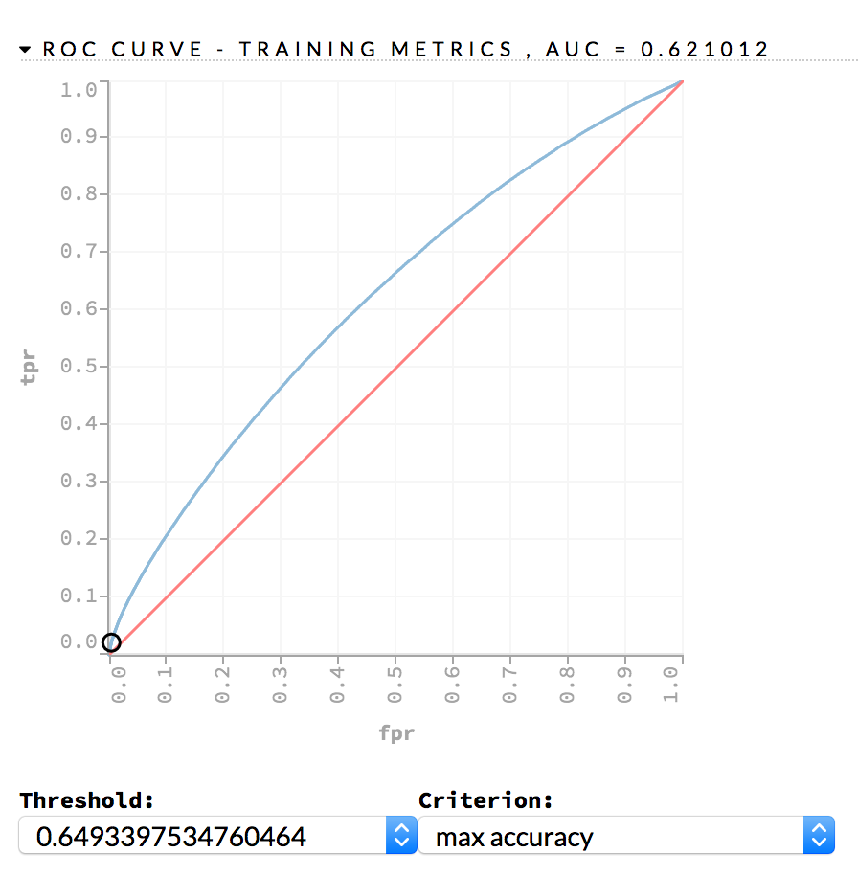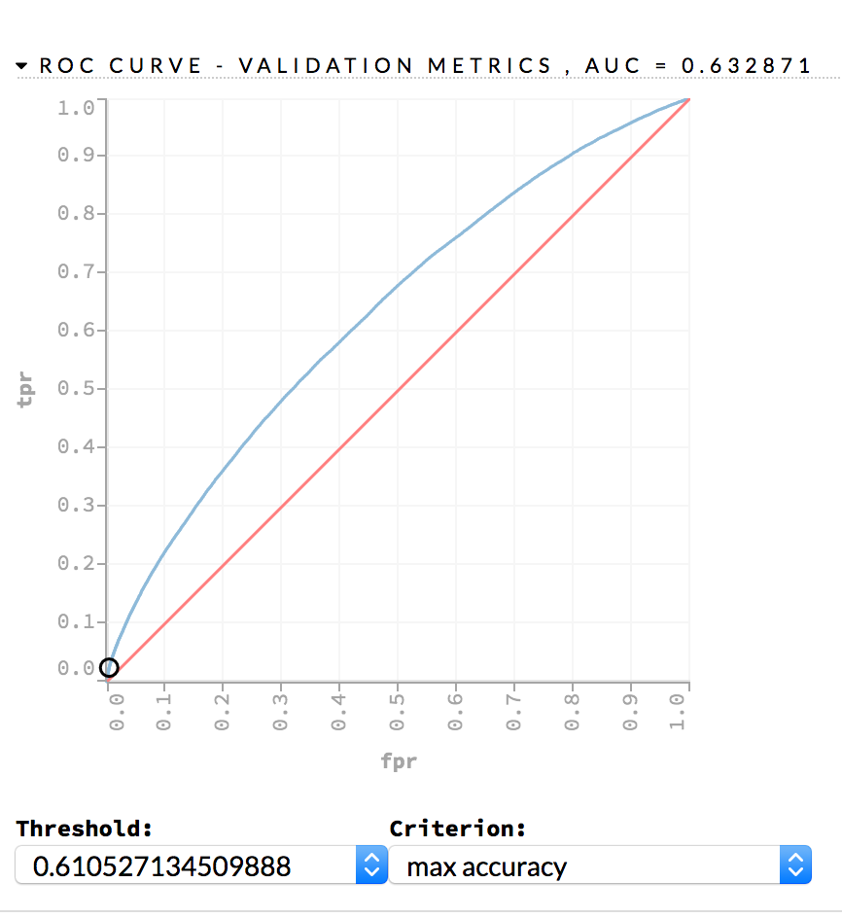

# Model Prediction

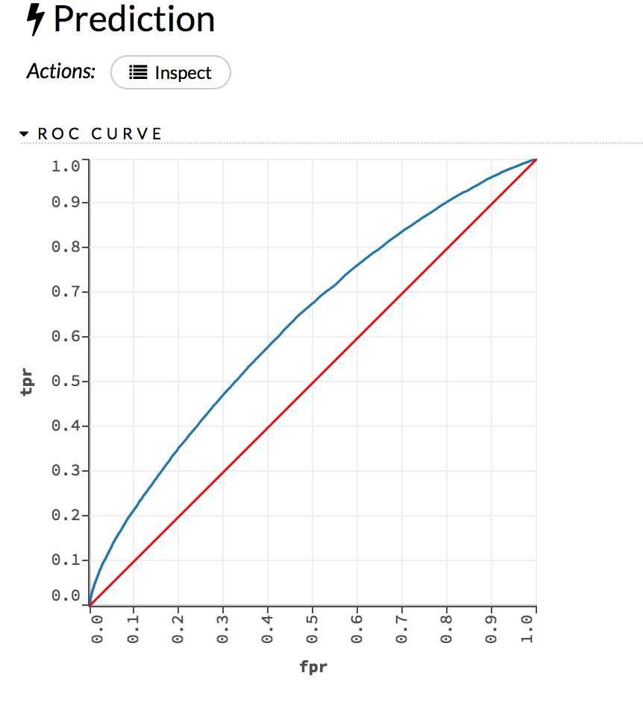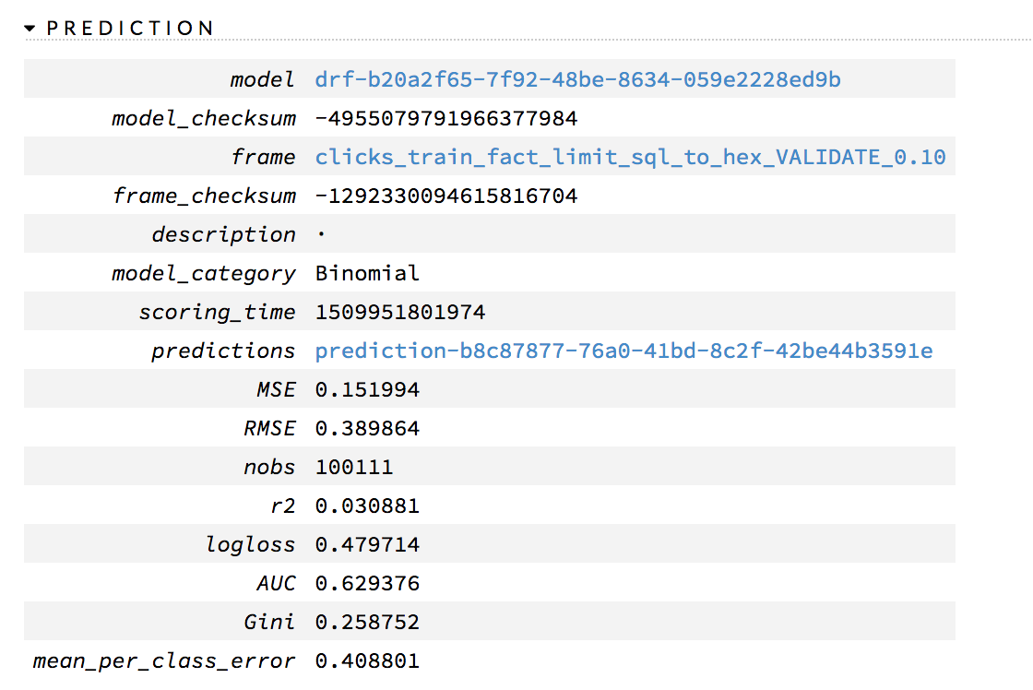

# Variable Importance

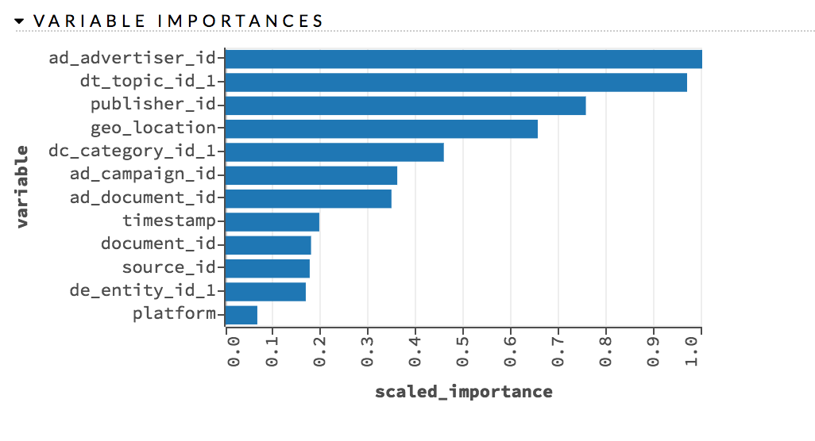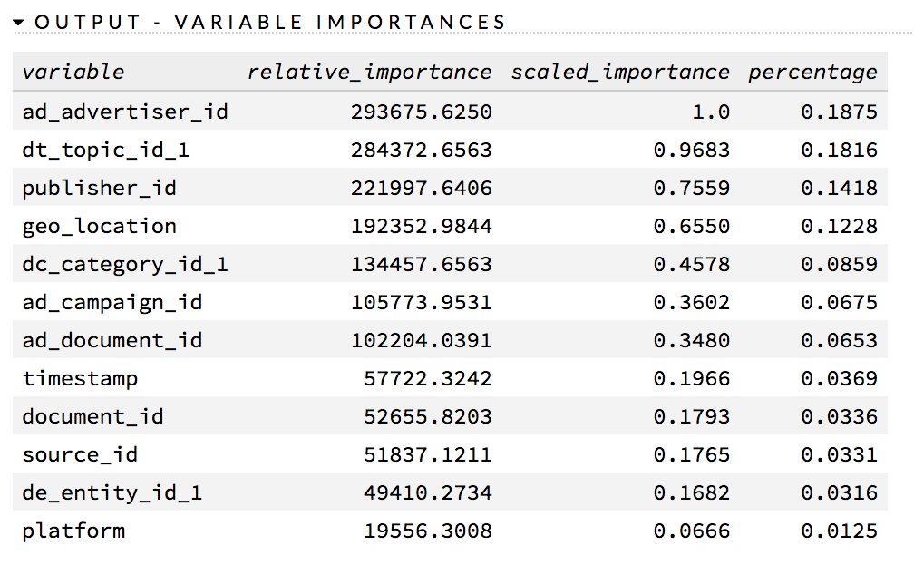

# Challenges and Success stories

Since Outbrain has masked the actual document data all we have are categorical ids. Expanding all these categorical variables results in a very high number of features [ insert data]

Using H2O to run through feature selection, data cleaning, model building was quick as compared to doing steps in python. Also, was able to leverage some of the parallel nature and easier migration to cloud as H20 manages distributed computing

# Conclusion and Learnings

[ To do ]

|  |  |  |
| --- | --- | --- |
| |  |  | | --- | --- | | |  | | --- | |  | | |

|  |
| --- |
|  |

# Future Work

* Add additional features to the model to improve accuracy
  + Pick top 3 topics, categories and entities by confidence level instead of 1
  + Enrich document ID features for the Ad
  + Cluster high cardinality features into low cardinality features
* Move to cloud to run on a larger training set
* Use other machine learning models to improve accuracy

# Reference

[1] <https://www.kaggle.com/c/outbrain-click-prediction/data>

[2] <https://github.com/Pramodv79/DSClickPrediction/blob/master/notebooks/EDA_OutbrainRawDataset.ipynb>

[3] [ insert link to H20 flow notebook]

[4] [ insert link to read me to create fact table]