Q1.

|  |
| --- |
| package Q_01;  public class Q_01 {  public static void main(String[] args) {   //a  int B=2,A=5,C=3;  double resultA=Math.*sqrt*((B * B)+ 4 * A * C);  System.*out*.println("Answer=" +resultA);   //b  int x=5,Y=3;  double resultB=Math.*sqrt*(x + 4 * Y * 3);  System.*out*.println("Answer=" +resultB);   //c  double resultC=Math.*cbrt*(x*Y);  System.*out*.println("Answer=" +resultC);   //d  int r=5;  double resultD=Math.*PI*\*Math.*pow*(r,2);  System.*out*.println("Answer=" +resultD);    } } |

Q2.

|  |
| --- |
| package Q2;  import java.util.Scanner;  public class Q2 {  public static void main(String[] args) {   Scanner scanner=new Scanner(System.*in*);  System.*out*.println("Enter the value in CentiMeeters:");  double centiMeters=scanner.nextDouble();  double inches=centiMeters/2.54;  double feet=inches/12;   System.*out*.println("Feet "+feet+" Inches "+inches);  } } |

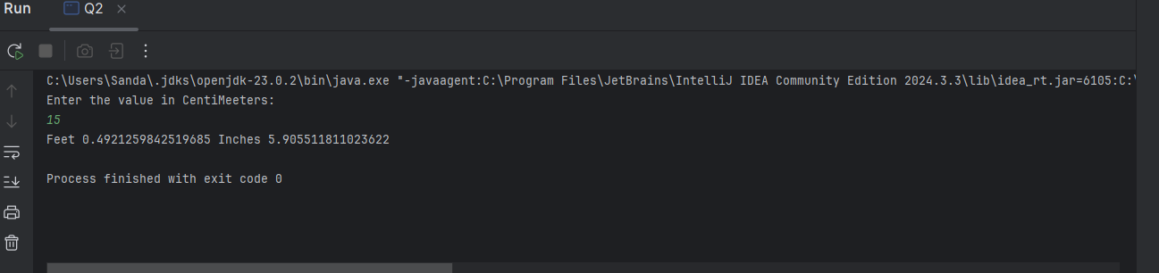

Q3.

|  |
| --- |
| package Q3;  import java.util.Scanner;  public class Q3 {  public static void main(String[] args) {  Scanner scanner=new Scanner(System.*in*);  System .*out*.println("Enter the value in Celsius:");  double celsius=scanner.nextDouble();    double fahrenheit=(1.8*celsius)+32;  System.*out*.println("Fahrenheit "+fahrenheit);  } } |

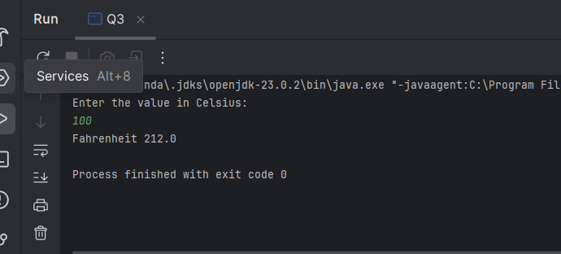

Q4.

|  |
| --- |
| package Q4;  import java.util.Scanner;  public class Q4 {  public static void main(String[] args) {  Scanner scanner =new Scanner(System.*in*);  System.*out*.println("input the Weight ");  float weight =scanner.nextInt();  float calories=weight*19;   System.*out*.println("The number of calories needed to maintain weight is "+calories);  } } |

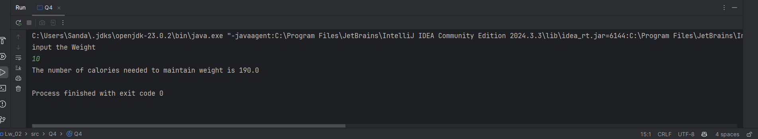

Q5.

|  |
| --- |
| package Q5;  import java.util.Scanner;  public class Q5 {  public static void main(String[] args) {  Scanner scanner=new Scanner(System.*in*);  System.*out*.println("input temperature in degree Fahrenheit ");  float fahrenheit =scanner.nextFloat();   float celsius =((float) 5 /9)*(fahrenheit-32);  System.*out*.println("Temperature in degree Celsius is "+celsius);   } } |

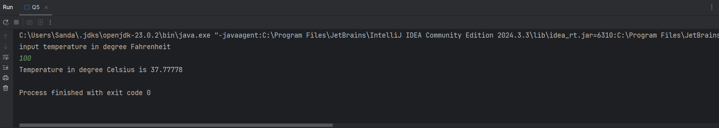

Q6.

|  |
| --- |
| package Q6;  import java.util.GregorianCalendar; import java.util.Scanner;  public class Q6 {  public static void main(String[] args) {  GregorianCalendar cal=new GregorianCalendar();  int currentyear=cal.get(GregorianCalendar.*YEAR*);   Scanner scanner=new Scanner(System.*in*);  System.*out*.println("input the year you were born ");  int birthyear=scanner.nextInt();  int age=currentyear-birthyear;   System.*out*.println("You were born in "+ birthyear +"and will be "+age+" this year");   }  } |

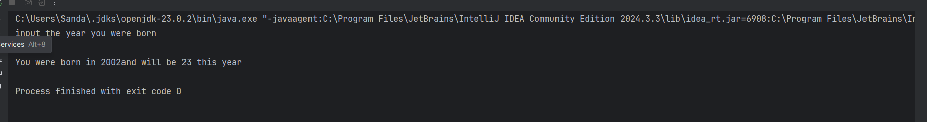

Q7.

|  |
| --- |
| package Q7;  import java.util.Scanner;  public class Q7 {  public static void main(String[] args) {  Scanner scanner =new Scanner(System.*in*);  System.*out*.println("input the Weight ");  int weight =scanner.nextInt();    System.*out*.println("input the Height ");  int height =scanner.nextInt();   float heightInMeters = (float) height / 100;  float bmi = weight / (heightInMeters * heightInMeters);   System.*out*.println("Body Mass Index is "+bmi);  } } |

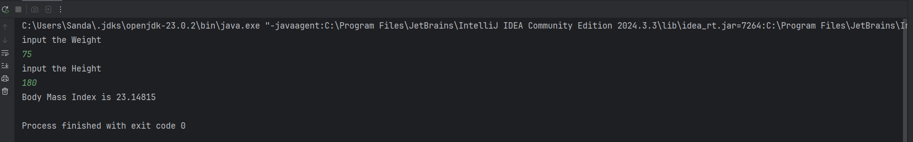

Q8.

|  |
| --- |
| package Q8;  import java.util.Scanner;  public class Q8 {  public static void main(String[] args) {  Scanner scanner =new Scanner(System.*in*);  System.*out*.println("input the radius ");  float radius =scanner.nextFloat();   final double pi = 3.14;  float volume= (float)((4.0/3.0)*(pi*radius*radius*radius));  System.*out*.println("The volume of the sphere is "+volume);       } } |

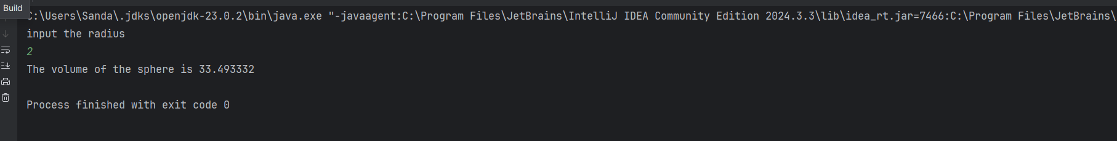

Q9.

|  |
| --- |
| package Q9;  import java.util.Scanner;  public class Q9 {  public static void main(String[] args) {  Scanner scanner =new Scanner(System.*in*);  System.*out*.println("input the count of dollars ");  double P=scanner.nextFloat();   System.*out*.println("input the rate");  double R=scanner.nextFloat();   System.*out*.println("input the number of years ");  double N=scanner.nextFloat();   double A= P *Math.*pow*((1+R/100),N);   System.*out*.println("After "+N+" years at "+R+"%, the investment will be worth $"+A);   } } |

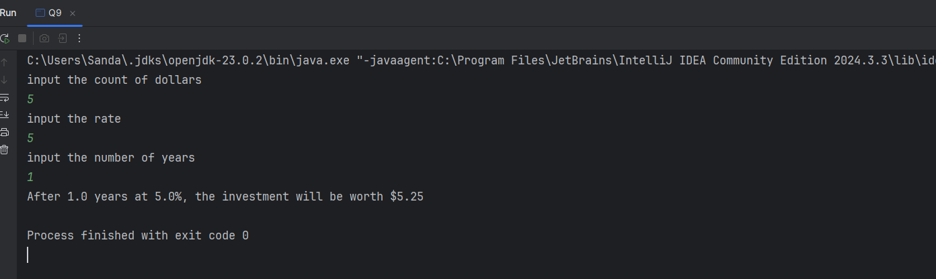

Q10.

|  |
| --- |
| package Q10; import java.util.Scanner; public class Q10 {  public static void main(String[] args) {  Scanner scanner =new Scanner (System.*in*);  System.*out*.println("input the loan amount ");  float loanAmount =scanner.nextFloat();   System.*out*.println("input the annual interest rate ");  float annualInterestRate =scanner.nextFloat();   System.*out*.println("input the number of years ");  float numberOfYears =scanner.nextFloat();   float monthlyInterestRate = (float) (annualInterestRate/100.0/12.0);  float numberOfPayment=numberOfYears*12;  float monthlyPayment = (float) (loanAmount*monthlyInterestRate/(1-Math.*pow*(1+monthlyInterestRate,-numberOfPayment)));  float totalPayment = monthlyPayment*numberOfPayment;   System.*out*.println("The monthly payment is $"+monthlyPayment);  System.*out*.println("The total payment is $"+totalPayment);      } } |

