Q1.

Code:

|  |
| --- |
| ***package Q_01;  import javax.swing.*;  public class Q1 {  public static void main(String[] args) {  JFrame Frame;  Frame=new JFrame();  Frame.setVisible(true);  Frame.setSize(800,600);  Frame.setTitle("Welcome to Java");  } }*** |

Output:

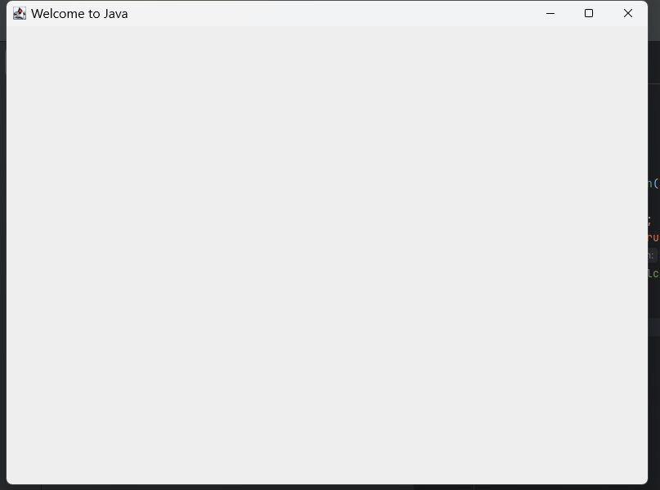

Q2.

Code:

|  |
| --- |
| package Q_02;  import javax.swing.*; import java.util.Scanner;  public class Q2 {  public static void main(String[] args) {  Scanner scanner=new Scanner(System.*in*);  String firstName;  System.*out*.println("Enter first name");  firstName=scanner.next();   String secondName;  System.*out*.println("Enter Second name");  secondName=scanner.next();   JFrame Frame=new JFrame();  Frame.setTitle(firstName+" "+secondName);  Frame.setVisible(true);  Frame.setSize(800,600);  } } |

Output:

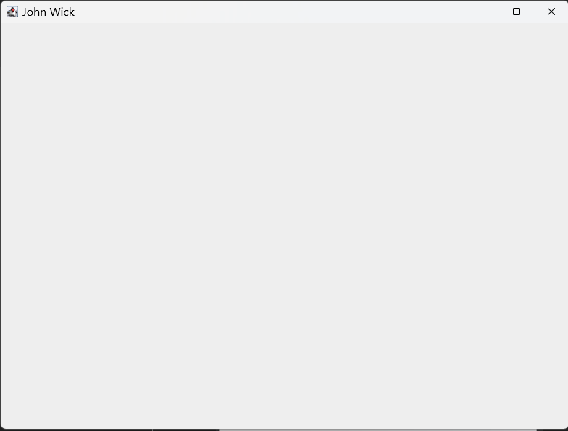

Console:

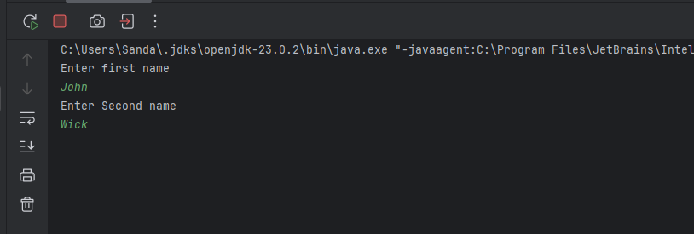

Q3.

Code:

|  |
| --- |
| import javax.swing.*; import java.util.Scanner;  public class Q3 {  public static void main(String[] args) {  Scanner scanner= new Scanner(System.*in*);  String firstName;  System.*out*.println("Enter first Name");  firstName=scanner.next();   String middleName ;  System.*out*.println("Enter Middle Name ");  middleName=scanner.next();   String lastName;  System.*out*.println("Enter Last Name");  lastName=scanner.next();   JFrame frame= new JFrame();  frame.setTitle(firstName+" "+(middleName.charAt(0))+". "+lastName);  frame.setVisible(true);  frame.setSize(300,500);   } } |

Console:

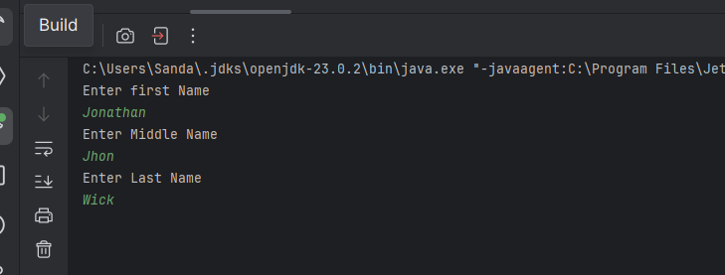

Output:

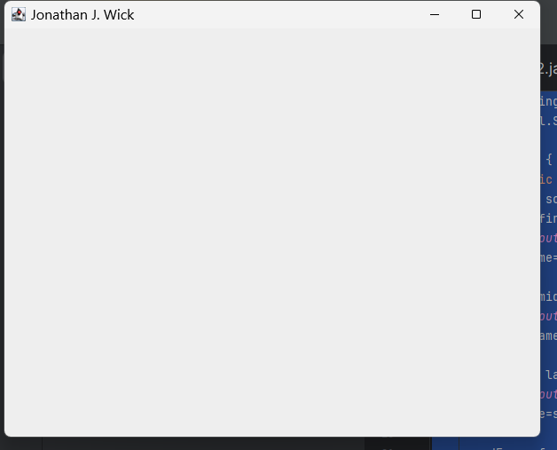

Q4.

Code:

|  |
| --- |
| package Q4;  import java.text.SimpleDateFormat; import java.util.Date;  public class Q4 {  public static void main(String[] args) {  Date today;  SimpleDateFormat sdf;  today=new Date();  sdf=new SimpleDateFormat("dd MMMM yyyy");  System.*out*.println(sdf.format(today));   } } |

Output:

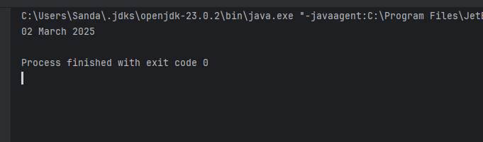

Q5.

Code:

|  |
| --- |
| package Q5;  import java.text.SimpleDateFormat; import java.util.Date;  public class Q5 {  public static void main(String[] args) {  Date today;  SimpleDateFormat sdf;  today=new Date();  sdf=new SimpleDateFormat("EEEE, MMMM dd, yyyy");  System.*out*.println(sdf.format(today));  } } |

Output:

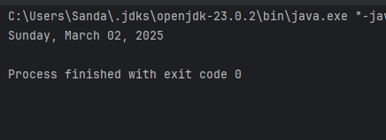

Q6.

Code:

|  |
| --- |
| package Q6;  import javax.swing.*; import java.util.Scanner;  public class Q6 {  public static void main(String[] args) {  Scanner scanner=new Scanner(System.*in*);  System.*out*.println("Enter Width");  int Width= Integer.*parseInt*(scanner.next());    System.*out*.println("Enter Height");  int Height=Integer.*parseInt*(scanner.next());  System.*out*.println(Height);    System.*out*.println("Enter Title");  scanner.nextLine();  String Title=scanner.nextLine();   JFrame frame=new JFrame();  frame.setSize(500,800);  frame.setVisible(true);  frame.setTitle(Title);   } } |

Output:

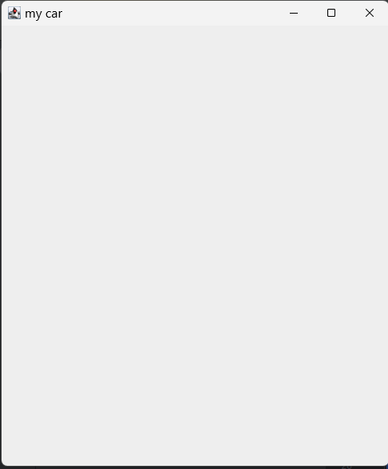

Console:

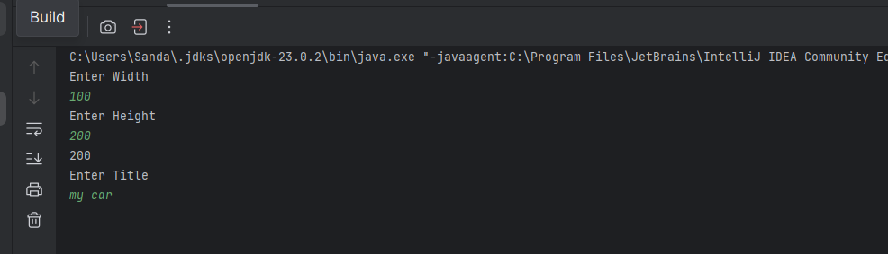

Q7.

Code:

|  |
| --- |
| package Q7;  import java.text.SimpleDateFormat; import java.util.Date;  public class Q7 {  public static void main(String[] args) {  Date today;  SimpleDateFormat sdf;  today=new Date();  sdf=new SimpleDateFormat("HH:mm:ss a");  System.*out*.println(sdf.format(today));  } } |

Output:

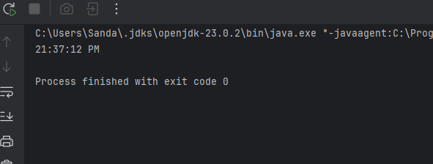

Q8.

Code:

|  |
| --- |
| package Q8;  import java.util.Scanner;  public class Q8 {  public static void main(String[] args) {  Scanner scanner=new Scanner(System.*in*);  System.*out*.println("Enter Words");  String input=scanner.nextLine();  int index=input.indexOf("!");   if (index != -1){  String firstPart=input.substring(0,index).trim();  String secondPart=input.substring(index+1).trim();  System.*out*.println(firstPart);  System.*out*.println(secondPart);  }    } } |

Output:

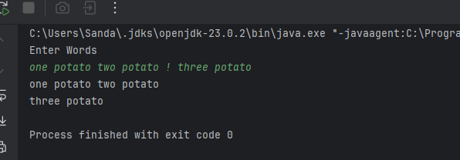

Q9.

Code:

|  |
| --- |
| package Q9;  import java.awt.*; import java.util.Scanner;  public class Q9 {  public static void main(String[] args) {  Scanner scanner=new Scanner(System.*in*);  System.*out*.println("Input String");  String input=scanner.nextLine();  System.*out*.println(input.length());  System.*out*.println(input.charAt(0));  System.*out*.println(input.charAt(input.length()-1));  } } |

Output:

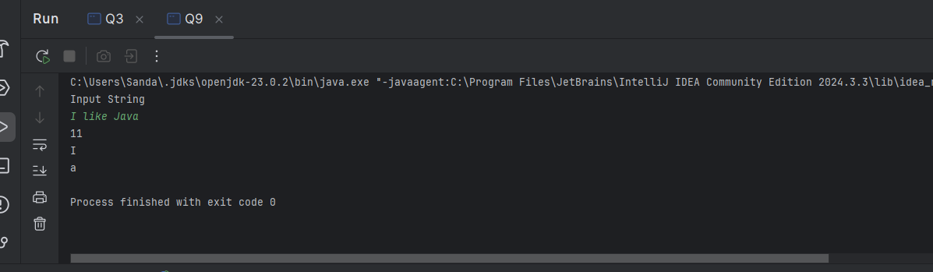

Q10.

Code:

|  |
| --- |
| package Q10;  import java.util.Scanner;  public class Q10 {  public static void main(String[] args) {  Scanner scanner =new Scanner(System.*in*);  System.*out*.println("Enter Word");  String word=scanner.nextLine();   int count= word.length();     if (count % 2 != 0){  int middleIndex=count/2;  System.*out*.println(word.charAt(middleIndex));   }   } } |

Output:

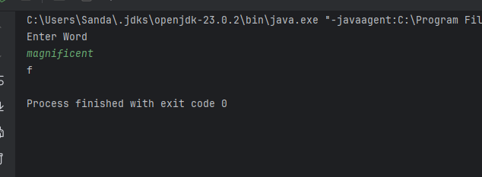

Q11.

Code:

|  |
| --- |
| public class Q11 {  public static void main(String[] args) {  Scanner scanner = new Scanner(System.*in*);  System.*out*.println("Enter your name in first middle last");  String name = scanner.nextLine();   String[] parts=name.split(" ");   String first=parts[0];  String middle=parts[1];  String last=parts[2];   System.*out*.println(last+","+first+" "+middle.charAt(0)+".");    } } |

Output:

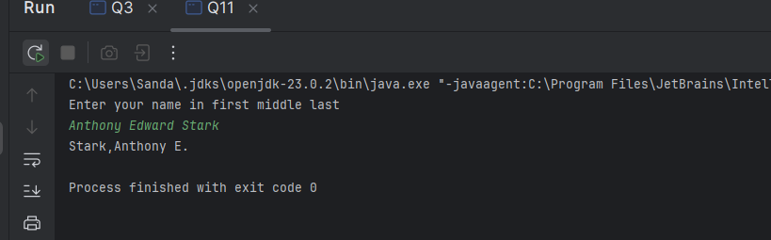

Q12.

Code:

|  |
| --- |
| package Q12;  import javax.swing.*;  public class Q12 {  public static void main(String[] args) {   JFrame frame=new JFrame();  frame.setVisible(true);  frame.setSize(300,200);  frame.setTitle("My First Frame");  frame.setLocation(50,50);  } } |

Output:

