Q1.

|  |
| --- |
| package Q1;  public class Q1 {  public static void main(String[] args) {  for(int i=10;i<50;i++){  System.*out*.print(i + " ");  }  } } |

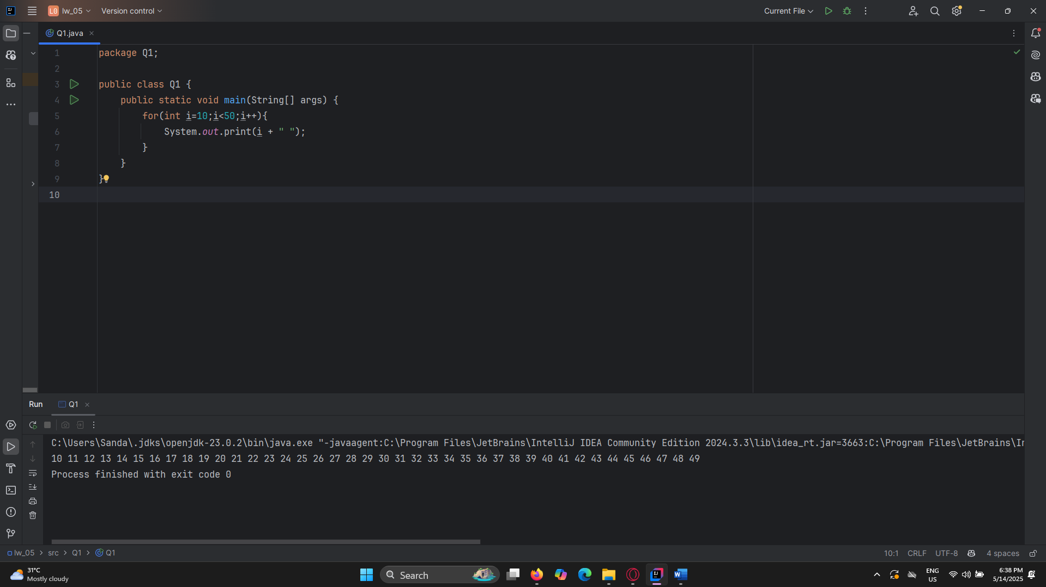

Q2.

|  |
| --- |
| package Q2;  import java.util.Scanner;  public class Q2 {  public static void main(String[] args) {  Scanner scanner = new Scanner(System.*in*);   while (true) {  System.*out*.println("Enter a number");  int number = scanner.nextInt();  if (number < 0) {  System.*out*.println("Negative number entered. Exiting...");  break;  }  int temp = number;  int sum = 0;   if (temp == 0) {  sum = 1;  } else {  while (temp > 0) {  temp = temp / 10;  sum++;   }  }  System.*out*.println("The number of digits in the number is: " + sum);  }    }     } |

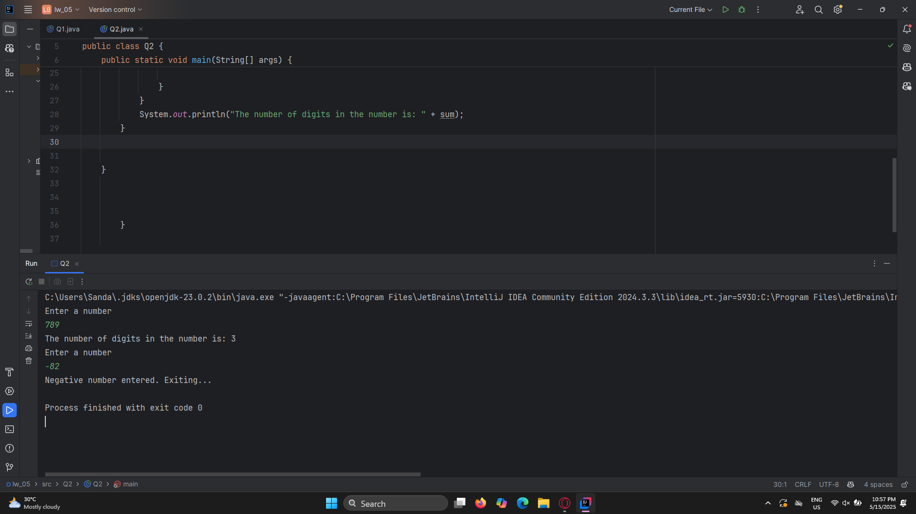

Q3.

|  |
| --- |
| package Q3;  import java.util.Scanner;   public class Q3 {  public static void main(String[] args) {  Scanner scanner=new Scanner(System.*in*);  System.*out*.println("Enter a number");  int number=scanner.nextInt();   for(int i=1;i<=10;i++){  System.*out*.println(number + " * " + i + " = " + (number*i));  } }} |

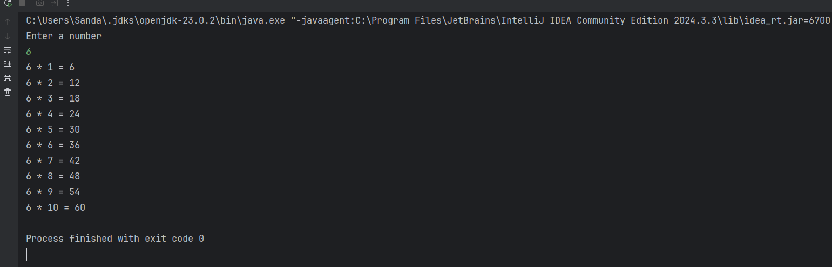

Q4.

|  |
| --- |
| package Q4; import java.util.Scanner;  public class Q4 {  public static void main(String[] args) {  Scanner scanner = new Scanner (System.*in*);  System.*out*.println("Enter a number");  int number= scanner.nextInt();   for (int i=1;i<=number;i++){  for (int j=1;j<=number-i;j++)  {  System.*out*.print(" ");  }  for (int k=1;k<=(2*i-1);k++){  System.*out*.print("*");  }  {  System.*out*.print("*");  }  System.*out*.println();  }   }    } |

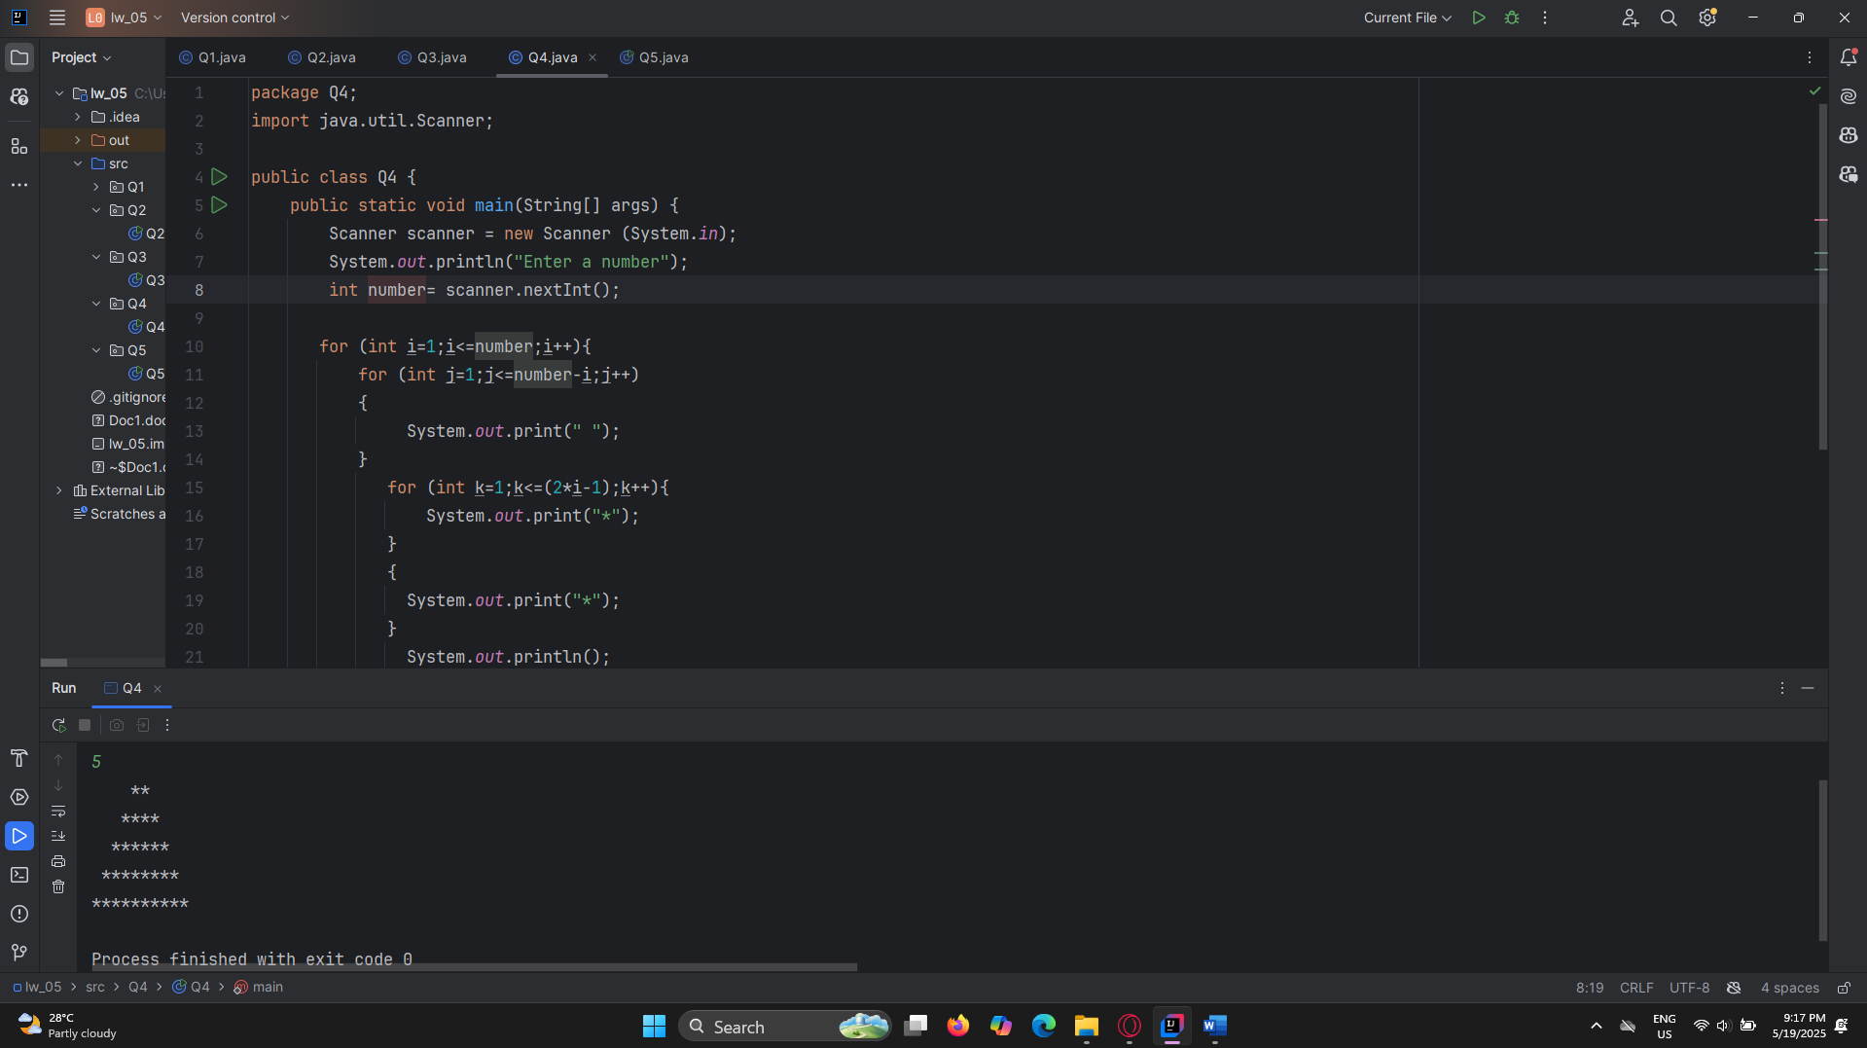

Q5.

|  |
| --- |
| package Q5; import java.util.Scanner;  public class Q5 {  public static void main(String[] args) {  Scanner scanner= new Scanner(System.*in*);   System.*out*.println("Enter word ");  String word= scanner.nextLine();   String reversed="";   for(int i=word.length()-1;i>=0;i--) {   reversed+=word.charAt(i);   }  if (word.equals(reversed)){  System.*out*.println("Palindrome");  }else {  System.*out*.println("Not Palindrome");  }     } } |

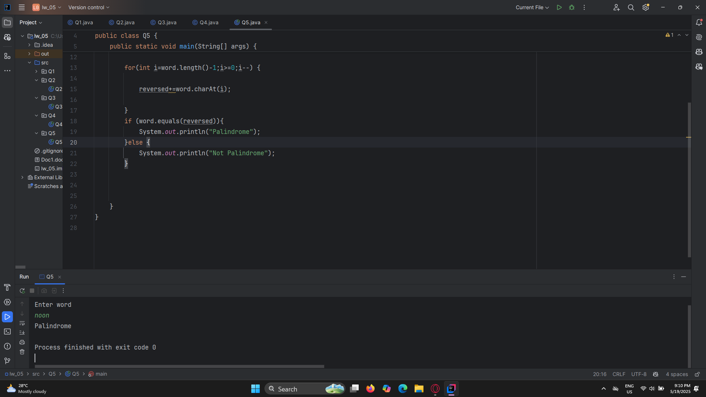

Q6.

|  |
| --- |
|  |
| package Q6; import java.util.Random; import java.util.Scanner; public class Q6 {  public static void main(String[] args) {  Scanner scanner= new Scanner(System.*in*);  Random random = new Random();   int secretNumber = random.nextInt(100) + 1;  int guess = 0;  int attempts = 0;   System.*out*.println("Welcome to the Guessing Game!");  System.*out*.println("Can you guess what I thinking?");   while (guess != secretNumber) {  System.*out*.print("Enter your guess : ");  guess = scanner.nextInt();  attempts++;   if (guess < secretNumber) {  System.*out*.println("Too low! Try again.");  } else if (guess > secretNumber) {  System.*out*.println("Too high! Try again.");  } else {  System.*out*.println("Congratulations! You've guessed the number in " + attempts + " attempts.");  }  }    } } |

Q7.

|  |
| --- |
| package Q7; import java.util.Scanner;  public class Q7 {  public static void main(String[] args) {  Scanner scanner = new Scanner(System.*in*);   System.*out*.println("Enter Sentence");  String sentence = scanner.nextLine();   System.*out*.println("Enter word you want to be replace");  String wordToReplace = scanner.nextLine();   System.*out*.println("Enter word you want to replace with");  String wordToReplaceWith = scanner.nextLine();   String UpdaatedSentence = sentence.replaceAll(wordToReplace, wordToReplaceWith);   System.*out*.println("Updated Sentence: " + UpdaatedSentence);       } } |

