Q1.

|  |
| --- |
| package Q1;  import java.util.Scanner;  public class Q1 {  public static void main(String[] args) {  Scanner scanner= new Scanner(System.*in*);  System.*out*.println("Enter the first number ");  int firstNumber = scanner.nextInt();  System.*out*.println("Enter the second number ");  int secondNumber = scanner.nextInt();  System.*out*.println("Enter the third number ");  int thirdNumber = scanner.nextInt();   if (firstNumber>secondNumber && firstNumber>thirdNumber)  {  System.*out*.println("first number is largest number");  }else  {  if (secondNumber>firstNumber && secondNumber>thirdNumber)  {  System.*out*.println("second number is largest number");  }else  {  System.*out*.println("third number is largest number");  }  }   } } |

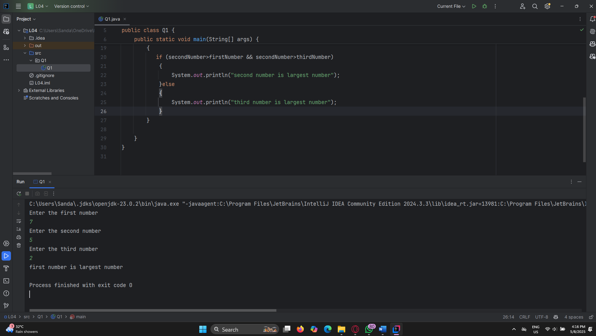

Q2.

|  |
| --- |
| package Q2;  import java.util.Scanner;  public class Q2 {  public static void main(String[] args) {  Scanner scanner =new Scanner(System.*in*);  System.*out*.println("0.Magenta");  System.*out*.println("1.Cyan");  System.*out*.println("2.Red");  System.*out*.println("3.Blue");  System.*out*.println("4.Green");  System.*out*.println("Select one color from the above\n" + "list:");   int selection=scanner.nextInt();   switch (selection)  {  case 0:  System.*out*.println("You selected Magenta");  break;  case 1:  System.*out*.println("You selected Cyan");  break;  case 2:  System.*out*.println("You selected Red");  break;  case 3:  System.*out*.println("You selected Blue");  break;  case 4:  System.*out*.println("You selected Green");  break;  default:  System.*out*.println("Invalid selection");  }  } } |

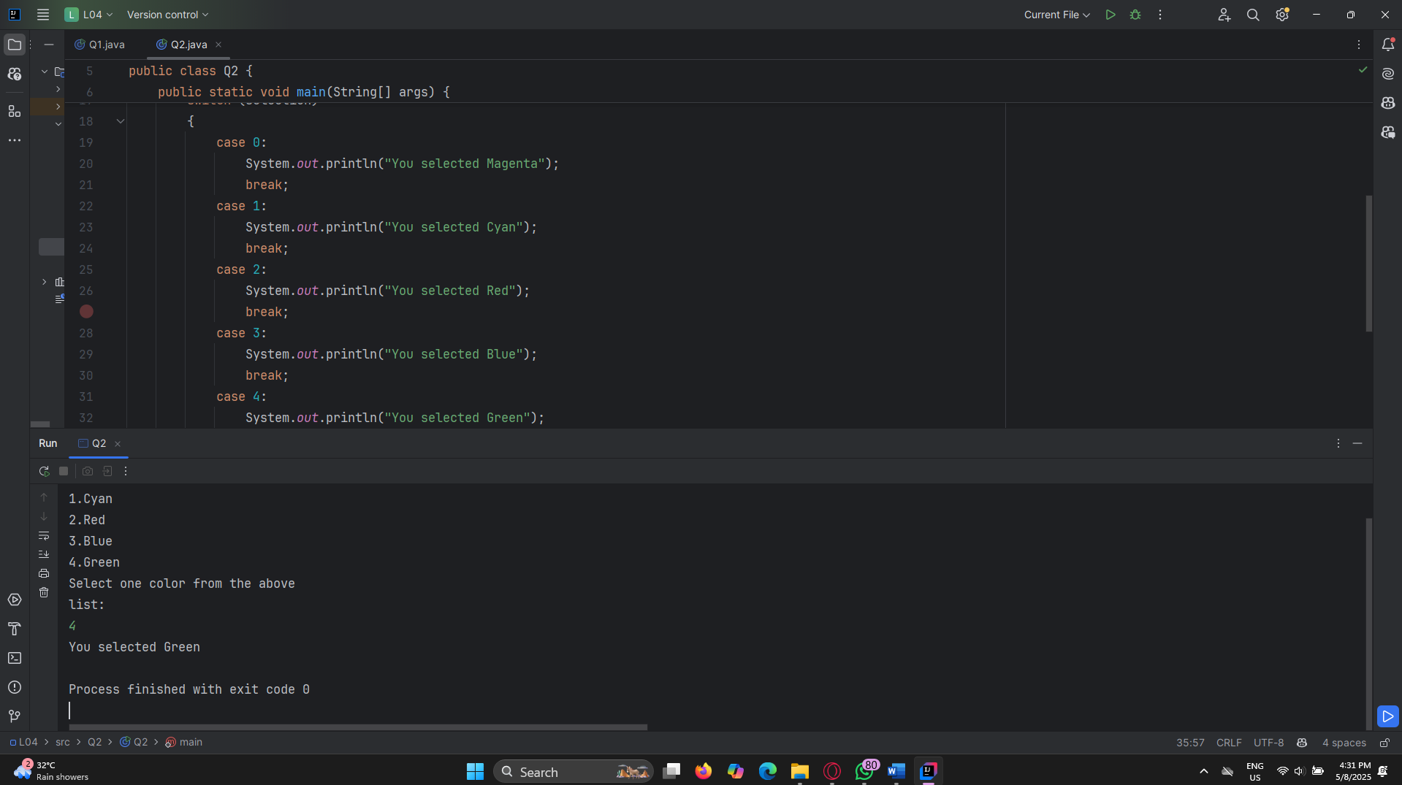

Q3.

|  |
| --- |
| package Q3;  import java.util.Scanner;  public class Q3 {  public static void main(String[] args) {  Scanner scanner =new Scanner(System.*in*);  System.*out*.println("Enter power of 10");    int power=scanner.nextInt();   switch (power)  {  case 6:  System.*out*.println("Million");  break;  case 9:  System.*out*.println("Billion");  break;  case 12:  System.*out*.println("Trillion");  break;  case 15:  System.*out*.println("Quadrillion");  break;   case 18:  System.*out*.println("Quintillion");  break;  case 21:  System.*out*.println("Sextillion");  break;  case 30:  System.*out*.println("Nonillion");  break;  case 100:  System.*out*.println("Googol");  break;  default:  System.*out*.println("Invalid selection");  }  } } |

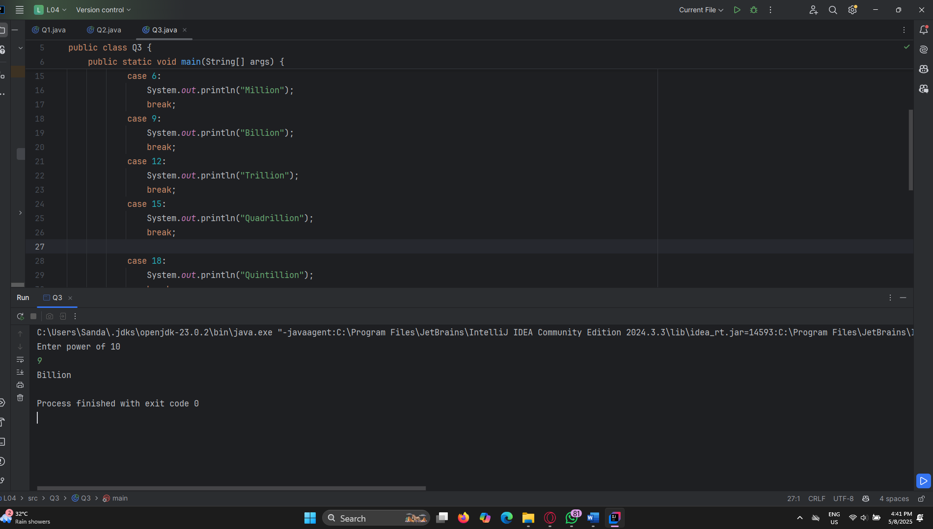

Q4.

|  |
| --- |
| package Q4; import java.util.Scanner;  public class Q4 {  public static void main(String[] args) {  Scanner scanner =new Scanner (System.*in*);  System.*out*.println("Enter year");  int year= scanner.nextInt();   if (year % 4==0 && year % 100 !=0 || year % 400==0) {  System.*out*.println(year + " is a leap year");  }else  {  System.*out*.println(year + " is not a leap year");  }  } } |

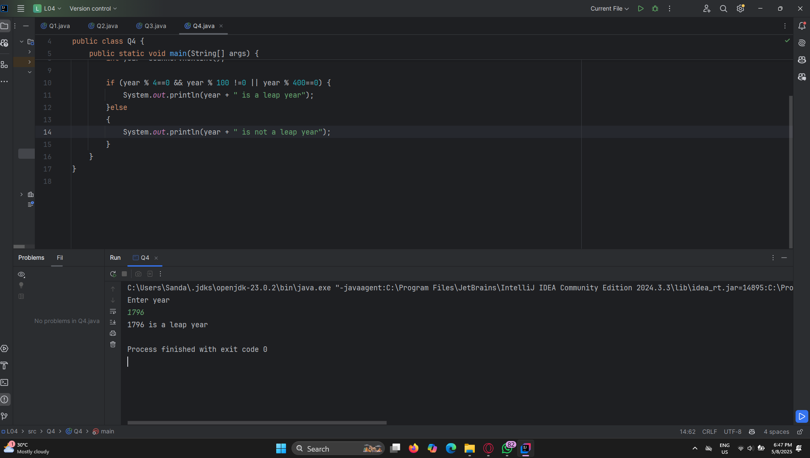

Q5.

|  |
| --- |
| package Q5;  import com.sun.source.doctree.EntityTree;  import java.util.Scanner;  public class Q5 {  public static void main(String[] args){  System.*out*.println("Entree price Side Dish price Drink price ");  System.*out*.println("1.Tofu Burger $3.49 5.Rice Cracker $0.79 9.Cafe Mocha $1.99");  System.*out*.println("2.TCajun Chicken $4.59 6.No-Salt Fries $0.69 10.Cafe Latte $1.90");  System.*out*.println("3.Buffalo Wings $3.99 7.Zucchini $1.09 11.Espresso $2.49");  System.*out*.println("4.Rainbow Fillet $2.99 8.Brown Rice $0.59 12.Oolong Tea $0.99");   Scanner scanner = new Scanner(System.*in*);  System.*out*.println("Enter food number");  int food = scanner.nextInt();   switch (food) {  case 1:  System.*out*.println("Tofu Burger $3.49");  break;  case 2:  System.*out*.println("Cajun Chicken $4.59");  break;  case 3:  System.*out*.println("Buffalo Wings $3.99");  break;  case 4:  System.*out*.println("Rainbow Fillet $2.99");  break;  case 5:  System.*out*.println("Rice Cracker $0.79");  break;  case 6:  System.*out*.println("No-Salt Fries $0.69");  break;  case 7:  System.*out*.println("Zucchini $1.09");  break;  case 8:  System.*out*.println("Brown Rice $0.59");  break;  case 9:  System.*out*.println("Cafe Mocha $1.99");  break;  case 10:  System.*out*.println("Cafe Latte $1.90");  break;  case 11:  System.*out*.println("Espresso $2.49");  break;  case 12:  System.*out*.println("Oolong Tea $0.99");  break;   default:  System.*out*.println("Invalid selection");  }  }  } |

