VX Leave Management System



Created By Pramuditha Sirisena

**Introduction**

This system is for manage the leaves in the Vizuamatix (pvt) ltd.

Already there is a system for this. But there are some faults in that system

* Not calculate the rest number of leaves according to joining date.
* Can’t request leave in one and half day from one application.
* Show same total leave count for everyone.
* Not inform to employees who assign for duties of leaved employees.

Therefore, there should be a system to achieve these tasks.

**Requirement Specification**

**User roles**

1. Admin
2. Supervisor
3. Employee

**Functional Requirements**

1. User Login
2. CRUD Employee by admin
3. Request the leaves by employee
4. View/ Approve/ Update/ Delete leave request of own employees by supervisor
5. View/ Approve/ Update/ Delete leave request of all employees by admin
6. If request leave that should send as an email to supervisor and admin.

**Functional Requirements**

1. Security
2. Accuracy
3. Speed
4. Portability
5. Recoverability
6. Maintainability

**Limitations**

1. This is only for manage the leaves of employee in the company.
2. There are no financial things.
3. View others details only for supervisors and admin.

**Tables**

* calender(id, date, reason, created_by, created_at)
* contact(contact_id, name, contact, relation, user_id)
* department(id, name)
* leave_count(id, annual, casual, medical, lieu, special, maternity, paternity, short, coverup, nopay)
* leave_request(id, emp_id, leave_type, start_date, end_date, number_of_dates, duties_cover, special_notes)
* leave_types(id, type, count)
* lieu_leaves(id, date, period, project, works_done, is_approved, request_at, employee, approved_at, approved_by)
* role(id, name )
* users(emp_id, first_name, second_name, initials, gender, email, residence, contact, role, department, supervior1, supervisor2, join_date, confirm_date, password, image )

**Use Case Diagram**

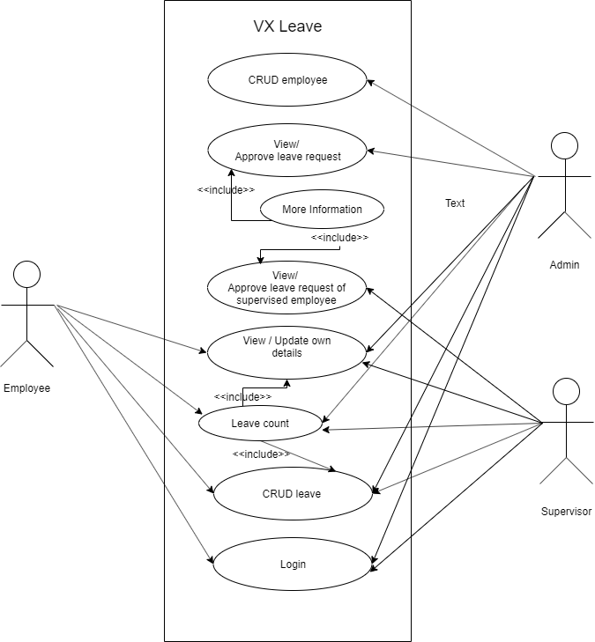

**High Level Architecture**

