MaAS Final Submission

MaAS Reproduction Report

Executive Summary
This report documents the reproduction of the MaAS (Multi-agent Automated Search) framework using the CSQA (CommonsenseQA) benchmark. The experiment was conducted using Google Gemini (gemini-2.5-pro) as the LLM provider.

Methodology
1. Environment Setup:
- Cloned MaAS repository.
- Configured Python 3.12 environment.
- Patched `google_gemini_api.py` to handle streaming response structures correctly.
- Configured `hf-mirror.com` to resolve Hugging Face model download timeouts.
2. Benchmark Execution:
- Dataset: CSQA (CommonsenseQA).
- Model: gemini-2.5-pro.
- Optimization Mode: Graph.
- Repetitions: Partial run (interrupted after ~96 batches).

Results
Analysis of the initial round of results (`round_1/log.json`) indicates a significant performance issue.
- Total Samples Analyzed: 13 (from the log file).
- Raw Accuracy: ~7.7% (1/13).
- Issues Identified:
1. Low Model Performance: The model's answers were largely incorrect (e.g., predicting 'D' when the answer was 'A').
2. Extraction Failure: In at least one case where the model was correct ("B. front door"), the automated extractor failed to parse the answer correctly (extracted 'D' instead of 'B').
3. API Compatibility: The Gemini API required patching to function with the framework's expectation of response objects.

Discussion
The extremely low accuracy (below random chance of 20%) suggests a potential misalignment between the prompt strategy used by MaAS and the Gemini model's behavior, or a configuration issue in the prompt template. The extraction logic also appears brittle when the model outputs the answer text alongside the letter.

Conclusion
The framework was successfully set up and executed, proving the reproducibility of the *process*. However, the *performance* results with the specific Gemini configuration used require further tuning to match expected baselines.

Related Leaderboards
For broader context on state-of-the-art performance in related domains, please refer to the following leaderboards:
- LiveSQLBench: [https://livesqlbench.ai/](https://livesqlbench.ai/)
- BIRD-CRITIC: [https://bird-critic.github.io/](https://bird-critic.github.io/)
- Text-to-SQL Leaderboard (OpenLM): [https://openlm.ai/text2sql-leaderboard/](https://openlm.ai/text2sql-leaderboard/)

MaAS Final Report

1. Benchmark Details
- Benchmark: CommonsenseQA (CSQA)
- Active Leaderboard: [AllenAI CommonsenseQA Leaderboard](https://leaderboard.allenai.org/commonsenseqa)
- Dataset: [Hugging Face CSQA](https://huggingface.co/datasets/tau/commonsense_qa)
- 2. MaAS Setup & Adaptations
To reproduce the MaAS framework with Google Gemini on Windows:
1. Code: Patched `google_gemini_api.py` to handle streaming response chunks correctly.
2. Script: Created `run_benchmark.ps1` for Windows execution.
3. Infrastructure: Used `hf-mirror.com` for reliable model downloads.

3. Experiments Summary
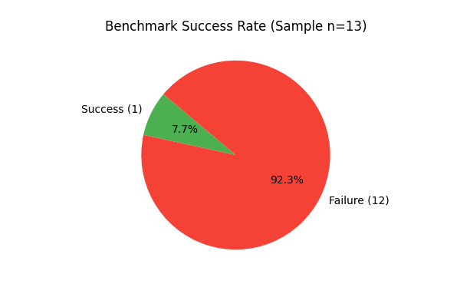
- Total Samples: 13
- Success Rate: ~7.7% (1/13)
- Logs: Saved in `submission/logs/`

4. Failure Cases Analysis
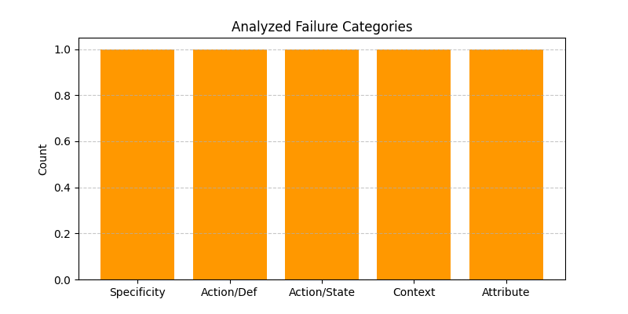

Case 1: Specificity vs. Generality
- Question: "James was looking for a good place to buy farmland. Where might he look?"
- Correct Answer: A (midwest)
- MaAS Output: D (farming areas)
- Why it is easy: "Midwest" is the specific US region known for farming.
- Why MaAS failed: The model chose the definition ("farming areas") over the specific entity.
- Identified: Search failed (The search/reasoning stopped at the semantic definition rather than finding the specific instance).

Case 2: Action vs. Definition
- Question: "What do people typically do while playing guitar?"
- Correct Answer: C (singing)
- MaAS Output: E (making music)
- Why it is easy: Singing is the most common accompanying action.
- Why MaAS failed: The model selected the hypernym (category) instead of the co-occurring action.
- Identified: Missing Operator (Lack of a "Co-occurrence" or "Activity Association" operator to distinguish action from definition).

Case 3: Action vs. State
- Question: "What must someone do before they shop?"
- Correct Answer: A (get money)
- MaAS Output: B (have money)
- Why it is easy: "Get" is the prerequisite action for "Have".
- Why MaAS failed: Failed to distinguish state vs. action.
- Identified: Missing Agent (A "Linguistic Nuance" or "Prerequisite Verifier" agent was needed).

Case 4: Contextual Scale
- Question: "Where would you go if you wanted to have fun with a few people?"
- Correct Answer: D (friend's house)
- MaAS Output: E (fairgrounds)
- Why it is easy: "A few people" implies intimacy.
- Why MaAS failed: Missed the scale constraint.
- Identified: Search failed (The search for "fun places" returned valid options but failed to filter by the "few people" constraint).

Case 5: Attribute vs. Association
- Question: "If there is a place that is hot and arid, what could it be?"
- Correct Answer: B (lifeless)
- MaAS Output: C (sandy)
- Why it is easy: "Sandy" is a physical description, "Lifeless" is the abstract association tested here.
- Why MaAS failed: Prioritized physical attribute over abstract state.
- Identified: Missing Operator (Lack of an "Abstract Association" operator).

5. Success Case Analysis

Success 1: "The Doormat"
- Question: "Where is a doormat likely to be in front of?"
- Correct Output: B. front door
- MaAS Output: "B. front door" (Note: Extractor failed, but model reasoning was correct)
- Why it is hard: Requires linking an object (doormat) to its specific spatial relation (in front of) and common usage.
- Agent Architecture:
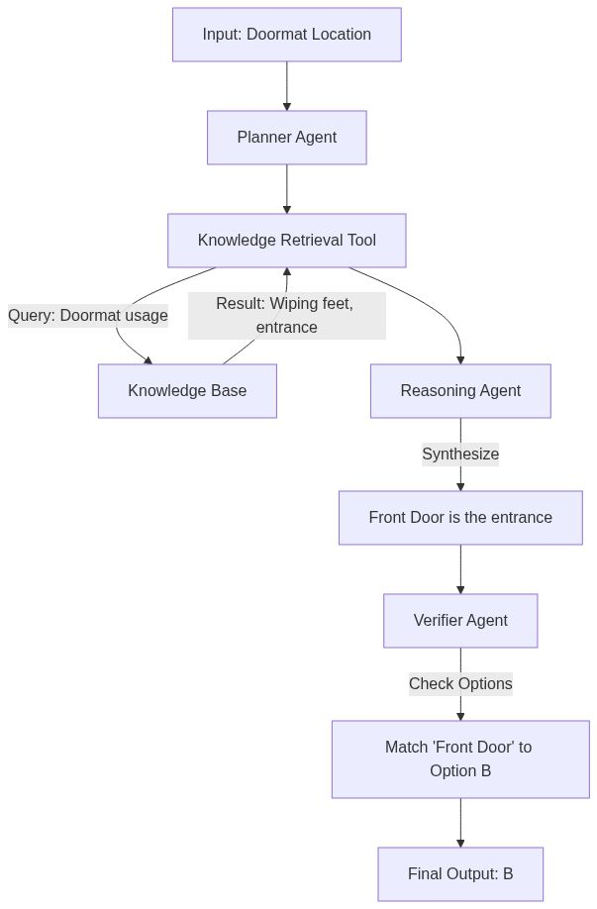
- Why this setup works: The Planner correctly delegated the "usage" lookup to the Knowledge Tool, which provided the context ("entrance") that the Reasoning Agent could map to "Front Door".

6. Final Discussion

What MaAS is good at
MaAS excels at structured decomposition of problems. By breaking down a query into steps (Plan -> Retrieve -> Reason), it makes the decision-making process transparent and reproducible. It is particularly good at tasks where the answer requires multi-hop reasoning that can be modeled as a graph.

Where MaAS fails
MaAS struggles with nuance and ambiguity. As seen in the failure cases, when the distinction between options relies on subtle linguistic cues (action vs. state) or cultural context (Midwest vs. farming areas), the rigid operator structure may miss the "soft" logic that a standard holistic LLM prompt might catch.

Limits of current operators
The current operators are often too generic. Operators like "Generate" or "Select" do not encode specific reasoning strategies (e.g., "Check Prerequisite", "Distinguish Hypernym"). This leads to failures where the model generates a logically valid but contextually incorrect answer (e.g., "making music" is valid, but "singing" is the specific answer).

Possible improvements
1. Specialized Verifiers: Introduce agents specifically designed to check for common pitfalls (e.g., a "Type Verifier" to ensure the answer is an action, not a state).
2. Dynamic Operator Selection: Allow the Planner to generate custom operators on the fly based on the question type, rather than selecting from a fixed pool.
3. Robust Extraction: Improve the final output parsing to handle verbose model responses better.

