**Assignment No.**

**Title:** Installing and configure DHCP server

**Problem Statement:** Installing and configure DHCP server and write a (C++/Python/Java) program to install the software on remote machine.

**Prerequisites:** DHCP Server, C++/Python/Java, SSH

**Objectives:**

* + - 1. To know the Installing and configure DHCP server
      2. To know the software installation on remote system

**Theory:**

**Dynamic Host Control Protocol (DHCP):** The Dynamic Host Configuration Protocol (DHCP) is a standardized network protocol used on Internet Protocol (IP) networks for dynamically distributing network configuration parameters, such as IP addresses for interfaces and services. With DHCP, computers request IP addresses and networking parameters automatically from a DHCP server, reducing the need for a network administrator or a user to configure these settings manually.

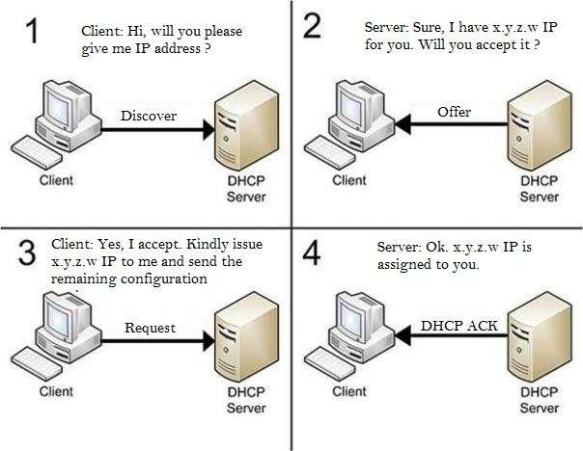

DHCP is based on BOOTP but can dynamically allocate IP addresses from a pool and reclaim them when they are no longer in use. It can also be used to deliver a wide range of extra configuration parameters to IP clients, including platform-specific parameters. It was first defined in RFC 1531 in October 1993; but due to errors in the editorial process was almost immediately reissued as RFC 1541. Four years later the DHCPINFORM message type and other small changes were added by RFC 2131; which as of 2014 remains the standard for IPv4 networks. Depending on implementation, the DHCP server may have three methods of allocating IP-addresses:

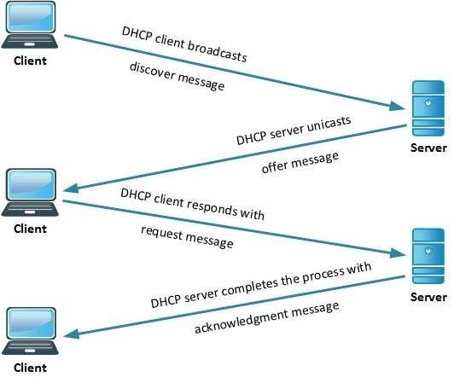

**Dynamic allocation:**

A network administrator reserves a range of IP addresses for DHCP, and each client computer on the LAN is configured to request an IP address from the DHCP server during network initialization. The request-and-grant process uses a lease concept with a controllable time period, allowing the DHCP server to reclaim (and then reallocate) IP addresses that are not renewed **Automatic allocation:**

The DHCP server permanently assigns an IP address to a requesting client from the range defined by the administrator. This is like dynamic allocation, but the DHCP server keeps a table of past IP address assignments, so that it can preferentially assign to a client the same IP address that the client previously had.

**Static allocation:**

The DHCP server allocates an IP address based on a precon_gured mapping to each client's MAC address. This feature is called static DHCP assignment.

**Working:**

The DHCP employs a connectionless service model, using the User Datagram Protocol (UDP). It is implemented with two UDP port numbers for its operations which are the same as for the BOOTP protocol. UDP port number 67 is the destination port of a server, and UDP port number 68 is used by the client. DHCP operations fall into four phases: server discovery, IP lease offer, IP request, and IP lease acknowledgment. These stages are often abbreviated as DORA for discovery, offer, request, and acknowledgment.

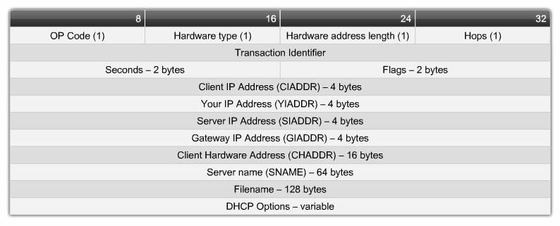

**DHCP discovery**

The client broadcasts messages on the network subnet using the destination address 255.255.255.255 or the specific subnet broadcast address. A DHCP client may also request its last-known IP address. If the client remains connected to the same network, the server may grant the request. Otherwise, it depends whether the server is set up as authoritative or not. An authoritative server denies the request, causing the client to issue a new request. A non-authoritative server simply ignores the request, leading to an implementation-dependent timeout for the client to expire the request and ask for a new IP address.

**DHCP offer**

When a DHCP server receives a DHCPDISCOVER message from a client, which is an IP address lease request, the server reserves an IP address for the client and makes a lease offer by sending a DHCPOFFER message to the client. This message contains the client's MAC address, the IP address that the server is offering, the subnet mask, the lease duration, and the IP address of the DHCP server making the offer. The server determines the configuration based on the client's hardware address as specified in the CHADDR (client hardware address) field. DHCP request in response to the DHCP offer, the client replies with a DHCP request, broadcast to the server, requesting the offered address. A client can receive DHCP offers from multiple servers, but it will accept only one DHCP offer. Based on required server identification option in the request and broadcast messaging, servers are informed whose offer the client has accepted. When other DHCP servers receive this message, they withdraw any offers that they might have made to the client and return the offered address to the pool of available addresses.

**DHCP acknowledgement**

When the DHCP server receives the DHCP REQUEST message from the client, the configuration process enters its final phase. The acknowledgement phase involves sending a DHC PACK packet to the client. This packet includes the lease duration and any other configuration information that the client might have requested. At this point, the IP configuration process is completed. The protocol expects the DHCP client to configure its network interface with the negotiated parameters. After the client obtains an IP address, it should probe the newly received address (e.g. With ARP Address Resolution Protocol) to prevent address conicts caused by overlapping address pools of DHCP servers.

**DHCP releasing**

The client sends a request to the DHCP server to release the DHCP information and the client deactivates its IP address. As client devices usually do not know when users may unplug them from the network, the protocol does not mandate the sending of DHCP Release.

**SSH:**

OpenSSH is the premier connectivity tool for remote login with the SSH protocol. It encrypts all traffic to eliminate eavesdropping, connection hijacking, and other attacks.

**How to install ssh?**

To install it, open terminal (Ctrl+Alt+T) or log in Ubuntu server and run command:

sudo apt-get install openssh-server

**Conclusion:** Hence we have install and configure DHCP server and installed software on remote system.

**DHCP Installation and Configuration**

**Installation**

To install DHCP server on Ubuntu 14.04 LTS, enter the following command:

sudo apt-get install isc-dhcp-server

**Configuration**

DHCP server configuration is not that difficult. First, we have to assign on what interfaces should the DHCP server (dhcpd) serve DHCP requests. In my case, I have only one Interface on my system (eth0), so I assigned **eth0**.

To do that, edit file **/etc/default/isc-dhcp-server**,

sudo nano /etc/default/isc-dhcp-server

Assign the network interface:

[...]

INTERFACES="eth0"

Save and close the file.

Now, edit **dhcpd.conf** file,

sudo nano /etc/dhcp/dhcpd.conf

Make the changes as shown below.

Set the domain name and domain-name servers:

[...]

# option definitions common to all supported networks...

option domain-name "unixmen.local";

option domain-name-servers server.unixmen.local;

[...]

If this DHCP server is the official DHCP server for the local network, you should uncomment the following line:

[...]

authoritative;

[...]

Define the sunbet, range of ip addresses, domain and domain name servers like below:

[...]

# A slightly different configuration for an internal subnet.

subnet 192.168.1.0 netmask 255.255.255.0 {

range 192.168.1.20 192.168.1.30;

option domain-name-servers server.unixmen.local;

option domain-name "unixmen.local";

option routers 192.168.1.1;

option broadcast-address 192.168.1.255;

default-lease-time 600;

max-lease-time 7200;

}

[...]

If you want to assign a fixed IP address to your client, you should enter it’s MAC id and the IP address in the following directive. For example, I want to assign a fixed IP address **192.168.1.15** to my Ubuntu client, hence I modified the following directive as shown below.

[...]

host ubuntu-client {

hardware ethernet 00:22:64:4f:e9:3a;

fixed-address 192.168.1.15;

}

[...]

After making all the changes you want, save and close the file. Be mindful that if you have another unused entries on the dhcpd.conf file, comment all of them. Otherwise, you’ll get issues while starting dhcp service.

Now, restart dhcp service and make it to start automatically on every reboot.

sudo service isc-dhcp-server restart

Likewise, you can start/stop dhcp service as shown below:

sudo service isc-dhcp-server start

sudo service isc-dhcp-server stop

**Configure Clients**

Now, go to the client configuration network settings and change the IP settings to **Automatic (DHCP)**.

Here is my Lubuntu 14.04 settings:

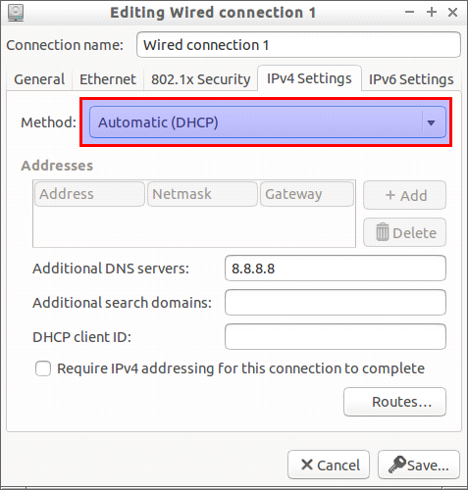

Restart the network or reboot the client system to get IP address automatically from the DHCP server.

Now, you should see the IP address has been automatically assigned to the clients from the DHCP server.

Run the following command from the client system Terminal:

sudo ifconfig

Sample output:

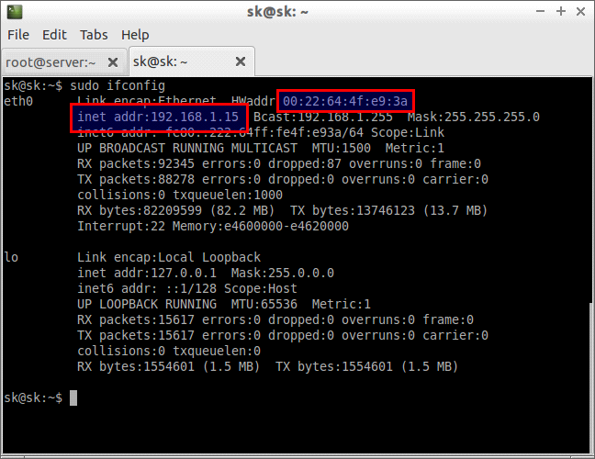

As you see in the above picture, My ubuntu client system which has MAC id **00:22:64:4f:e9:3a** gets a fixed IP address **192.168.1.15** from the DHCP server.

That’s it. DHCP server is up and ready.