Assignment No.
Title: To demonstrate subnetting and find subnet mask.
Problem Statement: Write a program to demonstrate subnetting and find subnet mask.

Prerequisites: :Jdk and python
Objectives: To understand subnetting concepts and also find subnet mask of network.
Theory:
What is IP address?
An Internet Protocol address (IP address) is a numerical label assigned to each device (e.g., computer, printer) participating in a computer network that uses the Internet Protocol for communication. An IP address serves two principal functions: host or network interface identification and location addressing. IP address is a 32 bit number. It is universally unique
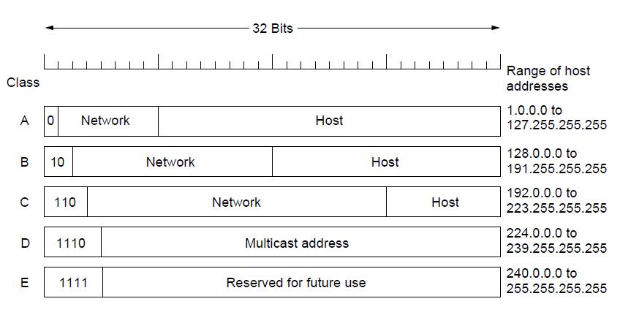
What is subnet?
A sub network, or subnet, is a logical, visible subdivision of an IP network. The practice of dividing a network into two or more networks is called sub netting. Computers that belong to a subenet are addressed with a common identical, most-significant bit-group in their IP . This results in the logical division of an IP address into two fields, a network or routing prefix and the rest field or host identifier. The rest field is an identifier for a specific host or network interface.
For the purpose of network management, an IP address is divided into two logical parts, the network prefix and the host identifier or rest field. All hosts on a sub network have the same network prefix. This routing prefix occupies the most-significant bits of the address. The number of bits allocated within a network to the internal routing prefix may vary between subnets, depending on the network architecture. While in IPv6 the prefix must consist of a set of contiguous 1-bits, in IPv4 this is not enforced, though there is no advantage to using non-contiguous 1-bits. The host part is a unique local identification and is either a host number on the local network or an interface identifier.

What is subnet masking?

An IP address has two components, the network address and the host address. A subnet mask separates the IP address into the network and host addresses (<network><host>). Subnetting further divides the host part of an IP address into a subnet and host address (<network><subnet><host>) if additional sub network is needed. It is called a subnet mask because it is used to identify network address of an IP address by performing a bitwise AND operation on the net mask.

A Subnet mask is a 32-bit number that masks an IP address, and divides the IP address into network address and host address. Subnet Mask is made by setting network bits to all "1"s and setting host bits to all "0"s. Within a given network, two host addresses are reserved for special purpose, and cannot be assigned to hosts. The "0" address is assigned a network address and "255" is assigned to a broadcast address, and they cannot be assigned to hosts.

A mask used to determine what subnet an IP address belongs to. An IP address has two components, the network address and the host address
For example
Consider the IP address 150.215.017.009. Assuming this is part of a Class B network, the first two numbers (150.215) represent the Class B network address, and the second two numbers (017.009) identify a particular host on this network. Subnetting an IP network is to separate a big network into smaller multiple networks for reorganization and security purposes. All nodes (hosts) in a sub network see all packets transmitted by any node in a network. Performance of a network is adversely affected under heavy traffic load due to collisions and retransmissions. Applying a subnet mask to an IP address separates network address from host address. The network bits are represented by the 1's in the mask, and the host bits are represented by 0's. Performing a bitwise logical AND operation on the IP address with the subnet mask produces the network address.

Conclusion: Thus we have implemented subnetting program .

Program:

import java.util.Scanner;
class subnet
{
public static void main(String args[])
{
Scanner sc = new Scanner(System.in);
System.out.print("Enter the ip address");
String ip = sc.nextLine();
String split_ip[]=ip.split("\\.");
//SPlit the string after every .
String split_bip[] = new String[4];
//split binary ip
String bip = "";
for(int i=0;i<4;i++)
{
split_bip[i] = appendZeros(Integer.toBinaryString(Integer.parseInt(split_ip[i])));
// â€œ18â€ => 18 => 10010=>00010010
bip += split_bip[i];
}
System.out.println("IP in binary is "+ bip);

System.out.print("Enter the number of addresses: ");
int n = sc.nextInt();
//Calculation of mask
int bits = (int)Math.ceil(Math.log(n)/Math.log(2));
/*eg if address = 120, log 120/log 2 gives log to the base 2 => 6.9068, ceil gives us upper integer */
System.out.println("Number of bits required for address = "+bits);
int mask = 32-bits;
System.out.println("The subnet mask is = " +mask);

//Calculation of first address and last address
int fbip[] = new int[32];
for(int i=0; i<32;i++)
{
fbip[i] = (int)bip.charAt(i)-48;

//convert cahracter 0,1 to integer 0,1 for(int i=31;i>31-bits;i--)
//Get first address by ANDing last n bits with 0

fbip[i]&= 0;
}
String fip[] = {"","","",""};
for(int i=0;i<32;i++)
fip[i/8] = new String(fip[i/8]+fbip[i]);
System.out.print("First address is = ");
for(int i=0;i<4;i++)
{
System.out.print(Integer.parseInt(fip[i],2));
if(i!=3) System.out.print(".");
}
System.out.println();
int lbip[] = new int[32];
for(int i=0; i<32;i++) lbip[i] = (int)bip.charAt(i)-48; //convert cahracter 0,1 to integer 0,1
for(int i=31;i>31-bits;i--) //Get last address by ORing last n bits with 1
lbip[i] |= 1;
String lip[] ={"","","",""};
for(int i=0;i<32;i++)
lip[i/8] = new String(lip[i/8]+lbip[i]);
System.out.print("Last address is =");
for(int i=0;i<4;i++)
{
System.out.print(Integer.parseInt(lip[i],2));
if(i!=3) System.out.print(".");
}
System.out.println();
}
static String appendZeros(String s){
String temp = new String("00000000");
return temp.substring(s.length())+ s;
}
}

OutPut:

Enter the ip address: 100.110.150.10
IP in binary is 01100100011011101001011000001010
Enter the number of addresses: 7
Number of bits required for address = 3
The subnet mask is = 29
First address is = 100.110.150.8
Last address is = 100.110.150.15

