Automatic Alert Based Switch with Motion Sensor
Pranab Datta1, Akash Chandra Paul¹, Partha Pratim Majumder1, Retuparna Das1

1 BRAC University, 66, Mohakhali,
Dhaka 1212, Bangladesh
{pranab.pronay, akash103691, partha.bracu16, dretuparna}@gmail.com
Abstract. In today’s world technology is everywhere. Automation lets us combine multiples into a single automated action. In today’s world consumption of electricity is increasing day by day. We need to reduce the consumption of electricity. Huge amount of electricity is wasting by fan in absence of human. Main moto of our project is to reduce the extravagance of electricity. This project will control the fan through motion detector which can detect the movement of human.
Keyword: Arduino Uno, PIR Sensor (HC-SR501), two channel Relay, GSM Module (SIM 800A).
1 Introduction
The 21st century is striving hard to save electrical energy. In our daily life, we are wasting a lot of electricity intentionally or unintentionally. One of the most energy wasting habit is leaving the lights or fans on. In 2004, the average U.S.A residential household consumed 10,982 kWh of electricity and spent around $2,200 annually on utility bill [1]. Luckily households can lower this amount up to 25 percent by being more proactive with energy conservation tip [2]. To solve this problem, we used home automation switch with motion sensor. In 1975, the general purpose home automation network technology X10 was developed [3]. According to Li et.al (2016), there are three generation of home automation [4]. Apart from this we also used a motion detector which is a device that detects moving objects particularly people. Such a device often integrated as component of a system that automatically performs a task or alerts a user of motion in an area. Human detection encompasses a range of technologies for detecting the presence of a human body in area of space typically without the intention, participation of the detected person. Our model describes the methodology of renewable energy based home automation which mainly focused on energy consumption.

To design an automatic switch with appropriate properties is a challenging task. In our model, we have added all the features of real life scenario. In real life, sometimes unintentionally we forget to turn off the switch and it is the cause of consumption of huge amount of electricity. However, there are some limitations in this model. Firstly, it only turns on or off the switch but it is not able to control the regulator. Besides, our model could not detect unauthorized access. Apart from these limitations, the automatic switch is capable of notify the registered user in an efficient way.

The rest of the paper is organized as follows: Section 2 is the proposed model with the block diagram of two phases of the model, Section 3 is the experimental setup and result analysis with pictures of used components and concludes with Section 4.
2 Proposed Model
The model has been built in two phases. At first, we have made an automatic switch which is controlled by PIR sensor and two channel relay. The relay will connect through power supply and electrical device (fan, light). In the second phase, GSM Module will notify users if Relay remains high for ten minutes without any movement of object. We have used GSM Module for both input and output purposes. The complete block diagram of our proposed model is given in Figure 1.

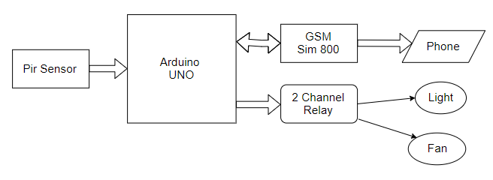
Figure 1: Block Diagram of Model
2.1 PIR Sensor Controlled Switch
As shown in Figure 1, Arduino will take inputs from the PIR Sensor Module HC-SR501. PIR Sensor will detect the movement of object through emitting heat energy in a form of infrared radiation. So when anyone comes into a room it will take reading and pass it to Arduino. Then, Arduino will send signals to the Two Channel Relay which is an electrically operated switch. The Relay module mainly protects the switch from high voltage spike. As we want to control the Relay manually we have used NC1 and COM ports for output purpose. Figure 2 will represent the complete flowchart of our project.
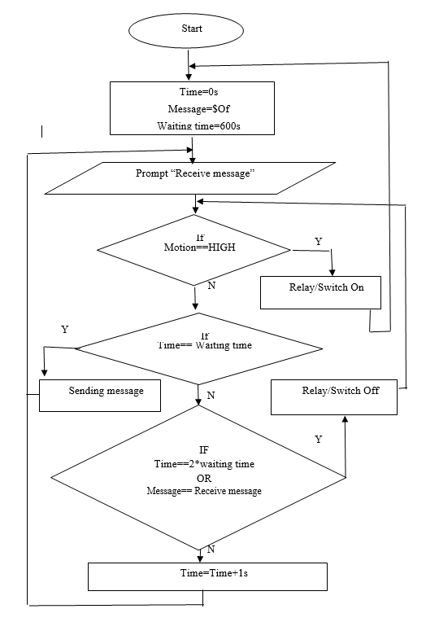
Figure 2: Flowchart of Project
2.2 Alert Enabled Switch
In this second phase of the module, we have used SIM 800A GSM Module which is a mobile communication modem. GSM Module is capable of sending and receiving messages with a SIM Card. SIM 800A needs 5v-12v of range to activate it. That is why we have used USB Cable to give it power which runs at 5v. If Arduino cannot get any signals from PIR Sensor for 10 minutes, it will send message to the registered user. After that, User can turn off the switches through sending message from their mobile phone.
3.1 Experimental Setup and Knowledge Analysis
To execute the process, we first need an Arduino Uno. Arduino Uno is a microcontroller board based on the ATmega328P. It has 14 digital input/output pins, 6 analog inputs, a USB connection, a power jack, and a reset button [5]. Not only will that Arduino control the model containing the uploading code in its software. Figure-3 shows the used micro controller that we used for our project.
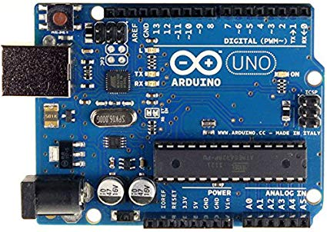
Figure 3: Arduino Uno
Next we also need a PIR Sensor Module named HC-SR501 which is an electronic sensor that measures infrared (IR) light radiating from objects in its field of view. An individual PIR sensor detects changes in the amount of infrared radiation impinging upon it, which varies depending on the temperature and surface characteristics of the objects in front of the sensor[6]. When an object, such as a human, passes in front of the background, such as a wall, the temperature at that point in the sensor's field of view will rise from room temperature to body temperature, and then back again [7]. We have adjusted the range of PIR Sensor by changing the value of resistor. Figure 4 shows representation of PIR Sensor Module.
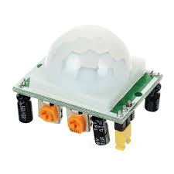
Figure 4: PIR Sensor Module HC-SR501

To make the connection between Arduino and electrical devices we have used Two Channel Relay. A relay is an electromagnetic switch that is used to turn on and turn off a circuit by a low power signal, or where several circuits must be controlled by one signal. The job of relay driver circuit is to provide the essential current energize the relay coil, when a LOGIC 1 is written on the PORT PIN thus turning on the relay. The relay is turn off by writing LOGIC 0 on the port pin [8]. For 2 Channels Relay each channel in the module has three connections named NC, COM, and NO. Figure 5 shows representation of 2 Channel Relay.

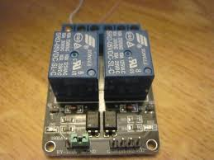

Figure 5: Two channel Relay

Furthermore, we also need a GSM Module named SIM 800a which allows for GPRS transmission, sending and receiving SMS and making and receiving voice calls. The power supply to the board should be 12v, 1-2A inputs.. When the modem turns ON the power and the LEDs also turn ON and the network LED starts blinking [9]. Figure 6 shows representation of SIM 800A GSM Module.
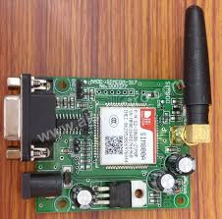

Figure 6: GSM Module SIM 800A

3.2 Result Analysis
As all the components are connected with each other. Now we turn on the Ardiuno and check out for our result which will show in our serial monitor.

Table no 1: Data from Serial Monitor

Time | PIR Sensor and Relay | GSM Action
10s | Motion detected and Relay on | No action
30s | No motion detected and Relay on | No action
300s | No motion detected and Relay on | No action
330s | No motion detected and Relay on | Sending message
630s | No motion detected and Relay off | Sending message

4 Conclusion
In order to save energy and electricity, our automatic alert based switch is capable of detecting objects movement to reduce the consumption of electricity. Additionally, people can control their electric switches from outside of their home through messages. In future we will use RFID which can prevent unauthorized access and control through voice command. Then our project will be used as part of a smart home.

5 References
[1, 2] J. Deesing: The 10 Biggest Energy Wasting Habits at Home (May26, 2016)
[3] R. Dave: "My Life at X10" AV and Automation Industry eMagazine. AV and Automation Industry eMagazine (September 26, 2014)
[4] Li, R. Y. Man, Li, H. C. Y. Mak, C Kei, Tang, T. Beiqi. “Sustainable Smart Home and Home Automation: Big Data Analytics Approach” (PDF). International Journal of Smart Home. (September 4, 2016).
[5] R. H. Sudhan, M. G. Kumar, A. U. Prakas, S. A. R. Devip: “An Arduino is an open source International Journal of Research in Engineering and Technology” (January 5, 2015).
[6] G. C. Nepal, D.M. Adhikari, R. Biswa: “Passive Infrared (PIR) Sensor Based Security System” (June 2, 2013).
[7] PIR Sensor, Ecoamica Technologies LLP, Retrieved from http://www.ecosirius.com/technology.html
[8] M. W. Islam, B. Roy, N. H. Preety, F. B. Mahtab: “Design of Arduino Based Home Automation Systems Incorporating Identity Detection” (December, 2017)
[9] Jojo: “How to Interface GSM Module to Arduino-Send and Receive SMS” (August 11, 2018)

