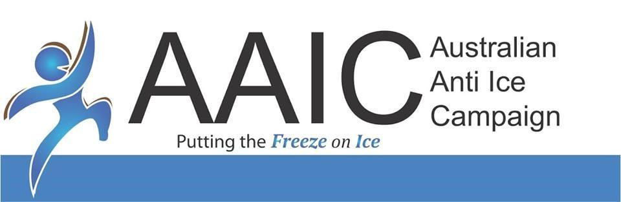

08
Fall
ABN: 56 609 511 695



AAIC Community Ice Action Team (AAIC CIAT) Operations Manual

Booking Business Workshops

Procedures Manual

April 2021
TABLE OF CONTENTS
1. Initial contact with schools. 2
2. Introductory Email after initial contact. 2
3. Explaining the workshop funding to the contact person at the school. 2
4. Invoicing and payment. 2
5. Confirming Workshop Presenters availability. 3
6. Making confirmed booking. 3
7. Email to school. 3
8. Entering workshops into calendar. 3
9. Prepare Presenters Packs. 3
10. One week before the Presentation 4
11. Email Presenter and confirm the following. 4
12. Post workshops follow up. 4
13. One week after Presentation 4
14. “Sales” team follow up. 4

The purpose of this document is to describe the process of booking business workshops from initial contact through to post workshop follow up.
The steps in this process are set out below.

Initial contact with business.
The initial contact is by phone and is designed to establish who the relevant decision maker at the business is, and hopefully get to talk directly to this person in the initial phone call.
The Workplace Health and Safety Officer, or Manager, is a good first point of contact to try to speak to.
A Standard Business Phone Script is used for this part of the process.
It is useful to keep details of names of the receptionist you speak to, as you may need to call back several times and knowing the names, and some details of the nature of your conversation will help build a relationship there if needed.
You will have a Business Data Base to work from to record all details of businesses you have spoken to and to assist you with timely and appropriate follow up.
The AAIC Workshop must be promoted to businesses as a once in a lifetime experience for the participants that they will never forget – because that is the truth and the reason, we press on with this mission despite any adversity.
When a cleaner at NASA was asked many years ago to describe what he did for a job, his response was – “I am helping to put man on the moon.”
When asked this same question, if your response is - “I phone businesses and book workshops for AAIC”, then in all probability, you will fail at this job.
When asked this same question, if your response is – “I save lives and I save families from the destruction the drug Ice inevitably brings” - then in all probability, you will succeed at this job.
Once you obtain the details of the decision maker, and whether you have personally spoken to this person or not, the next step is to customise the standard introductory business email (change industry – in the bold text just below the picture of a workshop being conducted) and send it to that decision maker.
Recording the time and date you send each email on your Business Data Base will also be helpful in follow up calls.

Introductory Email after initial contact.
The Standard Introductory Email to businesses is our sales pitch, with testimonials to highlight the impact of our workshops.
This email asks the business decision maker to call us back to discuss booking some workshops.
This will only happen on very rare occasions, as people are very busy and have a lot of organisations “hitting them up” for various products and services.
We need to be diligent and persistent in our follow up and never assume a failure to return a phone call or reply to an email means “NO”.

Explaining the workshop funding to the contact person at the school.
Once you have sent the Standard Introductory Email to the relevant decision maker, you need to connect with that person by phone to attempt to fully explain how the funding of the workshops and the peer support program works.

Invoicing and payment.
As businesses are booked, we need to email AAIC’s Accounts Department to arrange an appropriate invoice to be issued to the business.
Depending on the location of the business, we may need to arrange a quote for travel and accommodation for the presenters.
The PA to the CEO is to be emailed to get quotes for this expense.
This email to AAIC’s Accounts Department and where necessary the PA to the CEO, is to include the following details.
- Business Name
- Business Contact Name and Email
- Business Address
- Tentative date and numbers
Any brief intervention work will come after the initial workshop presentation.

Confirming Workshop Presenters availability.
As businesses are booked, we also need to email the Workshop Coordinator who will contact AAIC Presenters to ensure a Presenter or Presenters are available for the tentative dates envisaged for the business workshops.
Once Presenter availability is confirmed, the Education Coordinator will contact the business.

Making confirmed booking.
Once payment of the invoice has been received, the Accounts Department will email confirmation to the Workshop Coordinator.
The Workshop Coordinator then contacts the businesses contact person to confirm workshop times, dates, and participant numbers for each workshop.
The Workshop Coordinator then sends “AAIC - Business Booking Form” to be completed and returned by the business.
Receipt of this Booking Form is the final stage in confirming a workshop booking.

Email to school.
Once the booking form has been completed and returned, the Workshop Coordinator will email the business, attaching:
- “AAIC – Business Booking Confirmation Letter.”
- “AAIC - What Do You Know” form (request that the business print out 1 form per participant and supply pens for the day).
- Confirm they have HDMI capacity and sound system.

Entering workshops into calendar.
The Workshop Coordinator will then enter presentation dates and times into the Workshops Calendar and share these calendar entries with relevant Presenters and with the CEO’s Personal Assistant.

Prepare Presenters Packs.
The Workshop Coordinator will then prepare Presenters Packs including:
- “AAIC - Presenter Pack” form (has all details for the booking - Address, contact details etc).
- 1 per participant “AAIC Putting the Freeze on Ice” wristband or sticker.
- 1 per participant “AAIC - What You Need to Know About Ice Flyer” with National Pocket Card attached.
- “AAIC - Presenters Self-Assessment” forms (1 per workshop)
- Banner (ensure that all the parts are in the carry bag and that the banner is in good working condition).
- Laptop, USB with presentation on it, HDMI Cable, Clicker, spare batteries and carry case.
- Place all items in box and label with School Name, Date and Time.

One week before the Presentation
The Workshop Coordinator will contact the business to confirm that everything is in place for the workshops to proceed on the set dates. In this contact the Workshop Coordinator will confirm “AAIC - What Do You Know” forms have been printed and are ready to be handed out and that workshop participants will have a pen to complete this form during the workshop.

Email Presenter and confirm the following.
The Workshop Coordinator will email the allocated Presenters and confirm the following:
- Presentation dates and times.
- Remind them need AAIC Shirt, Lanyard with Name Tag and Blue Card.
- Come into AAIC Office to collect “AAIC - Presenter Pack” (ensure presenter signs out all items as they are responsible for them until they are signed back in)

Post workshops follow up.
The Workshop Coordinator will email the following documents to the business once all workshops have been conducted at that school.
- “AAIC - Follow up letter to businesses”.
- “AAIC - Workshop Presentation Feedback Form”.
- “AAIC - Business Booking Form” (encourage rebooking of other employees)
- Tripod system of support document.
The Workshop Coordinator will also check ALL items in Presenters Pack have been returned, in working order and signed back in by the Presenter (they have full responsibility for equipment until returned and signed off).
The Workshop Coordinator will also ensure each of the following steps have been completed:
- Put away any returned arm bands, stickers, or flyers.
- Check “AAIC - Workshop Presenters Self-Assessment” forms have been completed and returned by the Presenter.
- Scan Presenters Self-Assessment forms and save to drive.
- Scan completed “AAIC - What do you know” forms completed by participants and save to drive.
- Write up any comments the participants have written.
- Email Accounts and advise completed workshop and who Presenters were for each workshop.
- Email reminder to Presenter to send invoice to Accounts.
- Update Business Workshop Spreadsheet.

One week after Presentation
If the “Workshop Presentation Feedback Forms” is still not received send an email to the business requesting these forms be completed and returned.
When these forms are received back from the business:
- Scan and save to drive.
- Prepare a summary of feedback.
- Send this summary of feedback to the CEO and Social Media Department.
- Social Media to post summary of feedback on Facebook.

“Sales” team follow up.
Once the above steps have been completed, the Workshop Coordinator will notify the relevant AAIC Salesperson who made the booking. This person will then call the business contact person to:
- Thank them for their feedback and for hosting the workshops.
- Try to sell the Tripod System of Support.
- Obtain referrals to other businesses known to the business contact person who that person feels may be interested in AAIC attending their workplace.

