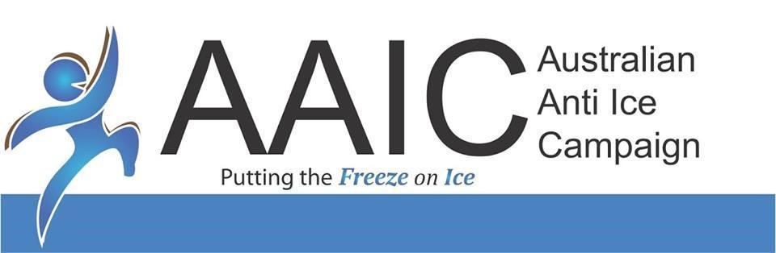

08
Fall
ABN: 56 609 511 695

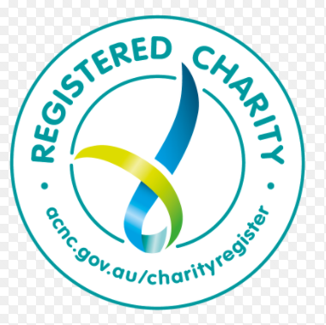

AAIC Community Ice Action Team (AAIC CIAT) Operations Manual

Care Team

Procedures Manual

April 2021
TABLE OF CONTENTS
1. INTRODUCTION 2
2. CARE TEAM - JOB DESCRIPTION/PROCEDURES 2
3. BUDDY - JOB DESCRIPTION (CLIENT / ADDICT) 2
4. FAMILY SUPPORT ASSISTANCE: 4
5. FACEBOOK PAGE 4
6. FOLLOW UP 5
7. CARE TEAM RESOURCE LIST 5
8. RECEIVING INCOMONG PHONE CALLS TO HELPLINE 5

INTRODUCTION

CARE TEAM - JOB DESCRIPTION/PROCEDURES
To serve and maintain Care Team Department By doing the following:
- Answer calls from those either caught in Ice addiction or families who have
Loved ones caught in addiction.
- Demonstrate sensitivity and empathy regarding drug addiction.
- Project a non-judgmental attitude towards those requiring assistance.
- Answer and provide appropriate intervention/assistance for listening and support as well as offering information following policies and procedures.
- Document calls correctly into our computer tracking system according to procedures. Commonly known as the Buddy Spreadsheets found in google Drive and only shared with the appropriate workers for confidentiality sake.
- Attend all scheduled Care Team meetings.
- Attend mandatory monthly Group Supervision in person, or by Zoom on the first Wednesday of each month at 4pm.

BUDDY - JOB DESCRIPTION (CLIENT / ADDICT)

- To come alongside the (client) person who is wanting to come clean of addiction and support them in their journey of recovery. This can be done through sharing personal experiences of addiction, which may help the client in their recovery.
- Start the journey together with the client by helping them access SAMHI brief intervention: ‘Chemically Speaking Two’ from the AAIC website (https://www.australianantiicecampaign.org.au/aaic-shop/samhi-chemically-speaking-two.html).
- Buddy will help client fill in the ‘Costs vs Benefits’ sheet to enable client to move towards the action plan and ‘Tripod of Support’.
- In the case of the addict going into Rehab, the Buddy will not have contact with the addict again, until the addict has finished their Rehab journey.
- If the addiction is not severe enough to warrant residential rehabilitation, or they have just come out of rehab, then the ‘Tripod of Support’ will be the next step. Counselling, self-help groups (NA/AA) & Sponsor. This is where the Buddies can take the client to meetings and introduce them to a Sponsor.

FAMILY SUPPORT ASSISTANCE:

- Similar to the Buddy position for addicts, a Family Support Counsellor/Buddy assists the loved one of an addict in coming to terms with and supporting their loved one who is in addiction.
- Start the journey together with the family by helping them access SAMHI brief intervention: ‘Chemically Speaking Two’ from the AAIC website (https://www.australianantiicecampaign.org.au/aaic-shop/samhi-chemically-speaking-two.html).
- The Family Support Buddy can share their own experiences, which will hopefully set an example for the family member/friend that they can get through this, with support.

FACEBOOK PAGE
🔶Beginning of each day and throughout the day I check inbox on Facebook page for anyone seeking help with drug addiction. If needing assistance:
- Respond with a reassuring message we care and will do our utmost to seek them help asking for a contact number or email.
- If needing intervention I contact one of our Lived experience Presenters to contact that person/s.
- Start the journey together with the client by helping them access SAMHI brief intervention: ‘Chemically Speaking Two’ from the AAIC website (https://www.australianantiicecampaign.org.au/aaic-shop/samhi-chemically-speaking-two.html).
- If needing family support I refer them to a Lived Experience Buddy who has had a loved one in addiction and who has been through the interview process with AAIC and been approved to come on the team.
- Start the journey together with the family by helping them access SAMHI brief intervention: ‘Chemically Speaking Two’ from the AAIC website (https://www.australianantiicecampaign.org.au/aaic-shop/samhi-chemically-speaking-two.html).
- If seeking counsel I refer to one of our Clinical counseling team staff who has been trained through Optimal Health and George Patriki.

FOLLOW UP
🔶 RECEIVING INCOMONG PHONE CALLS TO HELPLINE

CALL COMES IN
From Addict
Build rapport/Active listening
Explain what we do with tripod system of Support.
Ask where calling from/phone number/email address if have one
Pass number onto lived experience “Buddy” to follow up.
From loved One
Build Rapport/Active listening
Explain our Support System
Ask if their phone number can be passed on to a lived experience person who can support them.
Offer the video of Chemically Speaking 2 found on the Australian Anti Ice Campaign website at www.australianantiicecampaign.org.au .

