

08
Fall
ABN: 56 609 511 695



AAIC Community Ice Action Team (AAIC CIAT) Operations Manual

Core Plus

Procedures Manual

July 2021

TABLE OF CONTENTS
A. TO START PROGRAM 3
B. SEARCHING FOR CLIENTS 3
C. MAKING CLIENTS CLOSED OR DECEASED – CASE STATUS 4
D. ADDING NEW CLIENTS 5
E. USER TYPES 8
F. ACCESS AND CLIENT SHARING 10
G. FEATURE PERMISSIONS 13
H. ADDING BUDDY CONTACT NOTES TO CLIENT 16

TO START PROGRAM

Google Coreplus and then log in using:

SEARCHING FOR CLIENTS

- Highlight Clients and then enter client’s name in Search your clients field OR
- Enter clients name in Client List

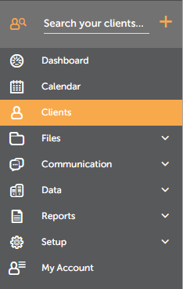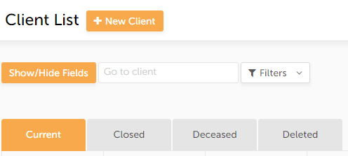

Clients can be sorted alphabetically by using up and down arrows next to Name.
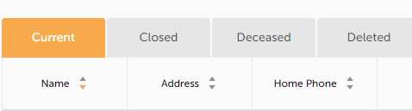

Clients for each buddy can likewise be sorted by using arrows next to Case Manager.

Past, deceased and deleted clients can be searched by pressing on appropriate tabs. Past and deleted clients can be re-opened and made current.

MAKING CLIENTS CLOSED OR DECEASED – CASE STATUS

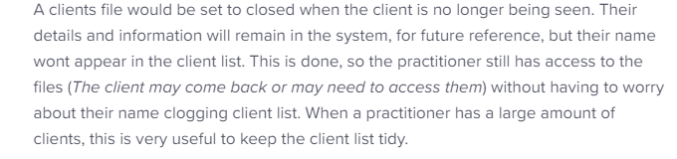

Highlight Details/Referrers under Client’s name

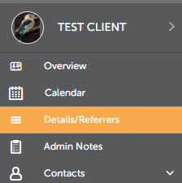

Then in Other Details field go to Case Status and choose arrow on Current drop down box and choose either Closed or Deceased.

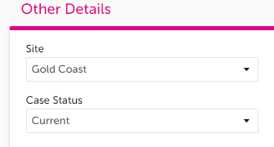

ADDING NEW CLIENTS

***IMPORTANT*** Before adding new client, search name in case they are still in the system as closed or deleted. If so, open and make active again.

Firstly to check for status, type client’s name in the Client List, Show/Hide Fields. See below.

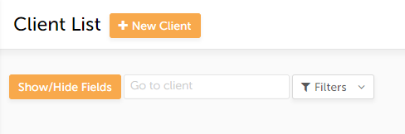

There are several ways to add new clients.

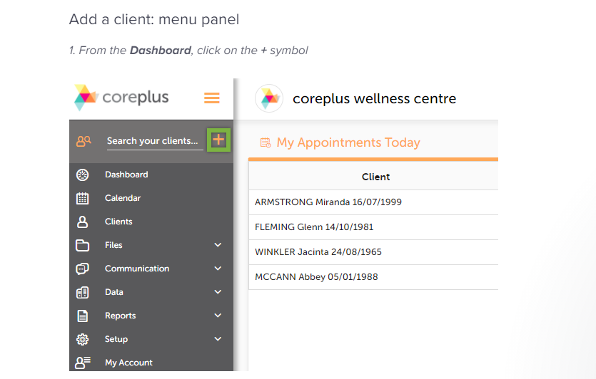

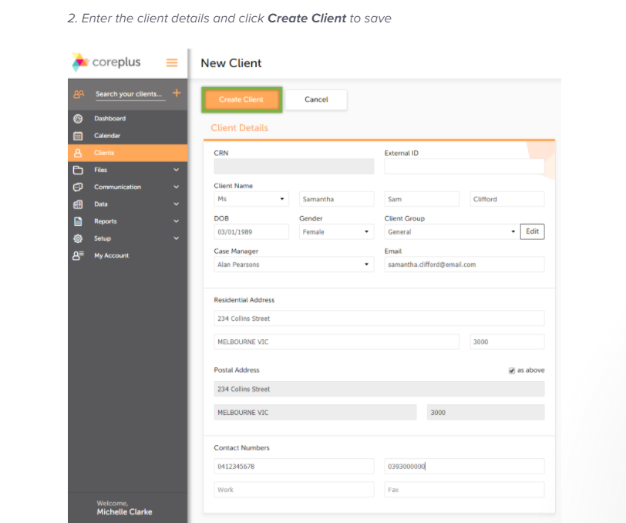

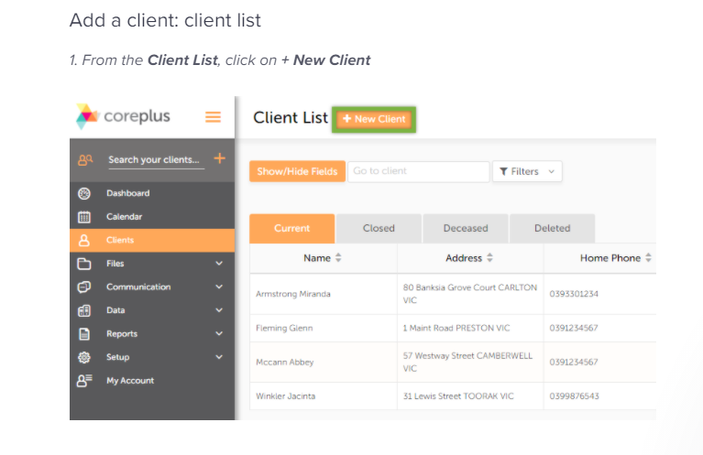
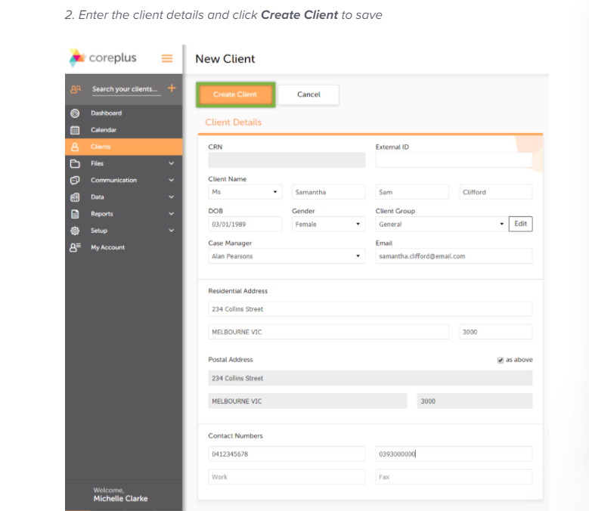

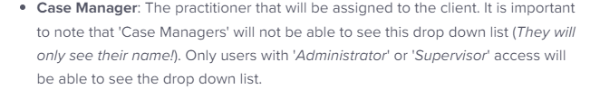

NOTE: Case Manager is the Buddy for AIC purposes

USER TYPES

Supervisor has full access to the account and the ability to make system and account changes. Can view all clients, modify system setting such as sharing permissions and user details.

Case manager (Buddy) can only view their own client details but shouldn’t have access to view all client files or be able to access system setting.

ADDING CASE MANAGERS (BUDDY)

Go to My Account and Click on Add User

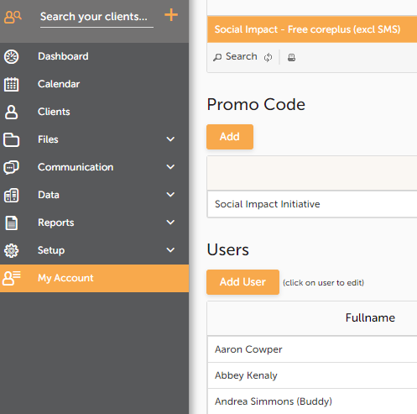

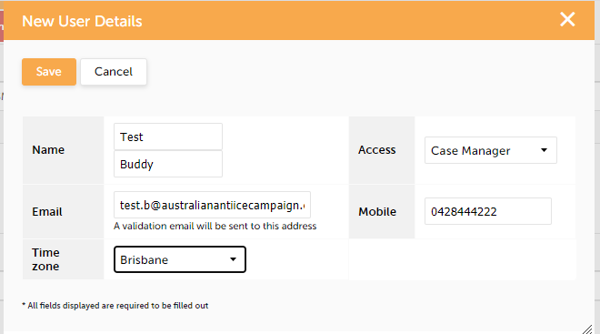

After adding personal details, including individual’s mobile number and email, Save. A notification will be sent via text message to the individual for them to activate.

Case Managers can be made Inactive when no longer current. To Edit User Details, click on their name which will bring up the following screen. Change to Inactive and Save They can also be changed back to Active if necessary.

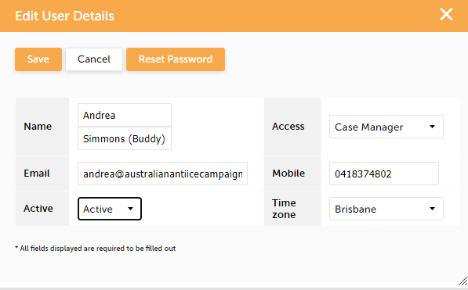

ACCESS AND CLIENT SHARING

Client sharing enables another User to have access to one of or all of another User’s clients.

Every client has an allocated case manager to their file. By default, a case manager can only view clients to which they are allocated. Client Access and Client Sharing enables the sharing of single client files or entire case loads between Case Managers.

Only a Supervisor can view and edit Client Sharing permissions.

The Client Sharing Settings should be set as follows: NO to all other users but Australian Anti Ice Campaign

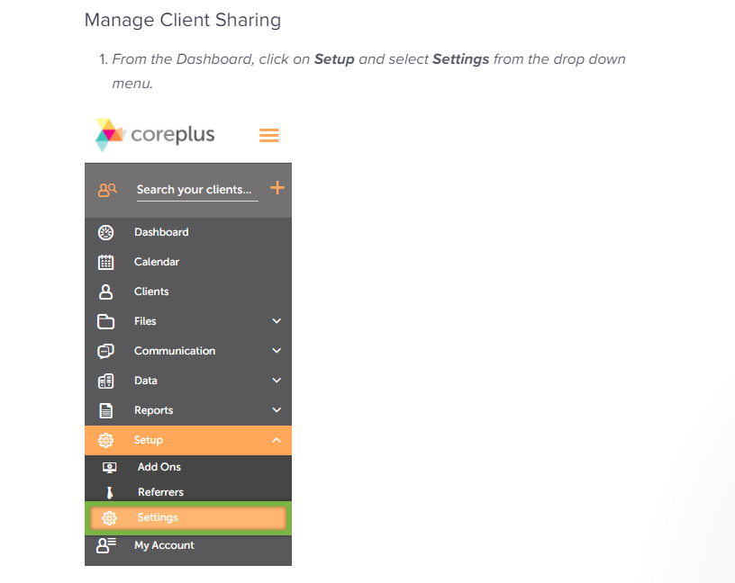
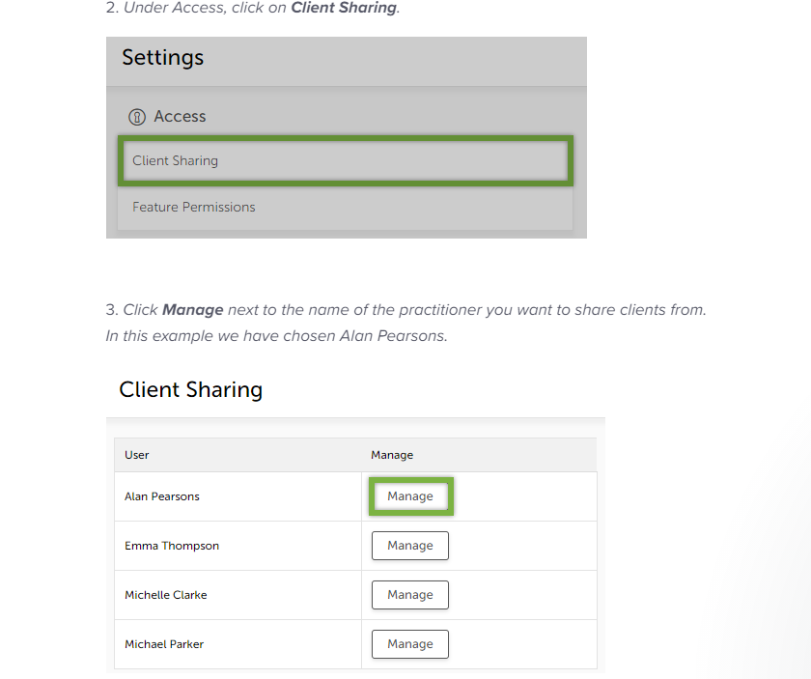
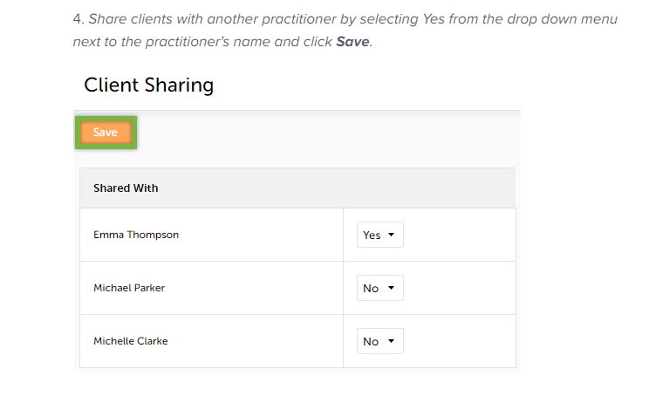
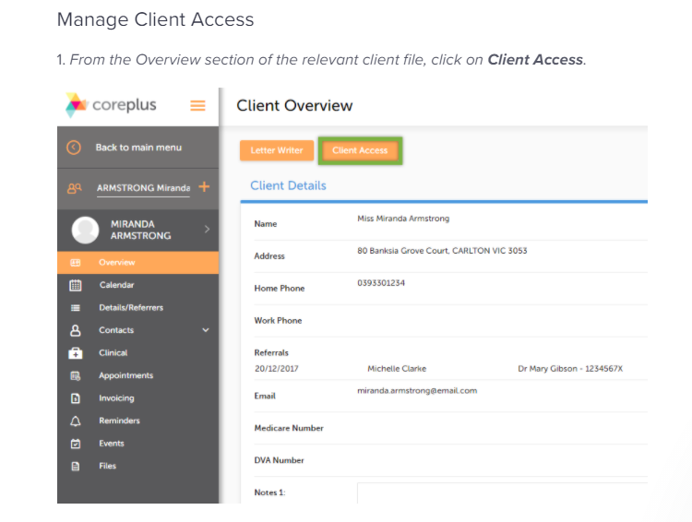

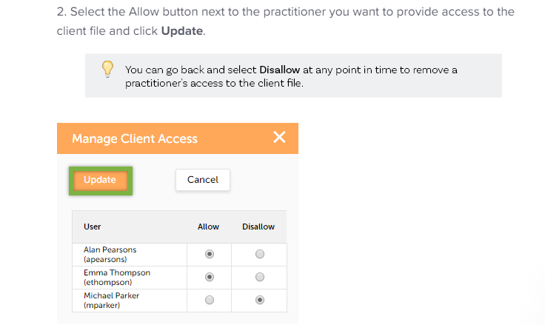

FEATURE PERMISSIONS

Restrict or allow users to access certain features of Coreplus.

The Feature Permissions Setting should be set as follows: NO to all other users but Australian Anti Ice Campaign.

Click on Setup then Settings.

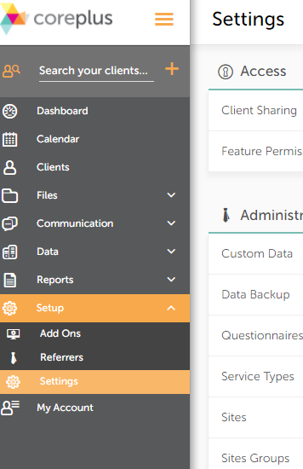

Select Feature Permissions

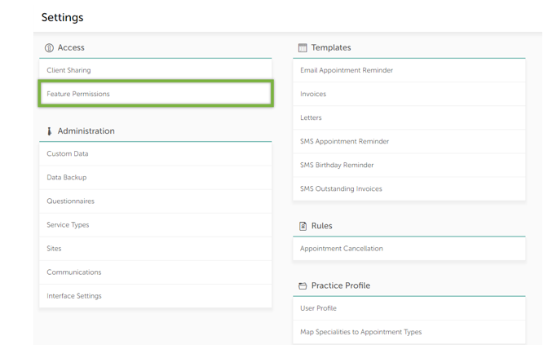

Select Manage next to the User’s name

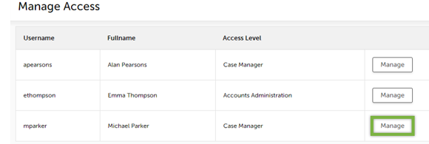

Set the options and click Save Permissions

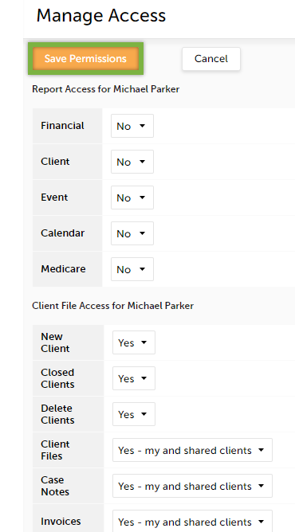

ADDING BUDDY CONTACT NOTES TO CLIENT

Go to client. Click on clinical. Copy or type in notes from Buddy spreadsheet and paste into Case Notes. Can be saved as a draft for editing or adding onto at a later stage or Save & Finalise. It will then show up under the right column under Case notes history.

