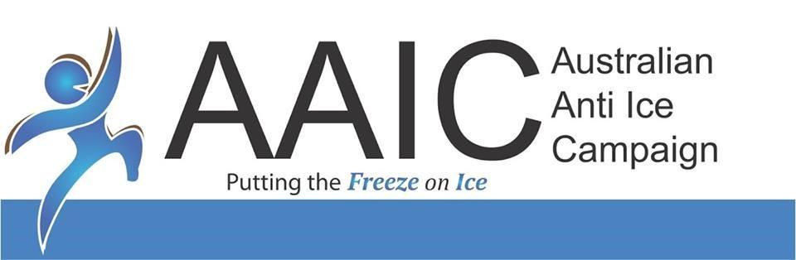

08
Fall
ABN: 56 609 511 695



AAIC Community Ice Action Team (AAIC CIAT) Operations Manual

Social Media and Marketing

Procedures Manual

April 2021
TABLE OF CONTENTS
1. Introduction. 3
2. Team Roles & Responsibilities 3
3. Social Media Accounts 3
4. Answering Online Enquiries 4
5. Questionable Content 4
6. Let’s Talk About Ice 4
7. Other Guidelines for Social Media Coordinator and Volunteers 5
8. Marketing Materials 6
9. Colour Scheme 7
10. Improper Use & Abuse of Logo 9
11. Canva 9
12. Copyright, Confidentiality, and Privacy 9

- Introduction.
This policy provides guidance for employee/volunteer use of Australian Anti Ice Campaign social media accounts and marketing department, which should be broadly understood for purpose of this policy to include blogs, chat rooms, electronic newsletters, social networking sites, and other sites and services that permit users to share information with others in a contemporaneous manner.
- Team Roles & Responsibilities
The Social Media and Marketing Head is responsible for providing marketing strategy and plan for the organisation with the approval of the CEO. Other responsibilities include:

- Daily/regular posting and engagement on our social networking sites.
- Creating content pillars for our social media.
- Monitoring of social media accounts
- Running ads for the organisation with the CEO’s approval.
- Creating marketing materials
- Monitoring of Let’s Talk About ICE Show
- Social media training for other volunteers (only if needed)

Please note that the Social Media & Marketing Head and AAIC volunteers do not have the authority to answer or make a statement on behalf of the organisation to big media outlets such as TV, Print, Radio, and/or other marketing channels unless told and given authority by the CEO.
- Social Media Accounts
Australian Anti Ice Campaign has accounts on the following websites:

Facebook - www.facebook.com/australianantiicecampaign
Instagram
- @australianantiice (Official Instagram Account)
- @aaic.2 (Secondary IG Account)
Youtube - Australian Anti Ice Campaign
Twitter - @austantiice
LinkedIn - Australian Anti Ice Campaign
MailChimp - Electronic Newsletter

In order to gain access to the following accounts, you have to provide our username/email address and password which will be given to you by our CEO. Please make sure that passwords are kept in private. In case of security risk and privacy concerns, talk to IT and the CEO.
As a volunteer and representative of Australian Anti Ice Campaign, you are expected to demonstrate best practices and appropriate behaviour on social media, including but not limited to the following:
- Be respectful to all
- No hate speech
- No releasing of company private information
- Be mindful of what you post and always for the best interest of the company, the volunteers, and our clients.
- Answering Online Enquiries
The Social Media and Marketing Head should answer comments and messages in a respectful manner. This will increase engagement and brand awareness. If another party enquires for a potential collaboration and partnership with our organisation, inform the CEO.

The Social Media and Marketing Head is not responsible for answering messages about Family Support, Buddies, etc, that involves intervention and reaching out to clients who are asking for help and support. Such queries should be directed to the Care Team and counsellors.
- Questionable Content
The Social Media and Marketing Head and other volunteers are expected to do the following when coming across misinformation, news leaks, confidential information, or other questionable content regarding the company social media:
- Escalate the concern to the CEO and Legal Team
- Do not answer or make a comment in behalf of the organisation
- In case we need proof, make sure you have a copy or a screenshot of the statement to protect our end.
- When in doubt, do not post or comment unless approved and given authorisation by the CEO & Legal Person.
- Let’s Talk About Ice
Let’s Talk About ICE is a weekly online talk show of Australian Anti Ice Campaign that is broadcasted LIVE on our Official Facebook Page every Thursday at 7:00 pm (AEST). The show is hosted by the State Team Leader (ex. Gold Coast HQ - Andre’a Simmons, Coff Harbour - Jose Porcia, etc).

The objectives of the show are the following:
- To highlight that there’s a good life after ICE and that change and recovery is possible.
- A medium for lived-experienced to share their journey and to help people not to touch the drug ICE.
- To let people know that drug addiction happens to every type of person (rich, poor, someone who came from a happy family and someone who isn’t) and it’s not always the same for everyone.
- A venue for our audience to ask questions and come forward and seek help

Our target audience are:
- People in addiction or in recovery
- Family members who are looking for support
- People who are curious about this drug

The Social Media and Marketing Head is responsible of the following:

Pre-Live
- Delegating show schedules to different states and teams.
- Coordinating guests and interviewees with the help and assistance of other lived-experienced volunteers.
- Briefing the host and guest of the flow of the program
- Preparing notes and list of acknowledgements of sponsors
- Camera framing and making sure that internet connection is stable.

During Live
- Answering and engaging with viewers on comment section
- Making sure that we are on time
- Providing questions in case the host runs out of topics.

Post-Live
- Posting of video with appropriate title and caption.
- Tagging of interviewee on the post.
- Uploading the video on our Youtube Account.

Let’s Talk About ICE Show Disclaimer: “The views, thoughts, and opinions expressed on the show by our guest belong solely to our guest, and do not represent the opinion of the host, the show, and the organization.”

For the show’s template and other information, look for Let’s Talk About ICE Template on our Shared Drives.

- Other Guidelines for Social Media Coordinator and Volunteers
When do I need approval to post a message on social media?

You will need approval when posting information about events, organisation’s activities and information, and other posts that you think may trigger clients’ recovery. Overall, when in doubt, ask the CEO of the second in command of their input to your post. Please refrain from posting any religious beliefs on behalf of AAIC. However, ex addicts who would like to share their story that would involve religion are welcome to do so.

What should I do on social media during a PR crisis?

In case of any legal complaints or PR crisis, escalate the concern to the CEO and Legal Personnel. Avoid making a statement without their approval. Make sure you have a copy of the complaint for proof and a backup in case it will be needed.

How do I comply with copyright law on social media?

Before posting a content that would involve other materials from different companies, make sure it is not copyrighted or if not ask for permission from the owner. We are using free images online that can be found at www.unsplash.com . For more information about Australian copyright and advertising laws, visit www.ipaustralia.gov.au and www.accc.gov.au

The following principles apply to professional use of social media on behalf of Australian Anti Ice Campaign as well as personal use of social media when referencing Australian Anti Ice Campaign.

- Employees and volunteers need to know and adhere to the Company’s Code of Conduct and Volunteer Handbook when using social media in reference to Australian Anti Ice Campaign.
- Employees and volunteers should be aware of the effect their action may have on their images, as well as the organisation’s image. The information that employees and volunteers post or publish may be public information for a long time.
- Employees and volunteers should be aware that AAIC may observe content and information made available by them through social media. They should use their best judgement in posting material that is neither inappropriate nor harmful to AAIC, its employees, or volunteers.
- Although not an exclusive list, some specific examples of prohibited social media conduct include posting commentary, content, or images that are defamatory, pornographic, proprietary, harassing, libelous, or that can create a hostile work environment.
- Employees and volunteers are not to publish, post, release any information that is considered confidential or not public.
- If an employee or a volunteer encounters a situation while using social media that threatens to become antagonistic, they should disengage from the dialogue in a polite manner and seek the advice of a supervisor.
- Marketing Materials
Logo Use and Identity Application Guidelines

Consistent and proper use of AAIC Official Logo can aid all as partners in effort to promote the importance of our mission in the organisation. These are just guidance to put consistency and uniformity in our marketing materials. This is to provide identity standards, consistency, and quality control.

Below is the official Australian Anti Ice Campaign Logo. The logo is to be used and visibly recognizable on all media including print, digital, and environmental. This logo is located in the company’s shared drives on Google.

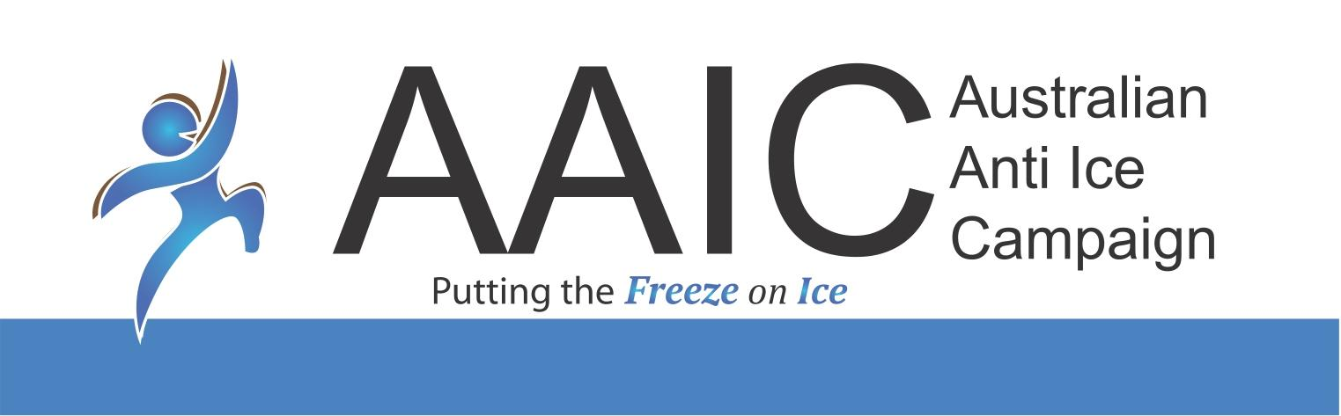
(Australian Anti Ice Campaign Official Logo)

Below is another AAIC Logo without the border and background.

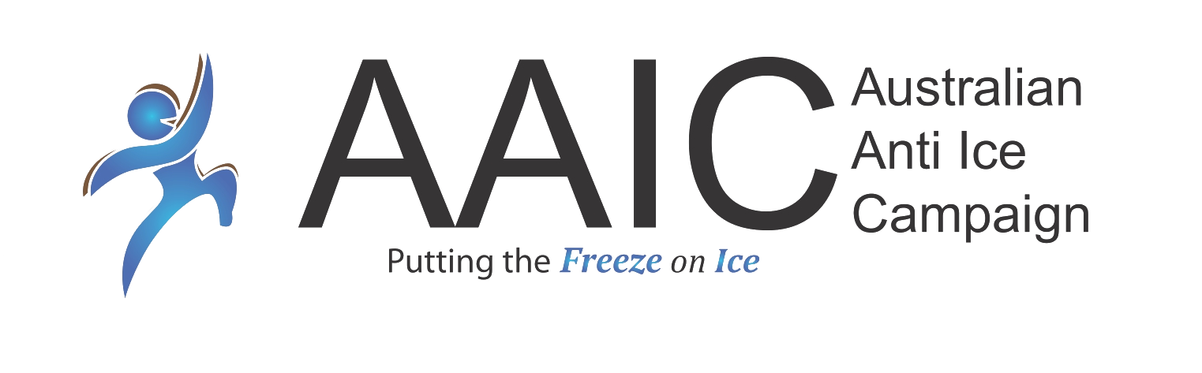
Not Even Once Logo

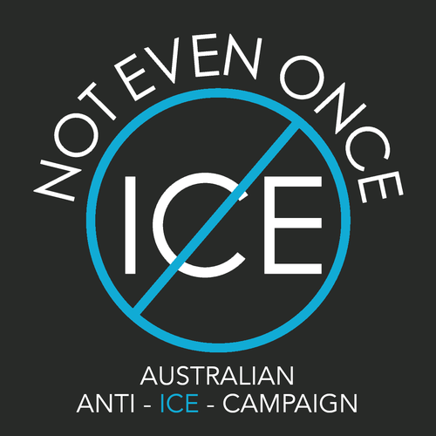
(This can be used without the black background)
- Colour Scheme
The primary logo colour is an important part of the logo as they represent the full spectrum of AAIC. Through print methods and screen renderings will have variances, the colour patterns below are meant to serve as a guide for colour consistency.

Primary Colour


HEX - #4b83c0
RGB - 75,131,192
CMYK - 73,42,2,0
Logo Colour Palette
(Based on our Official Logo)



HEX:#4c84c3  RGB:  76,132,195 | HEX: #e0e7ea  RGB:  224, 231, 234 | HEX: #373636  RGB:  55, 54, 54 | HEX: #4e6caf  RGB:  78, 108, 175 | HEX: #9ab1ca  RGB:  154, 177, 202



HEX: #8b8a89  RGB:  139, 138, 137 | HEX: #98cae7  RGB:  152, 202, 231 | HEX: #46a8d4  RGB:  70, 168, 212 | HEX: #947f6e  RGB:  148, 127, 110 | HEX: #3ebae4  RGB:  62, 186, 208

Colours complementing primary logo colour
(Please note that these colours are only a guide for creating designs for social media and marketing materials.)

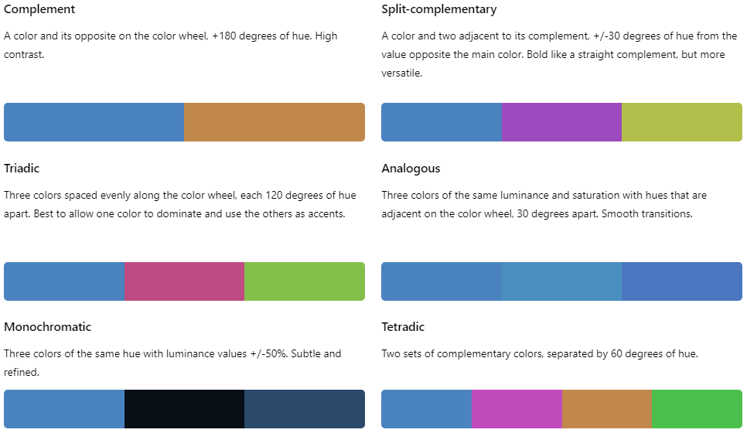

(Photo from: www.https://imagecolorpicker.com/en)

- Improper Use & Abuse of Logo
- Do not change colours.
- Do not rotate or adjust symbols.
- Do not change font, type case, or text orientation.
- Do not drop organisation’s name.
- Do not change orientation.
- Do not adjust proportions.
- Do not stretch or squish the logo.
- Do not create bevels or other visual elements.
- Do not crop the logo.

- Canva
Our organisation is granted by Canva 10 premium accounts. Simply log in to www.canva.com using your email address to join the AAIC Team.

- Copyright, Confidentiality, and Privacy
To avoid copyright or trademark infringements, always comply with copyright law on social media especially when using third-party content. Privacy is key. The Privacy Act 1988 (Privacy Act) is the principal piece of Australian legislation protecting the handling of personal information about individuals. This includes the collection, use, storage and disclosure of personal information in the federal public sector and in the private sector. Please make sure that any information collected should be kept in private and with confidentiality. Confidentiality refers to respecting your organization’s internal information. Whether you have your people sign non-disclosure agreements or not, they should be aware of the ramifications of disclosing information on social media that the organization considers private.

If in doubt, please talk to our legal counsel or visit www.accc.gov.au for more information.

