Assignment 6

Program 1:
Write a code for implementation of the PIPE IPC and write the complete working of it.

Obervation:

1. In this program one file descripter is used fd[2] have size 2 here
fd[0] ----> read
fd[1] ---->write

2. Create fork() which will create parent and child process store in a variable ret.

3. When ret == 0 which means we are in child process, In this we are performing writing operation while performing operation close fd[0]--->read and
fd[1]---->write must be open use write system call

write(fd[1],&buff,strlen(buff)
After writing close the fd[1] -----> write.

4. When ret > 0 it is in parent process, In this we are performing reading operation while performing close the fd[1] -----> write and open the fd[0] ------> for reading

(read(fd[0],&buff,sizeof(buff))
After reading close the fd[0] -------> read

5. In unnamed pipe while read we have to close the other end of writing and while writing we have to close other end of reading.

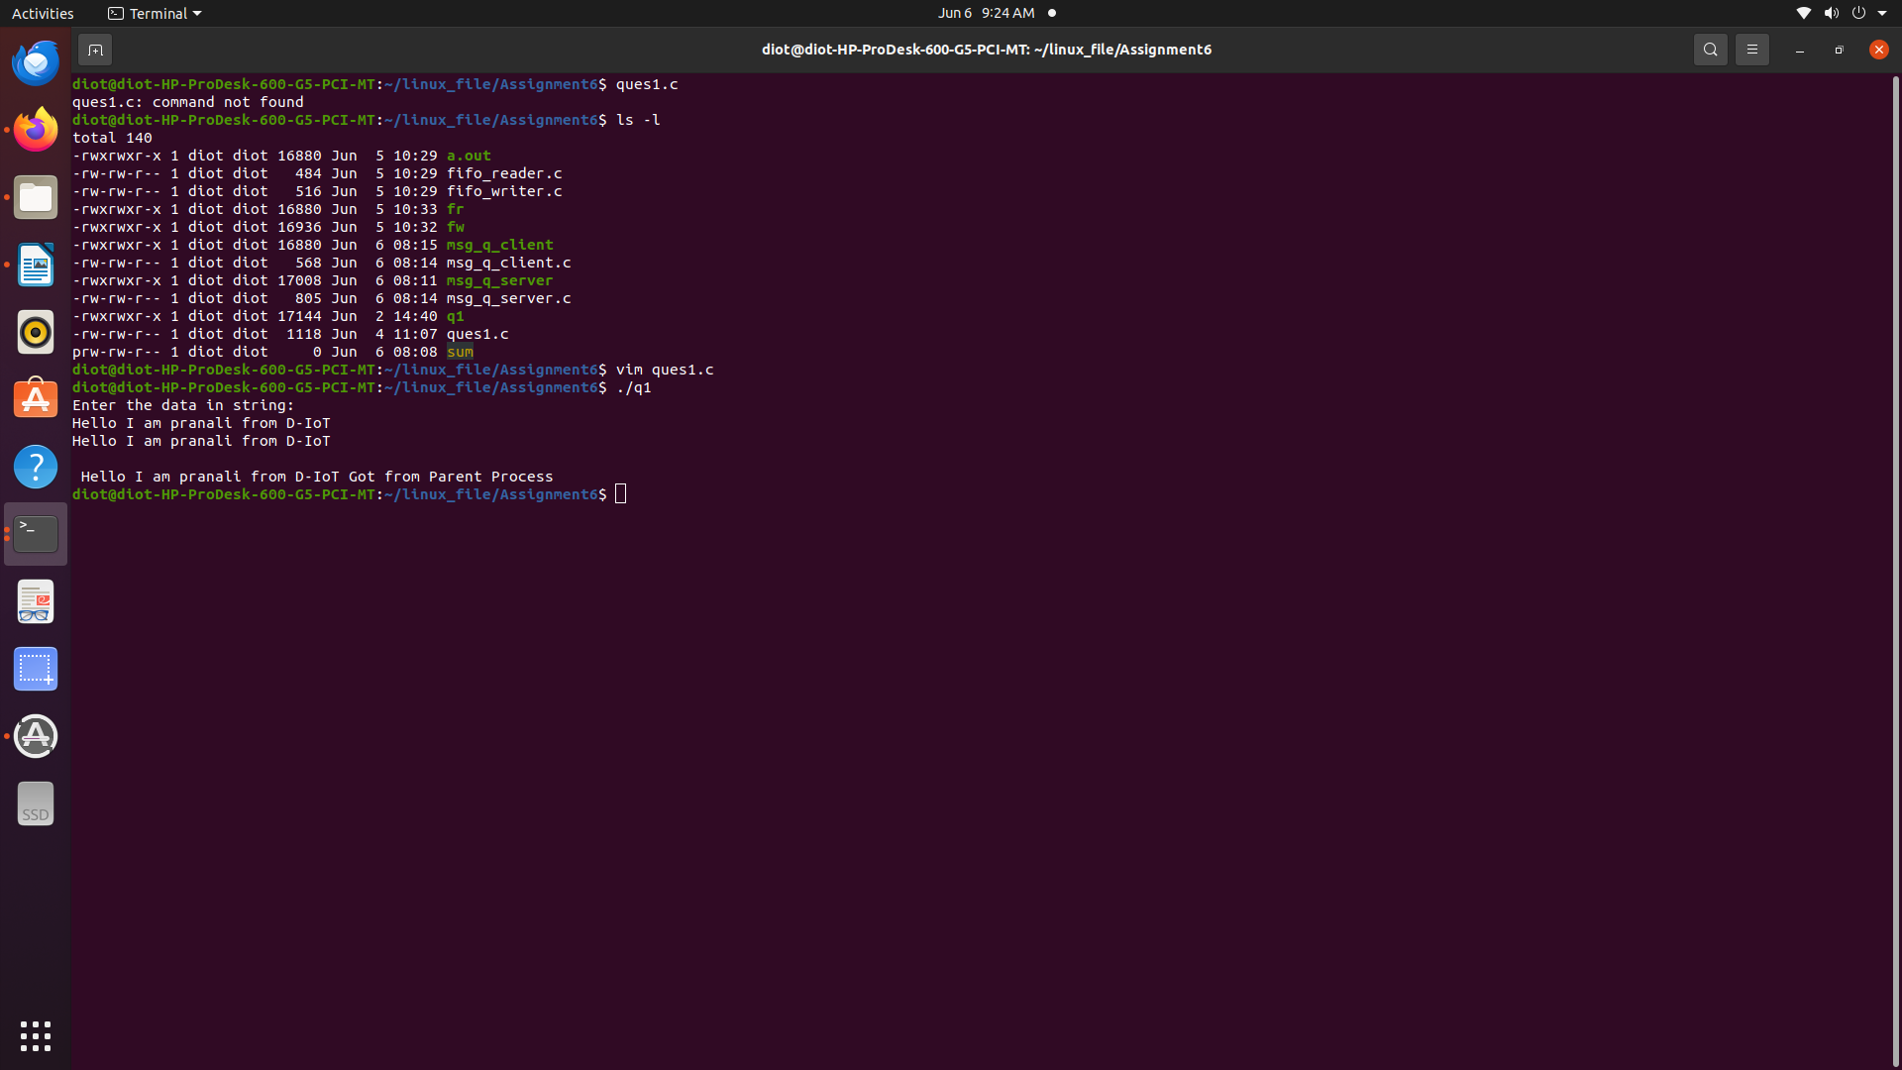

Program 2:
Write a code for implementation of message queue IPC and observe its working. Write down its observations.

Obervation:

1. I had use the library

#include <sys/ipc.h>
#include <sys/msg.h>

2. Create a common key

#define KEY 1552

3. Create a structure , in this initialize mtype as int mtext as buffer

Sending data from server end

4. I had use msgget system call and assign it to a variable

msgget(KEY, 0666 | IPC_CREAT)

Store the data in enter data in buffer
strcpy(msg.mtext,buff)

5. Pass the msessage from sever end use msgsnd() system call

msgsnd(msg_q_id,&msg,sizeof(struct message)

Receving data from client end

6. For receving data from server end use msgrcv() system call

msgrcv(msg_q_id, &msg, sizeof(struct message), 1, 0)

7. The data which has been writing by server end automatically store in msg.mtext with the use of same KEY value which been use in server and client side

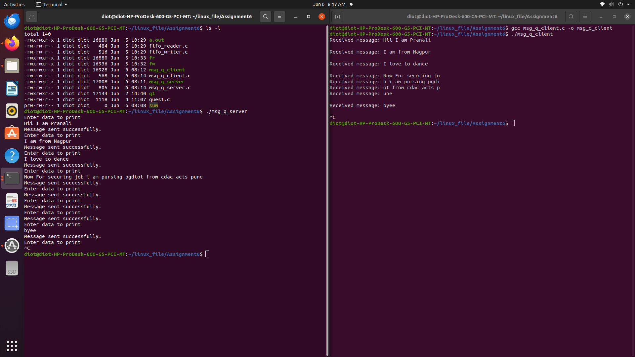

Program 3:

Write a code for implementation of the shared memory IPC.
NOTE : Use Mutex and semaphore wherever it is required to avoid the race conditions and deadlock
Obervation:

1. Include some library’s to create shared memory and semaphore

#include <sys/shm.h>
#include <sys/sem.h>

2. Here i had define some macro for

Shared Memory Size --------> #define SHM_SIZE 1024
Semaphore Key ---------------> #define SEM_KEY 0x1234
Shared Memory Key ----------> #define SHM_KEY 0x5678

3. Create a function handleError() to handle the error

Writer code

4. To create shared memory use shmget() system call

shmget(SHM_KEY, SHM_SIZE, IPC_CREAT | 0666)

5. To attached shared memory use shmat() systemcall
shmat(shmid, NULL, 0)

6. To handle the process in share memory i had use semaphore to create semaphore use semget() system call

semget(SEM_KEY, 2, IPC_CREAT | 0666)

7. To initialize semaphore use semctl() system call

semctl(semid, 0, SETVAL, 1); //writer semaphore
semctl(semid, 1, SETVAL, 0); //reader semaphore

8. After initializing semaphore you need to lock the semaphore for writer -----> 0
Here create a structure sembuf sb as array which contain 0, -1, 0

9. To apply operation in semaphore use semop() systemcall

semop(semid,&sb,1)

10. Then write the data in shared memory address

11. To unlock semaphore in reader -----> 1

sb.sem_num = 1;
sb.sem_op = 1;
semop(semid, &sb, 1)

12. Then wait for reader to read data

sb.sem_num = 0;
sb.sem_op = -1;
semop(semid, &sb, 1)

13. After completing the process detach the shared memory and semaphor

Detache share memory buffer ----->shmdt(shmaddr);
Clear the shared memory-----------> shmctl(shmid, IPC_RMID, NULL);
Clear the semaphore ----------------->semctl(semid, 0, IPC_RMID, 0);
Here RMID ------------------> command to mark the shared memory segment for deletion

14. In Reader process

15. Same create the shared memory, attached shared memory, get the semaphore

16. Read the data store in shmaddr address

17. Unlock the semaphore 0 for writer
set
sem_num = 0
sem_op = 1
semop(semid, &sb, 1)
Size of sb
semaphore id

Address of token

18. Detach the shared memrory

shmdt(shmaddr)

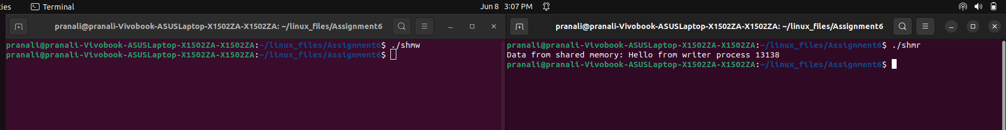

Program 4:
Write a code for implementation of the NAMED PIPE IPC.

Obervation:

1. Create a pipe file as sum using

mkfifo sum

2. Create fifo_writer.c file and the file should be in O_WRONLY mode in which you are sending the data in named pipe both read and write end are open

3. Open the file and write code to enter two number in array

4. Create fifo_reader.c file here you are receving the data from writer end the file should be in O_RDONLY mode.

