Assignment :- 04

Practical no : 1

Create 5 children processes from a common parent and ensure that the
parent terminates after cleaning all the terminated children using waitpid().
The waitpid() must be called after all the children are created
and the parent has completed its work real work,if any. You must interpret
the exit code of the cleanedup processes, using waitpid(), in parent process

Observation

1. Include <sys/wait.h> library for waitid() system call.

2. By using while loop 5 child are created with the help of fork() system call assign fork() to a variable ret.

3. There are three conditions
A. If ret < 0
No process exceute.
B. If ret == 0
Only child process exceute.
C. If ret > 0
Only parent process exceute.

4. Now check if the child process is exceuted successfully

5. Check ret > 0 Here parent will check if the child is terminated or not

6. Use while(1) loop so that the process run contineously

7. Under while loop use waitpid system call and assign to ret variable

ret = waitpid(-1,&status,0)

Wait for any child process
State
Options

A. If ret > 0
- Use of WIFEXITED(status) it is use to process terminate normally
- Use of (WEXITSTATUS(status)) print meassage process terminated normally or not.

B. If ret < 0 then directly exit the process.

8. After exceuteing the program it show that 5 child process get exceuted and each child process parent process get exceuted.

9. To terminate each child process we need to see the launch child process for type htop command in terminal.

10. The 5 child process are in running to terminate them select each child process select F9 them select SIGKILL command.

Output:
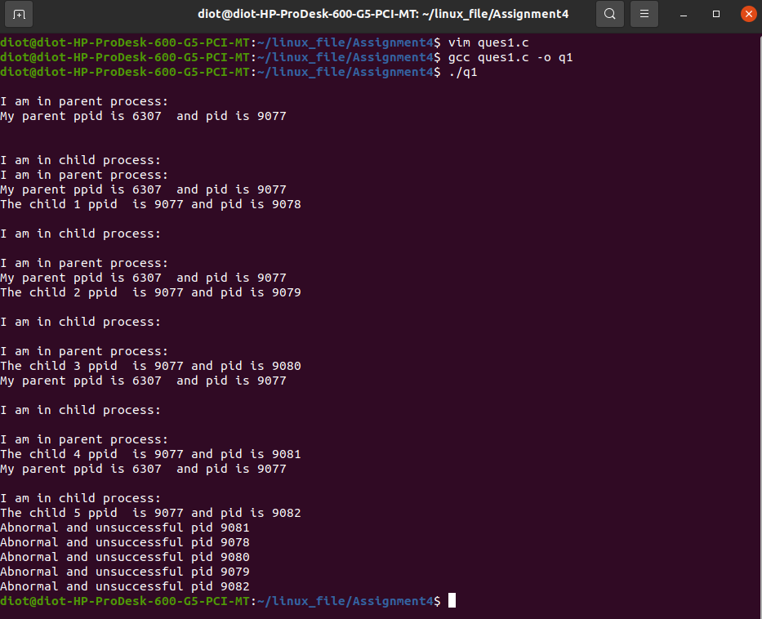

Launch Process
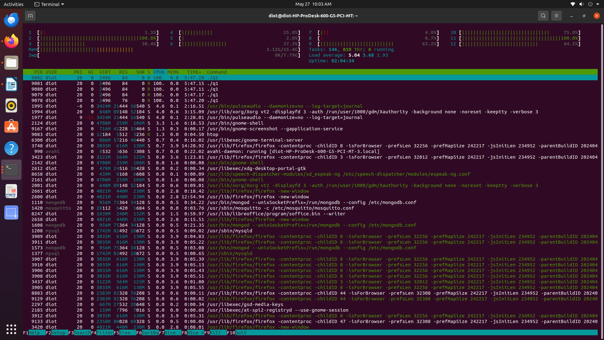

SIGKILL

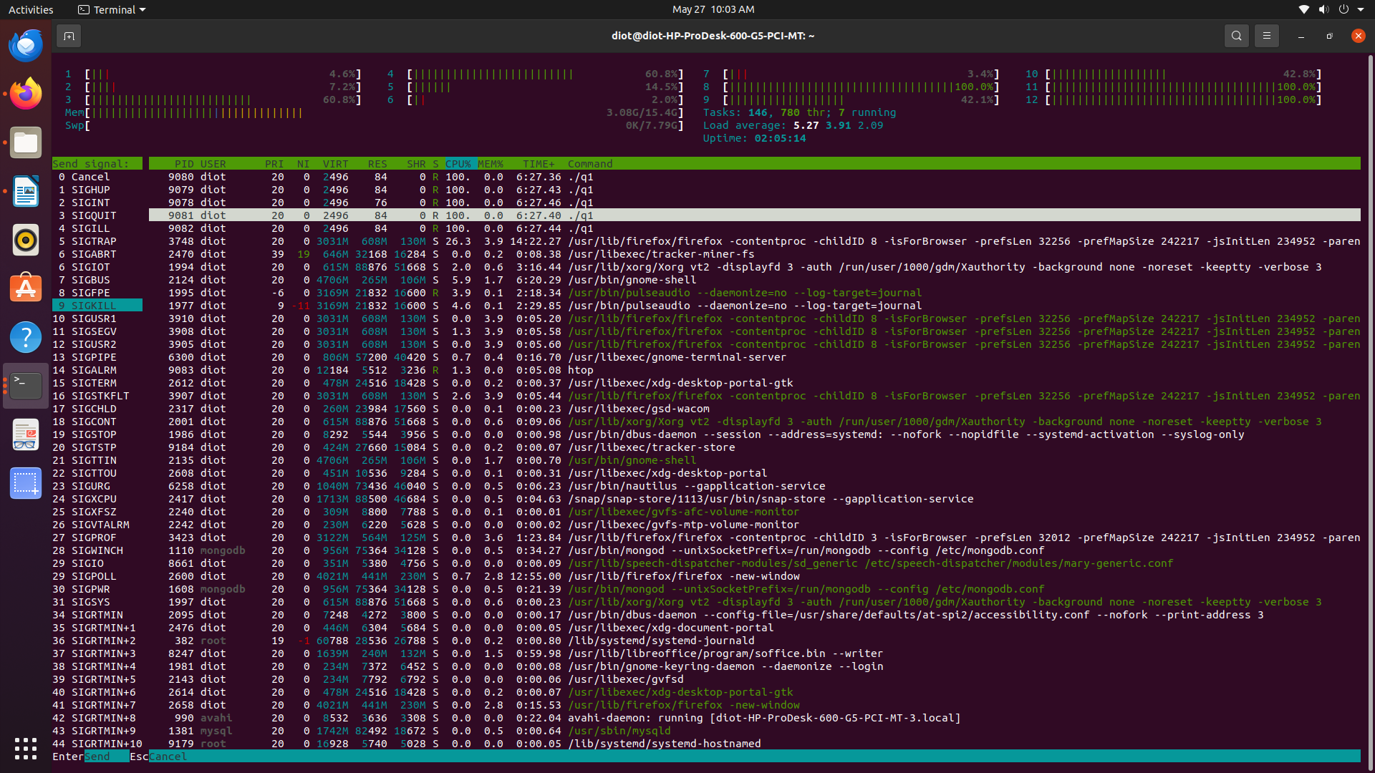

After terminating each child process

Practical no : 2

Create a 5 child process from a common parent and launch different
applications from the children processes you may launch pdf viewer,
kwrite, gcc, and w1(based on while1.c) parent process must use waitpid()
to collect the termination status of the child process waitpid()
must be called after all the children are created and the parent has
completed its work real work,if any. You must interpret the exit code of the
cleanedup processes, using waitpid(), in the parent process
– you must cover all the possible scenarios
meaning, terminate the children processes normally(successful/
unsuccessful) or abnormally !!!

Observation

1. To launch process i had use execl system call

execl(Pathname, appname,name_of_file,NULL)

eg:
execl("/usr/bin/evince","evince","MasteringSTM32-1.pdf",NULL);

2. Here i observe when i use while(1) in termination of child i need to forecbily sigkill the child
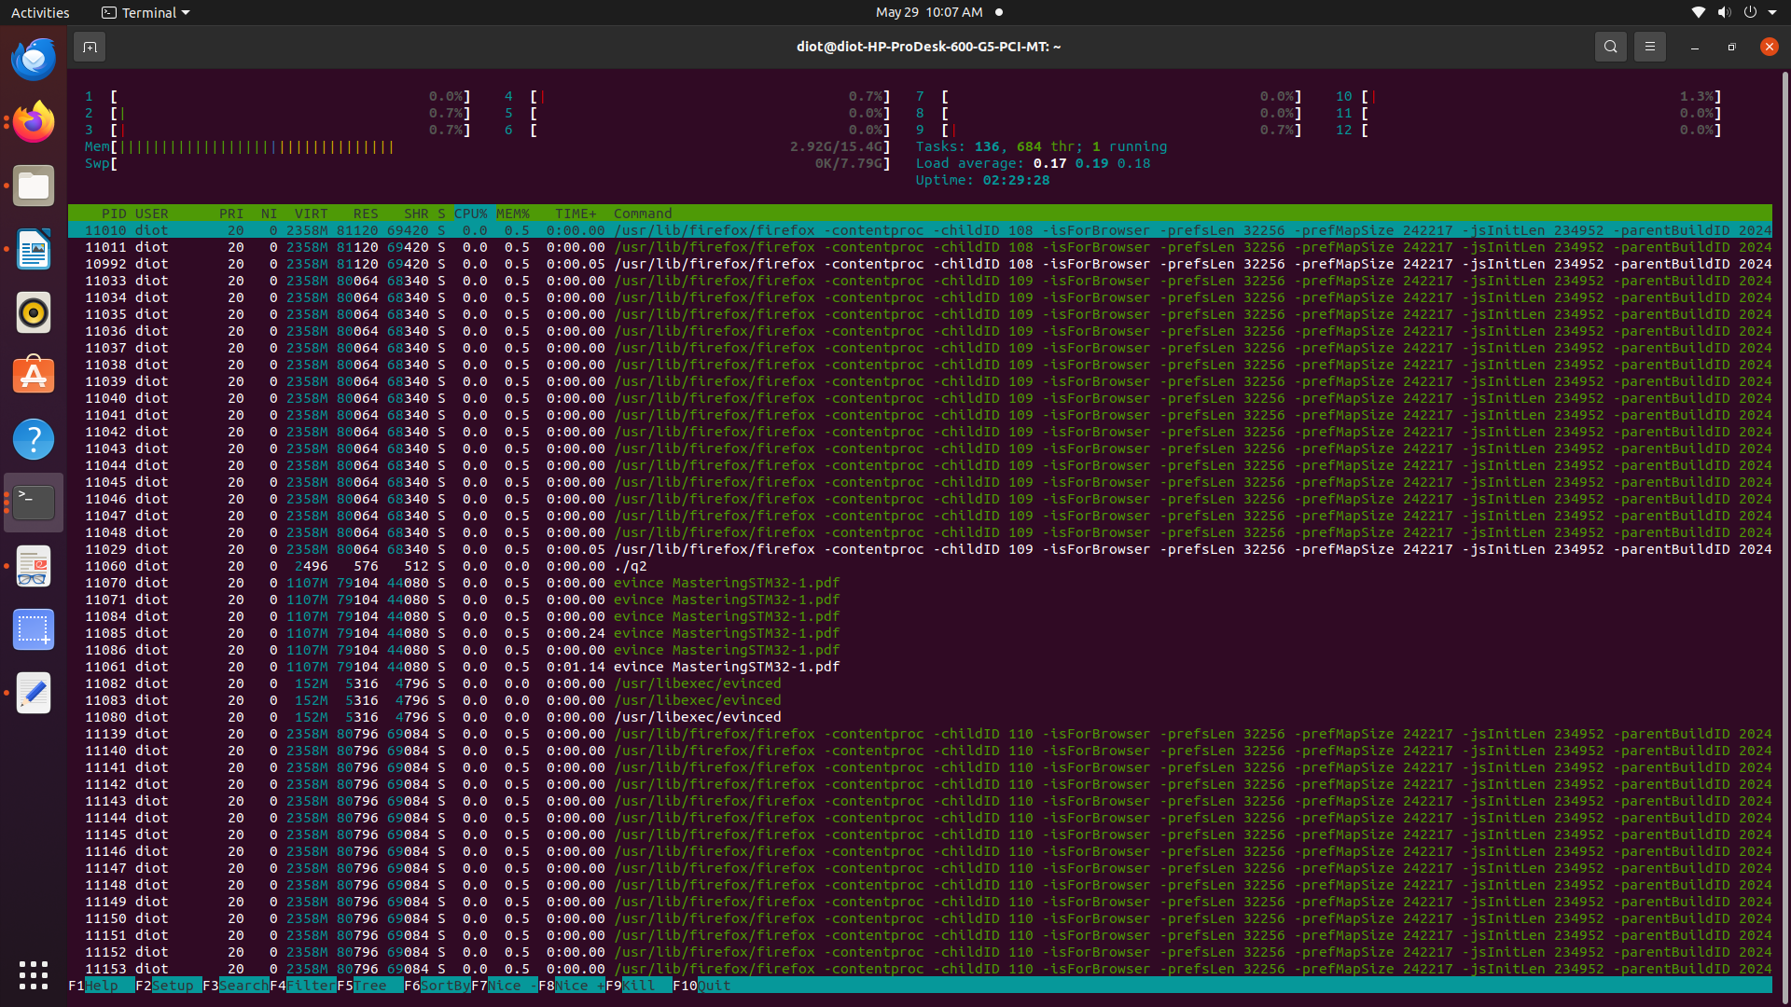

When you terminate each task forcibly automatically each task terminated.

Vim editor show

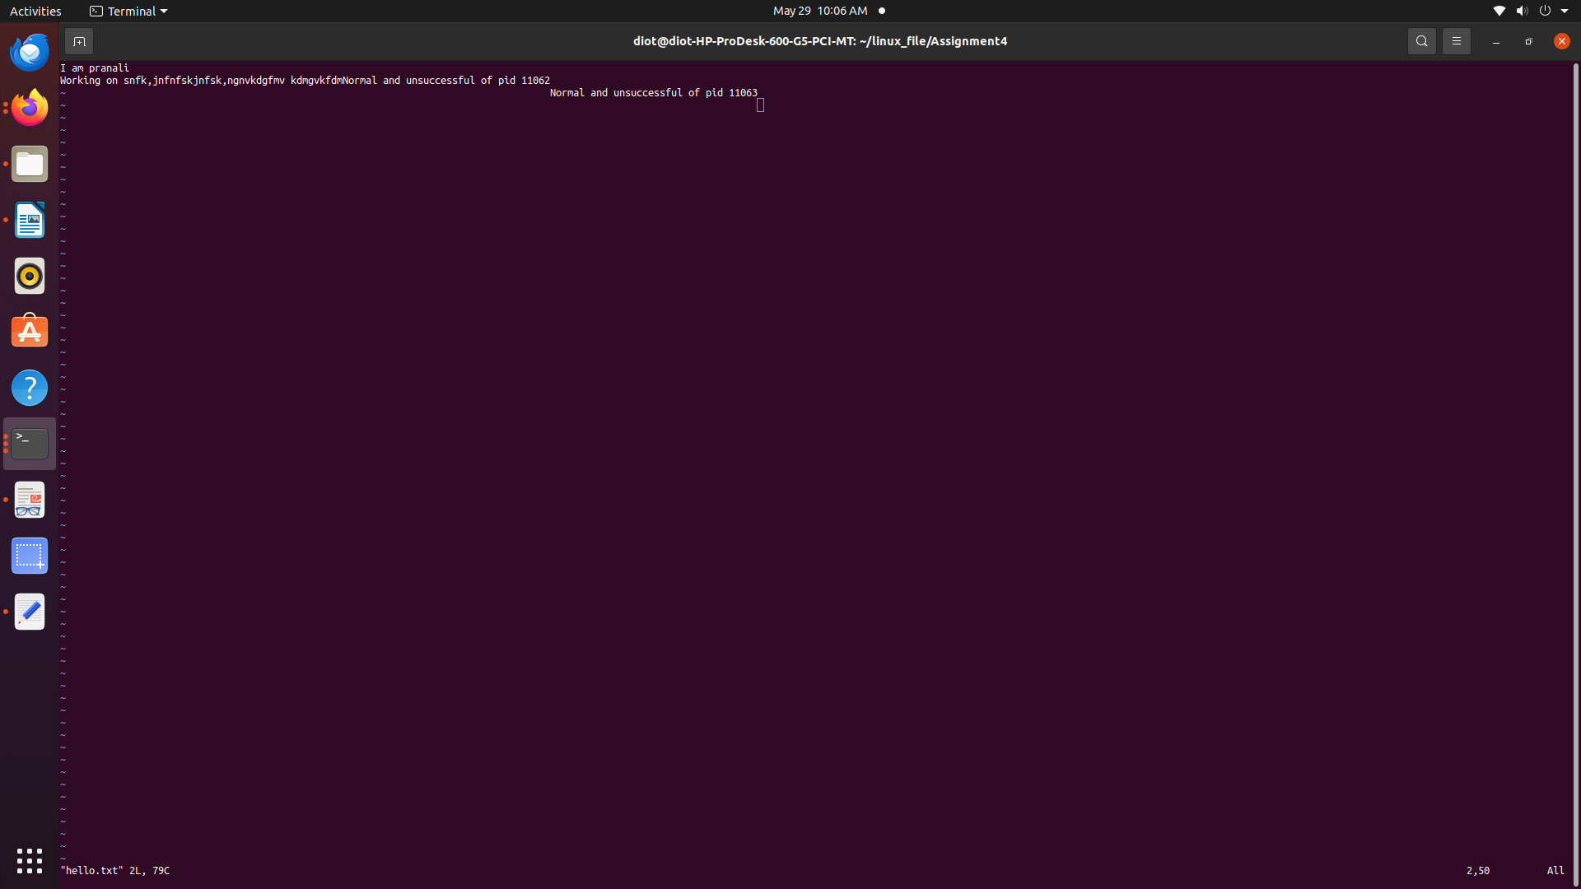
after closing the pdf it show

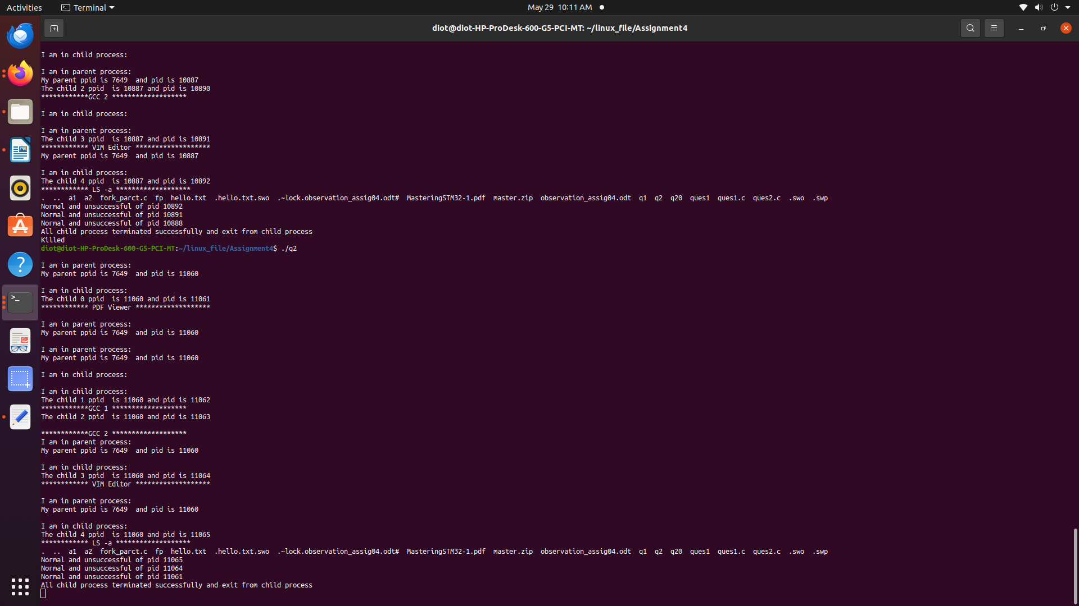

After closing q2 from htop
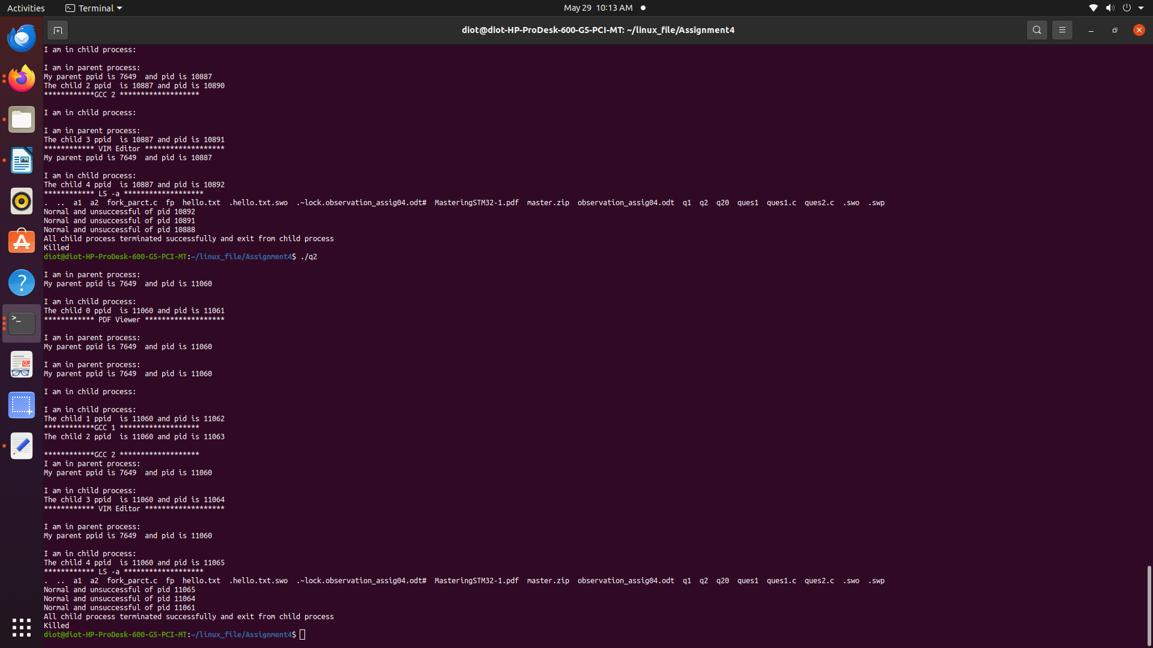
If we use while loop we don’t need to forecibly terminate the process

vim editor show both the proces gcc1 and ggc2 terminated

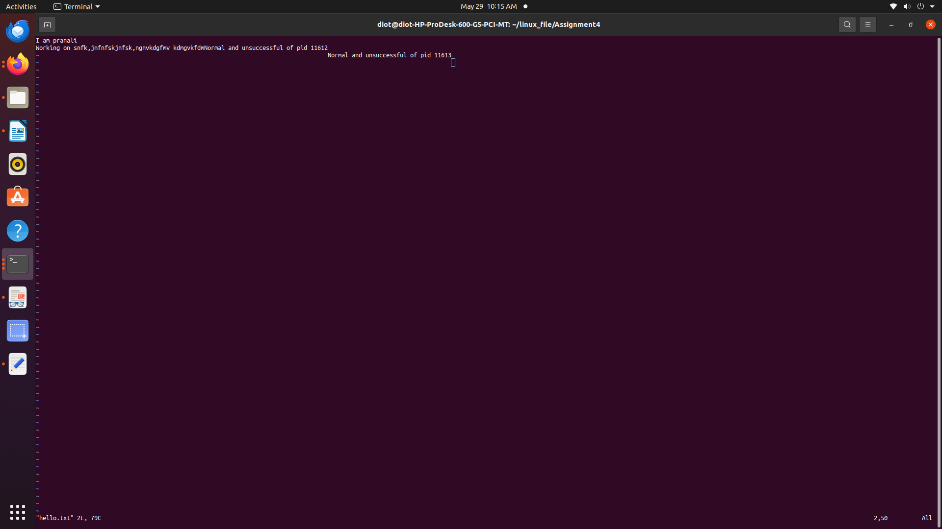

when we terminate the vim and pdf it terminate the process
and show how it terminated

Practical no : 3

Create 5 processes from a common parent and ensure that the parent
terminates after cleaning all the terminated children using waitpid().
The waitpid() must be called after all the children are created
and the parent has completed its work real work,if any; in addition, you must
compile 5 different program files to in children processes to generate their
respective object files ; the parent process must use waitpid() to collect the
termination status of children processes – based on the exit code information
generated by children processes, link all the object files to
generate the final, linked program/application. In addition, the generated
binary executable must be loaded in a new process, if the linking is
successful !!! Hint – refer to assgn1_4.c

1. I have created my own header file name as “myheader.h” i had declare function and their parameter

eg. filename myheader.h

#include <stdio.h>

int add(int,int);
int sub(int,int);
int mul(int,int);
int div(int,int);

2. Created each function file

add.c

#include "myheader.h"

int add(int num1,int num2){

return (num1+num2);
}

sub.c

#include "myheader.h"

int sub(int num1,int num2){

return (num1 -num2);
}

mul.c

#include "myheader.h"

int mul(int num1,int num2){
return (num1 * num2);
}

div.c

#include "myheader.h"

int div(int num1,int num2){

return (num1 / num2);
}

3. Create a main file where you call the each functions

main.c

#include "myheader.h"

int main(){
int num1 =20, num2 = 10;
printf("Addition : %d\n",add(num1,num2));
printf("Subtraction : %d\n",sub(num1,num2));
printf("Multiplication is : %d\n",mul(num1,num2));
printf("Division is : %d\n",div(num1,num2));

return 0;
}

4. In program you need to launch all the files in excel system call

execl("/usr/bin/gcc","gcc","-c","add.c","-o","add.o",NULL)

execl("/usr/bin/gcc","gcc","-c","sub.c","-o","sub.o",NULL)

execl("/usr/bin/gcc","gcc","-c","mul.c","-o","mul.o",NULL);

execl("/usr/bin/gcc","gcc","-c","div.c","-o","div.o",NULL);

Also launch the main.c file

execl("/usr/bin/gcc","gcc","-c","main.c","-o","main.o",NULL);

5. To launch all the object the in one file you need to create one fork()

6. After termination and checking of child done by parent create one more fork()

7. In it child process create one excel system call.

All binary file in one file final

execl("/usr/bin/gcc","gcc","add.o","sub.o","mul.o","div.o","main.o","-o","final",NULL)

Final is object file of all object files

8. Also check the Current excel called final is terminated successfully or not.

9. Compile the program

10. Complie the ./final object seperately.

