Project Title:-website to create a meme template

Name :-Pranali Shahaji Shivale

Internship type: - web development

College name:-Trinity academy of engineering pune

Branch-Computer

Year:-Third year

Email id:- [pranalishivale20@gmail.com](mailto:pranalishivale20@gmail.com)

**Abstract**

Internet memes have become a widespread tool used by people for interacting and exchanging ideas over social media, blogs, and open messengers. Internet memes most commonly take the form of an image which is a combination of image, text, and humor, making them a powerful tool to deliver information. Image memes are used in viral marketing and mass advertising to propagate any ideas ranging from simple commercials to those that can cause changes and development in the social structures like countering hate speech. This work proposes to treat automatic image meme generation as a translation process, and further present an end to end neural and probabilistic approach to generate an imagebased meme for any given sentence using encoder-decoder architecture.

For a given input sentence, a meme is generated by combining a meme template image and a text caption where the meme template image is selected from a set of popular candidates using a selection module and the meme caption is generated by an encoder-decoder model. An encoder is used to map the selected meme template and the input sentence into a meme embedding space and then a decoder is used to decode the meme caption from the meme embedding space. The generated natural language caption is conditioned on the input sentence and the selected meme template.

The model learns the dependencies between the meme captions and the meme template images and generates new memes using the learned dependencies. The quality of the generated captions and the generated memes is evaluated through both automated metrics and human evaluation. An experiment is designed to score how well the generated memes can represent from conversations.

**Table of Contents**

**1. Introduction**

**2. Existing Method**

**3. Proposed method with Architecture**

**4. Methodology**

**5. Implementation**

**6. Conclusion**

**Introduction**

A meme is defined as an element of a culture or system of behavior that may be considered to be passed from one individual to another by non-genetic means, especially imitation. The memes are composed of ideas and beliefs. Memes have played an important role in the evolution of human life and are the successful behaviors that were and are being used to pass on the essential and important behavioral aspects of life. Understanding what causes a meme to replicate and how it replicates is an important aspect of this study.

An essential or successful meme is the one that has stayed for a long time and passed on or used by the majority of the population. Examples of such successful memes would be language, religion, culture, etc., the evaluation of successful meme or a useful meme depends upon the population evaluating it. An idea that is considered as essential by a set of people may not be considered important by another set of people.

This leads to including the process of replication across population it replicates on as an integral part of the meme study. The process of replication of a meme is an interesting phenomenon which depends upon the process of observation and learning. Since memes are composed of ideas, concepts and beliefs, they are very subjective and their meaning and understanding will vary based on the interpretation. A few memes are replicated in their original form and few memes are subject to variation during the process of replication I.e., the memes mutate during replication based on the interpretation. The memes mutate based on the needs and other diverse set of factors associated with the people spreads across globe.

Another important aspect of memes is their rate of transmission. The rate at which a meme replicates upon factors like its importance, how easy it is to replicate, people it spreads across but the most important factor is the medium it replicates on. The modern era has given birth to a new and powerful medium which is the internet. The internet facilitates the transmission of ideas and concepts instantaneously across the globe and has enabled us to share an idea and opinion by virtue of platforms like social media, blogs and open or closed messengers. Over the internet, any idea is shared easily and is accessible to anyone.

The internet not only has facilitated the spread of the traditional memes faster and easy, it has also given birth to a new type of memes called the internet memes. “An Internet meme, commonly known as just a meme is an activity, concept, catchphrase, or piece of media that spreads, often as mimicry or for humorous purposes, from person to person via the Internet” - Wikipedia1 . The connected and social nature of the internet allows the internet memes to propagate more rapidly. An Internet meme could be anything from an image to video or a GIF. However it commonly takes the form of an image and is composed by combining a meme template (image) and a caption (a natural language sentence).

**Existing Method**

The image typically comes from a set of popular image candidates. The caption conveys the intended idea or message through natural language, and most commonly in English. Over the internet, information exists in the form of text, images, video, or a combination of these. Yet the information existing as a combination of image or video and short text often gets viral. Image memes are a combination of image, text, and humor, making them a powerful tool to deliver information and are used in viral marketing and mass advertising to propagate any ideas ranging from simple commercials to those that can cause changes and development in the social structures like countering hate speech.

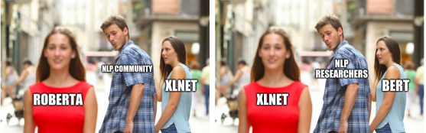

Figure 1.1: Memes Used by the Online Deep Learning Community on Social Media to Ridicule the State of the Art Pre-training Models.

The image memes are also important and popular because they portray the culture and social choices embraced by the internet community and they have a strong influence on the cultural norms of how a specific demographics of people operate. For example, in Figure 1.1, we present the memes used by an online deep learning community to ridicule how the new pre-training methods are outperforming the previous state of the art models.

The importance of image memes can be attributed to the fact that visual information is easier to process and understand when compared to reading large blocks of text, and this fact is evident in Figure 1.1. An organic and socially meaningful image meme has the potential to become viral through its powerful combination of visual and textual information, which has a strong influence in online social interaction to bring up topics, express ridicules, and sometimes create smearing effects, owing to the medium it strews upon.

**Proposed Method with architecture**

In this work, we intend to automatically generate a meme that can contextually represent a given input sentence (Ideal) as illustrated in Figure 1. The Behavior will be to select a meme template and generate a text caption to convey the Ideal and the Manifestation will be the generated meme that can represent the input sentence in an online social interaction, e.g. a twitter post. This is a challenging NLP task with immediate practical applications for online social interaction.

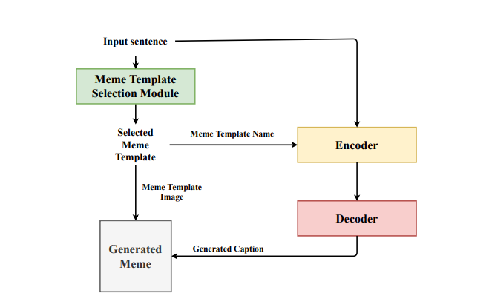

Figure 1.2: An Illustrative Figure of memeBot, an End to End Neural and Probabilistic Architecture for Automatic Meme Generation.

It Generates an Image Meme for a given Input Sentence by Combining the Selected Meme Template Image and the Generated Meme Caption.

Meme generation is a complex asks for human beings and it demands exposure to the multiple domains associate with meme and, good semantical and contextual exposure. In our work, we aim to learn the ideas or concepts associated with the meme templates by just using their language features.

**Methodology**

Meme Generation There are only a few studies on automatic meme generation and the existing approaches treat meme generation as a caption selection or caption generation problem. Wang and Wen (2015) combined an image and its text description to select a meme caption from a corpus using a ranking algorithm. In their work, they use an empirical cumulative density function to map both image and textual features to a compatible embedding space to estimate the pair-wise correlation between the text and image features.

They train a no paranormal model for ranking meme descriptions for an image and during inference, they use a meme generation pipeline to select a text description for a given image using the trained model. The meme generation pipeline of Wang and Wen (2015) is limited to selecting a text description from a corpus and they do not generate a meme caption for an image or an input sentence.

Text Classification In the domain of Natural Language Understanding (NLU), researchers have explored classifying a sentence based on their sentiment (Socher et al., 2013) and their linguistic acceptability (Warstadt et al., 2018). Socher et al. (2013) aims at understanding and analyzing the compositionality of textual features in determining the sentiment of a sentence. They explore the capabilities of neural networks to analyze the intricacies of sentiment and to capture complex linguistic phenomena using a Recurrent Neural Network. They encode a given sentence into a fixed size representation and classify the sentence into five sentiment classes.

Neural Machine Translation The idea of creating an encoded representation and decoding it into a desired target is well establish in Neural Machine Translation. Sutskever et al. (2014), Bahdanau et al. (2014a) use an encoder-decoder model to encode and decode a sentence from a source to a targeted language. Sutskever et al. (2014) presents a general end to end approach using a multi layered Long Short Term Memory (LSTM) network to encode the input sentence into a vector of fixed dimensionality and used a decoded LSTM to decode the latent vector to the target sentence. They experiment this architecture on English to French translation task. In this work, the authors claim that their model has learned the sensible phrases and sentence representations that are sensitive to word order and is relatively invariant to the active and passive voice.

Image Caption Generation In the domain of computer vision and natural language, Vinyals et al. (2015), Xu et al. (2015) and Karpathy and Fei-Fei (2015) address the image captioning task by encoding. 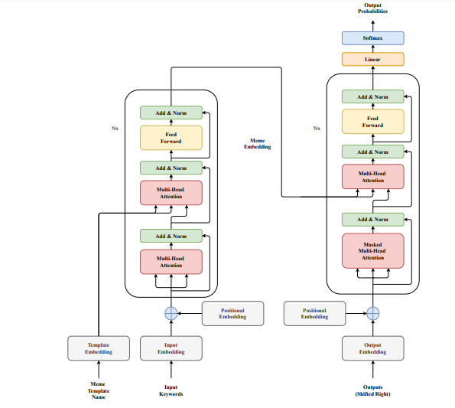

Features of an image and decoding the natural language description of the image. Vinyals et al. (2015) uses a Convolution Neural Network to encode the visual features of the image into a fixed size vector and generate the natural language description from the encoded embedding using an LSTM decoder.

They use a straight forward end to end neural and probabilistic model to generate the description of the image by maximizing the likelihood of generating the caption given the image. Xu et al. (2015) introduces two attention-based image caption generators for image captioning. A soft deterministic attention mechanism using standard back-propagation and a hard stochastic attention mechanism which can be trained by maximizing an approximate variational lower bound.

Meme Caption Dataset The main contribution of our work is that we have complied the first large scale meme caption dataset. Analyzing and understanding the Ideal, Bevier and Manifestation of a meme as defined by Davison (2012) is essential to create a successful meme generation pipeline. In an image meme, the ideal is the idea or concept that needs to be conveyed through the meme.

The behavior is to choose the right meme template that is capable of conveying the idea or concept in the intended manner and coming up with a text caption that can convey the intended idea through the selected meme template. The manifestation is the final meme created by combining the text caption and the image that conveys the intended idea

**Implementation**

The perspective of good quality of a meme is subjective and varies among people. To the best of our knowledge, there are no known automatic evaluation metrics to evaluate the quality of a meme. A fairly reliable technique is to perform human evaluation by a set of raters to evaluate the quality of a meme on a subjective score. In Machine Translation, adequacy and fluency (Snover et al., 2009) are used to subjectively rate the correctness and fluency of a translation. Inspired from adequacy and fluency, we define 2 metrics - Coherence and Relevance to evaluate the generated memes, described as follows: 32

Coherence: Can you understand the message conveyed through the meme (Image + text)?

Relevance: Is the meme contextually relevant to the text? The Relevance and Coherence metrics are scored on a range of 1 - 4. Coherence score captures the quality (fluency) of the generated meme and, Relevance score capture how well the generated meme represents the input sentence (correctness).

We also ask the rater’s if they like the meme to evaluate if the meme is considered good by them. To score these metrics, we set up an Amazon Mechanical Turk (AMT) experiment. Sample memes generated by our model for a given input tweet is presented in the Figure 5.2

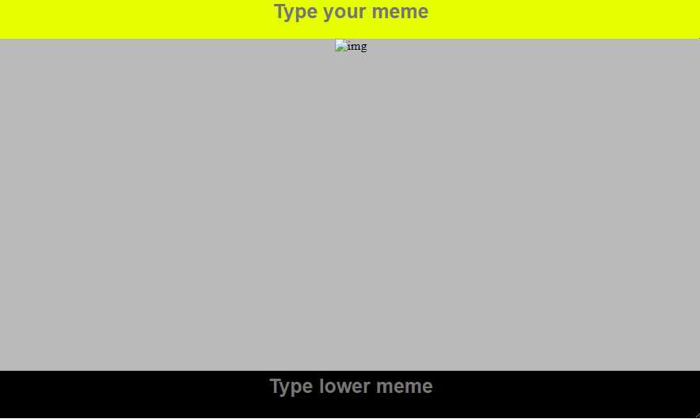

Template used to create a meme in MemeForFun application.

MemeForFun meme templates!

This templates provides very easy ways to create meme.

Following are the given easy steps divide into three parts to create meme.follow the following steps to create memes simple and cost free memes

1.First download a image or accept any picture from your device.  
  
2.Now go to the our website.  
  
3.First login and fill all the credentials.

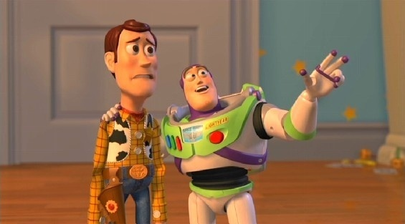

4.Go to customize.  
  
5.click on upload image.

6.Now select the image you want to add into the template.  
  
7.There are two part of template where you can write a text.  
  
8.write text in upper part whichg is yellow then write text in lower part which is black which is show below in image.

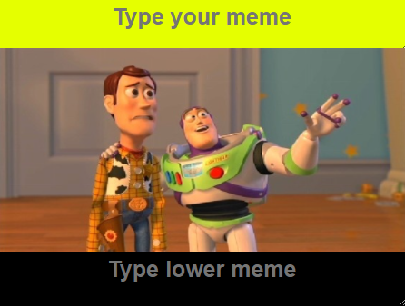

9.Now click on generate and to generate an image.  
  
10.You can also use refres button if required.the image will be disapper and you can again select a new image by clicking on upload an image.

11.Once you click on generate button the image is generated now click on download button.  
  
12.you can see the image downloading icon.

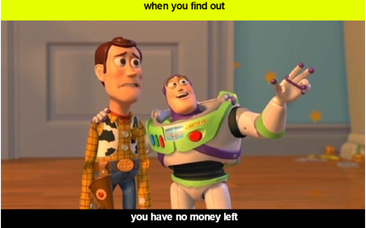

13.Your meme is created successfully!  
  
14.Now you can share your favorite meme to your close once.

**CONCLUSION**

We have presented memeBot, an end to end architecture that can automatically generate a meme from a given sentence. memeBot is composed of two components, a module to select a meme template and an encoder-decoder to generate a meme caption. Our model learns the dependency between the input sentence, meme template and the meme caption by utilizing the multi-head scaled-dot product attention and mask multi-head attention mechanisms in the transformer architecture.

The model is trained on a Meme Caption dataset to maximize the likelihood of selecting a template given a caption and to maximize the likelihood of generating a meme caption given the input sentence and the meme template. Automatic evaluation metrics on meme caption test data and human evaluation scores on Twitter data show promising performance in generating a meme representing a sentence in online social interaction. The concept of quality of a meme highly varies among people and is hard to evaluate using a set of pre-defined metrics. In real-world scenarios, if an individual likes a meme, he or she shares it with others. If a group of individuals like the same meme then the meme can become viral or trending.

Future work includes evaluating a meme by introducing it in a social media stream and rate the meme based on its transmission among the people. The meme transmission rate and the group of people it transmits across can be used as reinforcement to generate more creative and better quality meme. As mentioned in Section 1.2, image memes are usually associated with ideas or concepts from some popular pop culture, TV shows or movies references. To understand the concept associated with the meme, one has to posses the cross domain reference associated with the reference. In our work on translating a natural language to an image meme, we use only the 42 linguistic features of the meme to learn the concepts and ideas associated with it. It requires good amount of training data to learn the concepts just from the linguistic features and we address the limited resource issue as the potential extension of our current work