

SCHOOL OF COMPUTER SCIENCE AND
ENGINEERING (SCOPE)

REVIEW -0
ASSESMENT -8
BACSE202 LAB COMPONENT PROJECT
B. Tech [CSE & CSE-With Specialisation]
AY:2026-27

APPENDIX 1
(A typical Specimen of a cover page)

TITLE OF PROJECT REPORT:
MODERN AIRLINE LOGISTICS & SUSTAINABILITY MANAGEMENT SYSTEM

A PROJECT REPORT

Submitted by

25BCE2957 – Pranali Paygonda Patil

B.Tech Computer Science and Engineering
Vellore Institute of Technology
SCHOOL OF COMPUTER SCIENCE AND ENGINEERING (SCOPE)
AY: 2026-27

CONTENT

S.NO | TITLE | PAGE NO
1 | ABSTRACT OF THE PROJECT | 6
2. | ACKNOWLEDGEMENT | 7
3. | INTRODUCTION OF THE PROJECT | 8
4. | BACKGROUND OF THE PROJECT WORK | 9
5. | HARDWARE AND SOFTWARE REQUIREMENTS | 10
6. | E-R DIAGRAM | 12
7. | DESCRIPTION OF THE DATABASE DESIGN | 13
8. | Relationships / Cardinality Table | 15
8. | RELATIONAL SCHEMA | 16
9. | EXECUTION OF THE SQL QUERY WITH OUTPUT  SCREENSHOT  TABLE CREATION WITH ALL CONSTRAINTS  INSERTION UP TO 5 ROWS  DELETION  UPDATION (ON EACH TABLE)  SELECT  SINGLE ROW FUNCTIONS  SQL FUNCTIONS  GROUP BY  HAVING CLAUSE  SUB QUERY  JOIN QUERY | 19
8
9
CONTENT (CONTINUED)
S.NO | TITLE | PAGE NO
 | LIST OF FIGURES | 5
10. | FRONT END DESIGN | 41
11. | BACK END TABLES & CONNECTIVITY | 42
12. | PRACTICAL / BUSINESS / SUSTAINABILITY | 44
13. | CODE AND APPLICATION SCREENSHOTS | 46–78
14. | CONCLUSION / FUTURE SCOPE | 79
LIST OF FIGURES
Figure 1. ER Diagram
Figure 2. Overall System Design and Architecture
Figure 3. Workflow of the Project
Figure 4. Sign-in page
Figure 5. Overview dashboard
Figure 6. Account registration page
Figure 7. Flight schedule
Figure 8. Oracle flight rows before insertion
Figure 9. Create flight form
Figure 10. Oracle flight rows after insertion
Figure 11. Flight details
Figure 12. Update flight form
Figure 13. Oracle updated flight record
Figure 14. Delete confirmation prompt
Figure 15. Fleet module
Figure 16. Crew roster module
Figure 17. Cargo tracking module
Figure 18. Passengers and loyalty module
Figure 19. Disruptions module
Figure 20. Emissions module
Figure 21. Updated overview dashboard
ABSTRACT

The Modern Airline Logistics and Sustainability Management System is a database-driven system designed to manage and integrate major airline logistics operations through a centralized relational database. Airline operations involve the continuous coordination of aircraft, flights, crew, passengers, specialized cargo, emissions and unexpected operational disruptions. Managing these activities through disconnected systems can lead to data inconsistency, delays, cargo-handling errors and difficulty in obtaining timely operational information.
The proposed system uses a relational database to maintain accurate and structured information regarding the airline fleet, flight schedules, crew assignments, passenger loyalty tiers, baggage limits, specialized cargo and flight-level sustainability records. It also incorporates cold-chain cargo monitoring for temperature-sensitive shipments, carbon-emission logging for sustainability analysis, and disruption management for recording delays caused by weather, technical issues, air-traffic control, crew-related problems and security events.
The database consists of nine interconnected entities with appropriate primary keys, foreign keys, NOT NULL, UNIQUE, CHECK and DEFAULT constraints. The schema is designed according to relational database principles and aims to reduce redundancy while preserving referential integrity.
SQL operations including DDL, DML, SELECT queries, single-row functions, aggregate functions, GROUP BY, HAVING, subqueries and JOIN operations are implemented to demonstrate how the database can support both routine airline operations and management-level decision making.

ACKNOWLEDGEMENT

I would like to thank Dr. BOOMINATHAN P (HOD) for reviewing the entire project and guiding us as the team leader, and also for helping me coordinate my project. After the completion of my project, I would like to take this chance to express my sincere gratitude to my project guide, Dr. KAVITHA G, who has guided me thoroughly throughout my project development. I would like to express my gratitude to all our friends and teachers, who helped and cooperated directly or indirectly in the accomplishment of this project. Heartfelt appreciation to those who helped me through cooperative acts and logical devices to make this project effective and user-friendly.

INTRODUCTION OF THE PROJECT

Airline logistics is a complex and highly coordinated operational environment in which aircraft, flights, crew members, passengers, cargo and airport resources must be managed efficiently. Every flight requires accurate scheduling, aircraft assignment, crew allocation, cargo handling and monitoring. A small error in any one of these areas can result in delays, increased operational costs and disruption of the overall transportation network.

Traditional or fragmented information systems often maintain operational data in separate modules. Such systems can make it difficult to obtain a unified view of the current status of flights and logistics operations. Problems such as flight delays, inappropriate crew assignment, cargo-handling issues and inefficient fuel usage may therefore become difficult to monitor and analyse.

The proposed Modern Airline Logistics and Sustainability Management System provides a centralized database for airline logistics operations. The system manages aircraft information, flight schedules, crew assignments, passenger information, loyalty-based baggage allowances, specialized cargo, carbon emissions and operational disruptions.

The system gives special attention to three modern airline challenges:
- Cold-Chain Cargo Management – monitoring temperature-sensitive medical and perishable cargo.
- Sustainability Management – recording fuel consumption and carbon dioxide emissions for each flight.
- Disruption Management – recording and analysing delays caused by weather, technical problems, ATC, crew, security and other operational events.

BACKGROUND OF THE PROJECT WORK

Airline operations have traditionally depended on multiple independent systems to manage flight schedules, fleet details, passenger information, crew assignments and cargo handling. As airline operations expanded, the amount of data generated by each flight increased significantly. Separate systems and manual records can result in duplication, inconsistency and difficulty in obtaining a complete view of airline logistics.
Modern air transportation also faces challenges that go beyond basic passenger scheduling. Airlines transport temperature-sensitive pharmaceutical products, food, biological samples and other specialized cargo that require controlled environmental conditions during transportation. Therefore, cargo information must include handling requirements and temperature-monitoring information.
Environmental sustainability has also become an important part of airline operations. Fuel consumption and carbon emissions must be monitored so that organizations can analyse the environmental impact of individual flights and routes.
Another major challenge is operational disruption. Flights may be delayed because of weather conditions, technical faults, air-traffic restrictions, crew availability or security-related problems. Recording these events in a structured database allows management to identify frequent causes of delay and analyse operational performance.
The proposed database applies Entity-Relationship modelling and relational normalization principles to create a centralized airline logistics system. The design uses primary and foreign keys to maintain relationships among entities and uses constraints to prevent invalid data from entering the database.

HARDWARE AND SOFTWARE REQUIREMENTS

- Hardware Requirements:
Component | Minimum Requirement | Recommended
Processor | Intel Core i3 / equivalent | Intel Core i5 or higher
RAM | 4 GB | 8 GB or higher
Storage | 20 GB free space | 256 GB SSD or higher
Display | 1366 × 768 | 1920 × 1080
Input | Keyboard and mouse | Keyboard and mouse
Network | Wi-Fi/Ethernet | Stable broadband/LAN

- Software Requirements:
Component | Specification
Operating System | Windows 10/11, Linux or macOS
DBMS | MySQL 8.0
Query Interface | MySQL Workbench / MySQL Command Line Client
Query Language | SQL
ER Diagram Tool | draw.io / Lucidchart
Documentation | Microsoft Word / Google Docs
Browser | Google Chrome / Microsoft Edge

E-R DIAGRAM
Entity | Primary Key (PK) | Attributes | Foreign Key (FK)
AIRCRAFT | Aircraft_ID | Model, Capacity_kg, Fuel_Efficiency, Aircraft_Status | —
FLIGHT | Flight_ID | Route_Code, Dep_Time, Arr_Time, Flight_Status | Aircraft_ID → AIRCRAFT
CREW | Crew_ID | Crew_Name, Role, Base_Location | —
FLIGHT_CREW | Assignment_ID | Shift_Hours | Flight_ID → FLIGHT, Crew_ID → CREW
LOYALTY_TIER | Tier_ID | Tier_Name, Extra_Baggage_kg | —
PASSENGER | Passenger_ID | Passenger_Name, Passport_No, Baggage_kg | Tier_ID → LOYALTY_TIER
SPEC_CARGO | Cargo_ID | Cargo_Description, Weight_kg, Category, Req_Temp_C, Current_Temp_C, Tracking_Status | Flight_ID → FLIGHT
EMISSIONS | Log_ID | Fuel_Liters, CO2_Tons, Logged_At | Flight_ID → FLIGHT
DISRUPTION | Event_ID | Delay_Min, Reason_Code, Event_Date, Event_Status | Flight_ID → FLIGHT

DESCRIPTION ABOUT DESIGN OF THE DATABASE

The database is designed using relational database principles with emphasis on integrity, consistency and reduction of redundancy. The schema contains nine interconnected entities representing major airline logistics operations.

The FLIGHT entity acts as the central operational entity. Each flight is associated with one valid aircraft through the Aircraft_ID foreign key. This ensures that a flight cannot be scheduled without an aircraft existing in the database.

The relationship between FLIGHT and CREW is many-to-many because one flight requires multiple crew members and one crew member may participate in multiple flights. This relationship is resolved through the FLIGHT_CREW associative entity.

The LOYALTY_TIER and PASSENGER relationship allows the system to determine additional baggage allowances based on passenger membership level.

The SPEC_CARGO entity stores information about specialized cargo associated with flights. The design supports medical, perishable, hazardous and standard cargo and allows temperature-sensitive shipments to be monitored using required and current temperature values.

The EMISSIONS entity stores fuel consumption and carbon dioxide emission information for flights. This enables the airline to analyse environmental impact at flight and route level.

The DISRUPTION entity stores operational interruptions, including delay duration, reason and status. This supports analysis of delay patterns and operational performance.

Constraints such as PRIMARY KEY, FOREIGN KEY, UNIQUE, NOT NULL, CHECK and DEFAULT have been applied to maintain data validity. The design follows normalization principles so that information is stored in logically separated relations.

Relationships / Cardinality Table

Parent Entity | Relationship | Child Entity | Cardinality | Meaning
AIRCRAFT | assigned to | FLIGHT | 1 : M | One aircraft can operate many flights over time; each flight uses one aircraft.
FLIGHT | assigned through | FLIGHT_CREW | 1 : M | One flight can have multiple crew assignments.
CREW | assigned through | FLIGHT_CREW | 1 : M | One crew member can be assigned to multiple flights.
FLIGHT | carries | SPEC_CARGO | 1 : M | One flight can transport multiple cargo shipments.
FLIGHT | generates | EMISSIONS | 1 : M | A flight can have one or more emission logs.
FLIGHT | experiences | DISRUPTION | 1 : M | One flight can experience multiple disruption events.
LOYALTY_TIER | assigned to | PASSENGER | 1 : M | One loyalty tier can contain many passengers.
FLIGHT | has | CREW | M : N | A flight can have many crew members and a crew member can work on many flights; resolved through FLIGHT_CREW.

RELATIONAL SCHEMA
AIRCRAFT(
Aircraft_ID PK,
Model,
Capacity_kg,
Fuel_Efficiency,
Aircraft_Status
)

FLIGHT(
Flight_ID PK,
Route_Code,
Dep_Time,
Arr_Time,
Aircraft_ID FK → AIRCRAFT(Aircraft_ID),
Flight_Status
)

CREW(
Crew_ID PK,
Crew_Name,
Role,
Base_Location
)

FLIGHT_CREW(
Assignment_ID PK,
Flight_ID FK → FLIGHT(Flight_ID),
Crew_ID FK → CREW(Crew_ID),
Shift_Hours
)

LOYALTY_TIER(
Tier_ID PK,
Tier_Name UNIQUE,
Extra_Baggage_kg
)

PASSENGER(
Passenger_ID PK,
Passenger_Name,
Passport_No UNIQUE,
Tier_ID FK → LOYALTY_TIER(Tier_ID),
Baggage_kg
)

SPEC_CARGO(
Cargo_ID PK,
Flight_ID FK → FLIGHT(Flight_ID),
Cargo_Description,
Weight_kg,
Category,
Req_Temp_C,
Current_Temp_C,
Tracking_Status
)

EMISSIONS(
Log_ID PK,
Flight_ID FK → FLIGHT(Flight_ID),
Fuel_Liters,
CO2_Tons,
Logged_At
)

DISRUPTION(
Event_ID PK,
Flight_ID FK → FLIGHT(Flight_ID),
Delay_Min,
Reason_Code,
Event_Date,
Event_Status
)

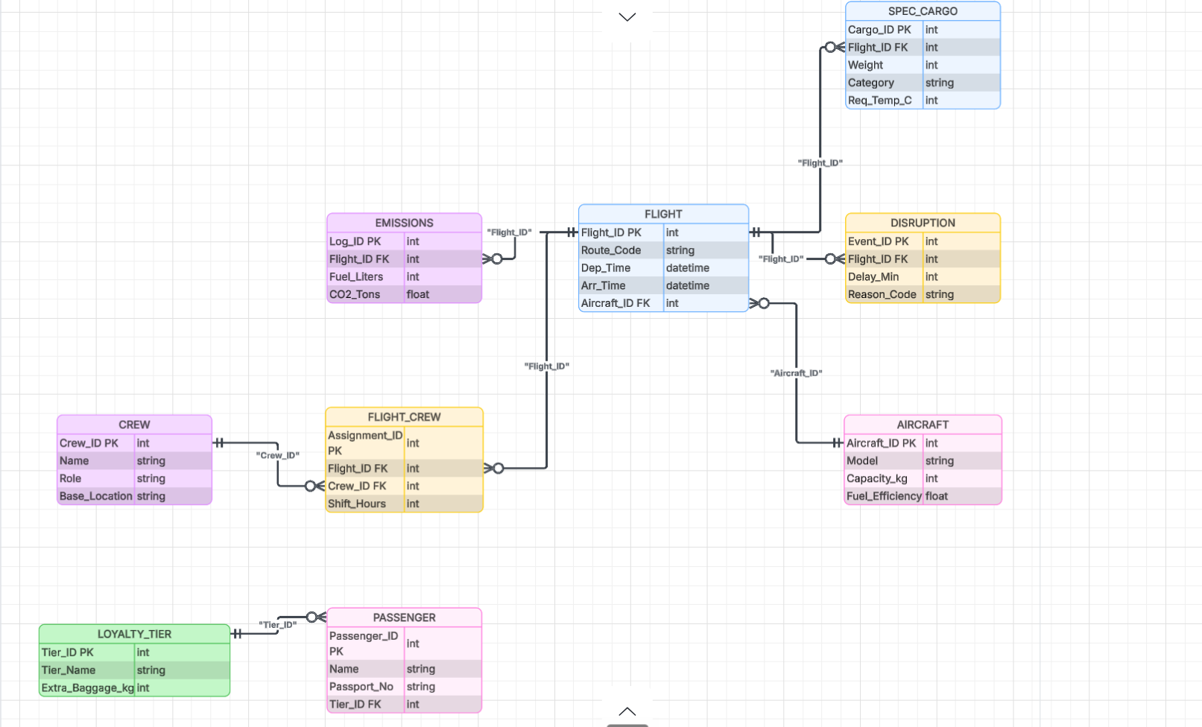

EXECUTION OF THE SQL QUERY

1. TABLE CREATION WITH ALL CONSTRAINTS

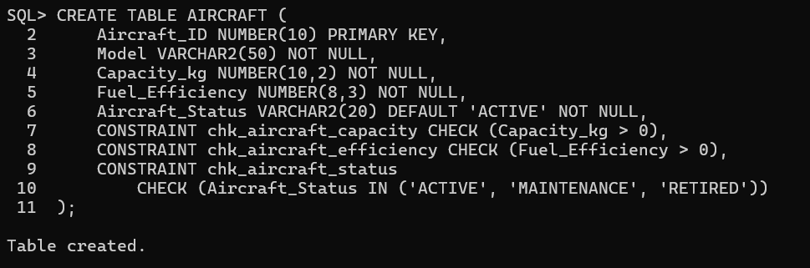
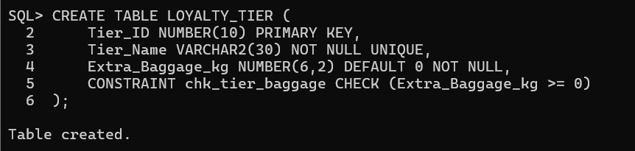
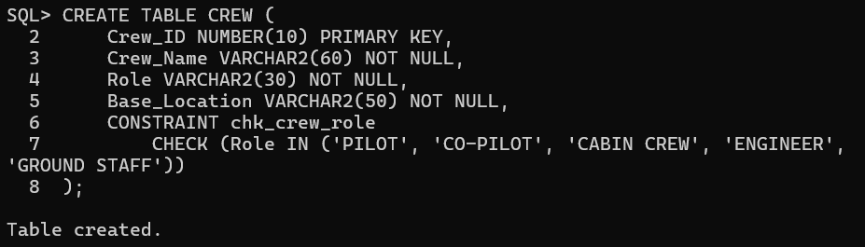
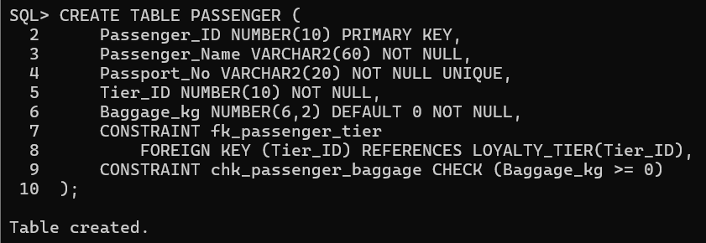

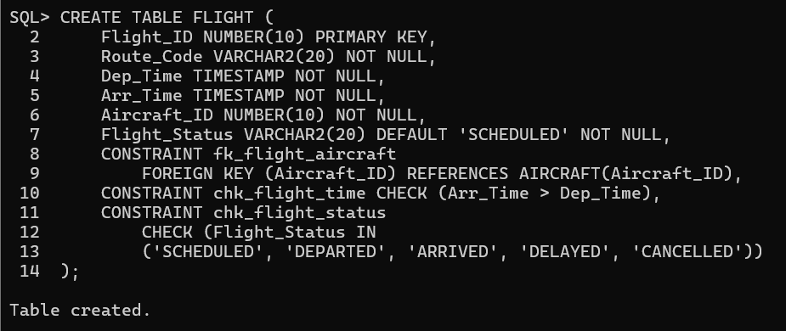
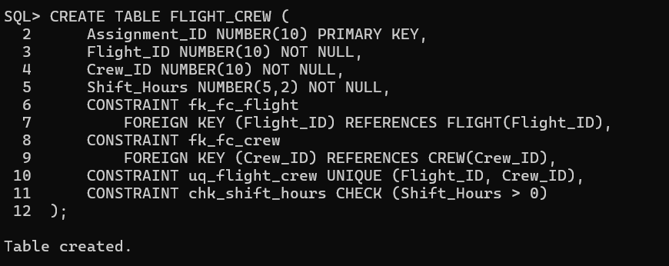
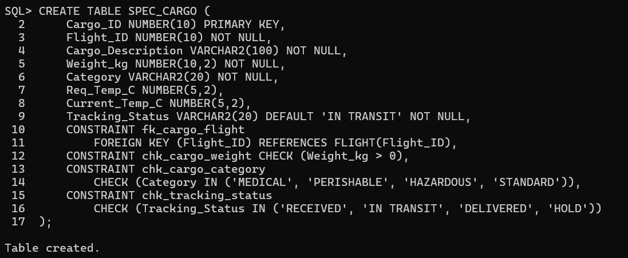

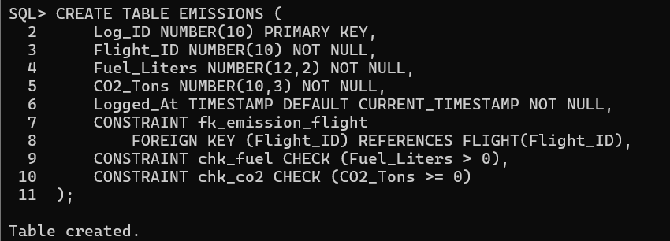
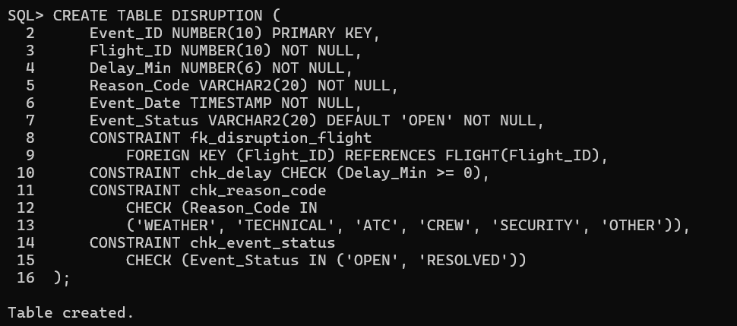

2. INSERTION - 5 ROWS PER TABLE
Aircraft table:
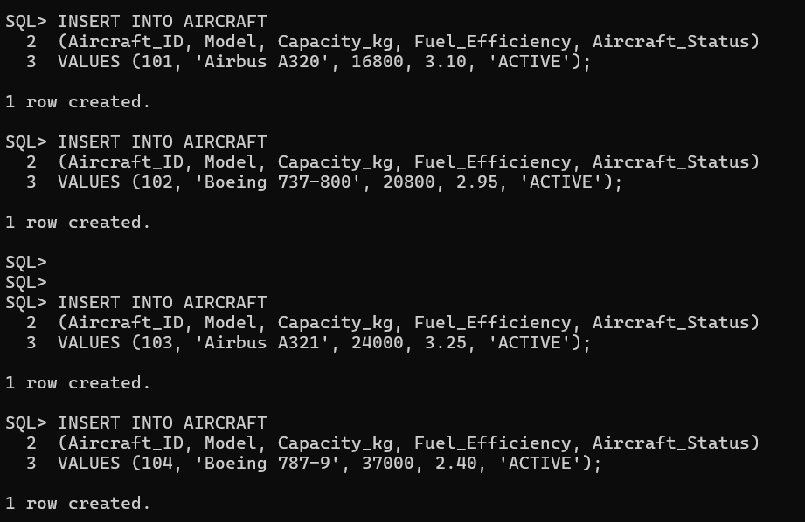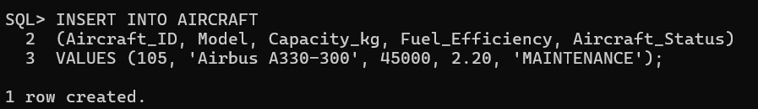
Loyalty_tier table:
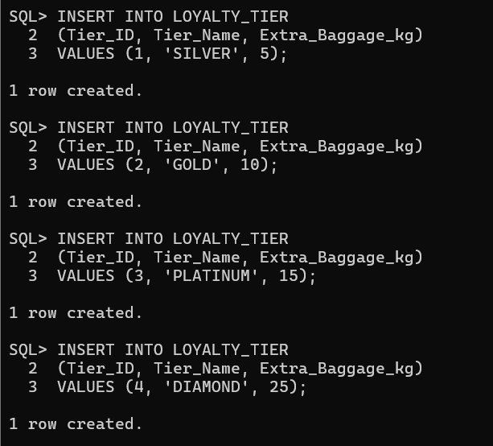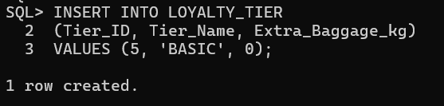
Crew table:
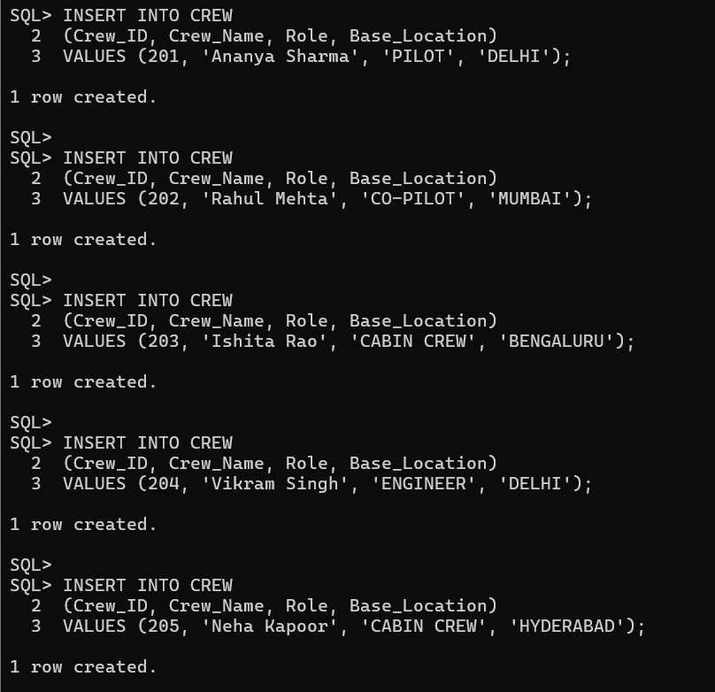
Flight table:
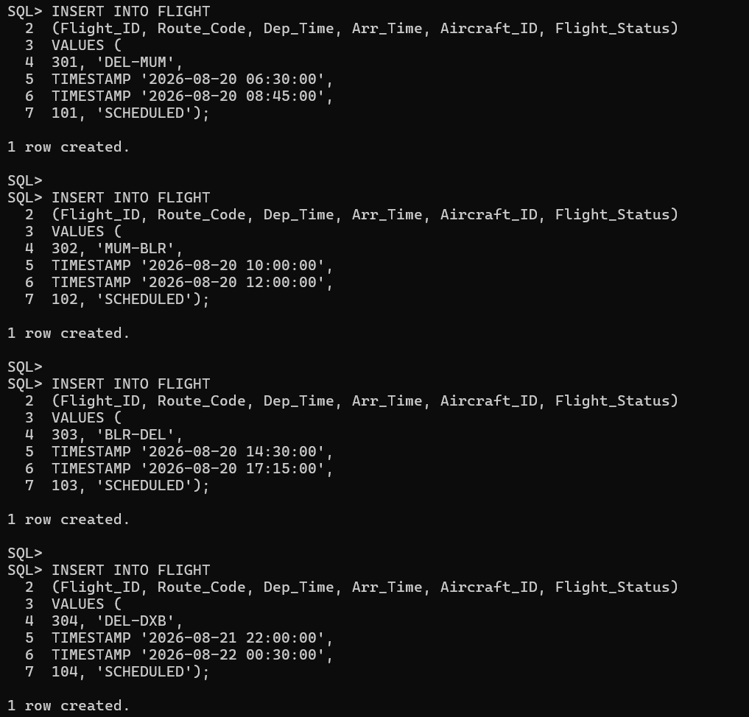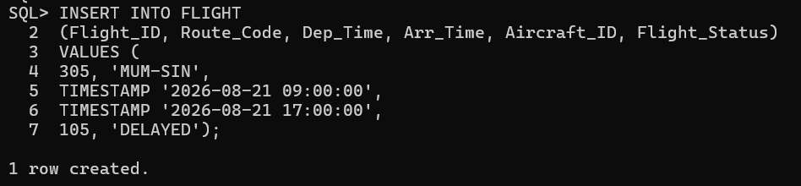
Flight_crew table:
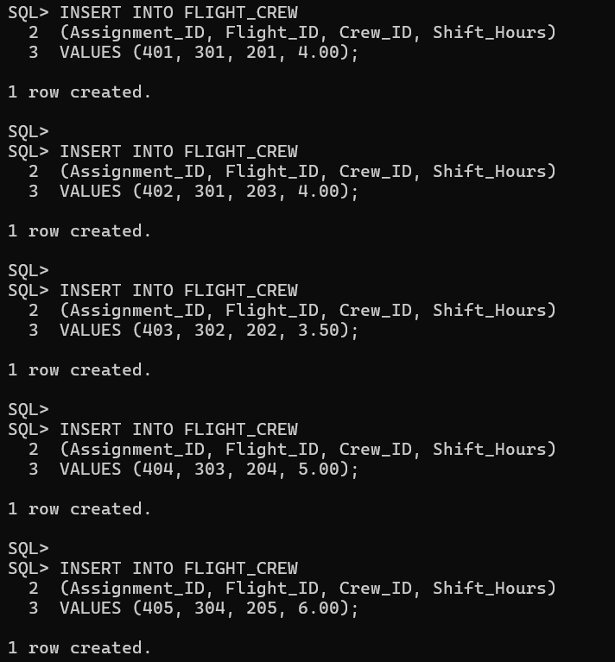
Passenger table:
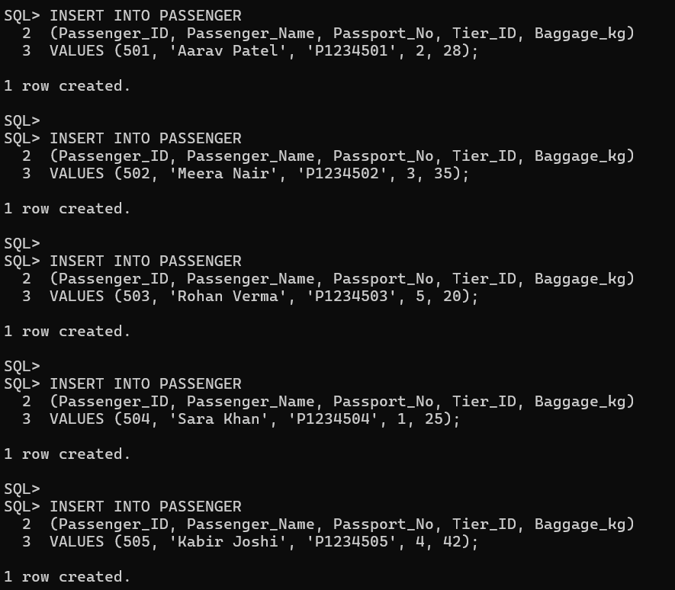
Spec_cargo table:
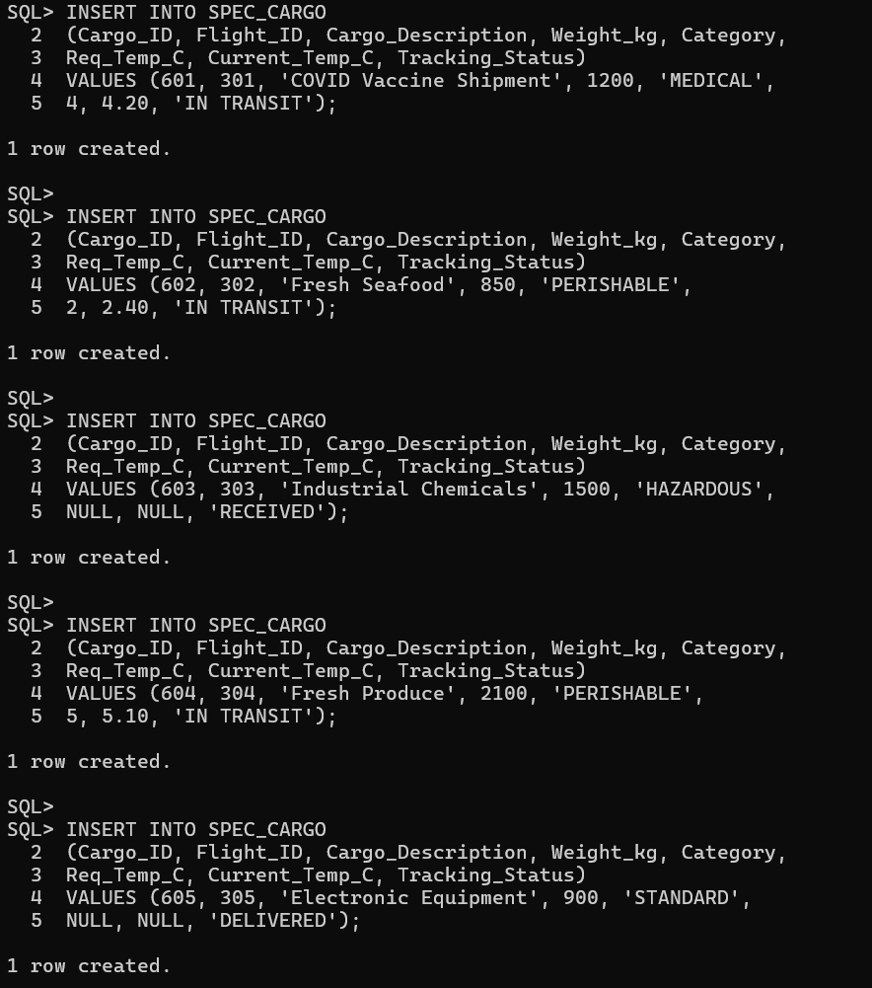
Emissions table:
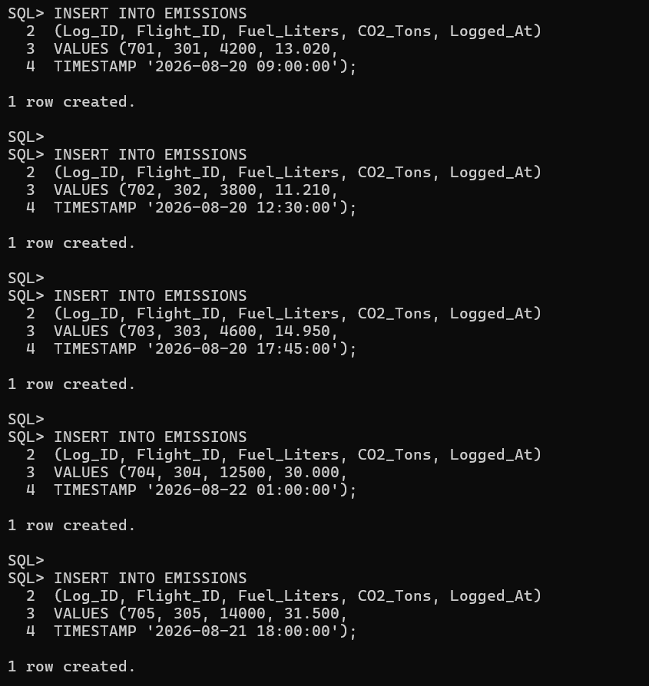
Disruption table:
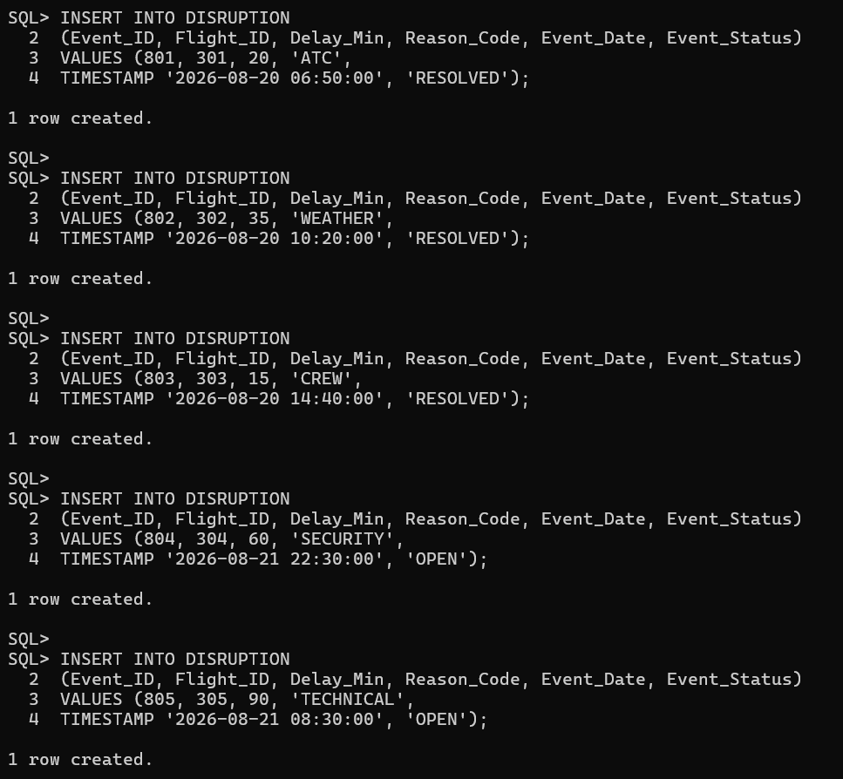

3.DELETION DEMONSTRATION:
Aircraft table:
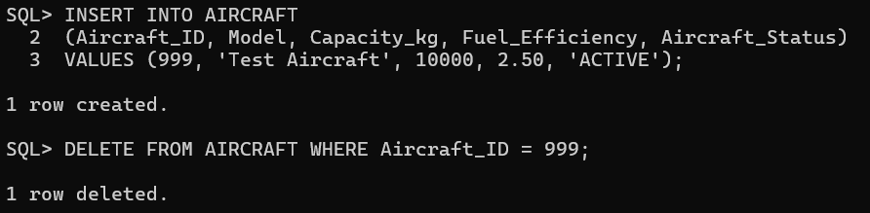
Loyalty_tier table:
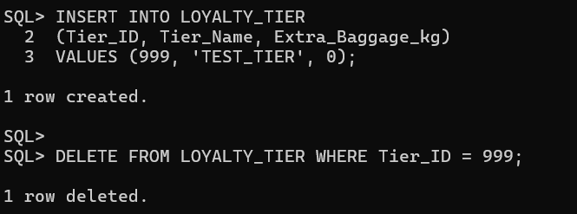
Crew table:
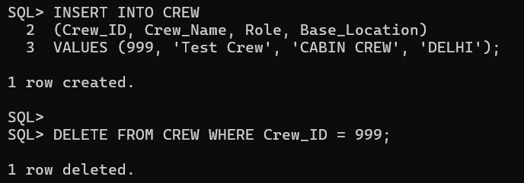

Flight table:
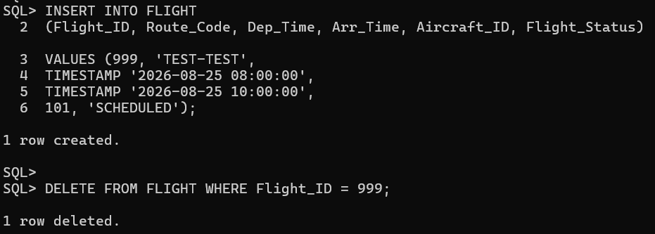
Flight_crew table:
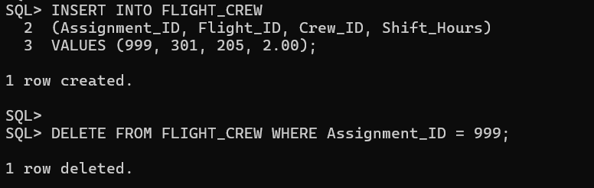
Passenger table:
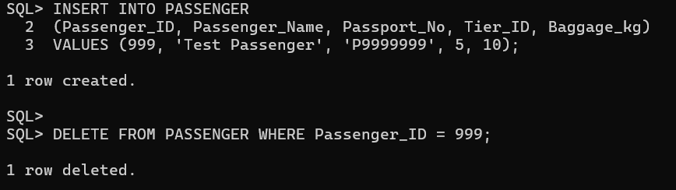
Spec_cargo table:
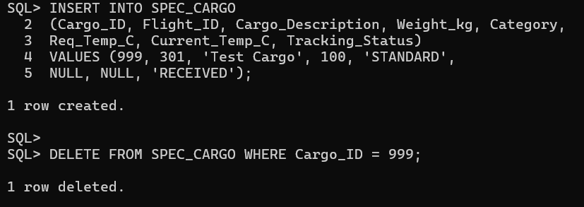

Emissions table:
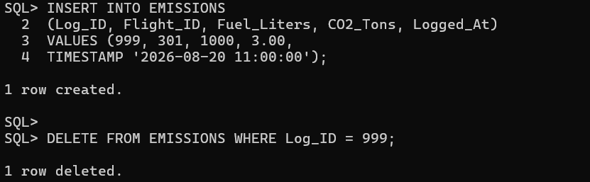

Disruption table:
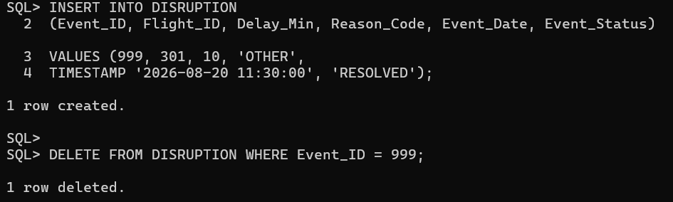

4.UPDATION - ONE UPDATE ON EACH TABLE

Aircraft table:
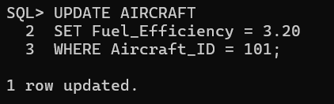
Loyalty_tier table:
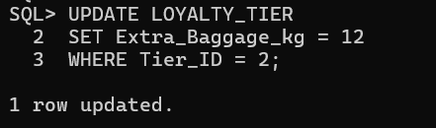
Crew table:
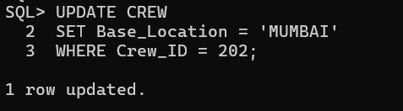
Flight table:
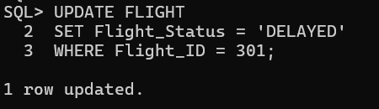
Flight_crew table:
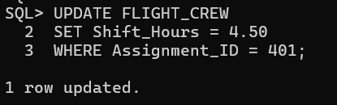

Passenger table:
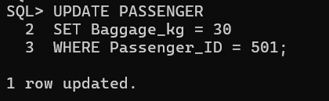
Spec_cargo table:
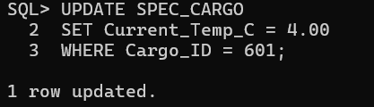
Emissions table:
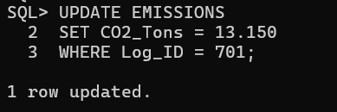
Disruption table:
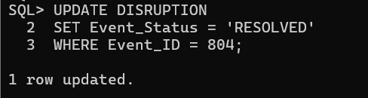

5.SELECT QUERIES

Flight table:
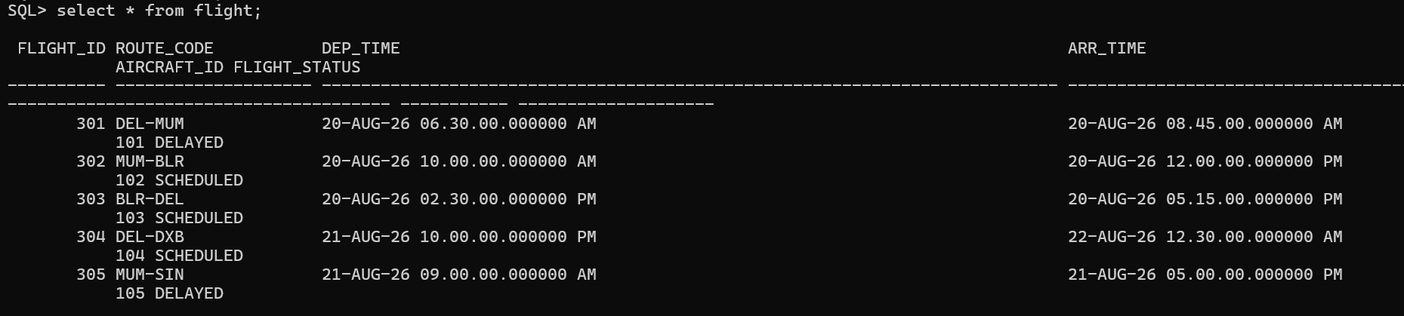
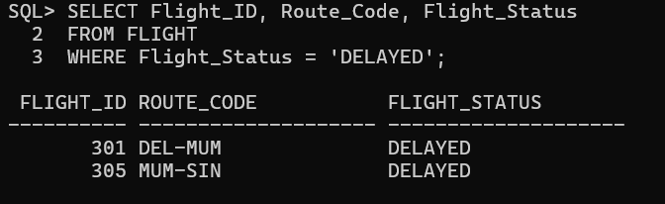
Passenger table:
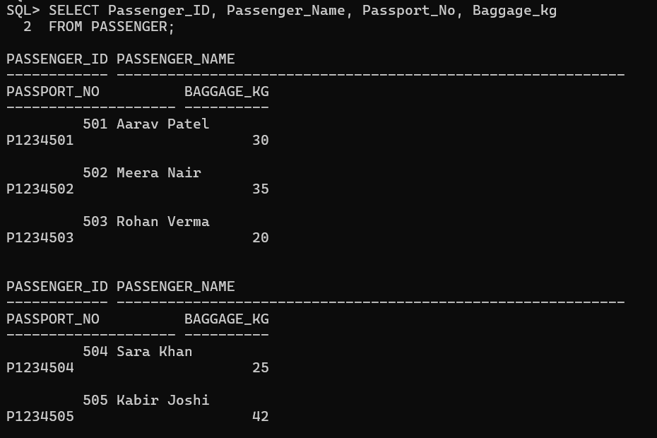

6.SINGLE-ROW FUNCTIONS

Aircraft table:
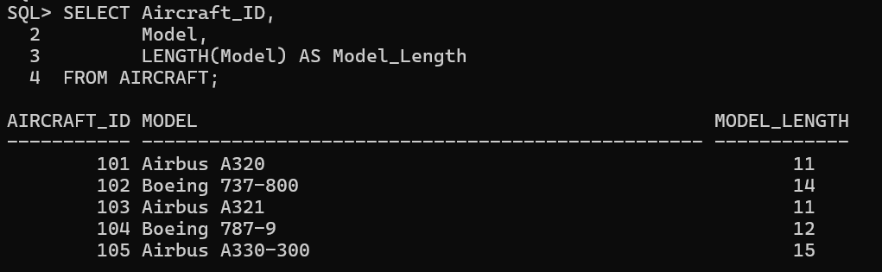
Crew table:
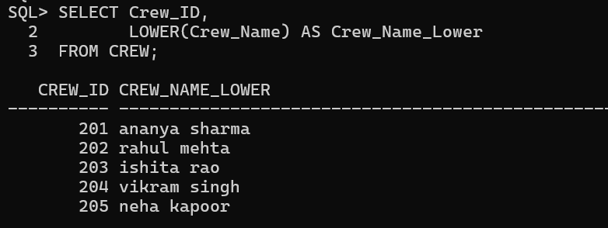

Passenger table:
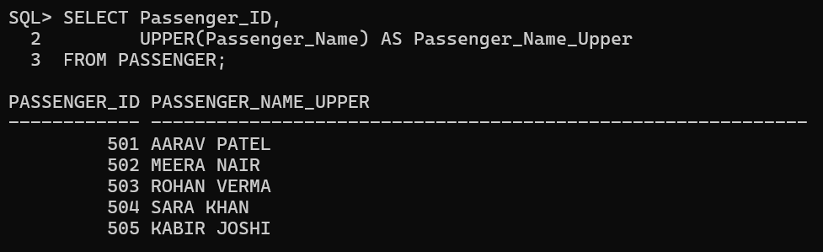

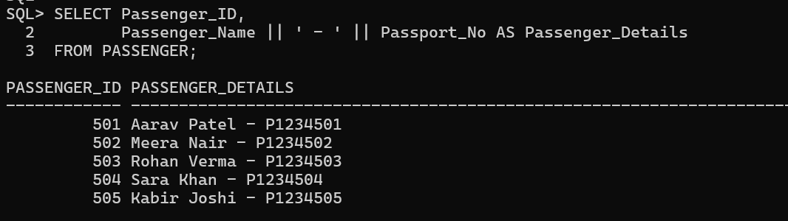
Spec_cargo table:
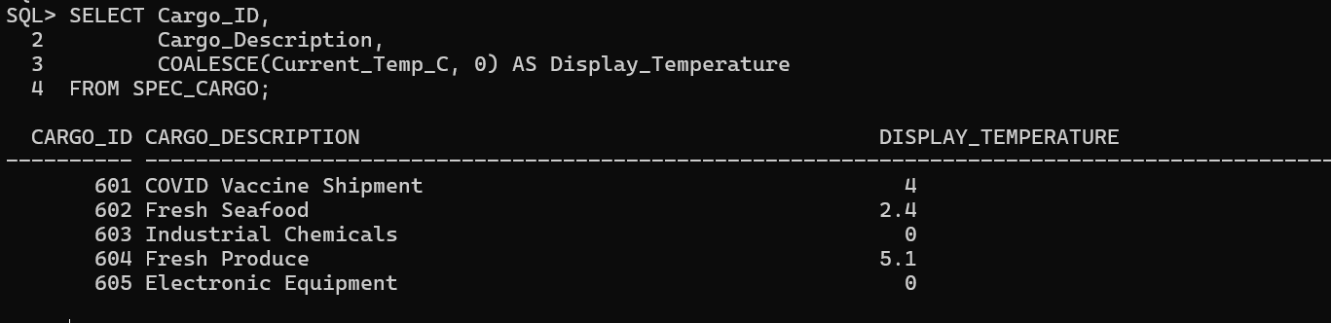
Emissions table:
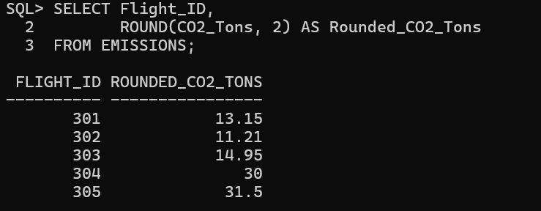

7.AGGREGATE FUNCTIONS

Flight table:
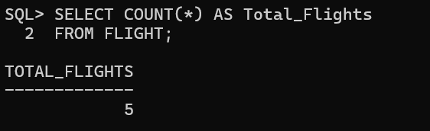
Spec_cargo table:
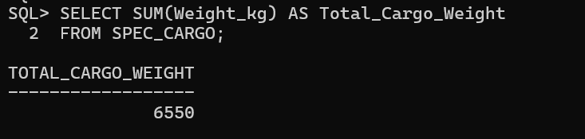
Emissions table:
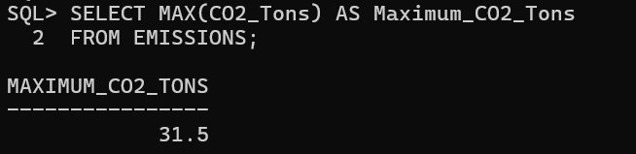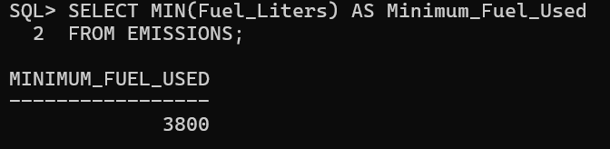
Disruption table:
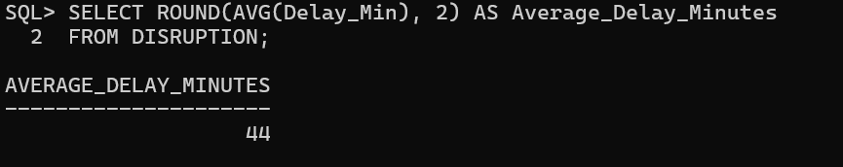

8.GROUP BY:

Flight table:
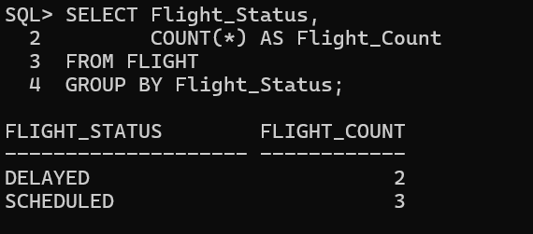
Spec_cargo table:
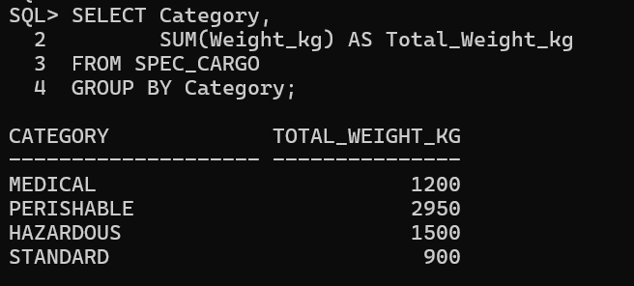
Disruption table:
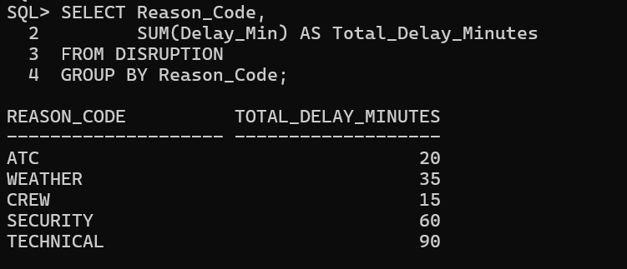

9.HAVING:

Spec_cargo table:
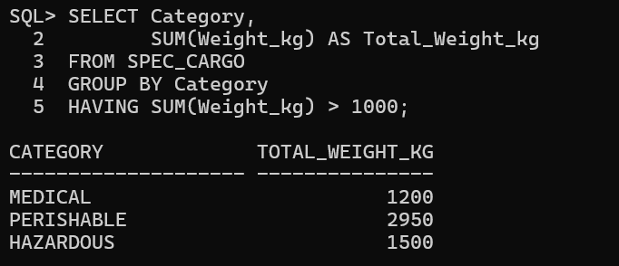

Disruption table:
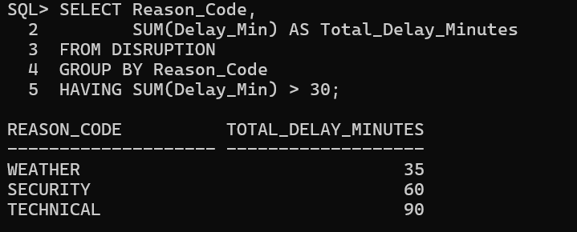

10.SUBQUERIES:

Aircraft table:
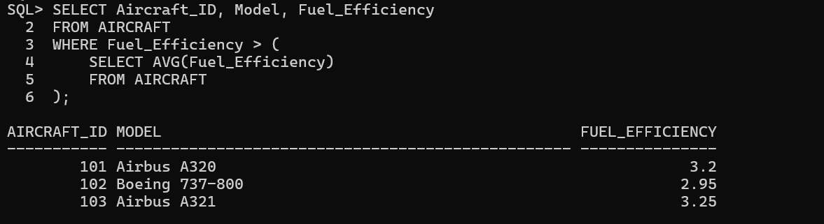
Passenger table:
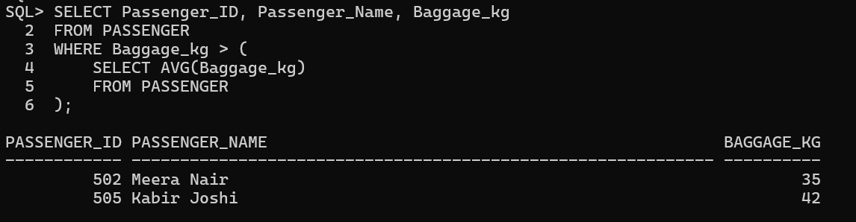
Emissions table:
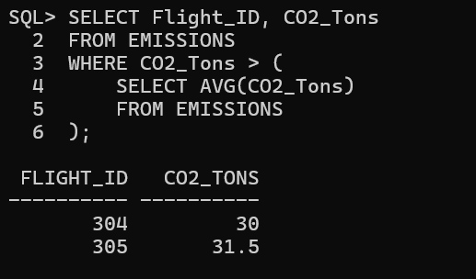

11.JOIN QUERIES

Aircraft table AND Flight table:
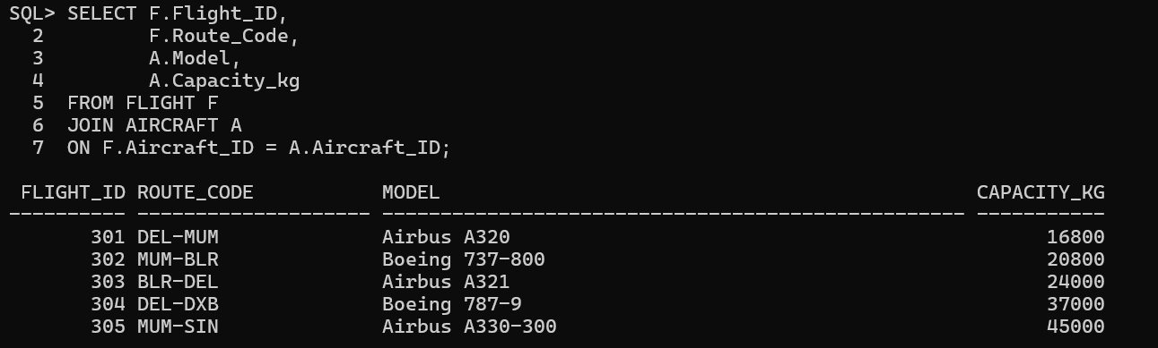
Loyalty_tier table AND Passenger:
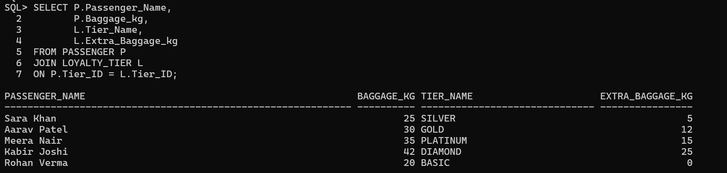

Crew table AND Flight table AND Flight_crew table:
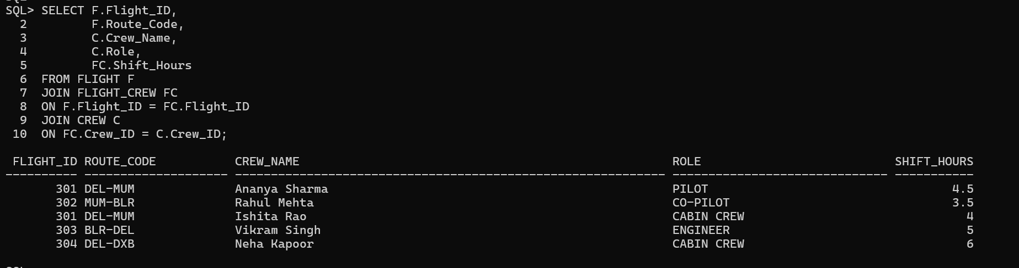

Spec_cargo table AND Flight table:
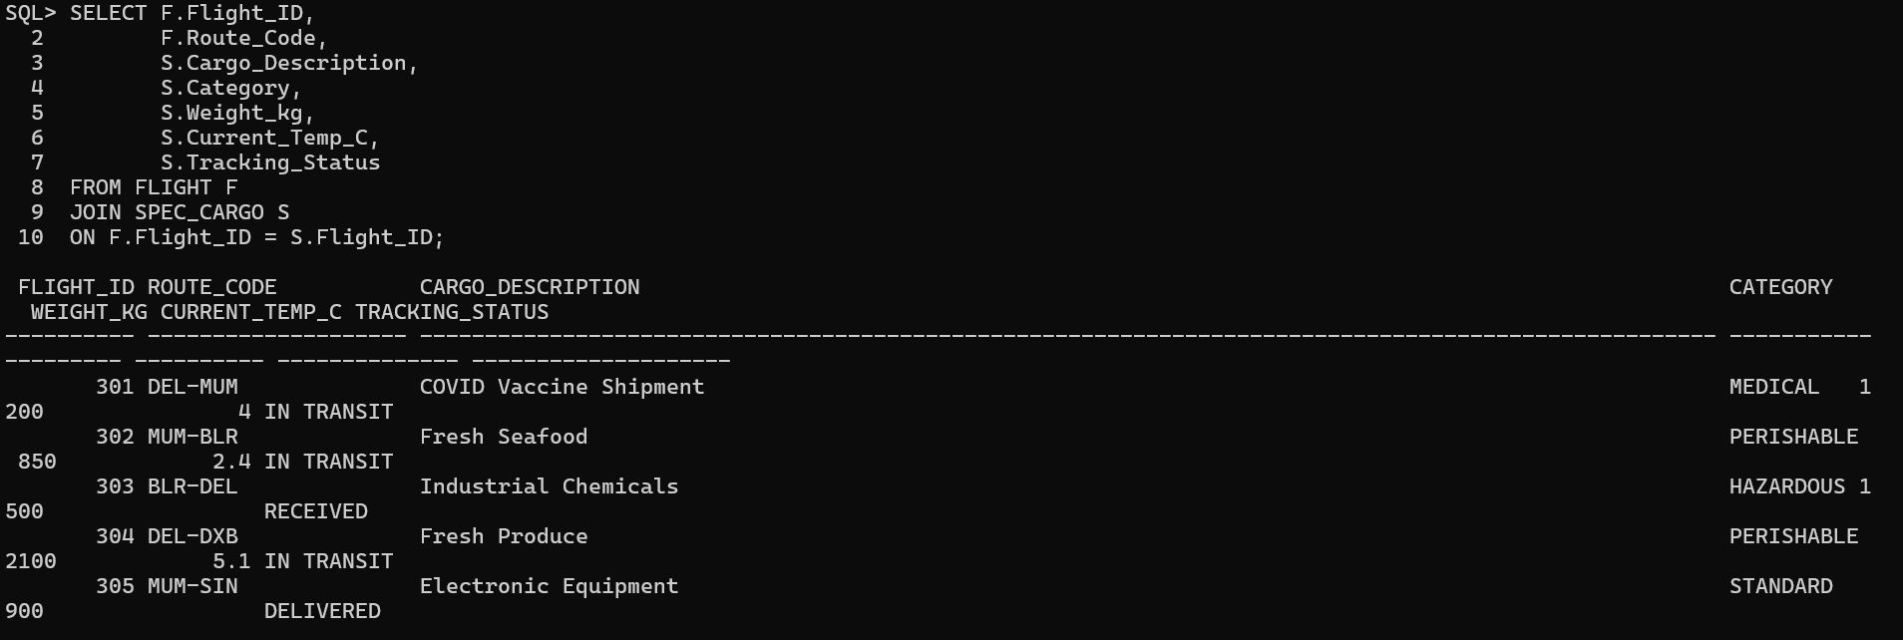

Flight table AND Aircraft table:
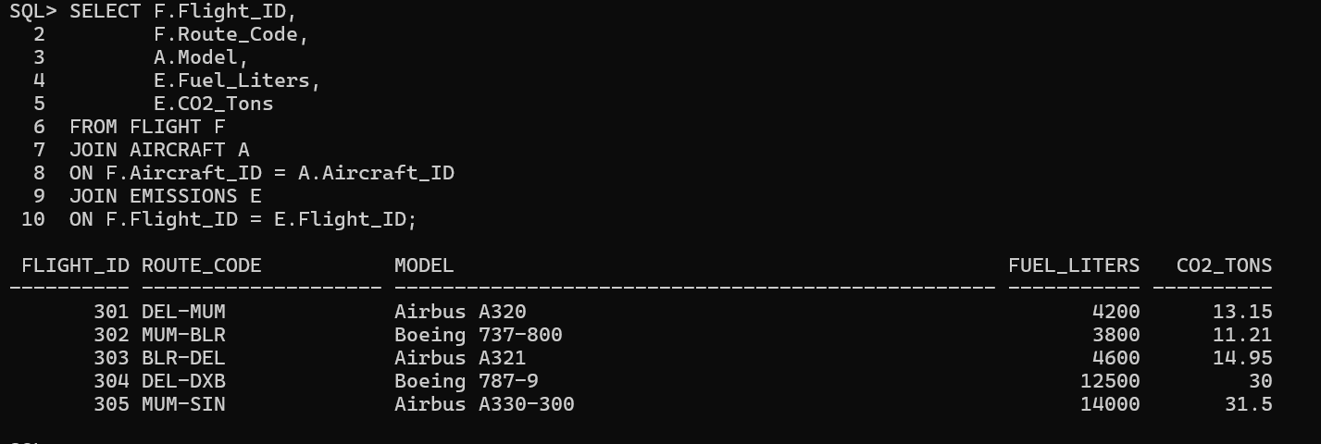

Disruption table AND Flight table:
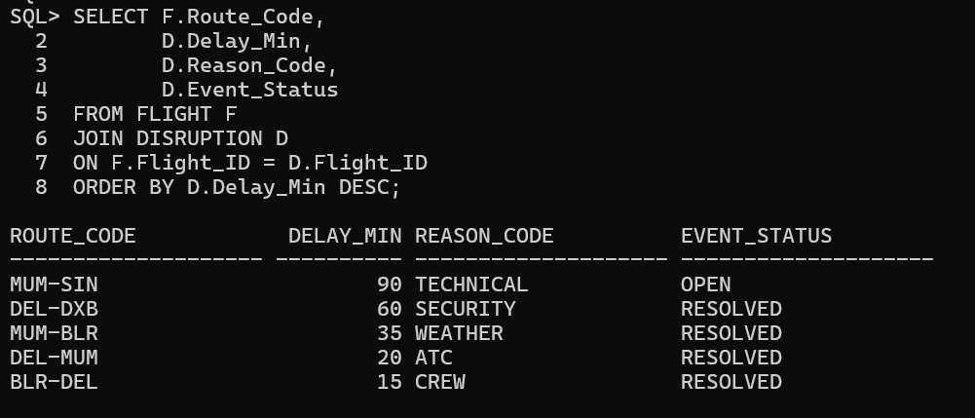

FRONT END APPLICATION DESIGN
The front end is a browser-based airline operations workspace implemented in index.html. It uses a persistent navigation sidebar and a content area for module-specific tables and dashboards. The screens use a Northstar Airways identity, with clear status labels, search controls, refresh actions, modal forms and CSV export.
The overview presents flight counts, fleet availability, open disruptions and CO2 totals, with a departure-flow visualization and upcoming departures. The chart is labelled as sample data and should be treated as illustrative unless the underlying aggregation is verified. The displayed values are snapshots of the supplied demonstration database.
Implemented modules
Module | Main information and actions
Overview | Summary cards, departure visualization and upcoming flights.
Flight schedule | Flight ID, route, departure/arrival, aircraft, status; search, filters, add, details, edit, delete and CSV.
Fleet | Aircraft ID/model, capacity, fuel efficiency, today’s flight and status.
Crew roster | Crew member, role, base, assignment, shift hours and duty status.
Cargo tracking | Shipment category, flight, weight, required/current temperature and tracking state.
Passengers & loyalty | Passenger ID, loyalty tier and baggage allowance.
Disruptions | Flight, route, cause, delay, event time and response status.
Emissions | Flight-level fuel and CO2 records and summary metrics.

Sign-in and account registration gate access to the workspace. The module screens provide a unified view over the nine database entities. A dedicated FLIGHT_CREW assignment-management page is not visible in the supplied interface; adding one is a future enhancement.

BACK END DATABASE TABLES
This data dictionary supplements the Review 0 relational schema with logical Oracle-friendly types and integrity rules. Exact deployed column widths and constraints should be checked against Oracle metadata before migration. Types below are representative and are not asserted as exact column declarations where the source schema does not record lengths.
Table | Attributes and logical data types | Key and constraints
AIRCRAFT | AIRCRAFT_ID NUMBER (PK); MODEL VARCHAR2; CAPACITY_KG NUMBER; FUEL_EFFICIENCY NUMBER; AIRCRAFT_STATUS VARCHAR2 | Primary key; valid capacity/status domains.
FLIGHT | FLIGHT_ID NUMBER (PK); ROUTE_CODE VARCHAR2; DEP_TIME TIMESTAMP; ARR_TIME TIMESTAMP; AIRCRAFT_ID NUMBER; FLIGHT_STATUS VARCHAR2 | FK AIRCRAFT_ID → AIRCRAFT; required route/time/status.
CREW | CREW_ID NUMBER (PK); CREW_NAME VARCHAR2; ROLE VARCHAR2; BASE_LOCATION VARCHAR2 | Primary key; required crew identity fields.
FLIGHT_CREW | ASSIGNMENT_ID NUMBER (PK); FLIGHT_ID NUMBER; CREW_ID NUMBER; SHIFT_HOURS NUMBER | FKs to FLIGHT and CREW; valid assignment hours.
LOYALTY_TIER | TIER_ID NUMBER (PK); TIER_NAME VARCHAR2; EXTRA_BAGGAGE_KG NUMBER | Unique tier name; nonnegative allowance.
PASSENGER | PASSENGER_ID NUMBER (PK); PASSENGER_NAME VARCHAR2; PASSPORT_NO VARCHAR2; TIER_ID NUMBER; BAGGAGE_KG NUMBER | Unique passport; FK TIER_ID → LOYALTY_TIER.
SPEC_CARGO | CARGO_ID NUMBER (PK); FLIGHT_ID NUMBER; CARGO_DESCRIPTION VARCHAR2; WEIGHT_KG NUMBER; CATEGORY VARCHAR2; REQ_TEMP_C NUMBER; CURRENT_TEMP_C NUMBER; TRACKING_STATUS VARCHAR2 | FK FLIGHT_ID; nonnegative weight; temperature fields.
EMISSIONS | LOG_ID NUMBER (PK); FLIGHT_ID NUMBER; FUEL_LITERS NUMBER; CO2_TONS NUMBER; LOGGED_AT TIMESTAMP | FK FLIGHT_ID; nonnegative logged quantities.
DISRUPTION | EVENT_ID NUMBER (PK); FLIGHT_ID NUMBER; DELAY_MIN NUMBER; REASON_CODE VARCHAR2; EVENT_DATE TIMESTAMP; EVENT_STATUS VARCHAR2 | FK FLIGHT_ID; nonnegative delay.

The application creates APP_LOGIN_USERS separately when needed. Its identity key and password hash support local authentication; it is an application-support table rather than a tenth airline-domain entity.
Database platform used by the application
Review 0 records MySQL 8.0 in the initial software-requirement table. The delivered server.py and README use Oracle XE through python-oracledb Thin mode. This Review 1 implementation therefore documents Oracle XE as the actual runtime. SQL dialect, identity generation and constraints must match the Oracle schema used by the application.

FRONT END AND BACK END CONNECTIVITY PROCEDURE
The application runs locally. A browser loads index.html from FastAPI; JavaScript sends JSON requests to the API; the service maps allowed presentation fields to Oracle columns and uses python-oracledb connections to retrieve or write records.
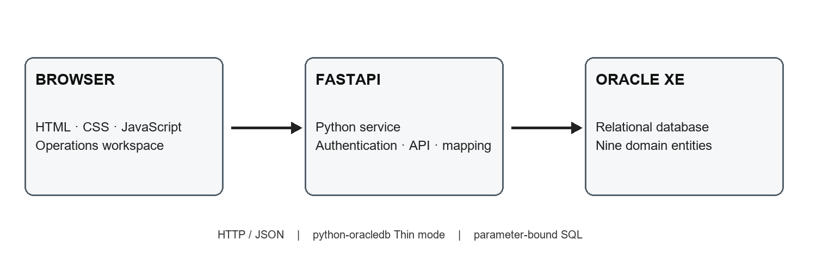
Figure 2. Overall system design and database connectivity.
Connectivity sequence
Step | Procedure
1. Configure | Set Oracle username, password, service DSN and session secret in private environment settings.
2. Start | Run the FastAPI application locally at 127.0.0.1:8001.
3. Authenticate | Register or sign in; the service checks a password hash and issues a signed HttpOnly cookie.
4. Read | The browser requests current operational data; the API queries Oracle using a connection pool.
5. Write | Create/update/delete requests use mapped fields and bound values; successful writes are committed.
6. Refresh | The browser reloads Oracle data; the project README describes automatic refresh every five seconds.

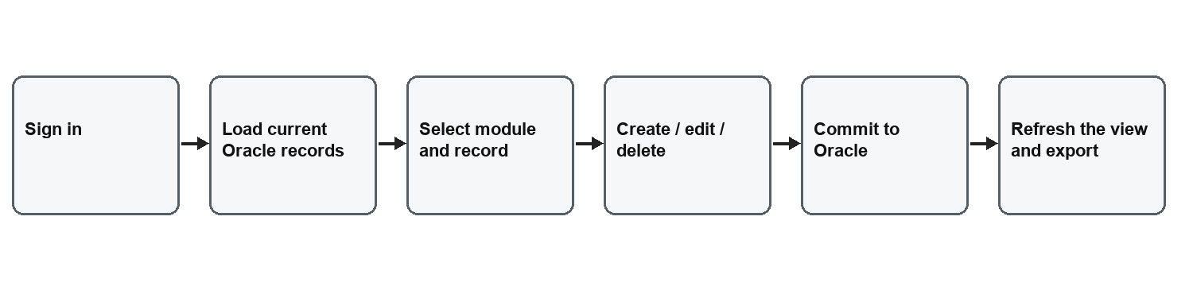
Figure 3. Authenticated operational data workflow.
Authentication and security notes
Passwords use scrypt hashes and signed HttpOnly cookies expire after 12 hours. All accounts share the same permissions; roles are not implemented. The app is for local coursework and needs production security before network exposure.

PRACTICAL IMPLEMENTATION, BUSINESS AND SUSTAINABILITY
Practical implementation
The stack comprises a browser interface (HTML, CSS and JavaScript), a Python FastAPI service, python-oracledb in Thin mode and Oracle XE. The API provides health and authentication endpoints, consolidated data reads, reference lookups and entity-level create, update and delete routes. Parameter binding is used for values, and database constraints remain authoritative for relationships and valid domains.
The supplied evidence shows a flight create flow from the Add Flight form through Oracle insertion, then a flight update reflected in a SQL query. Delete is represented by the browser confirmation prompt; the screenshot set does not show the subsequent deletion result. Key generation depends on the deployed identity/default/trigger configuration and should be confirmed against Oracle metadata.
Business aspect
Potential users include flight operations coordinators, fleet planners, cargo teams and sustainability analysts. A shared view can reduce manual switching among separate lists and make linked flight, fleet, cargo and emissions records easier to review. These are potential benefits; the coursework demonstration has not measured time savings or operational outcomes.
Business path | Application | Requirements before adoption
Internal operations tool | Deploy within an airline operations team. | Integration, access control, audit, uptime and governance.
Subscription service | Offer modules by airline size or user count. | Tenant isolation, cloud security, support and compliance.
Modular services | Add cargo monitoring, disruption analytics or reporting. | Verified data definitions and reliable source integrations.
Implementation support | Provide setup, data migration and training. | Domain validation and ongoing maintenance.

Cost drivers include database and service hosting, security review, integration work, identity management, monitoring, backup, support and training. A pilot should measure task time, data error rates, disruption response time and the completeness of fuel and emissions records before making financial claims.
Sustainability inspiration and practical scope
The project was inspired by making sustainability information part of day-to-day operational records. Fuel and CO2 logging can give analysts a starting point for comparing flights, routes and aircraft. Required and current cargo temperatures can support visibility for medical and perishable shipments. Better information can guide decisions, but the application does not itself reduce emissions, optimize routes or prove avoided spoilage.
Future sustainability work should define verified emission factors, data provenance, reporting boundaries, route distance and passenger/cargo load. Potential indicators include fuel per flight-distance, CO2 per passenger-kilometre or tonne-kilometre, cold-chain excursion rate and completeness of emission logs. External sustainability claims should be based on traceable and validated data.

FULL IMPLEMENTATION CODE
The following appendices reproduce the supplied implementation source. Private .env credentials, session secrets and local probes are excluded.
APPENDIX A SERVER SIDE IMPLEMENTATION
0001 import os
0002 import base64
0003 import hashlib
0004 import hmac
0005 import json
0006 import re
0007 import secrets
0008 from contextlib import contextmanager
0009 from datetime import date, datetime
0010 from pathlib import Path
0011 from typing import Any
0012
0013 import oracledb
0014 from dotenv import load_dotenv
0015 from fastapi import Depends, FastAPI, HTTPException, Request, Response
0016 from fastapi.responses import FileResponse
0017
0018 ROOT = Path(__file__).resolve().parent
0019 load_dotenv(ROOT / ".env")
0020
0021 app = FastAPI(title="Northstar Oracle API")
0022 _pool: oracledb.ConnectionPool | None = None
0023 AUTH_TABLE = "APP_LOGIN_USERS"
0024 SESSION_COOKIE = "northstar_session"
0025 SESSION_SECONDS = 12 * 60 * 60
0026 _session_secret: bytes | None = None
0027
0028 ENTITIES: dict[str, dict[str, Any]] = {
0029 "flights": {
0030 "table": "FLIGHT", "key": "FLIGHT_ID",
0031 "fields": {"route": "ROUTE_CODE", "departure": "DEP_TIME", "arrival": "ARR_TIME", "aircraft_id": "AIRCRAFT_ID", "status": "FLIGHT_STATUS"},
0032 },
0033 "fleet": {
0034 "table": "AIRCRAFT", "key": "AIRCRAFT_ID",
0035 "fields": {"model": "MODEL", "capacity_kg": "CAPACITY_KG", "efficiency": "FUEL_EFFICIENCY", "status": "AIRCRAFT_STATUS"},
0036 },
0037 "crew": {
0038 "table": "CREW", "key": "CREW_ID",
0039 "fields": {"name": "CREW_NAME", "role": "ROLE", "base": "BASE_LOCATION"},
0040 },
0041 "cargo": {
0042 "table": "SPEC_CARGO", "key": "CARGO_ID",
0043 "fields": {"flight_id": "FLIGHT_ID", "name": "CARGO_DESCRIPTION", "weight_kg": "WEIGHT_KG", "category": "CATEGORY", "required_temp_c": "REQ_TEMP_C", "current_temp_c": "CURRENT_TEMP_C", "tracking": "TRACKING_STATUS"},
0044 },
0045 "passengers": {
0046 "table": "PASSENGER", "key": "PASSENGER_ID",
0047 "fields": {"name": "PASSENGER_NAME", "passport_no": "PASSPORT_NO", "tier_id": "TIER_ID", "baggage_kg": "BAGGAGE_KG"},
0048 },
0049 "disruptions": {
0050 "table": "DISRUPTION", "key": "EVENT_ID",
0051 "fields": {"flight_id": "FLIGHT_ID", "delay_min": "DELAY_MIN", "reason": "REASON_CODE", "event_date": "EVENT_DATE", "status": "EVENT_STATUS"},
0052 },
0053 "emissions": {
0054 "table": "EMISSIONS", "key": "LOG_ID",
0055 "fields": {"flight_id": "FLIGHT_ID", "fuel_liters": "FUEL_LITERS", "co2_tons": "CO2_TONS", "logged_at": "LOGGED_AT"},
0056 },
0057 }
0058
0059
0060 def get_pool() -> oracledb.ConnectionPool:
0061 global _pool
0062 if _pool is None:
0063 user = os.getenv("ORACLE_USER")
0064 password = os.getenv("ORACLE_PASSWORD")
0065 dsn = os.getenv("ORACLE_DSN")
0066 if not user or not password or not dsn:
0067 raise HTTPException(status_code=503, detail="Set ORACLE_USER, ORACLE_PASSWORD, and ORACLE_DSN in the local .env file.")
0068 try:
0069 _pool = oracledb.create_pool(user=user, password=password, dsn=dsn, min=1, max=4, increment=1)
0070 except oracledb.Error as exc:
0071 raise HTTPException(status_code=503, detail=f"Oracle connection failed: {exc}") from exc
0072 return _pool
0073
0074
0075 @contextmanager
0076 def connection():
0077 try:
0078 conn = get_pool().acquire()
0079 except oracledb.Error as exc:
0080 raise HTTPException(status_code=503, detail=f"Cannot acquire an Oracle connection: {exc}") from exc
0081 try:
0082 yield conn
0083 finally:
0084 conn.close()
0085
0086
0087 def rows_as_dicts(cursor: oracledb.Cursor) -> list[dict[str, Any]]:
0088 names = [column[0].lower() for column in cursor.description]
0089 result = []
0090 for row in cursor:
0091 item = dict(zip(names, row))
0092 for key, value in item.items():
0093 if isinstance(value, (datetime, date)):
0094 item[key] = value.isoformat()
0095 result.append(item)
0096 return result
0097
0098
0099 def ensure_auth_table() -> None:
0100 with connection() as conn:
0101 with conn.cursor() as cursor:
0102 cursor.execute("SELECT COUNT(*) FROM USER_TABLES WHERE TABLE_NAME = :table_name", {"table_name": AUTH_TABLE})
0103 if cursor.fetchone()[0]:
0104 return
0105 try:
0106 cursor.execute(f"""CREATE TABLE {AUTH_TABLE} (
0107 USER_ID NUMBER GENERATED BY DEFAULT AS IDENTITY PRIMARY KEY,
0108 NAME VARCHAR2(80) NOT NULL,
0109 EMAIL VARCHAR2(254) NOT NULL UNIQUE,
0110 PASSWORD_HASH VARCHAR2(256) NOT NULL,
0111 CREATED_AT TIMESTAMP DEFAULT CURRENT_TIMESTAMP NOT NULL
0112 )""")
0113 except oracledb.DatabaseError as exc:
0114 if getattr(exc.args[0], "code", None) != 955:
0115 raise
0116
0117
0118 def hash_password(password: str, salt: bytes | None = None) -> str:
0119 salt = salt or secrets.token_bytes(16)
0120 digest = hashlib.scrypt(password.encode("utf-8"), salt=salt, n=2**14, r=8, p=1, dklen=64)
0121 return f"scrypt$16384$8$1${base64.urlsafe_b64encode(salt).decode()}${base64.urlsafe_b64encode(digest).decode()}"
0122
0123
0124 def verify_password(password: str, encoded: str) -> bool:
0125 try:
0126 algorithm, n, r, p, salt_text, digest_text = encoded.split("$", 5)
0127 if algorithm != "scrypt":
0128 return False
0129 salt = base64.urlsafe_b64decode(salt_text.encode())
0130 expected = base64.urlsafe_b64decode(digest_text.encode())
0131 actual = hashlib.scrypt(password.encode("utf-8"), salt=salt, n=int(n), r=int(r), p=int(p), dklen=len(expected))
0132 return hmac.compare_digest(actual, expected)
0133 except (ValueError, TypeError):
0134 return False
0135
0136
0137 def get_session_secret() -> bytes:
0138 global _session_secret
0139 if _session_secret is None:
0140 path = ROOT / ".session_secret"
0141 try:
0142 _session_secret = path.read_bytes()
0143 except FileNotFoundError:
0144 _session_secret = secrets.token_bytes(32)
0145 try:
0146 with path.open("xb") as secret_file:
0147 secret_file.write(_session_secret)
0148 except FileExistsError:
0149 _session_secret = path.read_bytes()
0150 return _session_secret
0151
0152
0153 def create_session(user: dict[str, Any]) -> str:
0154 payload = {"id": user["user_id"], "name": user["name"], "email": user["email"], "exp": int(datetime.now().timestamp()) + SESSION_SECONDS}
0155 encoded = base64.urlsafe_b64encode(json.dumps(payload, separators=(",", ":")).encode()).rstrip(b"=")
0156 signature = hmac.new(get_session_secret(), encoded, hashlib.sha256).digest()
0157 return f"{encoded.decode()}.{base64.urlsafe_b64encode(signature).rstrip(b'=').decode()}"
0158
0159
0160 def session_user(request: Request) -> dict[str, Any] | None:
0161 token = request.cookies.get(SESSION_COOKIE)
0162 if not token or "." not in token:
0163 return None
0164 encoded_text, signature_text = token.rsplit(".", 1)
0165 encoded = encoded_text.encode()
0166 expected = hmac.new(get_session_secret(), encoded, hashlib.sha256).digest()
0167 try:
0168 supplied = base64.urlsafe_b64decode(signature_text + "=" * (-len(signature_text) % 4))
0169 payload_bytes = base64.urlsafe_b64decode(encoded_text + "=" * (-len(encoded_text) % 4))
0170 payload = json.loads(payload_bytes)
0171 except (ValueError, json.JSONDecodeError):
0172 return None
0173 if not hmac.compare_digest(expected, supplied) or payload.get("exp", 0) < datetime.now().timestamp():
0174 return None
0175 return payload
0176
0177
0178 def require_user(request: Request) -> dict[str, Any]:
0179 user = session_user(request)
0180 if user is None:
0181 raise HTTPException(status_code=401, detail="Please sign in to continue.")
0182 return user
0183
0184
0185 def flight_label(flight_id: int | None) -> str:
0186 return f"NS {flight_id:03d}" if flight_id is not None else "—"
0187
0188
0189 def read_all() -> dict[str, list[dict[str, Any]]]:
0190 queries = {
0191 "flights": """SELECT f.FLIGHT_ID AS db_id, f.ROUTE_CODE AS route,
0192 TO_CHAR(f.DEP_TIME, 'YYYY-MM-DD\"T\"HH24:MI:SS') AS departure_iso,
0193 TO_CHAR(f.DEP_TIME, 'HH24:MI') AS departure,
0194 TO_CHAR(f.ARR_TIME, 'YYYY-MM-DD\"T\"HH24:MI:SS') AS arrival_iso,
0195 TO_CHAR(f.ARR_TIME, 'HH24:MI') AS arrival,
0196 f.AIRCRAFT_ID AS aircraft_id, a.MODEL AS model, f.FLIGHT_STATUS AS status
0197 FROM FLIGHT f JOIN AIRCRAFT a ON a.AIRCRAFT_ID = f.AIRCRAFT_ID ORDER BY f.DEP_TIME""",
0198 "fleet": """SELECT a.AIRCRAFT_ID AS db_id, a.MODEL AS model, a.CAPACITY_KG AS capacity_kg,
0199 a.FUEL_EFFICIENCY AS efficiency, a.AIRCRAFT_STATUS AS status,
0200 (SELECT MIN(f.FLIGHT_ID) FROM FLIGHT f WHERE f.AIRCRAFT_ID = a.AIRCRAFT_ID) AS flight_id
0201 FROM AIRCRAFT a ORDER BY a.AIRCRAFT_ID""",
0202 "crew": """SELECT c.CREW_ID AS db_id, c.CREW_NAME AS name, c.ROLE AS role,
0203 c.BASE_LOCATION AS base, fc.FLIGHT_ID AS flight_id, fc.SHIFT_HOURS AS shift
0204 FROM CREW c LEFT JOIN (SELECT CREW_ID, MIN(FLIGHT_ID) AS FLIGHT_ID,
0205 MIN(SHIFT_HOURS) AS SHIFT_HOURS FROM FLIGHT_CREW GROUP BY CREW_ID) fc
0206 ON fc.CREW_ID = c.CREW_ID ORDER BY c.CREW_ID""",
0207 "cargo": """SELECT c.CARGO_ID AS db_id, c.CARGO_DESCRIPTION AS name, c.CATEGORY AS category,
0208 c.FLIGHT_ID AS flight_id, c.WEIGHT_KG AS weight_kg, c.REQ_TEMP_C AS required_temp_c,
0209 c.CURRENT_TEMP_C AS current_temp_c, c.TRACKING_STATUS AS tracking
0210 FROM SPEC_CARGO c ORDER BY c.CARGO_ID""",
0211 "passengers": """SELECT p.PASSENGER_ID AS db_id, p.PASSENGER_NAME AS name,
0212 p.TIER_ID AS tier_id, lt.TIER_NAME AS tier, lt.EXTRA_BAGGAGE_KG AS allowance_kg,
0213 p.BAGGAGE_KG AS baggage_kg,
0214 (SELECT MIN(b.FLIGHTNO) FROM BOOKING b WHERE b.P_ID = TO_CHAR(p.PASSENGER_ID)) AS flight_id
0215 FROM PASSENGER p JOIN LOYALTY_TIER lt ON lt.TIER_ID = p.TIER_ID ORDER BY p.PASSENGER_ID""",
0216 "disruptions": """SELECT d.EVENT_ID AS db_id, d.FLIGHT_ID AS flight_id, f.ROUTE_CODE AS route,
0217 d.REASON_CODE AS reason, d.DELAY_MIN AS delay_min,
0218 TO_CHAR(d.EVENT_DATE, 'YYYY-MM-DD\"T\"HH24:MI:SS') AS event_date,
0219 d.EVENT_STATUS AS status FROM DISRUPTION d JOIN FLIGHT f ON f.FLIGHT_ID = d.FLIGHT_ID
0220 ORDER BY d.EVENT_DATE DESC""",
0221 "emissions": """SELECT e.LOG_ID AS db_id, e.FLIGHT_ID AS flight_id, f.ROUTE_CODE AS route,
0222 e.FUEL_LITERS AS fuel_liters, e.CO2_TONS AS co2_tons, f.AIRCRAFT_ID AS aircraft_id,
0223 TO_CHAR(e.LOGGED_AT, 'YYYY-MM-DD\"T\"HH24:MI:SS') AS logged_at
0224 FROM EMISSIONS e JOIN FLIGHT f ON f.FLIGHT_ID = e.FLIGHT_ID ORDER BY e.LOGGED_AT DESC""",
0225 "loyalty_tiers": "SELECT TIER_ID AS tier_id, TIER_NAME AS tier_name, EXTRA_BAGGAGE_KG AS allowance_kg FROM LOYALTY_TIER ORDER BY TIER_ID",
0226 }
0227 result: dict[str, list[dict[str, Any]]] = {}
0228 with connection() as conn:
0229 with conn.cursor() as cursor:
0230 for entity, sql in queries.items():
0231 cursor.execute(sql)
0232 records = rows_as_dicts(cursor)
0233 if entity == "flights":
0234 for row in records:
0235 row.update(id=flight_label(row["db_id"]), aircraft=f"AC-{row['aircraft_id']:03d} · {row['model']}")
0236 elif entity == "fleet":
0237 for row in records:
0238 row.update(id=f"AC-{row['db_id']:03d}", capacity=f"{row['capacity_kg']:,.0f} kg", efficiency=f"{row['efficiency']} L / 100 km", flights=flight_label(row["flight_id"]) if row["flight_id"] else "—")
0239 elif entity == "crew":
0240 for row in records:
0241 row.update(id=f"CR-{row['db_id']:03d}", flight=flight_label(row["flight_id"]) if row["flight_id"] else "—", shift=f"{row['shift']} h" if row["shift"] is not None else "—", status="On duty" if row["flight_id"] else "Standby")
0242 elif entity == "cargo":
0243 for row in records:
0244 row.update(id=f"CG-{row['db_id']:04d}", flight=flight_label(row["flight_id"]), weight=f"{row['weight_kg']:,.0f} kg", required=f"{row['required_temp_c']} °C" if row["required_temp_c"] is not None else "Not specified", current=f"{row['current_temp_c']} °C" if row["current_temp_c"] is not None else "Not recorded")
0245 elif entity == "passengers":
0246 for row in records:
0247 row.update(id=f"P-{row['db_id']:05d}", allowance=f"+{row['allowance_kg']:g} kg", baggage=f"{row['baggage_kg']:g} kg", flight=flight_label(row["flight_id"]) if row["flight_id"] else "—")
0248 elif entity == "disruptions":
0249 for row in records:
0250 row.update(id=f"DP-{row['db_id']:04d}", flight=flight_label(row["flight_id"]), delay=f"{row['delay_min']} min", date=row["event_date"])
0251 elif entity == "emissions":
0252 for row in records:
0253 row.update(id=f"EM-{row['db_id']:04d}", flight=flight_label(row["flight_id"]), fuel=f"{row['fuel_liters']:,.0f} L", co2=f"{row['co2_tons']:g} t", aircraft=f"AC-{row['aircraft_id']:03d}", logged=row["logged_at"])
0254 result[entity] = records
0255 return result
0256
0257
0258 @app.get("/api/health")
0259 def health() -> dict[str, Any]:
0260 with connection() as conn:
0261 with conn.cursor() as cursor:
0262 cursor.execute("SELECT USER, SYS_CONTEXT('USERENV','SERVICE_NAME'), SYS_CONTEXT('USERENV','CON_NAME') FROM DUAL")
0263 user, service, container = cursor.fetchone()
0264 cursor.execute("SELECT TABLE_NAME FROM USER_TABLES")
0265 visible = {row[0] for row in cursor.fetchall()}
0266 required = {"AIRCRAFT", "CREW", "DISRUPTION", "EMISSIONS", "FLIGHT", "LOYALTY_TIER", "PASSENGER", "SPEC_CARGO"}
0267 missing = sorted(required - visible)
0268 if missing:
0269 raise HTTPException(status_code=503, detail=f"Oracle is reachable as {user} on {service}/{container}, but this schema cannot see the airline tables. Use the same Oracle username and service as the SQL*Plus session where you ran the inserts.")
0270 return {"status": "ok", "database": "Oracle", "user": user, "service": service, "container": container}
0271
0272
0273 @app.post("/api/auth/signup", status_code=201)
0274 def signup(payload: dict[str, Any], response: Response) -> dict[str, Any]:
0275 name = str(payload.get("name", "")).strip()
0276 email = str(payload.get("email", "")).strip().lower()
0277 password = str(payload.get("password", ""))
0278 if not name or len(name) > 80:
0279 raise HTTPException(status_code=422, detail="Name is required and must be 80 characters or fewer.")
0280 if not re.fullmatch(r"[^\s@]+@[^\s@]+\.[^\s@]+", email) or len(email) > 254:
0281 raise HTTPException(status_code=422, detail="Enter a valid email address.")
0282 if len(password) < 10:
0283 raise HTTPException(status_code=422, detail="Password must be at least 10 characters.")
0284 ensure_auth_table()
0285 try:
0286 with connection() as conn:
0287 with conn.cursor() as cursor:
0288 user_id_var = cursor.var(oracledb.NUMBER)
0289 cursor.execute(
0290 f"INSERT INTO {AUTH_TABLE} (NAME, EMAIL, PASSWORD_HASH) VALUES (:name, :email, :password_hash) RETURNING USER_ID INTO :user_id",
0291 {"name": name, "email": email, "password_hash": hash_password(password), "user_id": user_id_var},
0292 )
0293 user_id = user_id_var.getvalue()
0294 conn.commit()
0295 except oracledb.DatabaseError as exc:
0296 if getattr(exc.args[0], "code", None) == 1:
0297 raise HTTPException(status_code=409, detail="An account with this email already exists.") from exc
0298 raise HTTPException(status_code=503, detail="Could not create the account in Oracle.") from exc
0299 if isinstance(user_id, list):
0300 user_id = user_id[0]
0301 user = {"user_id": int(user_id), "name": name, "email": email}
0302 response.set_cookie(SESSION_COOKIE, create_session(user), httponly=True, samesite="lax", secure=False, max_age=SESSION_SECONDS, path="/")
0303 return user
0304
0305
0306 @app.post("/api/auth/login")
0307 def login(payload: dict[str, Any], response: Response) -> dict[str, Any]:
0308 email = str(payload.get("email", "")).strip().lower()
0309 password = str(payload.get("password", ""))
0310 ensure_auth_table()
0311 try:
0312 with connection() as conn:
0313 with conn.cursor() as cursor:
0314 cursor.execute(f"SELECT USER_ID, NAME, EMAIL, PASSWORD_HASH FROM {AUTH_TABLE} WHERE EMAIL = :email", {"email": email})
0315 row = cursor.fetchone()
0316 except oracledb.DatabaseError as exc:
0317 raise HTTPException(status_code=503, detail="Could not check the account in Oracle.") from exc
0318 if row is None or not verify_password(password, row[3]):
0319 raise HTTPException(status_code=401, detail="Email or password is incorrect.")
0320 user = {"user_id": int(row[0]), "name": row[1], "email": row[2]}
0321 response.set_cookie(SESSION_COOKIE, create_session(user), httponly=True, samesite="lax", secure=False, max_age=SESSION_SECONDS, path="/")
0322 return user
0323
0324
0325 @app.get("/api/auth/me")
0326 def current_user(user: dict[str, Any] | None = Depends(session_user)) -> dict[str, Any]:
0327 if user is None:
0328 raise HTTPException(status_code=401, detail="Please sign in to continue.")
0329 return user
0330
0331
0332 @app.post("/api/auth/logout")
0333 def logout(response: Response) -> dict[str, str]:
0334 response.delete_cookie(SESSION_COOKIE, path="/")
0335 return {"message": "Signed out"}
0336
0337
0338 @app.get("/api/data")
0339 def get_data(_user: dict[str, Any] = Depends(require_user)) -> dict[str, list[dict[str, Any]]]:
0340 try:
0341 return read_all()
0342 except oracledb.DatabaseError as exc:
0343 error = exc.args[0]
0344 if getattr(error, "code", None) == 942:
0345 raise HTTPException(status_code=503, detail="Oracle is reachable, but the configured schema cannot see one or more airline tables. Use the same Oracle username and service as the SQL*Plus session where you ran the inserts.") from exc
0346 raise HTTPException(status_code=503, detail=f"Oracle query failed: {error}") from exc
0347
0348
0349 @app.get("/api/reference/{entity}")
0350 def get_reference(entity: str, _user: dict[str, Any] = Depends(require_user)) -> list[dict[str, Any]]:
0351 queries = {
0352 "flights": "SELECT FLIGHT_ID AS db_id, ROUTE_CODE AS route FROM FLIGHT ORDER BY FLIGHT_ID",
0353 "fleet": "SELECT AIRCRAFT_ID AS db_id, MODEL AS model FROM AIRCRAFT ORDER BY AIRCRAFT_ID",
0354 "tiers": "SELECT TIER_ID AS tier_id, TIER_NAME AS tier_name FROM LOYALTY_TIER ORDER BY TIER_ID",
0355 }
0356 sql = queries.get(entity)
0357 if sql is None:
0358 raise HTTPException(status_code=404, detail="Unknown reference list.")
0359 with connection() as conn:
0360 with conn.cursor() as cursor:
0361 cursor.execute(sql)
0362 return rows_as_dicts(cursor)
0363
0364
0365 def get_entity(entity: str) -> dict[str, Any]:
0366 definition = ENTITIES.get(entity)
0367 if definition is None:
0368 raise HTTPException(status_code=404, detail="Unknown entity.")
0369 return definition
0370
0371
0372 def write_record(entity: str, key_value: int | str | None, payload: dict[str, Any], create: bool) -> dict[str, Any]:
0373 definition = get_entity(entity)
0374 fields: dict[str, str] = definition["fields"]
0375 provided_key = payload.pop("db_id", None) if create else None
0376 unknown = set(payload) - set(fields)
0377 if unknown:
0378 raise HTTPException(status_code=422, detail=f"Unsupported fields: {', '.join(sorted(unknown))}")
0379 if provided_key is not None:
0380 try:
0381 provided_key = int(provided_key)
0382 except (TypeError, ValueError) as exc:
0383 raise HTTPException(status_code=422, detail="db_id must be a number.") from exc
0384 if not payload:
0385 raise HTTPException(status_code=422, detail="Provide at least one field.")
0386 columns = list(payload)
0387 binds = {name: payload[name] for name in columns}
0388 date_fields = {"departure", "arrival", "event_date", "logged_at"}
0389 for name in columns:
0390 if name in date_fields and binds[name] is not None:
0391 try:
0392 binds[name] = datetime.fromisoformat(str(binds[name]))
0393 except ValueError as exc:
0394 raise HTTPException(status_code=422, detail=f"{name} must be an ISO date/time.") from exc
0395 try:
0396 with connection() as conn:
0397 with conn.cursor() as cursor:
0398 if create:
0399 column_sql = ", ".join(fields[name] for name in columns)
0400 bind_sql = ", ".join(f":{name}" for name in columns)
0401 if provided_key is not None:
0402 column_sql = f"{definition['key']}, {column_sql}"
0403 bind_sql = f":provided_key, {bind_sql}"
0404 binds["provided_key"] = provided_key
0405 key_var = cursor.var(oracledb.NUMBER)
0406 sql = f"INSERT INTO {definition['table']} ({column_sql}) VALUES ({bind_sql}) RETURNING {definition['key']} INTO :new_key"
0407 cursor.execute(sql, {**binds, "new_key": key_var})
0408 new_key = key_var.getvalue()
0409 conn.commit()
0410 return {"db_id": new_key, "message": "Created"}
0411 assignments = ", ".join(f"{fields[name]} = :{name}" for name in columns)
0412 binds["record_key"] = key_value
0413 cursor.execute(f"UPDATE {definition['table']} SET {assignments} WHERE {definition['key']} = :record_key", binds)
0414 if cursor.rowcount == 0:
0415 raise HTTPException(status_code=404, detail="Record not found.")
0416 conn.commit()
0417 return {"db_id": key_value, "message": "Updated"}
0418 except HTTPException:
0419 raise
0420 except oracledb.Error as exc:
0421 raise HTTPException(status_code=409, detail=f"Oracle rejected the change. Check required fields, relationships, and generated IDs: {exc}") from exc
0422
0423
0424 @app.post("/api/{entity}", status_code=201)
0425 def create_record(entity: str, payload: dict[str, Any], _user: dict[str, Any] = Depends(require_user)) -> dict[str, Any]:
0426 return write_record(entity, None, payload, True)
0427
0428
0429 @app.put("/api/{entity}/{record_id}")
0430 def update_record(entity: str, record_id: str, payload: dict[str, Any], _user: dict[str, Any] = Depends(require_user)) -> dict[str, Any]:
0431 definition = get_entity(entity)
0432 try:
0433 key_value: int | str = int(record_id) if definition["key"] != "BOOKING_ID" else record_id
0434 except ValueError as exc:
0435 raise HTTPException(status_code=422, detail="Record ID must be numeric.") from exc
0436 return write_record(entity, key_value, payload, False)
0437
0438
0439 @app.delete("/api/{entity}/{record_id}")
0440 def delete_record(entity: str, record_id: str, _user: dict[str, Any] = Depends(require_user)) -> dict[str, str]:
0441 definition = get_entity(entity)
0442 try:
0443 key_value = int(record_id)
0444 except ValueError as exc:
0445 raise HTTPException(status_code=422, detail="Record ID must be numeric.") from exc
0446 try:
0447 with connection() as conn:
0448 with conn.cursor() as cursor:
0449 cursor.execute(f"DELETE FROM {definition['table']} WHERE {definition['key']} = :record_key", {"record_key": key_value})
0450 if cursor.rowcount == 0:
0451 raise HTTPException(status_code=404, detail="Record not found.")
0452 conn.commit()
0453 return {"message": "Deleted"}
0454 except HTTPException:
0455 raise
0456 except oracledb.Error as exc:
0457 raise HTTPException(status_code=409, detail=f"Oracle rejected the delete, possibly because related records exist: {exc}") from exc
0458
0459
0460 @app.get("/")
0461 def index() -> FileResponse:
0462 return FileResponse(ROOT / "index.html")
0463
0464
0465 @app.get("/{asset_path:path}")
0466 def static_files(asset_path: str) -> FileResponse:
0467 path = (ROOT / asset_path).resolve()
0468 if ROOT not in path.parents or not path.is_file():
0469 raise HTTPException(status_code=404, detail="Not found.")
0470 return FileResponse(path)

APPENDIX B BROWSER SIDE IMPLEMENTATION
0001 <!doctype html>
0002 <html lang="en">
0003 <head>
0004 <meta charset="utf-8"><meta name="viewport" content="width=device-width, initial-scale=1"><meta name="theme-color" content="#0b1421">
0005 <title>Northstar · Airline Logistics</title>
0006 <style>
0007 :root{--nav:#0b1421;--nav2:#121f30;--ink:#172638;--muted:#7f8b98;--line:#e7edf0;--bg:#f4f7f8;--teal:#17b394;--teal2:#e7f7f3;--amber:#d99438;--red:#d36c62;--shadow:0 18px 45px #1726380b}*{box-sizing:border-box}body{margin:0;background:var(--bg);font:14px/1.45 "Segoe UI",Arial,sans-serif;color:var(--ink)}button,input,select{font:inherit}button{cursor:pointer}.layout{display:grid;grid-template-columns:252px 1fr;min-height:100vh}.sidebar{background:var(--nav);color:#dbe4ed;padding:22px 15px 16px;display:flex;flex-direction:column;min-height:100vh;position:sticky;top:0;height:100vh;overflow:auto}.brand{display:flex;align-items:center;gap:11px;padding:2px 12px 28px;color:white;font-weight:800;letter-spacing:.13em;font-size:14px}.brand-mark{font-size:25px;color:#37d3b6}.brand small{display:block;color:#8293a4;font-size:9px;letter-spacing:.18em;margin-top:3px;font-weight:600}.workspace-label,.caption{color:#78899b;font-weight:700;letter-spacing:.17em;font-size:9px;padding:0 12px 9px}.workspace{display:flex;gap:10px;align-items:center;padding:10px;background:#142438;border:1px solid #26364a;border-radius:9px;margin-bottom:23px;font-size:11px;font-weight:700}.workspace-badge{display:grid;place-items:center;width:32px;height:32px;background:#234154;color:#69d8c0;border-radius:8px;font-size:10px}.workspace small,.profile small{display:block;color:#8da0b1;font-weight:400;margin-top:3px}.caption{margin:9px 0 3px}.nav{display:grid;gap:3px}.nav button{border:0;background:transparent;color:#a3b0be;display:flex;align-items:center;gap:11px;text-align:left;border-radius:7px;padding:10px 12px;font-size:12px}.nav button:hover{background:#142337;color:white}.nav button.active{background:#17382f;color:#6be0c4;font-weight:700}.nav .ico{width:17px;text-align:center;font-size:16px}.nav .count{margin-left:auto;padding:2px 7px;border-radius:20px;background:#25374a;font-size:9px}.nav .count.alert{background:#432c34;color:#f29c91}.side-bottom{margin-top:auto}.brief{padding:14px;margin:12px 4px 14px;border-radius:9px;background:linear-gradient(145deg,#173b3a,#152c30);border:1px solid #294a48}.brief .spark{font-size:18px;color:#64d9bc}.brief strong{display:block;font-size:12px;margin:8px 0 4px}.brief p{font-size:10px;color:#adc0bf;margin:0;line-height:1.55}.profile{display:flex;align-items:center;gap:9px;padding:13px 7px 0;border-top:1px solid #263547;font-size:11px;font-weight:700}.avatar{display:grid;place-items:center;width:31px;height:31px;background:#dcece9;color:#247d70;border-radius:50%;font-size:10px}.profile small{font-size:10px}.main{min-width:0}.topbar{height:70px;background:#fff;border-bottom:1px solid var(--line);display:flex;align-items:center;justify-content:space-between;padding:0 34px;gap:16px}.crumb{font-size:12px;color:#82909d}.crumb b{color:#18283a;margin-left:10px}.top-actions{display:flex;align-items:center;gap:15px}.live{color:#258d78;font-size:10px;display:flex;align-items:center;gap:7px;white-space:nowrap}.live i{width:7px;height:7px;background:#29bf99;border-radius:50%;box-shadow:0 0 0 4px #e4f6f0}.btn{border:1px solid #e1e8eb;background:#fff;border-radius:6px;padding:8px 11px;color:#526273;font-size:11px}.btn:hover{border-color:#98cfc2;color:#158a74}.btn.primary{background:#159d83;border-color:#159d83;color:white;font-weight:700}.top-avatar{display:grid;place-items:center;width:32px;height:32px;border-radius:50%;background:#dcece9;color:#247d70;font-weight:700;font-size:10px}.content{padding:30px 34px 42px;max-width:1550px;margin:auto}.eyebrow{font-size:9px;letter-spacing:.17em;font-weight:800;color:#778897}.title-row{display:flex;justify-content:space-between;align-items:flex-end;gap:16px;margin-bottom:22px}.title-row h1{font-size:25px;letter-spacing:-.04em;margin:5px 0 3px;color:#142437}.title-row p{font-size:11px;color:var(--muted);margin:0}.actions{display:flex;gap:8px}.stats{display:grid;grid-template-columns:repeat(4,minmax(0,1fr));gap:13px;margin-bottom:15px}.stat,.panel{background:#fff;border:1px solid var(--line);border-radius:10px;box-shadow:var(--shadow)}.stat{padding:16px 17px;min-height:112px}.stat-head{display:flex;justify-content:space-between;color:#607181;font-size:10px;font-weight:600}.stat-icon{display:grid;place-items:center;width:27px;height:27px;border-radius:7px;background:#e8f6f2;color:#168c77;font-size:14px}.stat-icon.blue{background:#eef2fc;color:#6079c1}.stat-icon.amber{background:#fbf2e4;color:#c18b3a}.stat-icon.red{background:#fbebea;color:#c96f67}.stat-value{font-size:26px;font-weight:750;letter-spacing:-.05em;margin-top:8px}.stat-foot{font-size:9px;color:#91a0aa;margin-top:1px}.overview-grid{display:grid;grid-template-columns:minmax(0,1.55fr) minmax(280px,.9fr);gap:14px;margin-bottom:14px}.panel{padding:17px 18px}.panel-head{display:flex;align-items:flex-start;justify-content:space-between;gap:12px;margin-bottom:13px}.panel-title{font-size:12px;font-weight:750;color:#26384a}.panel-sub{font-size:9px;color:#929da6;margin-top:3px}.text-link{border:0;background:transparent;color:#159b83;font-size:10px;font-weight:700}.chart-wrap{position:relative;width:100%;height:214px}.chart{display:block;width:100%;height:100%;overflow:visible}.chart .gridline{stroke:#ebf0f1;stroke-width:1}.chart text{font:9px "Segoe UI",Arial,sans-serif;fill:#98a4ad}.chart .line{fill:none;stroke:#19b69a;stroke-width:3;stroke-linecap:round;stroke-linejoin:round}.chart .area{fill:url(#area)}.chart .dot{fill:white;stroke:#16a98d;stroke-width:2}.tooltip{position:absolute;z-index:3;display:none;pointer-events:none;background:#132337;color:#fff;border-radius:7px;padding:8px 10px;min-width:135px;font-size:9px;line-height:1.5;box-shadow:0 8px 24px #13233735;transform:translate(-50%,-110%)}.tooltip.show{display:block}.tooltip b{display:block;font-size:11px;margin:2px 0}.status-list{display:grid;gap:0}.status-row{display:flex;align-items:center;gap:11px;padding:12px 0;border-bottom:1px solid #eef1f2}.status-row:last-child{border-bottom:0}.status-symbol{display:grid;place-items:center;width:30px;height:30px;border-radius:8px;background:#f0f5f6;color:#387c78;font-size:14px}.status-copy{flex:1}.status-copy strong{display:block;font-size:10px}.status-copy small{font-size:9px;color:#919da6}.status-value{text-align:right;font-weight:750;font-size:14px}.status-value small{display:block;font-size:8px;color:#9aa5ad;font-weight:400}.section-panel{margin-bottom:14px}.table-wrap{overflow:auto}table{border-collapse:collapse;width:100%;min-width:650px}th{text-align:left;color:#8b98a2;text-transform:uppercase;font-size:8px;letter-spacing:.08em;font-weight:700;padding:10px 9px;border-bottom:1px solid #e9eef0;white-space:nowrap}td{padding:11px 9px;border-bottom:1px solid #f0f3f4;font-size:10px;color:#506071;white-space:nowrap}tbody tr{cursor:pointer}tbody tr:hover{background:#f7fbfa}td:first-child{font-weight:700;color:#26394c}.badge{display:inline-flex;padding:4px 8px;border-radius:20px;font-size:8px;font-weight:700;background:#edf2f3;color:#647480}.badge.green{background:#e6f5ee;color:#23886d}.badge.amber{background:#fbf1e0;color:#b37c28}.badge.red{background:#fbeae8;color:#bd5d57}.badge.blue{background:#edf1fb;color:#5f74b3}.badge.gray{background:#eef0f2;color:#687681}.lower-grid{display:grid;grid-template-columns:1fr 1fr;gap:14px}.mini-row{display:flex;align-items:center;gap:10px;padding:10px 0;border-top:1px solid #eef1f2}.mini-mark{display:grid;place-items:center;width:27px;height:27px;border-radius:7px;background:#fff0eb;color:#cb7564}.mini-row strong{display:block;font-size:10px}.mini-row small{display:block;color:#909da6;font-size:9px;margin-top:3px}.mini-row .push{margin-left:auto;color:#b96d54;font-size:9px;font-weight:700}.controls{display:flex;align-items:center;gap:8px}.search{width:min(250px,42vw);border:1px solid #e4e9eb;background:#fff;border-radius:6px;padding:8px 10px;font-size:10px;outline:none}.search:focus,select:focus{border-color:#21aa90;box-shadow:0 0 0 3px #e6f6f2}select{border:1px solid #e4e9eb;background:#fff;border-radius:6px;padding:8px 10px;color:#607181;font-size:10px}.empty{text-align:center;color:#83909b;padding:42px 20px;font-size:11px}.modal-bg{position:fixed;inset:0;display:none;align-items:center;justify-content:center;padding:18px;background:#0b1421a8;z-index:20}.modal-bg.open{display:flex}.modal{position:relative;background:#fff;border-radius:11px;width:min(540px,100%);max-height:88vh;overflow:auto;padding:24px;box-shadow:0 28px 90px #07111e55}.modal-close{position:absolute;right:14px;top:10px;border:0;background:transparent;font-size:22px;color:#77838d}.modal h2{margin:6px 0;font-size:20px}.modal p{font-size:11px;color:var(--muted);margin:0 0 16px}.detail-grid{display:grid;grid-template-columns:1fr 1fr;gap:1px;background:var(--line);border:1px solid var(--line);border-radius:7px;overflow:hidden}.detail-cell{background:white;padding:11px}.detail-cell small{display:block;color:#8a969f;font-size:8px;margin-bottom:5px}.detail-cell strong{font-size:10px}.form-grid{display:grid;grid-template-columns:1fr 1fr;gap:12px}.form-grid label{font-size:9px;color:#697986;font-weight:700}.form-grid input,.form-grid select{display:block;width:100%;margin-top:5px;font-size:10px}.modal-actions{display:flex;justify-content:flex-end;gap:8px;margin-top:18px}.toast{position:fixed;right:22px;bottom:22px;background:#142438;color:white;padding:11px 15px;border-radius:7px;font-size:10px;box-shadow:0 8px 30px #17263830;opacity:0;transform:translateY(12px);transition:.2s;pointer-events:none;z-index:25}.toast.show{opacity:1;transform:translateY(0)}
0008 @media(max-width:1050px){.layout{grid-template-columns:220px 1fr}.content{padding:25px 22px}.topbar{padding:0 22px}.stats{grid-template-columns:repeat(2,minmax(0,1fr))}}
0009 body.auth-required .layout{display:none}.auth-screen{display:none;min-height:100vh;place-items:center;padding:24px;background:radial-gradient(ellipse at 18% 10%,#1a6052 0,transparent 38%),linear-gradient(135deg,#0b1421,#13283b 58%,#0e3c38);color:#e7eef3}.auth-required .auth-screen{display:grid}.auth-box{width:min(430px,100%);padding:30px;background:#fff;color:var(--ink);border:1px solid #dbe5e8;border-radius:10px;box-shadow:0 28px 90px #06111c70;animation:auth-in .35s ease-out}.auth-brand{display:flex;align-items:center;gap:10px;color:#15283b;font-weight:800;letter-spacing:.12em}.auth-brand-mark{color:#159d83;font-size:25px}.auth-kicker{margin-top:29px;color:#159b83;font-size:9px;font-weight:800;letter-spacing:.16em}.auth-box h1{margin:5px 0 5px;font-size:24px}.auth-copy{margin:0 0 22px;color:#7f8b98;font-size:12px}.auth-form{display:grid;gap:13px}.auth-form label{display:grid;gap:5px;color:#61717e;font-size:10px;font-weight:700}.auth-form input{width:100%;padding:10px 11px;border:1px solid #dce5e8;border-radius:6px;outline:none}.auth-form input:focus{border-color:#21aa90;box-shadow:0 0 0 3px #e6f6f2}.auth-submit{width:100%;margin-top:4px}.auth-switch{margin:18px 0 0;text-align:center;color:#788793;font-size:11px}.auth-switch button{border:0;background:none;color:#128b75;font-weight:700}.auth-error{display:none;margin:0;padding:9px 10px;border-radius:6px;background:#fbeae8;color:#a84f49;font-size:11px}.auth-error.show{display:block}.auth-note{margin-top:20px;padding-top:13px;border-top:1px solid #edf1f2;color:#98a3ab;font-size:9px;text-align:center}@keyframes auth-in{from{opacity:0;transform:translateY(8px)}to{opacity:1;transform:translateY(0)}}@media(max-width:500px){.auth-box{padding:23px}}
0010 @media(max-width:720px){.layout{grid-template-columns:66px 1fr}.sidebar{padding:18px 7px}.brand{padding:0 12px 25px}.brand>span:last-child,.workspace-label,.workspace,.caption,.nav-label,.brief,.profile>span,.profile>b{display:none}.nav button{justify-content:center;padding:10px 0;font-size:0}.nav .ico{font-size:17px}.nav .count{display:none}.side-bottom{margin-top:auto}.profile{justify-content:center;padding-left:0;padding-right:0}.topbar{height:60px;padding:0 13px}.crumb{font-size:10px}.top-actions{gap:8px}.live{font-size:0}.live i{font-size:0}.top-actions .btn{font-size:0;padding:7px}.content{padding:19px 13px}.title-row{align-items:flex-start;flex-direction:column}.title-row h1{font-size:22px}.actions{width:100%}.overview-grid,.lower-grid{grid-template-columns:1fr}.stats{gap:8px}.stat{padding:12px;min-height:98px}.stat-value{font-size:22px}.panel{padding:14px}.chart-wrap{height:180px}}
0011 </style>
0012 <style>.auth-form [hidden]{display:none}</style>
0013 </head>
0014 <body class="auth-required">
0015 <section class="auth-screen" id="authScreen" aria-label="Sign in">
0016 <div class="auth-box">
0017 <div class="auth-brand"><span class="auth-brand-mark">✳</span><span>NORTHSTAR</span></div>
0018 <div class="auth-kicker">FLIGHT OPERATIONS</div>
0019 <h1 id="authTitle">Welcome back</h1>
0020 <p class="auth-copy" id="authCopy">Sign in to access the airline operations workspace.</p>
0021 <form class="auth-form" id="authForm">
0022 <label id="authNameField" hidden>Name<input name="name" autocomplete="name" maxlength="80"></label>
0023 <label>Email<input name="email" type="email" autocomplete="email" required maxlength="254"></label>
0024 <label>Password<input name="password" type="password" autocomplete="current-password" required minlength="10"></label>
0025 <p class="auth-error" id="authError" role="alert"></p>
0026 <button class="btn primary auth-submit" id="authSubmit" type="submit">Sign in</button>
0027 </form>
0028 <p class="auth-switch"><span id="authSwitchText">New to Northstar?</span> <button id="authModeButton" type="button">Create an account</button></p>
0029 <div class="auth-note">Local airline operations workspace</div>
0030 </div>
0031 </section>
0032 <div class="layout">
0033 <aside class="sidebar">
0034 <div class="brand"><span class="brand-mark">✳</span><span>NORTHSTAR<small>FLIGHT OPERATIONS</small></span></div>
0035 <div class="workspace-label">WORKSPACE</div><div class="workspace"><span class="workspace-badge">NS</span><span>Northstar Airways<small>Airline logistics demo</small></span></div>
0036 <div class="caption">OPERATIONS</div><nav class="nav" id="nav">
0037 <button class="active" data-page="overview"><span class="ico">◫</span><span class="nav-label">Overview</span></button>
0038 <button data-page="flights"><span class="ico">↗</span><span class="nav-label">Flight schedule</span><span class="count" id="flightCount">12</span></button>
0039 <button data-page="fleet"><span class="ico">✈</span><span class="nav-label">Fleet</span></button>
0040 <button data-page="crew"><span class="ico">♙</span><span class="nav-label">Crew roster</span></button>
0041 <button data-page="cargo"><span class="ico">▦</span><span class="nav-label">Cargo tracking</span></button>
0042 <button data-page="passengers"><span class="ico">♧</span><span class="nav-label">Passengers & loyalty</span></button>
0043 </nav>
0044 <div class="caption">NETWORK WATCH</div><nav class="nav"><button data-page="disruptions"><span class="ico">⌁</span><span class="nav-label">Disruptions</span><span class="count alert" id="disruptionCount">2</span></button></nav>
0045 <div class="caption">SUSTAINABILITY</div><nav class="nav"><button data-page="emissions"><span class="ico">◉</span><span class="nav-label">Emissions</span></button></nav>
0046 <div class="side-bottom"><div class="brief"><span class="spark">✦</span><strong>Operations brief</strong><p>Review the network snapshot and sample operational alerts.</p></div><div class="profile"><div class="avatar" id="profileInitials">NS</div><span id="profileName">Account<small>Signed in</small></span><button class="btn" id="signOutBtn" type="button" title="Sign out">↪</button></div></div>
0047 </aside>
0048 <main class="main">
0049 <header class="topbar"><div class="crumb">Northstar Airways <span> / </span><b id="crumb">Overview</b></div><div class="top-actions"><span class="live" id="connectionStatus"><i></i> CONNECTING</span><button class="btn" id="resetBtn" title="Refresh from Oracle">↻ Refresh</button><button class="btn" id="notifyBtn" aria-label="Notifications">♧</button><div class="top-avatar" id="topAvatar">NS</div></div></header>
0050 <section class="content" id="content"></section>
0051 </main>
0052 </div>
0053 <div class="modal-bg" id="modalBg"><section class="modal"><button class="modal-close" id="modalClose">×</button><div id="modalBody"></div></section></div><div class="toast" id="toast"></div>
0054 <script>
0055 const seed={
0056 flights:[
0057 {id:'NS 204',route:'DEL → DXB',departure:'09:40',arrival:'12:15',aircraft:'VT-NXA · A321neo',gate:'A12',status:'Boarding'},
0058 {id:'NS 118',route:'BOM → SIN',departure:'10:25',arrival:'18:05',aircraft:'VT-NXB · B787-9',gate:'B06',status:'On time'},
0059 {id:'NS 356',route:'BLR → LHR',departure:'11:10',arrival:'17:45',aircraft:'VT-NXC · A350-900',gate:'C03',status:'On time'},
0060 {id:'NS 087',route:'DEL → LHR',departure:'12:30',arrival:'18:00',aircraft:'VT-NXD · B787-9',gate:'A08',status:'Delayed'},
0061 {id:'NS 412',route:'HYD → FRA',departure:'13:05',arrival:'19:10',aircraft:'VT-NXE · A321neo',gate:'D02',status:'On time'},
0062 {id:'NS 229',route:'MAA → CMB',departure:'14:20',arrival:'15:45',aircraft:'VT-NXF · A320',gate:'B14',status:'Boarding'},
0063 {id:'NS 630',route:'DEL → BOM',departure:'15:00',arrival:'17:10',aircraft:'VT-NXG · A320neo',gate:'A04',status:'On time'},
0064 {id:'NS 504',route:'CCU → SIN',departure:'16:40',arrival:'23:00',aircraft:'VT-NXH · A321neo',gate:'C08',status:'Scheduled'},
0065 {id:'NS 777',route:'BLR → DXB',departure:'18:15',arrival:'21:05',aircraft:'VT-NXI · A321neo',gate:'B09',status:'Scheduled'},
0066 {id:'NS 291',route:'BOM → DEL',departure:'19:30',arrival:'21:40',aircraft:'VT-NXJ · A320',gate:'A16',status:'Scheduled'},
0067 {id:'NS 642',route:'DEL → SIN',departure:'21:00',arrival:'05:25',aircraft:'VT-NXB · B787-9',gate:'A10',status:'Scheduled'},
0068 {id:'NS 094',route:'HYD → BOM',departure:'22:15',arrival:'23:50',aircraft:'VT-NXK · A320neo',gate:'D07',status:'Scheduled'}
0069 ],
0070 fleet:[
0071 {id:'VT-NXA',model:'Airbus A321neo',capacity:'24,000 kg',efficiency:'2.8 L / 100 km',status:'Active',flights:'NS 204'},
0072 {id:'VT-NXB',model:'Boeing 787-9',capacity:'44,000 kg',efficiency:'2.3 L / 100 km',status:'Active',flights:'NS 118 · NS 642'},
0073 {id:'VT-NXC',model:'Airbus A350-900',capacity:'45,000 kg',efficiency:'2.5 L / 100 km',status:'Active',flights:'NS 356'},
0074 {id:'VT-NXD',model:'Boeing 787-9',capacity:'44,000 kg',efficiency:'2.3 L / 100 km',status:'Active',flights:'NS 087'},
0075 {id:'VT-NXE',model:'Airbus A321neo',capacity:'24,000 kg',efficiency:'2.8 L / 100 km',status:'Active',flights:'NS 412'},
0076 {id:'VT-NXF',model:'Airbus A320',capacity:'19,000 kg',efficiency:'3.1 L / 100 km',status:'Maintenance',flights:'—'},
0077 {id:'VT-NXG',model:'Airbus A320neo',capacity:'20,000 kg',efficiency:'2.9 L / 100 km',status:'Active',flights:'NS 630'},
0078 {id:'VT-NXH',model:'Airbus A321neo',capacity:'24,000 kg',efficiency:'2.8 L / 100 km',status:'Active',flights:'NS 504'}
0079 ],
0080 crew:[
0081 {id:'CR-021',name:'Aarav Mehta',role:'Captain',base:'Delhi',flight:'NS 204',shift:'6.2 h',status:'On duty'},
0082 {id:'CR-034',name:'Mira Shah',role:'First Officer',base:'Mumbai',flight:'NS 118',shift:'5.8 h',status:'On duty'},
0083 {id:'CR-048',name:'Kabir Rao',role:'Cabin lead',base:'Bengaluru',flight:'NS 356',shift:'7.1 h',status:'On duty'},
0084 {id:'CR-055',name:'Anaya Iyer',role:'Captain',base:'Delhi',flight:'NS 087',shift:'4.4 h',status:'On duty'},
0085 {id:'CR-069',name:'Ishaan Das',role:'First Officer',base:'Hyderabad',flight:'NS 412',shift:'5.1 h',status:'On duty'},
0086 {id:'CR-073',name:'Sana Kapoor',role:'Cabin crew',base:'Chennai',flight:'NS 229',shift:'3.5 h',status:'Standby'}
0087 ],
0088 cargo:[
0089 {id:'CG-7401',name:'Temperature-controlled biologics',category:'Healthcare',flight:'NS 204',weight:'820 kg',required:'2–8 °C',current:'4.2 °C',tracking:'On track'},
0090 {id:'CG-7402',name:'Fresh seafood consignment',category:'Perishable',flight:'NS 118',weight:'1,260 kg',required:'0–4 °C',current:'3.1 °C',tracking:'On track'},
0091 {id:'CG-7403',name:'Precision instrument cases',category:'High value',flight:'NS 356',weight:'445 kg',required:'Ambient',current:'22 °C',tracking:'On track'},
0092 {id:'CG-7404',name:'Clinical trial samples',category:'Healthcare',flight:'NS 087',weight:'310 kg',required:'2–8 °C',current:'9.1 °C',tracking:'Alert'},
0093 {id:'CG-7405',name:'Specialty produce',category:'Perishable',flight:'NS 412',weight:'970 kg',required:'4–8 °C',current:'6.3 °C',tracking:'On track'}
0094 ],
0095 passengers:[
0096 {id:'P-28104',name:'Aditi Sharma',tier:'Summit',allowance:'+15 kg',baggage:'28 kg',flight:'NS 204'},
0097 {id:'P-28105',name:'Rohan Nair',tier:'Aurora',allowance:'+5 kg',baggage:'22 kg',flight:'NS 118'},
0098 {id:'P-28106',name:'Meera Kulkarni',tier:'Horizon',allowance:'+0 kg',baggage:'18 kg',flight:'NS 356'},
0099 {id:'P-28107',name:'Arjun Patel',tier:'Summit',allowance:'+15 kg',baggage:'31 kg',flight:'NS 087'},
0100 {id:'P-28108',name:'Diya Bose',tier:'Aurora',allowance:'+5 kg',baggage:'20 kg',flight:'NS 412'},
0101 {id:'P-28109',name:'Neel Menon',tier:'Horizon',allowance:'+0 kg',baggage:'17 kg',flight:'NS 229'}
0102 ],
0103 disruptions:[
0104 {id:'DP-5101',flight:'NS 087',route:'DEL → LHR',reason:'Weather restriction',delay:'42 min',date:'10 Oct · 12:30',status:'Monitoring'},
0105 {id:'DP-5102',flight:'NS 412',route:'HYD → FRA',reason:'Ground handling',delay:'18 min',date:'10 Oct · 13:05',status:'Response active'},
0106 {id:'DP-5103',flight:'NS 356',route:'BLR → LHR',reason:'Air traffic flow',delay:'12 min',date:'10 Oct · 11:10',status:'Resolved'}
0107 ],
0108 emissions:[
0109 {id:'EM-8801',flight:'NS 204',route:'DEL → DXB',fuel:'6,840 L',co2:'18.2 t',aircraft:'VT-NXA',logged:'10 Oct · 12:25'},
0110 {id:'EM-8802',flight:'NS 118',route:'BOM → SIN',fuel:'14,220 L',co2:'37.8 t',aircraft:'VT-NXB',logged:'10 Oct · 18:10'},
0111 {id:'EM-8803',flight:'NS 356',route:'BLR → LHR',fuel:'22,680 L',co2:'60.3 t',aircraft:'VT-NXC',logged:'10 Oct · 17:52'},
0112 {id:'EM-8804',flight:'NS 087',route:'DEL → LHR',fuel:'19,240 L',co2:'51.1 t',aircraft:'VT-NXD',logged:'10 Oct · 18:12'},
0113 {id:'EM-8805',flight:'NS 412',route:'HYD → FRA',fuel:'16,400 L',co2:'43.5 t',aircraft:'VT-NXE',logged:'10 Oct · 19:20'},
0114 {id:'EM-8806',flight:'NS 229',route:'MAA → CMB',fuel:'4,620 L',co2:'12.3 t',aircraft:'VT-NXF',logged:'10 Oct · 15:55'}
0115 ]
0116 };
0117 let data={flights:[],fleet:[],crew:[],cargo:[],passengers:[],disruptions:[],emissions:[],loyalty_tiers:[]},page='overview',toastTimer,firstRender=true,deferredRender=false;const configs={
0118 flights:{title:'Flight schedule',sub:'Coordinate departures, aircraft and crew across the network.',icon:'↗',cols:[['Flight','id'],['Route','route'],['Departure','departure'],['Arrival','arrival'],['Aircraft','aircraft'],['Status','status']]},
0119 fleet:{title:'Fleet',sub:'Aircraft capability and availability across the network.',icon:'✈',cols:[['Aircraft ID','id'],['Aircraft model','model'],['Capacity','capacity'],['Fuel efficiency','efficiency'],['Today’s flight','flights'],['Status','status']]},
0120 crew:{title:'Crew roster',sub:'Assignments, duty hours and operating bases.',icon:'♙',cols:[['Crew member','name'],['Role','role'],['Base','base'],['Flight assignment','flight'],['Shift hours','shift'],['Status','status']]},
0121 cargo:{title:'Cargo tracking',sub:'Special cargo manifests and temperature checkpoints.',icon:'▦',cols:[['Shipment','name'],['Category','category'],['Flight','flight'],['Weight','weight'],['Required temp.','required'],['Current temp.','current'],['Tracking','tracking']]},
0122 passengers:{title:'Passengers & loyalty',sub:'Passenger baggage details and loyalty tier allowances.',icon:'♧',cols:[['Passenger','name'],['Passenger ID','id'],['Loyalty tier','tier'],['Allowance','allowance'],['Baggage','baggage'],['Flight','flight']]},
0123 disruptions:{title:'Disruptions',sub:'Delay events, reason codes and response status linked to flights.',icon:'⌁',cols:[['Event','id'],['Flight','flight'],['Route','route'],['Reason','reason'],['Delay','delay'],['Event time','date'],['Status','status']]},
0124 emissions:{title:'Emissions',sub:'Flight-level fuel and CO₂ logs for sustainability reporting.',icon:'◉',cols:[['Log','id'],['Flight','flight'],['Route','route'],['Fuel logged','fuel'],['CO₂','co2'],['Aircraft','aircraft'],['Logged at','logged']]}
0125 };
0126 const content=document.getElementById('content'),crumb=document.getElementById('crumb');function clone(v){return JSON.parse(JSON.stringify(v))}function esc(v){return String(v??'').replace(/[&<>"']/g,c=>({'&':'&amp;','<':'&lt;','>':'&gt;','"':'&quot;',"'":'&#39;'}[c]))}function toast(msg){let t=document.getElementById('toast');t.textContent=msg;t.classList.add('show');clearTimeout(toastTimer);toastTimer=setTimeout(()=>t.classList.remove('show'),2400)}function badge(v){let s=String(v||'').toLowerCase(),c=s.includes('alert')||s.includes('delay')||s.includes('monitor')?'red':s.includes('board')||s.includes('response')||s.includes('maint')?'amber':s.includes('active')||s.includes('track')||s.includes('resolved')||s.includes('duty')?'green':s.includes('scheduled')?'blue':'gray';return `<span class="badge ${c}">${esc(v)}</span>`}function table(rows,cols){if(!rows.length)return '<div class="empty">No records match your search.</div>';return `<div class="table-wrap"><table><thead><tr>${cols.map(c=>`<th>${esc(c[0])}</th>`).join('')}</tr></thead><tbody>${rows.map((r,i)=>`<tr data-row="${i}">${cols.map((c,j)=>`<td>${c[1]==='status'||c[1]==='tracking'?badge(r[c[1]]):esc(r[c[1]])}</td>`).join('')}</tr>`).join('')}</tbody></table></div>`}
0127 function titleBlock(title,sub,actions=''){return `<div class="title-row"><div><div class="eyebrow">NORTHSTAR AIRWAYS · ${page==='overview'?'NETWORK CONTROL':'OPERATIONS CONSOLE'}</div><h1>${esc(title)}</h1><p>${esc(sub)}</p></div><div class="actions">${actions}</div></div>`}function panelHead(title,sub,link=''){return `<div class="panel-head"><div><div class="panel-title">${title}</div><div class="panel-sub">${sub}</div></div>${link}</div>`}
0128 function stats(){let co2=data.emissions.reduce((n,r)=>n+parseFloat(r.co2),0);return `<div class="stats"><article class="stat"><div class="stat-head">Flights today <span class="stat-icon">↗</span></div><div class="stat-value">${data.flights.length}</div><div class="stat-foot">Across ${data.flights.length} flights in Oracle</div></article><article class="stat"><div class="stat-head">Fleet in service <span class="stat-icon blue">✈</span></div><div class="stat-value">${data.fleet.filter(x=>String(x.status).toLowerCase()==='active').length} <small style="font-size:13px;color:#9aa5ad">/ ${data.fleet.length}</small></div><div class="stat-foot">Aircraft available today</div></article><article class="stat"><div class="stat-head">Open disruptions <span class="stat-icon amber">⌁</span></div><div class="stat-value">${data.disruptions.filter(x=>!String(x.status).toLowerCase().includes('resolved')).length}</div><div class="stat-foot">Events requiring coordination</div></article><article class="stat"><div class="stat-head">CO₂ logged <span class="stat-icon red">◉</span></div><div class="stat-value">${co2.toFixed(1)} <small style="font-size:13px;color:#9aa5ad">t</small></div><div class="stat-foot">From ${data.emissions.length} Oracle flight logs</div></article></div>`}
0129 function chart(){let vals=[3,5,4,7,6,9,8,11,9],xs=vals.map((_,i)=>54+i*88),ys=vals.map(v=>170-v*11),path=xs.map((x,i)=>`${i?'L':'M'}${x} ${ys[i]}`).join(' '),area=`${path} L758 180 L54 180 Z`;return `<div class="chart-wrap" id="chartWrap"><svg class="chart" viewBox="0 0 800 220" preserveAspectRatio="none" aria-label="Flight departures by time"><defs><linearGradient id="area" x1="0" x2="0" y1="0" y2="1"><stop offset="0" stop-color="#17b394" stop-opacity=".23"/><stop offset="1" stop-color="#17b394" stop-opacity="0"/></linearGradient></defs>${[30,70,110,150,190].map(y=>`<line class="gridline" x1="48" y1="${y}" x2="780" y2="${y}"/>`).join('')}${['06:00','09:00','12:00','15:00','18:00'].map((x,i)=>`<text x="${54+i*176}" y="211">${x}</text>`).join('')}<path class="area" d="${area}"/><path class="line" d="${path}"/>${xs.map((x,i)=>`<circle class="dot" cx="${x}" cy="${ys[i]}" r="4"/>`).join('')}</svg><div class="tooltip" id="chartTip"></div></div>`}
0130 function overview(){return `${titleBlock('Good morning, team','Here’s the latest view across your airline network.',`<button class="btn" data-export="flights">↓ Export report</button><button class="btn primary" data-add="flights">＋ New flight</button>`)}${stats()}<div class="overview-grid"><section class="panel">${panelHead('Departure flow','Sample departures · local time','<button class="text-link" data-page="flights">View schedule →</button>')}${chart()}</section><section class="panel">${panelHead('Live operations','Network status at a glance')}<div class="status-list"><div class="status-row"><span class="status-symbol">✈</span><span class="status-copy"><strong>Flights scheduled</strong><small>Across today’s network</small></span><span class="status-value">${data.flights.length}<small>flights</small></span></div><div class="status-row"><span class="status-symbol">♙</span><span class="status-copy"><strong>Crew on duty</strong><small>Assigned across the network</small></span><span class="status-value">${data.crew.length}<small>members</small></span></div><div class="status-row"><span class="status-symbol">⌁</span><span class="status-copy"><strong>Open disruptions</strong><small>Events still being monitored</small></span><span class="status-value">${data.disruptions.filter(x=>!x.status.toLowerCase().includes('resolved')).length}<small>events</small></span></div></div></section></div><section class="panel section-panel">${panelHead('Upcoming departures','Next scheduled flights','<button class="text-link" data-page="flights">All flights →</button>')}${table(data.flights.slice(0,5),configs.flights.cols)}</section><div class="lower-grid"><section class="panel">${panelHead('Cold-chain watch','Cargo temperature checkpoints','<button class="text-link" data-page="cargo">View cargo →</button>')}${data.cargo.slice(0,3).map(c=>`<div class="mini-row"><span class="status-symbol">▦</span><span style="flex:1"><strong>${esc(c.name)}</strong><small>${esc(c.id)} · ${esc(c.flight)} · ${esc(c.current)}</small></span>${badge(c.tracking)}</div>`).join('')}</section><section class="panel">${panelHead('Disruption desk','Events needing coordination','<button class="text-link" data-page="disruptions">View all →</button>')}${data.disruptions.slice(0,3).map(d=>`<div class="mini-row"><span class="mini-mark">!</span><span style="flex:1"><strong>${esc(d.flight)} · ${esc(d.reason)}</strong><small>${esc(d.route)} · ${esc(d.date)}</small></span><span class="push">+${esc(d.delay)}</span></div>`).join('')}</section></div>`}
0131 function section(view){let c=configs[view],rows=data[view],statuses=[...new Set(rows.map(r=>r.status||r.tracking).filter(Boolean))];return `${titleBlock(c.title,c.sub,`<button class="btn" data-export="${view}">↓ Export CSV</button><button class="btn primary" data-add="${view}">＋ Add ${view==='flights'?'flight':view==='fleet'?'aircraft':view==='crew'?'crew member':view==='cargo'?'shipment':view==='passengers'?'passenger':view==='emissions'?'log':'event'}</button>`)}${view==='emissions'?`<div class="stats">${emissionStats()}</div>`:''}<section class="panel section-panel">${panelHead(`<span style="color:#159b83">${c.icon}</span> &nbsp;${c.title}`,`${rows.length} records · Sample data`,`<div class="controls"><input class="search" id="search" placeholder="⌕ Search ${view}…" type="search"><select id="filter"><option value="">All statuses</option>${statuses.map(s=>`<option>${esc(s)}</option>`).join('')}</select></div>`)}<div id="tableArea">${table(rows,c.cols)}</div></section>${view==='passengers'?`<section class="panel">${panelHead('Loyalty tier allowances','Sample tier and baggage allowance reference')}<div class="status-list"><div class="status-row"><span class="status-symbol">✦</span><span class="status-copy"><strong>Summit</strong><small>Additional baggage allowance</small></span><span class="status-value">+15 kg</span></div><div class="status-row"><span class="status-symbol">✦</span><span class="status-copy"><strong>Aurora</strong><small>Additional baggage allowance</small></span><span class="status-value">+5 kg</span></div><div class="status-row"><span class="status-symbol">✦</span><span class="status-copy"><strong>Horizon</strong><small>Additional baggage allowance</small></span><span class="status-value">+0 kg</span></div></div></section>`:''}`}
0132 function emissionStats(){let fuel=data.emissions.reduce((n,r)=>n+Number(r.fuel.replace(/[ ,L]/g,'')),0),co2=data.emissions.reduce((n,r)=>n+Number(r.co2.replace(/[ t]/g,'')),0);return `<article class="stat"><div class="stat-head">CO₂ logged <span class="stat-icon red">◉</span></div><div class="stat-value">${co2.toFixed(1)} t</div><div class="stat-foot">Across sample flight logs</div></article><article class="stat"><div class="stat-head">Emission records <span class="stat-icon blue">▤</span></div><div class="stat-value">${data.emissions.length}</div><div class="stat-foot">Illustrative dataset</div></article><article class="stat"><div class="stat-head">Fuel logged <span class="stat-icon amber">◌</span></div><div class="stat-value">${fuel.toLocaleString()}</div><div class="stat-foot">Liters across records</div></article><article class="stat"><div class="stat-head">Average per log <span class="stat-icon">↘</span></div><div class="stat-value">${(co2/data.emissions.length).toFixed(1)} t</div><div class="stat-foot">Sample CO₂ per flight</div></article>`}
0133 function render(view='overview'){page=view;document.querySelectorAll('[data-page]').forEach(b=>b.classList.toggle('active',b.dataset.page===view));crumb.textContent=view==='overview'?'Overview':configs[view].title;content.innerHTML=view==='overview'?overview():section(view);if(view==='overview'&&data.flights.length)bindChart();if(view!=='overview')bindFilters(view)}
0134 function bindChart(){let wrap=document.getElementById('chartWrap'),tip=document.getElementById('chartTip'),svg=wrap.querySelector('svg');svg.addEventListener('pointermove',e=>{let r=svg.getBoundingClientRect(),ratio=Math.max(0,Math.min(1,(e.clientX-r.left)/r.width)),idx=Math.min(data.flights.length-1,Math.round(ratio*(data.flights.length-1))),f=data.flights[idx];if(!f)return;tip.style.left=`${Math.max(12,Math.min(88,ratio*100))}%`;tip.style.top=`${Math.max(8,e.clientY-r.top-8)}px`;tip.innerHTML=`Flight activity<b>${esc(f.id)} · ${esc(f.departure)}</b>${esc(f.route)} · ${esc(f.status)}`;tip.classList.add('show')});svg.addEventListener('pointerleave',()=>tip.classList.remove('show'))}
0135 function activeRows(view){let q=(document.getElementById('search')?.value||'').toLowerCase(),status=document.getElementById('filter')?.value||'';return data[view].filter(r=>JSON.stringify(r).toLowerCase().includes(q)&&(!status||(r.status||r.tracking)===status))}function bindFilters(view){document.getElementById('search').addEventListener('input',()=>updateTable(view));document.getElementById('filter').addEventListener('change',()=>updateTable(view))}function updateTable(view){document.getElementById('tableArea').innerHTML=table(activeRows(view),configs[view].cols)}
0136 const formFields={
0137 flights:[['route','Route','text'],['departure','Departure','datetime-local'],['arrival','Arrival','datetime-local'],['aircraft_id','Aircraft','fleet'],['status','Status','text']],
0138 fleet:[['model','Aircraft model','text'],['capacity_kg','Capacity (kg)','number'],['efficiency','Fuel efficiency','number'],['status','Status','text']],
0139 crew:[['name','Crew member','text'],['role','Role','text'],['base','Base location','text']],
0140 cargo:[['flight_id','Flight','flights'],['name','Description','text'],['weight_kg','Weight (kg)','number'],['category','Category','text'],['required_temp_c','Required temperature (°C)','number'],['current_temp_c','Current temperature (°C)','number'],['tracking','Tracking status','text']],
0141 passengers:[['name','Passenger name','text'],['passport_no','Passport number','text'],['tier_id','Loyalty tier','tiers'],['baggage_kg','Baggage (kg)','number']],
0142 disruptions:[['flight_id','Flight','flights'],['delay_min','Delay (minutes)','number'],['reason','Reason code','text'],['event_date','Event time','datetime-local'],['status','Status','text']],
0143 emissions:[['flight_id','Flight','flights'],['fuel_liters','Fuel (liters)','number'],['co2_tons','CO₂ (tons)','number'],['logged_at','Logged at','datetime-local']]
0144 };
0145 function inputFor([key,label,type],record={}){let value=record[key]??(key==='departure'?record.departure_iso:key==='arrival'?record.arrival_iso:'')??'',required=key!=='db_id'&&key!=='required_temp_c'&&key!=='current_temp_c';if(type==='fleet'||type==='flights'||type==='tiers'){let opts=type==='fleet'?data.fleet.map(x=>[x.db_id,x.id+' · '+x.model]):type==='flights'?data.flights.map(x=>[x.db_id,x.id+' · '+x.route]):data.loyalty_tiers.map(x=>[x.tier_id,x.tier_name]);return `<label>${esc(label)}<select name="${esc(key)}" ${required?'required':''}><option value="">Choose…</option>${opts.map(([id,text])=>`<option value="${esc(id)}" ${String(value)===String(id)?'selected':''}>${esc(text)}</option>`).join('')}</select></label>`}if(type==='datetime-local'&&value)value=String(value).slice(0,16);return `<label>${esc(label)}<input name="${esc(key)}" type="${type}" value="${esc(value)}" ${type==='number'?'step="any"':''} ${required?'required':''}></label>`}
0146 async function openRecordForm(view,row=null){let fields=row?formFields[view]:[['db_id','Numeric ID (leave blank if Oracle generates it)','number'],...formFields[view]];try{await Promise.all(['flights','fleet','tiers'].map(async reference=>{data[`ref_${reference}`]=await apiRequest(`/api/reference/${reference}`)}))}catch(error){toast(error.message);return}document.getElementById('modalBody').innerHTML=`<div class="eyebrow">${esc(configs[view].title.toUpperCase())} · ORACLE RECORD</div><h2>${row?'Edit':'Add'} ${esc(configs[view].title.replace(/s$/,''))}</h2><form id="recordForm"><div class="form-grid">${fields.map(field=>inputFor(field,row||{})).join('')}</div><div class="modal-actions"><button type="button" class="btn" id="cancelRecord">Cancel</button><button class="btn primary" type="submit">${row?'Save changes':'Add record'}</button></div></form>`;document.getElementById('modalBg').classList.add('open');document.getElementById('cancelRecord').onclick=closeModal;document.getElementById('recordForm').onsubmit=async e=>{e.preventDefault();let payload={};for(const [key,value] of new FormData(e.currentTarget).entries()){if(row&&key==='db_id')continue;const field=fields.find(item=>item[0]===key);payload[key]=value===''?null:field&&(field[2]==='number'||field[2]==='fleet'||field[2]==='flights'||field[2]==='tiers')?Number(value):value}try{await apiRequest(`/api/${view}${row?`/${row.db_id}`:''}`,row?'PUT':'POST',payload);closeModal();await refreshData(true);toast(row?'Oracle record updated.':'Oracle record added.')}catch(error){toast(error.message)}}}
0147 function showDetail(view,row){let fields=configs[view].cols;document.getElementById('modalBody').innerHTML=`<div class="eyebrow">${esc(configs[view].title.toUpperCase())} · ORACLE RECORD</div><h2>${esc(row.name||row.id||row.flight||'Record detail')}</h2><p>${esc(row.route||row.model||row.role||row.category||row.reason||'Database record')}</p><div class="detail-grid">${fields.map(([label,key])=>`<div class="detail-cell"><small>${esc(label)}</small><strong>${key==='status'||key==='tracking'?badge(row[key]):esc(row[key])}</strong></div>`).join('')}</div><div class="modal-actions"><button class="btn" id="deleteRecord">Delete</button><button class="btn" id="editRecord">Edit</button><button class="btn primary" id="closeDetail">Done</button></div>`;document.getElementById('modalBg').classList.add('open');document.getElementById('closeDetail').onclick=closeModal;document.getElementById('editRecord').onclick=()=>openRecordForm(view,row);document.getElementById('deleteRecord').onclick=async()=>{if(!confirm(`Delete ${row.id||row.name||'this record'} from Oracle?`))return;try{await apiRequest(`/api/${view}/${row.db_id}`,'DELETE');closeModal();await refreshData(true);toast('Oracle record deleted.')}catch(error){toast(error.message)}}}
0148 function closeModal(){document.getElementById('modalBg').classList.remove('open');if(deferredRender){deferredRender=false;render(page)}}
0149 function exportCsv(view){let cols=configs[view].cols,rows=data[view],csv=[cols.map(x=>x[0]).join(','),...rows.map(r=>cols.map(([,k])=>`"${String(r[k]??'').replaceAll('"','""')}"`).join(','))].join('\n'),a=document.createElement('a');a.href=URL.createObjectURL(new Blob([csv],{type:'text/csv'}));a.download=`northstar-${view}.csv`;a.click();URL.revokeObjectURL(a.href);toast('CSV downloaded.')}
0150 function addRecord(view){openRecordForm(view)}
0151 async function apiRequest(url,method='GET',body){let response;try{response=await fetch(url,{method,headers:body?{'Content-Type':'application/json'}:undefined,body:body?JSON.stringify(body):undefined})}catch{throw new Error('Cannot reach the API. Start the server and open http://127.0.0.1:8001.')}let result=await response.json().catch(()=>({}));if(!response.ok)throw new Error(result.detail||`Request failed (${response.status}).`);return result}
0152 async function refreshData(force=false){let next=await apiRequest('/api/data'),changed=JSON.stringify(next)!==JSON.stringify(data);data=next;document.getElementById('connectionStatus').innerHTML='<i></i> ORACLE CONNECTED';document.getElementById('connectionStatus').style.color='#258d78';document.getElementById('flightCount').textContent=data.flights.length;document.getElementById('disruptionCount').textContent=data.disruptions.filter(item=>!String(item.status).toLowerCase().includes('resolved')).length;if(changed||force){if(document.getElementById('modalBg').classList.contains('open'))deferredRender=true;else render(page)}return changed}
0153 async function startApp(){try{await refreshData(true)}catch(error){document.getElementById('connectionStatus').innerHTML='<i></i> DB OFFLINE';document.getElementById('connectionStatus').style.color='#bd5d57';render('overview');toast(error.message)}finally{firstRender=false}}
0154 document.addEventListener('click',e=>{let pageButton=e.target.closest('[data-page]');if(pageButton){render(pageButton.dataset.page);return}let row=e.target.closest('tbody tr');if(row){let view=page==='overview'?'flights':page,rows=page==='overview'?data.flights.slice(0,5):activeRows(view);if(rows[Number(row.dataset.row)])showDetail(view,rows[Number(row.dataset.row)]);return}let add=e.target.closest('[data-add]');if(add){addRecord(add.dataset.add);return}let ex=e.target.closest('[data-export]');if(ex){exportCsv(ex.dataset.export);return}});document.getElementById('modalClose').onclick=closeModal;document.getElementById('modalBg').addEventListener('click',e=>{if(e.target.id==='modalBg')closeModal()});document.addEventListener('keydown',e=>{if(e.key==='Escape')closeModal()});document.getElementById('resetBtn').onclick=()=>{data=clone(seed);render(page);toast('Sample data reset.')};document.getElementById('notifyBtn').onclick=()=>toast('You’re all caught up on notifications.');document.getElementById('flightCount').textContent=seed.flights.length;document.getElementById('disruptionCount').textContent=seed.disruptions.filter(x=>!x.status.toLowerCase().includes('resolved')).length;render('overview');
0155 </script>
0156 <script>
0157 let authUser=null,authMode='login';
0158 function setAuthMode(mode){authMode=mode;let signup=mode==='signup';document.getElementById('authTitle').textContent=signup?'Create your account':'Welcome back';document.getElementById('authCopy').textContent=signup?'Create a local account to access flight operations.':'Sign in to access the airline operations workspace.';document.getElementById('authNameField').hidden=!signup;document.querySelector('#authNameField input').required=signup;document.getElementById('authSubmit').textContent=signup?'Create account':'Sign in';document.getElementById('authSwitchText').textContent=signup?'Already have an account?':'New to Northstar?';document.getElementById('authModeButton').textContent=signup?'Sign in':'Create an account';document.querySelector('#authForm [name="password"]').autocomplete=signup?'new-password':'current-password';document.getElementById('authError').classList.remove('show')}
0159 function showAuth(message=''){authUser=null;document.body.classList.add('auth-required');let error=document.getElementById('authError');error.textContent=message;error.classList.toggle('show',Boolean(message));document.querySelector('#authForm [name="password"]').value=''}
0160 function setSignedInUser(user){authUser=user;document.body.classList.remove('auth-required');document.getElementById('profileName').innerHTML=`${esc(user.name)}<small>${esc(user.email)}</small>`;let initials=user.name.trim().split(/\s+/).slice(0,2).map(part=>part[0]).join('').toUpperCase();document.getElementById('profileInitials').textContent=initials;document.getElementById('topAvatar').textContent=initials}
0161 document.getElementById('authModeButton').onclick=()=>setAuthMode(authMode==='login'?'signup':'login');
0162 document.getElementById('authForm').onsubmit=async event=>{event.preventDefault();let form=new FormData(event.currentTarget),payload={email:form.get('email'),password:form.get('password')};if(authMode==='signup')payload.name=form.get('name');let submit=document.getElementById('authSubmit');submit.disabled=true;try{let user=await apiRequest(`/api/auth/${authMode}`,'POST',payload);setSignedInUser(user);document.getElementById('authForm').reset();await refreshData(true)}catch(error){showAuth(error.message)}finally{submit.disabled=false}};
0163 document.getElementById('signOutBtn').onclick=async()=>{try{await apiRequest('/api/auth/logout','POST')}finally{showAuth('You have signed out.');setAuthMode('login')}};
0164 document.getElementById('resetBtn').onclick=async()=>{try{await refreshData(true);toast('Refreshed from Oracle.')}catch(error){document.getElementById('connectionStatus').innerHTML='<i></i> DB OFFLINE';toast(error.message)}};
0165 async function startApp(){try{let user=await apiRequest('/api/auth/me');setSignedInUser(user);await refreshData(true)}catch(error){showAuth(error.message==='Please sign in to continue.'?'':'Oracle service is unavailable. '+error.message)}}
0166 startApp();
0167 setInterval(()=>{if(authUser)refreshData().catch(error=>{if(error.message.includes('sign in'))showAuth('Your session expired. Please sign in again.');else{document.getElementById('connectionStatus').innerHTML='<i></i> DB OFFLINE';document.getElementById('connectionStatus').style.color='#bd5d57'}})},5000);
0168 </script>
0169 </body>
0170 </html>

SCREENSHOTS OF THE APPLICATION WITH DATA
Application and Oracle captures supplied for Review 1. Displayed counts and rows are sample/demo data at the time of capture. The deletion image shows the confirmation dialogue only.
Demo video (Google Drive): shareable URL not supplied. Add the project demonstration link here before submission.
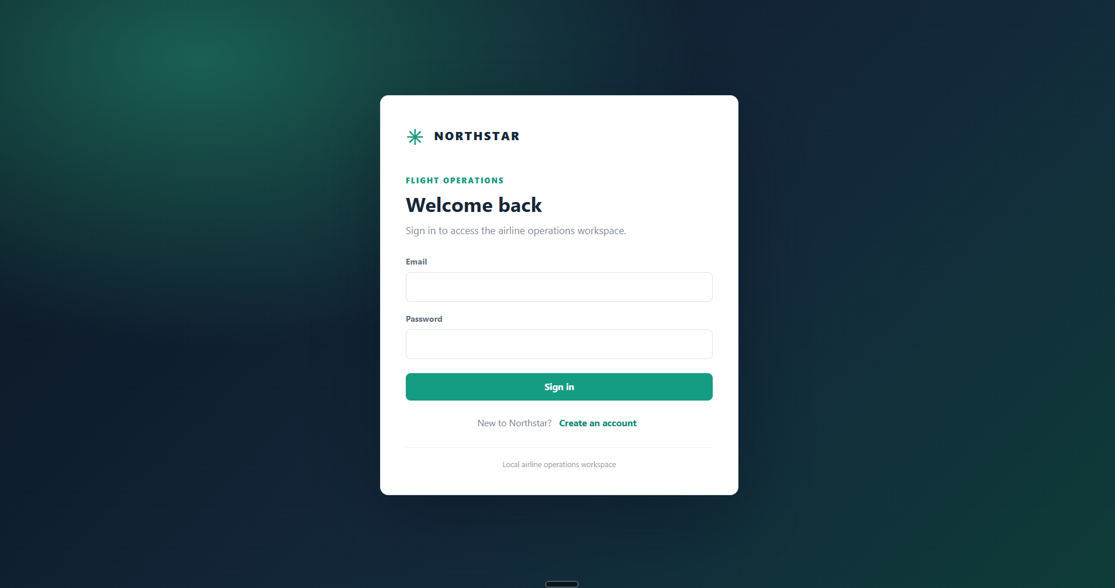
Figure 4. Sign-in page.

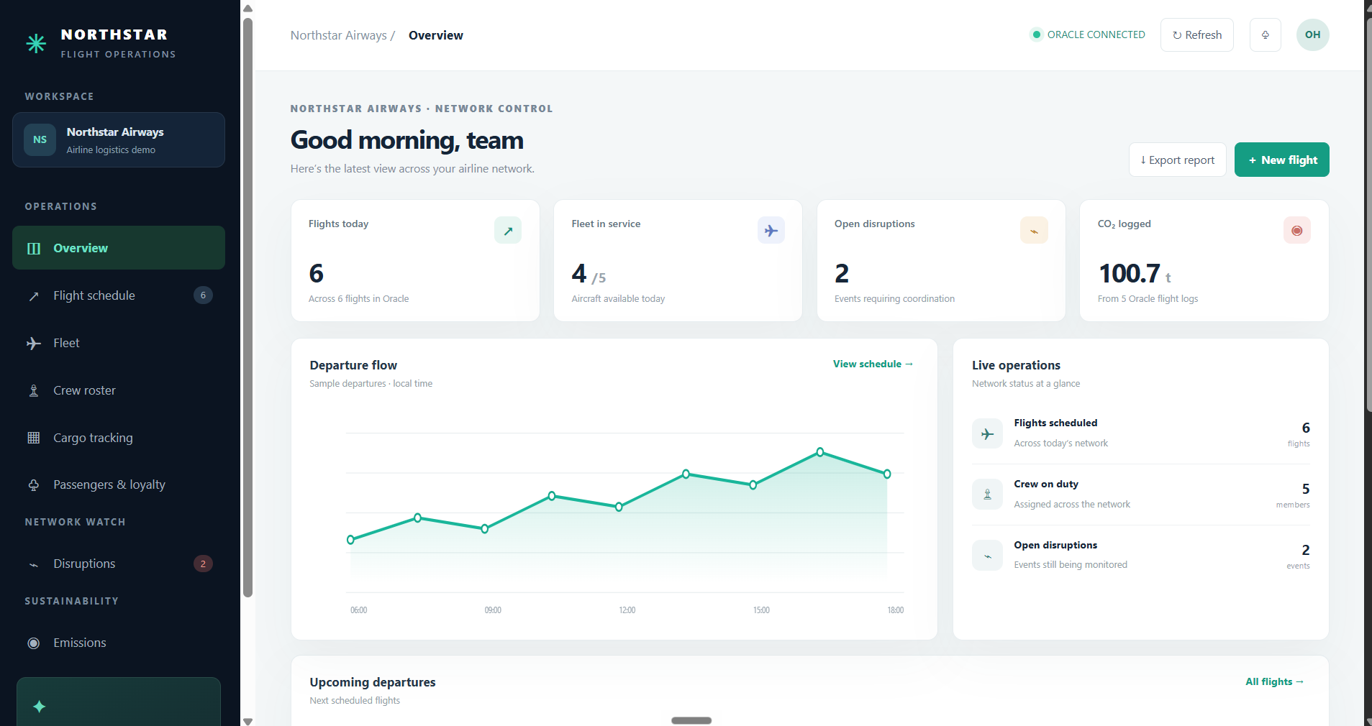
Figure 5. Overview dashboard and sample departure flow.

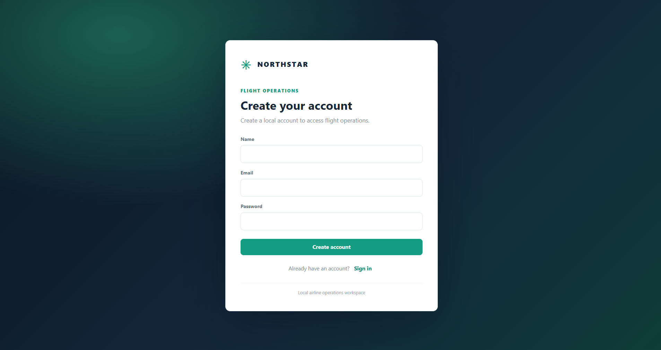
Figure 6. Local account registration page.

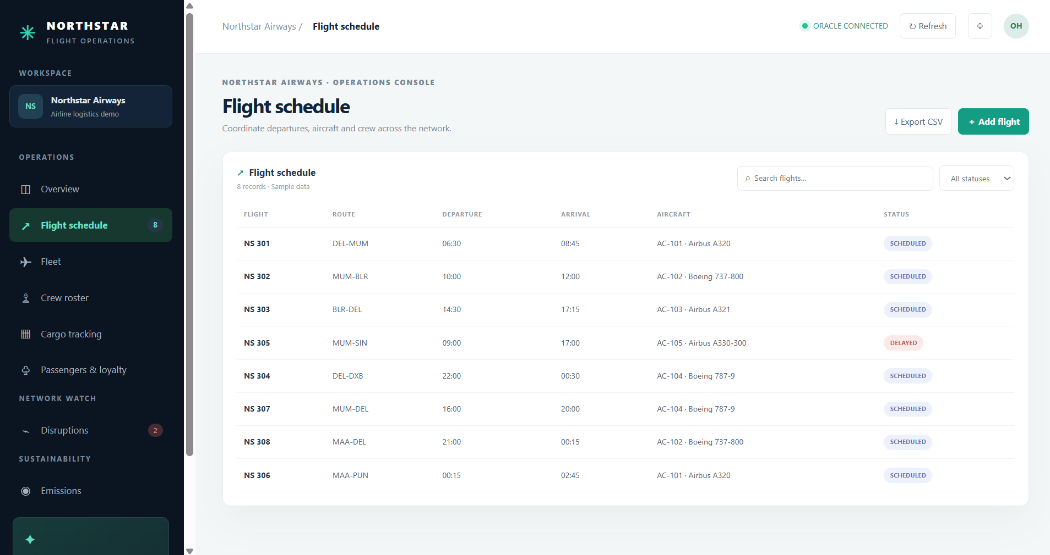
Figure 7. Flight schedule table before insertion.

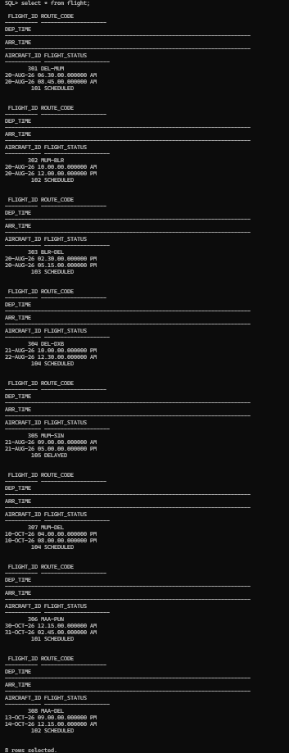
Figure 8. Oracle flight query before insertion.

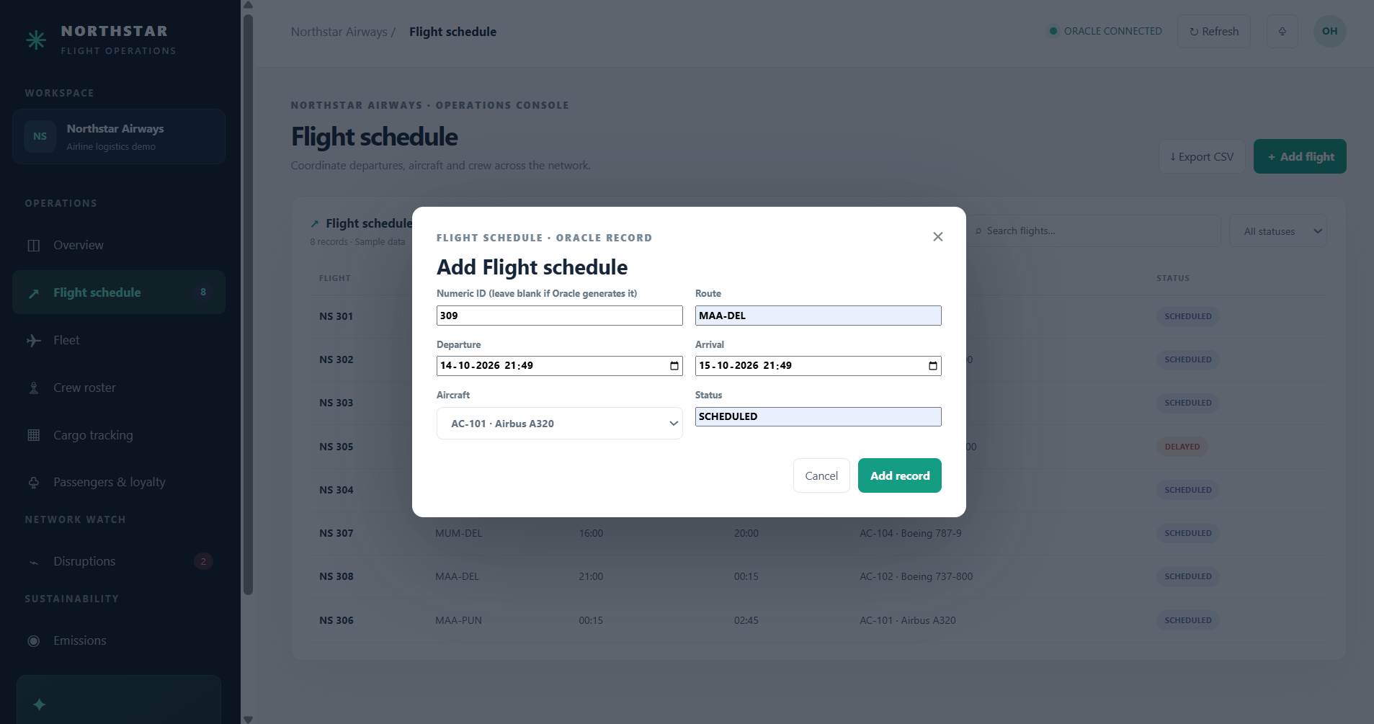
Figure 9. Create flight form for NS 309.

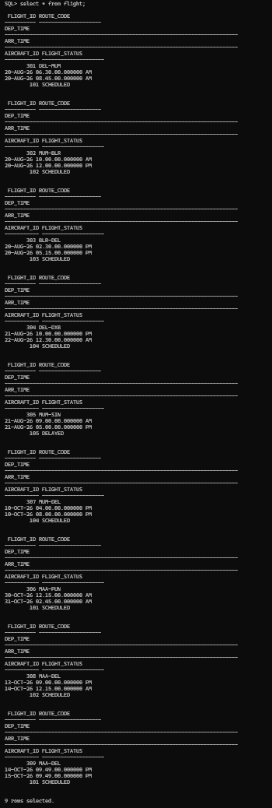
Figure 10. Oracle rows after insertion; nine rows shown.

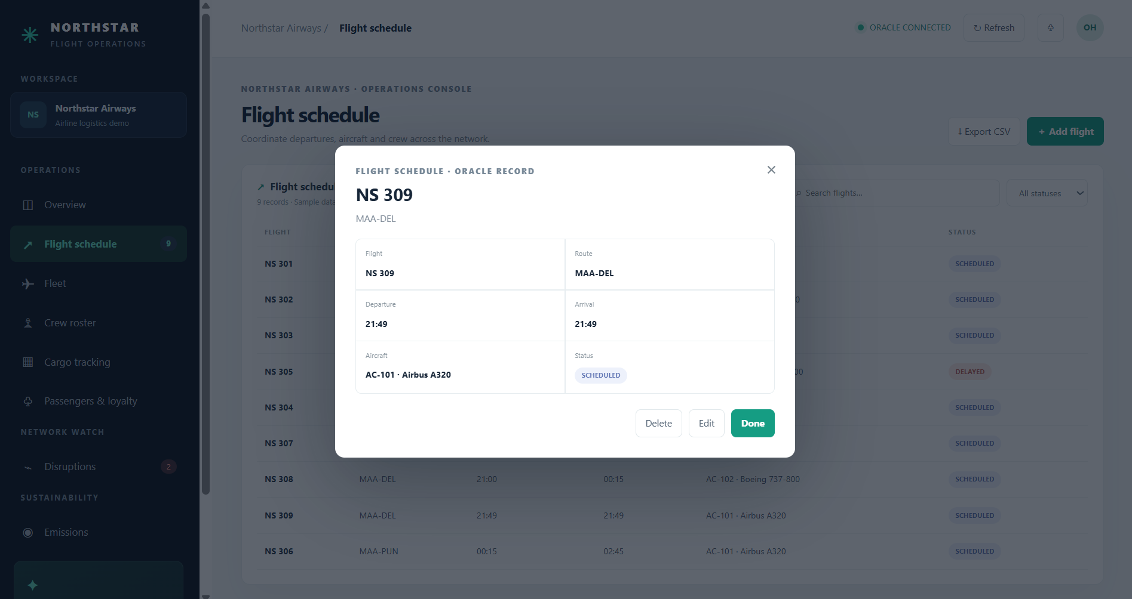
Figure 11. Flight detail view for NS 309.

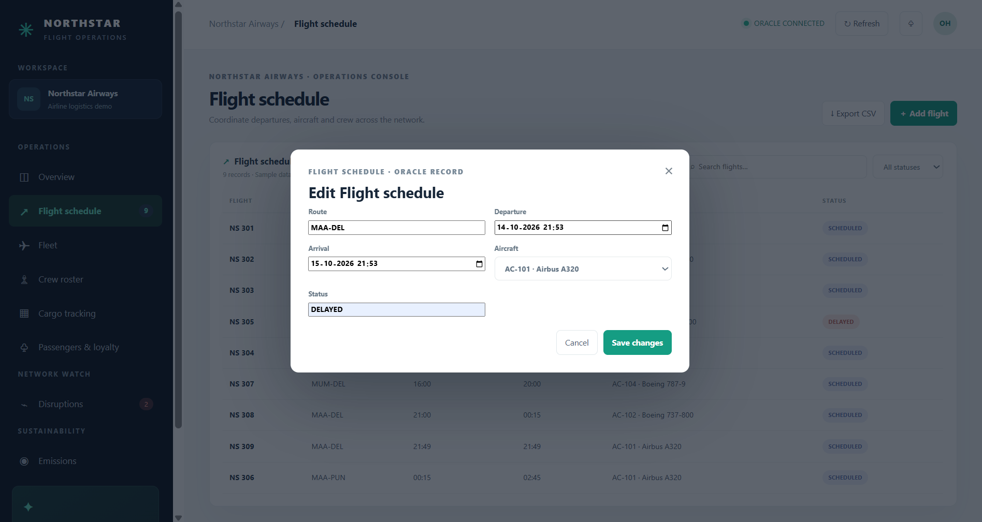
Figure 12. Update form for NS 309, with DELAYED status.

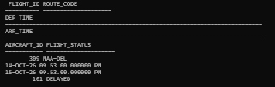
Figure 13. Oracle record after update.

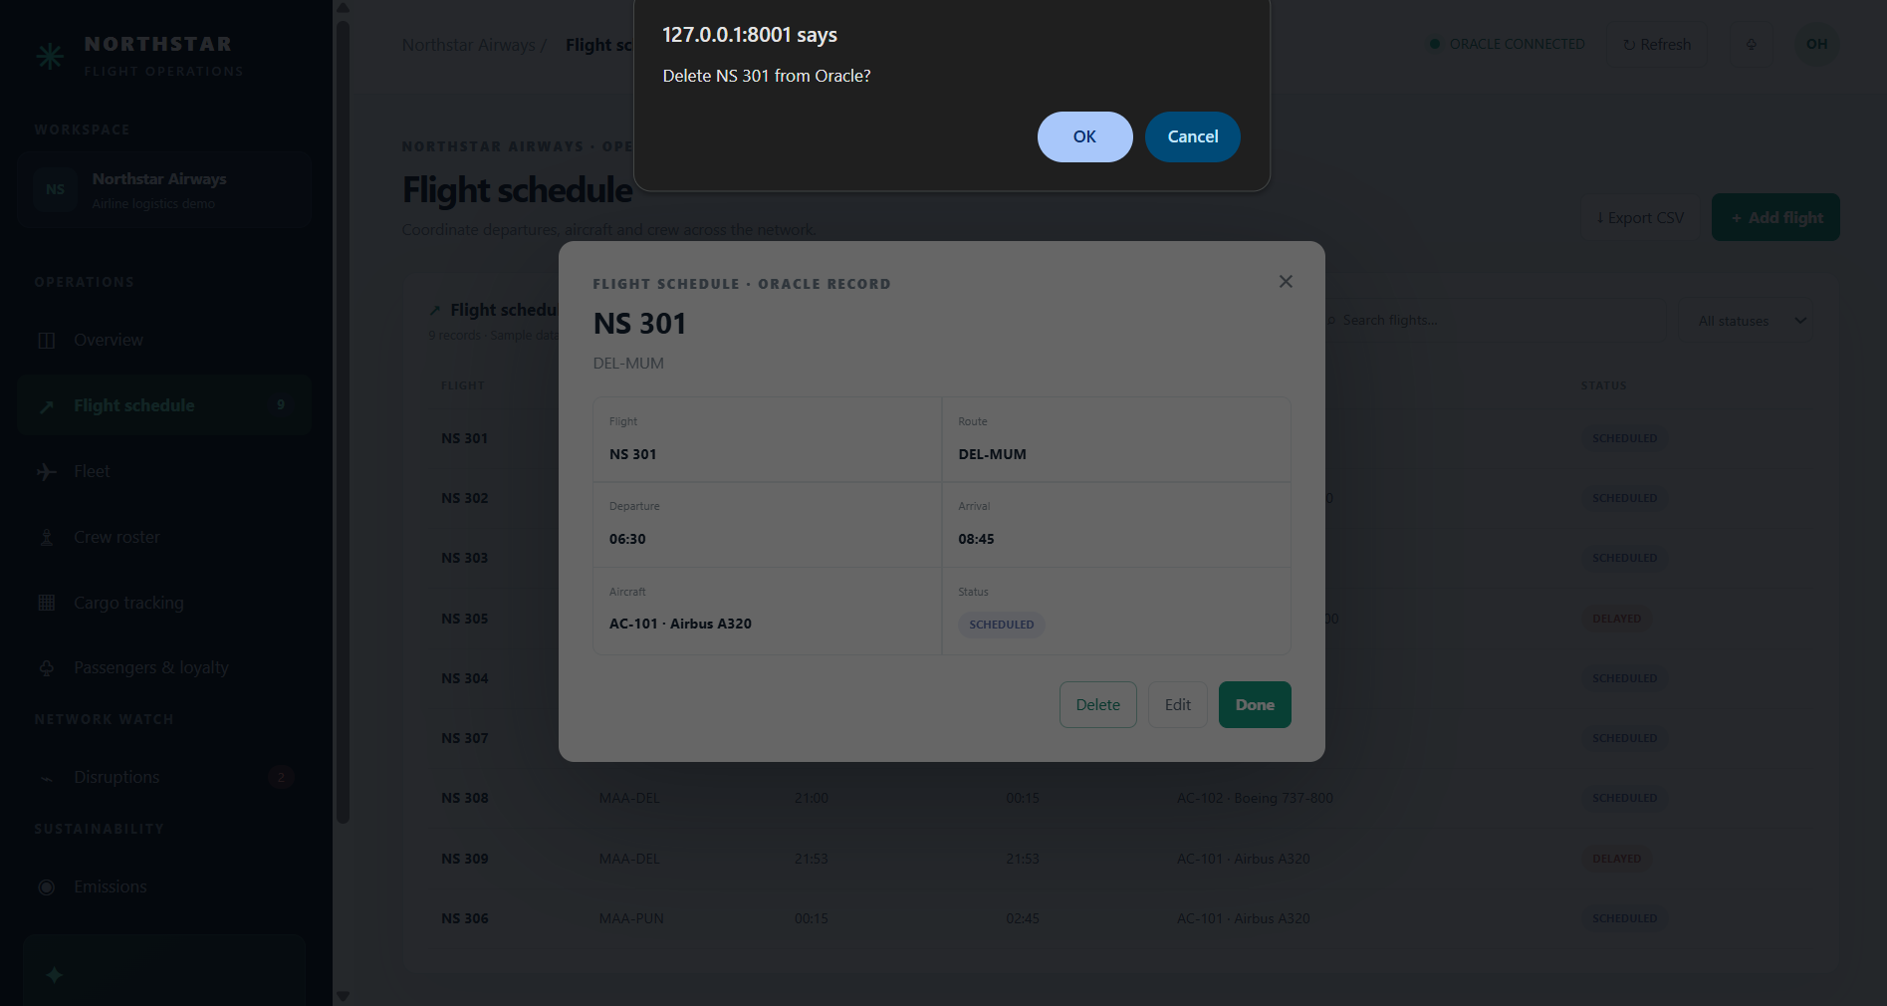
Figure 14. Delete confirmation dialogue for NS 301.

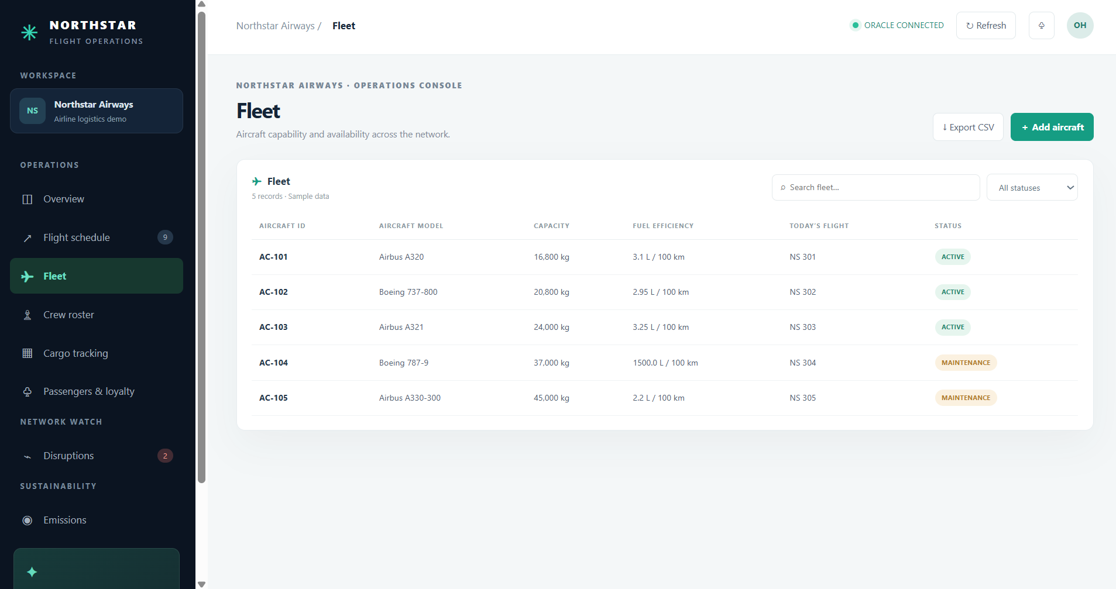
Figure 15. Fleet module.

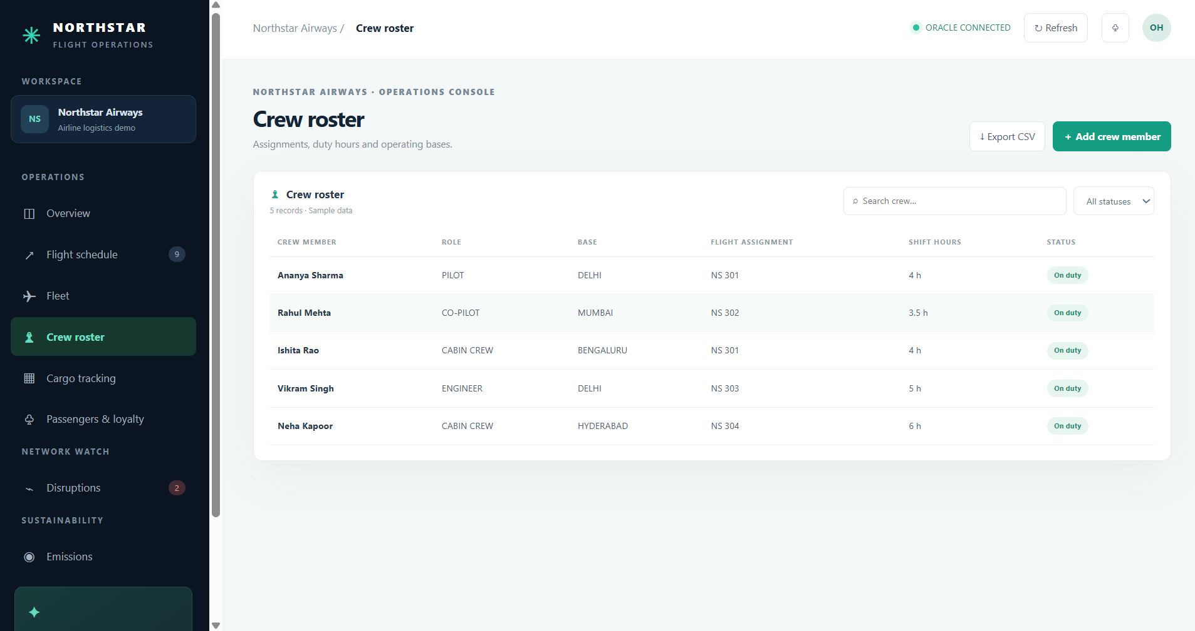
Figure 16. Crew roster module.

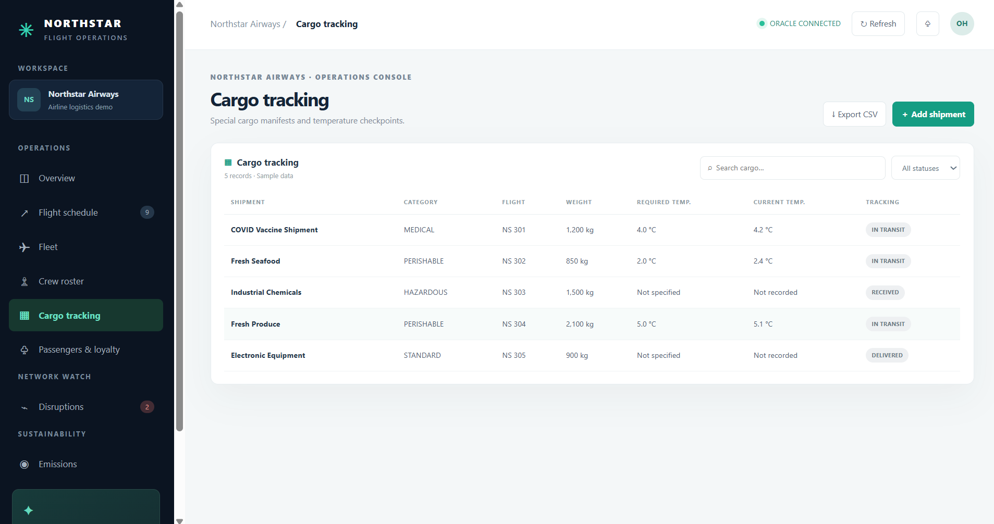
Figure 17. Cargo tracking module.

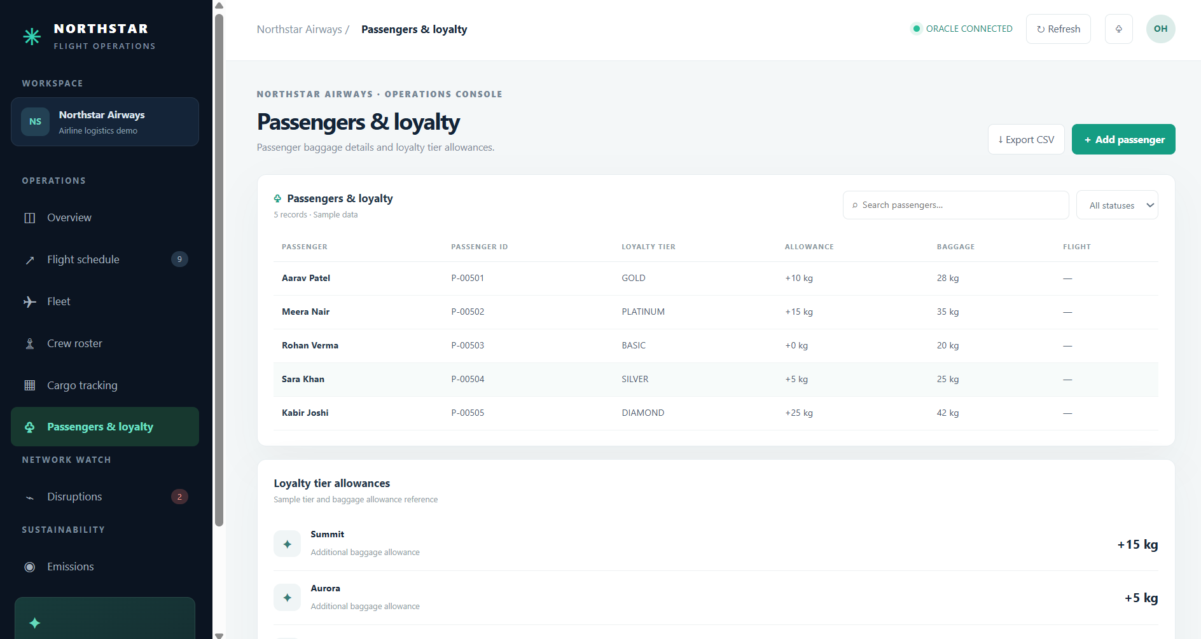
Figure 18. Passengers and loyalty module.

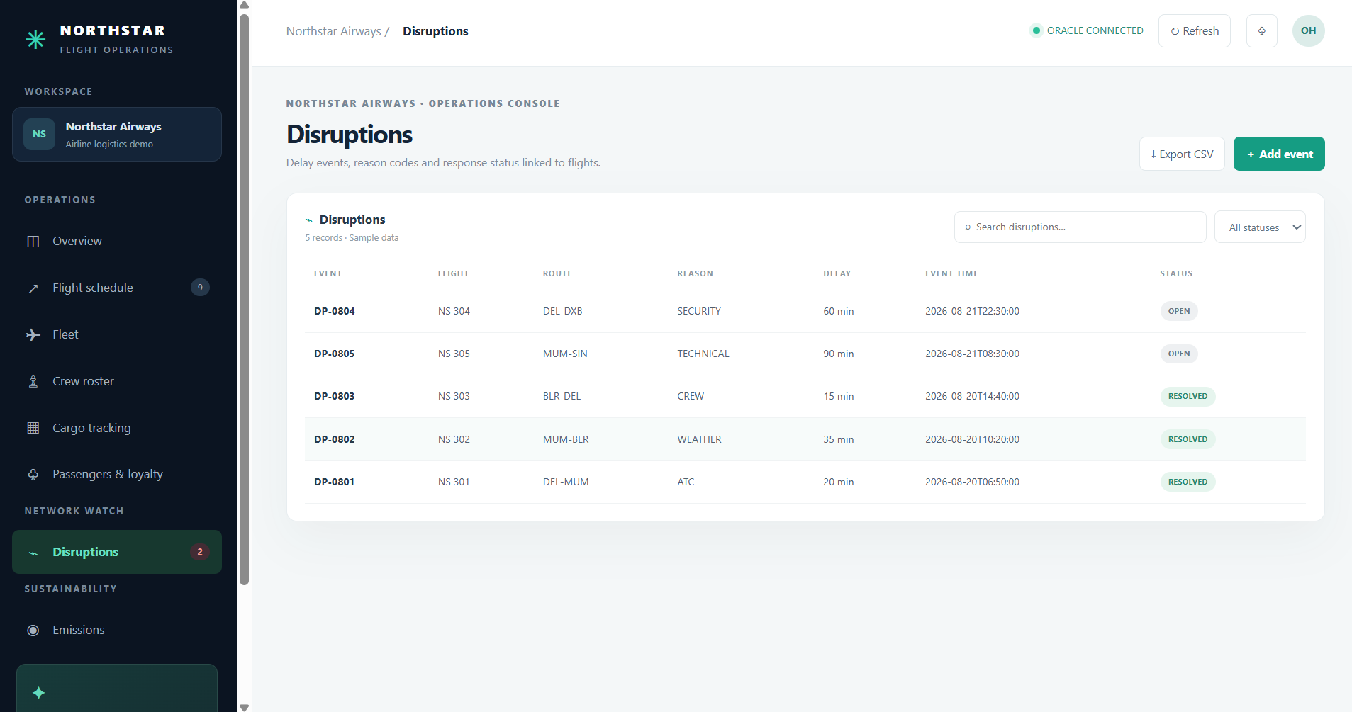
Figure 19. Disruptions module.

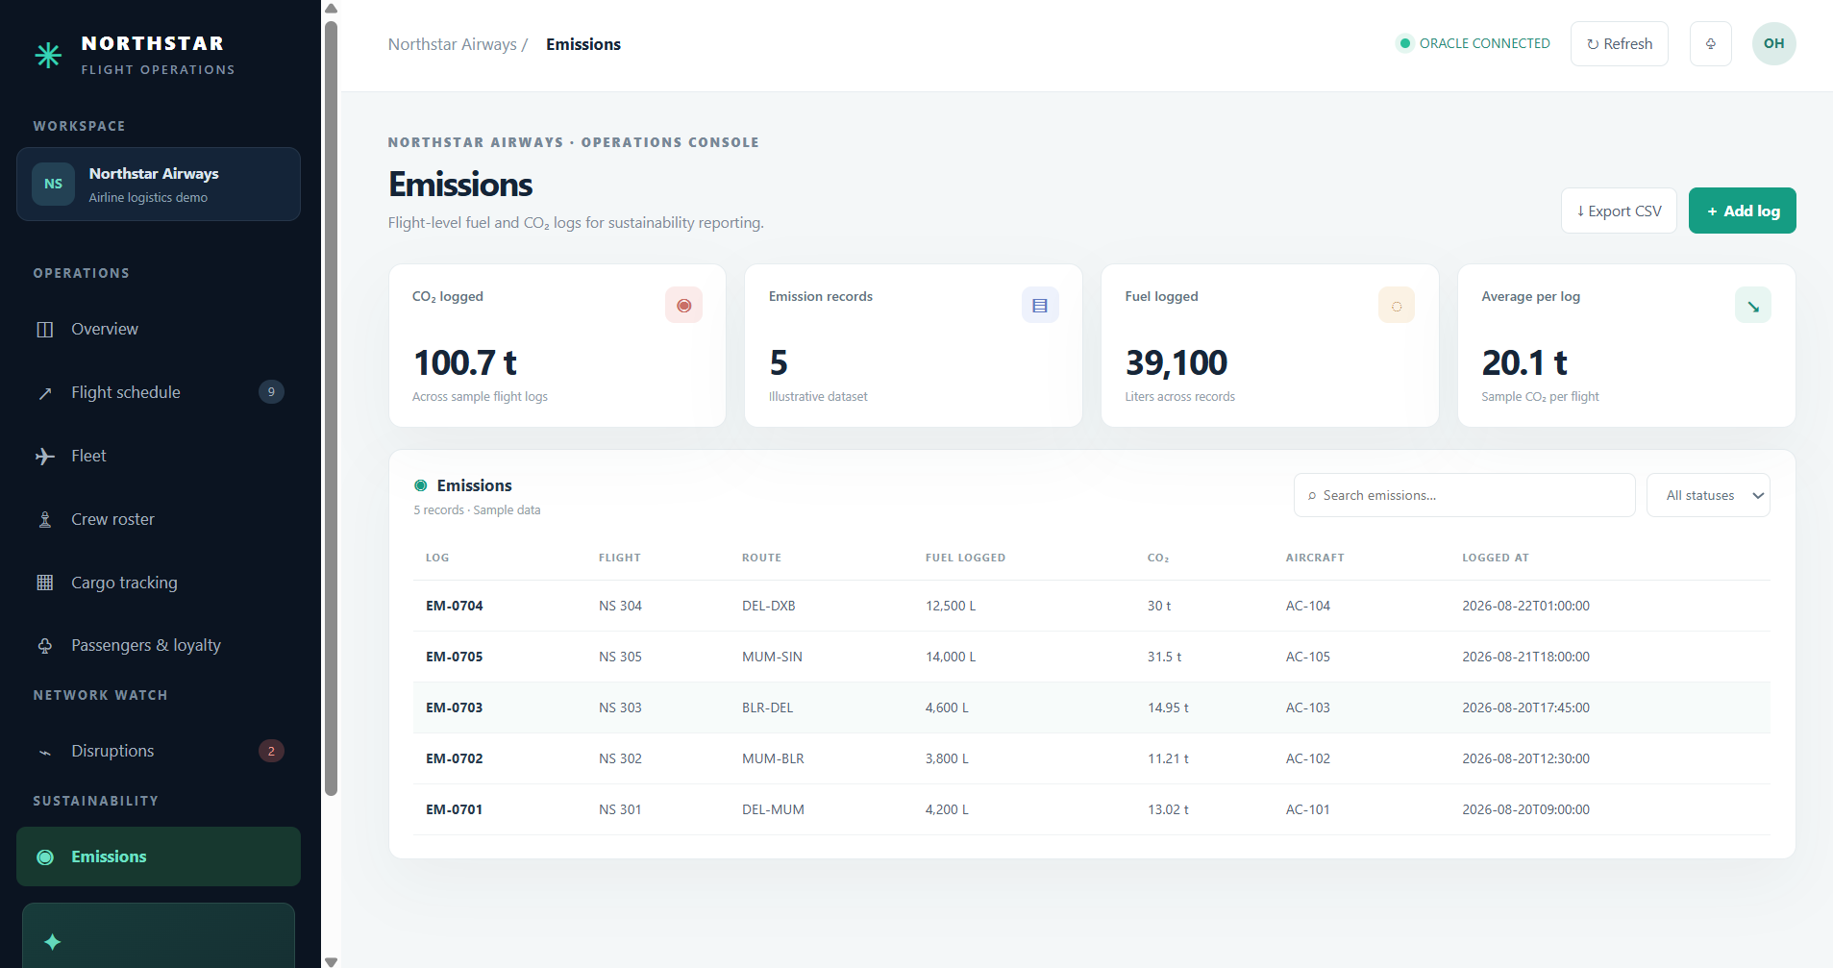
Figure 20. Emissions module.

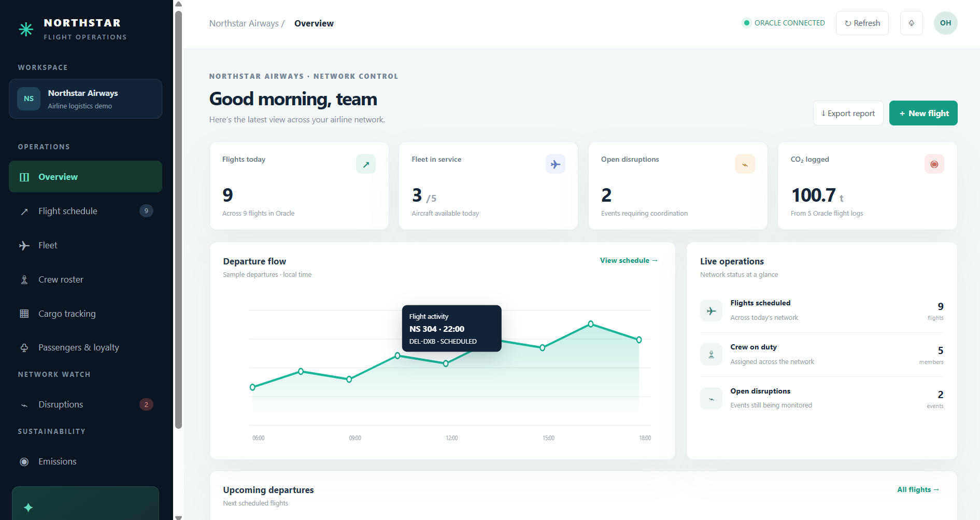
Figure 21. Overview dashboard after the additional flight.

CONCLUSION AND FUTURE SCOPE
The project has progressed from the Review 0 relational design to a local working application connected to Oracle XE. The browser workspace brings key airline records together and demonstrates authentication, flight schedule management, CRUD operations for the demonstrated flight, and module views for fleet, crew, cargo, passengers, disruptions and emissions. The data model uses relational keys and supports sustainability-related records.
The project remains a coursework proof of concept. The supplied dataset is illustrative, the backend is intended for localhost, all registered accounts share the same permissions, and sustainability outcomes have not been quantified. The supplied delete screenshot records the confirmation prompt, not the resulting database state.
Future enhancements
Priority | Enhancement | Expected outcome
1 | Role-based access, stronger session controls, TLS, audit logs and CSRF protection | Safer deployment and accountability.
2 | Validation, pagination, transaction handling and clearer database errors | More dependable workflows at larger scale.
3 | Crew assignment screen with duty/rest validation | Complete staffing workflow.
4 | Sensor ingestion and temperature threshold alerts | Faster response to cold-chain excursions.
5 | Verified emissions factors and normalized route/load reports | Traceable sustainability analysis.
6 | Disruption alerts and historical cause analysis | Improved coordination and operational learning.
7 | Automated API/browser checks, backups, migration and monitoring | Safer releases and recovery.
8 | Approved airport, booking and maintenance integrations | Fewer duplicate records and broader network view.

A practical next step is to validate every deployed table and key against Oracle metadata, then verify create, update, delete and unauthorized-access cases. Before any shared-network deployment, add roles and audit records. A limited pilot can then measure data completeness, exception-response time and normalized fuel/emissions indicators against an agreed baseline.

