SCHOOL OF COMPUTER SCIENCE AND ENGINEERING (SCOPE)
Vellore Institute of Technology
REVIEW 1 | ASSESSMENT 9
MODERN AIRLINE LOGISTICS AND
SUSTAINABILITY MANAGEMENT SYSTEM
A Project Report
Submitted in partial fulfilment of the requirements for the BACSE202 Lab Component Project
Submitted by
25BCE2957 | PRANALI PAYGONDA PATIL
B.Tech Computer Science and Engineering
Project Guide: Dr. Kavitha G
Head of School: Dr. Boominathan P
Academic Year 2026–27

CONTENT
CONTENT 2
LIST OF FIGURES 4
ABSTRACT 5
ACKNOWLEDGEMENT 6
1 INTRODUCTION OF THE PROJECT 7
1.1 Project overview 7
1.2 Problem statement 7
1.3 Objectives and scope 7
1.4 Scope boundaries 7
2 BACKGROUND OF THE PROJECT WORK 7
2.1 Operational and database context 7
2.2 Motivation and sustainability inspiration 8
2.3 Review 0 to Review 1 progression 8
2.4 Database platform clarification 8
3 HARDWARE AND SOFTWARE REQUIREMENTS 8
3.1 Runtime configuration 8
4 E-R DIAGRAM 9
4.1 Relationship cardinalities 9
5 DESCRIPTION ABOUT DESIGN OF THE DATABASE 10
5.1 Design approach 10
5.2 Entity summaries 10
5.3 Normalization and integrity 10
6 BACKEND DATABASE TABLES 10
7 EXECUTION OF SQL QUERIES WITH OUTPUT 11
7.1 Create and update evidence 11
7.2 Delete evidence boundary 12
7.3 Oracle behavior 12
8 FRONT END APPLICATION DESIGN 12
8.1 Screens and controls 12
8.2 Usability and data presentation 12
9 OVERALL SYSTEM DESIGN AND CONNECTIVITY 13
9.1 Front-end and back-end connectivity procedure 13
9.2 API and data flow 13
9.3 Authentication and security 13
10 PRACTICAL IMPLEMENTATION 14
10.1 Implementation stack 14
10.2 CRUD implementation 14
10.3 Demonstration workflow 14
10.4 Current implementation limits 14
11 BUSINESS ASPECT AND PRACTICAL VALUE 14
11.1 Stakeholders and value proposition 14
11.2 Business model options 14
11.3 Costs, value and adoption 15
12 SUSTAINABILITY IMPACT AND INSPIRATION 15
12.1 Potential sustainability KPIs 15
13 SCREENSHOTS OF THE APPLICATION WITH DATA 15
Figure 4. Sign-in screen for the Flight Operations workspace. 16
Figure 5. Local account registration screen. 17
Figure 6. Overview cards and sample departure flow. 18
Figure 7. Flight schedule with eight records before create. 19
Figure 8. Oracle SELECT output showing initial flight rows. 20
Figure 9. Add Flight form populated for flight 309. 21
Figure 10. Oracle output after insert; nine flight rows. 22
Figure 11. Detail view for NS 309 after creation. 23
Figure 12. Edit form with schedule change and DELAYED status. 24
Figure 13. Oracle output reflecting updated flight 309. 25
Figure 14. Delete confirmation prompt for NS 301; prompt only. 26
Figure 15. Fleet module with aircraft and service details. 27
Figure 16. Crew roster with roles, bases and assignments. 28
Figure 17. Cargo tracking with category and temperature fields. 29
Figure 18. Passenger and loyalty module. 30
Figure 19. Disruptions module with causes, delay and status. 31
Figure 20. Emissions module with fuel and CO2 records. 32
Figure 21. Overview after additional flight is present. 33
14 CONCLUSION AND FUTURE SCOPE 33
14.1 Conclusion 33
14.2 Future enhancements 33
14.3 Measurable next-step plan 34
REFERENCES AND PROJECT MATERIALS 34
APPENDIX A FULL IMPLEMENTATION CODE SERVER 35
APPENDIX B FULL IMPLEMENTATION CODE FRONT END 41

LIST OF FIGURES
Figure 1. ER diagram for nine domain entities
Figure 2. Overall system architecture
Figure 3. Operational workflow
Figure 4. Sign-in page
Figure 5. Overview dashboard
Figure 6. Account registration page
Figure 7. Flight schedule
Figure 8. Oracle flight rows before insert
Figure 9. Add flight form
Figure 10. Oracle flight rows after insert
Figure 11. Flight detail
Figure 12. Edit flight form
Figure 13. Oracle updated record
Figure 14. Delete confirmation prompt
Figure 15. Fleet module
Figure 16. Crew roster module
Figure 17. Cargo tracking module
Figure 18. Passengers and loyalty module
Figure 19. Disruptions module
Figure 20. Emissions module
Figure 21. Updated overview dashboard

ABSTRACT
The Modern Airline Logistics and Sustainability Management System is a database-backed application for viewing and maintaining interconnected airline operations. It brings flight schedules, aircraft, crew, passenger loyalty, specialized cargo, emissions and disruption records into one operational workspace. The project combines the relational design documented in Review 0 with a working browser interface and a local FastAPI service connected to Oracle XE.
The data model contains nine domain entities: AIRCRAFT, FLIGHT, CREW, FLIGHT_CREW, LOYALTY_TIER, PASSENGER, SPEC_CARGO, EMISSIONS and DISRUPTION. Primary and foreign keys and integrity constraints support consistent data. The web interface provides sign-in and registration, an overview dashboard, operational modules, search and status filtering, CSV export, and create, view, update and delete actions for supported records. Passwords are stored as scrypt hashes, and authenticated sessions use signed HttpOnly cookies.
The sustainability focus is practical: fuel and CO2 records can be reviewed by flight, while specialized cargo records retain handling and temperature information. The system does not itself reduce emissions or control aircraft; it provides an information layer to support monitoring and decisions. Screenshots show the implementation with the supplied Oracle dataset, including create and update examples. The delete capture documents the confirmation step. Security, data quality, scalability and sustainability analytics remain future work.
Keywords: airline logistics, Oracle XE, FastAPI, relational database, flight operations, emissions tracking, cold-chain cargo, sustainability.

ACKNOWLEDGEMENT
I would like to express my sincere gratitude to Dr. Boominathan P, Head of the School of Computer Science and Engineering, for reviewing the project, and to my project guide, Dr. Kavitha G, for guidance throughout its development. I also thank the faculty members, classmates and others who offered feedback and support during the design, implementation and documentation of this work.

1 INTRODUCTION OF THE PROJECT

1.1 Project overview
Airline operations depend on coordinated decisions about flight schedules, aircraft availability, crew assignments, passengers, cargo and disruption response. Operational facts are related: a flight uses an aircraft, may carry several cargo shipments, can generate multiple emission logs, and may have one or more disruption events. A reliable data model must represent these links and allow staff to retrieve current records without duplicating data across disconnected lists.
This project develops a database-oriented airline operations workspace. The browser interface organizes information into distinct modules, while a local Python service reads and writes records in Oracle. Review 0 established the relational model and SQL coursework requirements; Review 1 adds application implementation and visual evidence.

1.2 Problem statement
When flight, fleet, crew, cargo and environmental information are maintained separately, staff may face inconsistent records, delayed updates and limited visibility into network status. Temperature-sensitive cargo requires explicit handling information. Emission reporting requires fuel and CO2 values to be associated with flights. Disruption records need consistent reason, delay and resolution fields. The project addresses these information-management needs through a centralized relational database and integrated interface.

1.3 Objectives and scope
Objective | Project scope
Centralize records | Linked tables and dedicated views for principal airline entities.
Support maintenance | Authenticated create, view, update and delete workflows for supported records.
Preserve consistency | Relational keys and constraints; parameterized Oracle binds in the service.
Improve inspection | Overview metrics, lists, search, status filters, refresh and CSV export.
Surface sustainability data | Store/display fuel and CO2 logs and cold-chain temperature fields.
Demonstrate DBMS concepts | Document schema design and SQL operations required by the review rubric.

1.4 Scope boundaries
The implementation is a local coursework demonstrator. It is not connected to airline reservation, airport, aircraft telemetry, payment or regulatory systems. Screenshots use demonstration records. The project does not claim real-time aircraft locations, live booking, automated crew legality checks, predictive disruption analysis or verified carbon accounting.

2 BACKGROUND OF THE PROJECT WORK

2.1 Operational and database context
Airline information is naturally relational. Flight records refer to aircraft; crew-to-flight assignments form a many-to-many relationship; passengers refer to loyalty tiers; cargo, emission logs and disruptions reference flights. A normalized schema reduces repeated descriptive information and makes referential integrity enforceable. Review 0 describes the nine-entity design and illustrates DDL, DML, query functions and joins.

2.2 Motivation and sustainability inspiration
The sustainability inspiration is to make environmental information part of everyday operations data rather than treating it as an unrelated report. Recording fuel and CO2 at flight level gives analysts a starting point for comparing routes, aircraft and operating periods. Recording required and observed cargo temperatures supports visibility for medical and perishable shipments. Better information can inform decisions, but the application itself does not prove a reduction in fuel burn or emissions.

2.3 Review 0 to Review 1 progression
Review 0 foundation | Review 1 implementation
Problem context, objectives and requirements | Local web app with registration/sign-in and modules
Nine-entity ER and relational schema | Oracle XE connectivity through FastAPI and python-oracledb
Keys, constraints and SQL coursework coverage | Browser CRUD for supported entities; search, filters, CSV export
Illustrative sample rows and query examples | Application screenshots and Oracle create/update evidence

2.4 Database platform clarification
Review 0 names MySQL 8.0 and MySQL Workbench in its software-requirements table. The delivered application code and README instead connect to Oracle XE through python-oracledb in Thin mode. This report describes the running implementation as Oracle XE. SQL syntax and key-generation behavior must follow the Oracle schema actually installed; the MySQL entry is treated as an initial coursework requirement, not the application runtime.

3 HARDWARE AND SOFTWARE REQUIREMENTS
Category | Minimum / current setup | Recommended extension
Processor | Intel Core i3 equivalent | Intel Core i5 or higher
Memory | 4 GB RAM | 8 GB RAM or higher
Storage | 20 GB free | SSD for database, backups and logs
Operating system | Windows 10/11, Linux or macOS | Supported 64-bit OS with updates
Database | Oracle XE schema used by app | Managed Oracle with backup/monitoring
Backend | Python 3.10+; FastAPI; python-oracledb | Pinned dependencies; production ASGI
Frontend | Modern browser; HTML/CSS/JavaScript | Current Chrome, Edge or Firefox
Network | Local TCP access to Oracle | TLS-protected private network

3.1 Runtime configuration
The README instructs the operator to install requirements.txt dependencies, configure Oracle credentials and service DSN in a private .env file, and start the application on 127.0.0.1:8001. The browser should use the FastAPI-served page rather than opening index.html directly. The configured service must point to the same Oracle container/schema as the airline tables. Credentials and the session secret must remain private and must not be included in a report or shared repository.

4 E-R DIAGRAM
This ER model reproduces the nine domain entities documented in Review 0. FLIGHT is the operational hub. FLIGHT_CREW resolves the many-to-many relationship between flights and crew. Foreign keys connect related records. The authentication support table is separate from the nine-entity domain model.
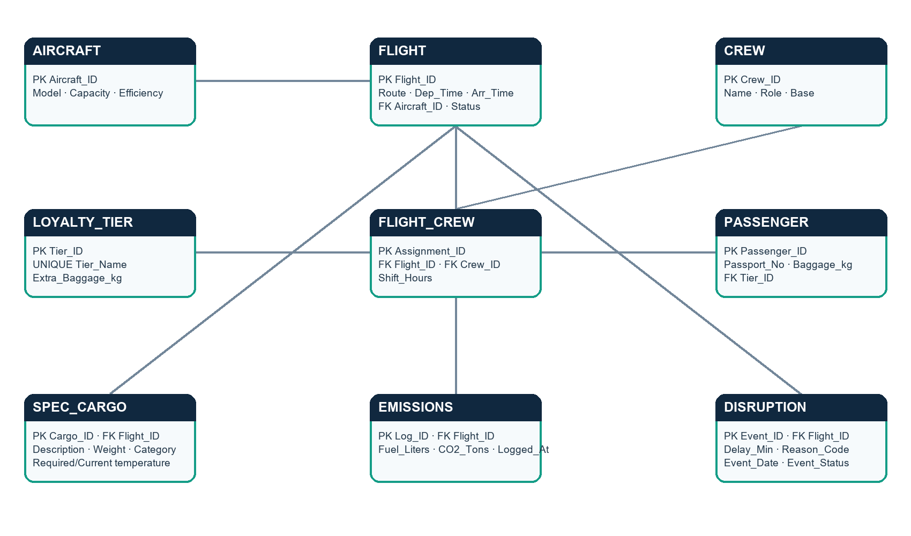
Figure 1. ER diagram for the nine domain entities; PK/FK labels identify keys.

4.1 Relationship cardinalities
Parent | Relationship | Child | Cardinality / meaning
AIRCRAFT | assigned to | FLIGHT | 1:M — each flight uses one aircraft; aircraft can operate flights over time.
FLIGHT | assigned through | FLIGHT_CREW | 1:M — a flight can have multiple crew assignments.
CREW | assigned through | FLIGHT_CREW | 1:M — a crew member can have multiple assignment records.
LOYALTY_TIER | assigned to | PASSENGER | 1:M — each passenger has a tier; a tier can include many passengers.
FLIGHT | carries | SPEC_CARGO | 1:M — a flight can carry multiple shipments.
FLIGHT | generates | EMISSIONS | 1:M — a flight can have multiple emission logs.
FLIGHT | experiences | DISRUPTION | 1:M — a flight can have multiple disruption events.

5 DESCRIPTION ABOUT DESIGN OF THE DATABASE

5.1 Design approach
The design separates entities by responsibility and uses primary keys to identify records. Foreign keys express operational relationships. Unique constraints are appropriate for tier names and passport numbers. NOT NULL constraints protect required fields, CHECK constraints constrain valid ranges or enumerated statuses, and DEFAULT constraints supply initial values where appropriate. The database remains the final authority for referential integrity during application writes.

5.2 Entity summaries
Entity | Purpose | Important links / integrity
AIRCRAFT | Fleet model, capacity, efficiency, service status | PK Aircraft_ID; referenced by FLIGHT.
FLIGHT | Route, departure/arrival, aircraft and status | PK Flight_ID; FK Aircraft_ID.
CREW | Crew identity, role and base | PK Crew_ID; linked by FLIGHT_CREW.
FLIGHT_CREW | Assignment bridge and shift hours | FK Flight_ID + FK Crew_ID; resolves M:N.
LOYALTY_TIER | Tier label and extra baggage allowance | PK Tier_ID; Tier_Name unique.
PASSENGER | Passenger, passport, tier and baggage | Passport_No unique; FK Tier_ID.
SPEC_CARGO | Shipment category, weight and temperatures | FK Flight_ID; status and temperature fields.
EMISSIONS | Fuel and CO2 by timestamp | FK Flight_ID; route/flight analysis.
DISRUPTION | Delay, reason, date and status | FK Flight_ID; event tracking.

5.3 Normalization and integrity
Separating aircraft, flights, crew, tiers, passengers and flight-linked records avoids storing repeated descriptive attributes in the flight table. FLIGHT_CREW prevents multi-valued crew lists in a single field. Bound values in the API reduce SQL injection risk for values, while database constraints reject invalid relationships and domains.

6 BACKEND DATABASE TABLES
This inventory presents the Review 0 attributes and logical Oracle-friendly types. Exact deployed widths should be verified against Oracle metadata before a production migration; undocumented lengths are not inferred here. Key and uniqueness requirements follow the project schema.
Table | PK | Type | Other attributes (logical types) | Constraints / links
AIRCRAFT | AIRCRAFT_ID | NUMBER | MODEL VARCHAR2; CAPACITY_KG NUMBER; FUEL_EFFICIENCY NUMBER; AIRCRAFT_STATUS VARCHAR2 | PK; valid capacity/status
FLIGHT | FLIGHT_ID | NUMBER | ROUTE_CODE VARCHAR2; DEP_TIME TIMESTAMP; ARR_TIME TIMESTAMP; AIRCRAFT_ID NUMBER; FLIGHT_STATUS VARCHAR2 | PK; FK AIRCRAFT_ID; required fields
CREW | CREW_ID | NUMBER | CREW_NAME VARCHAR2; ROLE VARCHAR2; BASE_LOCATION VARCHAR2 | PK; required identifying fields
FLIGHT_CREW | ASSIGNMENT_ID | NUMBER | FLIGHT_ID NUMBER; CREW_ID NUMBER; SHIFT_HOURS NUMBER | PK; two FKs; valid hours
LOYALTY_TIER | TIER_ID | NUMBER | TIER_NAME VARCHAR2; EXTRA_BAGGAGE_KG NUMBER | PK; unique name; nonnegative allowance
PASSENGER | PASSENGER_ID | NUMBER | PASSENGER_NAME VARCHAR2; PASSPORT_NO VARCHAR2; TIER_ID NUMBER; BAGGAGE_KG NUMBER | PK; unique passport; FK tier
SPEC_CARGO | CARGO_ID | NUMBER | FLIGHT_ID NUMBER; DESCRIPTION VARCHAR2; WEIGHT_KG NUMBER; CATEGORY VARCHAR2; REQ_TEMP_C NUMBER; CURRENT_TEMP_C NUMBER; TRACKING_STATUS VARCHAR2 | PK; FK flight; nonnegative weight
EMISSIONS | LOG_ID | NUMBER | FLIGHT_ID NUMBER; FUEL_LITERS NUMBER; CO2_TONS NUMBER; LOGGED_AT TIMESTAMP | PK; FK flight; nonnegative values
DISRUPTION | EVENT_ID | NUMBER | FLIGHT_ID NUMBER; DELAY_MIN NUMBER; REASON_CODE VARCHAR2; EVENT_DATE TIMESTAMP; EVENT_STATUS VARCHAR2 | PK; FK flight; nonnegative delay

Implementation note: the FastAPI service also creates APP_LOGIN_USERS as needed. It contains identity-generated USER_ID, NAME, EMAIL and PASSWORD_HASH for authentication, separate from the nine airline-domain entities.

7 EXECUTION OF SQL QUERIES WITH OUTPUT
Review 0 contains the coursework SQL section: table creation with constraints, five-row inserts, delete and update demonstrations for the domain tables, SELECT, single-row functions, aggregate functions, GROUP BY, HAVING, subqueries and joins. The application screenshots add Oracle terminal evidence for flight records and the live create/update path. The application issues parameterized Oracle SELECT, INSERT, UPDATE and DELETE statements through python-oracledb.
Required operation | Evidence / purpose
CREATE TABLE + constraints | Review 0 DDL; PK/FK and domain integrity establish schema.
INSERT up to five sample rows | Review 0 sample rows; app insert shown for flight ID 309.
DELETE | Review 0 deletion examples; UI confirmation prompt shown.
UPDATE | Review 0 per-table examples; flight 309 change shown in app and query output.
SELECT | Review 0 examples and live Oracle query outputs.
Single-row functions | Review 0 examples for text, date and numeric transformations.
Aggregate functions | Review 0 examples for counts, totals and averages.
GROUP BY / HAVING | Review 0 grouped summaries and filtered groups.
Subqueries | Review 0 nested query examples.
JOIN | Review 0 joins across aircraft/flights, passengers/tiers, crew and flight assignments, cargo and disruptions.

7.1 Create and update evidence
The supplied captures show eight initial flight rows, an Add Flight form for ID 309, and query output after insertion with nine rows. A detail view shows NS 309. The edit form changes its schedule and status to DELAYED; the subsequent Oracle output reflects that updated record. For this example, the evidence links the UI action to the database result.

7.2 Delete evidence boundary
The delete screenshot shows the browser confirmation prompt for NS 301. It evidences the confirmation step and intended delete action. The supplied capture set does not show a post-confirmation list or query proving absence, so this report does not claim the deletion result is independently verified by that screenshot.

7.3 Oracle behavior
The live implementation uses Oracle. The service binds values and commits successful writes. Numeric key generation depends on deployed identity/default/trigger behavior; the README flags this as a setup check. Confirm key generation and actual constraints in Oracle metadata before extending the system.

8 FRONT END APPLICATION DESIGN
The browser interface in index.html uses a persistent sidebar and content area. Its theme combines dark navigation, a light work surface, summary cards, record tables and modal forms. The supplied screens establish the Northstar Airways / Flight Operations identity for the demonstration.

8.1 Screens and controls
Area | Visible purpose / controls
Authentication | Sign-in and account creation before operational data.
Overview | Flight count, active fleet, open disruptions, CO2, departure visualization and upcoming flights.
Flight schedule | Route/time/aircraft/status; add, detail, edit, delete, search, filter, CSV export.
Fleet | Aircraft, capacity, fuel efficiency, today’s flight and status.
Crew roster | Name, role, base, assignment, hours and duty status.
Cargo tracking | Shipment, category, flight, weight, temperature and tracking status.
Passengers & loyalty | Passenger, tier, baggage and allowance.
Disruptions | Flight, route, reason, delay, event timestamp and status.
Emissions | Flight fuel/CO2 logs, summary metrics and timestamps.

8.2 Usability and data presentation
Search and status filters narrow lists; CSV export supports offline review; refresh reloads current records. Overview cards provide a summary, while module tables show record-level details. The departure chart is labelled as sample data and is illustrative unless the underlying aggregation is verified. Counts are screenshots of a changing demo dataset, not a live airline network report.

9 OVERALL SYSTEM DESIGN AND CONNECTIVITY
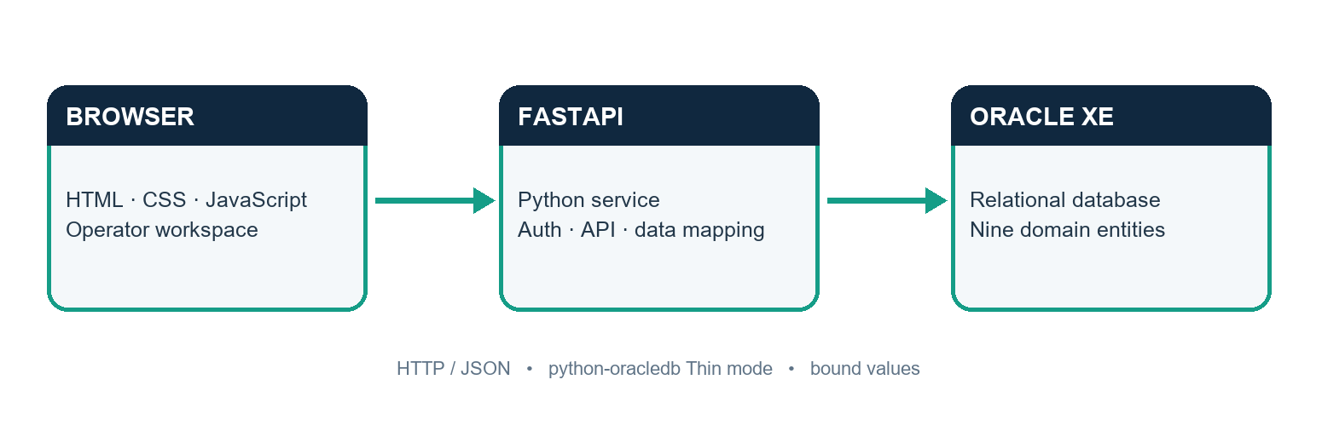
Figure 2. Browser, FastAPI service and Oracle XE architecture.

9.1 Front-end and back-end connectivity procedure
Step | Procedure
1. Configure | Keep Oracle credentials, service DSN and session secret in private environment settings.
2. Start service | Launch FastAPI at 127.0.0.1:8001; serve index.html from the same origin.
3. Authenticate | Register/sign in; server verifies the hash and issues a signed HttpOnly session cookie.
4. Read | Browser requests API data; service uses a pooled python-oracledb connection.
5. Write | Create/edit/delete calls map to allowed tables, bind values and commit successful writes.
6. Refresh | Browser reloads current Oracle records; README indicates refresh every five seconds.

9.2 API and data flow
The service provides health and authentication endpoints, consolidated data, reference lookups and entity-level create/update/delete routes. It maps presentation fields to Oracle columns and derives some view values from related tables. Health reports database connectivity and table visibility. Operational reads and writes require an authenticated user.
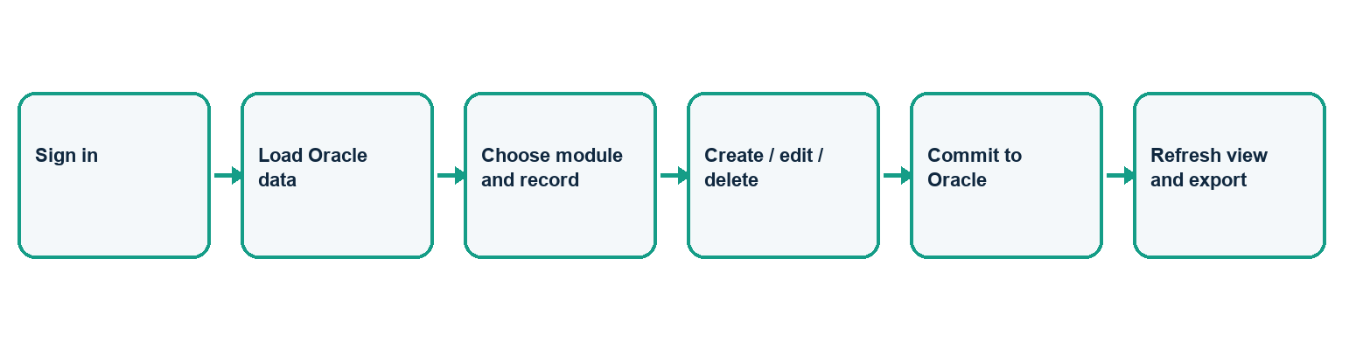
Figure 3. Typical authenticated data-maintenance workflow.

9.3 Authentication and security
The README and source describe scrypt password hashing, signed HttpOnly session cookies with a 12-hour expiry, a private session secret, and APP_LOGIN_USERS rather than the existing subscription-oriented USERS table. All accounts currently share the same permissions; role-based access is not implemented. The app is intended for local coursework and should not be exposed to an untrusted network without production security work.

10 PRACTICAL IMPLEMENTATION

10.1 Implementation stack
Layer | Technology / role
Browser | HTML, CSS and JavaScript for screens and interaction.
Application service | Python FastAPI for authentication, API routing, mapping and validation.
Database adapter | python-oracledb Thin mode and connection pooling.
Database | Oracle XE tables, relationships and constraints.
Transport | Local HTTP in coursework; JSON request/response bodies.

10.2 CRUD implementation
The API centralizes entity mapping so write logic can build INSERT or UPDATE statements from permitted fields and bind values. Delete routes target record keys and commit the operation. The interface presents forms and detail modals and reloads records after changes. Foreign-key violations, duplicates, invalid types and missing key generation remain database errors that should be clearly communicated.

10.3 Demonstration workflow
The screenshots cover sign-in and account creation; overview; flight list and detail; creation of NS 309; the Oracle row count change from eight to nine; an edit changing status to DELAYED; Oracle output reflecting the update; delete confirmation; and the fleet, crew, cargo, passenger, disruptions and emissions modules.

10.4 Current implementation limits
The service is local-only, has no separate user roles and uses illustrative sample views in parts of the overview. The evidence does not establish equivalent write testing for every module. FLIGHT_CREW is in the schema, while the visible menu has a crew roster and no dedicated assignment-management screen. These are practical next targets.

11 BUSINESS ASPECT AND PRACTICAL VALUE

11.1 Stakeholders and value proposition
Potential users include operations coordinators, fleet planners, cargo teams and sustainability analysts. A consolidated operational view can reduce time spent switching between lists, make update ownership clearer and make sustainability fields available alongside flights. The demonstrator illustrates this concept; operational savings have not been measured.

11.2 Business model options
Model | Application | Considerations
Internal deployment | Operate as an internal support workspace. | Needs integration, access control, audit, uptime and governance.
SaaS subscription | Tier by airline size, users or modules. | Needs tenant isolation, cloud hosting, support and compliance.
Modular add-ons | Cargo temperature, disruption analytics or emissions reports. | Needs verified data definitions and reliable integrations.
Implementation services | Configuration, migration and staff training. | Requires domain validation and maintenance.

11.3 Costs, value and adoption
A commercial estimate needs discovery rather than speculative pricing. Cost drivers include hosting, database licensing, identity management, monitoring, backups, security review, integration, support and training. Potential value drivers include less manual reconciliation, faster exception visibility, better cargo traceability and easier fuel/emissions reporting. A pilot should measure task time, data error rate, disruption response time and emissions-record completeness against a baseline.
A practical adoption path is to validate the model with an operations stakeholder, pilot a limited route or team, connect approved source systems, reconcile in parallel, train users and expand only after data-quality and security gates pass. This student build is a proof of concept, not production-ready software.

12 SUSTAINABILITY IMPACT AND INSPIRATION
The project was inspired by the need to make sustainability measurable in operational workflows. Fuel and CO2 logging makes environmental impact visible at flight level, and fuel-efficiency fields create a basis for comparison. Cargo temperature fields support careful movement of medical and perishable goods and can help reduce spoilage when connected to reliable measurements and response processes.
Environmental benefit depends on accurate data and decisions. The application stores and presents records; it does not independently measure emissions, calculate lifecycle impact, optimize routes or prove carbon reduction. Future work should document emission factors, provenance, reporting boundaries and verification before external sustainability claims.

12.1 Potential sustainability KPIs
KPI | Example definition | Data needed
Fuel per flight | Fuel liters per flight, normalized by distance | Fuel log; route distance; aircraft type
CO2 intensity | CO2 per passenger-km or tonne-km | Verified emissions; loads; distance
Cold-chain excursion rate | Shipments outside allowed range / monitored shipments | Timestamped sensor readings and thresholds
Data completeness | Flights with required logs / operated flights | Schedule and emission logs

13 SCREENSHOTS OF THE APPLICATION WITH DATA
Figures below reproduce the supplied application evidence. Counts, dates and values are shown as captured; dashboard metrics and sample records are illustrative, not live airline reports.
Demo video (Google Drive): link not provided. Insert the shareable demonstration URL here before submission.

Figure 4. Sign-in screen for the Flight Operations workspace.
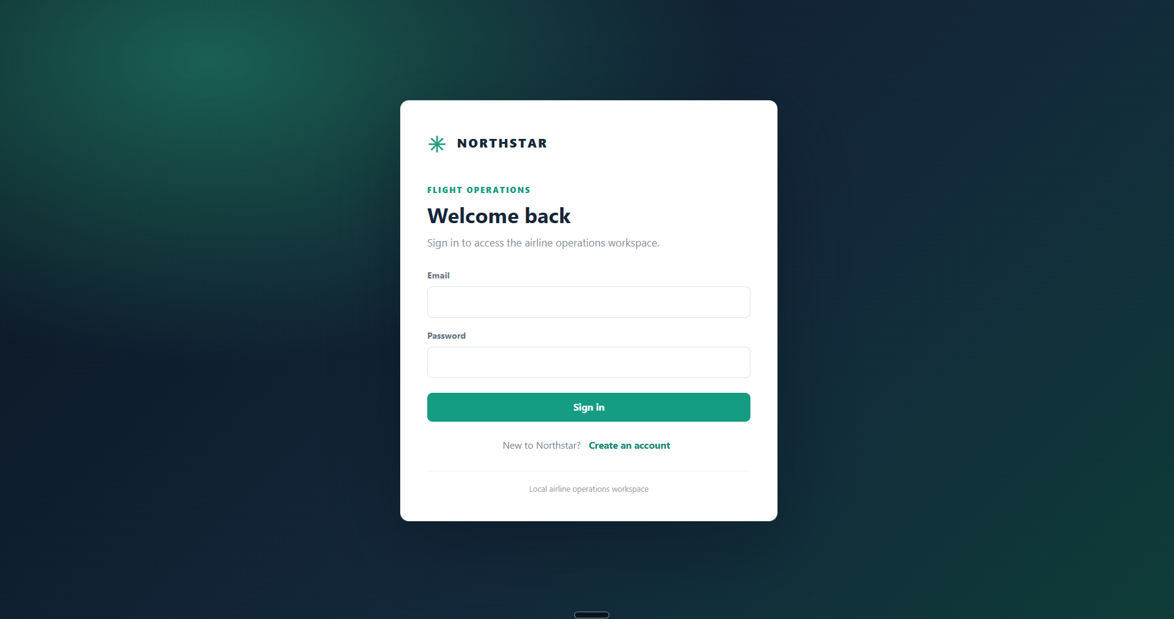
Figure 4. Sign-in screen for the Flight Operations workspace.

Figure 5. Local account registration screen.
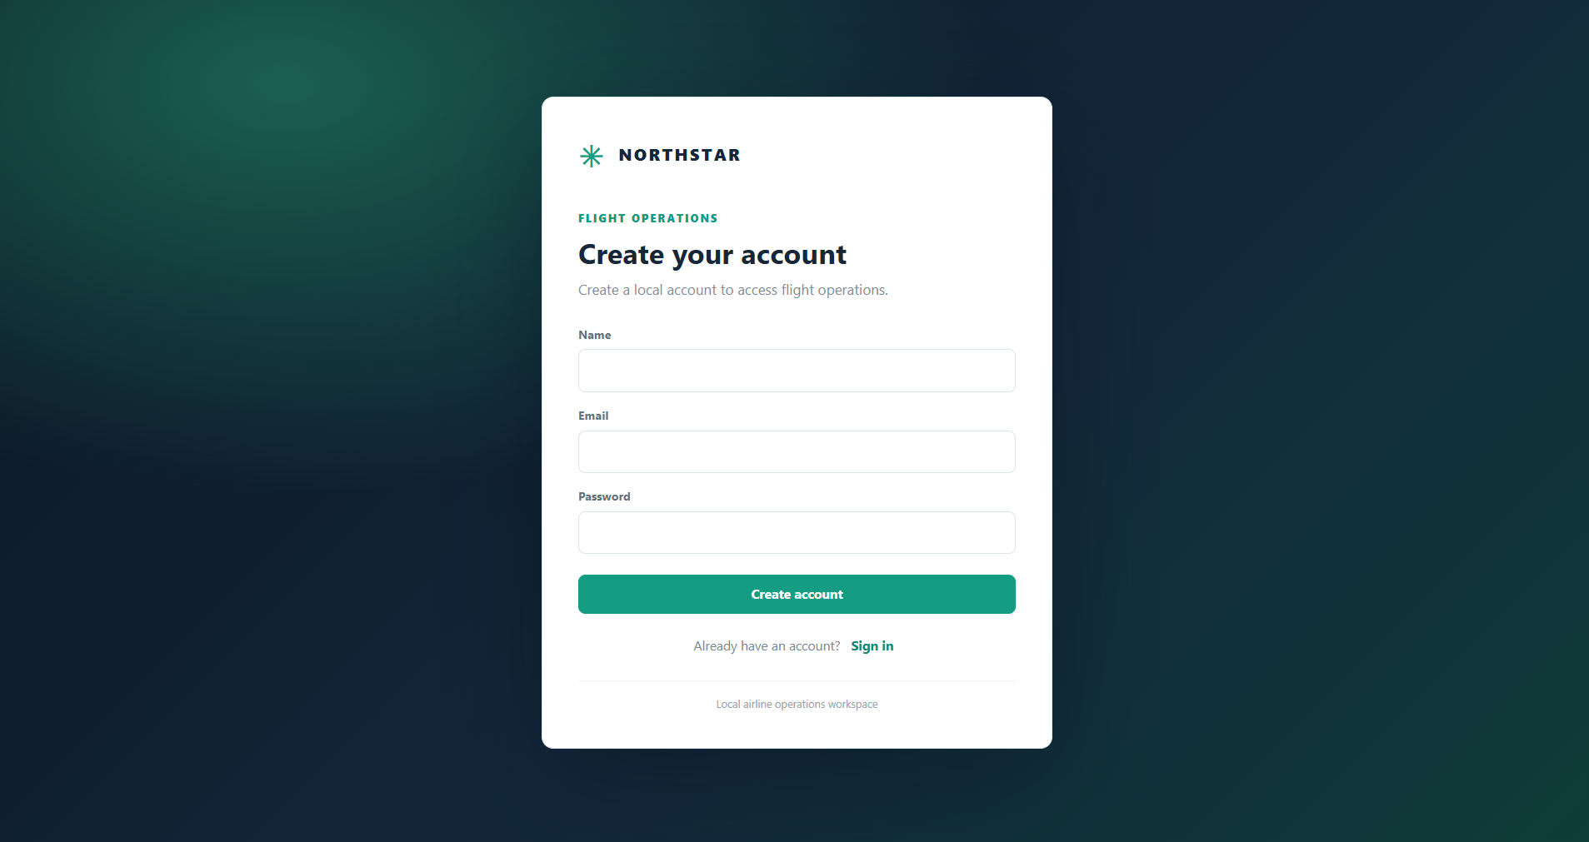
Figure 5. Local account registration screen.

Figure 6. Overview cards and sample departure flow.
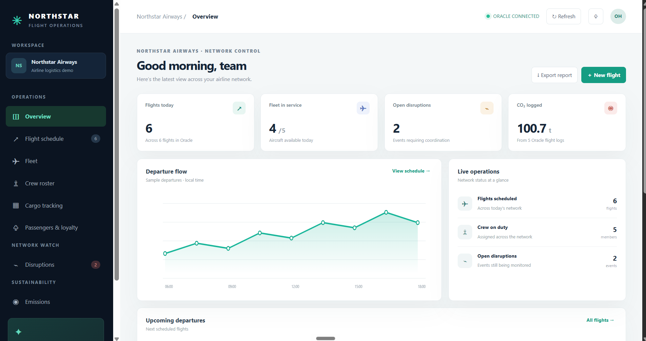
Figure 6. Overview cards and sample departure flow.

Figure 7. Flight schedule with eight records before create.
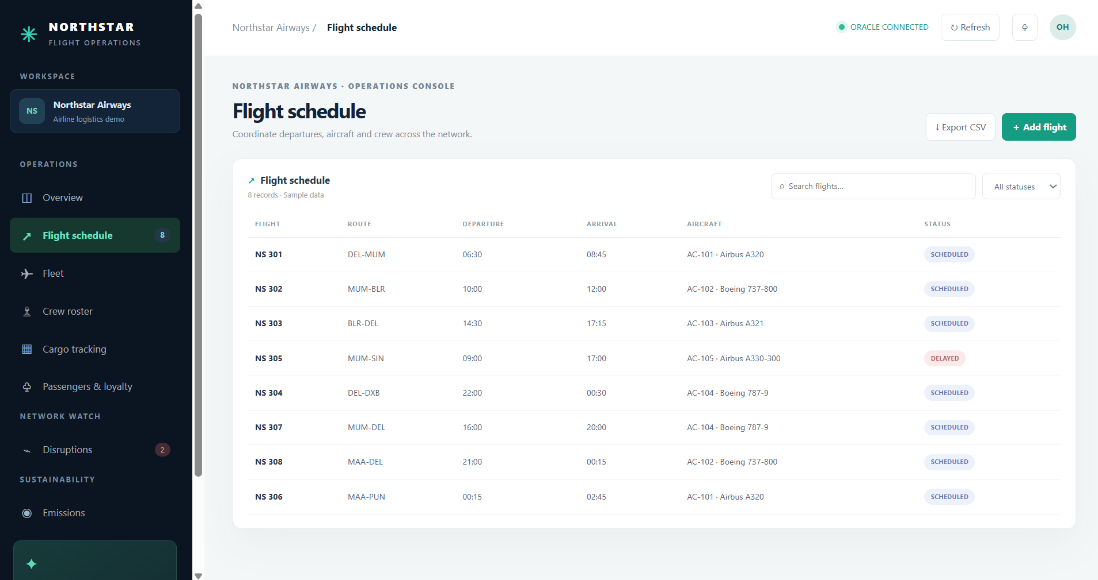
Figure 7. Flight schedule with eight records before create.

Figure 8. Oracle SELECT output showing initial flight rows.
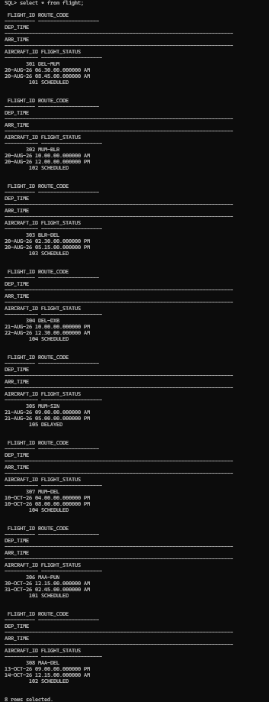
Figure 8. Oracle SELECT output showing initial flight rows.

Figure 9. Add Flight form populated for flight 309.
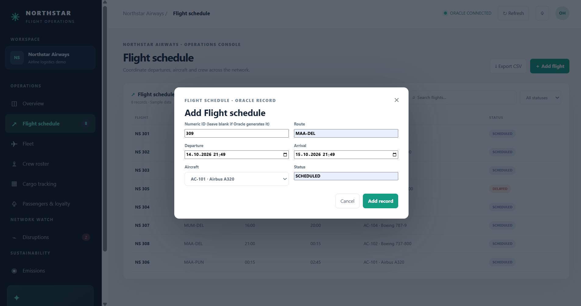
Figure 9. Add Flight form populated for flight 309.

Figure 10. Oracle output after insert; nine flight rows.
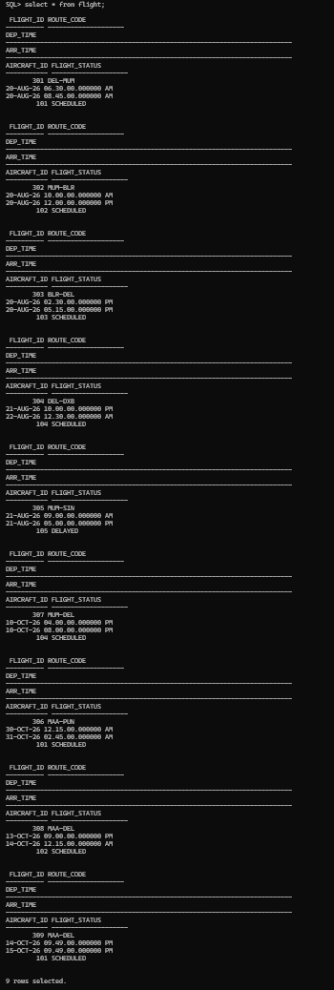
Figure 10. Oracle output after insert; nine flight rows.

Figure 11. Detail view for NS 309 after creation.
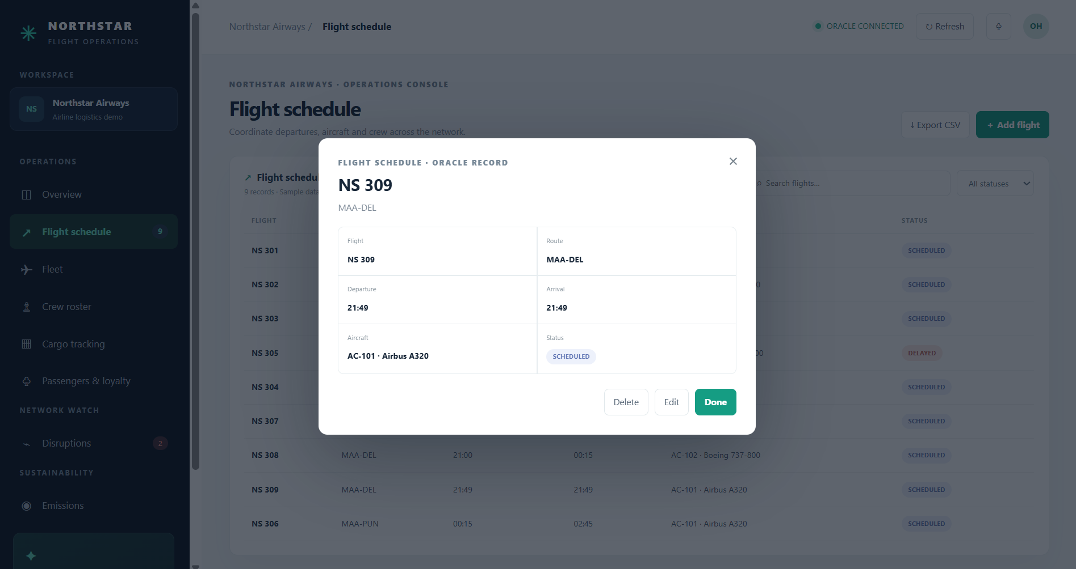
Figure 11. Detail view for NS 309 after creation.

Figure 12. Edit form with schedule change and DELAYED status.
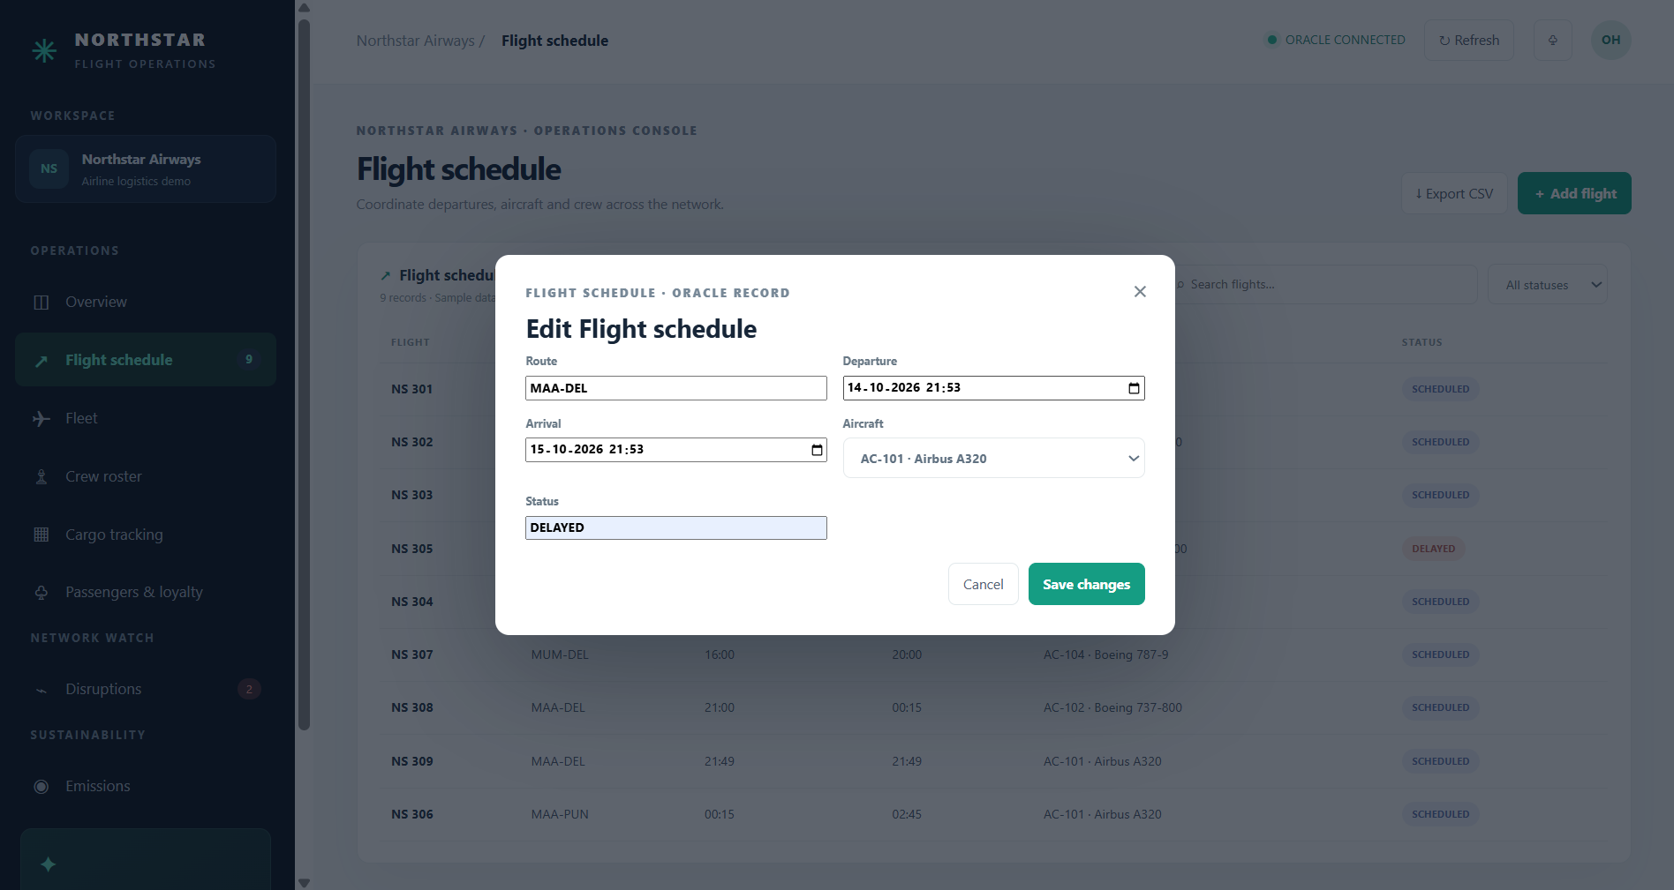
Figure 12. Edit form with schedule change and DELAYED status.

Figure 13. Oracle output reflecting updated flight 309.
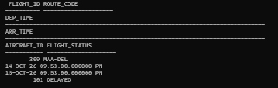
Figure 13. Oracle output reflecting updated flight 309.

Figure 14. Delete confirmation prompt for NS 301; prompt only.
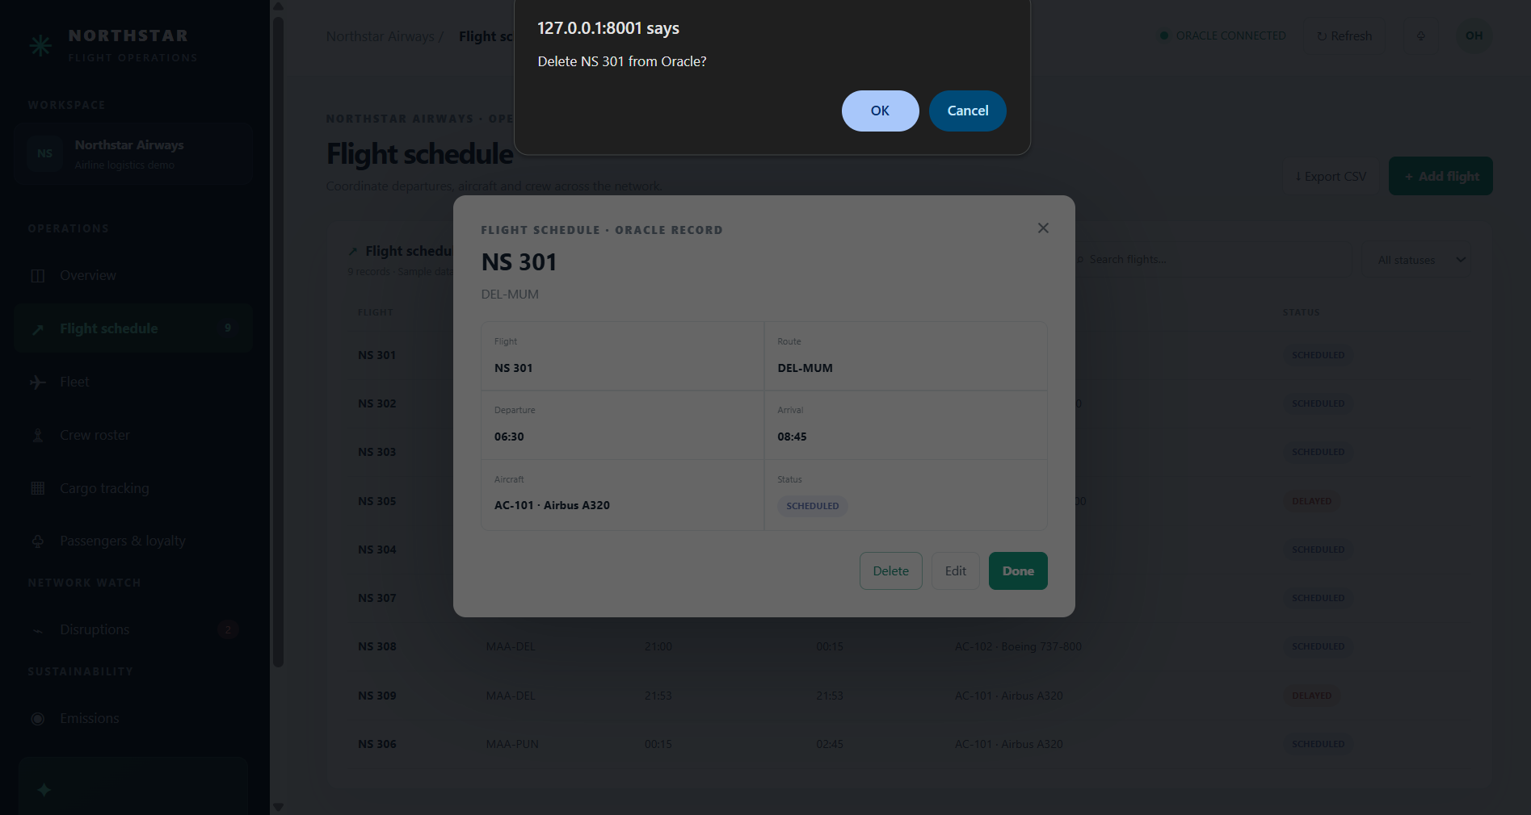
Figure 14. Delete confirmation prompt for NS 301; prompt only.

Figure 15. Fleet module with aircraft and service details.
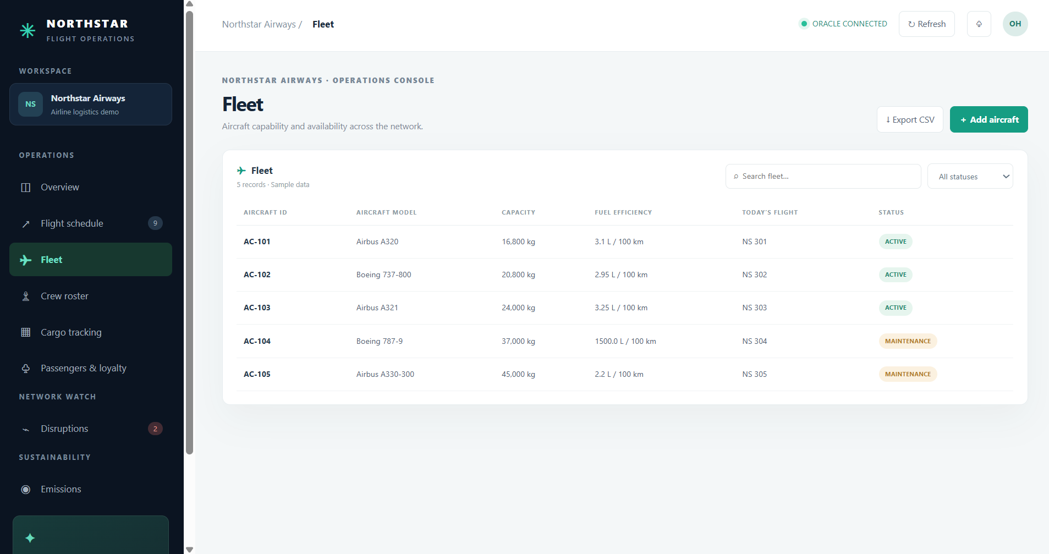
Figure 15. Fleet module with aircraft and service details.

Figure 16. Crew roster with roles, bases and assignments.
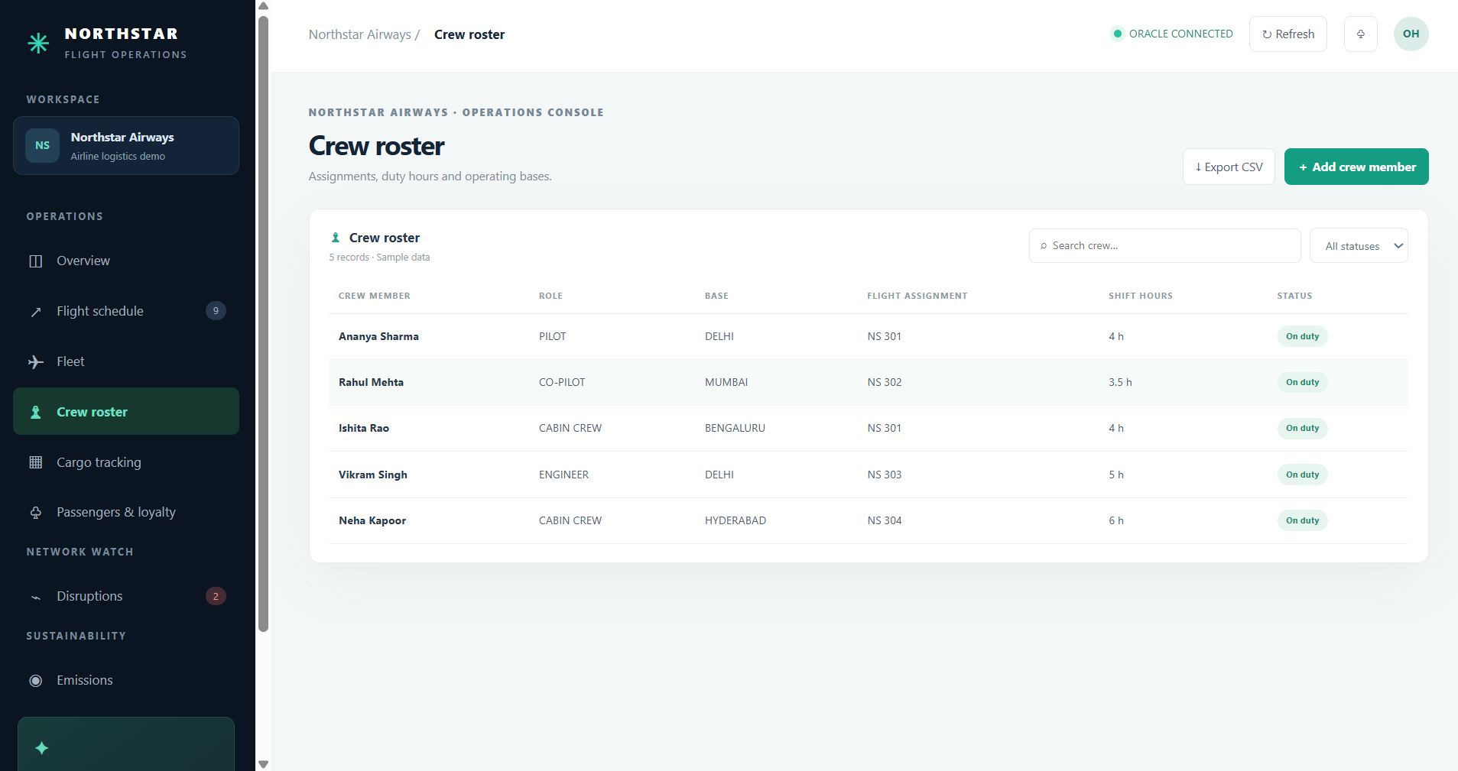
Figure 16. Crew roster with roles, bases and assignments.

Figure 17. Cargo tracking with category and temperature fields.
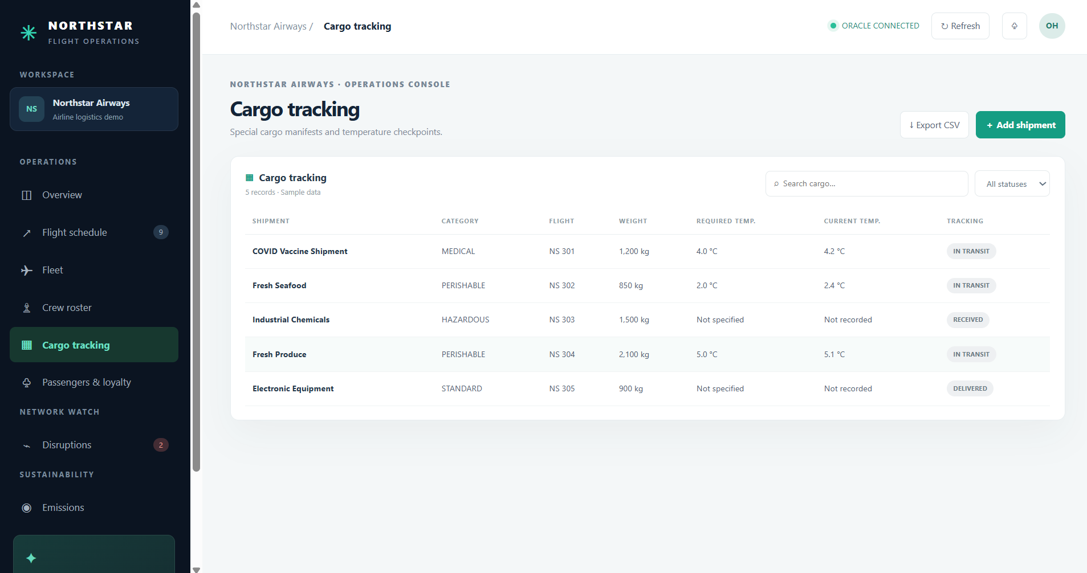
Figure 17. Cargo tracking with category and temperature fields.

Figure 18. Passenger and loyalty module.
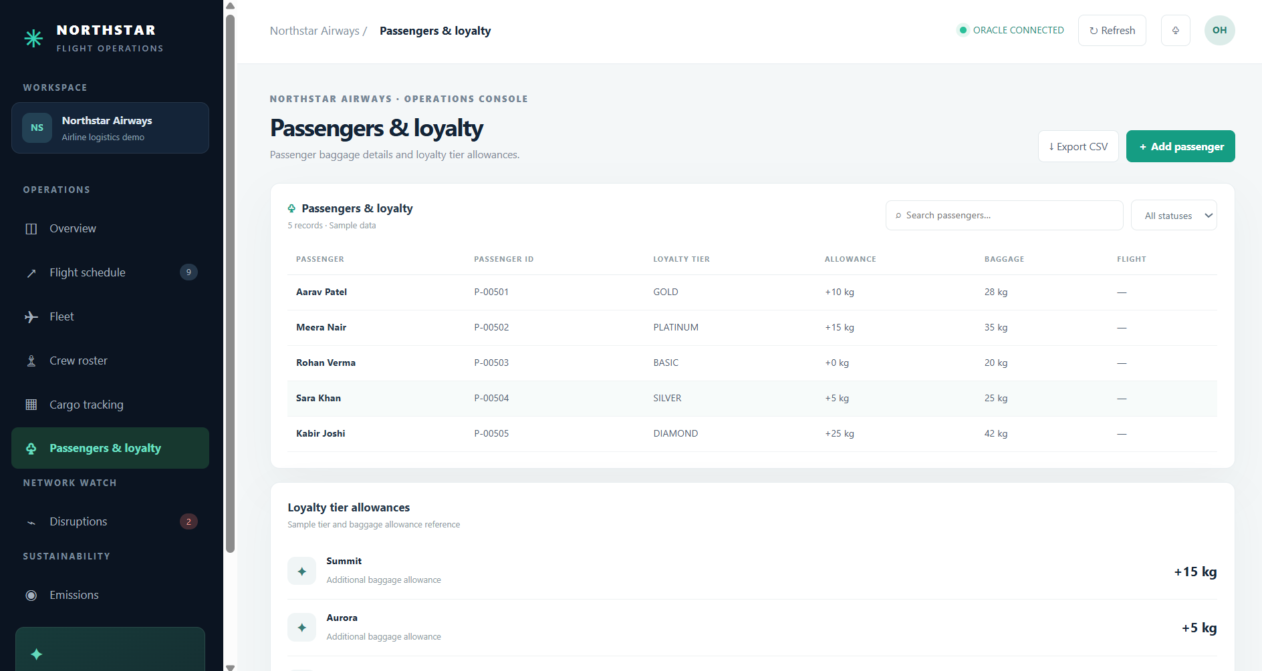
Figure 18. Passenger and loyalty module.

Figure 19. Disruptions module with causes, delay and status.
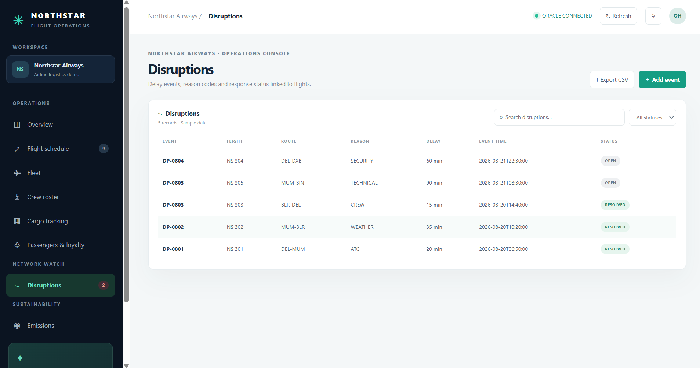
Figure 19. Disruptions module with causes, delay and status.

Figure 20. Emissions module with fuel and CO2 records.
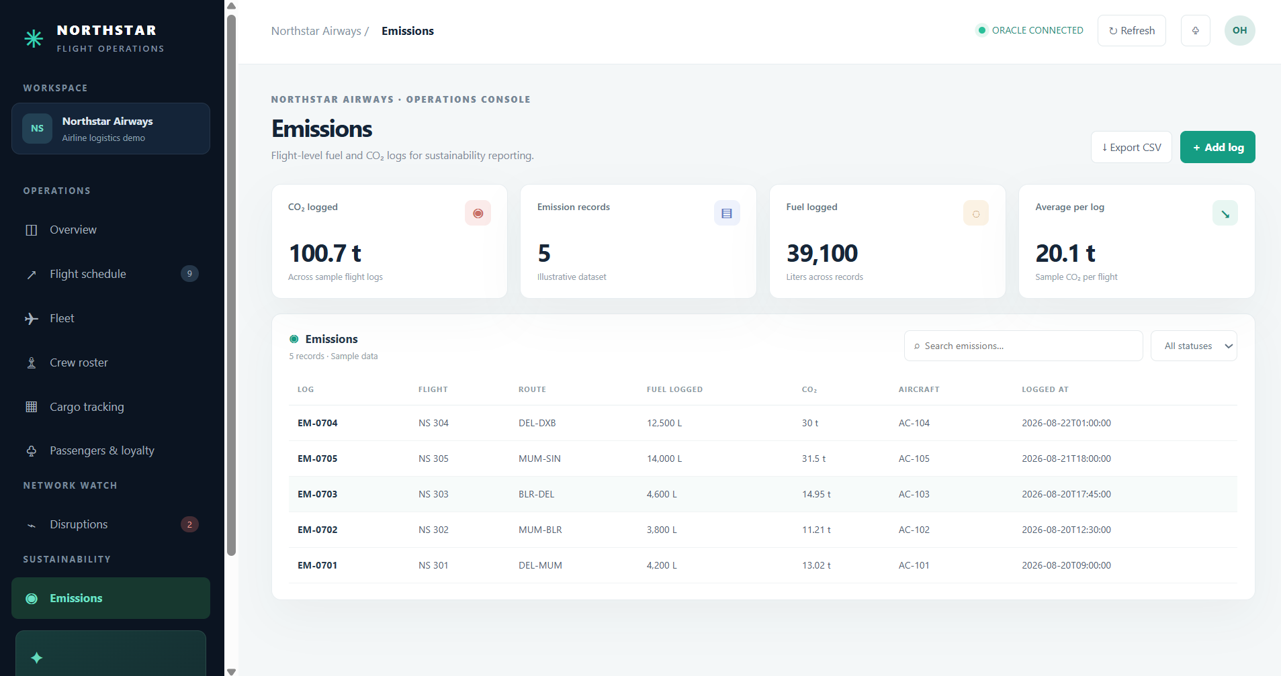
Figure 20. Emissions module with fuel and CO2 records.

Figure 21. Overview after additional flight is present.
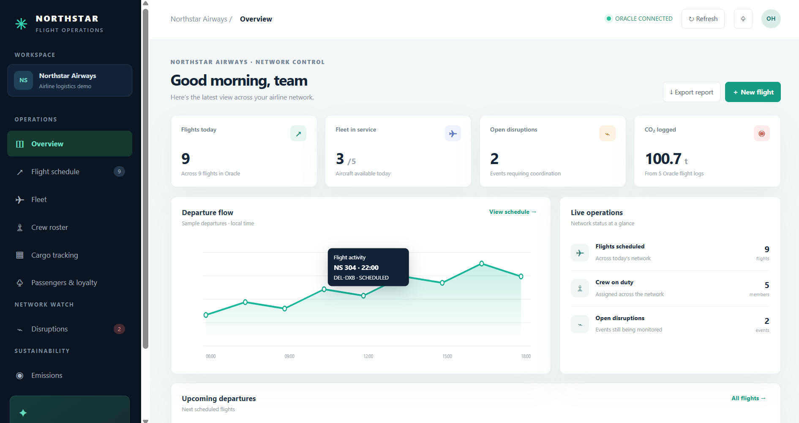
Figure 21. Overview after additional flight is present.

14 CONCLUSION AND FUTURE SCOPE

14.1 Conclusion
The project has progressed from a relational database design in Review 0 to a working local airline-operations application for Review 1. The implementation brings key records into a browser workspace and connects supported CRUD workflows to Oracle XE through FastAPI. Screenshots document authentication, flight schedule operations, database persistence for a create and update example, and fleet, crew, cargo, passenger, disruption and emissions views.
The design provides a foundation for structured operational data and sustainability visibility. It demonstrates database relationships, constraints, SQL concepts and an application layer. It remains a coursework proof of concept: data is illustrative, the service is local-only, permissions are uniform and sustainability outcomes have not been measured.

14.2 Future enhancements
Priority | Enhancement | Expected benefit
1 | Role access, session hardening, CSRF protection, TLS and audit logs | Safer deployment; accountability.
2 | Validation, allowlists, pagination, transactions and clear errors | Reliable maintenance at higher record volumes.
3 | Crew assignment UI and duty/rest rules | Complete staffing workflow; fewer invalid assignments.
4 | Sensor ingestion and cold-chain threshold alerts | Timely response and shipment traceability.
5 | Verified emissions factors and normalized reporting | Comparable, auditable sustainability analytics.
6 | Disruption analytics, alerts and recovery suggestions | Faster coordination and learning from recurring causes.
7 | Automated checks, CI, backups, migrations and monitoring | Safer releases and recoverability.
8 | Booking, airport and maintenance-system integration | Less duplicate entry; fuller network status.

14.3 Measurable next-step plan
First validate deployed columns and constraints against Oracle metadata. Add API and browser checks for create, update and delete, including unauthorized access and database constraint failures. Add roles and audit records before network deployment. Pilot emissions and cargo measurements with timestamped, attributed sources, then evaluate completeness, exception response time and normalized fuel/emissions indicators.

REFERENCES AND PROJECT MATERIALS
Review 0 report: Modern Airline Logistics and Sustainability Management System, BACSE202 Lab Component Project, AY 2026–27.
Review 1 guideline: Database Systems QP 9 (2).pdf, School of Computer Science and Engineering (SCOPE), AY 2026–27.
Project source files: server.py, index.html, requirements.txt and README.txt.
Implementation evidence: application and Oracle screenshots supplied by the author on 13 October 2026.

APPENDIX A FULL IMPLEMENTATION CODE SERVER
Listing reproduced from server.py. Private .env and session-secret files are intentionally excluded.
0001 import os
0002 import base64
0003 import hashlib
0004 import hmac
0005 import json
0006 import re
0007 import secrets
0008 from contextlib import contextmanager
0009 from datetime import date, datetime
0010 from pathlib import Path
0011 from typing import Any
0012
0013 import oracledb
0014 from dotenv import load_dotenv
0015 from fastapi import Depends, FastAPI, HTTPException, Request, Response
0016 from fastapi.responses import FileResponse
0017
0018 ROOT = Path(__file__).resolve().parent
0019 load_dotenv(ROOT / ".env")
0020
0021 app = FastAPI(title="Northstar Oracle API")
0022 _pool: oracledb.ConnectionPool | None = None
0023 AUTH_TABLE = "APP_LOGIN_USERS"
0024 SESSION_COOKIE = "northstar_session"
0025 SESSION_SECONDS = 12 * 60 * 60
0026 _session_secret: bytes | None = None
0027
0028 ENTITIES: dict[str, dict[str, Any]] = {
0029 "flights": {
0030 "table": "FLIGHT", "key": "FLIGHT_ID",
0031 "fields": {"route": "ROUTE_CODE", "departure": "DEP_TIME", "arrival": "ARR_TIME", "aircraft_id": "AIRCRAFT_ID", "status": "FLIGHT_STATUS"},
0032 },
0033 "fleet": {
0034 "table": "AIRCRAFT", "key": "AIRCRAFT_ID",
0035 "fields": {"model": "MODEL", "capacity_kg": "CAPACITY_KG", "efficiency": "FUEL_EFFICIENCY", "status": "AIRCRAFT_STATUS"},
0036 },
0037 "crew": {
0038 "table": "CREW", "key": "CREW_ID",
0039 "fields": {"name": "CREW_NAME", "role": "ROLE", "base": "BASE_LOCATION"},
0040 },
0041 "cargo": {
0042 "table": "SPEC_CARGO", "key": "CARGO_ID",
0043 "fields": {"flight_id": "FLIGHT_ID", "name": "CARGO_DESCRIPTION", "weight_kg": "WEIGHT_KG", "category": "CATEGORY", "required_temp_c": "REQ_TEMP_C", "current_temp_c": "CURRENT_TEMP_C", "tracking": "TRACKING_STATUS"},
0044 },
0045 "passengers": {
0046 "table": "PASSENGER", "key": "PASSENGER_ID",
0047 "fields": {"name": "PASSENGER_NAME", "passport_no": "PASSPORT_NO", "tier_id": "TIER_ID", "baggage_kg": "BAGGAGE_KG"},
0048 },
0049 "disruptions": {
0050 "table": "DISRUPTION", "key": "EVENT_ID",
0051 "fields": {"flight_id": "FLIGHT_ID", "delay_min": "DELAY_MIN", "reason": "REASON_CODE", "event_date": "EVENT_DATE", "status": "EVENT_STATUS"},
0052 },
0053 "emissions": {
0054 "table": "EMISSIONS", "key": "LOG_ID",
0055 "fields": {"flight_id": "FLIGHT_ID", "fuel_liters": "FUEL_LITERS", "co2_tons": "CO2_TONS", "logged_at": "LOGGED_AT"},
0056 },
0057 }
0058
0059
0060 def get_pool() -> oracledb.ConnectionPool:
0061 global _pool
0062 if _pool is None:
0063 user = os.getenv("ORACLE_USER")
0064 password = os.getenv("ORACLE_PASSWORD")
0065 dsn = os.getenv("ORACLE_DSN")
0066 if not user or not password or not dsn:
0067 raise HTTPException(status_code=503, detail="Set ORACLE_USER, ORACLE_PASSWORD, and ORACLE_DSN in the local .env file.")
0068 try:
0069 _pool = oracledb.create_pool(user=user, password=password, dsn=dsn, min=1, max=4, increment=1)
0070 except oracledb.Error as exc:
0071 raise HTTPException(status_code=503, detail=f"Oracle connection failed: {exc}") from exc
0072 return _pool
0073
0074
0075 @contextmanager
0076 def connection():
0077 try:
0078 conn = get_pool().acquire()
0079 except oracledb.Error as exc:
0080 raise HTTPException(status_code=503, detail=f"Cannot acquire an Oracle connection: {exc}") from exc
0081 try:
0082 yield conn
0083 finally:
0084 conn.close()
0085
0086
0087 def rows_as_dicts(cursor: oracledb.Cursor) -> list[dict[str, Any]]:
0088 names = [column[0].lower() for column in cursor.description]
0089 result = []
0090 for row in cursor:
0091 item = dict(zip(names, row))
0092 for key, value in item.items():
0093 if isinstance(value, (datetime, date)):
0094 item[key] = value.isoformat()
0095 result.append(item)
0096 return result
0097
0098
0099 def ensure_auth_table() -> None:
0100 with connection() as conn:
0101 with conn.cursor() as cursor:
0102 cursor.execute("SELECT COUNT(*) FROM USER_TABLES WHERE TABLE_NAME = :table_name", {"table_name": AUTH_TABLE})
0103 if cursor.fetchone()[0]:
0104 return
0105 try:
0106 cursor.execute(f"""CREATE TABLE {AUTH_TABLE} (
0107 USER_ID NUMBER GENERATED BY DEFAULT AS IDENTITY PRIMARY KEY,
0108 NAME VARCHAR2(80) NOT NULL,
0109 EMAIL VARCHAR2(254) NOT NULL UNIQUE,
0110 PASSWORD_HASH VARCHAR2(256) NOT NULL,
0111 CREATED_AT TIMESTAMP DEFAULT CURRENT_TIMESTAMP NOT NULL
0112 )""")
0113 except oracledb.DatabaseError as exc:
0114 if getattr(exc.args[0], "code", None) != 955:
0115 raise
0116
0117
0118 def hash_password(password: str, salt: bytes | None = None) -> str:
0119 salt = salt or secrets.token_bytes(16)
0120 digest = hashlib.scrypt(password.encode("utf-8"), salt=salt, n=2**14, r=8, p=1, dklen=64)
0121 return f"scrypt$16384$8$1${base64.urlsafe_b64encode(salt).decode()}${base64.urlsafe_b64encode(digest).decode()}"
0122
0123
0124 def verify_password(password: str, encoded: str) -> bool:
0125 try:
0126 algorithm, n, r, p, salt_text, digest_text = encoded.split("$", 5)
0127 if algorithm != "scrypt":
0128 return False
0129 salt = base64.urlsafe_b64decode(salt_text.encode())
0130 expected = base64.urlsafe_b64decode(digest_text.encode())
0131 actual = hashlib.scrypt(password.encode("utf-8"), salt=salt, n=int(n), r=int(r), p=int(p), dklen=len(expected))
0132 return hmac.compare_digest(actual, expected)
0133 except (ValueError, TypeError):
0134 return False
0135
0136
0137 def get_session_secret() -> bytes:
0138 global _session_secret
0139 if _session_secret is None:
0140 path = ROOT / ".session_secret"
0141 try:
0142 _session_secret = path.read_bytes()
0143 except FileNotFoundError:
0144 _session_secret = secrets.token_bytes(32)
0145 try:
0146 with path.open("xb") as secret_file:
0147 secret_file.write(_session_secret)
0148 except FileExistsError:
0149 _session_secret = path.read_bytes()
0150 return _session_secret
0151
0152
0153 def create_session(user: dict[str, Any]) -> str:
0154 payload = {"id": user["user_id"], "name": user["name"], "email": user["email"], "exp": int(datetime.now().timestamp()) + SESSION_SECONDS}
0155 encoded = base64.urlsafe_b64encode(json.dumps(payload, separators=(",", ":")).encode()).rstrip(b"=")
0156 signature = hmac.new(get_session_secret(), encoded, hashlib.sha256).digest()
0157 return f"{encoded.decode()}.{base64.urlsafe_b64encode(signature).rstrip(b'=').decode()}"
0158
0159
0160 def session_user(request: Request) -> dict[str, Any] | None:
0161 token = request.cookies.get(SESSION_COOKIE)
0162 if not token or "." not in token:
0163 return None
0164 encoded_text, signature_text = token.rsplit(".", 1)
0165 encoded = encoded_text.encode()
0166 expected = hmac.new(get_session_secret(), encoded, hashlib.sha256).digest()
0167 try:
0168 supplied = base64.urlsafe_b64decode(signature_text + "=" * (-len(signature_text) % 4))
0169 payload_bytes = base64.urlsafe_b64decode(encoded_text + "=" * (-len(encoded_text) % 4))
0170 payload = json.loads(payload_bytes)
0171 except (ValueError, json.JSONDecodeError):
0172 return None
0173 if not hmac.compare_digest(expected, supplied) or payload.get("exp", 0) < datetime.now().timestamp():
0174 return None
0175 return payload
0176
0177
0178 def require_user(request: Request) -> dict[str, Any]:
0179 user = session_user(request)
0180 if user is None:
0181 raise HTTPException(status_code=401, detail="Please sign in to continue.")
0182 return user
0183
0184
0185 def flight_label(flight_id: int | None) -> str:
0186 return f"NS {flight_id:03d}" if flight_id is not None else "—"
0187
0188
0189 def read_all() -> dict[str, list[dict[str, Any]]]:
0190 queries = {
0191 "flights": """SELECT f.FLIGHT_ID AS db_id, f.ROUTE_CODE AS route,
0192 TO_CHAR(f.DEP_TIME, 'YYYY-MM-DD\"T\"HH24:MI:SS') AS departure_iso,
0193 TO_CHAR(f.DEP_TIME, 'HH24:MI') AS departure,
0194 TO_CHAR(f.ARR_TIME, 'YYYY-MM-DD\"T\"HH24:MI:SS') AS arrival_iso,
0195 TO_CHAR(f.ARR_TIME, 'HH24:MI') AS arrival,
0196 f.AIRCRAFT_ID AS aircraft_id, a.MODEL AS model, f.FLIGHT_STATUS AS status
0197 FROM FLIGHT f JOIN AIRCRAFT a ON a.AIRCRAFT_ID = f.AIRCRAFT_ID ORDER BY f.DEP_TIME""",
0198 "fleet": """SELECT a.AIRCRAFT_ID AS db_id, a.MODEL AS model, a.CAPACITY_KG AS capacity_kg,
0199 a.FUEL_EFFICIENCY AS efficiency, a.AIRCRAFT_STATUS AS status,
0200 (SELECT MIN(f.FLIGHT_ID) FROM FLIGHT f WHERE f.AIRCRAFT_ID = a.AIRCRAFT_ID) AS flight_id
0201 FROM AIRCRAFT a ORDER BY a.AIRCRAFT_ID""",
0202 "crew": """SELECT c.CREW_ID AS db_id, c.CREW_NAME AS name, c.ROLE AS role,
0203 c.BASE_LOCATION AS base, fc.FLIGHT_ID AS flight_id, fc.SHIFT_HOURS AS shift
0204 FROM CREW c LEFT JOIN (SELECT CREW_ID, MIN(FLIGHT_ID) AS FLIGHT_ID,
0205 MIN(SHIFT_HOURS) AS SHIFT_HOURS FROM FLIGHT_CREW GROUP BY CREW_ID) fc
0206 ON fc.CREW_ID = c.CREW_ID ORDER BY c.CREW_ID""",
0207 "cargo": """SELECT c.CARGO_ID AS db_id, c.CARGO_DESCRIPTION AS name, c.CATEGORY AS category,
0208 c.FLIGHT_ID AS flight_id, c.WEIGHT_KG AS weight_kg, c.REQ_TEMP_C AS required_temp_c,
0209 c.CURRENT_TEMP_C AS current_temp_c, c.TRACKING_STATUS AS tracking
0210 FROM SPEC_CARGO c ORDER BY c.CARGO_ID""",
0211 "passengers": """SELECT p.PASSENGER_ID AS db_id, p.PASSENGER_NAME AS name,
0212 p.TIER_ID AS tier_id, lt.TIER_NAME AS tier, lt.EXTRA_BAGGAGE_KG AS allowance_kg,
0213 p.BAGGAGE_KG AS baggage_kg,
0214 (SELECT MIN(b.FLIGHTNO) FROM BOOKING b WHERE b.P_ID = TO_CHAR(p.PASSENGER_ID)) AS flight_id
0215 FROM PASSENGER p JOIN LOYALTY_TIER lt ON lt.TIER_ID = p.TIER_ID ORDER BY p.PASSENGER_ID""",
0216 "disruptions": """SELECT d.EVENT_ID AS db_id, d.FLIGHT_ID AS flight_id, f.ROUTE_CODE AS route,
0217 d.REASON_CODE AS reason, d.DELAY_MIN AS delay_min,
0218 TO_CHAR(d.EVENT_DATE, 'YYYY-MM-DD\"T\"HH24:MI:SS') AS event_date,
0219 d.EVENT_STATUS AS status FROM DISRUPTION d JOIN FLIGHT f ON f.FLIGHT_ID = d.FLIGHT_ID
0220 ORDER BY d.EVENT_DATE DESC""",
0221 "emissions": """SELECT e.LOG_ID AS db_id, e.FLIGHT_ID AS flight_id, f.ROUTE_CODE AS route,
0222 e.FUEL_LITERS AS fuel_liters, e.CO2_TONS AS co2_tons, f.AIRCRAFT_ID AS aircraft_id,
0223 TO_CHAR(e.LOGGED_AT, 'YYYY-MM-DD\"T\"HH24:MI:SS') AS logged_at
0224 FROM EMISSIONS e JOIN FLIGHT f ON f.FLIGHT_ID = e.FLIGHT_ID ORDER BY e.LOGGED_AT DESC""",
0225 "loyalty_tiers": "SELECT TIER_ID AS tier_id, TIER_NAME AS tier_name, EXTRA_BAGGAGE_KG AS allowance_kg FROM LOYALTY_TIER ORDER BY TIER_ID",
0226 }
0227 result: dict[str, list[dict[str, Any]]] = {}
0228 with connection() as conn:
0229 with conn.cursor() as cursor:
0230 for entity, sql in queries.items():
0231 cursor.execute(sql)
0232 records = rows_as_dicts(cursor)
0233 if entity == "flights":
0234 for row in records:
0235 row.update(id=flight_label(row["db_id"]), aircraft=f"AC-{row['aircraft_id']:03d} · {row['model']}")
0236 elif entity == "fleet":
0237 for row in records:
0238 row.update(id=f"AC-{row['db_id']:03d}", capacity=f"{row['capacity_kg']:,.0f} kg", efficiency=f"{row['efficiency']} L / 100 km", flights=flight_label(row["flight_id"]) if row["flight_id"] else "—")
0239 elif entity == "crew":
0240 for row in records:
0241 row.update(id=f"CR-{row['db_id']:03d}", flight=flight_label(row["flight_id"]) if row["flight_id"] else "—", shift=f"{row['shift']} h" if row["shift"] is not None else "—", status="On duty" if row["flight_id"] else "Standby")
0242 elif entity == "cargo":
0243 for row in records:
0244 row.update(id=f"CG-{row['db_id']:04d}", flight=flight_label(row["flight_id"]), weight=f"{row['weight_kg']:,.0f} kg", required=f"{row['required_temp_c']} °C" if row["required_temp_c"] is not None else "Not specified", current=f"{row['current_temp_c']} °C" if row["current_temp_c"] is not None else "Not recorded")
0245 elif entity == "passengers":
0246 for row in records:
0247 row.update(id=f"P-{row['db_id']:05d}", allowance=f"+{row['allowance_kg']:g} kg", baggage=f"{row['baggage_kg']:g} kg", flight=flight_label(row["flight_id"]) if row["flight_id"] else "—")
0248 elif entity == "disruptions":
0249 for row in records:
0250 row.update(id=f"DP-{row['db_id']:04d}", flight=flight_label(row["flight_id"]), delay=f"{row['delay_min']} min", date=row["event_date"])
0251 elif entity == "emissions":
0252 for row in records:
0253 row.update(id=f"EM-{row['db_id']:04d}", flight=flight_label(row["flight_id"]), fuel=f"{row['fuel_liters']:,.0f} L", co2=f"{row['co2_tons']:g} t", aircraft=f"AC-{row['aircraft_id']:03d}", logged=row["logged_at"])
0254 result[entity] = records
0255 return result
0256
0257
0258 @app.get("/api/health")
0259 def health() -> dict[str, Any]:
0260 with connection() as conn:
0261 with conn.cursor() as cursor:
0262 cursor.execute("SELECT USER, SYS_CONTEXT('USERENV','SERVICE_NAME'), SYS_CONTEXT('USERENV','CON_NAME') FROM DUAL")
0263 user, service, container = cursor.fetchone()
0264 cursor.execute("SELECT TABLE_NAME FROM USER_TABLES")
0265 visible = {row[0] for row in cursor.fetchall()}
0266 required = {"AIRCRAFT", "CREW", "DISRUPTION", "EMISSIONS", "FLIGHT", "LOYALTY_TIER", "PASSENGER", "SPEC_CARGO"}
0267 missing = sorted(required - visible)
0268 if missing:
0269 raise HTTPException(status_code=503, detail=f"Oracle is reachable as {user} on {service}/{container}, but this schema cannot see the airline tables. Use the same Oracle username and service as the SQL*Plus session where you ran the inserts.")
0270 return {"status": "ok", "database": "Oracle", "user": user, "service": service, "container": container}
0271
0272
0273 @app.post("/api/auth/signup", status_code=201)
0274 def signup(payload: dict[str, Any], response: Response) -> dict[str, Any]:
0275 name = str(payload.get("name", "")).strip()
0276 email = str(payload.get("email", "")).strip().lower()
0277 password = str(payload.get("password", ""))
0278 if not name or len(name) > 80:
0279 raise HTTPException(status_code=422, detail="Name is required and must be 80 characters or fewer.")
0280 if not re.fullmatch(r"[^\s@]+@[^\s@]+\.[^\s@]+", email) or len(email) > 254:
0281 raise HTTPException(status_code=422, detail="Enter a valid email address.")
0282 if len(password) < 10:
0283 raise HTTPException(status_code=422, detail="Password must be at least 10 characters.")
0284 ensure_auth_table()
0285 try:
0286 with connection() as conn:
0287 with conn.cursor() as cursor:
0288 user_id_var = cursor.var(oracledb.NUMBER)
0289 cursor.execute(
0290 f"INSERT INTO {AUTH_TABLE} (NAME, EMAIL, PASSWORD_HASH) VALUES (:name, :email, :password_hash) RETURNING USER_ID INTO :user_id",
0291 {"name": name, "email": email, "password_hash": hash_password(password), "user_id": user_id_var},
0292 )
0293 user_id = user_id_var.getvalue()
0294 conn.commit()
0295 except oracledb.DatabaseError as exc:
0296 if getattr(exc.args[0], "code", None) == 1:
0297 raise HTTPException(status_code=409, detail="An account with this email already exists.") from exc
0298 raise HTTPException(status_code=503, detail="Could not create the account in Oracle.") from exc
0299 if isinstance(user_id, list):
0300 user_id = user_id[0]
0301 user = {"user_id": int(user_id), "name": name, "email": email}
0302 response.set_cookie(SESSION_COOKIE, create_session(user), httponly=True, samesite="lax", secure=False, max_age=SESSION_SECONDS, path="/")
0303 return user
0304
0305
0306 @app.post("/api/auth/login")
0307 def login(payload: dict[str, Any], response: Response) -> dict[str, Any]:
0308 email = str(payload.get("email", "")).strip().lower()
0309 password = str(payload.get("password", ""))
0310 ensure_auth_table()
0311 try:
0312 with connection() as conn:
0313 with conn.cursor() as cursor:
0314 cursor.execute(f"SELECT USER_ID, NAME, EMAIL, PASSWORD_HASH FROM {AUTH_TABLE} WHERE EMAIL = :email", {"email": email})
0315 row = cursor.fetchone()
0316 except oracledb.DatabaseError as exc:
0317 raise HTTPException(status_code=503, detail="Could not check the account in Oracle.") from exc
0318 if row is None or not verify_password(password, row[3]):
0319 raise HTTPException(status_code=401, detail="Email or password is incorrect.")
0320 user = {"user_id": int(row[0]), "name": row[1], "email": row[2]}
0321 response.set_cookie(SESSION_COOKIE, create_session(user), httponly=True, samesite="lax", secure=False, max_age=SESSION_SECONDS, path="/")
0322 return user
0323
0324
0325 @app.get("/api/auth/me")
0326 def current_user(user: dict[str, Any] | None = Depends(session_user)) -> dict[str, Any]:
0327 if user is None:
0328 raise HTTPException(status_code=401, detail="Please sign in to continue.")
0329 return user
0330
0331
0332 @app.post("/api/auth/logout")
0333 def logout(response: Response) -> dict[str, str]:
0334 response.delete_cookie(SESSION_COOKIE, path="/")
0335 return {"message": "Signed out"}
0336
0337
0338 @app.get("/api/data")
0339 def get_data(_user: dict[str, Any] = Depends(require_user)) -> dict[str, list[dict[str, Any]]]:
0340 try:
0341 return read_all()
0342 except oracledb.DatabaseError as exc:
0343 error = exc.args[0]
0344 if getattr(error, "code", None) == 942:
0345 raise HTTPException(status_code=503, detail="Oracle is reachable, but the configured schema cannot see one or more airline tables. Use the same Oracle username and service as the SQL*Plus session where you ran the inserts.") from exc
0346 raise HTTPException(status_code=503, detail=f"Oracle query failed: {error}") from exc
0347
0348
0349 @app.get("/api/reference/{entity}")
0350 def get_reference(entity: str, _user: dict[str, Any] = Depends(require_user)) -> list[dict[str, Any]]:
0351 queries = {
0352 "flights": "SELECT FLIGHT_ID AS db_id, ROUTE_CODE AS route FROM FLIGHT ORDER BY FLIGHT_ID",
0353 "fleet": "SELECT AIRCRAFT_ID AS db_id, MODEL AS model FROM AIRCRAFT ORDER BY AIRCRAFT_ID",
0354 "tiers": "SELECT TIER_ID AS tier_id, TIER_NAME AS tier_name FROM LOYALTY_TIER ORDER BY TIER_ID",
0355 }
0356 sql = queries.get(entity)
0357 if sql is None:
0358 raise HTTPException(status_code=404, detail="Unknown reference list.")
0359 with connection() as conn:
0360 with conn.cursor() as cursor:
0361 cursor.execute(sql)
0362 return rows_as_dicts(cursor)
0363
0364
0365 def get_entity(entity: str) -> dict[str, Any]:
0366 definition = ENTITIES.get(entity)
0367 if definition is None:
0368 raise HTTPException(status_code=404, detail="Unknown entity.")
0369 return definition
0370
0371
0372 def write_record(entity: str, key_value: int | str | None, payload: dict[str, Any], create: bool) -> dict[str, Any]:
0373 definition = get_entity(entity)
0374 fields: dict[str, str] = definition["fields"]
0375 provided_key = payload.pop("db_id", None) if create else None
0376 unknown = set(payload) - set(fields)
0377 if unknown:
0378 raise HTTPException(status_code=422, detail=f"Unsupported fields: {', '.join(sorted(unknown))}")
0379 if provided_key is not None:
0380 try:
0381 provided_key = int(provided_key)
0382 except (TypeError, ValueError) as exc:
0383 raise HTTPException(status_code=422, detail="db_id must be a number.") from exc
0384 if not payload:
0385 raise HTTPException(status_code=422, detail="Provide at least one field.")
0386 columns = list(payload)
0387 binds = {name: payload[name] for name in columns}
0388 date_fields = {"departure", "arrival", "event_date", "logged_at"}
0389 for name in columns:
0390 if name in date_fields and binds[name] is not None:
0391 try:
0392 binds[name] = datetime.fromisoformat(str(binds[name]))
0393 except ValueError as exc:
0394 raise HTTPException(status_code=422, detail=f"{name} must be an ISO date/time.") from exc
0395 try:
0396 with connection() as conn:
0397 with conn.cursor() as cursor:
0398 if create:
0399 column_sql = ", ".join(fields[name] for name in columns)
0400 bind_sql = ", ".join(f":{name}" for name in columns)
0401 if provided_key is not None:
0402 column_sql = f"{definition['key']}, {column_sql}"
0403 bind_sql = f":provided_key, {bind_sql}"
0404 binds["provided_key"] = provided_key
0405 key_var = cursor.var(oracledb.NUMBER)
0406 sql = f"INSERT INTO {definition['table']} ({column_sql}) VALUES ({bind_sql}) RETURNING {definition['key']} INTO :new_key"
0407 cursor.execute(sql, {**binds, "new_key": key_var})
0408 new_key = key_var.getvalue()
0409 conn.commit()
0410 return {"db_id": new_key, "message": "Created"}
0411 assignments = ", ".join(f"{fields[name]} = :{name}" for name in columns)
0412 binds["record_key"] = key_value
0413 cursor.execute(f"UPDATE {definition['table']} SET {assignments} WHERE {definition['key']} = :record_key", binds)
0414 if cursor.rowcount == 0:
0415 raise HTTPException(status_code=404, detail="Record not found.")
0416 conn.commit()
0417 return {"db_id": key_value, "message": "Updated"}
0418 except HTTPException:
0419 raise
0420 except oracledb.Error as exc:
0421 raise HTTPException(status_code=409, detail=f"Oracle rejected the change. Check required fields, relationships, and generated IDs: {exc}") from exc
0422
0423
0424 @app.post("/api/{entity}", status_code=201)
0425 def create_record(entity: str, payload: dict[str, Any], _user: dict[str, Any] = Depends(require_user)) -> dict[str, Any]:
0426 return write_record(entity, None, payload, True)
0427
0428
0429 @app.put("/api/{entity}/{record_id}")
0430 def update_record(entity: str, record_id: str, payload: dict[str, Any], _user: dict[str, Any] = Depends(require_user)) -> dict[str, Any]:
0431 definition = get_entity(entity)
0432 try:
0433 key_value: int | str = int(record_id) if definition["key"] != "BOOKING_ID" else record_id
0434 except ValueError as exc:
0435 raise HTTPException(status_code=422, detail="Record ID must be numeric.") from exc
0436 return write_record(entity, key_value, payload, False)
0437
0438
0439 @app.delete("/api/{entity}/{record_id}")
0440 def delete_record(entity: str, record_id: str, _user: dict[str, Any] = Depends(require_user)) -> dict[str, str]:
0441 definition = get_entity(entity)
0442 try:
0443 key_value = int(record_id)
0444 except ValueError as exc:
0445 raise HTTPException(status_code=422, detail="Record ID must be numeric.") from exc
0446 try:
0447 with connection() as conn:
0448 with conn.cursor() as cursor:
0449 cursor.execute(f"DELETE FROM {definition['table']} WHERE {definition['key']} = :record_key", {"record_key": key_value})
0450 if cursor.rowcount == 0:
0451 raise HTTPException(status_code=404, detail="Record not found.")
0452 conn.commit()
0453 return {"message": "Deleted"}
0454 except HTTPException:
0455 raise
0456 except oracledb.Error as exc:
0457 raise HTTPException(status_code=409, detail=f"Oracle rejected the delete, possibly because related records exist: {exc}") from exc
0458
0459
0460 @app.get("/")
0461 def index() -> FileResponse:
0462 return FileResponse(ROOT / "index.html")
0463
0464
0465 @app.get("/{asset_path:path}")
0466 def static_files(asset_path: str) -> FileResponse:
0467 path = (ROOT / asset_path).resolve()
0468 if ROOT not in path.parents or not path.is_file():
0469 raise HTTPException(status_code=404, detail="Not found.")
0470 return FileResponse(path)

APPENDIX B FULL IMPLEMENTATION CODE FRONT END
Listing reproduced from index.html. Private .env and session-secret files are intentionally excluded.
0001 <!doctype html>
0002 <html lang="en">
0003 <head>
0004 <meta charset="utf-8"><meta name="viewport" content="width=device-width, initial-scale=1"><meta name="theme-color" content="#0b1421">
0005 <title>Northstar · Airline Logistics</title>
0006 <style>
0007 :root{--nav:#0b1421;--nav2:#121f30;--ink:#172638;--muted:#7f8b98;--line:#e7edf0;--bg:#f4f7f8;--teal:#17b394;--teal2:#e7f7f3;--amber:#d99438;--red:#d36c62;--shadow:0 18px 45px #1726380b}*{box-sizing:border-box}body{margin:0;background:var(--bg);font:14px/1.45 "Segoe UI",Arial,sans-serif;color:var(--ink)}button,input,select{font:inherit}button{cursor:pointer}.layout{display:grid;grid-template-columns:252px 1fr;min-height:100vh}.sidebar{background:var(--nav);color:#dbe4ed;padding:22px 15px 16px;display:flex;flex-direction:column;min-height:100vh;position:sticky;top:0;height:100vh;overflow:auto}.brand{display:flex;align-items:center;gap:11px;padding:2px 12px 28px;color:white;font-weight:800;letter-spacing:.13em;font-size:14px}.brand-mark{font-size:25px;color:#37d3b6}.brand small{display:block;color:#8293a4;font-size:9px;letter-spacing:.18em;margin-top:3px;font-weight:600}.workspace-label,.caption{color:#78899b;font-weight:700;letter-spacing:.17em;font-size:9px;padding:0 12px 9px}.workspace{display:flex;gap:10px;align-items:center;padding:10px;background:#142438;border:1px solid #26364a;border-radius:9px;margin-bottom:23px;font-size:11px;font-weight:700}.workspace-badge{display:grid;place-items:center;width:32px;height:32px;background:#234154;color:#69d8c0;border-radius:8px;font-size:10px}.workspace small,.profile small{display:block;color:#8da0b1;font-weight:400;margin-top:3px}.caption{margin:9px 0 3px}.nav{display:grid;gap:3px}.nav button{border:0;background:transparent;color:#a3b0be;display:flex;align-items:center;gap:11px;text-align:left;border-radius:7px;padding:10px 12px;font-size:12px}.nav button:hover{background:#142337;color:white}.nav button.active{background:#17382f;color:#6be0c4;font-weight:700}.nav .ico{width:17px;text-align:center;font-size:16px}.nav .count{margin-left:auto;padding:2px 7px;border-radius:20px;background:#25374a;font-size:9px}.nav .count.alert{background:#432c34;color:#f29c91}.side-bottom{margin-top:auto}.brief{padding:14px;margin:12px 4px 14px;border-radius:9px;background:linear-gradient(145deg,#173b3a,#152c30);border:1px solid #294a48}.brief .spark{font-size:18px;color:#64d9bc}.brief strong{display:block;font-size:12px;margin:8px 0 4px}.brief p{font-size:10px;color:#adc0bf;margin:0;line-height:1.55}.profile{display:flex;align-items:center;gap:9px;padding:13px 7px 0;border-top:1px solid #263547;font-size:11px;font-weight:700}.avatar{display:grid;place-items:center;width:31px;height:31px;background:#dcece9;color:#247d70;border-radius:50%;font-size:10px}.profile small{font-size:10px}.main{min-width:0}.topbar{height:70px;background:#fff;border-bottom:1px solid var(--line);display:flex;align-items:center;justify-content:space-between;padding:0 34px;gap:16px}.crumb{font-size:12px;color:#82909d}.crumb b{color:#18283a;margin-left:10px}.top-actions{display:flex;align-items:center;gap:15px}.live{color:#258d78;font-size:10px;display:flex;align-items:center;gap:7px;white-space:nowrap}.live i{width:7px;height:7px;background:#29bf99;border-radius:50%;box-shadow:0 0 0 4px #e4f6f0}.btn{border:1px solid #e1e8eb;background:#fff;border-radius:6px;padding:8px 11px;color:#526273;font-size:11px}.btn:hover{border-color:#98cfc2;color:#158a74}.btn.primary{background:#159d83;border-color:#159d83;color:white;font-weight:700}.top-avatar{display:grid;place-items:center;width:32px;height:32px;border-radius:50%;background:#dcece9;color:#247d70;font-weight:700;font-size:10px}.content{padding:30px 34px 42px;max-width:1550px;margin:auto}.eyebrow{font-size:9px;letter-spacing:.17em;font-weight:800;color:#778897}.title-row{display:flex;justify-content:space-between;align-items:flex-end;gap:16px;margin-bottom:22px}.title-row h1{font-size:25px;letter-spacing:-.04em;margin:5px 0 3px;color:#142437}.title-row p{font-size:11px;color:var(--muted);margin:0}.actions{display:flex;gap:8px}.stats{display:grid;grid-template-columns:repeat(4,minmax(0,1fr));gap:13px;margin-bottom:15px}.stat,.panel{background:#fff;border:1px solid var(--line);border-radius:10px;box-shadow:var(--shadow)}.stat{padding:16px 17px;min-height:112px}.stat-head{display:flex;justify-content:space-between;color:#607181;font-size:10px;font-weight:600}.stat-icon{display:grid;place-items:center;width:27px;height:27px;border-radius:7px;background:#e8f6f2;color:#168c77;font-size:14px}.stat-icon.blue{background:#eef2fc;color:#6079c1}.stat-icon.amber{background:#fbf2e4;color:#c18b3a}.stat-icon.red{background:#fbebea;color:#c96f67}.stat-value{font-size:26px;font-weight:750;letter-spacing:-.05em;margin-top:8px}.stat-foot{font-size:9px;color:#91a0aa;margin-top:1px}.overview-grid{display:grid;grid-template-columns:minmax(0,1.55fr) minmax(280px,.9fr);gap:14px;margin-bottom:14px}.panel{padding:17px 18px}.panel-head{display:flex;align-items:flex-start;justify-content:space-between;gap:12px;margin-bottom:13px}.panel-title{font-size:12px;font-weight:750;color:#26384a}.panel-sub{font-size:9px;color:#929da6;margin-top:3px}.text-link{border:0;background:transparent;color:#159b83;font-size:10px;font-weight:700}.chart-wrap{position:relative;width:100%;height:214px}.chart{display:block;width:100%;height:100%;overflow:visible}.chart .gridline{stroke:#ebf0f1;stroke-width:1}.chart text{font:9px "Segoe UI",Arial,sans-serif;fill:#98a4ad}.chart .line{fill:none;stroke:#19b69a;stroke-width:3;stroke-linecap:round;stroke-linejoin:round}.chart .area{fill:url(#area)}.chart .dot{fill:white;stroke:#16a98d;stroke-width:2}.tooltip{position:absolute;z-index:3;display:none;pointer-events:none;background:#132337;color:#fff;border-radius:7px;padding:8px 10px;min-width:135px;font-size:9px;line-height:1.5;box-shadow:0 8px 24px #13233735;transform:translate(-50%,-110%)}.tooltip.show{display:block}.tooltip b{display:block;font-size:11px;margin:2px 0}.status-list{display:grid;gap:0}.status-row{display:flex;align-items:center;gap:11px;padding:12px 0;border-bottom:1px solid #eef1f2}.status-row:last-child{border-bottom:0}.status-symbol{display:grid;place-items:center;width:30px;height:30px;border-radius:8px;background:#f0f5f6;color:#387c78;font-size:14px}.status-copy{flex:1}.status-copy strong{display:block;font-size:10px}.status-copy small{font-size:9px;color:#919da6}.status-value{text-align:right;font-weight:750;font-size:14px}.status-value small{display:block;font-size:8px;color:#9aa5ad;font-weight:400}.section-panel{margin-bottom:14px}.table-wrap{overflow:auto}table{border-collapse:collapse;width:100%;min-width:650px}th{text-align:left;color:#8b98a2;text-transform:uppercase;font-size:8px;letter-spacing:.08em;font-weight:700;padding:10px 9px;border-bottom:1px solid #e9eef0;white-space:nowrap}td{padding:11px 9px;border-bottom:1px solid #f0f3f4;font-size:10px;color:#506071;white-space:nowrap}tbody tr{cursor:pointer}tbody tr:hover{background:#f7fbfa}td:first-child{font-weight:700;color:#26394c}.badge{display:inline-flex;padding:4px 8px;border-radius:20px;font-size:8px;font-weight:700;background:#edf2f3;color:#647480}.badge.green{background:#e6f5ee;color:#23886d}.badge.amber{background:#fbf1e0;color:#b37c28}.badge.red{background:#fbeae8;color:#bd5d57}.badge.blue{background:#edf1fb;color:#5f74b3}.badge.gray{background:#eef0f2;color:#687681}.lower-grid{display:grid;grid-template-columns:1fr 1fr;gap:14px}.mini-row{display:flex;align-items:center;gap:10px;padding:10px 0;border-top:1px solid #eef1f2}.mini-mark{display:grid;place-items:center;width:27px;height:27px;border-radius:7px;background:#fff0eb;color:#cb7564}.mini-row strong{display:block;font-size:10px}.mini-row small{display:block;color:#909da6;font-size:9px;margin-top:3px}.mini-row .push{margin-left:auto;color:#b96d54;font-size:9px;font-weight:700}.controls{display:flex;align-items:center;gap:8px}.search{width:min(250px,42vw);border:1px solid #e4e9eb;background:#fff;border-radius:6px;padding:8px 10px;font-size:10px;outline:none}.search:focus,select:focus{border-color:#21aa90;box-shadow:0 0 0 3px #e6f6f2}select{border:1px solid #e4e9eb;background:#fff;border-radius:6px;padding:8px 10px;color:#607181;font-size:10px}.empty{text-align:center;color:#83909b;padding:42px 20px;font-size:11px}.modal-bg{position:fixed;inset:0;display:none;align-items:center;justify-content:center;padding:18px;background:#0b1421a8;z-index:20}.modal-bg.open{display:flex}.modal{position:relative;background:#fff;border-radius:11px;width:min(540px,100%);max-height:88vh;overflow:auto;padding:24px;box-shadow:0 28px 90px #07111e55}.modal-close{position:absolute;right:14px;top:10px;border:0;background:transparent;font-size:22px;color:#77838d}.modal h2{margin:6px 0;font-size:20px}.modal p{font-size:11px;color:var(--muted);margin:0 0 16px}.detail-grid{display:grid;grid-template-columns:1fr 1fr;gap:1px;background:var(--line);border:1px solid var(--line);border-radius:7px;overflow:hidden}.detail-cell{background:white;padding:11px}.detail-cell small{display:block;color:#8a969f;font-size:8px;margin-bottom:5px}.detail-cell strong{font-size:10px}.form-grid{display:grid;grid-template-columns:1fr 1fr;gap:12px}.form-grid label{font-size:9px;color:#697986;font-weight:700}.form-grid input,.form-grid select{display:block;width:100%;margin-top:5px;font-size:10px}.modal-actions{display:flex;justify-content:flex-end;gap:8px;margin-top:18px}.toast{position:fixed;right:22px;bottom:22px;background:#142438;color:white;padding:11px 15px;border-radius:7px;font-size:10px;box-shadow:0 8px 30px #17263830;opacity:0;transform:translateY(12px);transition:.2s;pointer-events:none;z-index:25}.toast.show{opacity:1;transform:translateY(0)}
0008 @media(max-width:1050px){.layout{grid-template-columns:220px 1fr}.content{padding:25px 22px}.topbar{padding:0 22px}.stats{grid-template-columns:repeat(2,minmax(0,1fr))}}
0009 body.auth-required .layout{display:none}.auth-screen{display:none;min-height:100vh;place-items:center;padding:24px;background:radial-gradient(ellipse at 18% 10%,#1a6052 0,transparent 38%),linear-gradient(135deg,#0b1421,#13283b 58%,#0e3c38);color:#e7eef3}.auth-required .auth-screen{display:grid}.auth-box{width:min(430px,100%);padding:30px;background:#fff;color:var(--ink);border:1px solid #dbe5e8;border-radius:10px;box-shadow:0 28px 90px #06111c70;animation:auth-in .35s ease-out}.auth-brand{display:flex;align-items:center;gap:10px;color:#15283b;font-weight:800;letter-spacing:.12em}.auth-brand-mark{color:#159d83;font-size:25px}.auth-kicker{margin-top:29px;color:#159b83;font-size:9px;font-weight:800;letter-spacing:.16em}.auth-box h1{margin:5px 0 5px;font-size:24px}.auth-copy{margin:0 0 22px;color:#7f8b98;font-size:12px}.auth-form{display:grid;gap:13px}.auth-form label{display:grid;gap:5px;color:#61717e;font-size:10px;font-weight:700}.auth-form input{width:100%;padding:10px 11px;border:1px solid #dce5e8;border-radius:6px;outline:none}.auth-form input:focus{border-color:#21aa90;box-shadow:0 0 0 3px #e6f6f2}.auth-submit{width:100%;margin-top:4px}.auth-switch{margin:18px 0 0;text-align:center;color:#788793;font-size:11px}.auth-switch button{border:0;background:none;color:#128b75;font-weight:700}.auth-error{display:none;margin:0;padding:9px 10px;border-radius:6px;background:#fbeae8;color:#a84f49;font-size:11px}.auth-error.show{display:block}.auth-note{margin-top:20px;padding-top:13px;border-top:1px solid #edf1f2;color:#98a3ab;font-size:9px;text-align:center}@keyframes auth-in{from{opacity:0;transform:translateY(8px)}to{opacity:1;transform:translateY(0)}}@media(max-width:500px){.auth-box{padding:23px}}
0010 @media(max-width:720px){.layout{grid-template-columns:66px 1fr}.sidebar{padding:18px 7px}.brand{padding:0 12px 25px}.brand>span:last-child,.workspace-label,.workspace,.caption,.nav-label,.brief,.profile>span,.profile>b{display:none}.nav button{justify-content:center;padding:10px 0;font-size:0}.nav .ico{font-size:17px}.nav .count{display:none}.side-bottom{margin-top:auto}.profile{justify-content:center;padding-left:0;padding-right:0}.topbar{height:60px;padding:0 13px}.crumb{font-size:10px}.top-actions{gap:8px}.live{font-size:0}.live i{font-size:0}.top-actions .btn{font-size:0;padding:7px}.content{padding:19px 13px}.title-row{align-items:flex-start;flex-direction:column}.title-row h1{font-size:22px}.actions{width:100%}.overview-grid,.lower-grid{grid-template-columns:1fr}.stats{gap:8px}.stat{padding:12px;min-height:98px}.stat-value{font-size:22px}.panel{padding:14px}.chart-wrap{height:180px}}
0011 </style>
0012 <style>.auth-form [hidden]{display:none}</style>
0013 </head>
0014 <body class="auth-required">
0015 <section class="auth-screen" id="authScreen" aria-label="Sign in">
0016 <div class="auth-box">
0017 <div class="auth-brand"><span class="auth-brand-mark">✳</span><span>NORTHSTAR</span></div>
0018 <div class="auth-kicker">FLIGHT OPERATIONS</div>
0019 <h1 id="authTitle">Welcome back</h1>
0020 <p class="auth-copy" id="authCopy">Sign in to access the airline operations workspace.</p>
0021 <form class="auth-form" id="authForm">
0022 <label id="authNameField" hidden>Name<input name="name" autocomplete="name" maxlength="80"></label>
0023 <label>Email<input name="email" type="email" autocomplete="email" required maxlength="254"></label>
0024 <label>Password<input name="password" type="password" autocomplete="current-password" required minlength="10"></label>
0025 <p class="auth-error" id="authError" role="alert"></p>
0026 <button class="btn primary auth-submit" id="authSubmit" type="submit">Sign in</button>
0027 </form>
0028 <p class="auth-switch"><span id="authSwitchText">New to Northstar?</span> <button id="authModeButton" type="button">Create an account</button></p>
0029 <div class="auth-note">Local airline operations workspace</div>
0030 </div>
0031 </section>
0032 <div class="layout">
0033 <aside class="sidebar">
0034 <div class="brand"><span class="brand-mark">✳</span><span>NORTHSTAR<small>FLIGHT OPERATIONS</small></span></div>
0035 <div class="workspace-label">WORKSPACE</div><div class="workspace"><span class="workspace-badge">NS</span><span>Northstar Airways<small>Airline logistics demo</small></span></div>
0036 <div class="caption">OPERATIONS</div><nav class="nav" id="nav">
0037 <button class="active" data-page="overview"><span class="ico">◫</span><span class="nav-label">Overview</span></button>
0038 <button data-page="flights"><span class="ico">↗</span><span class="nav-label">Flight schedule</span><span class="count" id="flightCount">12</span></button>
0039 <button data-page="fleet"><span class="ico">✈</span><span class="nav-label">Fleet</span></button>
0040 <button data-page="crew"><span class="ico">♙</span><span class="nav-label">Crew roster</span></button>
0041 <button data-page="cargo"><span class="ico">▦</span><span class="nav-label">Cargo tracking</span></button>
0042 <button data-page="passengers"><span class="ico">♧</span><span class="nav-label">Passengers & loyalty</span></button>
0043 </nav>
0044 <div class="caption">NETWORK WATCH</div><nav class="nav"><button data-page="disruptions"><span class="ico">⌁</span><span class="nav-label">Disruptions</span><span class="count alert" id="disruptionCount">2</span></button></nav>
0045 <div class="caption">SUSTAINABILITY</div><nav class="nav"><button data-page="emissions"><span class="ico">◉</span><span class="nav-label">Emissions</span></button></nav>
0046 <div class="side-bottom"><div class="brief"><span class="spark">✦</span><strong>Operations brief</strong><p>Review the network snapshot and sample operational alerts.</p></div><div class="profile"><div class="avatar" id="profileInitials">NS</div><span id="profileName">Account<small>Signed in</small></span><button class="btn" id="signOutBtn" type="button" title="Sign out">↪</button></div></div>
0047 </aside>
0048 <main class="main">
0049 <header class="topbar"><div class="crumb">Northstar Airways <span> / </span><b id="crumb">Overview</b></div><div class="top-actions"><span class="live" id="connectionStatus"><i></i> CONNECTING</span><button class="btn" id="resetBtn" title="Refresh from Oracle">↻ Refresh</button><button class="btn" id="notifyBtn" aria-label="Notifications">♧</button><div class="top-avatar" id="topAvatar">NS</div></div></header>
0050 <section class="content" id="content"></section>
0051 </main>
0052 </div>
0053 <div class="modal-bg" id="modalBg"><section class="modal"><button class="modal-close" id="modalClose">×</button><div id="modalBody"></div></section></div><div class="toast" id="toast"></div>
0054 <script>
0055 const seed={
0056 flights:[
0057 {id:'NS 204',route:'DEL → DXB',departure:'09:40',arrival:'12:15',aircraft:'VT-NXA · A321neo',gate:'A12',status:'Boarding'},
0058 {id:'NS 118',route:'BOM → SIN',departure:'10:25',arrival:'18:05',aircraft:'VT-NXB · B787-9',gate:'B06',status:'On time'},
0059 {id:'NS 356',route:'BLR → LHR',departure:'11:10',arrival:'17:45',aircraft:'VT-NXC · A350-900',gate:'C03',status:'On time'},
0060 {id:'NS 087',route:'DEL → LHR',departure:'12:30',arrival:'18:00',aircraft:'VT-NXD · B787-9',gate:'A08',status:'Delayed'},
0061 {id:'NS 412',route:'HYD → FRA',departure:'13:05',arrival:'19:10',aircraft:'VT-NXE · A321neo',gate:'D02',status:'On time'},
0062 {id:'NS 229',route:'MAA → CMB',departure:'14:20',arrival:'15:45',aircraft:'VT-NXF · A320',gate:'B14',status:'Boarding'},
0063 {id:'NS 630',route:'DEL → BOM',departure:'15:00',arrival:'17:10',aircraft:'VT-NXG · A320neo',gate:'A04',status:'On time'},
0064 {id:'NS 504',route:'CCU → SIN',departure:'16:40',arrival:'23:00',aircraft:'VT-NXH · A321neo',gate:'C08',status:'Scheduled'},
0065 {id:'NS 777',route:'BLR → DXB',departure:'18:15',arrival:'21:05',aircraft:'VT-NXI · A321neo',gate:'B09',status:'Scheduled'},
0066 {id:'NS 291',route:'BOM → DEL',departure:'19:30',arrival:'21:40',aircraft:'VT-NXJ · A320',gate:'A16',status:'Scheduled'},
0067 {id:'NS 642',route:'DEL → SIN',departure:'21:00',arrival:'05:25',aircraft:'VT-NXB · B787-9',gate:'A10',status:'Scheduled'},
0068 {id:'NS 094',route:'HYD → BOM',departure:'22:15',arrival:'23:50',aircraft:'VT-NXK · A320neo',gate:'D07',status:'Scheduled'}
0069 ],
0070 fleet:[
0071 {id:'VT-NXA',model:'Airbus A321neo',capacity:'24,000 kg',efficiency:'2.8 L / 100 km',status:'Active',flights:'NS 204'},
0072 {id:'VT-NXB',model:'Boeing 787-9',capacity:'44,000 kg',efficiency:'2.3 L / 100 km',status:'Active',flights:'NS 118 · NS 642'},
0073 {id:'VT-NXC',model:'Airbus A350-900',capacity:'45,000 kg',efficiency:'2.5 L / 100 km',status:'Active',flights:'NS 356'},
0074 {id:'VT-NXD',model:'Boeing 787-9',capacity:'44,000 kg',efficiency:'2.3 L / 100 km',status:'Active',flights:'NS 087'},
0075 {id:'VT-NXE',model:'Airbus A321neo',capacity:'24,000 kg',efficiency:'2.8 L / 100 km',status:'Active',flights:'NS 412'},
0076 {id:'VT-NXF',model:'Airbus A320',capacity:'19,000 kg',efficiency:'3.1 L / 100 km',status:'Maintenance',flights:'—'},
0077 {id:'VT-NXG',model:'Airbus A320neo',capacity:'20,000 kg',efficiency:'2.9 L / 100 km',status:'Active',flights:'NS 630'},
0078 {id:'VT-NXH',model:'Airbus A321neo',capacity:'24,000 kg',efficiency:'2.8 L / 100 km',status:'Active',flights:'NS 504'}
0079 ],
0080 crew:[
0081 {id:'CR-021',name:'Aarav Mehta',role:'Captain',base:'Delhi',flight:'NS 204',shift:'6.2 h',status:'On duty'},
0082 {id:'CR-034',name:'Mira Shah',role:'First Officer',base:'Mumbai',flight:'NS 118',shift:'5.8 h',status:'On duty'},
0083 {id:'CR-048',name:'Kabir Rao',role:'Cabin lead',base:'Bengaluru',flight:'NS 356',shift:'7.1 h',status:'On duty'},
0084 {id:'CR-055',name:'Anaya Iyer',role:'Captain',base:'Delhi',flight:'NS 087',shift:'4.4 h',status:'On duty'},
0085 {id:'CR-069',name:'Ishaan Das',role:'First Officer',base:'Hyderabad',flight:'NS 412',shift:'5.1 h',status:'On duty'},
0086 {id:'CR-073',name:'Sana Kapoor',role:'Cabin crew',base:'Chennai',flight:'NS 229',shift:'3.5 h',status:'Standby'}
0087 ],
0088 cargo:[
0089 {id:'CG-7401',name:'Temperature-controlled biologics',category:'Healthcare',flight:'NS 204',weight:'820 kg',required:'2–8 °C',current:'4.2 °C',tracking:'On track'},
0090 {id:'CG-7402',name:'Fresh seafood consignment',category:'Perishable',flight:'NS 118',weight:'1,260 kg',required:'0–4 °C',current:'3.1 °C',tracking:'On track'},
0091 {id:'CG-7403',name:'Precision instrument cases',category:'High value',flight:'NS 356',weight:'445 kg',required:'Ambient',current:'22 °C',tracking:'On track'},
0092 {id:'CG-7404',name:'Clinical trial samples',category:'Healthcare',flight:'NS 087',weight:'310 kg',required:'2–8 °C',current:'9.1 °C',tracking:'Alert'},
0093 {id:'CG-7405',name:'Specialty produce',category:'Perishable',flight:'NS 412',weight:'970 kg',required:'4–8 °C',current:'6.3 °C',tracking:'On track'}
0094 ],
0095 passengers:[
0096 {id:'P-28104',name:'Aditi Sharma',tier:'Summit',allowance:'+15 kg',baggage:'28 kg',flight:'NS 204'},
0097 {id:'P-28105',name:'Rohan Nair',tier:'Aurora',allowance:'+5 kg',baggage:'22 kg',flight:'NS 118'},
0098 {id:'P-28106',name:'Meera Kulkarni',tier:'Horizon',allowance:'+0 kg',baggage:'18 kg',flight:'NS 356'},
0099 {id:'P-28107',name:'Arjun Patel',tier:'Summit',allowance:'+15 kg',baggage:'31 kg',flight:'NS 087'},
0100 {id:'P-28108',name:'Diya Bose',tier:'Aurora',allowance:'+5 kg',baggage:'20 kg',flight:'NS 412'},
0101 {id:'P-28109',name:'Neel Menon',tier:'Horizon',allowance:'+0 kg',baggage:'17 kg',flight:'NS 229'}
0102 ],
0103 disruptions:[
0104 {id:'DP-5101',flight:'NS 087',route:'DEL → LHR',reason:'Weather restriction',delay:'42 min',date:'10 Oct · 12:30',status:'Monitoring'},
0105 {id:'DP-5102',flight:'NS 412',route:'HYD → FRA',reason:'Ground handling',delay:'18 min',date:'10 Oct · 13:05',status:'Response active'},
0106 {id:'DP-5103',flight:'NS 356',route:'BLR → LHR',reason:'Air traffic flow',delay:'12 min',date:'10 Oct · 11:10',status:'Resolved'}
0107 ],
0108 emissions:[
0109 {id:'EM-8801',flight:'NS 204',route:'DEL → DXB',fuel:'6,840 L',co2:'18.2 t',aircraft:'VT-NXA',logged:'10 Oct · 12:25'},
0110 {id:'EM-8802',flight:'NS 118',route:'BOM → SIN',fuel:'14,220 L',co2:'37.8 t',aircraft:'VT-NXB',logged:'10 Oct · 18:10'},
0111 {id:'EM-8803',flight:'NS 356',route:'BLR → LHR',fuel:'22,680 L',co2:'60.3 t',aircraft:'VT-NXC',logged:'10 Oct · 17:52'},
0112 {id:'EM-8804',flight:'NS 087',route:'DEL → LHR',fuel:'19,240 L',co2:'51.1 t',aircraft:'VT-NXD',logged:'10 Oct · 18:12'},
0113 {id:'EM-8805',flight:'NS 412',route:'HYD → FRA',fuel:'16,400 L',co2:'43.5 t',aircraft:'VT-NXE',logged:'10 Oct · 19:20'},
0114 {id:'EM-8806',flight:'NS 229',route:'MAA → CMB',fuel:'4,620 L',co2:'12.3 t',aircraft:'VT-NXF',logged:'10 Oct · 15:55'}
0115 ]
0116 };
0117 let data={flights:[],fleet:[],crew:[],cargo:[],passengers:[],disruptions:[],emissions:[],loyalty_tiers:[]},page='overview',toastTimer,firstRender=true,deferredRender=false;const configs={
0118 flights:{title:'Flight schedule',sub:'Coordinate departures, aircraft and crew across the network.',icon:'↗',cols:[['Flight','id'],['Route','route'],['Departure','departure'],['Arrival','arrival'],['Aircraft','aircraft'],['Status','status']]},
0119 fleet:{title:'Fleet',sub:'Aircraft capability and availability across the network.',icon:'✈',cols:[['Aircraft ID','id'],['Aircraft model','model'],['Capacity','capacity'],['Fuel efficiency','efficiency'],['Today’s flight','flights'],['Status','status']]},
0120 crew:{title:'Crew roster',sub:'Assignments, duty hours and operating bases.',icon:'♙',cols:[['Crew member','name'],['Role','role'],['Base','base'],['Flight assignment','flight'],['Shift hours','shift'],['Status','status']]},
0121 cargo:{title:'Cargo tracking',sub:'Special cargo manifests and temperature checkpoints.',icon:'▦',cols:[['Shipment','name'],['Category','category'],['Flight','flight'],['Weight','weight'],['Required temp.','required'],['Current temp.','current'],['Tracking','tracking']]},
0122 passengers:{title:'Passengers & loyalty',sub:'Passenger baggage details and loyalty tier allowances.',icon:'♧',cols:[['Passenger','name'],['Passenger ID','id'],['Loyalty tier','tier'],['Allowance','allowance'],['Baggage','baggage'],['Flight','flight']]},
0123 disruptions:{title:'Disruptions',sub:'Delay events, reason codes and response status linked to flights.',icon:'⌁',cols:[['Event','id'],['Flight','flight'],['Route','route'],['Reason','reason'],['Delay','delay'],['Event time','date'],['Status','status']]},
0124 emissions:{title:'Emissions',sub:'Flight-level fuel and CO₂ logs for sustainability reporting.',icon:'◉',cols:[['Log','id'],['Flight','flight'],['Route','route'],['Fuel logged','fuel'],['CO₂','co2'],['Aircraft','aircraft'],['Logged at','logged']]}
0125 };
0126 const content=document.getElementById('content'),crumb=document.getElementById('crumb');function clone(v){return JSON.parse(JSON.stringify(v))}function esc(v){return String(v??'').replace(/[&<>"']/g,c=>({'&':'&amp;','<':'&lt;','>':'&gt;','"':'&quot;',"'":'&#39;'}[c]))}function toast(msg){let t=document.getElementById('toast');t.textContent=msg;t.classList.add('show');clearTimeout(toastTimer);toastTimer=setTimeout(()=>t.classList.remove('show'),2400)}function badge(v){let s=String(v||'').toLowerCase(),c=s.includes('alert')||s.includes('delay')||s.includes('monitor')?'red':s.includes('board')||s.includes('response')||s.includes('maint')?'amber':s.includes('active')||s.includes('track')||s.includes('resolved')||s.includes('duty')?'green':s.includes('scheduled')?'blue':'gray';return `<span class="badge ${c}">${esc(v)}</span>`}function table(rows,cols){if(!rows.length)return '<div class="empty">No records match your search.</div>';return `<div class="table-wrap"><table><thead><tr>${cols.map(c=>`<th>${esc(c[0])}</th>`).join('')}</tr></thead><tbody>${rows.map((r,i)=>`<tr data-row="${i}">${cols.map((c,j)=>`<td>${c[1]==='status'||c[1]==='tracking'?badge(r[c[1]]):esc(r[c[1]])}</td>`).join('')}</tr>`).join('')}</tbody></table></div>`}
0127 function titleBlock(title,sub,actions=''){return `<div class="title-row"><div><div class="eyebrow">NORTHSTAR AIRWAYS · ${page==='overview'?'NETWORK CONTROL':'OPERATIONS CONSOLE'}</div><h1>${esc(title)}</h1><p>${esc(sub)}</p></div><div class="actions">${actions}</div></div>`}function panelHead(title,sub,link=''){return `<div class="panel-head"><div><div class="panel-title">${title}</div><div class="panel-sub">${sub}</div></div>${link}</div>`}
0128 function stats(){let co2=data.emissions.reduce((n,r)=>n+parseFloat(r.co2),0);return `<div class="stats"><article class="stat"><div class="stat-head">Flights today <span class="stat-icon">↗</span></div><div class="stat-value">${data.flights.length}</div><div class="stat-foot">Across ${data.flights.length} flights in Oracle</div></article><article class="stat"><div class="stat-head">Fleet in service <span class="stat-icon blue">✈</span></div><div class="stat-value">${data.fleet.filter(x=>String(x.status).toLowerCase()==='active').length} <small style="font-size:13px;color:#9aa5ad">/ ${data.fleet.length}</small></div><div class="stat-foot">Aircraft available today</div></article><article class="stat"><div class="stat-head">Open disruptions <span class="stat-icon amber">⌁</span></div><div class="stat-value">${data.disruptions.filter(x=>!String(x.status).toLowerCase().includes('resolved')).length}</div><div class="stat-foot">Events requiring coordination</div></article><article class="stat"><div class="stat-head">CO₂ logged <span class="stat-icon red">◉</span></div><div class="stat-value">${co2.toFixed(1)} <small style="font-size:13px;color:#9aa5ad">t</small></div><div class="stat-foot">From ${data.emissions.length} Oracle flight logs</div></article></div>`}
0129 function chart(){let vals=[3,5,4,7,6,9,8,11,9],xs=vals.map((_,i)=>54+i*88),ys=vals.map(v=>170-v*11),path=xs.map((x,i)=>`${i?'L':'M'}${x} ${ys[i]}`).join(' '),area=`${path} L758 180 L54 180 Z`;return `<div class="chart-wrap" id="chartWrap"><svg class="chart" viewBox="0 0 800 220" preserveAspectRatio="none" aria-label="Flight departures by time"><defs><linearGradient id="area" x1="0" x2="0" y1="0" y2="1"><stop offset="0" stop-color="#17b394" stop-opacity=".23"/><stop offset="1" stop-color="#17b394" stop-opacity="0"/></linearGradient></defs>${[30,70,110,150,190].map(y=>`<line class="gridline" x1="48" y1="${y}" x2="780" y2="${y}"/>`).join('')}${['06:00','09:00','12:00','15:00','18:00'].map((x,i)=>`<text x="${54+i*176}" y="211">${x}</text>`).join('')}<path class="area" d="${area}"/><path class="line" d="${path}"/>${xs.map((x,i)=>`<circle class="dot" cx="${x}" cy="${ys[i]}" r="4"/>`).join('')}</svg><div class="tooltip" id="chartTip"></div></div>`}
0130 function overview(){return `${titleBlock('Good morning, team','Here’s the latest view across your airline network.',`<button class="btn" data-export="flights">↓ Export report</button><button class="btn primary" data-add="flights">＋ New flight</button>`)}${stats()}<div class="overview-grid"><section class="panel">${panelHead('Departure flow','Sample departures · local time','<button class="text-link" data-page="flights">View schedule →</button>')}${chart()}</section><section class="panel">${panelHead('Live operations','Network status at a glance')}<div class="status-list"><div class="status-row"><span class="status-symbol">✈</span><span class="status-copy"><strong>Flights scheduled</strong><small>Across today’s network</small></span><span class="status-value">${data.flights.length}<small>flights</small></span></div><div class="status-row"><span class="status-symbol">♙</span><span class="status-copy"><strong>Crew on duty</strong><small>Assigned across the network</small></span><span class="status-value">${data.crew.length}<small>members</small></span></div><div class="status-row"><span class="status-symbol">⌁</span><span class="status-copy"><strong>Open disruptions</strong><small>Events still being monitored</small></span><span class="status-value">${data.disruptions.filter(x=>!x.status.toLowerCase().includes('resolved')).length}<small>events</small></span></div></div></section></div><section class="panel section-panel">${panelHead('Upcoming departures','Next scheduled flights','<button class="text-link" data-page="flights">All flights →</button>')}${table(data.flights.slice(0,5),configs.flights.cols)}</section><div class="lower-grid"><section class="panel">${panelHead('Cold-chain watch','Cargo temperature checkpoints','<button class="text-link" data-page="cargo">View cargo →</button>')}${data.cargo.slice(0,3).map(c=>`<div class="mini-row"><span class="status-symbol">▦</span><span style="flex:1"><strong>${esc(c.name)}</strong><small>${esc(c.id)} · ${esc(c.flight)} · ${esc(c.current)}</small></span>${badge(c.tracking)}</div>`).join('')}</section><section class="panel">${panelHead('Disruption desk','Events needing coordination','<button class="text-link" data-page="disruptions">View all →</button>')}${data.disruptions.slice(0,3).map(d=>`<div class="mini-row"><span class="mini-mark">!</span><span style="flex:1"><strong>${esc(d.flight)} · ${esc(d.reason)}</strong><small>${esc(d.route)} · ${esc(d.date)}</small></span><span class="push">+${esc(d.delay)}</span></div>`).join('')}</section></div>`}
0131 function section(view){let c=configs[view],rows=data[view],statuses=[...new Set(rows.map(r=>r.status||r.tracking).filter(Boolean))];return `${titleBlock(c.title,c.sub,`<button class="btn" data-export="${view}">↓ Export CSV</button><button class="btn primary" data-add="${view}">＋ Add ${view==='flights'?'flight':view==='fleet'?'aircraft':view==='crew'?'crew member':view==='cargo'?'shipment':view==='passengers'?'passenger':view==='emissions'?'log':'event'}</button>`)}${view==='emissions'?`<div class="stats">${emissionStats()}</div>`:''}<section class="panel section-panel">${panelHead(`<span style="color:#159b83">${c.icon}</span> &nbsp;${c.title}`,`${rows.length} records · Sample data`,`<div class="controls"><input class="search" id="search" placeholder="⌕ Search ${view}…" type="search"><select id="filter"><option value="">All statuses</option>${statuses.map(s=>`<option>${esc(s)}</option>`).join('')}</select></div>`)}<div id="tableArea">${table(rows,c.cols)}</div></section>${view==='passengers'?`<section class="panel">${panelHead('Loyalty tier allowances','Sample tier and baggage allowance reference')}<div class="status-list"><div class="status-row"><span class="status-symbol">✦</span><span class="status-copy"><strong>Summit</strong><small>Additional baggage allowance</small></span><span class="status-value">+15 kg</span></div><div class="status-row"><span class="status-symbol">✦</span><span class="status-copy"><strong>Aurora</strong><small>Additional baggage allowance</small></span><span class="status-value">+5 kg</span></div><div class="status-row"><span class="status-symbol">✦</span><span class="status-copy"><strong>Horizon</strong><small>Additional baggage allowance</small></span><span class="status-value">+0 kg</span></div></div></section>`:''}`}
0132 function emissionStats(){let fuel=data.emissions.reduce((n,r)=>n+Number(r.fuel.replace(/[ ,L]/g,'')),0),co2=data.emissions.reduce((n,r)=>n+Number(r.co2.replace(/[ t]/g,'')),0);return `<article class="stat"><div class="stat-head">CO₂ logged <span class="stat-icon red">◉</span></div><div class="stat-value">${co2.toFixed(1)} t</div><div class="stat-foot">Across sample flight logs</div></article><article class="stat"><div class="stat-head">Emission records <span class="stat-icon blue">▤</span></div><div class="stat-value">${data.emissions.length}</div><div class="stat-foot">Illustrative dataset</div></article><article class="stat"><div class="stat-head">Fuel logged <span class="stat-icon amber">◌</span></div><div class="stat-value">${fuel.toLocaleString()}</div><div class="stat-foot">Liters across records</div></article><article class="stat"><div class="stat-head">Average per log <span class="stat-icon">↘</span></div><div class="stat-value">${(co2/data.emissions.length).toFixed(1)} t</div><div class="stat-foot">Sample CO₂ per flight</div></article>`}
0133 function render(view='overview'){page=view;document.querySelectorAll('[data-page]').forEach(b=>b.classList.toggle('active',b.dataset.page===view));crumb.textContent=view==='overview'?'Overview':configs[view].title;content.innerHTML=view==='overview'?overview():section(view);if(view==='overview'&&data.flights.length)bindChart();if(view!=='overview')bindFilters(view)}
0134 function bindChart(){let wrap=document.getElementById('chartWrap'),tip=document.getElementById('chartTip'),svg=wrap.querySelector('svg');svg.addEventListener('pointermove',e=>{let r=svg.getBoundingClientRect(),ratio=Math.max(0,Math.min(1,(e.clientX-r.left)/r.width)),idx=Math.min(data.flights.length-1,Math.round(ratio*(data.flights.length-1))),f=data.flights[idx];if(!f)return;tip.style.left=`${Math.max(12,Math.min(88,ratio*100))}%`;tip.style.top=`${Math.max(8,e.clientY-r.top-8)}px`;tip.innerHTML=`Flight activity<b>${esc(f.id)} · ${esc(f.departure)}</b>${esc(f.route)} · ${esc(f.status)}`;tip.classList.add('show')});svg.addEventListener('pointerleave',()=>tip.classList.remove('show'))}
0135 function activeRows(view){let q=(document.getElementById('search')?.value||'').toLowerCase(),status=document.getElementById('filter')?.value||'';return data[view].filter(r=>JSON.stringify(r).toLowerCase().includes(q)&&(!status||(r.status||r.tracking)===status))}function bindFilters(view){document.getElementById('search').addEventListener('input',()=>updateTable(view));document.getElementById('filter').addEventListener('change',()=>updateTable(view))}function updateTable(view){document.getElementById('tableArea').innerHTML=table(activeRows(view),configs[view].cols)}
0136 const formFields={
0137 flights:[['route','Route','text'],['departure','Departure','datetime-local'],['arrival','Arrival','datetime-local'],['aircraft_id','Aircraft','fleet'],['status','Status','text']],
0138 fleet:[['model','Aircraft model','text'],['capacity_kg','Capacity (kg)','number'],['efficiency','Fuel efficiency','number'],['status','Status','text']],
0139 crew:[['name','Crew member','text'],['role','Role','text'],['base','Base location','text']],
0140 cargo:[['flight_id','Flight','flights'],['name','Description','text'],['weight_kg','Weight (kg)','number'],['category','Category','text'],['required_temp_c','Required temperature (°C)','number'],['current_temp_c','Current temperature (°C)','number'],['tracking','Tracking status','text']],
0141 passengers:[['name','Passenger name','text'],['passport_no','Passport number','text'],['tier_id','Loyalty tier','tiers'],['baggage_kg','Baggage (kg)','number']],
0142 disruptions:[['flight_id','Flight','flights'],['delay_min','Delay (minutes)','number'],['reason','Reason code','text'],['event_date','Event time','datetime-local'],['status','Status','text']],
0143 emissions:[['flight_id','Flight','flights'],['fuel_liters','Fuel (liters)','number'],['co2_tons','CO₂ (tons)','number'],['logged_at','Logged at','datetime-local']]
0144 };
0145 function inputFor([key,label,type],record={}){let value=record[key]??(key==='departure'?record.departure_iso:key==='arrival'?record.arrival_iso:'')??'',required=key!=='db_id'&&key!=='required_temp_c'&&key!=='current_temp_c';if(type==='fleet'||type==='flights'||type==='tiers'){let opts=type==='fleet'?data.fleet.map(x=>[x.db_id,x.id+' · '+x.model]):type==='flights'?data.flights.map(x=>[x.db_id,x.id+' · '+x.route]):data.loyalty_tiers.map(x=>[x.tier_id,x.tier_name]);return `<label>${esc(label)}<select name="${esc(key)}" ${required?'required':''}><option value="">Choose…</option>${opts.map(([id,text])=>`<option value="${esc(id)}" ${String(value)===String(id)?'selected':''}>${esc(text)}</option>`).join('')}</select></label>`}if(type==='datetime-local'&&value)value=String(value).slice(0,16);return `<label>${esc(label)}<input name="${esc(key)}" type="${type}" value="${esc(value)}" ${type==='number'?'step="any"':''} ${required?'required':''}></label>`}
0146 async function openRecordForm(view,row=null){let fields=row?formFields[view]:[['db_id','Numeric ID (leave blank if Oracle generates it)','number'],...formFields[view]];try{await Promise.all(['flights','fleet','tiers'].map(async reference=>{data[`ref_${reference}`]=await apiRequest(`/api/reference/${reference}`)}))}catch(error){toast(error.message);return}document.getElementById('modalBody').innerHTML=`<div class="eyebrow">${esc(configs[view].title.toUpperCase())} · ORACLE RECORD</div><h2>${row?'Edit':'Add'} ${esc(configs[view].title.replace(/s$/,''))}</h2><form id="recordForm"><div class="form-grid">${fields.map(field=>inputFor(field,row||{})).join('')}</div><div class="modal-actions"><button type="button" class="btn" id="cancelRecord">Cancel</button><button class="btn primary" type="submit">${row?'Save changes':'Add record'}</button></div></form>`;document.getElementById('modalBg').classList.add('open');document.getElementById('cancelRecord').onclick=closeModal;document.getElementById('recordForm').onsubmit=async e=>{e.preventDefault();let payload={};for(const [key,value] of new FormData(e.currentTarget).entries()){if(row&&key==='db_id')continue;const field=fields.find(item=>item[0]===key);payload[key]=value===''?null:field&&(field[2]==='number'||field[2]==='fleet'||field[2]==='flights'||field[2]==='tiers')?Number(value):value}try{await apiRequest(`/api/${view}${row?`/${row.db_id}`:''}`,row?'PUT':'POST',payload);closeModal();await refreshData(true);toast(row?'Oracle record updated.':'Oracle record added.')}catch(error){toast(error.message)}}}
0147 function showDetail(view,row){let fields=configs[view].cols;document.getElementById('modalBody').innerHTML=`<div class="eyebrow">${esc(configs[view].title.toUpperCase())} · ORACLE RECORD</div><h2>${esc(row.name||row.id||row.flight||'Record detail')}</h2><p>${esc(row.route||row.model||row.role||row.category||row.reason||'Database record')}</p><div class="detail-grid">${fields.map(([label,key])=>`<div class="detail-cell"><small>${esc(label)}</small><strong>${key==='status'||key==='tracking'?badge(row[key]):esc(row[key])}</strong></div>`).join('')}</div><div class="modal-actions"><button class="btn" id="deleteRecord">Delete</button><button class="btn" id="editRecord">Edit</button><button class="btn primary" id="closeDetail">Done</button></div>`;document.getElementById('modalBg').classList.add('open');document.getElementById('closeDetail').onclick=closeModal;document.getElementById('editRecord').onclick=()=>openRecordForm(view,row);document.getElementById('deleteRecord').onclick=async()=>{if(!confirm(`Delete ${row.id||row.name||'this record'} from Oracle?`))return;try{await apiRequest(`/api/${view}/${row.db_id}`,'DELETE');closeModal();await refreshData(true);toast('Oracle record deleted.')}catch(error){toast(error.message)}}}
0148 function closeModal(){document.getElementById('modalBg').classList.remove('open');if(deferredRender){deferredRender=false;render(page)}}
0149 function exportCsv(view){let cols=configs[view].cols,rows=data[view],csv=[cols.map(x=>x[0]).join(','),...rows.map(r=>cols.map(([,k])=>`"${String(r[k]??'').replaceAll('"','""')}"`).join(','))].join('\n'),a=document.createElement('a');a.href=URL.createObjectURL(new Blob([csv],{type:'text/csv'}));a.download=`northstar-${view}.csv`;a.click();URL.revokeObjectURL(a.href);toast('CSV downloaded.')}
0150 function addRecord(view){openRecordForm(view)}
0151 async function apiRequest(url,method='GET',body){let response;try{response=await fetch(url,{method,headers:body?{'Content-Type':'application/json'}:undefined,body:body?JSON.stringify(body):undefined})}catch{throw new Error('Cannot reach the API. Start the server and open http://127.0.0.1:8001.')}let result=await response.json().catch(()=>({}));if(!response.ok)throw new Error(result.detail||`Request failed (${response.status}).`);return result}
0152 async function refreshData(force=false){let next=await apiRequest('/api/data'),changed=JSON.stringify(next)!==JSON.stringify(data);data=next;document.getElementById('connectionStatus').innerHTML='<i></i> ORACLE CONNECTED';document.getElementById('connectionStatus').style.color='#258d78';document.getElementById('flightCount').textContent=data.flights.length;document.getElementById('disruptionCount').textContent=data.disruptions.filter(item=>!String(item.status).toLowerCase().includes('resolved')).length;if(changed||force){if(document.getElementById('modalBg').classList.contains('open'))deferredRender=true;else render(page)}return changed}
0153 async function startApp(){try{await refreshData(true)}catch(error){document.getElementById('connectionStatus').innerHTML='<i></i> DB OFFLINE';document.getElementById('connectionStatus').style.color='#bd5d57';render('overview');toast(error.message)}finally{firstRender=false}}
0154 document.addEventListener('click',e=>{let pageButton=e.target.closest('[data-page]');if(pageButton){render(pageButton.dataset.page);return}let row=e.target.closest('tbody tr');if(row){let view=page==='overview'?'flights':page,rows=page==='overview'?data.flights.slice(0,5):activeRows(view);if(rows[Number(row.dataset.row)])showDetail(view,rows[Number(row.dataset.row)]);return}let add=e.target.closest('[data-add]');if(add){addRecord(add.dataset.add);return}let ex=e.target.closest('[data-export]');if(ex){exportCsv(ex.dataset.export);return}});document.getElementById('modalClose').onclick=closeModal;document.getElementById('modalBg').addEventListener('click',e=>{if(e.target.id==='modalBg')closeModal()});document.addEventListener('keydown',e=>{if(e.key==='Escape')closeModal()});document.getElementById('resetBtn').onclick=()=>{data=clone(seed);render(page);toast('Sample data reset.')};document.getElementById('notifyBtn').onclick=()=>toast('You’re all caught up on notifications.');document.getElementById('flightCount').textContent=seed.flights.length;document.getElementById('disruptionCount').textContent=seed.disruptions.filter(x=>!x.status.toLowerCase().includes('resolved')).length;render('overview');
0155 </script>
0156 <script>
0157 let authUser=null,authMode='login';
0158 function setAuthMode(mode){authMode=mode;let signup=mode==='signup';document.getElementById('authTitle').textContent=signup?'Create your account':'Welcome back';document.getElementById('authCopy').textContent=signup?'Create a local account to access flight operations.':'Sign in to access the airline operations workspace.';document.getElementById('authNameField').hidden=!signup;document.querySelector('#authNameField input').required=signup;document.getElementById('authSubmit').textContent=signup?'Create account':'Sign in';document.getElementById('authSwitchText').textContent=signup?'Already have an account?':'New to Northstar?';document.getElementById('authModeButton').textContent=signup?'Sign in':'Create an account';document.querySelector('#authForm [name="password"]').autocomplete=signup?'new-password':'current-password';document.getElementById('authError').classList.remove('show')}
0159 function showAuth(message=''){authUser=null;document.body.classList.add('auth-required');let error=document.getElementById('authError');error.textContent=message;error.classList.toggle('show',Boolean(message));document.querySelector('#authForm [name="password"]').value=''}
0160 function setSignedInUser(user){authUser=user;document.body.classList.remove('auth-required');document.getElementById('profileName').innerHTML=`${esc(user.name)}<small>${esc(user.email)}</small>`;let initials=user.name.trim().split(/\s+/).slice(0,2).map(part=>part[0]).join('').toUpperCase();document.getElementById('profileInitials').textContent=initials;document.getElementById('topAvatar').textContent=initials}
0161 document.getElementById('authModeButton').onclick=()=>setAuthMode(authMode==='login'?'signup':'login');
0162 document.getElementById('authForm').onsubmit=async event=>{event.preventDefault();let form=new FormData(event.currentTarget),payload={email:form.get('email'),password:form.get('password')};if(authMode==='signup')payload.name=form.get('name');let submit=document.getElementById('authSubmit');submit.disabled=true;try{let user=await apiRequest(`/api/auth/${authMode}`,'POST',payload);setSignedInUser(user);document.getElementById('authForm').reset();await refreshData(true)}catch(error){showAuth(error.message)}finally{submit.disabled=false}};
0163 document.getElementById('signOutBtn').onclick=async()=>{try{await apiRequest('/api/auth/logout','POST')}finally{showAuth('You have signed out.');setAuthMode('login')}};
0164 document.getElementById('resetBtn').onclick=async()=>{try{await refreshData(true);toast('Refreshed from Oracle.')}catch(error){document.getElementById('connectionStatus').innerHTML='<i></i> DB OFFLINE';toast(error.message)}};
0165 async function startApp(){try{let user=await apiRequest('/api/auth/me');setSignedInUser(user);await refreshData(true)}catch(error){showAuth(error.message==='Please sign in to continue.'?'':'Oracle service is unavailable. '+error.message)}}
0166 startApp();
0167 setInterval(()=>{if(authUser)refreshData().catch(error=>{if(error.message.includes('sign in'))showAuth('Your session expired. Please sign in again.');else{document.getElementById('connectionStatus').innerHTML='<i></i> DB OFFLINE';document.getElementById('connectionStatus').style.color='#bd5d57'}})},5000);
0168 </script>
0169 </body>
0170 </html>

