**Kubernetes**

**Introduction to Kubernetes (K8S)**

Kubernetes is an open-source platform that manages Docker containers in the form of a cluster.

It is also called as container **Orchestration** tool.

Golang – written language

**Benefits of Using Kubernetes**

1. Automated deployment and management

2. Scalability – Horizontal POD scaling

Cluster

Pods

containers

3. High availability

4. Cost-effectiveness

5. Improved developer productivity

**Use cases of Kubernetes in real-world scenarios**

* E-commerce
* Media and entertainment
* Financial services
* Healthcare
* **Architecture of Kubernetes**

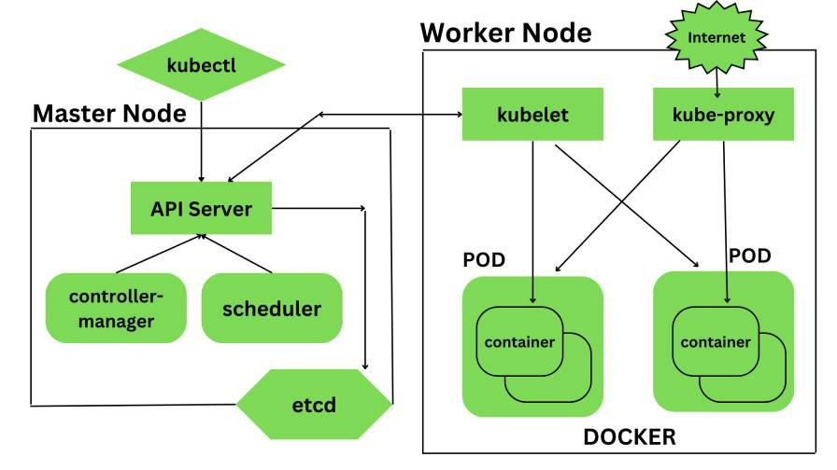

**Key components of Kubernetes**

**1. Kubernetes- Master Node Components**

API Server

Scheduler

Controller Manager

etc

**2. Kubernetes- Worker Node Components**

Kubelet

Kube-Proxy

Pods

Docker

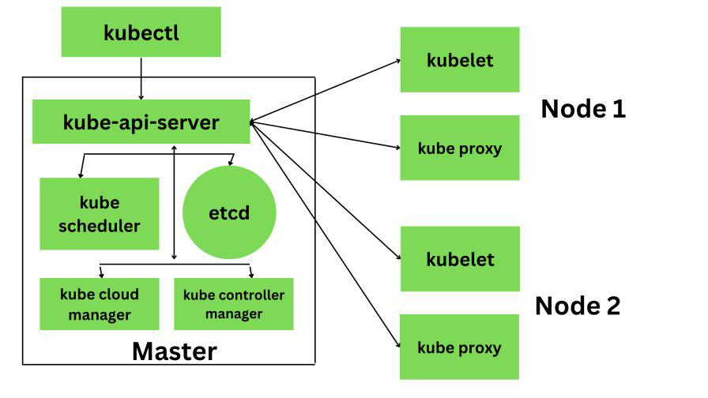

**Application of Kubernetes**

**CI/CD**

**Continuous Integration/Continuous Delivery**