New York City (NYC) Food Inspections –

Part 1

Name: Pranali Ramesh Sawant

NUID: 002724773

**Data Preparation:**

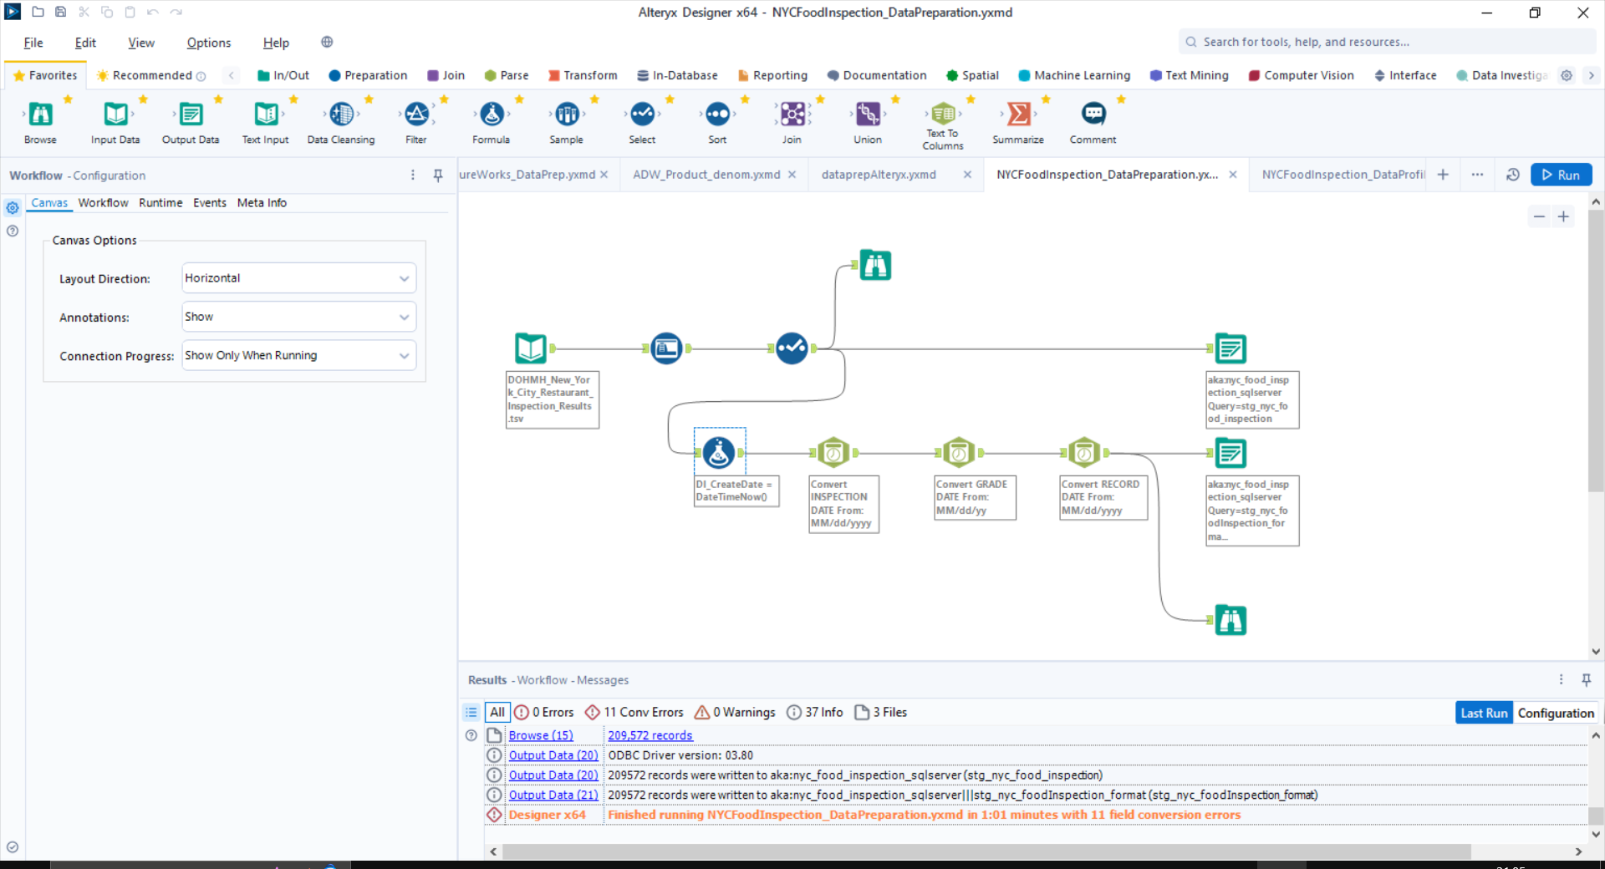

Job execution time: 1:01 mins

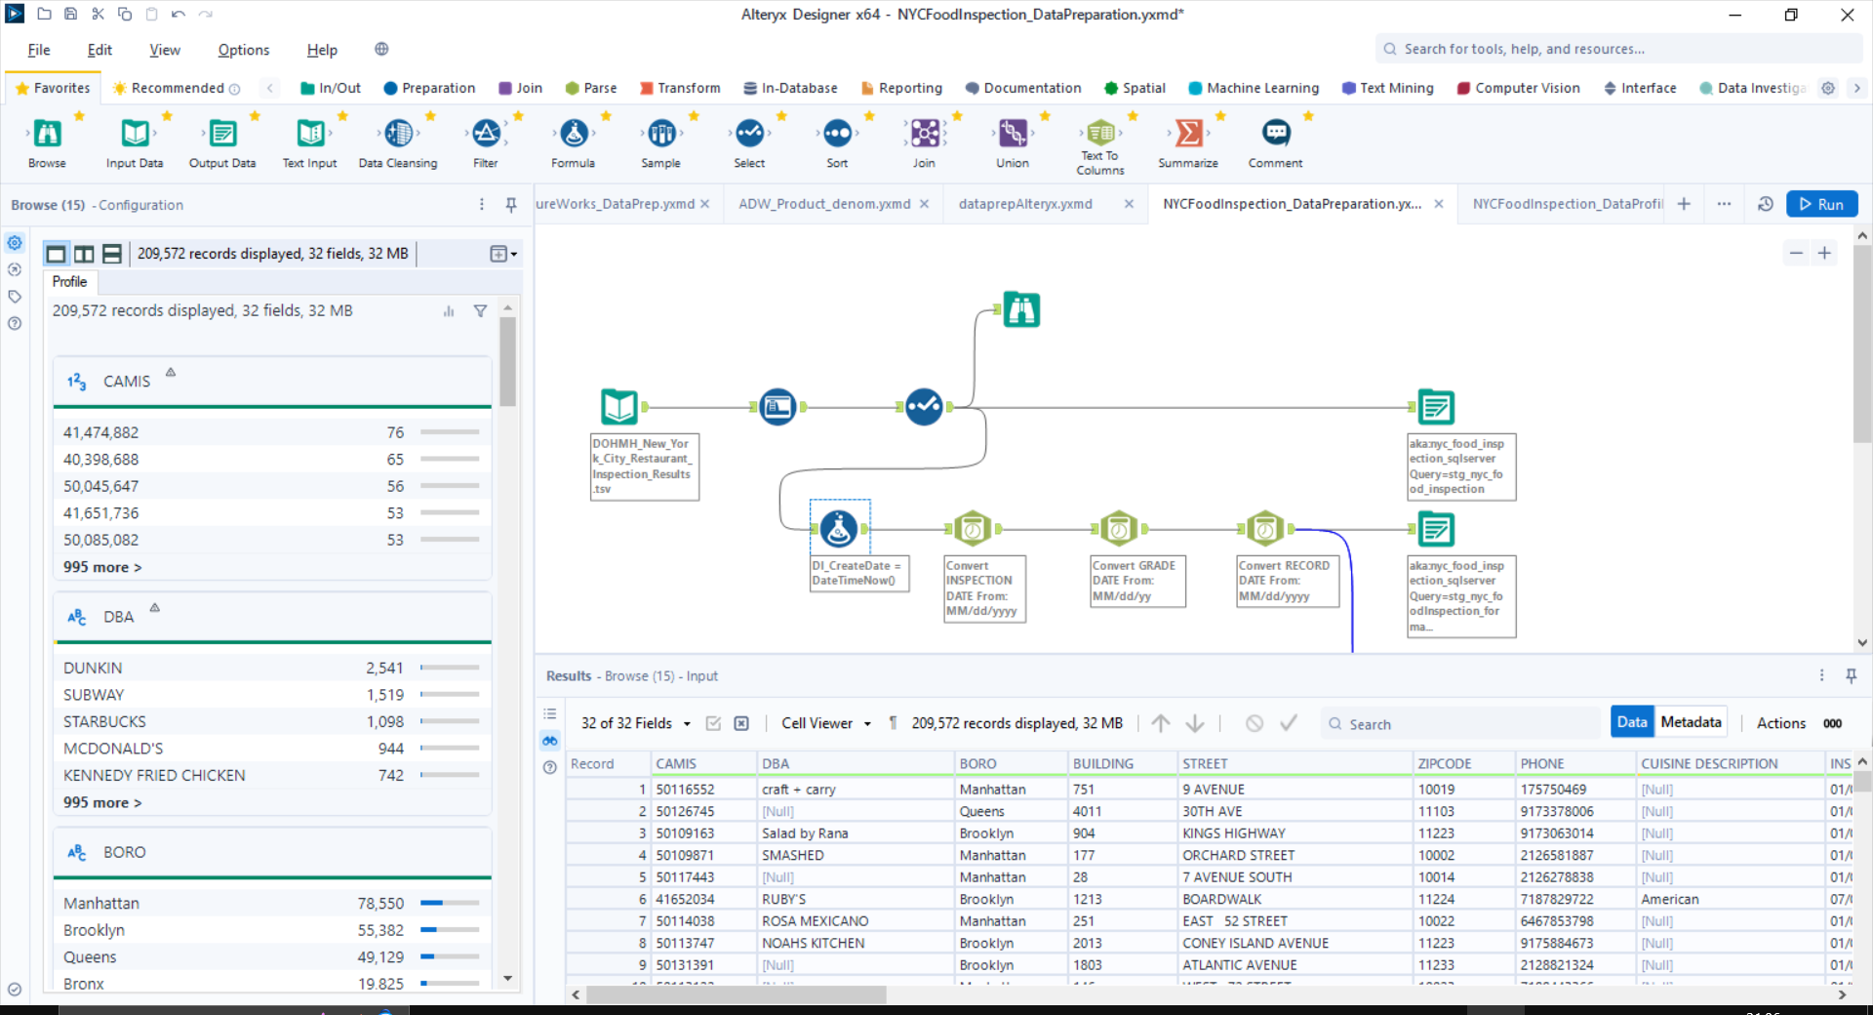

**Data Profiling:**

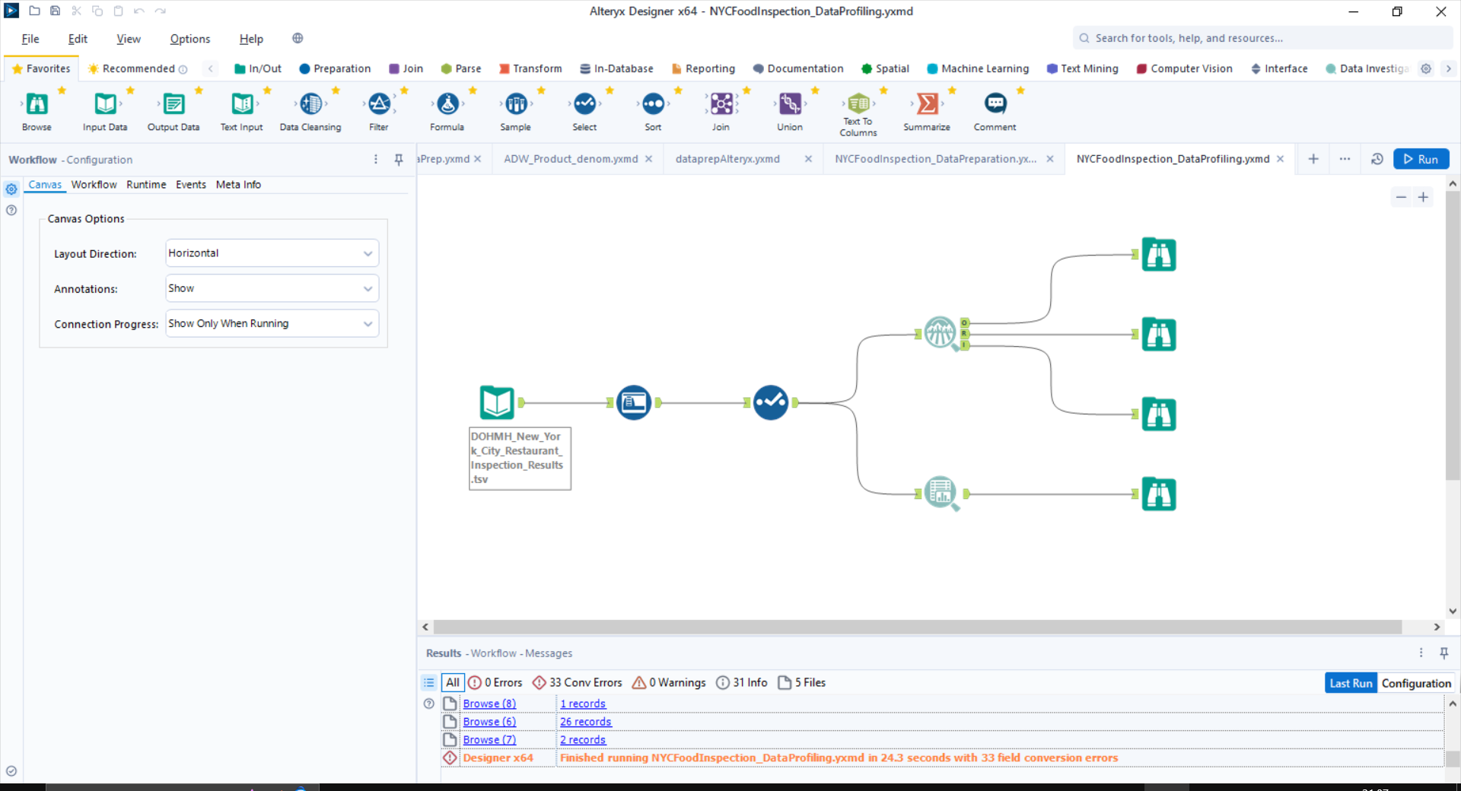

Job execution time: 24.3 seconds

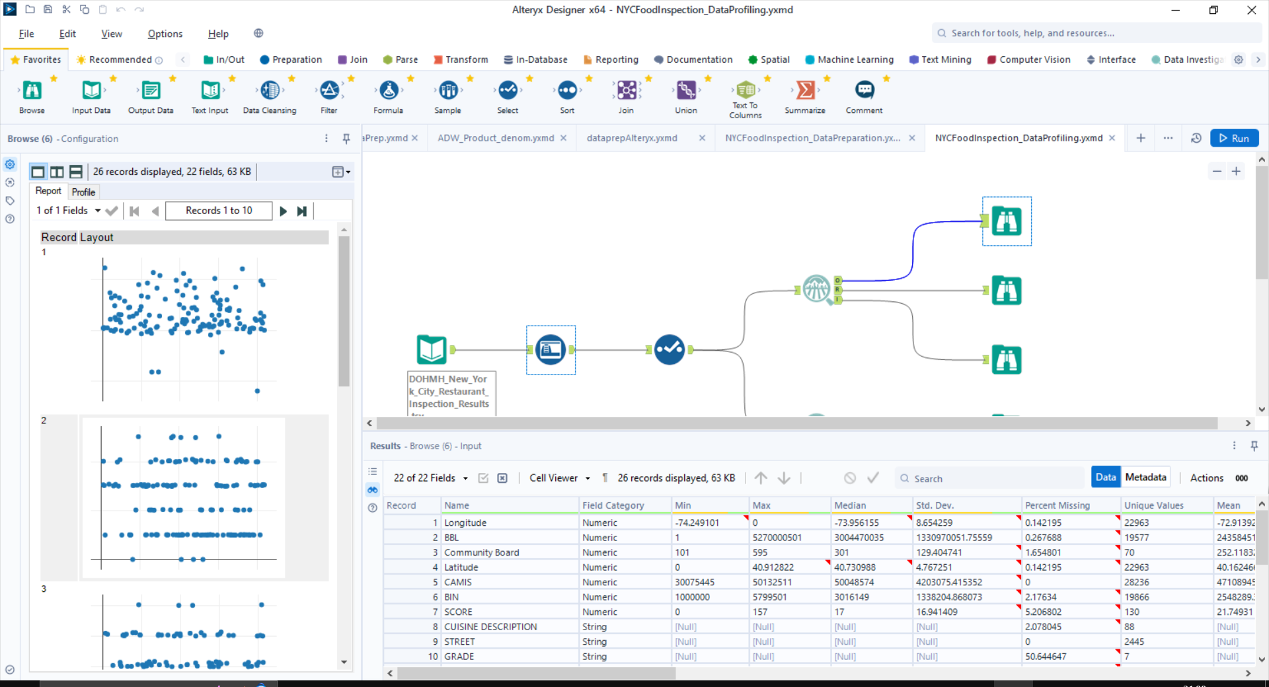

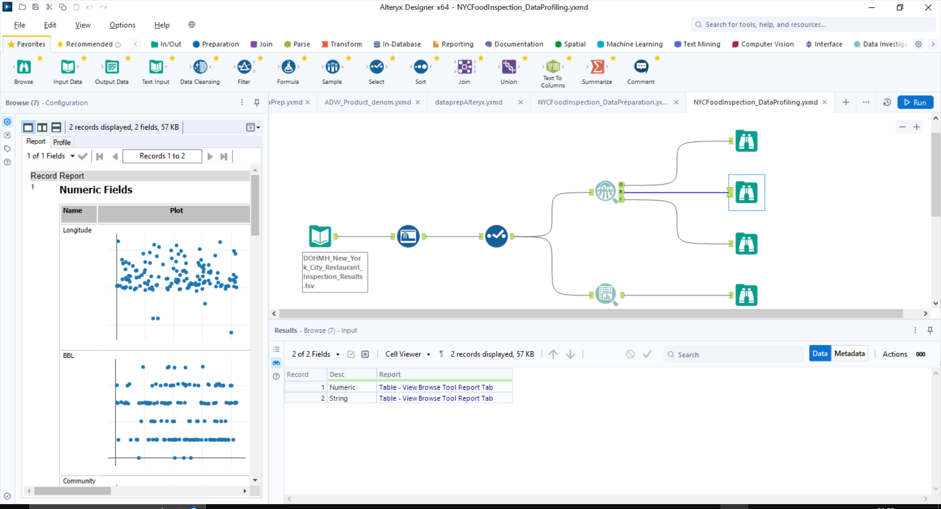

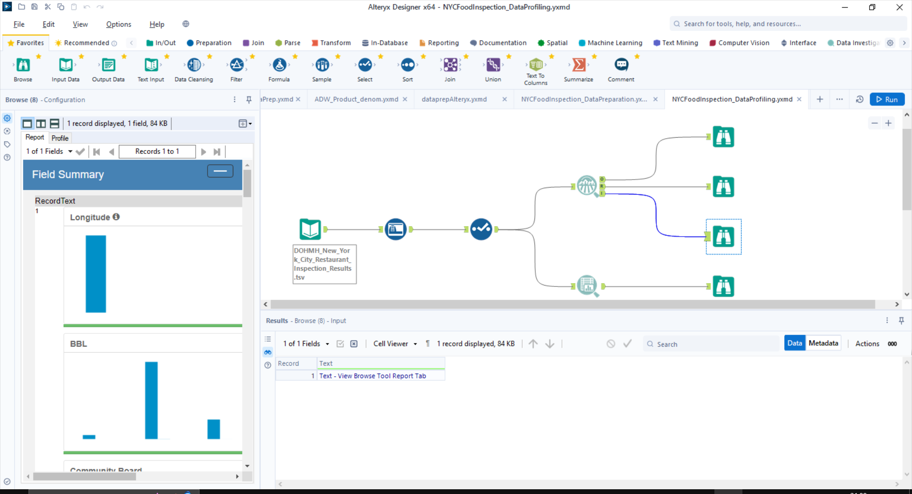

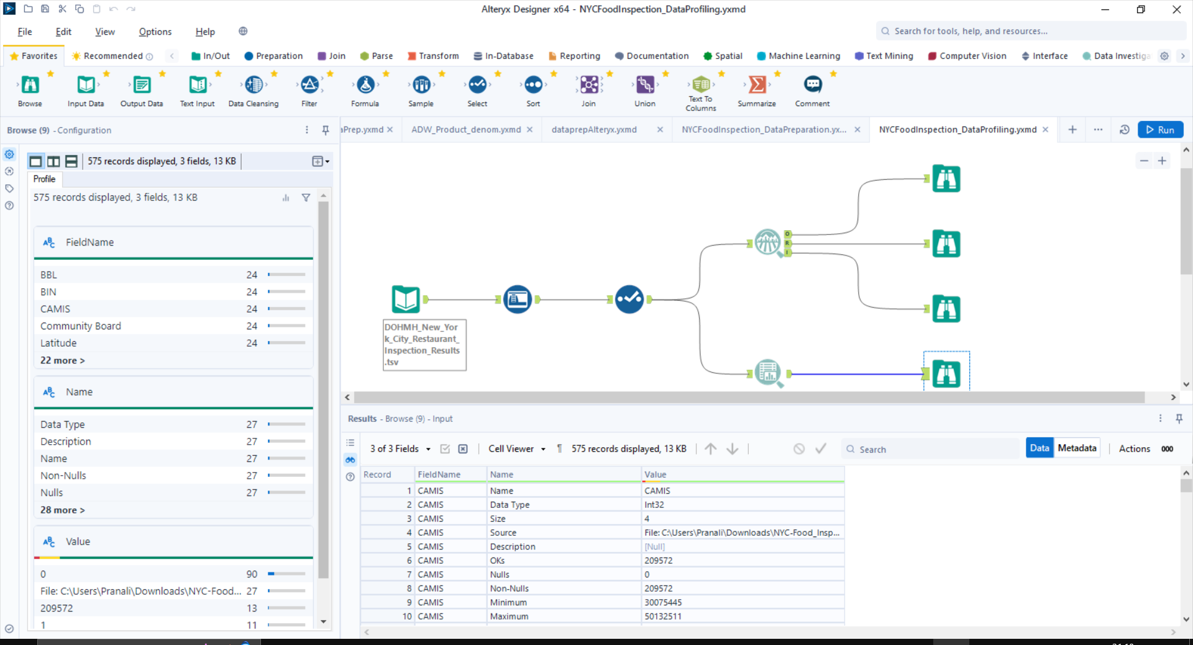

Part 2

NYC Food Inspection Dimensional Model:

**Fact Tables:**

* FactRestaurantInspection

**Dimensional Tables:**

* DimRestaurant
* DimViolation
* DimGrade
* DimInspection
* DimDate
* DimAddress

Physical Model

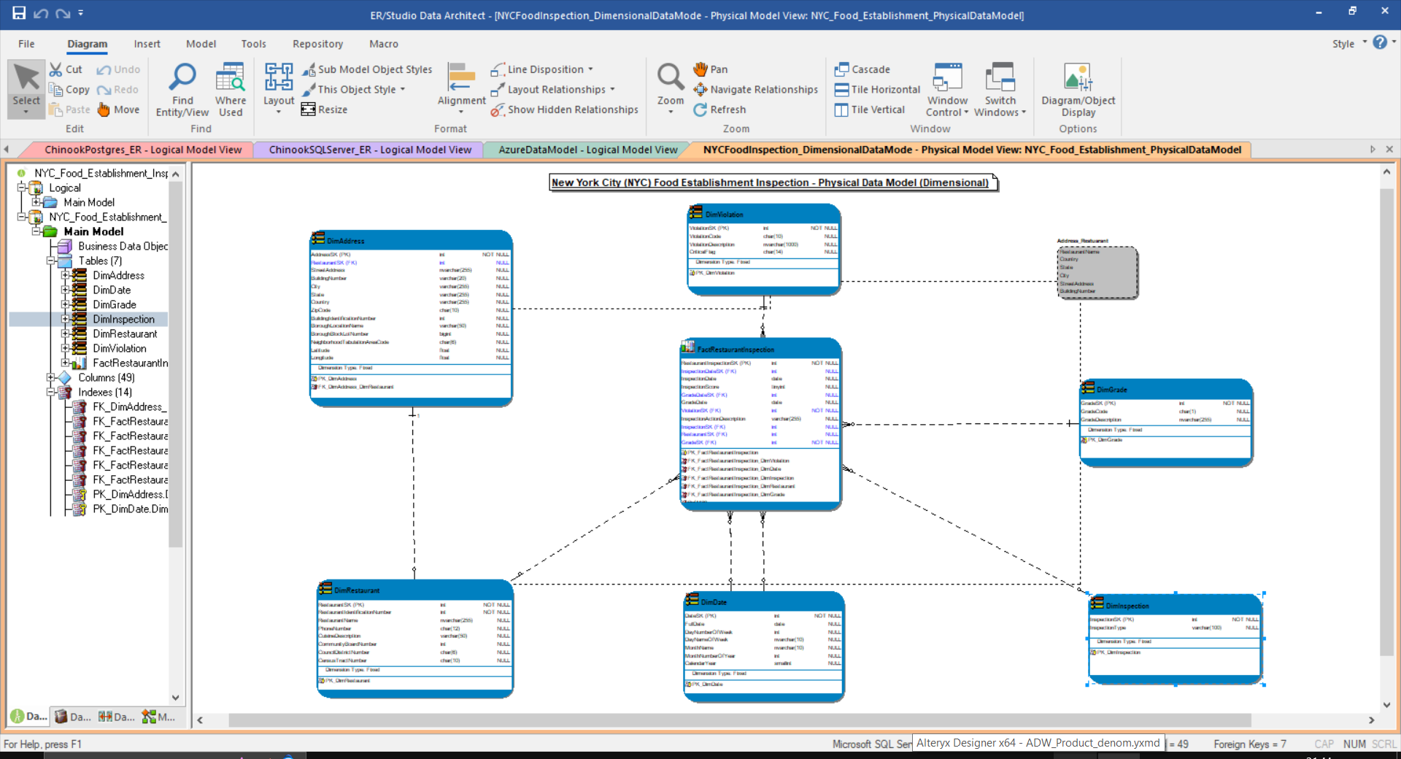

Logical Model

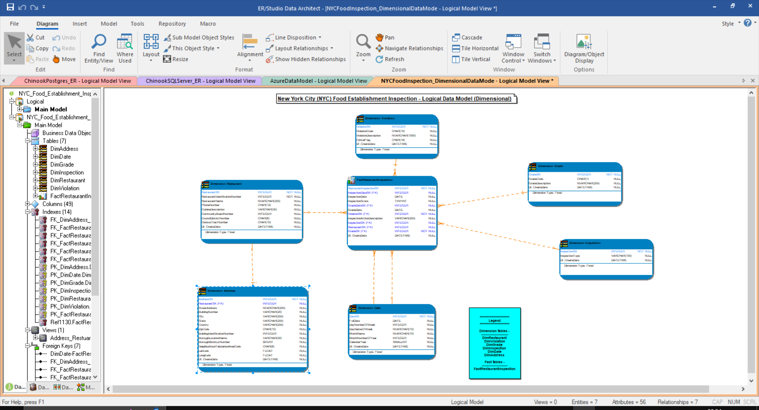

DDL Script for Dimensional Model

