Make 2 two tables Employee and Department.
CREATE DATABASE internship_db;
USE internship_db;

//Department Table
CREATE TABLE Department (
dept_id INT PRIMARY KEY,
dept_name VARCHAR(50)
);

//Employee Table
CREATE TABLE Employee (
emp_id INT PRIMARY KEY,
emp_name VARCHAR(50),
salary DECIMAL(10,2),
hire_date DATE,
dept_id INT,
FOREIGN KEY (dept_id) REFERENCES Department(dept_id)
);

// Values for department table
INSERT INTO Department VALUES
(1,'HR'),
(2,'IT'),
(3,'Finance');

// Values for Employee
INSERT INTO Employee VALUES
(101,'Pranali',50000,'2025-10-15',1),
(102,'Kajal',70000,'2025-11-20',2),
(103,'Amit',60000,'2025-12-05',2),
(104,'Sneha',80000,'2026-02-10',3),
(105,'Karan',55000,'2026-01-15',1),
(106,'Neha',90000,'2026-06-01',2),
(107,'Vikas',65000,'2026-03-12',3),
(108,'Pooja',72000,'2026-04-25',1),
(109,'Rohan',85000,'2026-05-18',2),
(110,'Anjali',58000,'2026-02-28',3),
(111,'Pranali',50000,'2025-09-10',1),
(112,'Kajal',70000,'2025-08-25',2);

//To view Deapartment Table
SELECT * FROM Department;

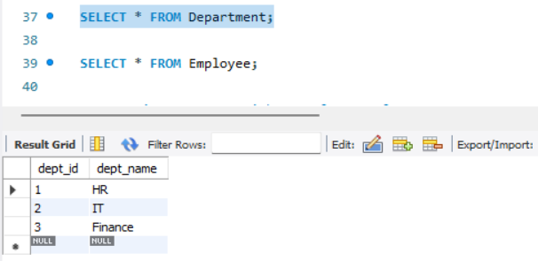

//To view Employee Table
SELECT * FROM Employee;
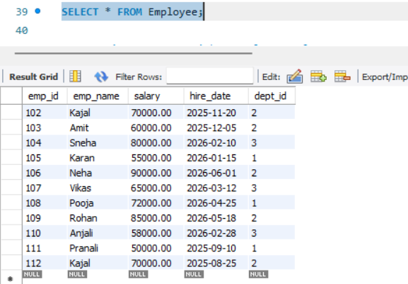

Question 1: Top 5 Highest Salary Employees
SELECT *
FROM Employee
ORDER BY salary DESC
LIMIT 5;

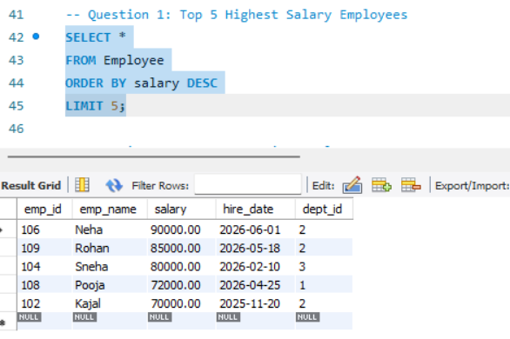
Question 2: Department Wise Employee Count
SELECT dept_id, COUNT(*) AS employee_count
FROM Employee
GROUP BY dept_id;

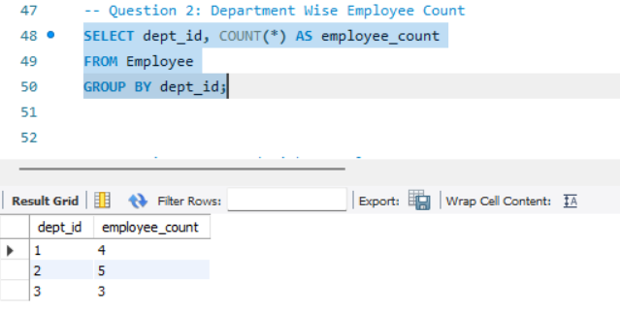

Question 3: Second Highest Salary
SELECT MAX(salary) AS second_highest_salary
FROM Employee
WHERE salary < (SELECT MAX(salary) FROM Employee);
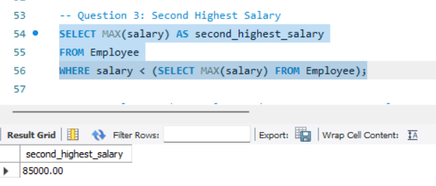

Q4. Employees whose salary > department average salary

SELECT e.*
FROM Employee e
WHERE e.salary >
(
SELECT AVG(salary)
FROM Employee
WHERE dept_id = e.dept_id
);

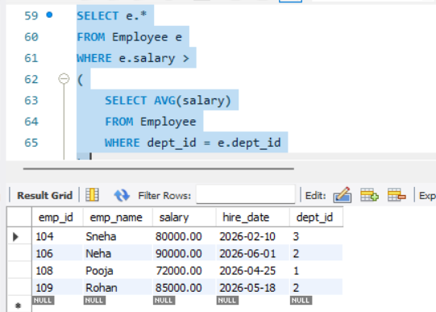

Q5. Inner Join
SELECT e.emp_id,
e.emp_name,
d.dept_name
FROM Employee e
INNER JOIN Department d
ON e.dept_id = d.dept_id;

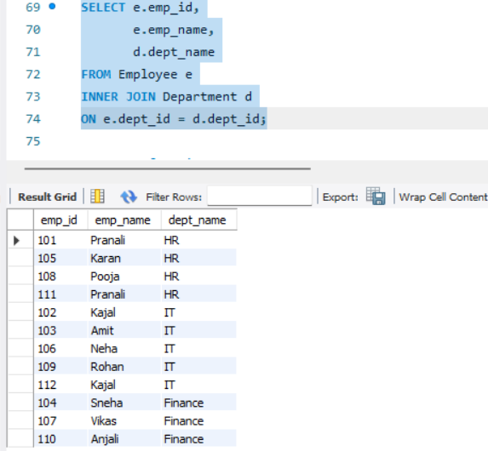

Q6. Left Join
SELECT e.emp_id,
e.emp_name,
d.dept_name
FROM Employee e
LEFT JOIN Department d
ON e.dept_id = d.dept_id;

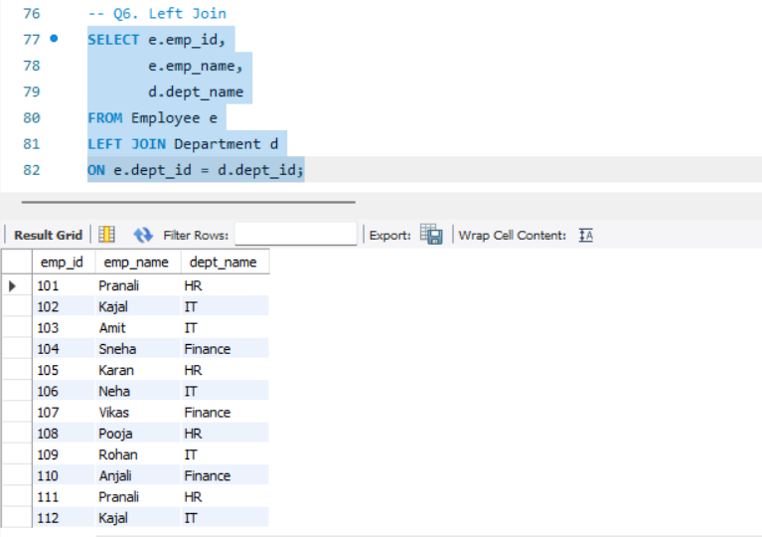

Q7. Group By with Having
SELECT dept_id,
COUNT(*) AS total_employees
FROM Employee
GROUP BY dept_id
HAVING COUNT(*) > 3;

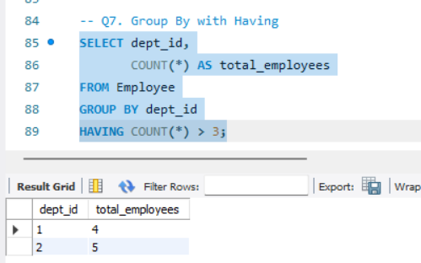

Q8. Employees hired in last 6 months
SELECT *
FROM Employee
WHERE hire_date >= DATE_SUB(CURDATE(), INTERVAL 6 MONTH);

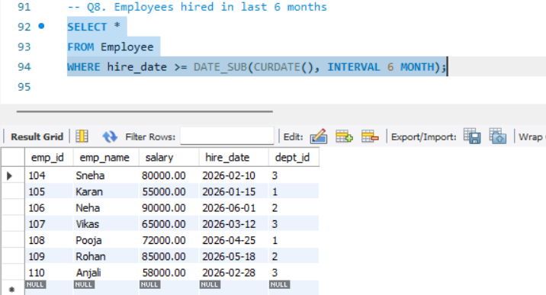

Q9. Find Duplicate Records
SELECT emp_name,
COUNT(*)
FROM Employee
GROUP BY emp_name
HAVING COUNT(*) > 1;

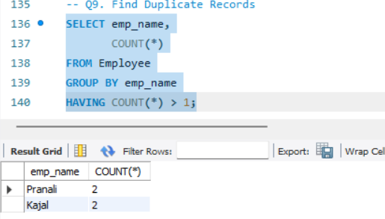

Q10. How to Remove Duplicate Records
DELETE e1
FROM Employee e1
JOIN Employee e2
ON e1.emp_name = e2.emp_name
AND e1.emp_id > e2.emp_id;

