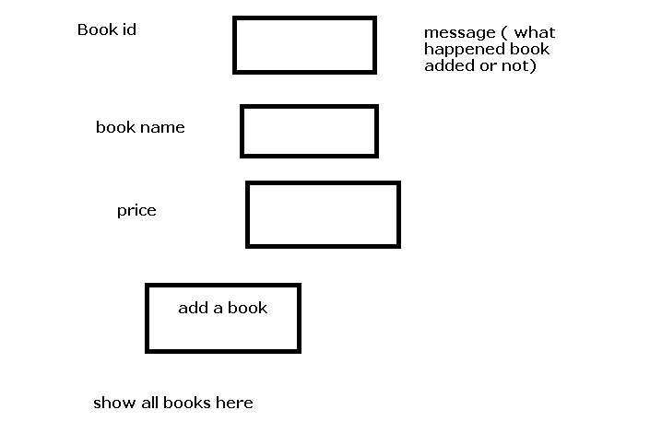

1. Create a table in mysql called book with bookid integer, bookname varchar(15) and price integer.
2. Event
   1. When we click on add a book , add details to the table by using nodejs provided bookid is not found in the table.
   2. Show a message , next to the bookid textbox
      1. Where book was added or not
3. Below add a book ensure
   1. All the books currently present in the table are shown.

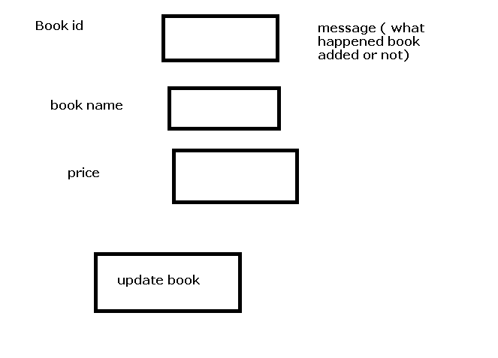

1. Create a table in mysql called book with bookid integer, bookname varchar(15) and price integer.
2. Insert some rows in the table directly in the mysql console.
3. when user types book some book id in the textbox and during the blur event ensure
   1. you contact the nodejs server and pick up the book details.
   2. In case book id is not found, show a message “bookid not found” next to the bookid textbox
   3. In case bookid is found, show a message bookid is found, next to the bookid textbox
   4. Fill the bookname and price in the bookname and price textboxes
4. Change the price of the book and click on update button
   1. Then we should go to a nodejs function which will update the price in the table.

Softwares needed.

1. Nodejs installed
2. Mysql installed they must know username, password
3. Reference zip file should be provided to them.