How data is transferred over the internet?
Every type of data sent over the internet—like web pages, WhatsApp messages, Zoom calls, emails, or file downloads follows TCP/IP model, and the OSI model is used to help us understand how data flows through a network.
There is no other method to send data over the internet.
- TCP/IP Model (4 Layers) :Used in actual implementation
- OSI Model (7 Layers) :Used for understanding and teaching

OSI MODEL LAYERS:
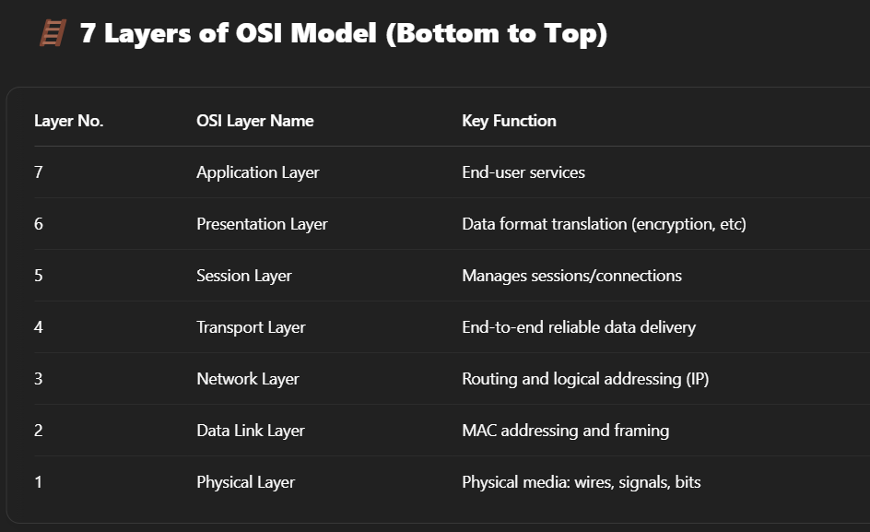
What is the TCP/IP Model?
The TCP/IP model is a 4-layer architecture that describes how data is sent and received over the internet.
How Data Transfer Happens?
Layer | Purpose | Key Protocols | What Happens
Application Layer | What data is sent | - HTTP/HTTPS (web browsing) | User types https://example.com in browser  Browser uses DNS to resolve the domain to IP
 |  | - DNS (domain resolution)
 |  | - SMTP, IMAP, POP3 (email)
 |  | - SSH (remote login)
 |  | - FTP/SFTP (file transfer)
Transport Layer | How it’s delivered | - TCP (reliable) | HTTPS data is split into segments
 |  | - UDP (fast, connectionless)
Internet Layer | Where to deliver | - IP (IPv4/IPv6) | Each TCP segment is wrapped into an IP packet  IP header contains source & destination Ips
 |  | - ICMP (ping, error)
 |  | - ARP (IP to MAC)
 |  | - IGMP (multicast)
Network Access (Link) Layer | How it travels (Physical data transmission over media | - Ethernet (wired) | Sent via Wi-Fi/cables as bits over the physical medium
 |  | - Wi-Fi (802.11)
 |  | - PPP, DSL, Fiber
 |  | - MAC addressing, framing, error detection

Does Every Data Transfer Happen via This Model- Every form of internet communication uses the TCP/IP stack

Protocols Involved in Accessing a Web Page:
Layer (TCP/IP) | Protocol | Purpose
Application Layer | DNS | Resolves domain name to IP address
 | HTTPS (HTTP + TLS) | Secure communication for web browsing
 | TLS/SSL | Encryption and authentication (within HTTPS)
Transport Layer | TCP | Reliable connection between client and server
Internet Layer | IP (IPv4/IPv6) | Every packet carries source & destination IP addresses
 | ICMP (optional) | Error reporting and diagnostics
 | ARP (on local network) | Resolves IP to MAC address
Network Access Layer | Ethernet / Wi-Fi | Data transfer over local link
 | MAC addressing | Unique physical addressing

How HTTP Work?
It’s a request-response protocol.
1. Client enter URL in browser.
2. DNS resolution: Browser resolves the domain name to an IP address using DNS.
3. TCP 3 -way Handshake- Establish connection between client and server.
SYN (Synchronize)- The client (your browser) sends a SYN message to the server.
SYN-ACK (Synchronize-Acknowledge)- The server responds with a SYN-ACK message: “I’m ready, and I acknowledge your request.”
ACK (Acknowledge) - The client replies with an ACK message, saying: “Great, connection established!”
4. The client sends an HTTP request to the server.
5. The server processes the request and sends back an HTTP response.
Problem: The entire request and response is plain text. Anyone on the network (like a hacker) can see or change it!

How HTTPS Work?
HTTPS uses asymmetric encryption — but only during the initial handshake. After that, it switches to symmetric encryption for faster data transfer.

HTTPS secures data in transit using SSL/TLS encryption, which involves a digital certificate, key exchange, and session encryption. It prevents attackers from intercepting, reading, or modifying the data.
- User Request: The user enters https://example.com in their browser.

- DNS Resolution: The browser resolves the domain example.com to an IP address (e.g., 93.184.216.34).

- TCP Connection: A TCP connection is established between the browser and the server.

- TLS Handshake: The client and server exchange keys and verify the server's certificate, establishing a secure encrypted connection.

- HTTP Request: The browser sends a secure HTTP GET request for index.html.

- Encrypted Response: The server responds with encrypted data (HTML, CSS, etc.), which is decrypted and displayed by the browser.

1. DNS Resolution (Getting the Server’s IP Address)
Just like with HTTP, the client (your browser) starts by typing a URL (e.g., https://example.com) into the address bar.

The browser uses DNS (Domain Name System) to resolve the domain name (example.com) to an IP address (e.g., 93.184.216.34).

Once the IP address is obtained, the browser can then reach the web server.

2. TCP Handshake (Establishing the Connection)
TCP (Transmission Control Protocol) is still used in HTTPS, so the process of establishing a connection begins with the TCP 3-way handshake:

SYN: The client sends a SYN (synchronize) message to the server to initiate the connection.

SYN-ACK: The server responds with SYN-ACK (synchronize-acknowledge) to acknowledge the request.

ACK: The client sends an ACK (acknowledge) message, completing the handshake. Now, the client and server can begin to communicate.

3. TLS Handshake (Establishing a Secure Connection)
Once the TCP connection is established, HTTPS uses SSL/TLS to secure the connection.

The TLS handshake occurs, and this process involves several steps:

TLS Handshake Steps:
Client Hello:

The client sends a "Hello" message, including:

Supported encryption algorithms (e.g., RSA, AES, etc.)

A randomly generated number (for session key creation).

Server Hello:

The server responds with its own "Hello" message, including:

The chosen encryption algorithm and cipher suite.

The server’s digital certificate (more on this below).

Server Certificate:

The server sends its digital certificate to the client. This certificate includes:

The server's public key.

The server's identity (e.g., example.com).

The certificate is signed by a trusted Certificate Authority (CA) to prove the server’s authenticity.

Client Verifies the Certificate:

The client verifies that the server’s certificate is valid, trusted, and hasn’t expired.

If it is valid, the client proceeds with the handshake.

Key Exchange:

Using the server’s public key (from the certificate), the client generates a shared session key (a symmetric key) for encrypting the communication.

The client then encrypts the session key with the server’s public key and sends it to the server.

Server Decrypts the Session Key:

The server decrypts the session key using its private key.

Both the client and server now have a shared session key that will be used for encrypting and decrypting all further data during the session.

Client and Server Ready:

Both parties exchange Finished messages indicating that the handshake is complete and the connection is now secure.

4. Data Encryption & Communication
After the handshake, the client and server communicate using the session key.

All data transferred between the client and server (requests, responses, and any other communication) is encrypted using the session key.

This encryption ensures that even if a hacker intercepts the data, they won't be able to read or modify it because they don't have the session key.

5. HTTP Request/Response Over Encrypted Channel
With the secure TLS connection established, the client sends its HTTP request (e.g., GET /index.html).

The server processes the request and sends back an encrypted HTTP response (e.g., the HTML content of the page).

This encrypted exchange prevents anyone from reading or tampering with the data in transit.

6. Session Termination
After the communication is complete, the session can be terminated by either the client or the server, using the TLS close_notify alert.

This step ensures that both parties agree that the session is finished, and they can discard the session keys.
- User Request: The user enters https://example.com in their browser.

- DNS Resolution: The browser resolves the domain example.com to an IP address (e.g., 93.184.216.34).

- TCP Connection: A TCP connection is established between the browser and the server.

- TLS Handshake: The client and server exchange keys and verify the server's certificate, establishing a secure encrypted connection.

- HTTP Request: The browser sends a secure HTTP GET request for index.html.

- Encrypted Response: The server responds with encrypted data (HTML, CSS, etc.), which is decrypted and displayed by the browser.

