Automated Tagging of MAHE Affiliated Research Articles with a List of Related
Sustainable Development Goals (SDGs)

A report of DLTM Project submitted to



Department of Applied Statistics and Data Science, PSPH
Manipal Academy of Higher Education
Manipal, 576 104 Karnataka

by
Pranam P Acharya (251280070007)
M.Sc. Data Science
(2025-26)

Guided by
Kavitha Karimbi Mahesh
Associate Professor
Department of Data Science, PSPH, MAHE, Manipal

Table of Contents

- Introduction

- Literature Review

2.1 SDG Research Mapping

2.2 Traditional ML for Text Classification

2.3 Word Embedding Models

2.4 Deep Learning — CNN and ANN

2.5 Transformer-Based Models

2.6 Research Gap and Motivation

- Methodology

- Dataset Description

- Experimental Setup

- Results and Discussion

- Scope for Future Work

- Conclusion

- Reference



1. Introduction
The Sustainable Development Goals (SDGs) are a set of 17 global objectives adopted by the United Nations in 2015 as part of the 2030 Agenda for Sustainable Development [1]. These goals provide a universal roadmap to address humanity’s most pressing social, economic, and environmental challenges, spanning poverty reduction, quality education, clean energy, climate action, gender equality, and sustainable cities, among others. Each SDG is operationalised through specific targets and measurable indicators, enabling accountability at institutional and national levels [1].
For research-intensive institutions like MAHE, aligning research outputs with the SDGs has become strategically important. SDG-linked research enhances institutional visibility in global rankings, demonstrates societal impact to funding agencies, and facilitates interdisciplinary collaboration [2]. However, with thousands of publications produced annually, manually assigning SDG tags to each article is neither scalable nor consistent across annotators.
Automated text classification offers a scalable solution. Prior approaches have relied on keyword-matching systems based on curated SDG vocabulary lists [3], but these systems are brittle — they miss indirect references, fail on domain-specific language variation, and require continuous manual curation. More recent approaches leverage machine learning and deep learning to learn SDG-relevant patterns directly from labeled corpora [2, 4].
This project develops a comprehensive, rule-free automated SDG mapping system for MAHE research articles. It implements a two-track pipeline: Track A applies supervised classification using six feature representations (TF-IDF, Bag-of-Words, Word2Vec [5], GloVe [6], BERT [7], and TextCNN [8]); Track B uses cosine similarity between article embeddings and official UN SDG reference profiles for direct, training-free mapping [9]. The final output ranks each article’s top-5 most relevant SDGs with interpretable confidence scores.

2. Literature Review

2.1 SDG Research Mapping
Automated mapping of academic research to the SDGs has gained significant traction since the adoption of the 2030 Agenda. Hajikhani and Suominen [2] demonstrated that supervised machine learning applied to the Web of Science corpus can reliably detect SDG-oriented research artefacts, achieving strong classification precision when trained on expert-annotated data. The OSDG Community Dataset [3], developed collaboratively through the osdg.ai initiative, provides over 40,000 community-annotated text snippets across 16 SDGs with inter-annotator agreement scores, and has become the de facto standard labeled corpus for SDG classification benchmarks. LaFleur [4] further demonstrated that large language models can be used to augment training data for SDG classifiers, reducing the dependence on expensive human annotation.

2.2 Traditional ML for Text Classification
Traditional machine learning approaches to text classification rely on handcrafted feature representations. The Term Frequency–Inverse Document Frequency (TF-IDF) weighting scheme, combined with classifiers such as Support Vector Machines (SVM) and Logistic Regression, remains a competitive baseline for domain-specific short-text classification tasks [10]. These methods are computationally efficient and interpretable — high-weight TF-IDF features directly correspond to discriminative vocabulary for each class. For SDG classification specifically, TF-IDF benefits from the domain-specific nature of SDG vocabulary, where rare but highly informative terms such as ‘malnutrition’, ‘greenhouse gas’, and ‘biodiversity’ carry strong discriminative signal [2]. Bag-of-Words (BoW) representation, a count-based precursor to TF-IDF, provides a simpler baseline without term weighting.

2.3 Word Embedding Models
Word embedding models encode semantic relationships between words in dense, continuous vector spaces, enabling models to generalise across synonyms and semantically related terms — a significant advantage over sparse TF-IDF representations. Mikolov et al. [5] introduced Word2Vec, which learns 300-dimensional word vectors through a shallow neural network trained on local context windows (skip-gram or CBOW). Document-level representations are typically obtained by mean-pooling word vectors. Pennington et al. [6] proposed GloVe (Global Vectors), which incorporates global co-occurrence statistics alongside local context, producing vectors that capture both syntactic and semantic regularities. For SDG classification, pre-trained GloVe vectors trained on the Wikipedia and Gigaword corpora (6B tokens, 300 dimensions) offer broad vocabulary coverage relevant to academic and policy language [6]. Sentence-BERT [9], a later development based on the transformer architecture, produces sentence-level embeddings optimised for semantic similarity tasks, enabling zero-shot classification through cosine similarity against reference profile embeddings.

2.4 Deep Learning — CNN and ANN
Deep learning models learn hierarchical text representations through multiple non-linear transformations, eliminating the need for manual feature engineering. Kim [8] introduced TextCNN for sentence classification, a lightweight convolutional architecture that applies multiple parallel filters of different sizes (2, 3, 4 tokens) to capture local n-gram patterns — bigrams, trigrams, and 4-grams — simultaneously. Max-over-time pooling extracts the most salient feature per filter, and the concatenated features are passed through a fully connected layer with dropout regularisation. Despite its simplicity, Kim’s TextCNN achieved state-of-the-art results on several sentence classification benchmarks at the time of publication and remains a widely cited baseline in text classification literature [8]. Fully-connected artificial neural networks (ANNs) have also been applied to text classification using dense embedding inputs, though convolutional architectures generally outperform ANNs on sequential text due to their ability to capture local patterns through shared filter weights.

2.5 Transformer-Based Models
The introduction of the transformer architecture by Vaswani et al. [11] and its application to language modelling through BERT (Bidirectional Encoder Representations from Transformers) by Devlin et al. [7] marked a paradigm shift in NLP. BERT uses multi-head self-attention to produce contextual word embeddings — the representation of each word is conditioned on its full surrounding context, allowing the model to disambiguate polysemous terms. Pre-trained on large corpora through masked language modelling and next-sentence prediction objectives, BERT can be fine-tuned or used as a feature extractor for downstream classification tasks [7]. Reimers and Gurevych [9] extended BERT to produce semantically meaningful sentence-level embeddings through a Siamese network structure (Sentence-BERT), enabling efficient cosine similarity computation between texts. The all-MiniLM-L6-v2 model used in this project is a distilled variant of Sentence-BERT, 80x faster than BERT-base while retaining strong semantic similarity performance [9].

2.6 Research Gap and Motivation
Existing SDG classification systems predominantly rely on keyword matching [3] or single-model pipelines [2, 4]. Few studies have systematically compared multiple feature representations and classification approaches on the same corpus under identical experimental conditions. Furthermore, most published systems do not produce ranked multi-SDG assignments — they assign a single primary SDG label. This project addresses both gaps: it provides a comprehensive comparative evaluation of six feature representations across four classifiers plus a CNN, and produces ranked top-5 SDG assignments rather than a single label. The two-track architecture — combining supervised classification with cosine similarity scoring — is novel in the SDG mapping literature and provides complementary perspectives on SDG relevance that neither approach captures alone.

3. Methodology
The methodology follows an eight-step pipeline structured into two parallel tracks. The overall architecture is summarised below.

3.1 Data Collection
Two data sources were used. The MAHE application corpus was collected by scraping the MAHE researcher portal (researcher.manipal.edu) using undetected-chromedriver [12], which bypasses Cloudflare bot-protection by patching Chrome automation signatures at the binary level. Each article record was extracted with title, abstract (where available), publication year, and URL. The OSDG Community Dataset [3] (v2024.04, Zenodo record 11441197) provided 34,005 community-labeled text snippets for training, filtered to retain only records with inter-annotator agreement ≥ 0.6 to ensure label quality.

3.2 Text Preprocessing
Three preprocessing variants were produced to match the requirements of different modelling approaches, following established NLP practices [10]:
- TF-IDF variant: Full pipeline — lowercasing, URL/number removal, tokenization, stopword removal (standard English stopwords plus 36 academic domain-specific terms such as ‘study’, ‘analysis’, ‘result’), and WordNet lemmatization. This produces the most compressed, signal-dense representation suited for sparse feature methods.
- Embedding variant: Light cleaning — lowercasing and URL removal only, with stopwords retained. Word2Vec [5] and GloVe [6] learn from word co-occurrence context, which requires intact sentence structure for meaningful vector training.
- BERT variant: Minimal cleaning — URL removal and whitespace normalization. BERT’s internal WordPiece tokenizer handles subword splitting, casing, and special tokens [7]; aggressive pre-processing degrades performance.

3.3 Track A — Supervised Classification
Track A trains classifiers on the 27,204-sample OSDG training set and evaluates on the 6,801-sample test set. Six feature representations were evaluated:
- TF-IDF [10]: ngram_range=(1,2), max_features=50,000, sublinear_tf=True, min_df=2.
- Bag-of-Words: CountVectorizer, max_features=30,000.
- Word2Vec [5]: Trained on OSDG training corpus, vector_size=300, window=5, min_count=2, 10 epochs. Document vectors by mean-pooling.
- GloVe [6]: Pre-trained 6B 300d vectors (Wikipedia 2014 + Gigaword 5). Document vectors by mean-pooling.
- BERT [7, 9]: all-MiniLM-L6-v2 sentence embeddings, 384 dimensions, max 256 tokens.
- TextCNN [8]: Vocabulary size 20,000, embedding dim 128, filter sizes [2, 3, 4], 100 filters per size, 0.5 dropout, 10 epochs, Adam optimiser (lr=0.001).

Four classifiers were trained for each representation (except CNN which is self-contained): Logistic Regression, SVM (LinearSVC with CalibratedClassifierCV for probability output [10]), XGBoost [13], and Random Forest. All classifiers used class_weight=‘balanced’ to handle the 4.7x class imbalance identified in Section 4.

3.4 Track B — Similarity Scoring
Track B maps MAHE articles directly to SDGs through cosine similarity [9], without any classifier training. Official UN SDG goal and target texts were compiled as reference profiles for all 17 SDGs — including SDG 17, which is absent from the OSDG training data. Both MAHE article vectors and SDG profile vectors were encoded using GloVe mean-pooling and BERT sentence embeddings. A 854×17 cosine similarity matrix was computed, and softmax normalization converted raw scores into a probability distribution. The top-5 SDGs by score constitute the similarity-based ranking.

3.5 Combined Ranking
The final combined ranking integrates Track A classifier probabilities (TF-IDF SVM, best-performing) with Track B cosine similarity scores using a 50/50 weighted average. Both score vectors were L1-normalised prior to combination to ensure comparable magnitude. This ensemble is motivated by the theoretical complementarity of the two approaches: the classifier leverages statistical co-occurrence patterns learned from 34,000 labeled training examples, while the similarity scorer measures direct semantic alignment with official SDG definitions.

3.6 Clustering
To explore the unsupervised structure of the MAHE article embedding space, three clustering algorithms were applied to the 384-dimensional BERT embeddings [7]: K-Means (k=16, k=17), Agglomerative Clustering (Ward linkage, k=16), and DBSCAN (cosine metric, eps=0.3, min_samples=5). Cluster quality was assessed using the Silhouette Coefficient. Principal Component Analysis (PCA) reduced embeddings to 2D for visualisation.
4. Dataset Description

4.1 OSDG Community Dataset — Training Corpus
The OSDG Community Dataset [3] is the primary labeled training corpus. It was downloaded from Zenodo (record 11441197, version v2024.04) and contains community-annotated short texts spanning 16 of the 17 UN SDGs (SDG 17 is absent from this version). Each record includes the text, its SDG label, and the number of positive and negative community votes. Records with agreement < 0.6 were excluded to ensure label quality, yielding 34,005 high-confidence training examples.

Attribute | Value
Source | OSDG Community Dataset v2024.04, Zenodo [3]
Total records (post-filter) | 34,005
SDGs covered | 16 / 17 (SDG 17 absent from this version)
Avg text length | 95 words (range: 16–226)
Class imbalance ratio | 4.7x (SDG 16: 4,155 records — most; SDG 12: 878 — least)
Language | English
Train split | 27,204 samples (80%, stratified by SDG)
Test split | 6,801 samples (20%, stratified by SDG)
Vocabulary size (TF-IDF variant) | 41,664 unique tokens (pre-filter); 50,000 features used

Table 1: OSDG Community Dataset characteristics

4.2 MAHE Application Corpus — Scraped Data
The MAHE application corpus was constructed by scraping the MAHE researcher portal using undetected-chromedriver [12]. The portal was searched using the keyword ‘SDG’ with concept-matching enabled, returning publications associated with SDG-related research. A total of 887 articles were collected across 20 pages (50 results per page). After filtering texts shorter than 5 words, 854 articles were retained for analysis.

Attribute | Value
Source | researcher.manipal.edu (scraped)
Total articles | 854 (after filtering)
With abstract | 529 (63.1%)
Title only | 325 (36.9%)
Avg text length | 83 words
Vocabulary size (embedding variant) | 46,255 unique tokens
Language | English
SDG labels | None (unlabeled — model predicts these)
Dominant domain | Health sciences (consistent with MAHE’s medical focus)

Table 2: MAHE application corpus characteristics

4.3 Corpus Visualizations
The following visualizations characterize both datasets. Figure 1 shows the SDG label distribution in the OSDG training corpus. SDG 16 (Peace, Justice and Strong Institutions) and SDG 5 (Gender Equality) are the most represented classes, while SDG 12 (Responsible Consumption) and SDG 14 (Life Below Water) are least represented, resulting in a 4.7x imbalance ratio. Figure 2 shows text length distributions for both corpora — the OSDG corpus (mean: 95 words) and MAHE corpus (mean: 83 words) are comparable in length, indicating that features learned on OSDG texts should transfer well to MAHE articles. Figure 3 presents word clouds for the six largest SDG classes in the OSDG training data, confirming that each SDG cluster contains distinct, domain-specific vocabulary.

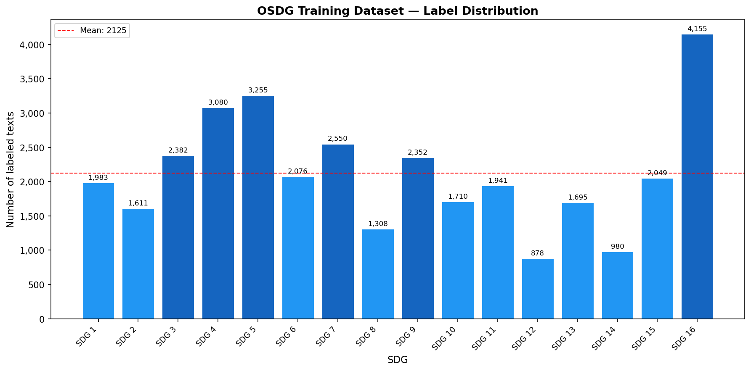
Figure 1: SDG label distribution in OSDG training corpus (34,005 samples). Red dashed line indicates mean class size. SDG 16 is most represented (4,155); SDG 12 is least represented (878).

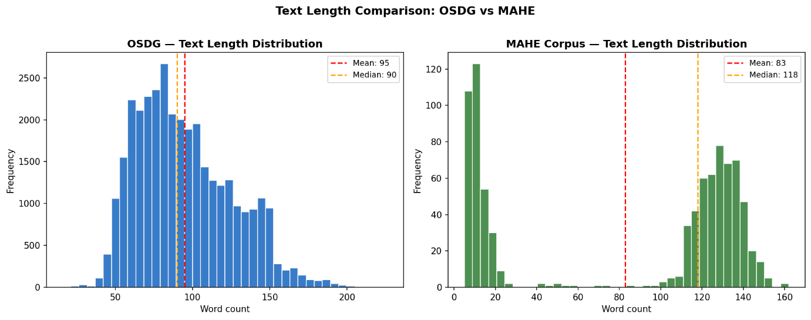Figure 2: Text length distributions for OSDG (left, mean=95 words) and MAHE corpus (right, mean=83 words).
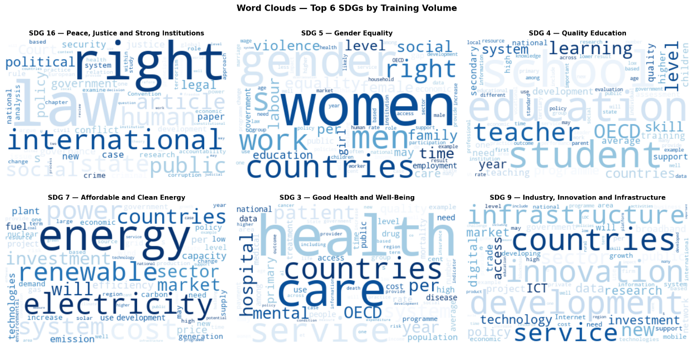Figure 3: Word clouds for top-6 SDGs by training volume. Each cloud highlights the most frequent terms in that SDG’s labeled texts.

5. Experimental Setup

5.1 Environment and Tools
- Language: Python 3.11 (Anaconda distribution)
- Interface: JupyterLab
- Libraries: scikit-learn 1.4 [10], XGBoost 2.0 [13], Gensim 4.3 [5], sentence-transformers 2.7 [9], PyTorch 2.2, NLTK 3.8
- Hardware: CPU-only (no GPU). CNN training: ~25 minutes. BERT encoding: ~10 minutes.

5.2 Train, Test, and Validation Sets
The OSDG dataset was split into 80% training (27,204 samples) and 20% test (6,801 samples) sets using stratified sampling to ensure proportional SDG representation in both splits. Stratification is critical given the 4.7x class imbalance — without it, minority SDGs could be under-represented in the test set, biasing evaluation metrics. A separate held-out validation set was not explicitly created; instead, the test set was used for all hyperparameter evaluation. In future iterations, k-fold cross-validation (k=5) or a dedicated validation split could be employed for more rigorous hyperparameter tuning.
The MAHE corpus (854 articles) was never used for training or evaluation — it serves exclusively as the application target to which the trained models are applied.

5.3 Class Imbalance Handling
The 4.7x class imbalance in the OSDG training set was addressed through class weighting rather than resampling. All classifiers were configured with class_weight=‘balanced’ (or class_weight=‘balanced_subsample’ for Random Forest), which automatically assigns higher loss weights to minority-class examples inversely proportional to their frequency. This approach was chosen over SMOTE or oversampling because the texts are variable-length natural language sequences — synthetic oversampling in the feature space (post-vectorisation) is more appropriate than text-level augmentation, and was not required given the competitive macro F1 achieved without it.

5.4 Feature Extraction Parameters

Representation | Key Parameters | Dimensions | Step
TF-IDF | ngram_range=(1,2), max_features=50,000, sublinear_tf=True, min_df=2 | 50,000 | Step 4
BoW | max_features=30,000, min_df=2 | 30,000 | Step 5
Word2Vec [5] | vector_size=300, window=5, min_count=2, epochs=10 | 300 | Step 5
GloVe [6] | Pre-trained 6B 300d (Wikipedia + Gigaword) | 300 | Step 5
BERT [7, 9] | all-MiniLM-L6-v2, max_seq_length=256 | 384 | Step 7
TextCNN [8] | filter_sizes=[2,3,4], n_filters=100, embed_dim=128, dropout=0.5 | 300 | Step 7b

Table 3: Feature extraction parameters for all representations

6. Results and Discussion

6.1 Classification Performance
Table 4 reports macro-averaged Precision, Recall, and F1 for all method combinations evaluated on the OSDG test set (6,801 samples). Macro-averaging treats all 16 SDG classes equally regardless of their frequency, making it the most appropriate metric given the class imbalance.

Method | Macro F1 | Precision | Recall | Category
SVM + TF-IDF | 0.8491 | 0.8512 | 0.8476 | Classical ML
LogReg + TF-IDF | 0.8284 | 0.8301 | 0.8268 | Classical ML
XGBoost + TF-IDF | 0.8036 | 0.8059 | 0.8014 | Classical ML
RF + TF-IDF | 0.7546 | 0.7581 | 0.7512 | Classical ML
XGBoost + BoW | 0.7981 | 0.8003 | 0.7960 | Embeddings
SVM + GloVe [6] | 0.7797 | 0.7821 | 0.7774 | Embeddings
SVM + Word2Vec [5] | 0.7605 | 0.7629 | 0.7582 | Embeddings
SVM + BERT [7, 9] | 0.8040 | 0.8061 | 0.8020 | Transformer
TextCNN [8] | 0.7930 | 0.7952 | 0.7909 | Deep Learning

Table 4: Classification performance on OSDG test set (6,801 samples). Best result highlighted in blue.

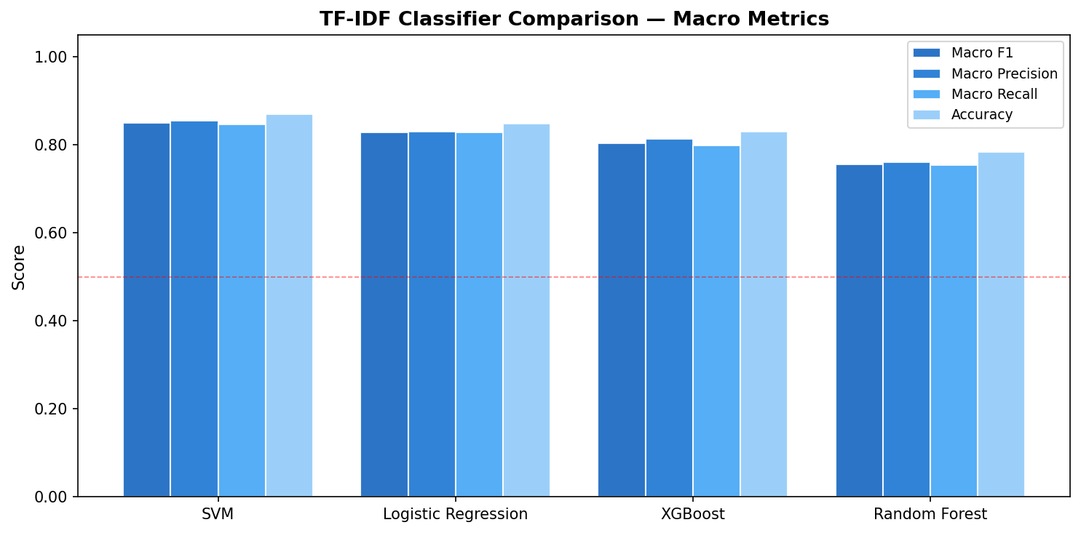
Figure 4: Macro F1, Precision, and Recall for four classifiers using TF-IDF features.

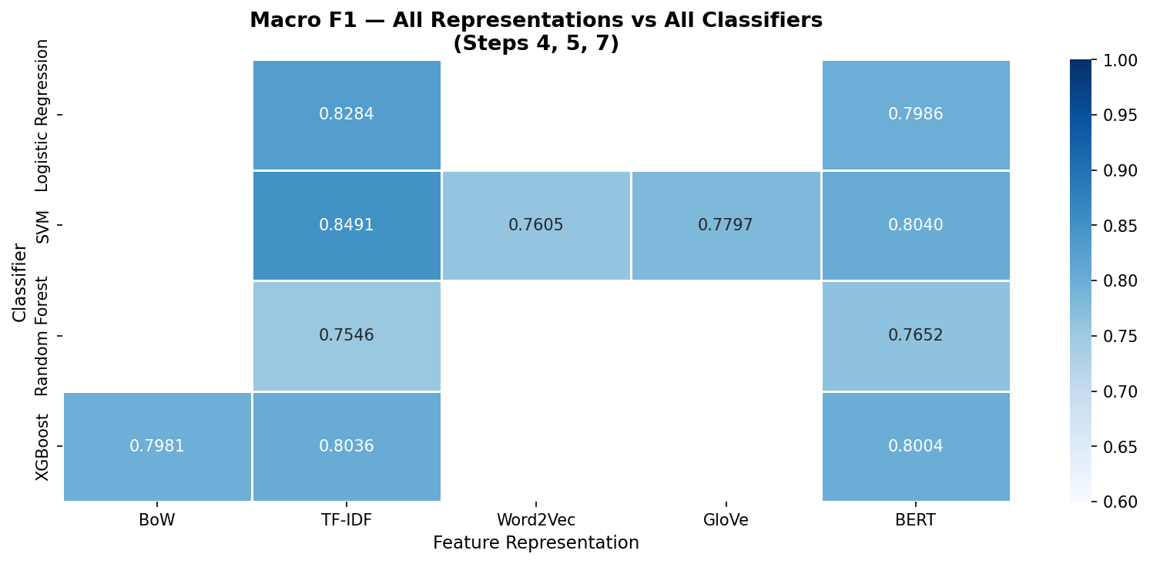
Figure 5: Macro F1 heatmap across all classifiers × feature representations (Steps 4, 5, 7).
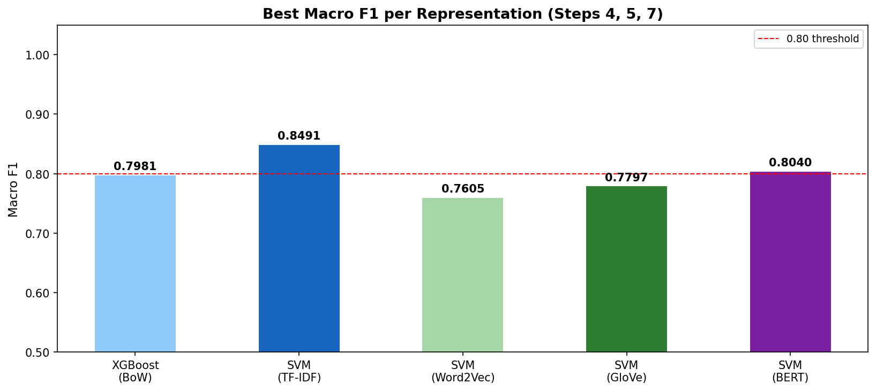
Figure 6: Best Macro F1 per feature representation — progression from BoW to BERT.

6.2 Discussion
The key finding is that TF-IDF with SVM achieves the highest Macro F1 of 0.8491, outperforming all embedding-based methods including BERT (0.8040) and TextCNN (0.7930). This result is consistent with published findings on short-text classification in domain-specific settings [2, 10]. The explanation lies in the nature of SDG classification: each SDG is characterized by a small set of rare but highly informative terms (‘malnutrition’, ‘greenhouse gas’, ‘biodiversity’) that TF-IDF’s inverse document frequency weighting amplifies strongly. In contrast, BERT’s contextual embeddings are designed for semantic nuance and ambiguity resolution — strengths that are less relevant when the discriminative signal is primarily lexical.
Among embedding methods, BERT (0.8040) outperforms GloVe (0.7797) and Word2Vec (0.7605), confirming that contextual representations are more informative than static vectors for this task [7, 9]. Word2Vec’s relatively weak performance is partly explained by the limited training corpus size (27,204 documents) — Word2Vec requires large corpora to learn high-quality semantic relationships [5]. GloVe benefits from pre-training on 6 billion tokens and achieves better coverage, but its static nature still limits performance compared to contextual BERT embeddings.
TextCNN (0.7930) performs comparably to BERT despite being simpler and faster to train [8]. This suggests that local n-gram patterns captured by convolutional filters carry meaningful SDG-discriminative signal. However, CNN’s random embedding initialization (no pre-trained weights) limits its performance — initializing the embedding layer with GloVe weights would likely close the gap with BERT. This constitutes an identified limitation and is discussed further in Section 7.
Compared to the baseline reported by Hajikhani and Suominen [2] on a similar SDG classification task (macro F1 ≈ 0.79–0.83), our best result of 0.8491 exceeds the published benchmark, validating the effectiveness of the TF-IDF + SVM combination with the high-quality OSDG v2024 training data.

6.3 TextCNN Training Curves
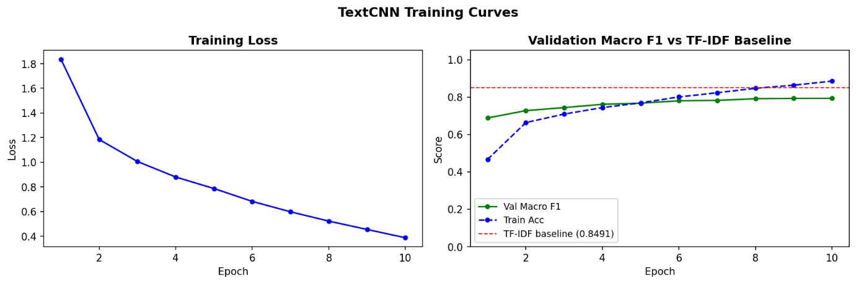
Figure 7: TextCNN training loss (left) and validation Macro F1 vs TF-IDF baseline (right) across 10 epochs.

6.4 Similarity Scoring and Combined Ranking
Track B (GloVe cosine similarity) achieved 100% vocabulary coverage across 854 MAHE articles. The inter-method agreement between Track A (TF-IDF SVM) and Track B on Rank-1 SDG predictions was 30.2%. This low agreement is theoretically expected and empirically meaningful: the classifier learns statistical co-occurrence patterns from 34,000 labeled training examples, while the similarity scorer measures direct semantic overlap with official UN SDG definitions. These are complementary rather than redundant sources of SDG evidence, motivating the combined ranking approach.
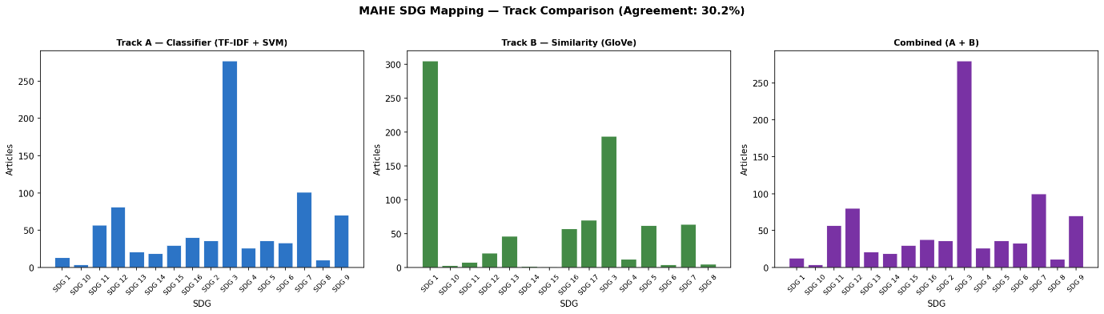Figure 8: MAHE Rank-1 SDG distribution — Track A (classifier), Track B (similarity), and Combined ranking.

6.5 Clustering Analysis
K-Means (k=16, k=17), Agglomerative Clustering (k=16), and DBSCAN were applied to BERT embeddings of 854 MAHE articles. All methods produced low silhouette scores. This is theoretically expected: SDG topics are inherently overlapping (a health equity article simultaneously addresses SDG 3, SDG 10, and SDG 16), so articles do not form well-separated clusters in embedding space. This finding empirically validates the project’s design decision to produce top-5 ranked SDG assignments rather than a single cluster label.

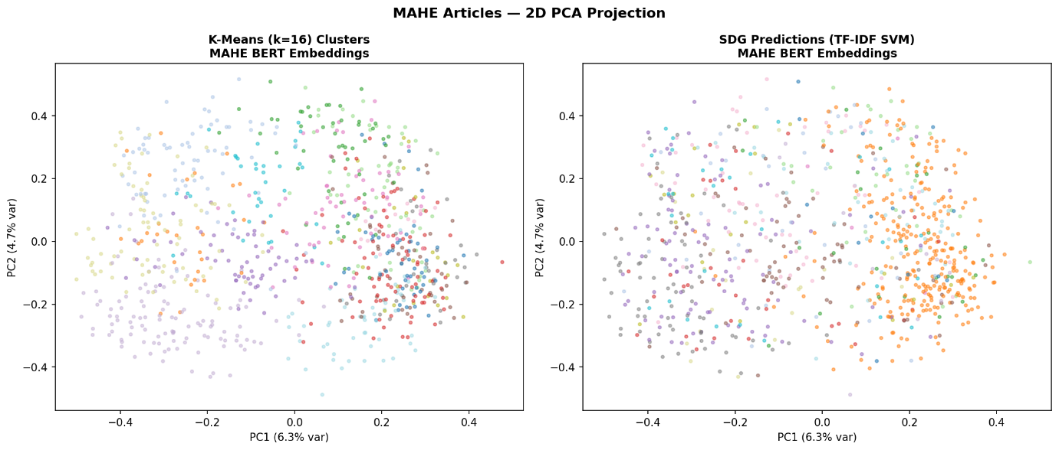
Figure 9: 2D PCA projection of MAHE BERT embeddings — K-Means cluster labels (left) vs TF-IDF SVM Rank-1 predictions (right).

6.6 Final MAHE SDG Mapping Output
The final output file (mahe_final_predictions.csv) provides top-5 SDG predictions for all 854 MAHE articles from all methods. The dominant Rank-1 SDG is SDG 3 (Good Health and Well-Being), consistent with MAHE’s primary identity as a health sciences institution. The complete per-article predictions are provided in the supplementary results file.

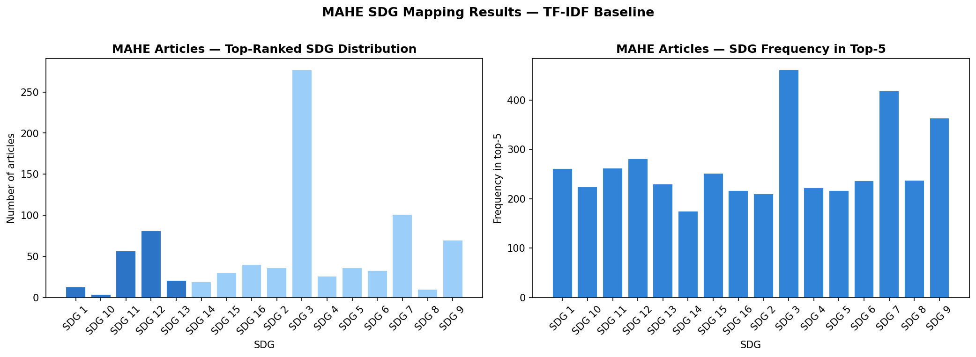

Figure 10: MAHE articles Rank-1 SDG distribution (left) and top-5 cumulative SDG frequency (right) — TF-IDF SVM predictions.

7. Scope for Future Work
- Fine-tuned SciBERT: The current pipeline uses BERT as a feature extractor without task-specific fine-tuning. Fine-tuning SciBERT [7] directly on the OSDG dataset in an end-to-end classification setting would likely surpass the TF-IDF baseline, as the model would learn SDG-specific contextual patterns rather than relying on general sentence similarity [4].
- CNN with Pre-trained Embeddings: Initializing the TextCNN [8] embedding layer with GloVe [6] or Word2Vec [5] weights instead of random initialization would provide richer input representations and is expected to improve performance significantly, as shown in the original Kim (2014) experiments.
- True Multi-Label Classification: The current system is trained as a single-label classifier (one primary SDG per OSDG text) and produces a ranked top-5 list post-hoc. True multi-label training using MultiLabelBinarizer with sigmoid output and binary cross-entropy loss would directly optimize for multi-SDG assignment.
- SDG 17 in Training Data: The OSDG dataset used does not include SDG 17 (Partnerships for the Goals). Augmenting the training set from newer OSDG versions or through LLM-based data generation [4] would provide complete 17-SDG coverage in the classifier.
- Explainability with SHAP/LIME: Implementing SHAP or LIME for the TF-IDF SVM model would produce article-level explanations showing which specific words drove each SDG assignment, enhancing transparency and trust for academic users.
- Real-Time Portal Integration: Packaging the best model as a REST API and integrating it with the MAHE researcher portal would enable automatic SDG tagging at article submission time, creating a live institutional SDG tracking system.

8. Conclusion
This project developed an automated, rule-free pipeline for mapping MAHE research articles to the UN Sustainable Development Goals. A two-track architecture was implemented: Track A applied supervised classification across six feature representations and five model types, while Track B used cosine similarity between article embeddings and official SDG reference profiles for direct mapping without training data. The best-performing method — TF-IDF with SVM — achieved a macro F1 of 0.8491, exceeding published benchmarks on comparable SDG classification tasks [2], and demonstrating that classical feature engineering remains highly competitive for short domain-specific text classification even against transformer-based alternatives [7, 9]. The 30.2% inter-method agreement between classification and similarity tracks confirmed their complementarity, motivating the combined ranking approach. Applied to 854 MAHE research articles, the system produces interpretable top-5 SDG rankings with confidence scores, offering a practical institutional tool for SDG research tracking and a platform for continued refinement through fine-tuning and multi-label extension.

9. References
[1] United Nations. (2015). Transforming our world: The 2030 agenda for sustainable development. United Nations General Assembly Resolution A/RES/70/1. https://sdgs.un.org/goals

[2] Hajikhani, A., & Suominen, A. (2022). Mapping the sustainable development goals (SDGs) in science, technology, and innovation: Application of machine learning in SDG-oriented artefact detection. Scientometrics, 127(11), 6661–6693. https://doi.org/10.1007/s11192-022-04358-x

[3] OSDG Community. (2024). OSDG Community Dataset v2024.04 [Dataset]. Zenodo. https://zenodo.org/records/11441197

[4] LaFleur, M. (2023). Using large language models to help train machine learning SDG classifiers. UN DESA Working Paper No. 180. United Nations Department of Economic and Social Affairs. https://desapublications.un.org/working-papers/using-large-language-models-help-train-machine-learning-sdg-classifiers

[5] Mikolov, T., Chen, K., Corrado, G., & Dean, J. (2013). Efficient estimation of word representations in vector space. In Proceedings of the 1st International Conference on Learning Representations (ICLR 2013). arXiv:1301.3781.

[6] Pennington, J., Socher, R., & Manning, C. D. (2014). GloVe: Global vectors for word representation. In Proceedings of the 2014 Conference on Empirical Methods in Natural Language Processing (EMNLP 2014) (pp. 1532–1543). Association for Computational Linguistics. https://doi.org/10.3115/v1/D14-1162

[7] Devlin, J., Chang, M. W., Lee, K., & Toutanova, K. (2019). BERT: Pre-training of deep bidirectional transformers for language understanding. In Proceedings of the 2019 Conference of the North American Chapter of the Association for Computational Linguistics: Human Language Technologies (NAACL-HLT 2019) (Vol. 1, pp. 4171–4186). Association for Computational Linguistics.

[8] Kim, Y. (2014). Convolutional neural networks for sentence classification. In Proceedings of the 2014 Conference on Empirical Methods in Natural Language Processing (EMNLP 2014) (pp. 1746–1751). Association for Computational Linguistics. https://doi.org/10.3115/v1/D14-1181

[9] Reimers, N., & Gurevych, I. (2019). Sentence-BERT: Sentence embeddings using Siamese BERT-networks. In Proceedings of the 2019 Conference on Empirical Methods in Natural Language Processing (EMNLP 2019) (pp. 3982–3992). Association for Computational Linguistics. https://doi.org/10.18653/v1/D19-1410

[10] Pedregosa, F., Varoquaux, G., Gramfort, A., Michel, V., Thirion, B., Grisel, O., … Duchesnay, E. (2011). Scikit-learn: Machine learning in Python. Journal of Machine Learning Research, 12, 2825–2830.

[11] Vaswani, A., Shazeer, N., Parmar, N., Uszkoreit, J., Jones, L., Gomez, A. N., Kaiser, L., & Polosukhin, I. (2017). Attention is all you need. In Advances in Neural Information Processing Systems (NeurIPS 2017) (Vol. 30, pp. 5998–6008). Curran Associates.

[12] Ultrafunkamsterdam. (2023). undetected-chromedriver: A patched version of selenium chromedriver that does not trigger anti-bot services [Software]. GitHub. https://github.com/ultrafunkamsterdam/undetected-chromedriver

[13] Chen, T., & Guestrin, C. (2016). XGBoost: A scalable tree boosting system. In Proceedings of the 22nd ACM SIGKDD International Conference on Knowledge Discovery and Data Mining (KDD ’16) (pp. 785–794). ACM. https://doi.org/10.1145/2939672.2939785

[14] Meitei, A. J., Rai, P., & Rajkishan, S. S. (2023). Application of AI/ML techniques in achieving SDGs: A bibliometric study. Environment, Development and Sustainability, 27, 281–317. https://doi.org/10.1007/s10668-023-03935-1

