FPGA-Based Smart Security Locker with Camera Monitoring and Telegram Alerts

Internship Project Documentation

Submitted By

Sinchana
Pranam U

Internship Organization

VIVEQA
Anmaya Technologies

Table of Contents
- Project Overview
- Project Objectives
- Problem Statement
- Existing System
- Proposed System
- Design and Architecture
- Hardware Components
- Software Requirements
- Working Principle
- System Flow
- Module Description
- Build Instructions
- Run Instructions
- Testing Procedure
- Test Results
- Conclusion
- References

1. Project Overview

This project presents an FPGA-Based Smart Security Locker with Camera Monitoring and Telegram Alerts. The system is designed to provide secure access control using a password-based authentication mechanism implemented on an Artix-7 FPGA. Users enter a password through a 4×4 keypad. If the entered password is correct, the FPGA unlocks the locker using a servo motor, activates a green LED, generates a short buzzer confirmation, and displays the success status on a MAX7219-based seven-segment display.

If an incorrect password is entered, the FPGA activates a red LED and buzzer, then sends a UART command to the onboard ESP32-C3 module. The ESP32-C3 communicates with the ESP32-CAM over Wi-Fi. The camera captures an image of the unauthorized user and immediately sends it to a Telegram bot, providing real-time intrusion alerts.

The system combines FPGA-based digital design, embedded systems, wireless communication, and IoT technology to create an intelligent locker suitable for homes, offices, laboratories, and security-sensitive environments.

2. Project Objectives

• Design a secure FPGA-based locker system.

• Authenticate users using a keypad.

• Unlock the locker using a servo motor.

• Generate visual and audio feedback.

• Capture intruder images during unauthorized access.

• Send captured images to Telegram.

• Demonstrate FPGA and IoT integration.

3. Problem Statement

Traditional lockers provide only mechanical security and cannot notify the owner during unauthorized access attempts. This project aims to improve security by combining FPGA-based password authentication with real-time camera monitoring and Telegram notifications.

4. Existing System

Traditional lockers use mechanical keys or simple electronic locks. These systems cannot capture images of intruders, send remote alerts, or provide real-time monitoring. Passwords are usually fixed and no notification mechanism is available.

5. Proposed System

The proposed smart locker uses an FPGA as the primary controller. A keypad is used for password entry. Correct passwords unlock the locker, while incorrect passwords activate an alarm and trigger image capture through the ESP32-CAM. The captured image is sent instantly to Telegram using Wi-Fi.

6. Design and Architecture
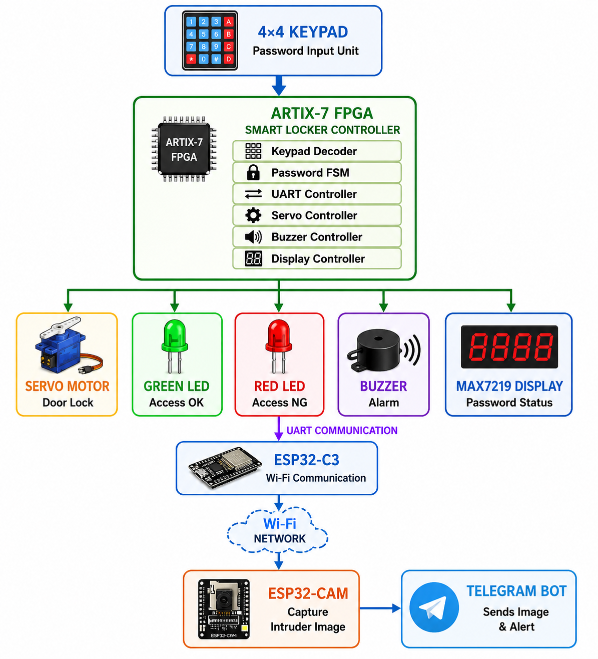

7. Hardware Components

• Artix-7 FPGA Development Board

• ESP32-C3 Mini

• ESP32-CAM

• 4×4 Keypad

• Servo Motor

• Buzzer

• Green LED

• Red LED

• MAX7219 Seven Segment Display

• Wi-Fi Hotspot

8. Software Requirements

• Vivado Design Suite

• Arduino IDE

• Git

• Telegram Bot API

9. Working Principle

User enters the password through the keypad.

FPGA verifies the password.

Correct password:

• Servo unlocks.

• Green LED turns ON.

• Short buzzer confirmation.

• Seven-segment display updates.

Incorrect password:

• Red LED turns ON.

• Alarm buzzer activates.

• FPGA sends UART command.

• ESP32-C3 receives command.

• ESP32-CAM captures image.

• Image is sent to Telegram.

10. System Flow
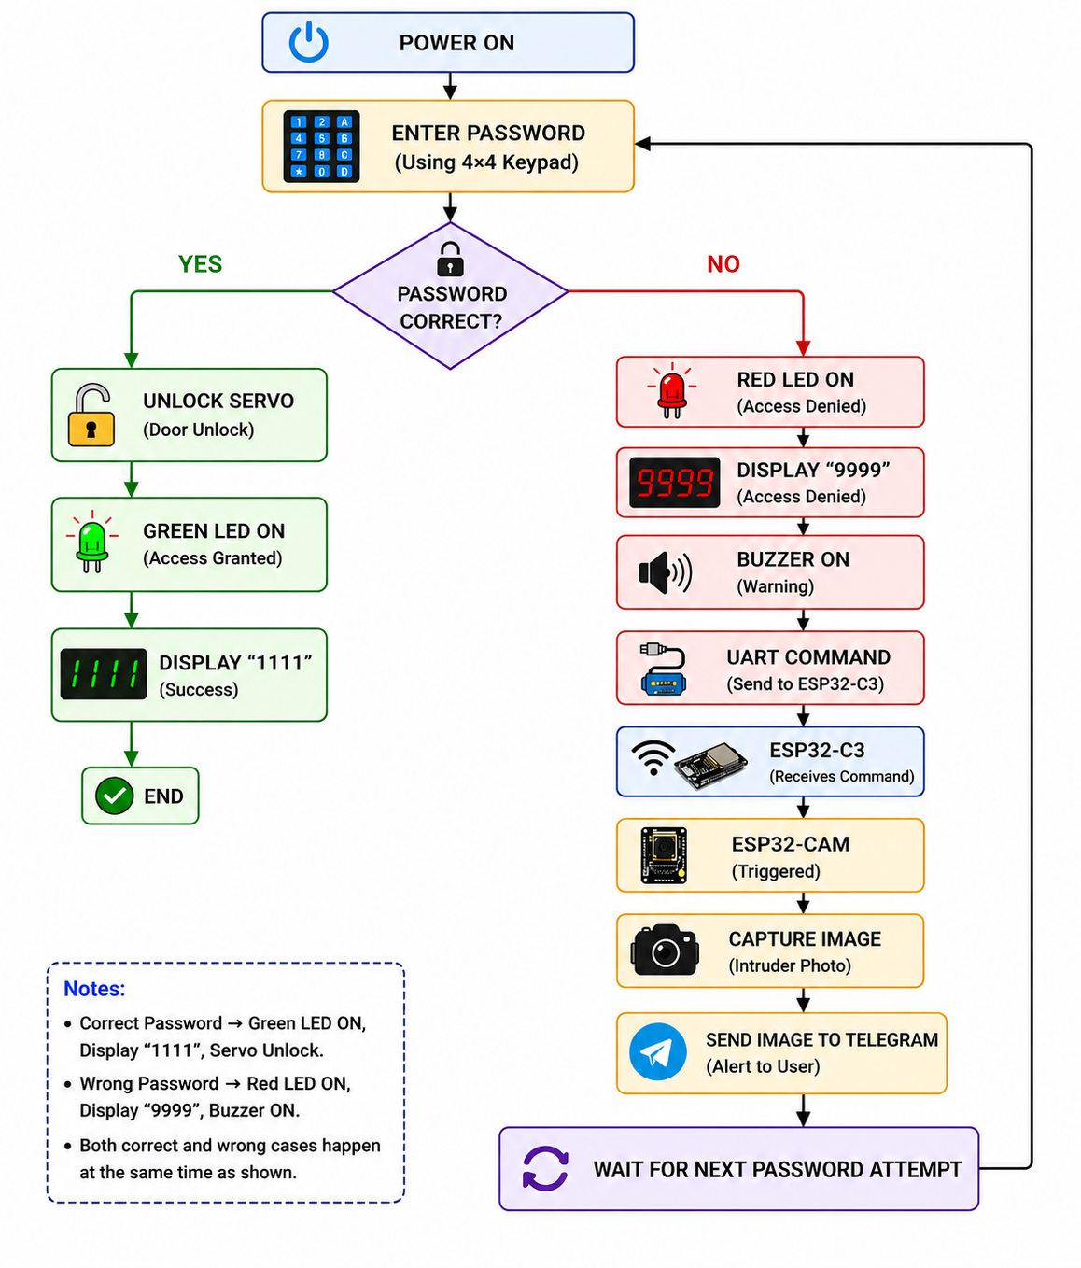

11. Module Description

keypad_decoder.v

Reads keypad inputs and generates the corresponding key code.

password_fsm.v

Stores password digits, verifies authentication, and generates unlock or alarm signals.

uart_message.v

Generates UART messages ("G" and "D") for communication with the ESP32-C3.

uart_tx.v

Serially transmits UART data to the ESP32-C3.

servo_pwm.v

Generates PWM signals for locking and unlocking the servo motor.

buzzer_controller.v

Produces confirmation beeps and alarm patterns.

password_display.v

Displays password entry and authentication status.

seg_display.v

Drives the MAX7219 seven-segment display.

smart_locker_top.v

Integrates all hardware modules into the complete system.

12. Build Instructions

Open Vivado.

Create a new RTL project.

Add all Verilog source files.

Add the XDC constraints file.

Run Synthesis.

Run Implementation.

Generate Bitstream.

Program the FPGA.

Upload ESP32-C3 firmware.

Upload ESP32-CAM firmware.

13. Run Instructions

Power the FPGA board.

Power the servo motor.

Connect ESP32-C3 and ESP32-CAM to the same Wi-Fi network.

Verify Telegram Bot configuration.

Enter a password using the keypad.

Observe the system response.

14. Testing Procedure
Test Case | Description | Expected Result | Actual Result | Status
TC-01 | Correct Password Authentication | Servo motor unlocks, Green LED turns ON, seven-segment display shows 1111, UART transmits 'G', no alarm is generated, and no image is captured. | System operated as expected. | Pass
TC-02 | Incorrect Password Authentication | Red LED turns ON, alarm buzzer is activated, seven-segment display shows 9999, UART transmits 'D', ESP32-C3 triggers the ESP32-CAM, captured image is sent to Telegram. | System operated as expected. | Pass
TC-03 | Password Clear Function | Pressing the F key clears the previously entered password, resets the display, and prepares the system for a new password entry. | System operated as expected. | Pass
TC-04 | UART Communication | FPGA successfully transmits 'G' for correct authentication and 'D' for incorrect authentication. ESP32-C3 correctly receives both commands. | UART communication verified successfully. | Pass
TC-05 | Telegram Notification | ESP32-CAM captures the intruder's image and successfully sends it to the configured Telegram bot after an incorrect password attempt. | Image successfully received on Telegram. | Pass

15. Test Results

The FPGA successfully authenticated users using keypad input. Correct passwords unlocked the servo motor, while incorrect passwords triggered the ESP32-CAM to capture images and send them to Telegram. The system successfully demonstrated FPGA, UART, Wi-Fi, and IoT integration.

Figure 15.1
Hardware Setup:
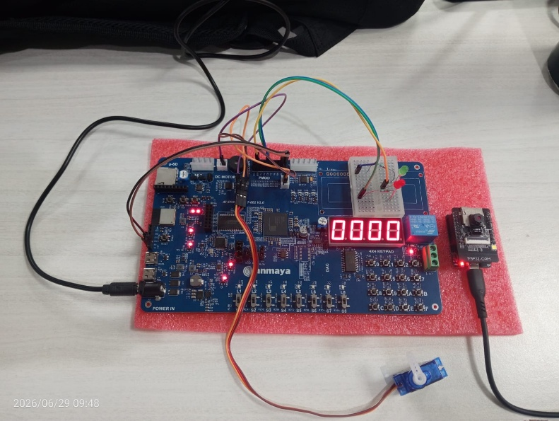
Figure 15.2
Correct Password:
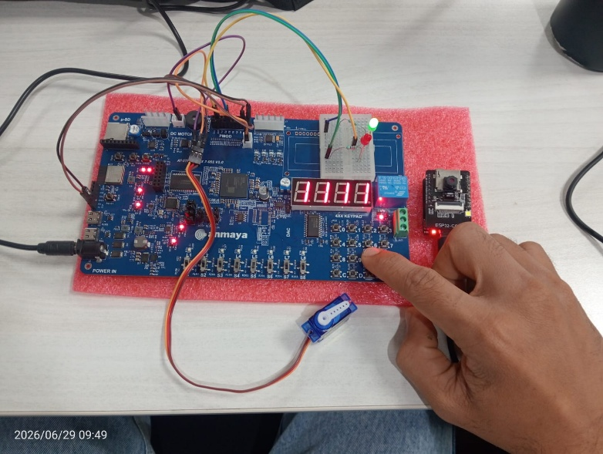

Figure 15.3
Wrong Password:
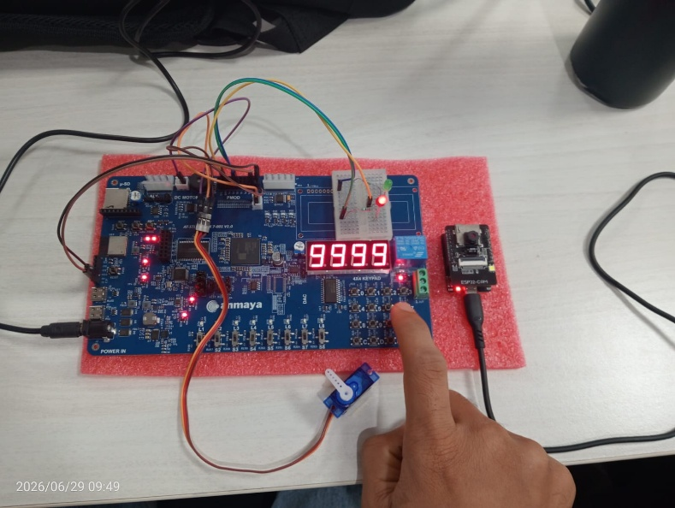

Figure 15.4
Telegram Alert:
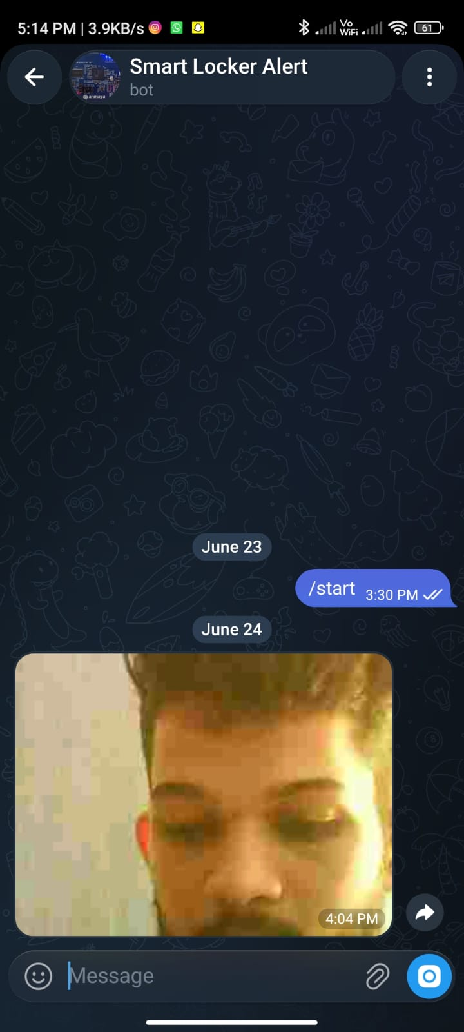

Figure 15.5
Simulation:
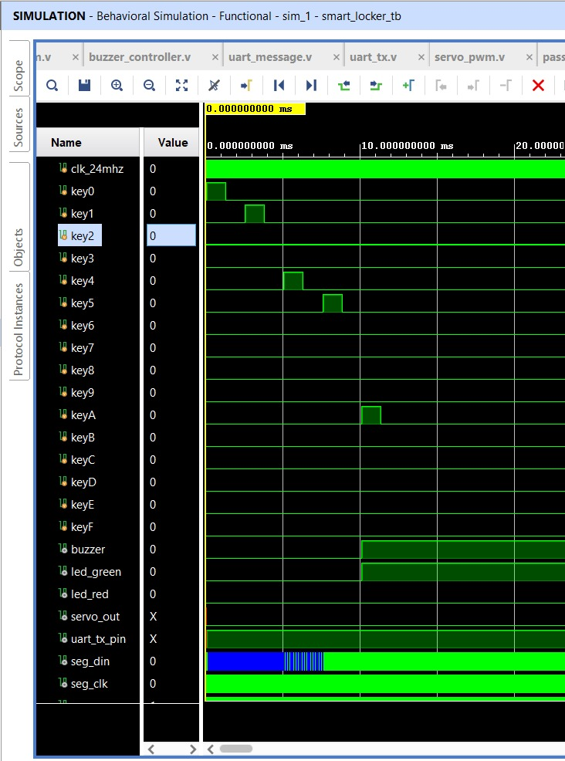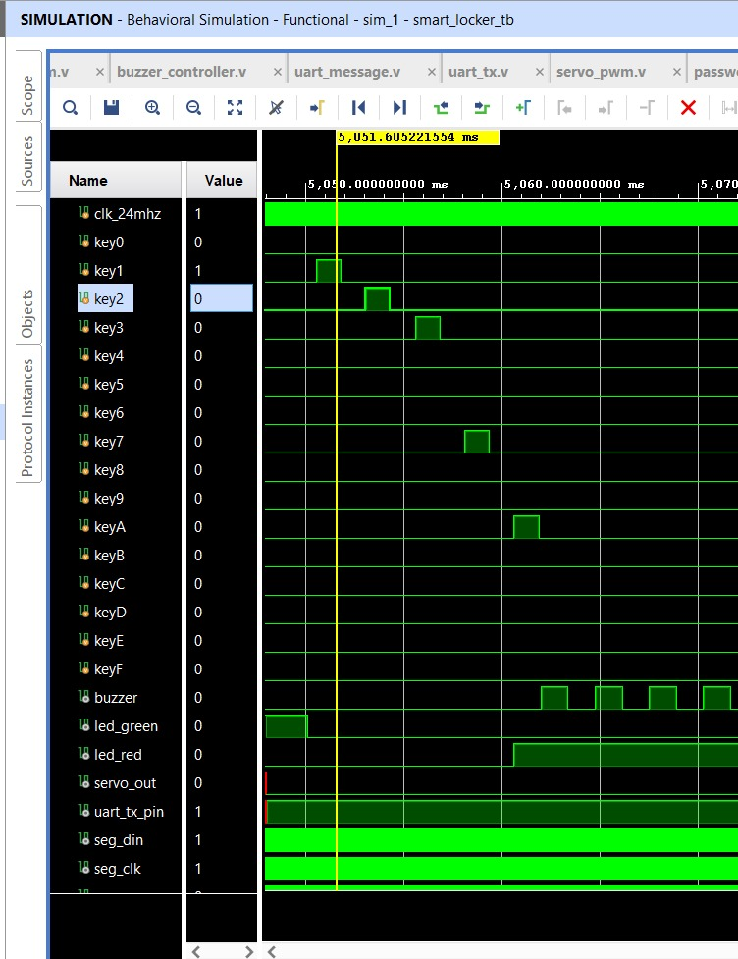

16. Conclusion
The FPGA-Based Smart Security Locker successfully combines password authentication, servo-based access control, camera monitoring, and Telegram notifications into a reliable security solution. The project demonstrates effective integration of FPGA hardware design with embedded systems and IoT technologies to provide enhanced security and real-time intrusion monitoring.

17. References

• Xilinx Vivado Documentation

• Artix-7 FPGA User Manual

• ESP32-C3 Technical Reference

• ESP32-CAM Documentation

• Telegram Bot API Documentation

