VISHWAKARMA INSTITUTE OF TECHNOLOGY
BRANCH - AI&DS DIVISION- C BATCH- B2
NAME- PRANAMYA VEMULA ROLL NO- 59 PRN NO- 12110758
OS LAB - ASSIGNMENT 1
Basic Linux Commands
- ls (List Directory Contents)

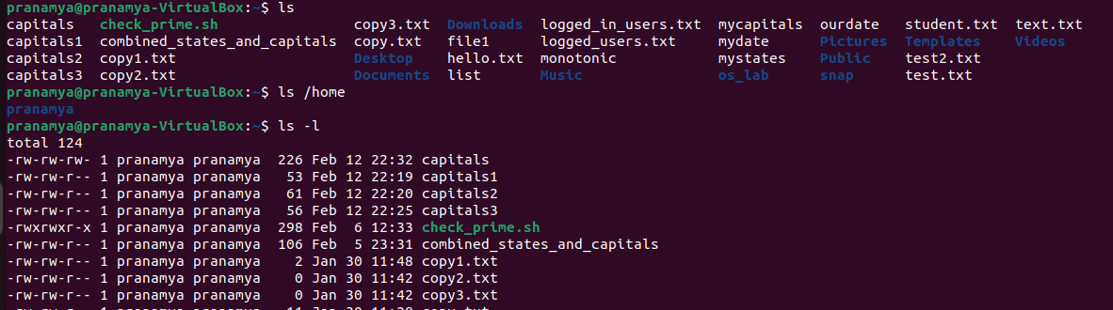
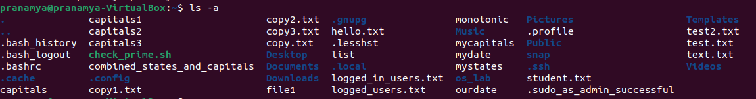

- cd (Change Directory)

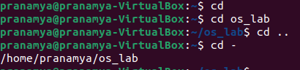

- mkdir (Make Directory)

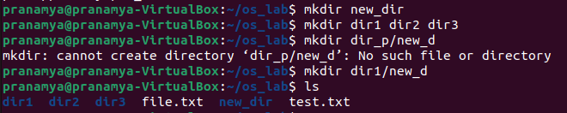

- touch (Create new file)

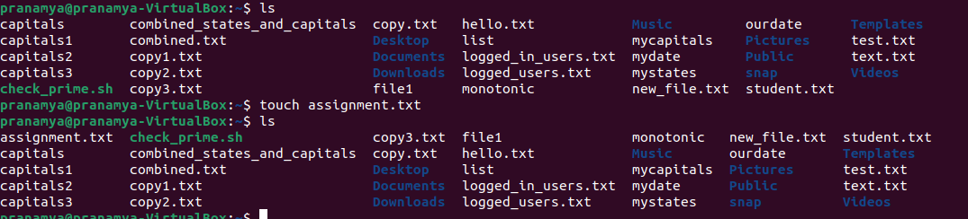

- rm (Remove)

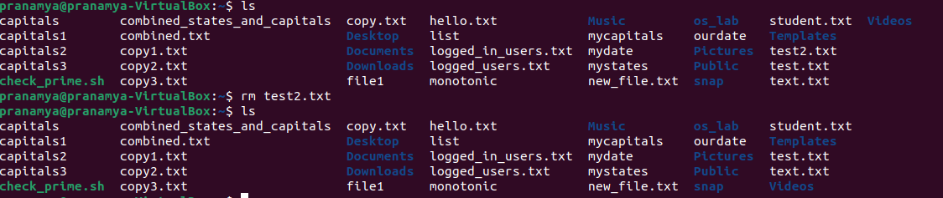
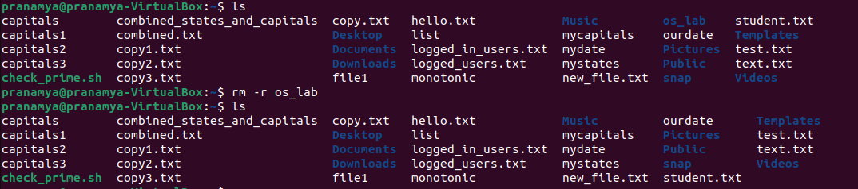

- pwd (Print Working Directory)

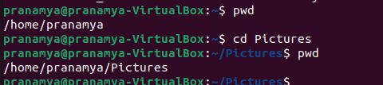

- cat (Concatenate)

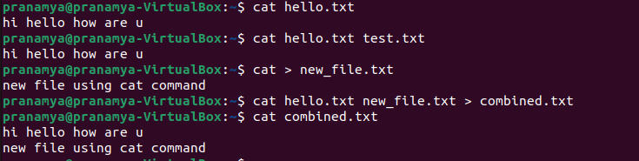

VISHWAKARMA INSTITUTE OF TECHNOLOGY
BRANCH - AI&DS DIVISION- C BATCH- B2
NAME- PRANAMYA VEMULA ROLL NO- 59 PRN NO- 12110758
OS LAB - ASSIGNMENT 3
Program to check whether the number is prime or not.
#!/bin/bash
echo "Enter a number:"
read number
i=2
if [ $number -lt 2 ]
then
echo "$number is not a prime number."
exit
fi
while [ $i -lt $number ]
do
if [ `expr $number % $i` -eq 0 ]
then
echo "$number is not a prime number."
exit
fi
i=`expr $i + 1`
done
echo "$number is a prime number."
Output –
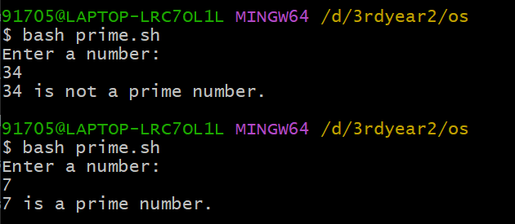
Program to print the factorial of a number.
echo "Enter a Number"
read n
i=`expr $n - 1`
p=1
while [ $i -ge 1 ]
do
n=`expr $n \* $i`
i=`expr $i - 1`
done
echo "The Factorial of the given Number is $n"
Output –
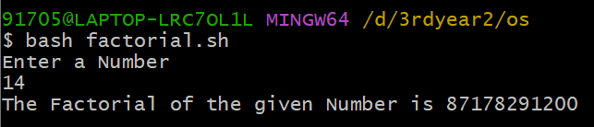
Program to check if the given string is palindrome or not.
#!/bin/bash
echo "Enter a String"
read input
reverse=""
len=${#input}
for (( i=$len-1; i>=0; i-- ))
do
reverse="$reverse${input:$i:1}"
done
if [ $input == $reverse ]
then
echo "$input is palindrome"
else
echo "$input is not palindrome"
fi
Output –
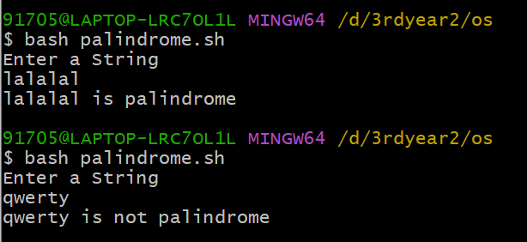
VISHWAKARMA INSTITUTE OF TECHNOLOGY
BRANCH - AI&DS DIVISION- C BATCH- B2
NAME- PRANAMYA VEMULA ROLL NO- 59 PRN NO- 12110758
OS LAB - ASSIGNMENT 4
Implementation of Classical problem Reader Writer using Threads and Mutex.
#include <stdio.h>
#include <pthread.h>
#include <stdbool.h>
#include <unistd.h>
typedef struct {
// no. of readers
int rcnt;
// no. of writers
int wcnt;
// no. of readers waiting
int waitr;
// no. of writers waiting
int waitw;
// condition variable to check whether reader can read
pthread_cond_t canread;
// condition variable to check whether writer can write
pthread_cond_t canwrite;
// mutex for synchronization
pthread_mutex_t condlock;
} Monitor;
Monitor M;
void beginread(int i) {
pthread_mutex_lock(&M.condlock);
if (M.wcnt == 1 || M.waitw > 0) {
M.waitr++;
printf("Reader %d can't read as writer is writing.\n", i);
pthread_cond_wait(&M.canread, &M.condlock);
M.waitr--;
}
M.rcnt++;
printf("Reader %d starts reading.\n", i);
pthread_mutex_unlock(&M.condlock);
pthread_cond_broadcast(&M.canread);
}
void endread(int i) {
pthread_mutex_lock(&M.condlock);
if (--M.rcnt == 0)
pthread_cond_signal(&M.canwrite);
pthread_mutex_unlock(&M.condlock);
}
void beginwrite(int i) {
pthread_mutex_lock(&M.condlock);
if (M.wcnt == 1 || M.rcnt > 0) {
printf("Writer %d can't write as reader is reading.\n", i);
++M.waitw;
pthread_cond_wait(&M.canwrite, &M.condlock);
--M.waitw;
}
M.wcnt = 1;
printf("Writer %d starts writing.\n", i);
pthread_mutex_unlock(&M.condlock);
}

void endwrite(int i) {
pthread_mutex_lock(&M.condlock);
M.wcnt = 0;
if (M.waitr > 0)
pthread_cond_signal(&M.canread);
else
pthread_cond_signal(&M.canwrite);
pthread_mutex_unlock(&M.condlock);
}
void *reader(void *id) {
int c = 0;
int i = *(int *)id;
while (c < 5) {
usleep(1);
beginread(i);
endread(i);
c++;
}
pthread_exit(NULL);
}

void *writer(void *id) {
int c = 0;
int i = *(int *)id;
while (c < 5) {
usleep(1);
beginwrite(i);
endwrite(i);
c++;
}
pthread_exit(NULL);
}
int main() {
pthread_t r[5], w[5];
int id[5];
pthread_mutex_init(&M.condlock, NULL);
pthread_cond_init(&M.canread, NULL);
pthread_cond_init(&M.canwrite, NULL);
for (int i = 0; i < 5; i++) {
id[i] = i;
pthread_create(&r[i], NULL, &reader, &id[i]);
pthread_create(&w[i], NULL, &writer, &id[i]);
}
for (int i = 0; i < 5; i++) {
pthread_join(r[i], NULL);
}
for (int i = 0; i < 5; i++) {
pthread_join(w[i], NULL);
}
pthread_mutex_destroy(&M.condlock);
pthread_cond_destroy(&M.canread);
pthread_cond_destroy(&M.canwrite);
return 0;
}
OUTPUT –
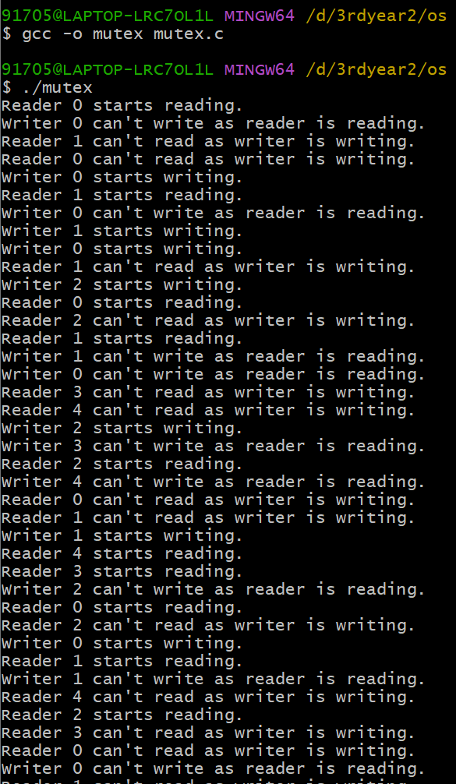
VISHWAKARMA INSTITUTE OF TECHNOLOGY
BRANCH - AI&DS DIVISION- C BATCH- B2
NAME- PRANAMYA VEMULA ROLL NO- 59 PRN NO- 12110758
OS LAB - ASSIGNMENT 5
Implementation of Classical problems Producer Consumer using Threads and Semaphore.
import java.util.concurrent.Semaphore;
public class Assignment5{

public static void main(String[] args){

Semaphore semaphoreProducer=new Semaphore(1);
Semaphore semaphoreConsumer=new Semaphore(0);

Producer producer=new Producer(semaphoreProducer,semaphoreConsumer);
Consumer consumer=new Consumer(semaphoreConsumer,semaphoreProducer);

Thread producerThread = new Thread(producer, "ProducerThread");
Thread consumerThread = new Thread(consumer, "ConsumerThread");

producerThread.start();
consumerThread.start();

}
}

class Producer implements Runnable{

Semaphore semaphoreProducer;
Semaphore semaphoreConsumer;

public Producer(Semaphore semaphoreProducer,Semaphore semaphoreConsumer) {
this.semaphoreProducer=semaphoreProducer;
this.semaphoreConsumer=semaphoreConsumer;
}

public void run() {
for(int i=1;i<=5;i++){
try {
semaphoreProducer.acquire();
System.out.println("Produced : "+i);
Thread.sleep(1000);
semaphoreConsumer.release();

} catch (InterruptedException e) {
e.printStackTrace();
}
}
}
}

class Consumer implements Runnable{

Semaphore semaphoreConsumer;
Semaphore semaphoreProducer;

public Consumer(Semaphore semaphoreConsumer,Semaphore semaphoreProducer) {
this.semaphoreConsumer=semaphoreConsumer;
this.semaphoreProducer=semaphoreProducer;
}

public void run() {

for(int i=1;i<=5;i++){
try {
semaphoreConsumer.acquire();
System.out.println("Consumed : "+i);
Thread.sleep(1000);
semaphoreProducer.release();
} catch (InterruptedException e) {
e.printStackTrace();
}
}
}

}

Output –
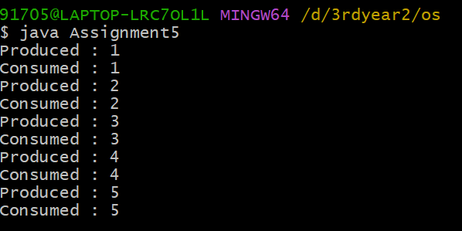
VISHWAKARMA INSTITUTE OF TECHNOLOGY
BRANCH - AI&DS DIVISION- C BATCH- B2
NAME- PRANAMYA VEMULA ROLL NO- 59 PRN NO- 12110758
OS LAB - ASSIGNMENT 6
System Calls
Write a program demonstrating use of different system calls.
1) process related system call:fork,wait,
2) file related:open ,read,write,close
3)protection: chmod
#include <stdio.h>
#include <stdlib.h>
#include <unistd.h>
#include <fcntl.h>
#include <sys/wait.h>
#include <sys/stat.h>
#include <string.h>

#define FILE_PATH "test.txt"

int main() {
// Process related system calls: fork, wait
pid_t pid = fork();
if (pid < 0) {
perror("Fork failed");
exit(EXIT_FAILURE);
} else if (pid == 0) {
// Child process
printf("Child process is running.\n");
} else {
// Parent process
printf("Parent process is waiting for child...\n");
wait(NULL);
printf("Parent process has finished waiting.\n");
}

// File related system calls: open, read, write, close
int fd = open(FILE_PATH, O_CREAT | O_RDWR | O_TRUNC, S_IRUSR | S_IWUSR | S_IRGRP | S_IWGRP | S_IROTH | S_IWOTH);
if (fd == -1) {
perror("Open failed");
exit(EXIT_FAILURE);
}

char *buffer = "Hello, world!\n";
ssize_t bytes_written = write(fd, buffer, strlen(buffer));
if (bytes_written == -1) {
perror("Write failed");
close(fd); // Close file descriptor before exiting
exit(EXIT_FAILURE);
}

close(fd);

// Read and print file contents before chmod
fd = open(FILE_PATH, O_RDONLY);
if (fd == -1) {
perror("Open failed");
exit(EXIT_FAILURE);
}

char read_buffer_before[256];
ssize_t bytes_read_before = read(fd, read_buffer_before, sizeof(read_buffer_before));
if (bytes_read_before == -1) {
perror("Read failed before chmod");
close(fd); // Close file descriptor before exiting
exit(EXIT_FAILURE);
}
printf("%s", read_buffer_before);
close(fd);

// Demonstrate chmod
if (chmod(FILE_PATH, S_IRWXU | S_IRWXG | S_IRWXO) == -1) {
perror("Chmod failed");
exit(EXIT_FAILURE);
}
printf("Chmod : Permissions Changed");
// Read and print file contents after chmod
fd = open(FILE_PATH, O_RDONLY);
if (fd == -1) {
perror("Open failed");
exit(EXIT_FAILURE);
}

char read_buffer_after[256];
ssize_t bytes_read_after = read(fd, read_buffer_after, sizeof(read_buffer_after));
if (bytes_read_after == -1) {
perror("Read failed after chmod");
close(fd); // Close file descriptor before exiting
exit(EXIT_FAILURE);
}
printf("%s", read_buffer_after);

close(fd);

return 0;
}
Output –
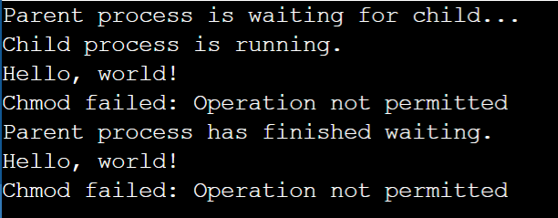
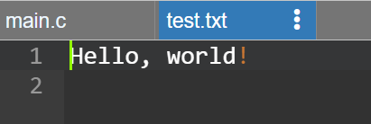
VISHWAKARMA INSTITUTE OF TECHNOLOGY
BRANCH - AI&DS DIVISION- C BATCH- B2
NAME- PRANAMYA VEMULA ROLL NO- 59 PRN NO- 12110758
OS LAB - ASSIGNMENT 7
Implement Scheduling Algorithms – First Come First Serve(FCFS), Shortest Job First(SJF) and Round Robin(RR).
FCFS–
#include<iostream>
using namespace std;

// Function to find the waiting time for all processes
void findWaitingTime(int processes[], int n, int bt[], int wt[], int at[]) {
int service_time[n];
service_time[0] = at[0];
wt[0] = 0;

// calculating waiting time
for (int i = 1; i < n; i++) {
// Calculating service time for each process
service_time[i] = service_time[i - 1] + bt[i - 1];

// If the current process hasn't arrived yet, wait until it arrives
if (service_time[i] < at[i])
service_time[i] = at[i];

// Calculate waiting time
wt[i] = service_time[i] - at[i];

// If waiting time is negative, make it 0
if (wt[i] < 0)
wt[i] = 0;
}
}

void findTurnAroundTime(int processes[], int n, int bt[], int wt[], int tat[]) {
// calculating turnaround time by adding bt[i] + wt[i]
for (int i = 0; i < n; i++)
tat[i] = bt[i] + wt[i];
}

void findavgTime(int processes[], int n, int bt[], int at[]) {
int wt[n], tat[n], total_wt = 0, total_tat = 0;

// Function to find waiting time of all processes
findWaitingTime(processes, n, bt, wt, at);

// Function to find turn around time for all processes
findTurnAroundTime(processes, n, bt, wt, tat);

// Display processes along with all details
cout << "PID " << " AT " << " BT "
<< " WT " << " TAT\n";

// Calculate total waiting time and total turn around time
for (int i = 0; i < n; i++) {
total_wt = total_wt + wt[i];
total_tat = total_tat + tat[i];
cout << " " << processes[i] << "\t" << at[i] << "\t"
<< bt[i] << "\t " << wt[i] << "\t " << tat[i] << endl;
}

cout << "Average waiting time = "
<< (float)total_wt / (float)n;
cout << "\nAverage turn around time = "
<< (float)total_tat / (float)n;
}

int main() {
int n;
cout << "Enter the number of processes: ";
cin >> n;

int processes[n];
int arrival_time[n];
int burst_time[n];

cout << "Enter arrival time for each process:\n";
for (int i = 0; i < n; i++) {
cout << "Arrival time of process " << i + 1 << ": ";
cin >> arrival_time[i];
processes[i] = i + 1;
}

cout << "Enter burst time for each process:\n";
for (int i = 0; i < n; i++) {
cout << "Burst time for process " << i + 1 << ": ";
cin >> burst_time[i];
}

findavgTime(processes, n, burst_time, arrival_time);
return 0;
}

Output –

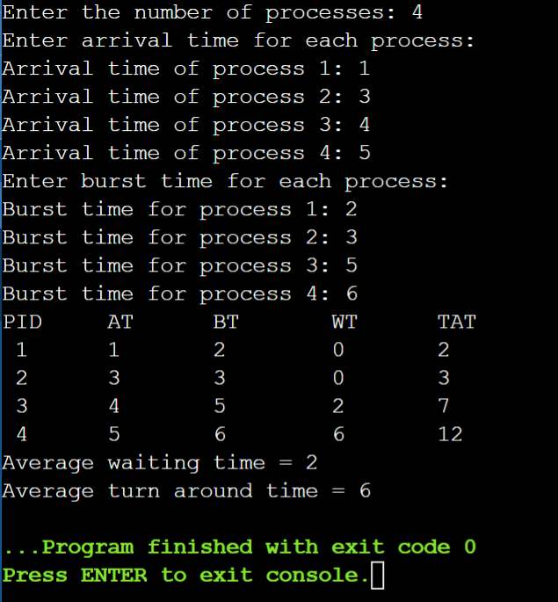

SJF—

struct Process {
int arrival_time;
int burst_time;
int waiting_time;
};

int compare(const void *a, const void *b) {
struct Process *p1 = (struct Process *)a;
struct Process *p2 = (struct Process *)b;
return p1->burst_time - p2->burst_time;
}

int main() {
int n, i, j;
float avg_waiting_time = 0, avg_turnaround_time = 0;
printf("Enter the number of processes: ");
scanf("%d", &n);
struct Process processes[n];
for (i = 0; i< n; i++) {
printf("Enter arrival time and burst time of process %d: ", i+1);
scanf("%d %d", &processes[i].arrival_time, &processes[i].burst_time);
}
qsort(processes, n, sizeof(struct Process), compare);
processes[0].waiting_time = 0;
for (i = 1; i< n; i++) {
processes[i].waiting_time = 0;
for (j = 0; j <i; j++)
{

processes[i].waiting_time += processes[j].burst_time;

}

avg_waiting_time += processes[i].waiting_time;

}

avg_waiting_time /= n;

for (i = 0; i< n; i++) {

avg_turnaround_time += processes[i].burst_time + processes[i].waiting_time;

}

avg_turnaround_time /= n;

printf("\nPID\tAT\tBT\tWT\tTAT\n");

for (i = 0; i< n; i++) {

printf("%d\t%d\t%d\t%d\t%d\n", i+1, processes[i].arrival_time, processes[i].burst_time, processes[i].waiting_time, processes[i].burst_time+processes[i].waiting_time);

}

printf("\nAverage Waiting Time: %f\n", avg_waiting_time);

printf("Average Turnaround Time: %f\n", avg_turnaround_time);

return 0;

}

Output –

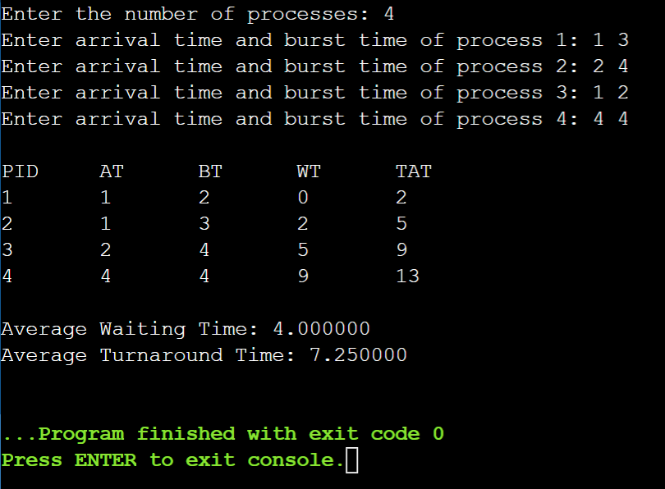

RR–

#include <iostream>
#include <climits>
using namespace std;

struct Process {
int AT, BT, ST[20], WT, FT, TAT, pos;
};

int quant;

int main() {
int n, i, j;

// Taking Input
cout << "Enter the no. of processes: ";
cin >> n;
Process p[n];

cout << "Enter the quantum: " << endl;
cin >> quant;

cout << "Enter the process numbers: " << endl;
for (i = 0; i < n; i++)
cin >> p[i].pos;

cout << "Enter the Arrival time of processes: " << endl;
for (i = 0; i < n; i++)
cin >> p[i].AT;

cout << "Enter the Burst time of processes: " << endl;
for (i = 0; i < n; i++)
cin >> p[i].BT;

// Declaring variables
int c = n, s[n][20];
float time = 0, mini = INT_MAX, b[n], a[n];

// Initializing burst and arrival time arrays
int index = -1;
for (i = 0; i < n; i++) {
b[i] = p[i].BT;
a[i] = p[i].AT;
for (j = 0; j < 20; j++) {
s[i][j] = -1;
}
}

int tot_wt, tot_tat;
tot_wt = 0;
tot_tat = 0;
bool flag = false;

while (c != 0) {
mini = INT_MAX;
flag = false;

for (i = 0; i < n; i++) {
float p = time + 0.1;
if (a[i] <= p && mini > a[i] && b[i] > 0) {
index = i;
mini = a[i];
flag = true;
}
}

// if at =1 then loop gets out hence set flag to false
if (!flag) {
time++;
continue;
}

// calculating start time
j = 0;

while (s[index][j] != -1) {
j++;
}

if (s[index][j] == -1) {
s[index][j] = time;
p[index].ST[j] = time;
}

if (b[index] <= quant) {
time += b[index];
b[index] = 0;
} else {
time += quant;
b[index] -= quant;
}

if (b[index] > 0) {
a[index] = time + 0.1;
}

// calculating arrival, burst, final times
if (b[index] == 0) {
c--;
p[index].FT = time;
p[index].WT = p[index].FT - p[index].AT - p[index].BT;
tot_wt += p[index].WT;
p[index].TAT = p[index].BT + p[index].WT;
tot_tat += p[index].TAT;
}
} // end of while loop

// Printing output
cout << "Process number ";
cout << "Arrival time ";
cout << "Burst time ";
cout << "\tStart time";
j = 0;
while (j != 10) {
j += 1;
cout << " ";
}
cout << "\t\tFinal time";
cout << "\tWait Time ";
cout << "\tTurnAround Time" << endl;

for (i = 0; i < n; i++) {
cout << p[i].pos << "\t\t";
cout << p[i].AT << "\t\t";
cout << p[i].BT << "\t";
j = 0;
int v = 0;
while (s[i][j] != -1) {
cout << p[i].ST[j] << " ";
j++;
v += 3;
}
while (v != 40) {
cout << " ";
v += 1;
}
cout << p[i].FT << "\t\t";
cout << p[i].WT << "\t\t";
cout << p[i].TAT << endl;
}

// Calculating average wait time and turnaround time
double avg_wt, avg_tat;
avg_wt = tot_wt / static_cast<double>(n);
avg_tat = tot_tat / static_cast<double>(n);

// Printing average wait time and turnaround time
cout << "The average wait time is: " << avg_wt << endl;
cout << "The average TurnAround time is: " << avg_tat << endl;

return 0;
}

Output—

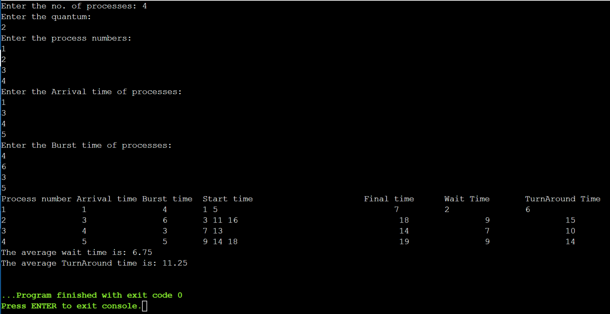
VISHWAKARMA INSTITUTE OF TECHNOLOGY
BRANCH - AI&DS DIVISION- C BATCH- B2
NAME- PRANAMYA VEMULA ROLL NO- 59 PRN NO- 12110758
OS LAB - ASSIGNMENT 8
Implement Bankers algorithm for deadlock avoidance and find out a safe sequence for processes.
Code –
import java.util.ArrayList;
import java.util.Arrays;
import java.util.Scanner;
public class bankers {
static int m;
static int n;
static Scanner in=new Scanner(System.in);
public static void input(int[][] matrix,String s){
System.out.println("Enter "+s+" values: ");
for(int i=0;i<m;i++){
for(int j=0;j<n;j++){
matrix[i][j]=in.nextInt();
}
}
}
public static void main(String[] args) {
ArrayList<Integer> arrayList=new ArrayList<>();
System.out.println("Enter number of resources: ");
n=in.nextInt();
System.out.println("Enter number of processes: ");
m=in.nextInt();
int[][] allocate=new int[m][n];
int[][] maxNeed=new int[m][n];
int[][] remNeed=new int[m][n];
int[] flag=new int[m];
Arrays.fill(flag,0);
int[] totalAvailable=new int[n];
int[] totalAllocate=new int[n];
int[] available=new int[n];
input(allocate,"Allocated");
input(maxNeed,"Max Need");
System.out.println("Total Available Memory: ");
for(int i=0;i<n;i++){
totalAvailable[i]=in.nextInt();
}
for(int i=0;i<m;i++){
for(int j=0;j<n;j++){
remNeed[i][j]=maxNeed[i][j]-allocate[i][j];
}
}
// System.out.println(Arrays.deepToString(remNeed));
int sum=0;
for(int i=0;i<n;i++){
sum=0;
for(int j=0;j<m;j++){
sum+=allocate[j][i];
}
totalAllocate[i]=sum;
}
for(int i=0;i<n;i++){
available[i]=totalAvailable[i]-totalAllocate[i];
}
// System.out.println(Arrays.toString(available));
int count=0;
int release=0;
boolean flg=true;
while(flg){
for(int i=0;i<m;i++){
for(int j=0;j<n;j++){
if(remNeed[i][j]<=available[j] && flag[i]==0){
count++;
if(count==n){
count=0;
flag[i]=1;
for(int k=0;k<n;k++){
available[k]=available[k]+allocate[i][k];
}
arrayList.add(i+1);
}
}
else{
release++;
if(release==m){
flg=false;
}
break;
}
}
}
}
if(arrayList.isEmpty()){
System.out.println("Deadlock occurs.");
}
else{
System.out.println("Order: ");
for(int i: arrayList){
System.out.print(i+" ");
}
}
}
}

Output –
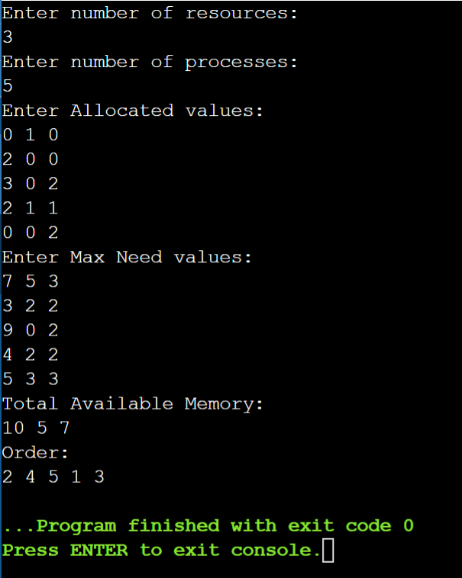
VISHWAKARMA INSTITUTE OF TECHNOLOGY
BRANCH - AI&DS DIVISION- C BATCH- B2
NAME- PRANAMYA VEMULA ROLL NO- 59 PRN NO- 12110758
OS LAB - ASSIGNMENT 9
Write a program to calculate the number of page faults for a reference string for the following page replacement algorithms: a) FIFO b) LRU c) Optimal
FIFO
import java.util.Arrays;
import java.util.HashMap;
import java.util.Map;
import java.util.Scanner;

class Replacement {
int f;
int[] runQ;
int pageF = 0;
int time = 0;
HashMap<Integer, Integer> map = new HashMap<>();

Replacement(int f) {
this.f = f;
runQ = new int[f];
Arrays.fill(runQ, -1);
}

public void push(int m) {
if (!contains(m)) {
runQ[pageF % f] = m;
pageF++;
map.put(pageF, time);
System.out.println("Miss: " + m);
} else {
System.out.println("Hit: " + m);
}
time++;
System.out.println(Arrays.toString(runQ));
}

public boolean contains(int m) {
for (int i = 0; i < f; i++) {
if (runQ[i] == m) {
return true;
}
}
return false;
}
}
public class FIFO {
public static void main(String[] args) {
Scanner in = new Scanner(System.in);
System.out.println("Enter string: ");
String str = in.nextLine();
int n = str.length();
int[] ref = new int[n];
for (int i = 0; i < n; i++) {
ref[i] = Integer.parseInt(String.valueOf(str.charAt(i)));
}
System.out.println(Arrays.toString(ref));
System.out.println("Enter number of frames");
int f = in.nextInt();
Replacement r = new Replacement(f);
for (int i = 0; i < n; i++) {
r.push(ref[i]);
}
System.out.println("PageFs\tTime");
for (Map.Entry<Integer, Integer> map : r.map.entrySet()) {
System.out.println(map.getKey() + "\t\t" + map.getValue());
}
}
}

OUTPUT –
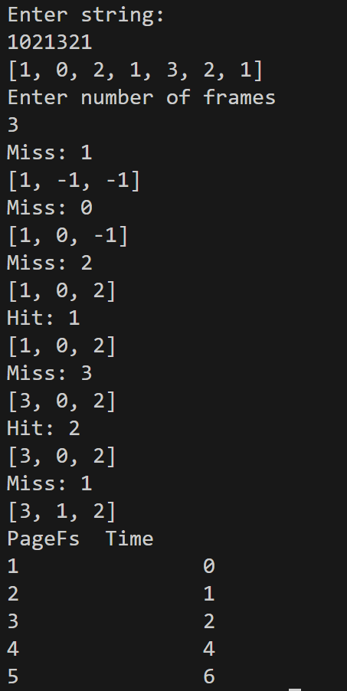
LRU
import java.util.*;
class ReplacementLRU {
int f;
int[] runQ;
int pageF = 0;
int time = 0;
HashMap<Integer, Integer> map = new HashMap<>();
HashMap<Integer, Integer> page = new HashMap<>();
ReplacementLRU(int f) {
this.f = f;
runQ = new int[f];
Arrays.fill(runQ, -1);
}
public void push(int m) {
if (!contains(m)) {
if (pageF < f) {
runQ[pageF % f] = m;
pageF++;
page.put(pageF,time);
} else {
pageF++;
int lruIndex = 0;
int lruTime = map.get(runQ[0]);
for (int i = 1; i < f; i++) {
if (map.get(runQ[i]) < lruTime) {
lruTime = map.get(runQ[i]);
lruIndex = i;
}
}
runQ[lruIndex] = m;
page.put(pageF,time);
}
map.put(m, time);
System.out.println("Miss: " + m);
} else {
map.put(m, time);
System.out.println("Hit: " + m);
}
time++;
System.out.println(Arrays.toString(runQ));
}
public boolean contains(int m) {
for (int i = 0; i < f; i++) {
if (runQ[i] == m) {
return true;
}
}
return false;
}
}
public class LRU {
public static void main(String[] args) {
Scanner in = new Scanner(System.in);
System.out.println("Enter string: ");
String str = in.nextLine();
int n = str.length();
int[] ref = new int[n];
for (int i = 0; i < n; i++) {
ref[i] = Integer.parseInt(String.valueOf(str.charAt(i)));
}
System.out.println(Arrays.toString(ref));
System.out.println("Enter number of frames");
int f = in.nextInt();
ReplacementLRU r = new ReplacementLRU(f);
for (int i = 0; i < n; i++) {
r.push(ref[i]);
}
System.out.println("PageFs\tTime");
for (Map.Entry<Integer, Integer> page : r.page.entrySet()) {
System.out.println(page.getKey() + "\t\t" + page.getValue());
}
}
}
OUTPUT –
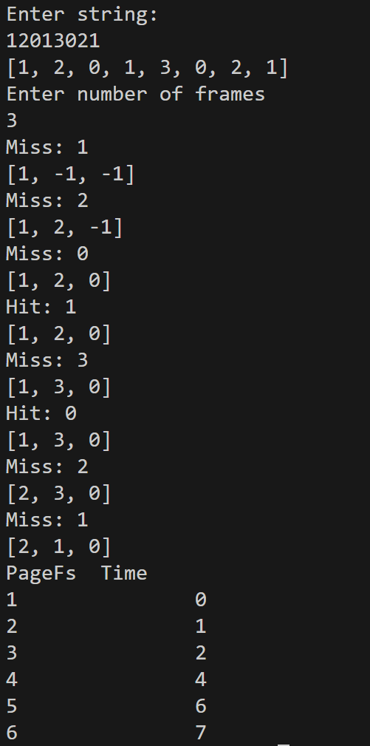
OPTIMAL
import java.util.*;
class ReplacementOptimal {
int f;
int[] runQ;
int pageF = 0;
int time = 0;
HashMap<Integer, Integer> map = new HashMap<>();
ReplacementOptimal(int f) {
this.f = f;
runQ = new int[f];
Arrays.fill(runQ, -1);
}
public void push(int m, int[] futRef) {
if (!contains(m)) {
if (pageF < f) {
runQ[pageF % f] = m;
pageF++;
} else {
pageF++;
int farthest = -1;
int replaceIndex = -1;
for (int i = 0; i < f; i++) {
int currentP = runQ[i];
boolean found = false;
for (int j = time; j < futRef.length; j++) {
if (currentP == futRef[j]) {
found = true;
if (j > farthest) {
farthest = j;
replaceIndex = i;
}
break;
}
}
if (!found) {
replaceIndex = i;
break;
}
}
runQ[replaceIndex] = m;
}
map.put(pageF, time);
System.out.println("Miss: " + m);
} else {
System.out.println("Hit: " + m);
}
time++;
System.out.println(Arrays.toString(runQ));
}
public boolean contains(int m) {
for (int i = 0; i < f; i++) {
if (runQ[i] == m) {
return true;
}
}
return false;
}
}
public class optimal {
public static void main(String[] args) {
Scanner in = new Scanner(System.in);
System.out.println("Enter string: ");
String str = in.nextLine();
int n = str.length();
int[] ref = new int[n];
for (int i = 0; i < n; i++) {
ref[i] = Integer.parseInt(String.valueOf(str.charAt(i)));
}
System.out.println(Arrays.toString(ref));
System.out.println("Enter number of frames");
int f = in.nextInt();
int[] futRef = Arrays.copyOfRange(ref, 1, n);
ReplacementOptimal r = new ReplacementOptimal(f);
for (int i = 0; i < n; i++) {
r.push(ref[i], futRef);
}
System.out.println("PageFs\tTime");
for (Map.Entry<Integer, Integer> map : r.map.entrySet()) {
System.out.println(map.getKey() + "\t\t" + map.getValue());
}
}
}

OUTPUT –
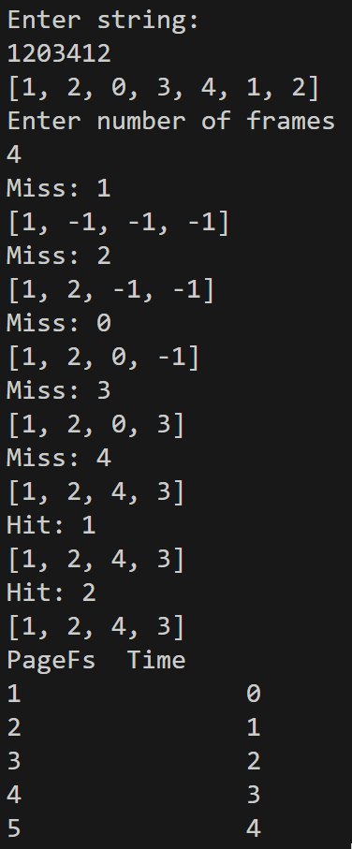
VISHWAKARMA INSTITUTE OF TECHNOLOGY
BRANCH - AI&DS DIVISION- C BATCH- B2
NAME- PRANAMYA VEMULA ROLL NO- 59 PRN NO- 12110758
OS LAB - ASSIGNMENT 4
Implementation of Producer Consumer problem using Threads and semaphore.
import java.util.concurrent.Semaphore;
public class Assignment5{
public static void main(String[] args){

Semaphore semaphoreProducer=new Semaphore(1);
Semaphore semaphoreConsumer=new Semaphore(0);
Producer producer=new Producer(semaphoreProducer,semaphoreConsumer);
Consumer consumer=new Consumer(semaphoreConsumer,semaphoreProducer);
Thread producerThread = new Thread(producer, "ProducerThread");
Thread consumerThread = new Thread(consumer, "ConsumerThread");

producerThread.start();
consumerThread.start();
}
}
class Producer implements Runnable{
Semaphore semaphoreProducer;
Semaphore semaphoreConsumer;
public Producer(Semaphore semaphoreProducer,Semaphore semaphoreConsumer) {
this.semaphoreProducer=semaphoreProducer;
this.semaphoreConsumer=semaphoreConsumer;
}
public void run() {
for(int i=1;i<=5;i++){
try {
semaphoreProducer.acquire();
System.out.println("Produced : "+i);
Thread.sleep(1000);
semaphoreConsumer.release();

} catch (InterruptedException e) {
e.printStackTrace();
}
}
}
}
class Consumer implements Runnable{
Semaphore semaphoreConsumer;
Semaphore semaphoreProducer;
public Consumer(Semaphore semaphoreConsumer,Semaphore semaphoreProducer) {
this.semaphoreConsumer=semaphoreConsumer;
this.semaphoreProducer=semaphoreProducer;
}
public void run() {
for(int i=1;i<=5;i++){
try {
semaphoreConsumer.acquire();
System.out.println("Consumed : "+i);
System.out.println("Producer is Waiting");
Thread.sleep(1000);
semaphoreProducer.release();
} catch (InterruptedException e) {
e.printStackTrace();
}
}
}
}

Output –

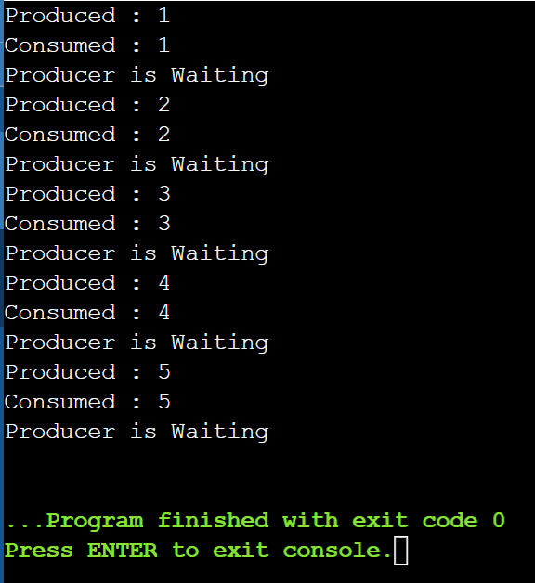
VISHWAKARMA INSTITUTE OF TECHNOLOGY
BRANCH - AI&DS DIVISION- C BATCH- B2
NAME- PRANAMYA VEMULA ROLL NO- 59 PRN NO- 12110758
OS LAB - ASSIGNMENT 2
1. Change your password to a password you would like to use for the remainder of the semester.
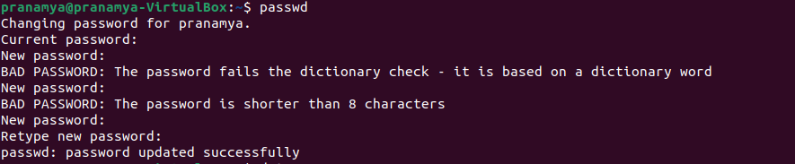
2. Display the system’s date.
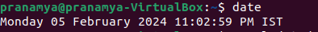
3. Count the number of lines in the /etc/passwd file.
4. Find out who else is on the system.
5. Direct the output of the man pages for the date command to a file named mydate.
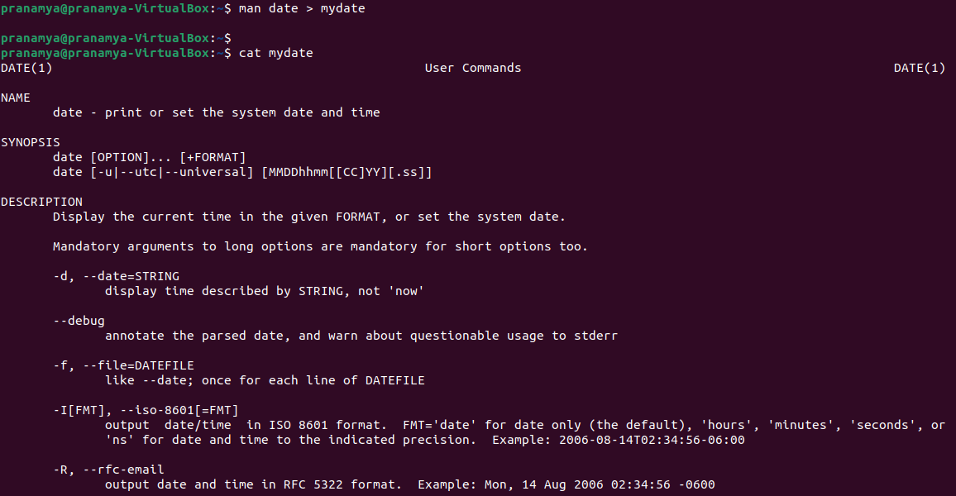
6. Create a subdirectory called mydir.
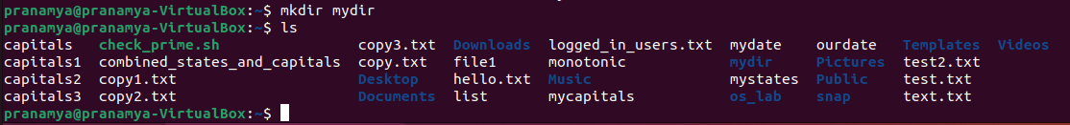
7. Move the file mydate into the new subdirectory.
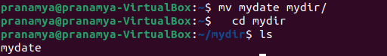
8. Go to the subdirectory mydir and copy the file mydate to a new file called ourdate
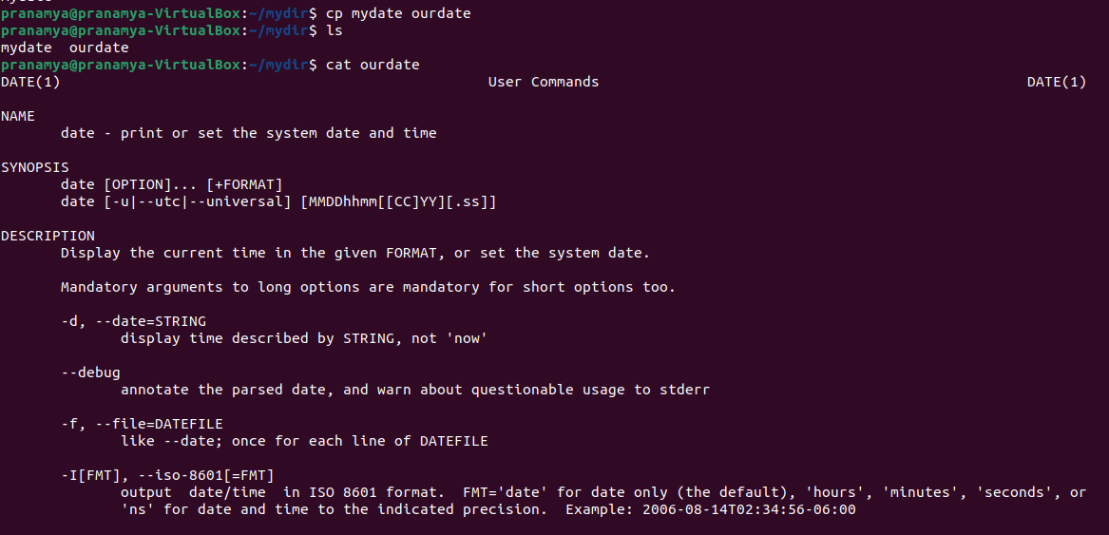
9. List the contents of mydir.
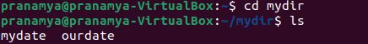
10. Do a long listing on the file ourdate and note the permissions.
11. Display the name of the current directory starting from the root.
12. Move the files in the directory mydir back to the HOME directory.
13. List all the files in your HOME directory.
14. Display the first 5 lines of mydate.
15. Display the last 8 lines of mydate.
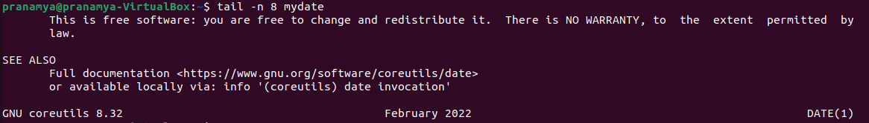
16. Remove the directory mydir.
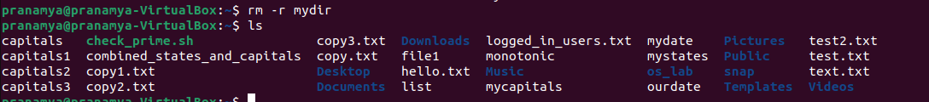
17. Redirect the output of the long listing of files to a file named list.
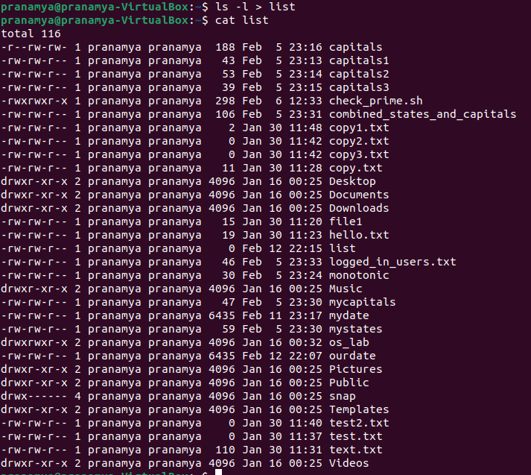
18. Select any 5 capitals of states in India and enter them in a file named capitals1. Choose 5more capitals and enter them in a file named capitals2. Choose 5 more capitals and enter them in a file named capitals3. Concatenate all 3 files and redirect the output to a file named capitals.
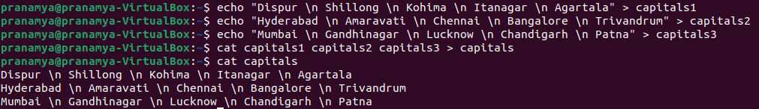
19. Concatenate the file capitals2 at the end of file capitals.
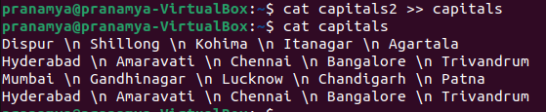
20. Redirect the file capitals as an input to the command “wc –l”.
21. Give read and write permissions to all users for the file capitals.
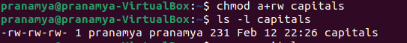
22. Give read permissions only to the owner of the file capitals. Open the file, make some changes and try to save it. What happens ?
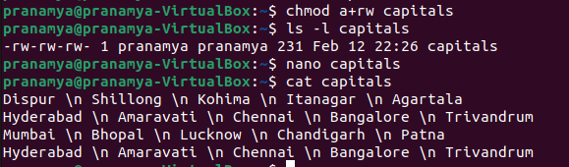
23. Create an alias to concatenate the 3 files capitals1, capitals2, capitals3 and redirect the output to a file named capitals. Activate the alias and make it run.
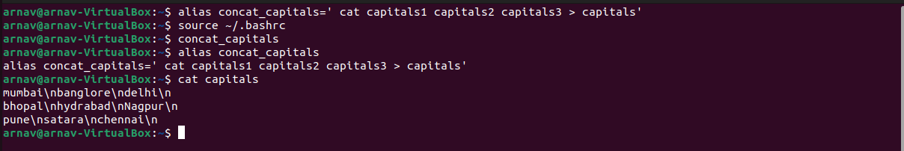
24. What are the environment variables PATH, HOME and TERM set to on your terminal ?
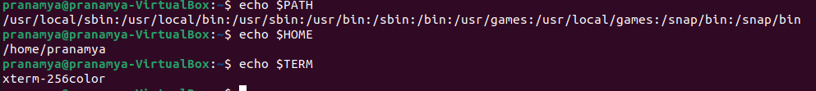
25. Find out the number of times the string “the” appears in the file mydate.
26. Find out the line numbers on which the string “date” exists in mydate.
27. Print all lines of mydate except those that have the letter “i” in them.
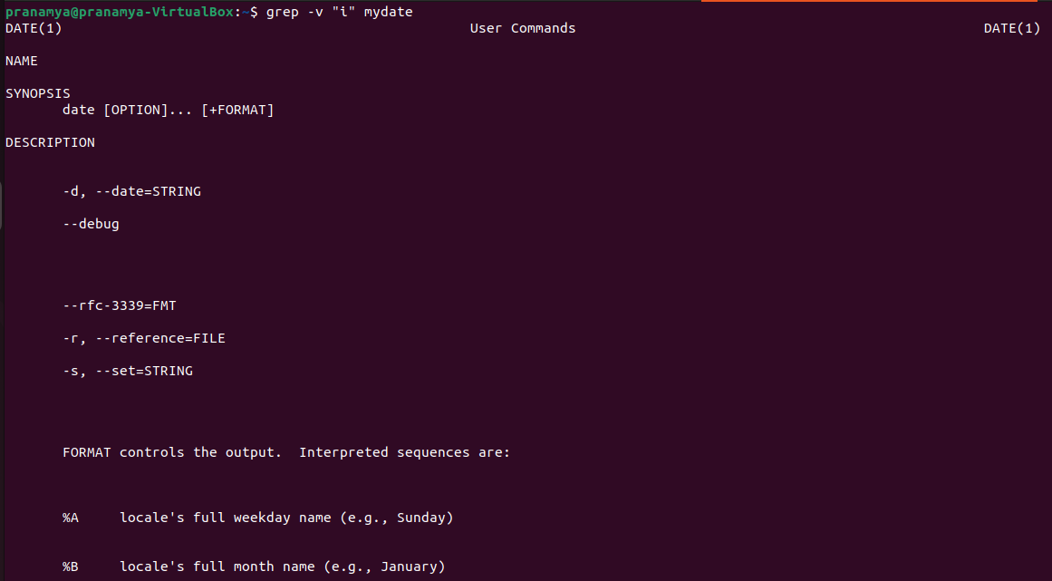
28. Create the file monotonic as follows: ^a?b?b?c? .................x?y?z$ Run the egrep command for monotonic against /usr/dict/words and search for all 4 letter words.
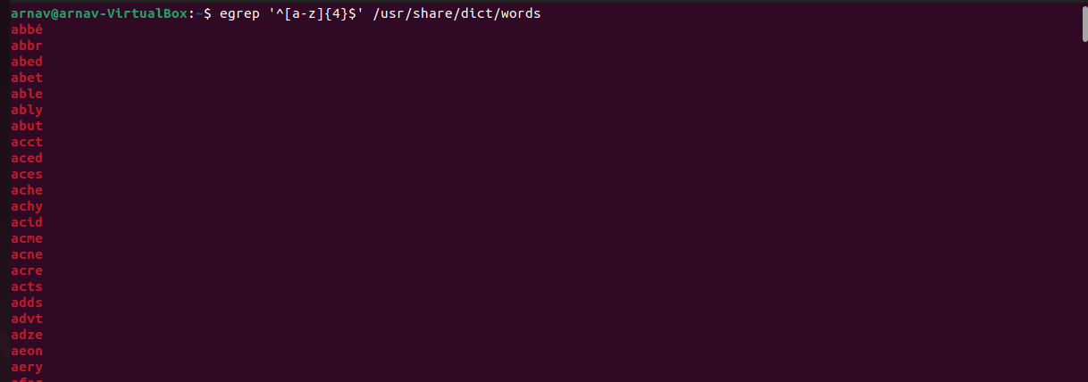
29. List 5 states in north east India in a file mystates. List their corresponding capitals in a file mycapitals. Use the paste command to join the 2 files.
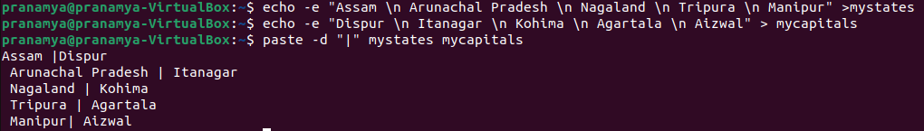
30. Use the cut command to print the 1st and 3rd columns of the /etc/passwd file for all students in this class.
31. Count the number of people logged in and also trap the users in a file using the tee command.
