Exercise 2: E-commerce Platform Search Function

Scenario:
You are working on the search functionality of an e-commerce platform. The search needs to be optimized for fast performance.

Steps:
- Understand Asymptotic Notation:
  - Explain Big O notation and how it helps in analyzing algorithms.
  - Describe the best, average, and worst-case scenarios for search operations.
- Setup:
  - Create a class Product with attributes for searching, such as productId, productName, and category.
- Implementation:
  - Implement linear search and binary search algorithms.
  - Store products in an array for linear search and a sorted array for binary search.
- Analysis:
  - Compare the time complexity of linear and binary search algorithms.
  - Discuss which algorithm is more suitable for your platform and why.

ANSWER

import java.util.Arrays;
import java.util.Comparator;

public class ProductSearchTest {
// Product class with attributes
static class Product {
int productId;
String productName;
String category;
public Product(int id, String name, String category) {
this.productId = id;
this.productName = name;
this.category = category;
}
public String toString() {
return productId + " - " + productName + " (" + category + ")";
}
}

// Linear Search
public static int linearSearch(Product[] products, String name) {
for (int i = 0; i < products.length; i++) {
if (products[i].productName.equalsIgnoreCase(name)) {
return i;
}
}
return -1;
}

// Binary Search (requires sorted array)
public static int binarySearch(Product[] products, String name) {
int left = 0, right = products.length - 1;
while (left <= right) {
int mid = (left + right) / 2;
int cmp = name.compareToIgnoreCase(products[mid].productName);
if (cmp == 0)
return mid;
else if (cmp < 0)
right = mid - 1;
else
left = mid + 1;
}
return -1;
}

// Main method to test searches
public static void main(String[] args) {
Product[] products = {
new Product(101, "Shoes", "Footwear"),
new Product(102, "Laptop", "Electronics"),
new Product(103, "Watch", "Accessories"),
new Product(104, "Phone", "Electronics")
};

System.out.println("🔍 Linear Search for 'Laptop':");
int linearIndex = linearSearch(products, "Laptop");
if (linearIndex != -1)
System.out.println("Found at index: " + linearIndex + " → " + products[linearIndex]);
else
System.out.println("Not found.");
// Sort before binary search
Arrays.sort(products, Comparator.comparing(p -> p.productName.toLowerCase()));
System.out.println("\n🔍 Binary Search for 'Laptop':");
int binaryIndex = binarySearch(products, "Laptop");
if (binaryIndex != -1)
System.out.println("Found at index: " + binaryIndex + " → " + products[binaryIndex]);
else
System.out.println("Not found.");
}
}

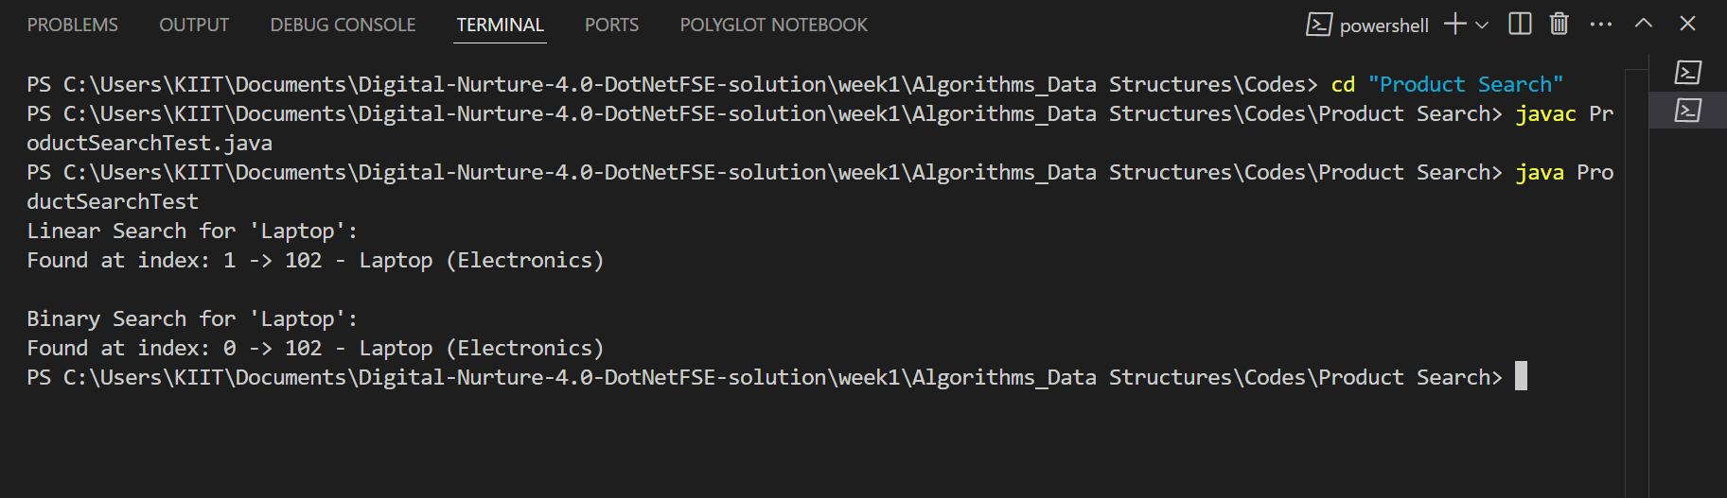
Linear Search is simple but slow for large data. Time: O(n). Binary Search is much faster but requires sorted data. Time: O(log n). We can use binary search with a sorted array or a more advanced structure like Trie or HashMap for real-world performance.
Exercise 7: Financial Forecasting

Scenario:
You are developing a financial forecasting tool that predicts future values based on past data.

Steps:
- Understand Recursive Algorithms:
  - Explain the concept of recursion and how it can simplify certain problems.
- Setup:
  - Create a method to calculate the future value using a recursive approach.
- Implementation:
  - Implement a recursive algorithm to predict future values based on past growth rates.
- Analysis:
  - Discuss the time complexity of your recursive algorithm.
  - Explain how to optimize the recursive solution to avoid excessive computation.

ANSWER

public class FinancialForecastTest {

// Recursive method to forecast future value
public static double forecastRecursive(double amount, double rate, int years) {
if (years == 0)
return amount;
return forecastRecursive(amount * (1 + rate), rate, years - 1);
}

// Main method for testing
public static void main(String[] args) {
double initialAmount = 1000.0;
double annualRate = 0.10; // 10%
int years = 5;

// Using recursive method
double recursiveForecast = forecastRecursive(initialAmount, annualRate, years);
System.out.printf("Recursive Forecast after %d years: Rs%.2f\n", years, recursiveForecast);
}
}

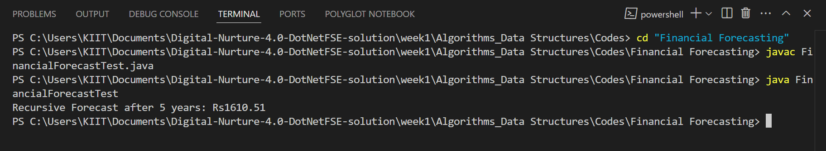

Time Complexity: O(n) due to n recursive calls
Drawback: Can cause stack overflow for very large n
Optimization: Use iteration or memoization

