Exercise 1: Implementing the Singleton Pattern
Scenario:
You need to ensure that a logging utility class in your application has only one instance throughout the application lifecycle to ensure consistent logging.
Steps:
- Create a New Java Project:
  - Create a new Java project named SingletonPatternExample.
- Define a Singleton Class:
  - Create a class named Logger that has a private static instance of itself.
  - Ensure the constructor of Logger is private.
  - Provide a public static method to get the instance of the Logger class.
- Implement the Singleton Pattern:
  - Write code to ensure that the Logger class follows the Singleton design pattern.
- Test the Singleton Implementation:
  - Create a test class to verify that only one instance of Logger is created and used across the application.
ANSWER
public class SingletonTest {
// Singleton Logger class
static class Logger {
private static Logger instance;
private Logger() {
System.out.println("Logger initialized.");
}
public static Logger getInstance() {
if (instance == null) {
instance = new Logger();
}
return instance;
}
public void log(String message) {
System.out.println("Log: " + message);
}
}
// Main method to test Logger
public static void main(String[] args) {
Logger logger1 = Logger.getInstance();
Logger logger2 = Logger.getInstance();
logger1.log("First log message");
logger2.log("Second log message");
if (logger1 == logger2) {
System.out.println("Both logger instances are the same.");
} else {
System.out.println("Logger instances are different.");
}
}
}

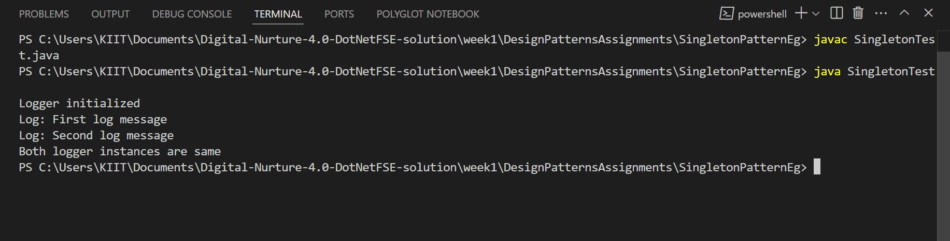
Exercise 2: Implementing the Factory Method Pattern
Scenario:
You are developing a document management system that needs to create different types of documents (e.g., Word, PDF, Excel). Use the Factory Method Pattern to achieve this.
Steps:
- Create a New Java Project:
  - Create a new Java project named FactoryMethodPatternExample.
- Define Document Classes:
  - Create interfaces or abstract classes for different document types such as WordDocument, PdfDocument, and ExcelDocument.
- Create Concrete Document Classes:
  - Implement concrete classes for each document type that implements or extends the above interfaces or abstract classes.
- Implement the Factory Method:
  - Create an abstract class DocumentFactory with a method createDocument().
  - Create concrete factory classes for each document type that extends DocumentFactory and implements the createDocument() method.
- Test the Factory Method Implementation:
  - Create a test class to demonstrate the creation of different document types using the factory method.

ANSWER
public class FactoryMethodTest {
// Document interface
interface Document {
void open();
}
// Concrete document types
static class WordDocument implements Document {
public void open() {
System.out.println("Opening Word document.");
}
}
static class PdfDocument implements Document {
public void open() {
System.out.println("Opening PDF document.");
}
}
static class ExcelDocument implements Document {
public void open() {
System.out.println("Opening Excel document.");
}
}
// Abstract factory
abstract static class DocumentFactory {
public abstract Document createDocument();
}
// Concrete factories
static class WordFactory extends DocumentFactory {
public Document createDocument() {
return new WordDocument();
}
}
static class PdfFactory extends DocumentFactory {
public Document createDocument() {
return new PdfDocument();
}
}
static class ExcelFactory extends DocumentFactory {
public Document createDocument() {
return new ExcelDocument();
}
}
// Main method to test factory
public static void main(String[] args) {
DocumentFactory wordFactory = new WordFactory();
Document wordDoc = wordFactory.createDocument();
wordDoc.open();
DocumentFactory pdfFactory = new PdfFactory();
Document pdfDoc = pdfFactory.createDocument();
pdfDoc.open();
DocumentFactory excelFactory = new ExcelFactory();
Document excelDoc = excelFactory.createDocument();
excelDoc.open();
}
}
