**REACT**

**9. ReactJS-HOL**

**Cricketapp**

**CODE: (App.js)**

import React from 'react';

// Component to list all players

const ListofPlayers = ({ players }) => {

return (

<div>

{players.map((player, index) => (

<div key={index}>

<li>Mr. {player.name} <span>{player.score}</span></li>

</div>

))}

</div>

);

};

// Component to list players with scores below 70

const Scorebelow70 = ({ players }) => {

const playersWithScoresBelow70 = players.filter(item => item.score < 70);

return (

<div>

{playersWithScoresBelow70.map((item, index) => (

<div key={index}>

<li>Mr. {item.name} <span>{item.score}</span></li>

</div>

))}

</div>

);

};

// Component for odd players using destructuring

const OddPlayers = ({ players }) => {

const [first, , third, , fifth] = players;

return (

<div>

<li>First : {first}</li>

<li>Third : {third}</li>

<li>Fifth : {fifth}</li>

</div>

);

};

// Component for even players using destructuring

const EvenPlayers = ({ players }) => {

const [, second, , fourth, , sixth] = players;

return (

<div>

<li>Second : {second}</li>

<li>Fourth : {fourth}</li>

<li>Sixth : {sixth}</li>

</div>

);

};

// Component to list merged players

const ListofIndianPlayers = ({ IndianPlayers }) => {

return (

<div>

{IndianPlayers.map((player, index) => (

<div key={index}>

<li>Mr. {player}</li>

</div>

))}

</div>

);

};

// Main App component

const App = () => {

const flag = true; // Set to 'true' or 'false' to switch the output

const players = [

{ name: 'Jackmen', score: 50 },

{ name: 'Michael killer', score: 70 },

{ name: 'Jagan', score: 40 },

{ name: 'Annil', score: 61 },

{ name: 'Elisabeth steel', score: 61 },

{ name: 'Sachin', score: 95 },

{ name: 'MS Dhoni', score: 100 },

{ name: 'Virat Kohli', score: 94 },

{ name: 'Jadeja', score: 64 },

{ name: 'Raina', score: 75 },

{ name: 'Rohit Sharma', score: 99 }

];

if (flag) {

return (

<div>

<h1>List of Players</h1>

<ListofPlayers players={players} />

<hr />

<h1>List of Players having Scores Less than 70</h1>

<Scorebelow70 players={players} />

</div>

);

} else {

const T20Players = ['Sachin', 'Dhoni', 'Virat'];

const RanjiTrophyPlayers = ['Yuvraj', 'Raina', 'Rohit'];

const IndianTeam = [...T20Players, ...RanjiTrophyPlayers];

return (

<div>

<h1>Indian Team</h1>

<hr />

<h1>Odd Players</h1>

<OddPlayers players={IndianTeam} />

<hr />

<h1>Even Players</h1>

<EvenPlayers players={IndianTeam} />

<hr />

<h1>List of Indian Players Merged:</h1>

<ListofIndianPlayers IndianPlayers={IndianTeam} />

</div>

);

}

};

export default App;

**OUPUT:**

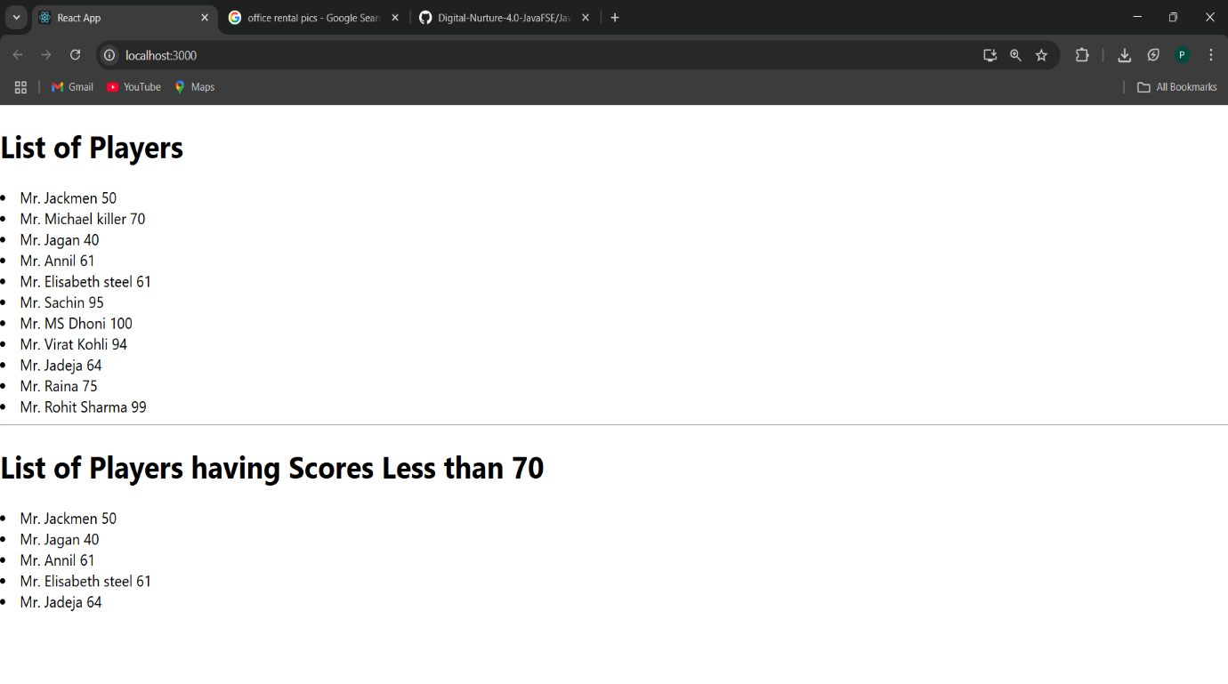

**10. ReactJS-HOL**

**Officespacerentalapp**

**Code(App.js):**

import React from 'react';

function App() {

const officeSpaces = [

{

name: 'IndiQube Alpha',

rent: 55000,

address: 'Koramangala, Bangalore',

image: 'https://via.placeholder.com/300x200?text=Office+1',

},

{

name: 'Regus Business Center',

rent: 75000,

address: 'MG Road, Bangalore',

image: 'https://via.placeholder.com/300x200?text=Office+2',

},

{

name: 'WeWork Galaxy',

rent: 68000,

address: 'Residency Road, Bangalore',

image: 'https://via.placeholder.com/300x200?text=Office+3',

},

{

name: 'StartupHuts',

rent: 45000,

address: 'HSR Layout, Bangalore',

image: 'https://via.placeholder.com/300x200?text=Office+4',

},

];

// Style for heading

const headingStyle = {

textAlign: 'center',

color: '#2c3e50',

marginTop: '20px',

};

// Component to render a single office card

const renderOfficeCard = (office, index) => {

const rentStyle = {

color: office.rent > 60000 ? 'green' : 'red',

fontWeight: 'bold',

};

return (

<div

key={index}

style={{

border: '1px solid #ccc',

borderRadius: '8px',

padding: '16px',

margin: '16px',

width: '300px',

boxShadow: '2px 2px 10px rgba(0,0,0,0.1)',

}}

>

<img

src={office.image}

alt={office.name}

style={{ width: '100%', borderRadius: '5px' }}

/>

<h3>{office.name}</h3>

<p style={rentStyle}>Rent: ₹{office.rent}</p>

<p>Address: {office.address}</p>

</div>

);

};

return (

<div>

<h1 style={headingStyle}>Office Space Rental App</h1>

<div

style={{

display: 'flex',

flexWrap: 'wrap',

justifyContent: 'center',

}}

>

{officeSpaces.map(renderOfficeCard)}

</div>

</div>

);

}

export default App;

**OUPUT:**

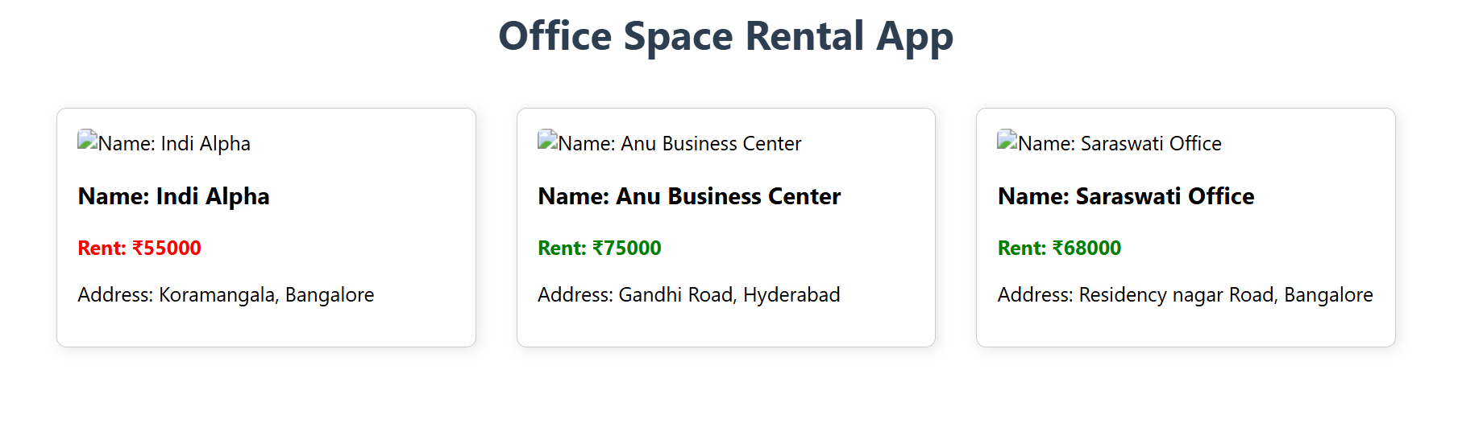

**11. ReactJS-HOL**

**Eventexamplesapp**

**CODE(App.js):**

import React, { useState } from 'react';

function App() {

const [count, setCount] = useState(0);

const [rupees, setRupees] = useState('');

const [euro, setEuro] = useState(null);

// Increment handlers

const handleIncrement = () => {

increment();

greet();

};

const increment = () => {

setCount(prev => prev + 1);

};

const greet = () => {

console.log('Hello! Keep Learning React!');

};

// Decrement handler

const handleDecrement = () => {

setCount(prev => prev - 1);

};

// Say Welcome handler

const sayWelcome = (message) => {

alert(`Message: ${message}`);

};

// Synthetic event handler

const handleSyntheticClick = (e) => {

console.log('Synthetic Event Type:', e.type);

alert('I was clicked');

};

// Currency Conversion

const handleCurrencyConvert = (e) => {

e.preventDefault();

const rupeeValue = parseFloat(rupees);

if (!isNaN(rupeeValue)) {

const converted = (rupeeValue / 90).toFixed(2); // Assume 1 Euro = 90 INR

setEuro(converted);

} else {

setEuro(null);

alert('Please enter a valid number!');

}

};

return (

<div style={{ padding: '20px', fontFamily: 'Arial' }}>

<h1 style={{ textAlign: 'center' }}>React Event Handling Examples</h1>

<div style={{ marginBottom: '30px' }}>

<h2>Counter: {count}</h2>

<button onClick={handleIncrement} style={{ marginRight: '10px' }}>Increment</button>

<button onClick={handleDecrement}>Decrement</button>

</div>

<div style={{ marginBottom: '30px' }}>

<button onClick={() => sayWelcome('Welcome to React Event Handling!')}>

Say Welcome

</button>

</div>

<div style={{ marginBottom: '30px' }}>

<button onClick={handleSyntheticClick}>Synthetic OnPress</button>

</div>

<div>

<h2>Currency Convertor (INR → Euro)</h2>

<form onSubmit={handleCurrencyConvert}>

<input

type="text"

placeholder="Enter amount in ₹"

value={rupees}

onChange={(e) => setRupees(e.target.value)}

style={{ padding: '5px', marginRight: '10px' }}

/>

<button type="submit">Convert</button>

</form>

{euro && (

<p style={{ marginTop: '10px' }}>

€ {euro}

</p>

)}

</div>

</div>

);

}

export default App;

**OUPUT:**

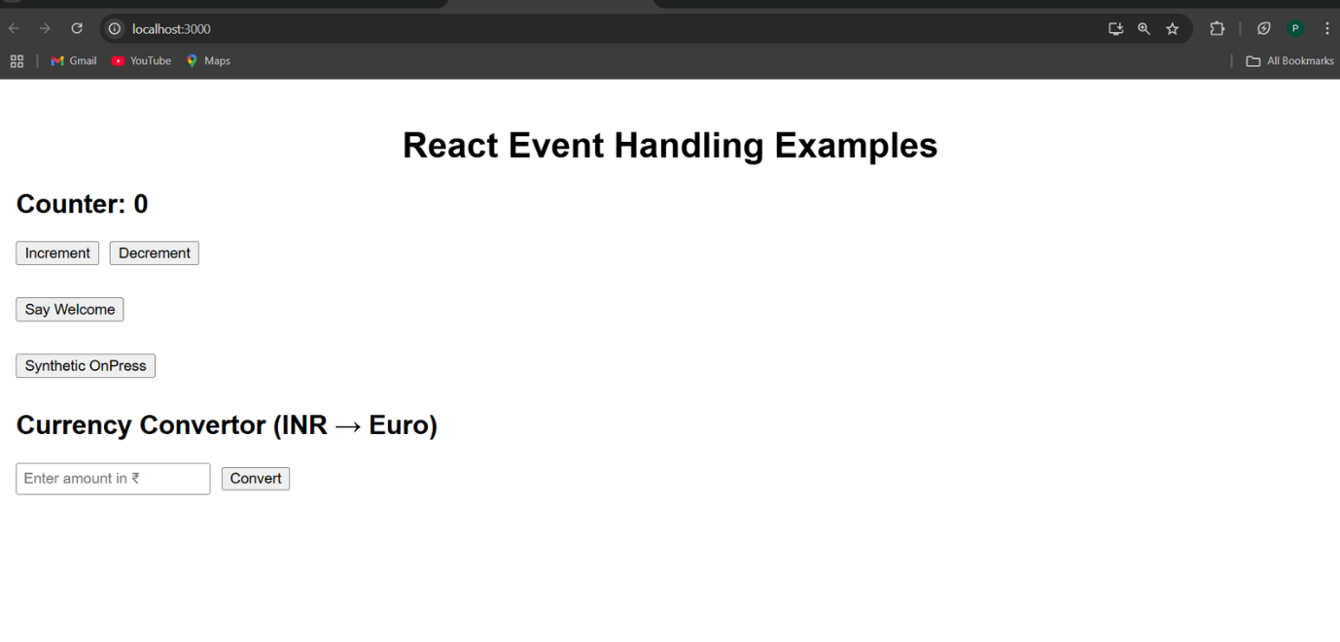

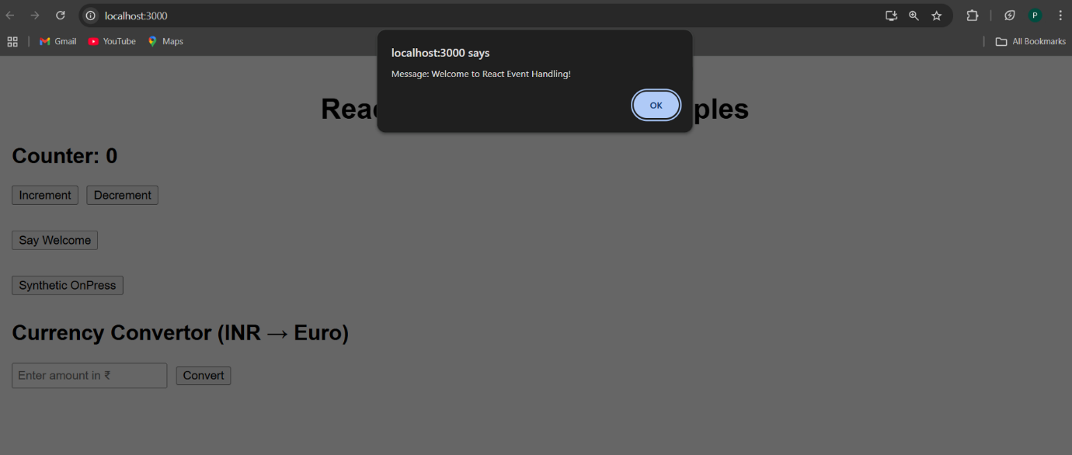

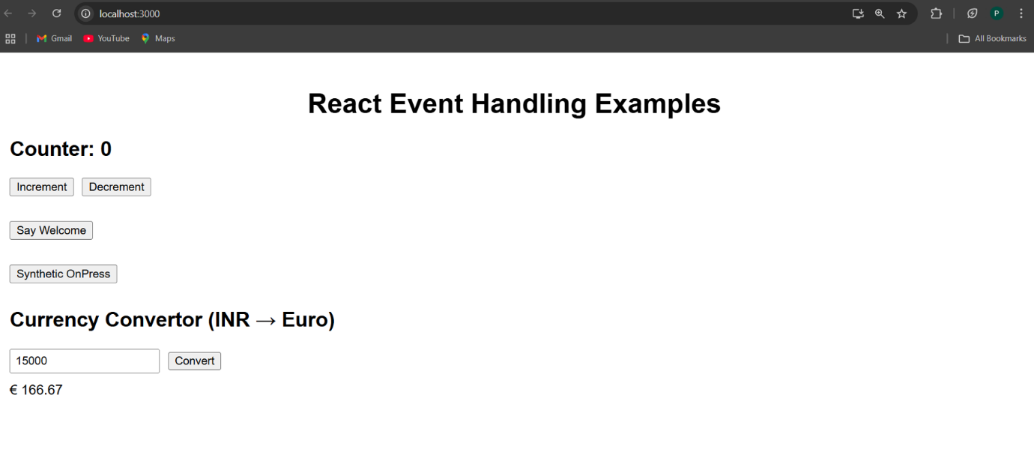

12. ReactJS-HOL

**Ticketbookingapp**

**Code(App.js):**

import React, { useState } from 'react';

function App() {

// State to track if user is logged in

const [isLoggedIn, setIsLoggedIn] = useState(false);

// Sample flight details

const flightDetails = [

{ flightNo: 'AI202', from: 'Bangalore', to: 'Delhi', time: '10:00 AM' },

{ flightNo: 'SG345', from: 'Hyderabad', to: 'Mumbai', time: '1:45 PM' },

{ flightNo: '6E789', from: 'Chennai', to: 'Kolkata', time: '6:20 PM' },

];

// Login handler

const handleLogin = () => {

setIsLoggedIn(true);

};

// Logout handler

const handleLogout = () => {

setIsLoggedIn(false);

};

// Conditionally rendered button

const authButton = isLoggedIn ? (

<button onClick={handleLogout} style={buttonStyle}>Logout</button>

) : (

<button onClick={handleLogin} style={buttonStyle}>Login</button>

);

// Component for flight list

const renderFlights = () => (

<table style={tableStyle}>

<thead>

<tr>

<th>Flight No</th>

<th>From</th>

<th>To</th>

<th>Time</th>

{isLoggedIn && <th>Action</th>}

</tr>

</thead>

<tbody>

{flightDetails.map((flight, index) => (

<tr key={index}>

<td>{flight.flightNo}</td>

<td>{flight.from}</td>

<td>{flight.to}</td>

<td>{flight.time}</td>

{isLoggedIn && <td><button style={bookBtnStyle}>Book Ticket</button></td>}

</tr>

))}

</tbody>

</table>

);

return (

<div style={containerStyle}>

<h1 style={headingStyle}>Ticket Booking App</h1>

{authButton}

<p style={messageStyle}>

{isLoggedIn ? 'Welcome, you can book tickets!' : 'Hello Guest, please login to book tickets.'}

</p>

{renderFlights()}

</div>

);

}

const containerStyle = {

padding: '20px',

fontFamily: 'Arial',

textAlign: 'center',

};

const headingStyle = {

color: '#2c3e50',

};

const buttonStyle = {

marginBottom: '15px',

padding: '8px 16px',

fontSize: '16px',

cursor: 'pointer',

};

const bookBtnStyle = {

padding: '5px 10px',

backgroundColor: '#2980b9',

color: 'white',

border: 'none',

borderRadius: '4px',

cursor: 'pointer',

};

const tableStyle = {

width: '80%',

margin: '0 auto',

borderCollapse: 'collapse',

};

const messageStyle = {

fontStyle: 'italic',

marginBottom: '10px',

};

export default App;

**OUTPUT:**

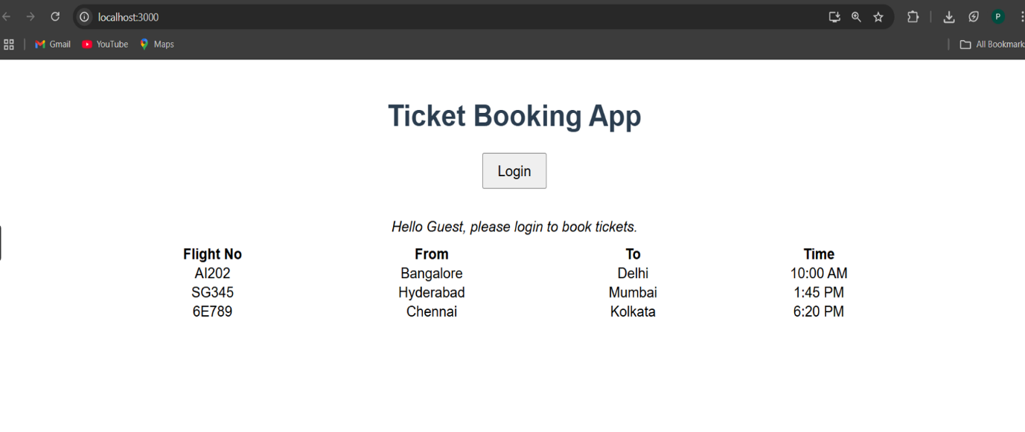

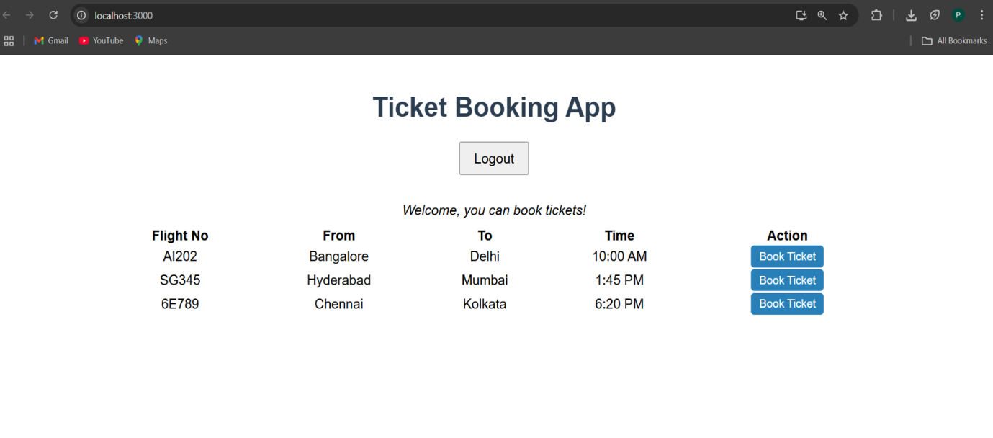

**13. ReactJS-HOL**

**Bloggerapp**

**CODE(App.js):**

import React, { useState } from 'react';

const BookDetails = ({ books }) => (

<div>

<h2>Book List</h2>

<ul>

{books.map((book, index) => (

<li key={index}>

<strong>{book.title}</strong> by {book.author}

</li>

))}

</ul>

</div>

);

const BlogDetails = ({ blogs }) => (

<div>

<h2>Blog Posts</h2>

{blogs.length > 0 ? (

<ul>

{blogs.map((blog, index) => (

<li key={index}>

<strong>{blog.title}</strong> - {blog.snippet}

</li>

))}

</ul>

) : (

<p>No blogs to show.</p>

)}

</div>

);

const CourseDetails = ({ courses }) => {

if (!courses || courses.length === 0) {

return <p>No courses available.</p>;

}

return (

<div>

<h2>Courses</h2>

<ul>

{courses.map((course, index) => (

<li key={index}>

{course.name} ({course.duration})

</li>

))}

</ul>

</div>

);

};

function App() {

const [activeComponent, setActiveComponent] = useState('book');

const books = [

{ title: 'Atomic Habits', author: 'James Clear' },

{ title: 'The Alchemist', author: 'Paulo Coelho' },

];

const blogs = [

{ title: 'React Basics', snippet: 'Learn components and JSX' },

{ title: 'State & Props', snippet: 'Understand state management' },

];

const courses = [

{ name: 'React Fundamentals', duration: '4 weeks' },

{ name: 'Advanced React', duration: '6 weeks' },

];

let displayElement;

// Element variable (used here)

if (activeComponent === 'book') {

displayElement = <BookDetails books={books} />;

} else if (activeComponent === 'blog') {

displayElement = <BlogDetails blogs={blogs} />;

} else {

displayElement = <CourseDetails courses={courses} />;

}

return (

<div style={styles.container}>

<h1 style={styles.heading}>Blogger App</h1>

{/* Ternary operator */}

<p style={styles.info}>

{activeComponent === 'book'

? 'Showing Book Details'

: activeComponent === 'blog'

? 'Showing Blog Posts'

: 'Showing Courses'}

</p>

{/* Buttons */}

<div style={styles.buttonGroup}>

<button onClick={() => setActiveComponent('book')}>Books</button>

<button onClick={() => setActiveComponent('blog')}>Blogs</button>

<button onClick={() => setActiveComponent('course')}>Courses</button>

</div>

{/* Logical && Operator */}

{activeComponent && <div>{displayElement}</div>}

</div>

);

}

// Styles

const styles = {

container: {

textAlign: 'center',

fontFamily: 'Arial, sans-serif',

padding: '20px',

},

heading: {

color: '#2c3e50',

},

info: {

fontStyle: 'italic',

color: '#555',

},

buttonGroup: {

margin: '20px',

display: 'flex',

justifyContent: 'center',

gap: '10px',

},

};

export default App;

OUPUT:

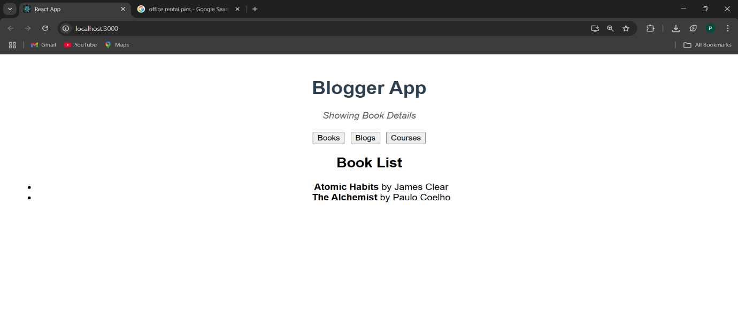

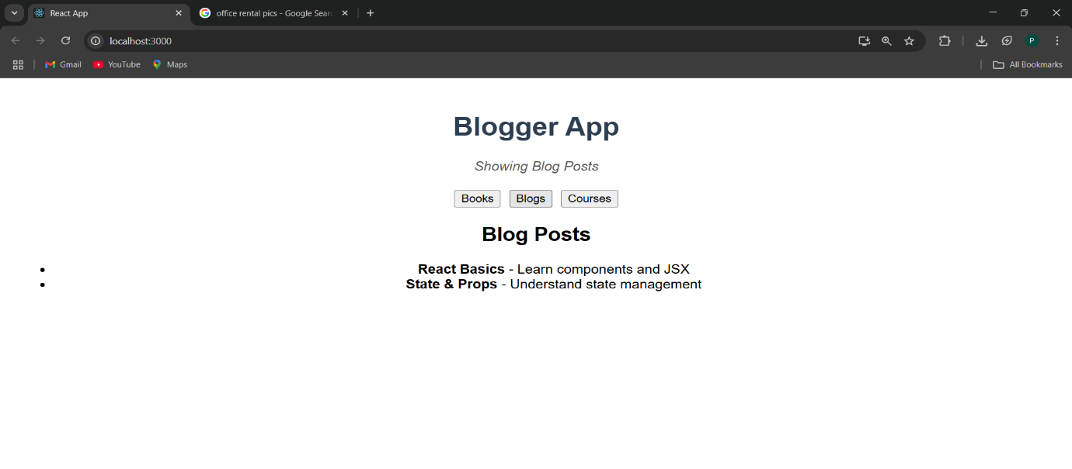

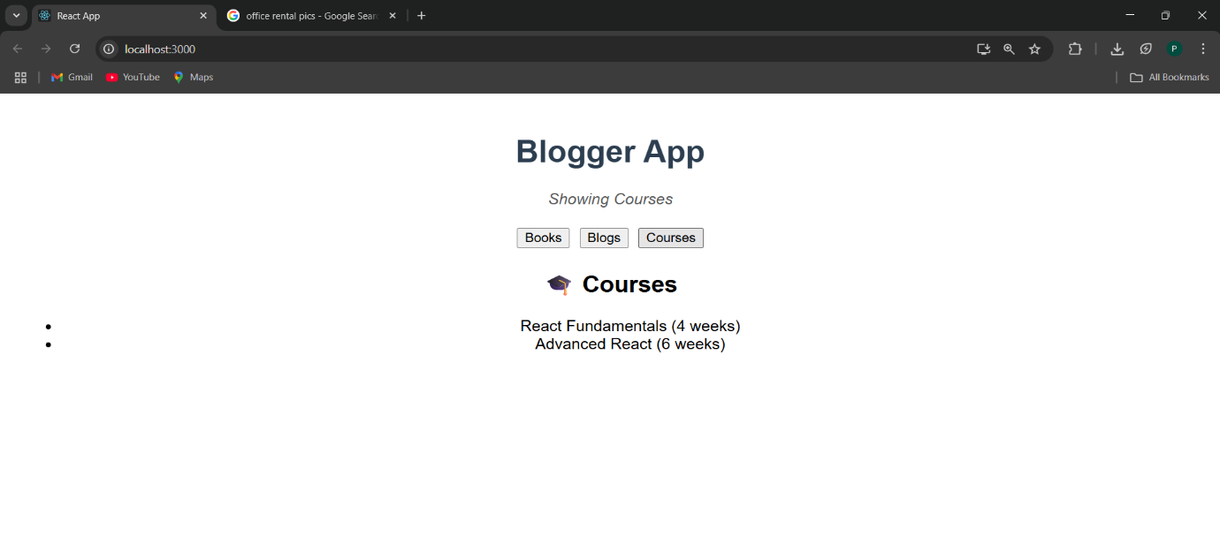

**14. ReactJS-HOL**

**Employee Management Applications**

**Code(App.js):**

import React, { useState, createContext, useContext } from 'react';

// Create the context with default value

const ThemeContext = createContext('light');

// EmployeeCard component

const EmployeeCard = ({ employee }) => {

const theme = useContext(ThemeContext);

const cardStyle = {

border: '1px solid #ccc',

borderRadius: '10px',

padding: '15px',

margin: '10px auto',

width: '300px',

backgroundColor: theme === 'light' ? '#fff' : '#444',

color: theme === 'light' ? '#000' : '#fff'

};

const btnStyle = {

padding: '8px 16px',

border: 'none',

borderRadius: '5px',

backgroundColor: theme === 'light' ? '#007bff' : '#00bcd4',

color: '#fff',

cursor: 'pointer'

};

return (

<div style={cardStyle}>

<h3>{employee.name}</h3>

<p>{employee.position}</p>

<button style={btnStyle}>View Profile</button>

</div>

);

};

// EmployeeList component

const EmployeeList = () => {

const employees = [

{ id: 1, name: 'Anu Sri', position: 'Frontend Developer' },

{ id: 2, name: 'Priyamani', position: 'Backend Developer' },

{ id: 3, name: 'Ravi Kumar', position: 'DevOps Engineer' },

];

return (

<div style={{ marginTop: '30px' }}>

{employees.map(emp => (

<EmployeeCard key={emp.id} employee={emp} />

))}

</div>

);

};

// App component

function App() {

const [theme, setTheme] = useState('light');

const toggleTheme = () => {

setTheme(prev => (prev === 'light' ? 'dark' : 'light'));

};

const appStyle = {

backgroundColor: theme === 'light' ? '#f9f9f9' : '#222',

color: theme === 'light' ? '#000' : '#fff',

minHeight: '100vh',

padding: '20px',

textAlign: 'center'

};

return (

<ThemeContext.Provider value={theme}>

<div style={appStyle}>

<h1>Employee Management System</h1>

<button onClick={toggleTheme} style={{ marginBottom: '20px', padding: '10px 20px' }}>

Switch to {theme === 'light' ? 'Dark' : 'Light'} Mode

</button>

<EmployeeList />

</div>

</ThemeContext.Provider>

);

}

export default App;

OUPUT:

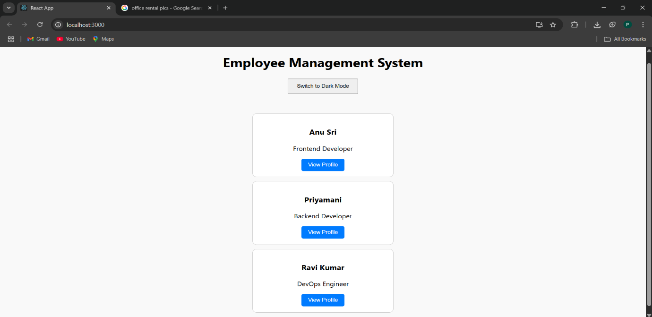

**15. ReactJS-HOL**

**Ticketraisingapp**

**Code(App.js):**

import React, { useState } from 'react';

function App() {

const [employeeName, setEmployeeName] = useState('');

const [complaint, setComplaint] = useState('');

// Generate a random reference number (6-digit)

const generateRefNumber = () => {

return 'REF' + Math.floor(100000 + Math.random() * 900000);

};

const handleSubmit = (e) => {

e.preventDefault();

if (employeeName.trim() === '' || complaint.trim() === '') {

alert('Please fill in all fields before submitting.');

return;

}

const refNumber = generateRefNumber();

alert(`Thank you, ${employeeName}! Your complaint has been submitted.\nReference Number: ${refNumber}`);

// Clear the form

setEmployeeName('');

setComplaint('');

};

const containerStyle = {

maxWidth: '500px',

margin: '50px auto',

padding: '20px',

border: '1px solid #ddd',

borderRadius: '8px',

backgroundColor: '#f9f9f9',

fontFamily: 'Arial',

};

const inputStyle = {

width: '100%',

padding: '10px',

marginBottom: '15px',

borderRadius: '4px',

border: '1px solid #ccc',

fontSize: '16px',

};

const buttonStyle = {

padding: '10px 20px',

fontSize: '16px',

backgroundColor: '#007bff',

color: '#fff',

border: 'none',

borderRadius: '4px',

cursor: 'pointer',

};

return (

<div style={containerStyle}>

<h2>📝 Complaint Register</h2>

<form onSubmit={handleSubmit}>

<label>

Employee Name:

<input

type="text"

value={employeeName}

onChange={(e) => setEmployeeName(e.target.value)}

placeholder="Enter your name"

style={inputStyle}

/>

</label>

<br />

<label>

Complaint Details:

<textarea

value={complaint}

onChange={(e) => setComplaint(e.target.value)}

rows="5"

placeholder="Describe your complaint here..."

style={inputStyle}

></textarea>

</label>

<br />

<button type="submit" style={buttonStyle}>

Submit Complaint

</button>

</form>

</div>

);

}

export default App;

OUPUT:

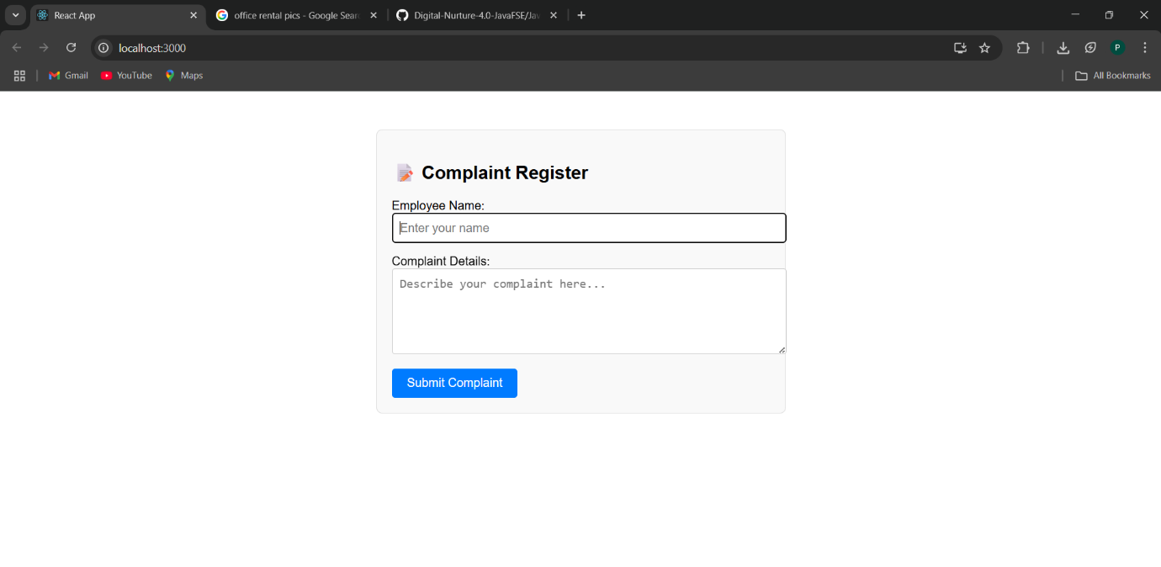

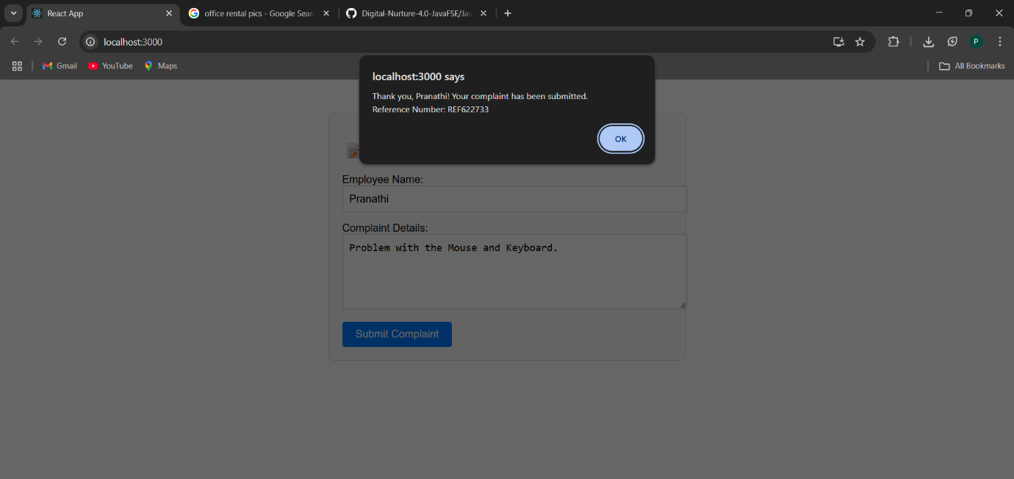

**16. ReactJS-HOL**

**Mailregisterapp**

**Code(App.js):**

import React, { useState } from 'react';

function App() {

const [formData, setFormData] = useState({

name: '',

email: '',

password: '',

});

const [errors, setErrors] = useState({});

// Validation logic

const validate = () => {

const newErrors = {};

if (formData.name.trim().length < 5) {

newErrors.name = 'Name must be at least 5 characters long.';

}

if (!formData.email.includes('@') || !formData.email.includes('.')) {

newErrors.email = 'Email must be valid and contain "@" and "."';

}

if (formData.password.length < 8) {

newErrors.password = 'Password must be at least 8 characters long.';

}

return newErrors;

};

const handleChange = (e) => {

const { name, value } = e.target;

setFormData(prev => ({

...prev,

[name]: value

}));

};

const handleSubmit = (e) => {

e.preventDefault();

const validationErrors = validate();

setErrors(validationErrors);

if (Object.keys(validationErrors).length === 0) {

alert(`Registration successful!\nName: ${formData.name}\nEmail: ${formData.email}`);

setFormData({ name: '', email: '', password: '' });

}

};

const containerStyle = {

maxWidth: '500px',

margin: '40px auto',

padding: '20px',

border: '1px solid #ddd',

borderRadius: '8px',

backgroundColor: '#f4f4f4',

fontFamily: 'Arial'

};

const inputStyle = {

width: '100%',

padding: '10px',

marginBottom: '8px',

borderRadius: '4px',

border: '1px solid #ccc',

fontSize: '15px',

};

const errorStyle = {

color: 'red',

fontSize: '13px',

marginBottom: '10px'

};

const buttonStyle = {

padding: '10px 20px',

backgroundColor: '#28a745',

color: '#fff',

border: 'none',

borderRadius: '5px',

fontSize: '16px',

cursor: 'pointer',

};

return (

<div style={containerStyle}>

<h2>Mail Register Here!!!</h2>

<form onSubmit={handleSubmit}>

<label>Name:</label>

<input

type="text"

name="name"

value={formData.name}

onChange={handleChange}

style={inputStyle}

placeholder="Enter your name"

/>

{errors.name && <div style={errorStyle}>{errors.name}</div>}

<label>Email:</label>

<input

type="email"

name="email"

value={formData.email}

onChange={handleChange}

style={inputStyle}

placeholder="Enter your email"

/>

{errors.email && <div style={errorStyle}>{errors.email}</div>}

<label>Password:</label>

<input

type="password"

name="password"

value={formData.password}

onChange={handleChange}

style={inputStyle}

placeholder="Enter a strong password"

/>

{errors.password && <div style={errorStyle}>{errors.password}</div>}

<button type="submit" style={buttonStyle}>Register</button>

</form>

</div>

);

}

export default App;

OUPUT:

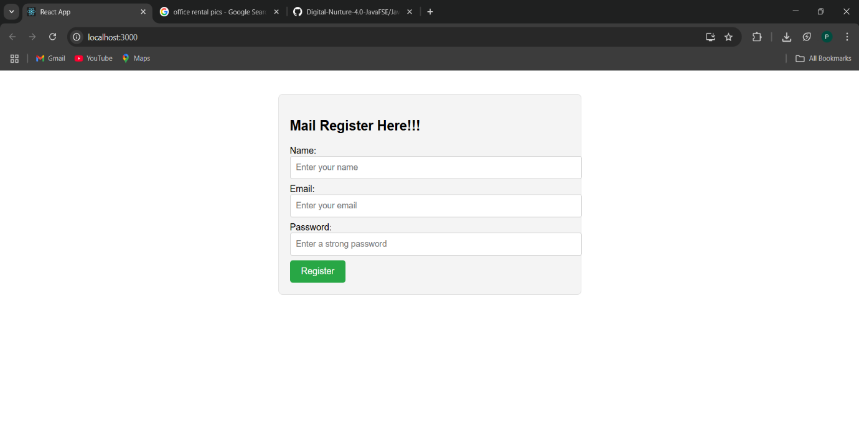

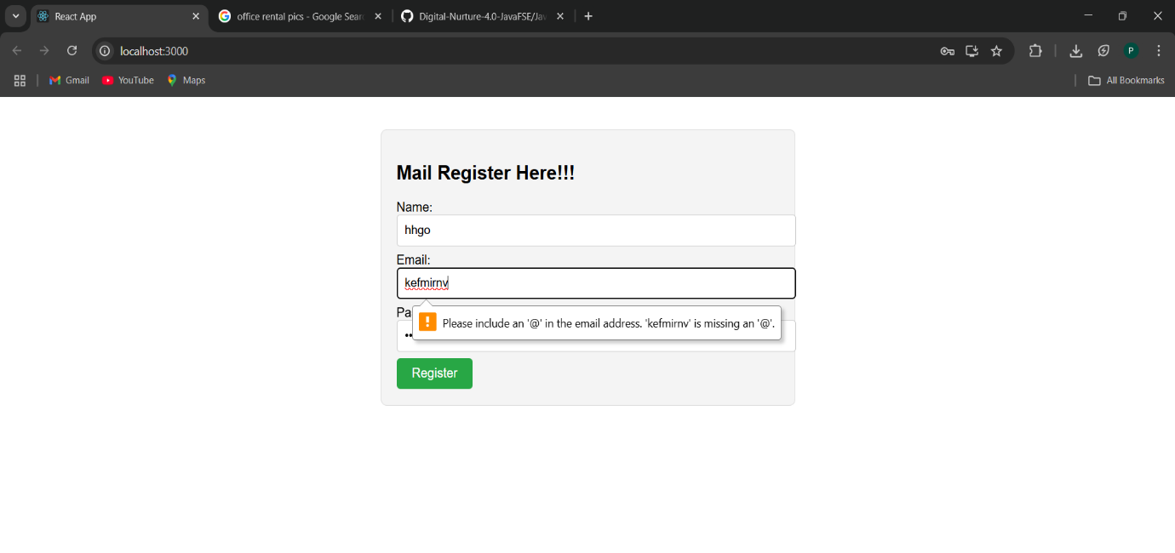

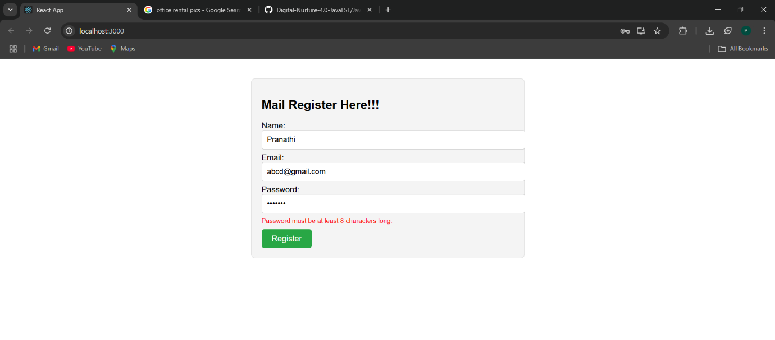

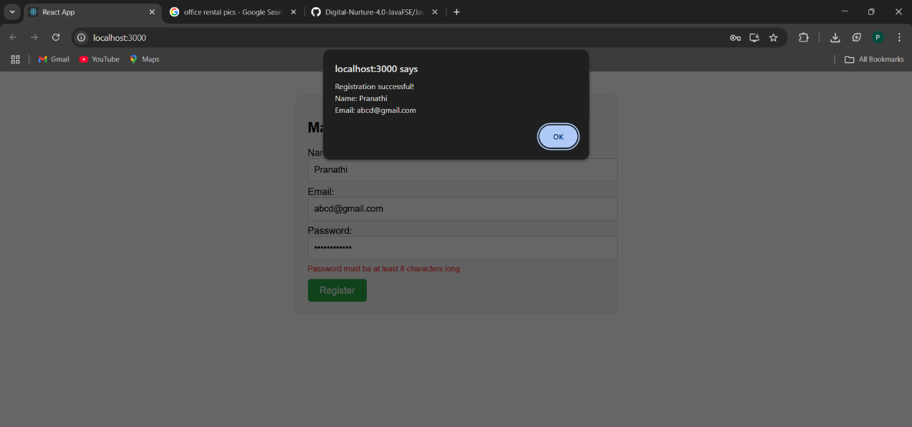

**17. ReactJS-HOL**

**Fetchuserapp**

**Code(App.js):**

import React from 'react';

class Getuser extends React.Component {

constructor(props) {

super(props);

this.state = {

user: null,

loading: true,

error: null,

};

}

async componentDidMount() {

try {

const response = await fetch('https://api.randomuser.me/');

if (!response.ok) {

throw new Error('Failed to fetch user data.');

}

const data = await response.json();

const userData = data.results[0];

this.setState({

user: {

title: userData.name.title,

firstName: userData.name.first,

picture: userData.picture.large,

},

loading: false,

});

} catch (error) {

this.setState({ error: error.message, loading: false });

}

}

render() {

const { user, loading, error } = this.state;

const containerStyle = {

textAlign: 'center',

marginTop: '50px',

fontFamily: 'Arial',

};

const cardStyle = {

display: 'inline-block',

border: '1px solid #ccc',

borderRadius: '10px',

padding: '20px',

backgroundColor: '#f4f4f4',

boxShadow: '0px 2px 8px rgba(0,0,0,0.1)',

};

if (loading) {

return <div style={containerStyle}><p>Loading user data...</p></div>;

}

if (error) {

return <div style={containerStyle}><p style={{ color: 'red' }}>Error: {error}</p></div>;

}

return (

<div style={containerStyle}>

<h2>User Profile</h2>

<div style={cardStyle}>

<img

src={user.picture}

alt="User"

style={{ borderRadius: '50%', width: '150px', marginBottom: '15px' }}

/>

<h3>{user.title} {user.firstName}</h3>

</div>

</div>

);

}

}

// App Component

function App() {

return (

<div>

<Getuser />

</div>

);

}

export default App;

OUTPUT:

