A Project Stage-I Report on

FAKE NEWS DETECTION USING GNNs
Submitted in Partial fulfillment of requirements for the award of the degree of

BACHELOR OF TECHNOLOGY

In INFORMATION TECHNOLOGY
By

AKULA SAI VIJAYA 23BD1A1203 BODHANKARADITYA 23BD1A1212 KARNATI ABHIGNYA
SHANTHI DURGA 23BD1A1228 PRANATHI BAREDDY 23BD1A1253

Under the guidance of

Ms. T N SRI RANJANI
Assistant Professor, Department of IT



DEPARTMENT OF INFORMATION TECHNOLOGY



KESHAV MEMORIAL INSTITUTE OF TECHNOLOGY
(AN AUTONOMOUS INSTITUTION)
Accredited by NBA & NAAC, Approved by AICTE, Affiliated to JNTUH.
Narayanaguda, Hyderabad, Telangana-29
2026-27

DEPARTMENT OF INFORMATION TECHNOLOGY
CERTIFICATE


This is to certify that this is a bonafide record of the project report titled “FAKE NEWS DETECTION USING GNNs” which is being presented as the Project Stage-I report in IV year I Semester (KR23) by

- AKULA SAI VIJAYA 23BD1A1203
- BODHANKAR ADITYA 23BD1A1212
- KARNATI ABHIGNYA SHANTHI DURGA 23BD1A1228
- PRANATHI BAREDDY 23BD1A1253

In partial fulfillment for the award of the degree of Bachelor of Technology in Computer Science and Engineering at Keshav Memorial Institute of Technology (An Autonomous Institution) Narayanaguda, affiliated to the Jawaharlal Nehru Technological University Hyderabad, Hyderabad

Faculty Supervisor Head of Department
(Ms T N SRI RANJANI) (Mr. Para Upendar)

Vision & Mission of KMIT

Vision of the Institution

  - To be the fountain head in producing highly skilled, globally competent engineers.
  - Producing quality graduates trained in the latest software technologies and related tools and striving to make India a world leader in software products and services.

Mission of the Institution

  - To provide a learning environment that inculcates problem solving skills, professional, ethical responsibilities, lifelong learning through multi modal platforms and prepares students to become successful professionals.
  - To establish an industry institute Interaction to make students ready for the industry.
  - To provide exposure to students on the latest hardware and software tools.
  - To promote research-based projects/activities in the emerging areas of technology convergence.
  - To encourage and enable students to not merely seek jobs from the industry but also to create new enterprises.
  - To induce a spirit of nationalism which will enable the student to develop, understand India's challenges and to encourage them to develop effective solutions.
  - To support the faculty to accelerate their learning curve to deliver excellent service to students.

Vision & Mission of CSE

Vision of the Department
To be among the region's premier teaching and research Computer Science and Engineering departments producing globally competent and socially responsible graduates in the most conducive academic environment.

Mission of the Department

- To provide faculty with state of the art facilities for continuous professional development and research, both in foundational aspects and of relevance to emerging computing trends.
- To impart skills that transform students to develop technical solutions for societal needs and inculcate entrepreneurial talents.
- To inculcate an ability in students to pursue the advancement of knowledge in various specializations of Computer Science and Engineering and make them industry-ready.
- To engage in collaborative research with academia and industry and generate adequate resources for research activities for seamless transfer of knowledge resulting in sponsored projects and consultancy.
- To cultivate responsibility through sharing of knowledge and innovative computing solutions that benefit the society-at-large.
- To collaborate with academia, industry and community to set high standards in academic excellence and in fulfilling societal responsibilities

PROGRAM OUTCOMES (POs)

PO1. Engineering Knowledge: Apply the knowledge of mathematics, science, engineering fundamentals, and an engineering specialization to the solution of complex engineering problems.

PO2. Problem Analysis: Identify formulate, review research literature, and analyze complex engineering problems reaching substantiated conclusions using first principles of mathematics, natural sciences, and engineering sciences

PO3. Design/Development of solutions: Design solutions for complex engineering problems and design system components or processes that meet the specified needs with appropriate consideration for the public health and safety, and the cultural, societal, and environmental considerations.

PO4. Conduct Investigations of Complex problems: Use research-based knowledge and research methods including design of experiments, analysis and interpretation of data, and synthesis of the information to provide valid conclusions.

PO5. Modern Tool Usage: Create select, and, apply appropriate techniques, resources, and modern engineering and IT tools including prediction and modeling to complex engineering activities with an understanding of the limitations.

PO6. The Engineer and Society: Apply reasoning informed by contextual knowledge to societal, health, safety. Legal und cultural issues and the consequent responsibilities relevant to professional engineering practice.

PO7. Environment and Sustainability: Understand the impact of the professional engineering solutions in societal and environmental contexts and demonstrate the knowledge of, and need for sustainable development.

PO8. Ethics: Apply ethical principles and commit to professional ethics and responsibilities and norms of the engineering practice.

PO9. Individual and Team Work: Function effectively as an individual, and as a member or leader in diverse teams and in multidisciplinary settings.

PO10. Communication: Communicate effectively on complex engineering activities with the engineering community and with society at large, such as, being able to comprehend and write effective reports and design documentation, make effective presentations, and give and receive clear instructions.

PO11. Project Management and Finance: Demonstrate knowledge and understanding of the engineering and management principles and apply these to one's own work, as a member and leader in a team, to manage projects and in multidisciplinary environments.

PO12. Life-Long Learning: Recognize the need for, and have the preparation and ability to engage in independent and life-long learning in the broadest context of technological change.

PROGRAM SPECIFIC OUTCOMES (PSOs)

PSO1: An ability to analyze the common business functions to design and develop appropriate Information Technology solutions for social upliftments.
PSO2: Shall have expertise on the evolving technologies like Python, Machine Learning, Deep learning, IOT, Data Science, Full stack development, Social Networks, Cyber Security, Mobile Apps, CRM, ERP, Big Data, etc.

PROGRAM EDUCATIONAL OBJECTIVES (PEOs)

PEO1: To imbibe analytical and professional skills for successful careers and create enthusiasts to pursue advance education supplementing their career growth.
PEO2: Graduates will solve real time problems design, develop and implement innovative ideas by applying their computer engineering principles.
PEO3: Graduates will develop necessary skillset for industry by imparting state of art technology in various areas of computer science engineering.
PEO4: Graduates will engage in lifelong learning and be able to work collaboratively exhibiting high level of professionalism.

DECLARATION

We hereby declare that the results embodied in the dissertation entitled “FAKE NEWS DETECTION USING GNNs'' has been carried out by us together during the academic year 2026-27 as a partial fulfillment of the award of the B.Tech degree in Computer Science and Engineering from Keshav Memorial Institute of Technology (An Autonomous Institution) Narayanaguda, affiliated to JNTUH. We have not submitted this report to any other university or organization for the award of any other degree.

Student Name Rollno.

AKULA SAI VIJAYA 23BD1A1203
BODHANKAR ADITYA 23BD1A1212 KARNATI ABHIGNYA SHANTHI DURGA 23BD1A1228
PRANATHI BAREDDY 23BD1A1253

ACKNOWLEDGEMENT

We take this opportunity to thank all the people who have rendered their full support to our project work. We render our thanks to Dr. B L Malleswari, Principal who encouraged us to do the Project.

We are grateful to Mr. Neil Gogte, Founder & Director, Mr. S. Nitin, Director for facilitating all the amenities required for carrying out this project.

We express our sincere gratitude to Ms. Deepa Ganu, Director Academic for providing an excellent environment in the college.

We are also thankful to Mr. Para Upendar, Head of the Department for providing us with time to make this project a success within the given schedule.

We are also thankful to our Faculty Supervisor Ms. SRI RANJANI, for her/his valuable guidance and encouragement given to us throughout the project work.

We would like to thank the entire CSE Department faculty, who helped us directly and indirectly in the completion of the project.

We sincerely thank our friends and family for their constant motivation during the project work.

Student Name Rollno.
AKULA SAI VIJAYA 23BD1A1203
BODHANKAR ADITYA 23BD1A1212 KARNATI ABHIGNYA SHANTHI DURGA 23BD1A1228
PRANATHI BAREDDY 23BD1A1253

ABSTRACT

VERITY is an explainable factual verification system designed to identify whether a submitted news claim is supported or contradicted by available evidence. The system combines Graph Attention Network (GAT) prediction, Retrieval-Augmented Generation (RAG), FAISS-based semantic retrieval, live web evidence search, and Large Language Model (LLM) verification. Given a textual claim or article, VERITY retrieves semantically related articles from its evidence store and searches the live web for additional evidence. A GAT model provides an independent prediction, while the LLM evaluates the retrieved evidence and determines whether the claim is supported, contradicted, or lacks sufficient evidence. The system returns a final REAL, FAKE, or INSUFFICIENT EVIDENCE result along with a confidence score, supporting or contradicting sources, retrieved evidence, and an explanation. This evidence-oriented pipeline aims to improve transparency and reduce reliance on unsupported model predictions.

LIST OF FIGURES

S.No | Name of Screensh ot | Page  No.
1. | Fig 1.1 Architecture diagram | 5
2. | Fig 4.1 Class diagram | 19
3. | Fig 4.2 Sequence diagram | 20
4. | Fig 4.3 State chart diagram | 21
5. | Fig 4.4 Deployment diagram | 21

11

CONTENTS

DESCRIPTION PAGE
CHAPTER - 1 1
- INTRODUCTION 2-5
  - Purpose of the project 2
  - Problem with Existing System 3
  - Proposed System 3
  - Scope of the Project 4
  - Architecture Diagram 5
CHAPTER – 2 6
- LITERATURE SURVEY 7-9
CHAPTER - 3 10
- SOFTWARE REQUIREMENT SPECIFICATION 11-13
  - Introduction to SRS 11
  - Role of SRS 11
  - Requirements Specification Document 11
  - Functional Requirements 13
  - Non-Functional Requirements 13-14
  - Performance Requirements 15
  - Software Requirements 15
  - Hardware Requirements 16
CHAPTER-4 17
- SYSTEM DESIGN 18-21
  - Introduction to UML 18
  - UML Diagram 18
    - Class Diagram  18
12

    - Sequence Diagram 19
    - State Chart Diagram 21
    - Deployment Diagram 21
  - TECHNOLOGIES USED 22
REFERENCES 23

13i

CHAPTER-1

Keshav Memorial Institute Of Technology | Fake News Detection Using GNNs | Page No - 1

INTRODUCTION
The proposed VERITY system combines GAT-based prediction, Retrieval-Augmented Generation, live web evidence retrieval and LLM-based verification. Instead of relying only on a single classification model, VERITY retrieves related evidence from a FAISS-based knowledge store and from live web sources. The retrieved evidence is analysed along with the GAT prediction by an LLM verifier, which determines whether the claim is supported, contradicted, or insufficiently supported. The system also presents the evidence, confidence score and reasoning to improve transparency and explainability.

Purpose of the Project
The purpose of this project is to build an automated fake news detection system that is accurate, evidence-based and explainable The specific aims are:
- Capture relationships: build a knowledge graph linking the news article, its entities, events and retrieved evidence, instead of treating each document in isolation.
- Improve accuracy: use a Graph Attention Network to learn which relationships matter most for judging credibility.
- Ground predictions in evidence: use RAG to retrieve real-time evidence from trusted news, government and fact-check sources, reducing reliance on the LLM's internal knowledge and the risk of hallucination.
- Explain every verdict: produce a Fake/Real label with a confidence score, supporting sources and a reasoning path from claim to entity to evidence to verdict.
- Support users and platforms: help social media platforms, news organisations and ordinary readers identify misleading information early and reduce its spread.

Keshav Memorial Institute Of Technology | Fake News Detection Using GNNs | Page No - 2

Problem with Existing Systems
Existing approaches to multimodal RAG framework of Harris et al have the following problems:

- Evidence is treated in isolation: each retrieved document is processed independently, so 2 the system cannot see how the claim, entities, events and evidence connect.
- No structured knowledge: it does not use a knowledge graph, so entities and events are never represented in a form that supports graph-based reasoning.
- Weak explanations: the LLM writes a text justification, but it does not give an explicit evidence path showing how the verdict was reached, which makes the explanation harder to verify.
- Nothing is reused: because there is no reusable knowledge structure, fresh retrieval is needed for every query, which adds cost and delay
- Dependence on retrieval quality: performance depends heavily on the documents retrieved. The base paper itself reports errors from off-topic or weak evidence, especially for low-resource languages, and from evidence that is topically related but factually insufficient.

Proposed System
Proposed System — VERITY

- Input: The user submits a news article or factual claim through the VERITY web interface.
- RAG Retrieval: The submitted text is passed to the RAG module, which uses a SentenceTransformer-based embedding model and FAISS to retrieve semantically similar articles from the indexed evidence collection.
- GAT Prediction: The article is passed to the GAT prediction module, which produces an initial REAL/FAKE prediction and confidence score.
- Live Web Search: The system performs live web search to obtain additional evidence from online sources.
- Evidence Analysis: Retrieved web results are filtered according to source quality and analysed for supporting, contradicting or uncertain relationships with the submitted claim.
- LLM verification: The selected web evidence is passed to the LLM verifier. The LLM evaluates the evidence and returns a SUPPORTS, CONTRADICTS, or UNCERTAIN verdict with confidence and selected sources.
Keshav Memorial Institute Of Technology | Fake News Detection Using GNNs | Page No - 3

- Output: Final Decision The system converts:
16
SUPPORTS → REAL CONTRADICTS → FAKE
UNCERTAIN → INSUFFICIENT EVIDENCE
The final result is displayed with confidence, GAT prediction, RAG evidence, web evidence and explanation.

Area | Base paper (Harris et al., 2026) | GraphVerify
Knowledge base | None; each retrieved snippet is treated separately | Knowledge graph linking the article, entities, events and evidence
Reasoning model | Frozen Qwen2-VL, single-pass, zero-shot | GAT learns relationships, then an LLM (Llama/Mistral) verifies
Input | Text claim and one image | Text and optional image (BERT and a vision model)
Evidence retrieval | Claim text sent to live search engines (Google, Bing, Baidu); LaBSE similarity ranking | Extracted entities query a FAISS vector database of trusted sources
Explanation | Free-text justification written by the LLM | Verification report with a reasoning path: claim → entity → evidence → verdict
Table 1.1 Enhancements of GraphVerify over the base paper

Scope of the Project
In scope:VERITY is a web-based factual verification system that accepts a textual news article or claim and produces a REAL, FAKE, or INSUFFICIENT EVIDENCE result with a confidence score. The system includes a RAG module using SentenceTransformer embeddings and FAISS retrieval, a GAT-based prediction module, live web search, evidence filtering and relation analysis, and an LLM-based verification module. The system presents retrieved evidence, supporting and contradicting sources, model predictions and an explanation through the web dashboard.
Out of scope: The current implementation does not perform image-based fake-news detection, fake-video/audio/deepfake detection, or social-network propagation analysis. The system should be treated as an evidence-assisted decision-support tool and not as a replacement for professional fact-checking.
Stage II. The next stage will evaluate the system on a held-out test set, reduce inference time, expand the trusted-source database, and deploy the same pipeline as a hosted web service.

Keshav Memorial Institute Of Technology | Fake News Detection Using GNNs | Page No - 4

Architecture Diagram
4
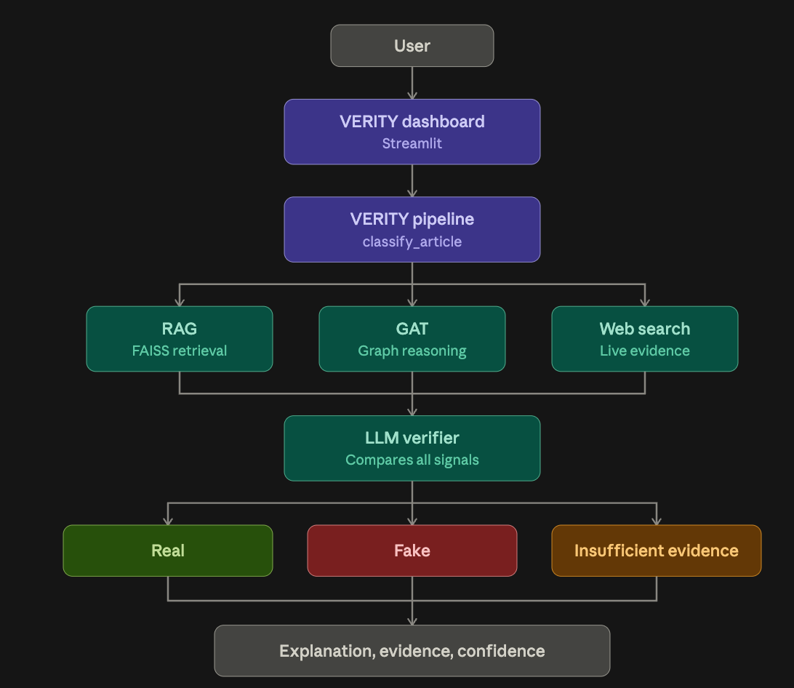
The VERITY architecture has five stages. The user enters a news article in the VERITY dashboard, built with Streamlit, which passes it to the VERITY pipeline. The pipeline runs the classify_article function, which sends the article to three analysis modules at the same time. The RAG module retrieves relevant evidence from a FAISS vector database. The Graph Attention Network (GAT) module represents the article as a graph and predicts its credibility from the relationships in it. The web search module finds live evidence online so that recent claims can be checked. The LLM verifier then compares the outputs of all three modules and decides the final verdict: Real, Fake or Insufficient evidence. The system returns the verdict with an explanation, the supporting evidence and a confidence score, which the dashboard shows to the user.

Fig 1.1 Architecture diagram

Keshav Memorial Institute Of Technology | Fake News Detection Using GNNs | Page No - 5

198

CHAPTER-2
CHAPTER-2

LITERATURE SURVEY
This chapter reviews the work on which GraphVerify is built: the base paper, retrieval-augmented generation, text and multimodal fake news detectors, graph-based detection, LLM-based evidence verification, and vector search for retrieval.

S. Harris, V. T. Ta, M. Trovati, G. Nakhla, F. Latif and I. Korkontzelos, "Multimodal Misinformation Detection Across Diverse Languages Using RAG and LLMs", Journal of Intelligent Information Systems, Springer, 2026 (base paper)..
The authors proposed M&M-RAG, which embeds a news claim with LaBSE, retrieves evidence from live search engines (Google, Bing, Baidu), filters it with a domain whitelist and keeps the top five snippets. These are passed with the claim and image to a frozen Qwen2-VL model, which returns a Fake/Real label with a short justification. The system reached 94.6% accuracy and 94.2% F1 across English, Chinese and Urdu datasets without any fine-tuning. Gap: retrieved snippets are processed independently, no knowledge graph or graph reasoning is used, and the explanation is free text without an explicit evidence path, which GraphVerify addresses.

P. Lewis et al., "Retrieval-Augmented Generation for Knowledge-Intensive NLP Tasks", NeurIPS, 2020.
Introduced RAG, which combines a neural retriever with a generator so that answers are conditioned on retrieved documents. RAG improves factual accuracy and lets the knowledge be updated without retraining. GraphVerify follows this design and additionally structures the retrieved evidence as a graph.

J. Devlin, M.-W. Chang, K. Lee and K. Toutanova, "BERT: Pre-training of Deep Bidirectional Transformers for Language Understanding", NAACL, 2019.
BERT learns contextual text representations from large unlabelled corpora and is widely used for text classification, including fake news detection. Gap: a text-only classifier judges how an article reads and cannot check its claims against external evidence. GraphVerify uses BERT only to embed the text, not to decide the verdict.

P. Veličković et al., "Graph Attention Networks", ICLR, 2018.
Introduced the Graph Attention Network (GAT), which uses attention to give each node's neighbours different weights, so the model learns which relationships matter most. GraphVerify uses a GAT over the claim–entity graph to predict credibility.

- Y. Wang et al., "EANN: Event Adversarial Neural Networks for Multi-Modal Fake News Detection", ACM SIGKDD, 2018.Learned event-invariant features from text and images through adversarial training, reducing overfitting to specific events. Gap: it uses no external evidence and no relationships between entities, so its predictions cannot be verified.

S. Singhal et al., "SpotFake: A Multi-modal Framework for Fake News Detection", IEEE BigMM, 2019.
Fused BERT text features with VGG-19 image features for classification on Twitter and Weibo data. Gap: early feature fusion with no evidence retrieval or explanation.

J. Jing et al., "Multimodal Fake News Detection via Progressive Fusion Networks", Information Processing & Management, 2023.
Proposed a multi-tier fusion network that captures modality-specific representations of text and images. The base paper notes that it must be trained on each dataset and lacks zero-shot ability, interpretability and external knowledge.

S. Nie and Z. Zeng, "Towards Real-World Multimodal Propagation Networks: Multimodal Uncertainty Graph Contrastive Learning for Fake News Detection", Journal of Intelligent Information Systems, 2025 (MUGCL).
Combined text, images and social propagation networks in a contrastive learning framework, building dual propagation graphs and filtering out deceptive signals. It shows the value of graph learning for fake news. Gap: its graphs model how news spreads, not the facts in the claim, and it does not verify claims against retrieved evidence.

B. M. Yao et al., "End-to-End Multimodal Fact-Checking and Explanation Generation: A Challenging Dataset and Models", ACM SIGIR, 2023 (MOCHEG).
Combined evidence retrieval, claim verification and explanation generation for multimodal news. According to the base paper, it did not implement a true RAG architecture and struggled with complex evidence selection.

S. Tahmasebi, E. Müller-Budack and R. Ewerth, "Multimodal Misinformation Detection Using Large Vision-Language Models", ACM CIKM, 2024.
Used a vision-language model in a zero-shot setting with CLIP-based visual evidence retrieval. It shows that large models can detect misinformation without training, but the evidence is still handled as separate items.

Summary of the Survey

The survey shows that text and multimodal classifiers detect fake news well but cannot check claims against evidence. Graph-based methods learn useful relationships but give no external verification or explanation, and RAG-based systems retrieve evidence but treat it as isolated documents. No single existing system combines graph learning, evidence retrieval and LLM verification with a clear reasoning path. GraphVerify combines these elements in one pipeline.

CHAPTER-3
CCHHAAPPTTEERR--3

- SOFTWARE REQUIREMENT SPECIFICATION

Introduction to SRS

This Software Requirements Specification (SRS) describes the requirements of GraphVerify, an explainable multimodal fake news detection system. It defines what the system must do, the inputs it accepts, the outputs it produces and the constraints it works under. It is intended for the project guide, the development team and the evaluators. It serves as the reference for the design, implementation and testing of the system.

Role of SRS
The SRS acts as an agreement between the project team, the guide and the users of the system. It is used to:
  - give all team members a common understanding of the system to be built;
  - form the basis for design, implementation and the division of work;
  - define the test cases and the evaluation metrics against which the system is verified;
  - control changes, because every new feature can be checked against the agreed requirements;
  - record the safety limits of the system, which is particularly important for a healthcare application.

Requirements Specification Document
Product perspective. VERITY is a Python-based web application with a Streamlit frontend. The user submits a textual news claim or article through the dashboard. The application passes the input to the VERITY verification pipeline, which coordinates RAG retrieval, GAT prediction, live web search, evidence analysis and LLM verification. The RAG module uses a FAISS vector index containing the project's indexed news articles. The final prediction, confidence score, retrieved evidence, supporting or contradicting sources and explanation are returned to the dashboard.
Users. (1) General users, such as readers, journalists and platform moderators, who submit a news article and read the verdict, confidence score, supporting evidence and verification report.
(2) Administrators or developers, who build and update the evidence database from trusted news, government and fact-check sources, manage the trusted-source list, train the GAT, and run evaluations.
Operating environment. Windows 10/11, Linux or macOS; Python 3.10 or newer with PyTorch and a graph learning library; a modern browser. A GPU is recommended for GAT training and LLM inference, but not required for the frontend.

Constraints and assumptions. VERITY depends on the availability of the locally configured machine-learning models, FAISS index and LLM service. Live web verification requires an internet connection. The quality of the final verdict depends on the relevance and reliability of retrieved evidence. Claims for which sufficiently relevant evidence cannot be retrieved may result in INSUFFICIENT EVIDENCE. Because the pipeline combines semantic retrieval, GAT prediction, web search and LLM verification, processing time is greater than that of a standalone classifier. VERITY is intended as an evidence-assisted decision-support system and should not replace human fact-checking for high-stakes decisions.

Functional Requirements

ID | Requirement
FR1 | The system shall accept a news article or textual claim through the web interface.
FR2 | The system shall retrieve semantically similar articles using the RAG module and FAISS vector index.
FR3 | The system shall generate an initial prediction using the GAT model.
FR4 | The system shall perform live web search for additional evidence.
FR5 | The system shall filter retrieved web sources based on source quality.
FR6 | The system shall classify retrieved evidence as supporting, contradicting or uncertain.
FR7 | The system shall provide retrieved evidence and web evidence to the LLM verification module.
FR8 | The LLM verifier shall return SUPPORTS, CONTRADICTS or UNCERTAIN with confidence and source indices.
FR9 | The system shall convert SUPPORTS to REAL and CONTRADICTS to FAKE.
FR10 | The system shall return INSUFFICIENT EVIDENCE when the available evidence is insufficient or uncertain.
FR11 | The system shall display confidence, GAT prediction, RAG evidence, web evidence and supporting/contradicting sources.
FR12 | The system shall generate an explanation describing the basis of the final result.
Table 3.1 Functional requirements

Non-Functional Requirements
  - Accuracy and reliability of verdicts: the system must base every Fake or Real verdict on retrieved evidence and must not rely on the LLM's internal knowledge alone. When the evidence is weak, conflicting or missing, it must return "Inconclusive" instead of guessing.
  - Explainability: each result must show the verdict, a confidence score, the supporting sources and a verification report with the reasoning path from claim to entity to evidence to verdict.
  - Security and privacy: access to the system should be controlled, and submitted articles and stored results should be protected from unauthorised access. Models and the evidence store run locally or on the project server, so submitted content is not sent to third-party AI

services.
  - Performance: a request passes through graph construction, GAT processing, retrieval and LLM inference, so it takes longer than a single-model classifier. The response time should be measured and reported, and the evidence retrieval should stay fast as the vector database grows.
  - Explainability: each answer shows its triage level, confidence and sources.
  - Maintainability: configuration of the trusted-source list, confidence thresholds and arbitration rules through editable files or environment variables, with the pipeline split into separate modules (preprocessing, graph, GAT, retrieval, LLM) that can be tested and updated independently.
  - Portability: runs on Windows, Linux and macOS, with a GPU recommended for GAT training and LLM inference.
12

Performance Requirements

Measure | Requirement | Measured result
Verdict accuracy | Higher than the RAG-only baseline (the b a s e p a p e r reports 94.6%) | 96.5%
Precision, recall and F1 (Fake and Real) | Recall = 1.0 | Precision 1.00 and recall 1.00
Retrieval quality (300 MedQuAD questions) | Recall@5 of at least 0.90 | Recall@1 0.84, Recall@5 0.93, MRR  0.89
Triage accuracy (55 labelled cases) | At least 0.85 | 0.93 (English 0.91, Hindi 0.91,  Telugu 1.00)
Typed question, full pipeline on CPU | Mean under 60 s | Mean 31 s, 95th percentile 74 s
Memory | Fits in 16 GB RAM | About 8 GB for all models together
Table 3.2 Performance requirements and measured results

Software Requirements

Component | Technology | Purpose
Web interface | Streamlit | Interactive dashboard
Programming languages | Python | Core implementation
RAG  embeddings | SentenceTransformer (all-MiniLM-L6-v2) | Semantic embeddings
Vector database | FAISS | Similarity-based retrieval
Graph model | GAT, PyTorch Geometric | Initial classification
Web retrieval | ddgs, web search module | Live evidence retrieval
LLM | Ollama (configured Llama model) | Evidence verification
Data processing | pandas, NumPy | Data handling
Machine learning | scikit-learn | Supporting ML utilities
Visualization | Plotly, Streamlit | Dashboard visualizations
Backend logic | Python modules | Pipeline orchestration

Table 3.3 Software requirements

Hardware Requirements

Component | Minimum | Used in this project
Processor | 4-core 64-bit CPU | Intel Core i5-13420H
RAM | 16 GB | 16 GB
Storage | 15 GB free (models, packages, data) | SSD
GPU | Not required | Not used
Peripherals | Microphone and speakers for voice | Laptop microphone and speakers
Network | Internet for setup and gTTS | Broadband

Table 3.4 Hardware requirements

CHAPTER-4

SYSTEM DESIGN

Introduction to UML
The Unified Modeling Language (UML) is a standard visual language for specifying, constructing and documenting the parts of a software system. It was adopted as a standard by the Object Management Group (OMG). UML diagrams fall into two groups: structural diagrams, such as class and deployment diagrams, which show the static parts of a system, and behavioural diagrams, such as use case, sequence and state chart diagrams, which show how the system behaves over time. The following sections describe MedRAG+ with these diagrams.

UML Diagrams

Class Diagram
A class diagram shows the main classes of a system, their attributes and operations, and the relationships between them. The GraphVerify class diagram has three groups of classes. The core classes are User, Claim and VerificationResult. A User (with an id, name, email and role) can log in, submit a claim for verification and view the results. One user can submit many Claim objects. Each Claim holds the claim text, its creation time and a status. It can be analysed, and its result and explanation can be retrieved. Each claim has exactly one VerificationResult, which stores the verdict and the confidence score. It can generate a report and return the signals behind the decision. The four pipeline components do the processing for a claim. BERTRetriever encodes the text and retrieves the top-k relevant items. GraphReasoning builds the graph, applies the GAT and returns a prediction. WebEvidence searches the web, fetches articles and ranks the evidence. LLMVerifier verifies the claim, generates the explanation and returns the final verdict. The data model classes store the knowledge. An Article (title, content and source) is linked to many GraphNode objects (entities with a type and name), and nodes are connected by Edge objects that record the source node, the target node and the relation between them, with a weight. The Database class saves, fetches, updates and deletes these records.

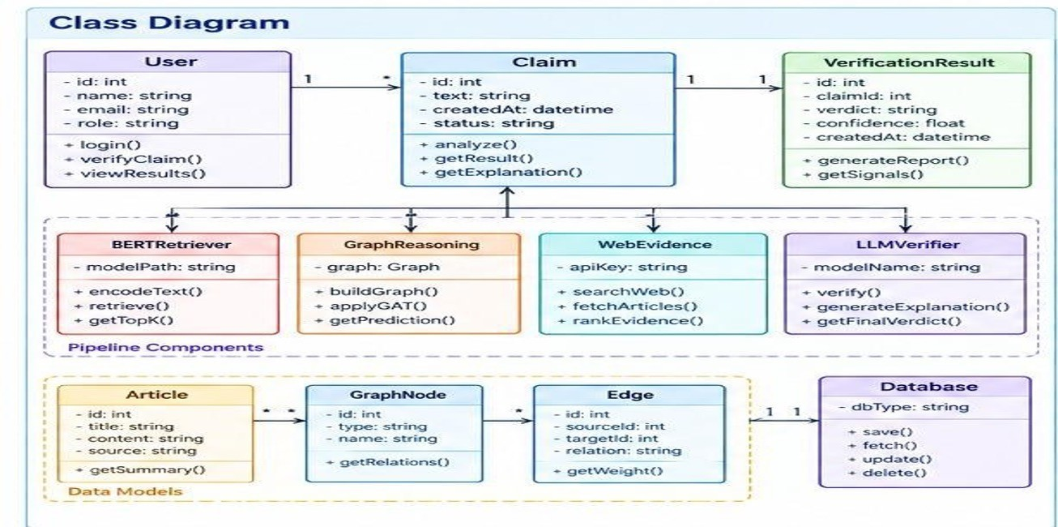

Fig 4.1 Class diagram

Sequence Diagram
A sequence diagram shows how the actors and components of a system exchange messages over time to complete one task. This diagram follows the Verify Claim flow of GraphVerify, which involves five participants: the User, the Frontend (React), the Backend (FastAPI), the Pipeline Services and the Database. The user enters a claim in the web interface and clicks Verify. The frontend sends the claim text to the backend with a POST /verify request. The backend validates the request and fetches the data it needs from the database. It then calls the pipeline services in four steps, each of which returns its output before the next one starts. First, the services retrieve relevant articles using BERT embeddings. Second, they build the graph and apply the Graph Attention Network (GAT). Third, they search the web for evidence related to

the claim. Fourth, they use the LLM to generate the verdict. The backend returns the result, containing the verdict and the explanation, to the frontend, which displays it to the user. The user therefore sees only the first and last steps, while the pipeline stages run behind the backend.
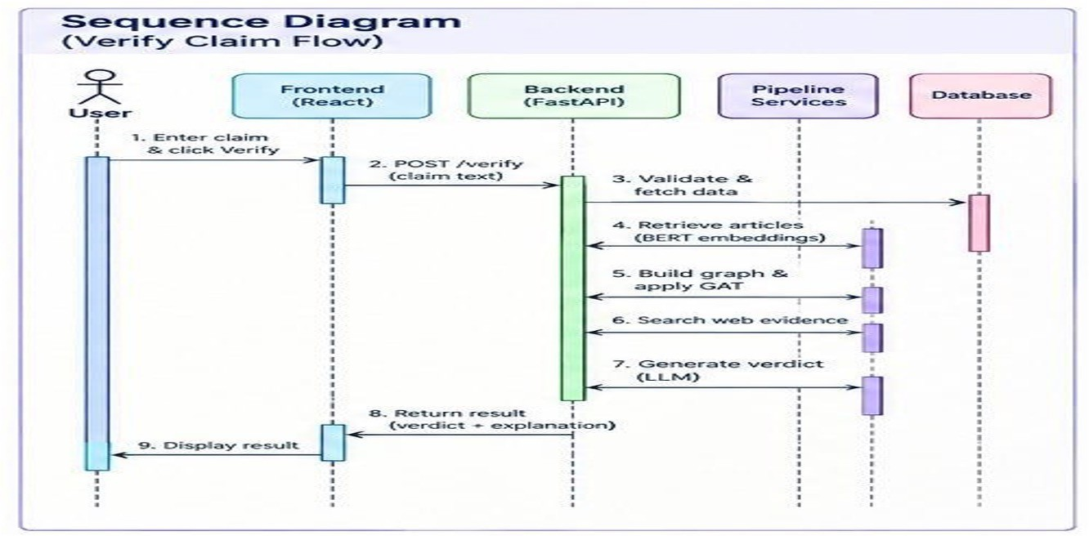

Fig 4.2 Sequence diagram

State Chart Diagram
A state chart diagram shows the states a system passes through and the events that move it from one state to the next. This diagram follows a claim in GraphVerify from entry to display. The system starts in the Idle state. When the user enters a claim, it moves to Claim Entered and then to Analyzing. In the Analyzing state, four processing stages run: BERT Retrieval (encoding the claim and retrieving relevant articles), Graph Reasoning (building the graph and applying the GAT), Web Evidence (searching, fetching and ranking evidence) and LLM Verification (verifying the claim and producing the explanation). When these stages finish, the system reaches a decision point, All Stages Complete?. If the answer is No, it returns to Analyzing and continues processing. If the answer is Yes, it moves to Generate Result, where the verdict, confidence score and explanation are produced. It then moves to Store in Database, where the result is saved. Finally it reaches Display to User, where the result is shown, and the process ends.

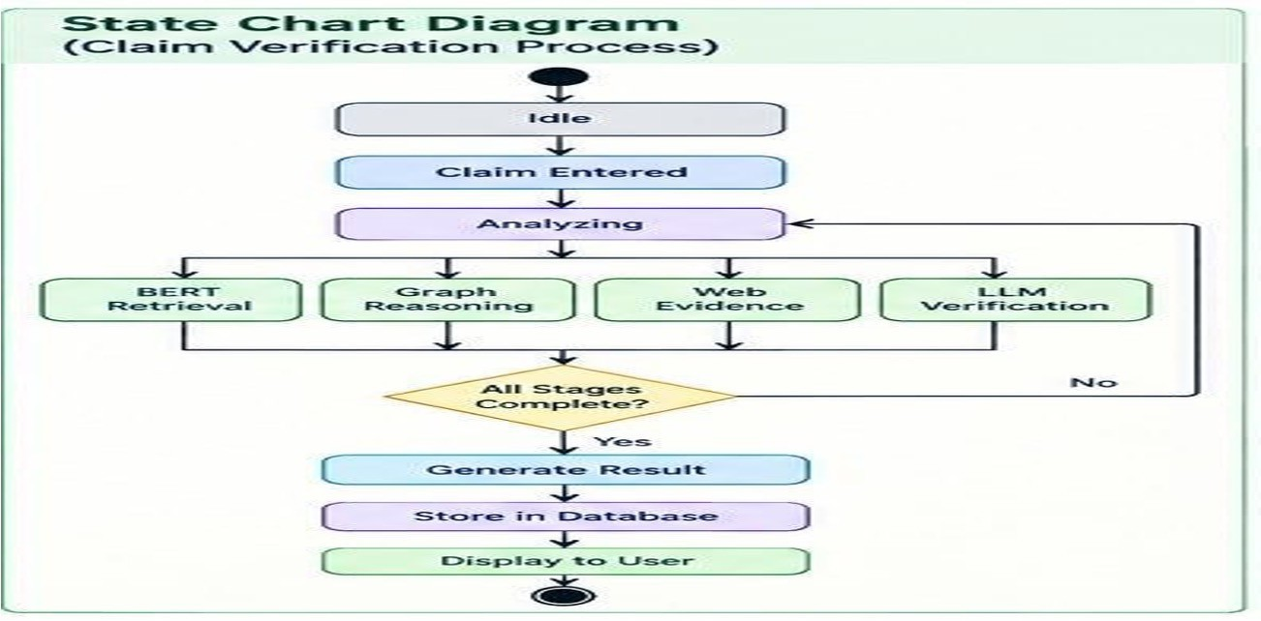
Fig 4.3 State chart diagram

Deployment Diagram
A deployment diagram shows the physical nodes on which the system runs and how they communicate. The GraphVerify deployment has three parts. The Client Device is the user's web browser (React frontend) on a desktop or a mobile device with a responsive interface. It talks to the server over HTTPS. The Cloud / Server node hosts the system. A Web Server (Nginx) receives incoming requests and passes them to the Application Server (FastAPI), which runs the verification pipeline. The application server uses two stores. Model Storage holds the pre-trained models, and a Database (PostgreSQL) holds the application data, such as claims and results. The External Services node is reached through API calls from the server. It includes a Web Search API for news and articles, a Knowledge Base of articles and documents, and an LLM Service for verification and explanation. A user's request therefore travels from the

Fig 4.4 Deployment diagram
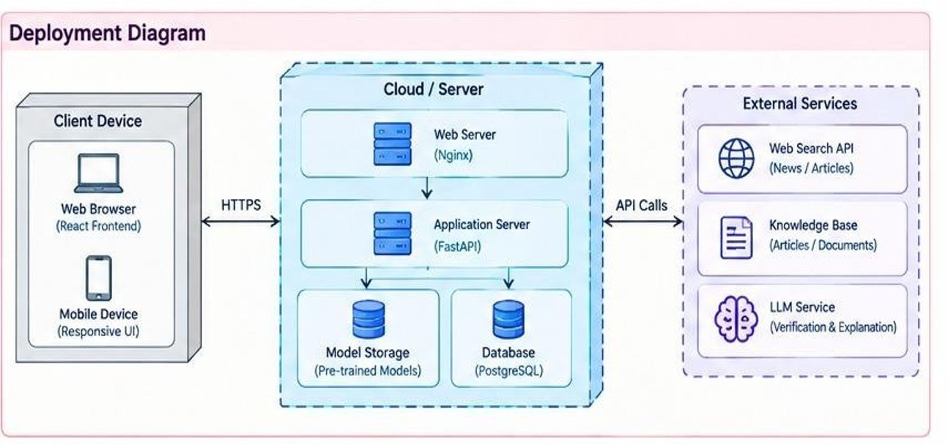
browser through Nginx to FastAPI, which loads the models, reads and writes the database, and calls the external services before the result goes back the same way.
Keshav Memorial Institute Of Technology | Fake News Detection Using GNNs | Page No - 21

Technologies Used

Layer | Technology | Purpose in MedRAG+
Language | Python | Core implementation
Frontend | Streamlit | User interface
Semantic retrieval | SentenceTransformer | Generating article embeddings

Graph learning | GAT, PyTorch Geometric | Initial Fake or Real prediction
Vector store | FAISS | Retrieving similar articles
Web evidence | DDGS, web search | Retrieving live evidence
LLM | Ollama, Llama model | Evidence-based verification
Data processing | pandas, NumPy | Dataset and result processing
ML utilities | scikit-learn | Supporting machine-learning operations
Visualization | Plotly | Dashboard charts
Development | VS Code, Git | Development and version control
Table 4.1 Technologies used

REFERENCES

- S. Harris, V. T. Ta, M. Trovati, G. Nakhla, F. Latif and I. Korkontzelos, "Multimodal misinformation detection across diverse languages using RAG and LLMs," Journal of Intelligent Information Systems, Springer, 2026, doi: 10.1007/s10844-026-01042-x.
- P. Lewis et al., "Retrieval-Augmented Generation for Knowledge-Intensive NLP Tasks," in Advances in Neural Information Processing Systems (NeurIPS), vol. 33, 2020.
- J. Devlin, M.-W. Chang, K. Lee and K. Toutanova, "BERT: Pre-training of Deep Bidirectional Transformers for Language Understanding," in Proc. NAACL-HLT, 2019,
pp. 4171-4186.
- P. Veličković, G. Cucurull, A. Casanova, A. Romero, P. Liò and Y. Bengio, "Graph Attention Networks," in Proc. International Conference on Learning Representations (ICLR), 2018, arXiv:1710.10903.
- Y. Wang et al., "EANN: Event Adversarial Neural Networks for Multi-Modal Fake News Detection," in Proc. 24th ACM SIGKDD International Conference on Knowledge Discovery & Data Mining, 2018, pp. 849-857, doi: 10.1145/3219819.3219903.
- S. Singhal, R. R. Shah, T. Chakraborty, P. Kumaraguru and S. Satoh, "SpotFake: A Multi-modal Framework for Fake News Detection," in Proc. IEEE Fifth International Conference on Multimedia Big Data (BigMM), 2019, pp. 39-47, doi: 10.1109/ BigMM.2019.00-44.
- J. Jing et al., "Multimodal fake news detection via progressive fusion networks," Information Processing & Management, vol. 60, no. 1, art. 103120, 2023, doi: 10.1016/ j.ipm.2022.103120.
- S. Nie and Z. Zeng, "Towards real-world multimodal propagation networks: Multimodal uncertainty graph contrastive learning for fake news detection," Journal of Intelligent Information Systems, 2025, doi: 10.1007/s10844-025-00987-9.
- B. M. Yao et al., "End-to-End Multimodal Fact-Checking and Explanation Generation: A Challenging Dataset and Models," in Proc. 46th International ACM SIGIR Conference on Research and Development in Information Retrieval, 2023, pp. 2733-2743, doi: 10.1145/3539618.3591879.
- S. Tahmasebi, E. Müller-Budack and R. Ewerth, "Multimodal Misinformation Detection Using Large Vision-Language Models," in Proc. 33rd ACM International Conference on Information and Knowledge Management (CIKM), 2024, pp. 2189-2199, doi: 10.1145/3627673.3679826.
- K. Huang, X. Li and S. Uddin, "Enhancing fake news detection through fact-augmented LLM generation with co-attention," Journal of Intelligent Information Systems, vol. 64, no. 1, pp. 425-443, 2026, doi: 10.1007/s10844-025-01007-6.
- J. Johnson, M. Douze and H. Jégou, "Billion-scale similarity search with GPUs," IEEE Transactions on Big Data, vol. 7, no. 3, pp. 535-547, 2021.

