**SALES PREDICTION SYSTEM BASED ON**

**SOCIAL NETWORK ADS**

COMP 7118

DATA MINING

FALL 2022

PRESENTED BY

PRANATHI SUNDARI

UID: U00869903

Contact Mail: psndari1@memphis.edu

**INTRODUCTION**

In today’s competitive global market, social media have become a path where

marketers can spread their marketing campaigns to a broader range of customers. The

tools and methods for interacting with customers have transformed significantly with the

occurrence of social media; so, businesses must understand utilizing social media in a

manner that is constant with their business plan (Mangold and Faulds 2009). Social

media marketing helps companies to gain a competitive advantage and increase their sale. Social media websites such as Face book, Twitter, and YouTube have nearby to five

million visitors daily, hence an essential hub for marketing. Social media has transformed

the face of advertising most obviously in that it has almost eliminated the necessity for

print advertising, thus providing a greener environment. There are a massive number of

social media sites for advertising, but YouTube advertising is selected for this research.

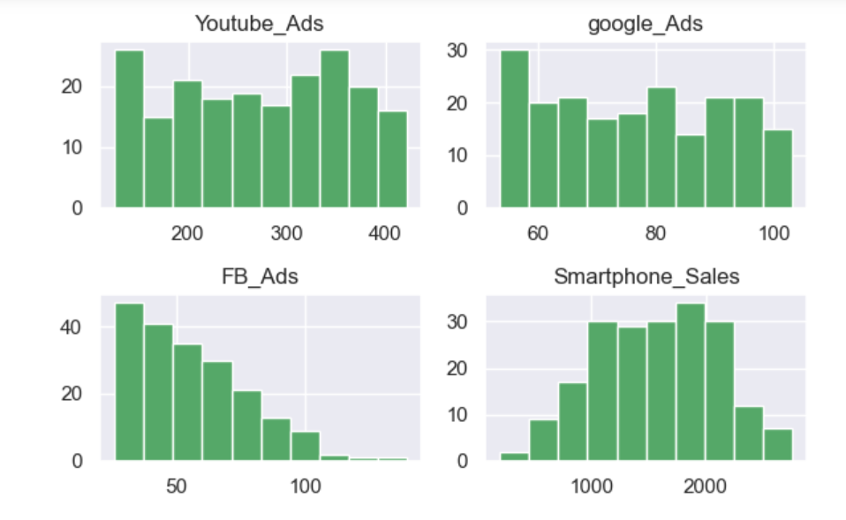

**PREPROCESSING**

For experimentation, the Input Data Sets for Sales Ads given in the UCI

machine learning repository such as, Facebook Ads and Sales data sets, YouTube Ads and

Sales data sets, google Ads and Sales data sets etc. was utilized to social network ads and

sales prediction. Firstly, the libraries imported are:

• Pandas- this library is used for handling the data structure.

• NumPy- this library is for the linear algebra and the mathematics used.

• Seaborn- this library is used for data visualization.

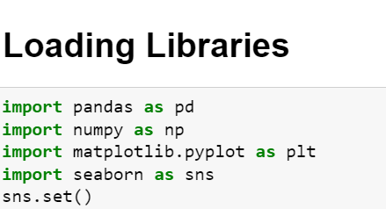

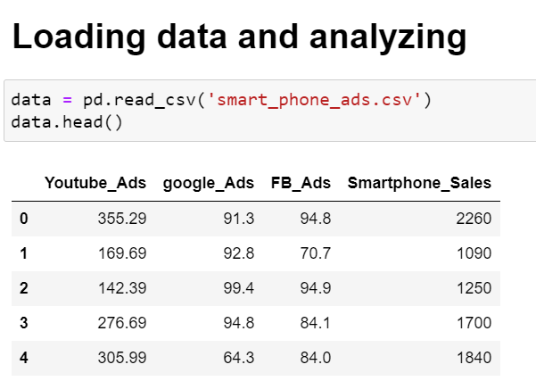

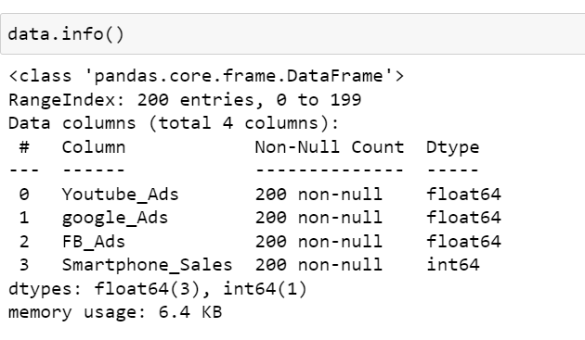

**DATA VISUALISATION**

The graphical representation of the data is known as data visualization. It is the way to see the trends, outliers, and the patterns of the provided data. Data visualization is the technique used to analyze massive data and make data driven decisions.

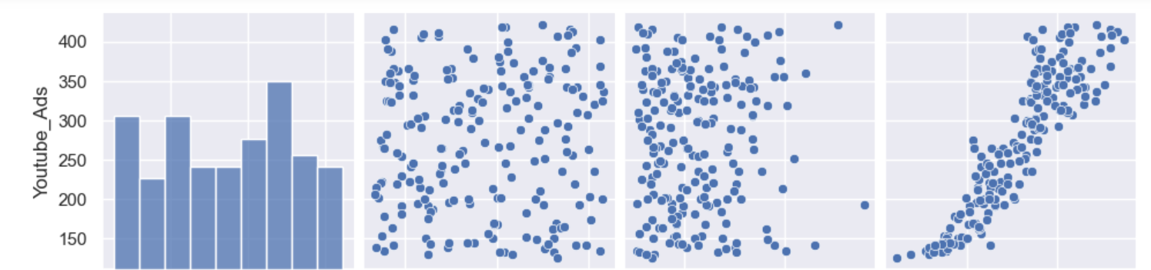

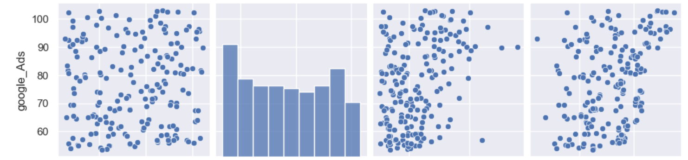

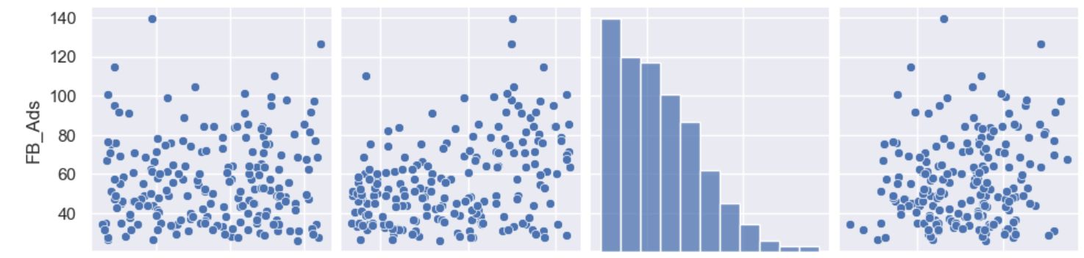

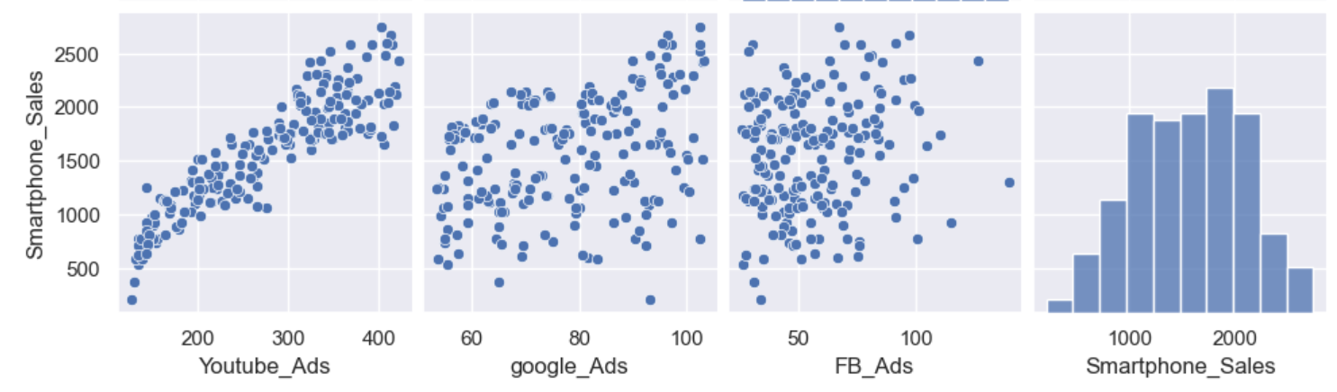

**MODEL BUILDING**

It is important to know about the relationships in the existing data, constructing a correlation matrix gives that data and this is essential guide to model building.

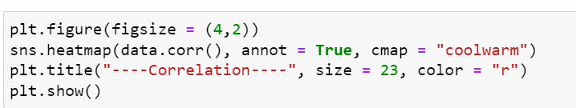

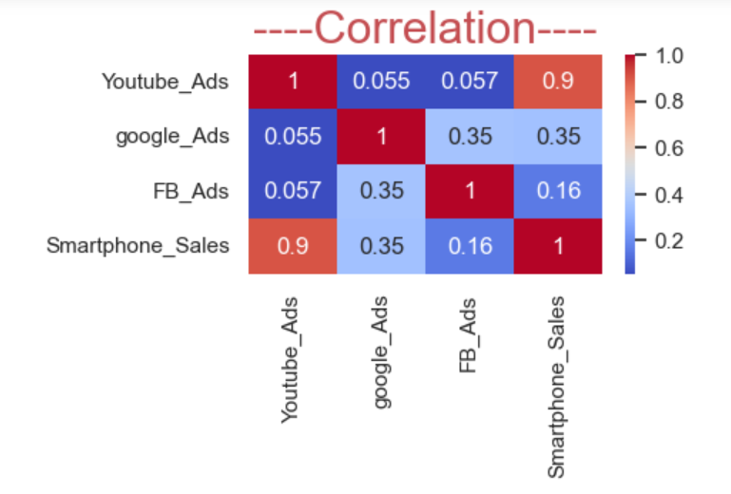

**Training and validation**

Linear Regression Linear regression is the machine learning algorithm which is based on supervised learning. It is used to predict the values based on the independent variables given in the data set and mostly used to find the relationship between variables and forecasting

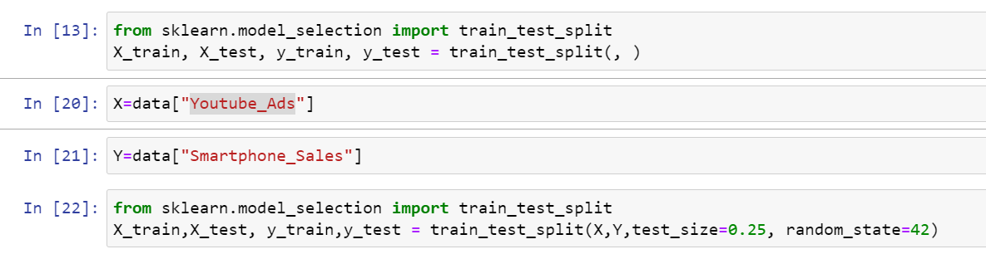

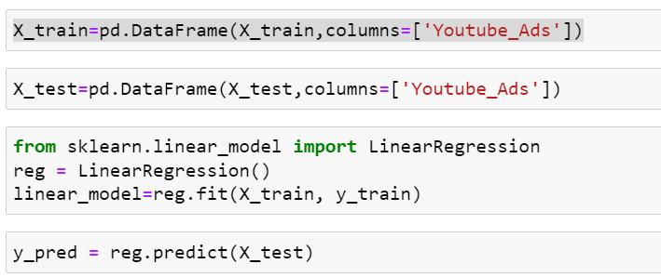

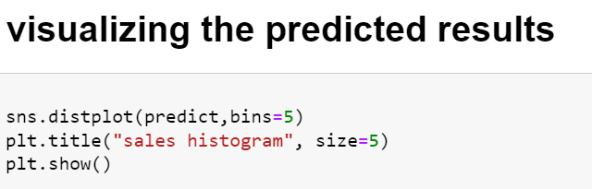

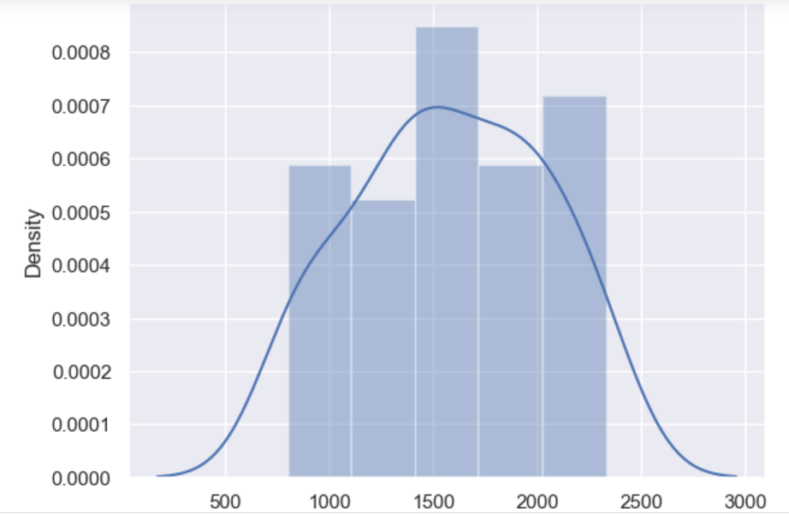

**EVALUATION**

• Checking the differences between actual and predicted prices:

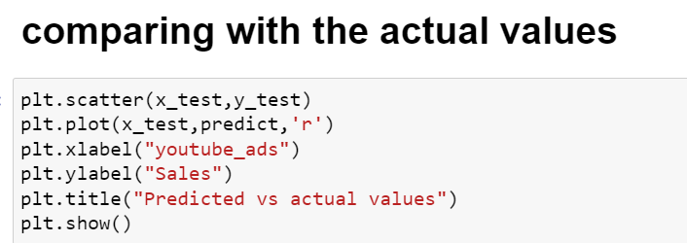

PREDICTED VS ACTUAL VALUES:

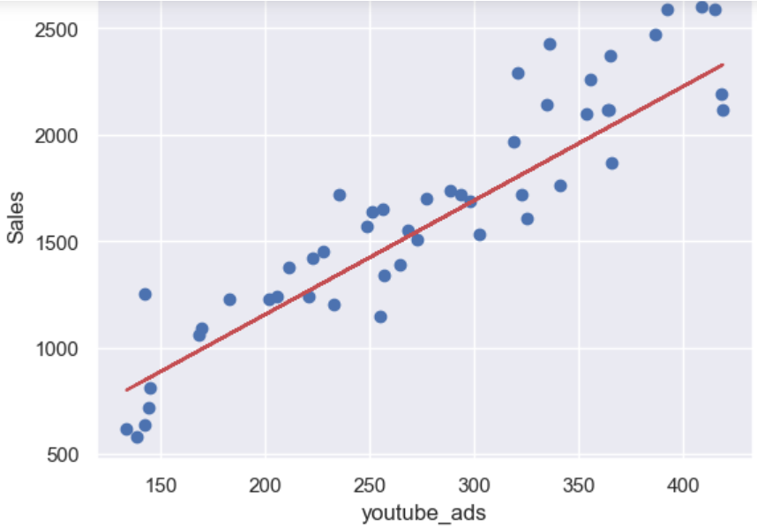

RESIDUAL PLOTS

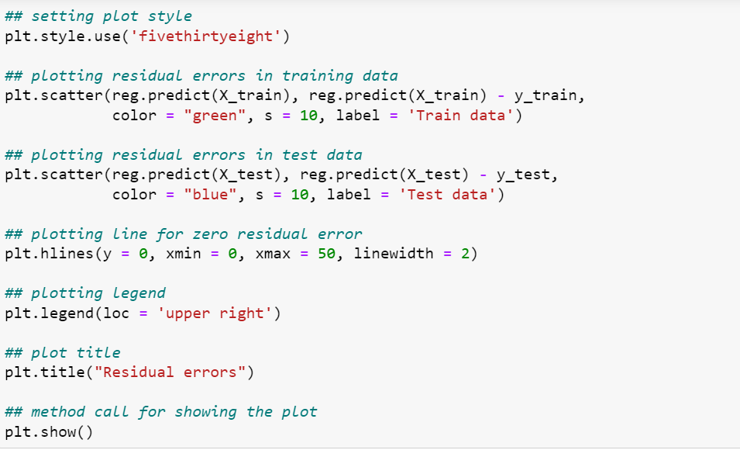

RESIDUAL ERRORS:

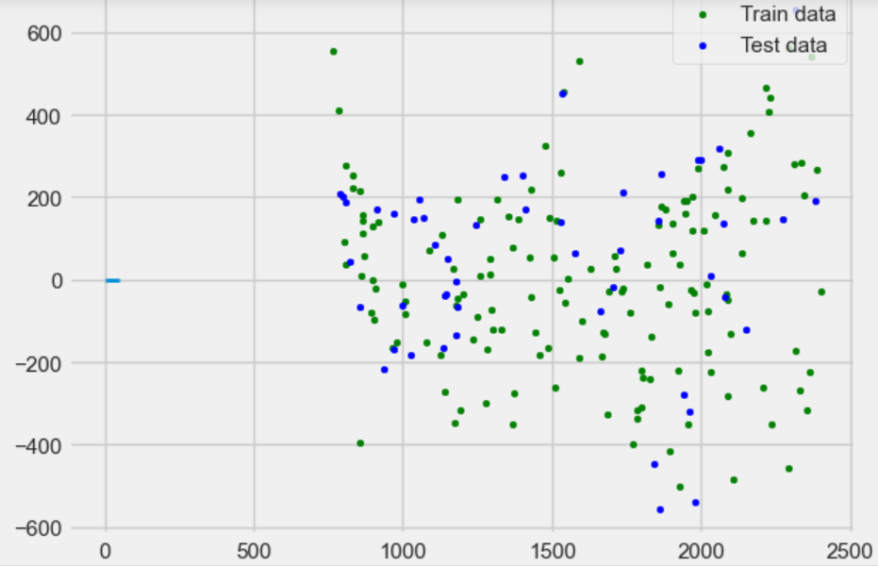

**CONCLUSION**

The linear regression algorithm Using Deep Learning Techniques were proposed. The implementation of the proposed methods was done by using python open-source

software program

For experimentation, the Input Data Sets for Sales Ads given in the UCI

machine learning repository such as, Facebook Ads and Sales data sets, YouTube Ads and

Sales data sets, google Ads and Sales data sets etc. was utilized to social network ads and

sales prediction, From the above predictions by using different data sets YouTube

prediction is to be considered as the best prediction from result analysis by using

proposed method i.e., linear regression algorithm Using Deep Learning Techniques. This result impacts or improves the sales factor, profitability, and consumer’s

factors. It is fact that the brands of company are viewed worldwide and match with

other similar brands of various companies

**FUTURE SCOPE**

The proposed work can be extended in future by improving social network

ads and sales prediction based on multiple data sets at a time, so that users can

monitor their ads and sales prediction more accurately.

Linear regression algorithm Using Deep Learning Techniques may be

guaranteed as to provide high accuracy and not to allow the social media dataset

loss. Proposed technique can be enhanced by considering more number of multiple data

sets at a time for their ads and sales prediction.

Linear regression techniques can be implemented in future in the various

fields like the stock marketing, bitcoin value prediction and the many other varies

business, this technique may be applied to multiple regression and logistic

regression. The future scope can be very much accurate and error can be reduced and

model can be made more robust.

**REFERENCES**

1. Afuah, A., and Tucci, C. L. 2003. “A model of the Internet as creative

destroyer,” IEEE Transactions on Engineering Management (50:4), pp. 395–402.

2. Agarwal, R., and Dhar, V. 2014. “Editorial—Big data, data science, and

analytics: The opportunity and challenge for IS research”

Information Systems Research (25:3), pp. 443-448.

3. Aldrich, H. 1999. Organizations evolving: Sage. 4. Alvarez, S. A., and Barney, J. B. 2007. “Discovery and creation: