**STEPS TO INSTALL WORDPRESS ON WINDOWS (LOCALHOST):**

**1.Download wordpress**

* **Search “wordpress download”**
* **Open “wordpress.org” link**
* **Download wordpress**

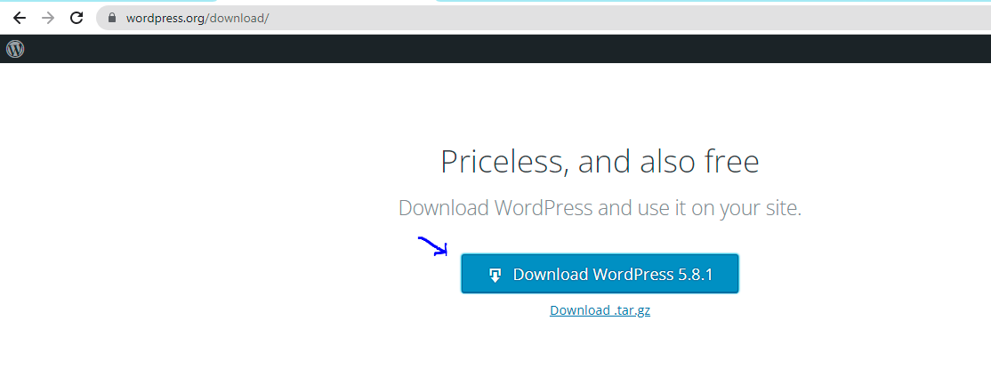

**2.Download xampp**

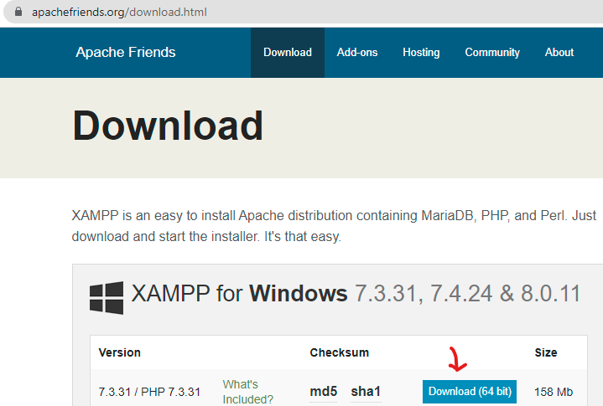

**3.Once the download is completed, open xampp control panel and start Apache and MySQL.**

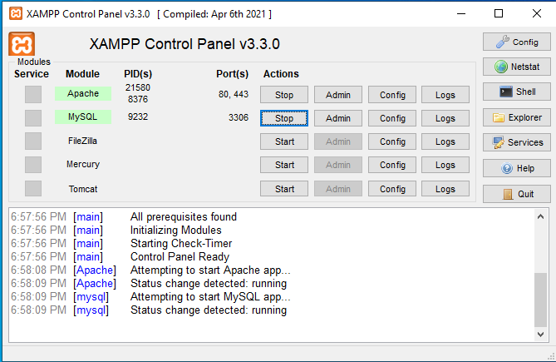

**4.Go to downloads and select wordpress zip file and copy it in the htdocs of xampp folder present in disk (D).**

* **Select the wordpress zip file and click copy.**

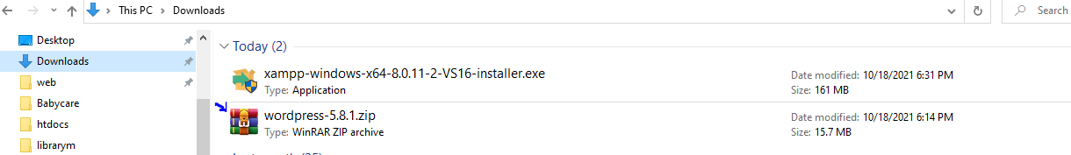

* **Now click on disk(D), open the xampp folder**

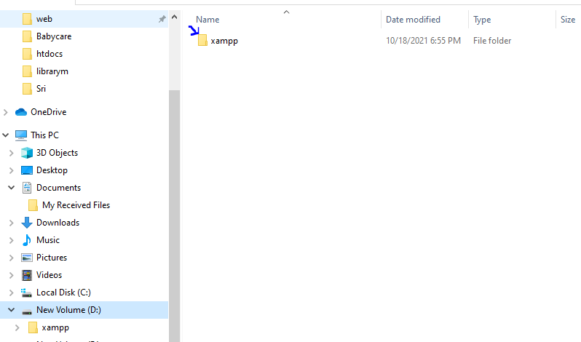

* **Click on htdocs**

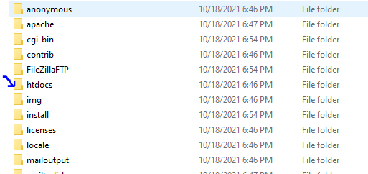

* **Paste the wordpress zip file in htdocs and extract it.**

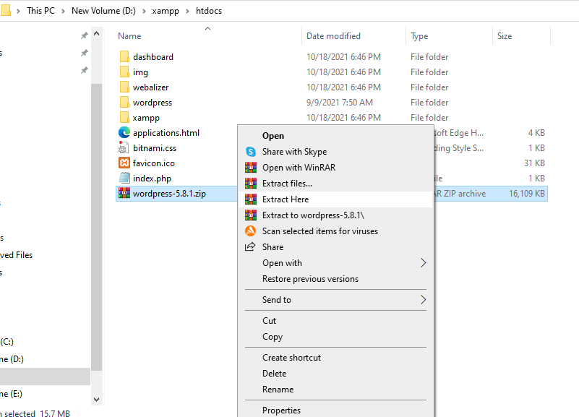

**6. To create a database , first we need to open phpMyAdmin. Type the url “localhost/phpMyadmin/” in search engine.**

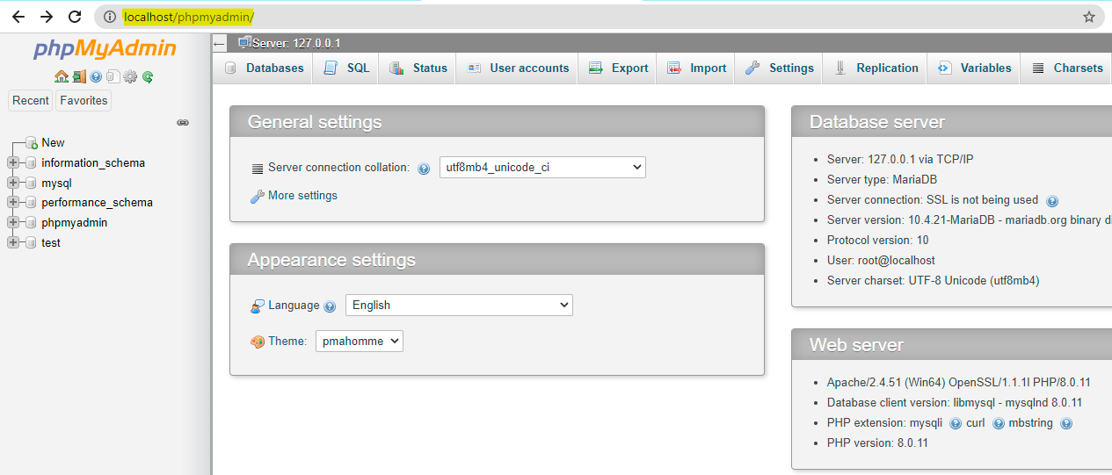

**7. In phpMyAdmin, click on Databases. Now give a database name and click on create button .**

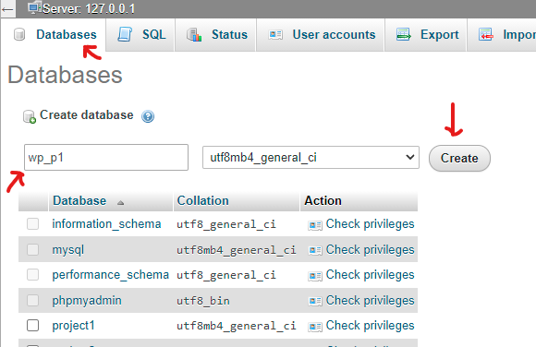

**8. Now type the url “localhost/databasename”. Select English and click continue**

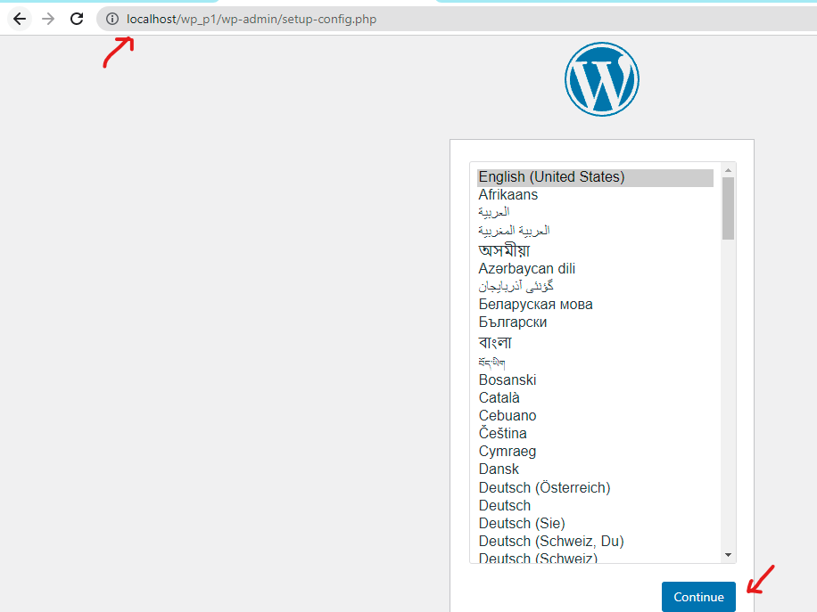

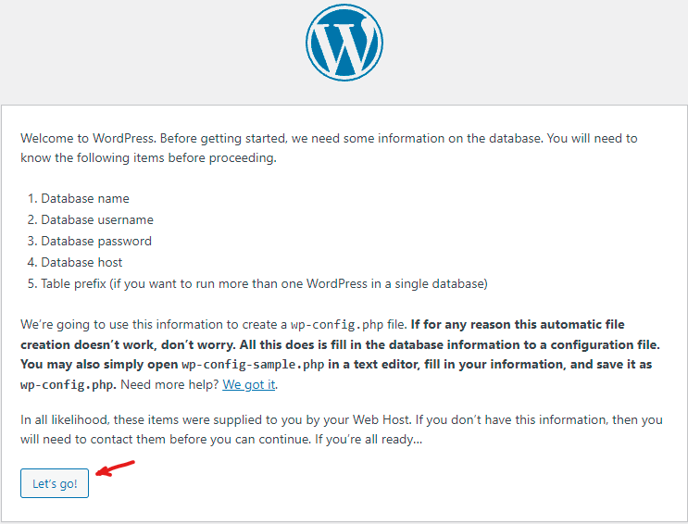

**9.Now give the database name , username, password etc.. and click on submit. Give the username as “root” only. Then click on run installation.**

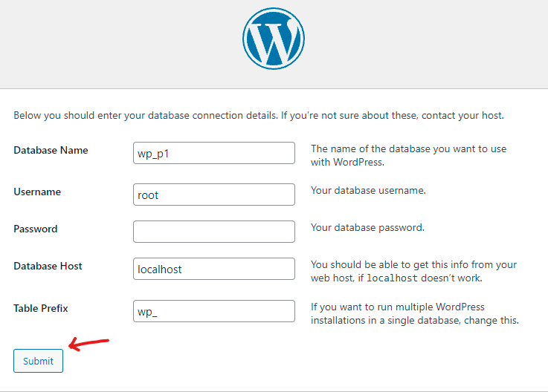

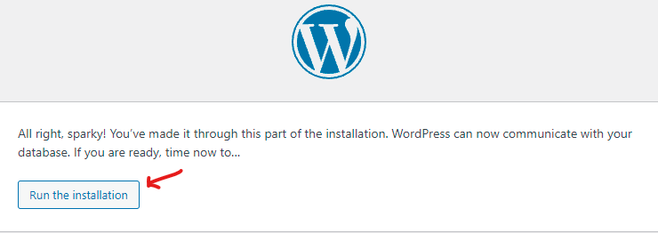

**10.Give site details,username,password etc.. and click on install wordpress.**

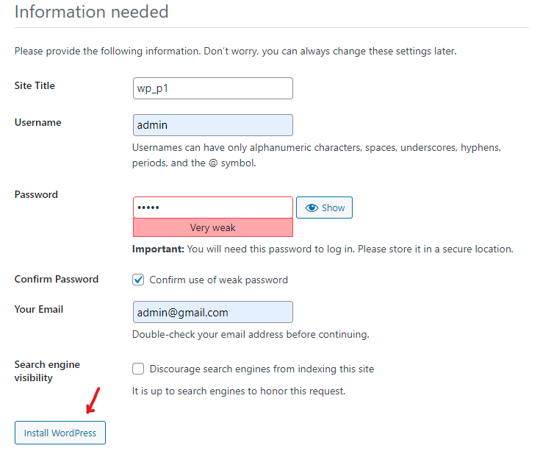

**11.A success message will be shown that the wordpress has been installed.Now click on login and give username and password .The dashboard will be opened.**

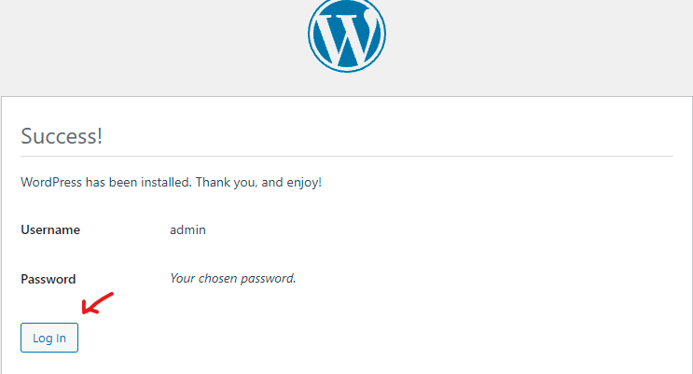

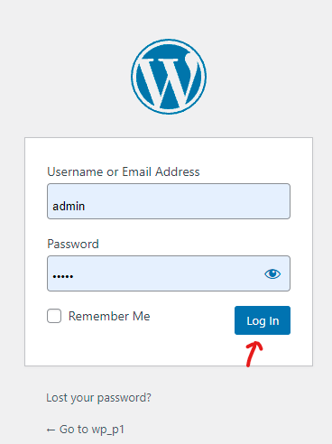

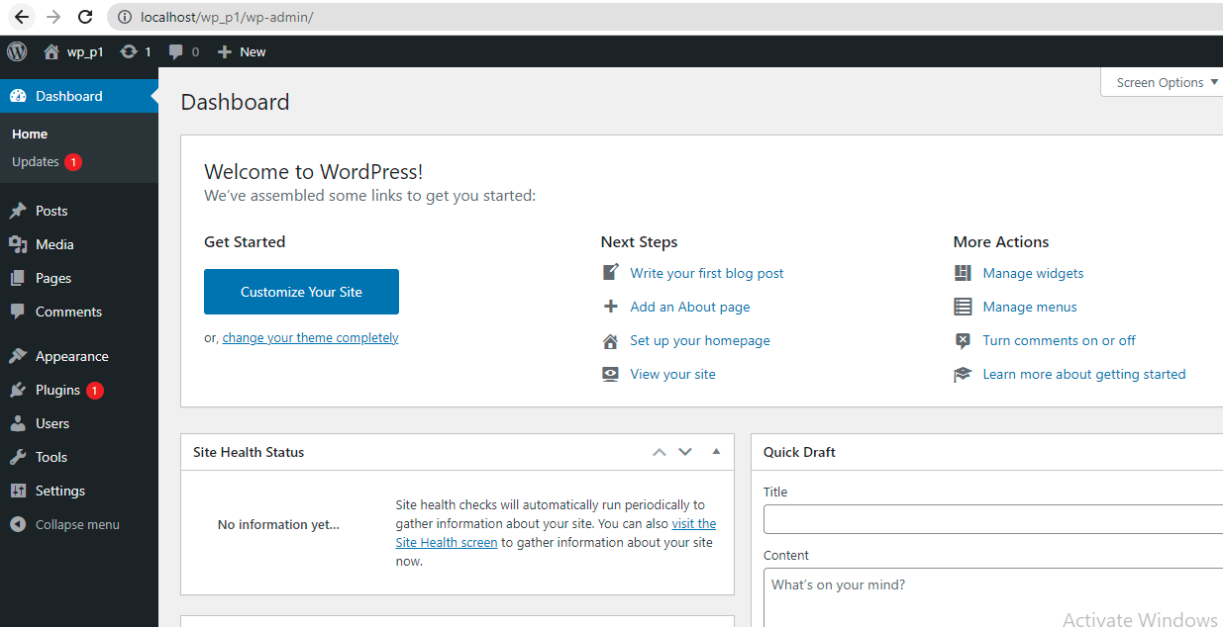

**12. Now try to open the website with the url “localhost/sitename”.**

