SIMATS ENGINEERING
ASSESSMENT TOOL 3

COURSE NAME: MLA03
COURSE CODE: Reinforcement learning for Environment and Agent

COURSE OUTCOME COVERED

CO1: Analyze reinforcement learning frameworks and Markov Decision Process concepts to model decision-making problems.( BL2, BL3)

Assessment Tool Weightage: 30%

Dr G.A. SENTHIL

QUESTIONS: 05 Total Marks:50

Annexure A

Constraint - Based Problem-Solving Duration: 2Hrs
1.Implement an ε-greedy Multi-Armed Bandit algorithm in Python to maximize rewards under a limited budget of 500 trials. Compare the effect of different ε values (0.1, 0.3, and 0.5) on exploration, exploitation, and constraint satisfaction.
CODE :
import numpy as np
import matplotlib.pyplot as plt

# Make the output reproducible
np.random.seed(42)

# True reward probabilities of 5 slot machines (arms)
true_probabilities = [0.2, 0.5, 0.7, 0.4, 0.9]

num_arms = len(true_probabilities)
trials = 500

# -----------------------------------------------------
# ε-Greedy Algorithm
# -----------------------------------------------------
def epsilon_greedy(epsilon):

estimated_rewards = np.zeros(num_arms)
arm_counts = np.zeros(num_arms)

total_reward = 0
cumulative_rewards = []

exploration = 0
exploitation = 0

for t in range(trials):

# Exploration
if np.random.rand() < epsilon:
arm = np.random.randint(num_arms)
exploration += 1

# Exploitation
else:
arm = np.argmax(estimated_rewards)
exploitation += 1

# Reward (1 = Success, 0 = Failure)
reward = 1 if np.random.rand() < true_probabilities[arm] else 0

arm_counts[arm] += 1

# Update estimated reward
estimated_rewards[arm] += (reward - estimated_rewards[arm]) / arm_counts[arm]

total_reward += reward
cumulative_rewards.append(total_reward)

return cumulative_rewards, total_reward, exploration, exploitation

epsilons = [0.1, 0.3, 0.5]

plt.figure(figsize=(10,6))

print("Results after 500 Trials\n")

for eps in epsilons:

rewards, total, explore, exploit = epsilon_greedy(eps)

print("-------------------------------------")
print(f"Epsilon = {eps}")
print(f"Total Reward : {total}")
print(f"Exploration Steps : {explore}")
print(f"Exploitation Steps : {exploit}")

if explore + exploit == trials:
print("Constraint (500 Trials): Satisfied")

plt.plot(rewards, label=f"ε = {eps}")

plt.title("ε-Greedy Multi-Armed Bandit")
plt.xlabel("Trials")
plt.ylabel("Cumulative Reward")
plt.legend()
plt.grid(True)
plt.show()
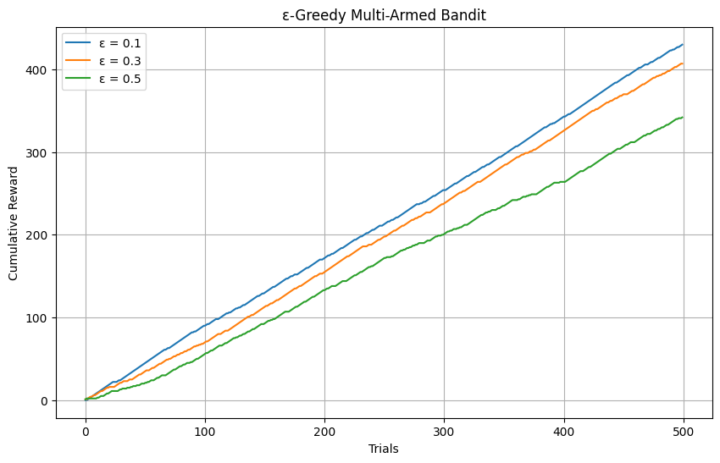
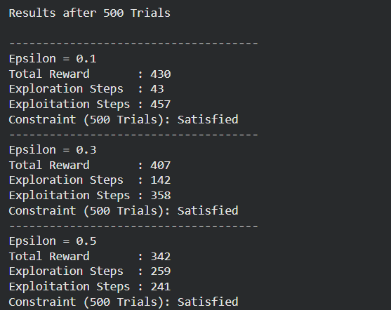
OUTPUT:
2.Design a Markov Decision Process (MDP) for an autonomous robot that must reach a destination while minimizing energy consumption. Define the states,actions, transition probabilities, rewards, and energy constraints.
CODE
import numpy as np

# Grid size
GRID_SIZE = 4

# Start and Goal positions
start = (0, 0)
goal = (3, 3)

# Obstacles
obstacles = [(1, 1), (2, 2)]

# Battery energy
battery = 20

# Actions
actions = {
0: (-1, 0), # Up
1: (1, 0), # Down
2: (0, -1), # Left
3: (0, 1) # Right
}

state = start
total_reward = 0

print("Autonomous Robot MDP Simulation")
print("--------------------------------")

while battery > 0:

print(f"\nCurrent State : {state}")
print(f"Battery : {battery}")

# Stop if goal reached
if state == goal:
print("Goal Reached!")
total_reward += 100
break

# Random action (MDP transition)
action = np.random.choice([0, 1, 2, 3])

move = actions[action]

next_state = (
max(0, min(GRID_SIZE - 1, state[0] + move[0])),
max(0, min(GRID_SIZE - 1, state[1] + move[1]))
)

# Transition Probability
transition_probability = 0.9

# Check obstacle
if next_state in obstacles:
reward = -20
battery -= 5
print("Obstacle Hit!")
else:
reward = -1
battery -= 2
state = next_state

total_reward += reward

print("\n---------------------------")
print("Final State :", state)
print("Remaining Battery :", battery)
print("Total Reward :", total_reward)
OUTPUT:
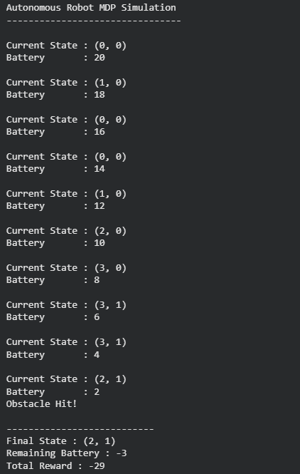
3.A warehouse robot has a battery capacity of only 30 minutes. Design an RL framework that enables the robot to complete the maximum number of deliveries without exceeding the battery limit. Explain the constraints, policy, and reward design.
CODE:
import random

# Battery capacity (minutes)
battery = 30

# Initial values
deliveries = 0
total_reward = 0

print("Warehouse Robot Reinforcement Learning")
print("--------------------------------------")
print("Initial Battery:", battery, "minutes\n")

while battery > 0:

# Random delivery time between 3 and 7 minutes
delivery_time = random.randint(3, 7)

# Stop if battery is insufficient
if battery < delivery_time:
print("Battery too low for next delivery.")
break

# Perform delivery
battery -= delivery_time
deliveries += 1
reward = 10
total_reward += reward

print(f"Delivery {deliveries}")
print(f"Time Used : {delivery_time} minutes")
print(f"Remaining Battery: {battery} minutes")
print(f"Reward : +{reward}")
print()

print("--------------------------------------")
print("Total Deliveries :", deliveries)
print("Remaining Battery:", battery, "minutes")
print("Total Reward :", total_reward)
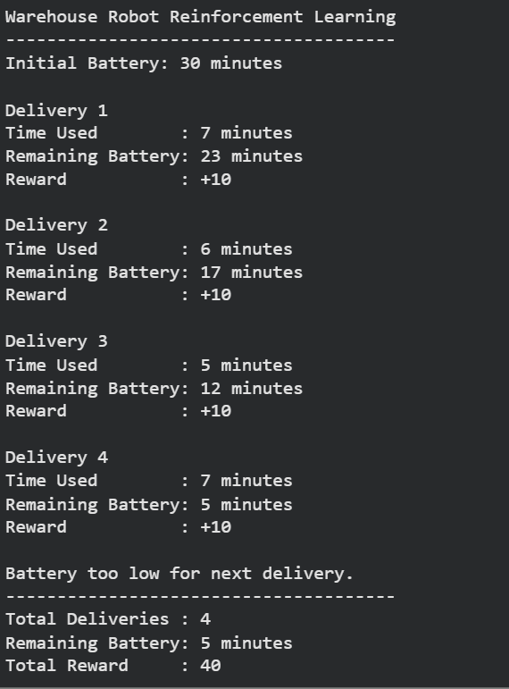
OUTPUT:

4.Analyse an experimental comparison between random action selection and ε-greedy action selection in a Multi-Armed Bandit problem under a fixed time constraint. Record cumulative rewards and explain which strategy provides better performance.
CODE:
import numpy as np
import matplotlib.pyplot as plt

# Make results reproducible
np.random.seed(42)

# Reward probabilities for 5 slot machines
true_rewards = [0.2, 0.5, 0.7, 0.4, 0.9]

num_arms = len(true_rewards)
trials = 500

# -----------------------------
# Random Action Selection
# -----------------------------
def random_selection():

total_reward = 0
cumulative_rewards = []

for _ in range(trials):
arm = np.random.randint(num_arms)

reward = 1 if np.random.rand() < true_rewards[arm] else 0

total_reward += reward
cumulative_rewards.append(total_reward)

return cumulative_rewards, total_reward

# -----------------------------
# ε-Greedy Action Selection
# -----------------------------
def epsilon_greedy(epsilon=0.1):

estimated_rewards = np.zeros(num_arms)
arm_counts = np.zeros(num_arms)

total_reward = 0
cumulative_rewards = []

for _ in range(trials):

if np.random.rand() < epsilon:
arm = np.random.randint(num_arms) # Explore
else:
arm = np.argmax(estimated_rewards) # Exploit

reward = 1 if np.random.rand() < true_rewards[arm] else 0

arm_counts[arm] += 1

estimated_rewards[arm] += (reward - estimated_rewards[arm]) / arm_counts[arm]

total_reward += reward
cumulative_rewards.append(total_reward)

return cumulative_rewards, total_reward

# Run both strategies
random_rewards, random_total = random_selection()
greedy_rewards, greedy_total = epsilon_greedy(0.1)

# Print Results
print("Comparison of Action Selection Strategies")
print("-----------------------------------------")
print("Total Trials:", trials)
print()
print("Random Action Selection")
print("Cumulative Reward:", random_total)
print()
print("ε-Greedy Action Selection (ε = 0.1)")
print("Cumulative Reward:", greedy_total)

if greedy_total > random_total:
print("\nε-Greedy performs better than Random Selection.")
else:
print("\nRandom Selection performs better.")

# Plot graph
plt.figure(figsize=(10,6))
plt.plot(random_rewards, label="Random Action Selection")
plt.plot(greedy_rewards, label="ε-Greedy (ε=0.1)")
plt.xlabel("Trials")
plt.ylabel("Cumulative Reward")
plt.title("Random vs ε-Greedy Action Selection")
plt.legend()
plt.grid(True)
plt.show()
OUTPUT:
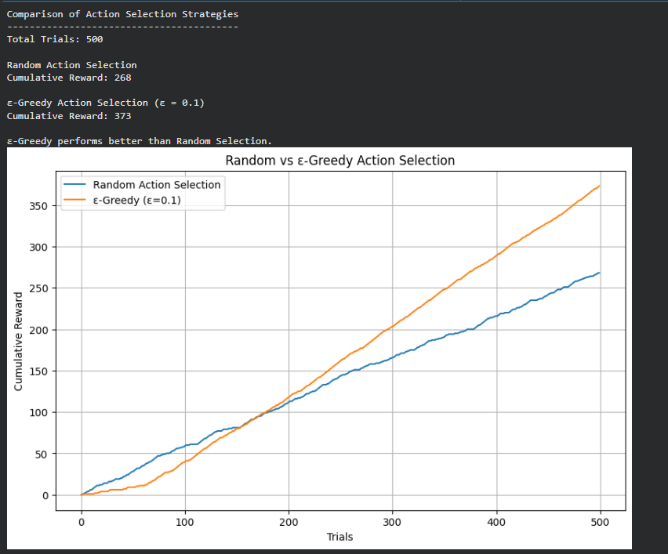

5.Implement a Reinforcement Learning solution using Python for a smart energy management system where electricity consumption must remain below a specified threshold. Explain how reward shaping, policy learning, and feasibility constraints improve decision-making.
CODE:
import random

# Threshold for electricity consumption (units)
THRESHOLD = 100

# Initial values
current_consumption = 0
total_reward = 0

# Appliances and their energy consumption
appliances = {
"Light": 10,
"Fan": 20,
"AC": 40,
"Washing Machine": 30,
"Refrigerator": 25
}

print("Smart Energy Management using Reinforcement Learning")
print("----------------------------------------------------")
print("Maximum Allowed Consumption:", THRESHOLD, "Units\n")

while True:

appliance = random.choice(list(appliances.keys()))
energy = appliances[appliance]

# Check feasibility constraint
if current_consumption + energy <= THRESHOLD:

current_consumption += energy
reward = 10
total_reward += reward

print(f"{appliance} ON")
print(f"Energy Used : {energy} Units")
print(f"Total Consumption : {current_consumption}")
print(f"Reward : +{reward}\n")

else:

print(f"{appliance} cannot be turned ON")
print("Threshold Exceeded!")
reward = -20
total_reward += reward
break

print("--------------------------------------------")
print("Final Electricity Consumption :", current_consumption)
print("Total Reward :", total_reward)

OUTPUT:
