Course: Full Stack Web Development
Course Code: 23CM4121
Assignment No.: 1
Student Name: B Pranathi
Roll No.: A24126552071
Date: 30-08-2026

1
.
Title :

Implement Inheritance Types using Java Script

- Aim: Implementing types of inheritances using Java Script.
- OBJECTIVE :
The objectives of this experiment are:
  - To implement five types of inheritance in JavaScript: Single, Multilevel, Hierarchical, Multiple (using Mixins), and Prototype-based inheritance
  - To use ES6 class syntax with extends and super keywords for creating parent-child relationships
  - To demonstrate method overriding, polymorphism, and code reusability through inheritance hierarchies
  - To model real-world scenarios (Employee-Developer-Manager, Animal-Dog-Cat, Vehicle-CarSUV) using different inheritance patterns
  - To simulate multiple inheritance using Object.assign() with mixins since JavaScript doesn't support it directly
  - To understand JavaScript's prototype chain and implement inheritance using Object.create()
  - To differentiate between inheritance types and choose appropriate patterns for specific use cases
  - To create clean, maintainable, and well-documented code following best practices
- THEORY :
Inheritance:
Inheritance is a fundamental concept in Object-Oriented Programming (OOP) where a child class (subclass) acquires properties and methods from a parent class (superclass).
Types of Inheritance in JavaScript 1. Single Inheritance
One child class inherits from one parent class. This is the most basic and common form of inheritance.
Parent Class
↓
Child Class
- Multilevel Inheritance
Inheritance chain with multiple levels where a child becomes parent for another class. Properties and methods propagate down the chain.

Grandparent Class
↓
Parent Class
↓
Child Class
- Hierarchical Inheritance
One parent class has multiple child classes. All children inherit common functionality from parent while having specialized behavior.
Parent Class
/ | \
Child1 Child2 Child3
- Multiple Inheritance (Using Mixins) :
One child inherits from multiple parent classes. NOT SUPPORTED directly in JavaScript; simulated using Mixins.
Parent1 Parent2
\ /
Child Class
- Hybrid inheritance :
Hybrid Inheritance is a combination of two or more inheritance types (single, multilevel, hierarchical, multiple) in one program. It's like mixing different inheritance patterns.
Implementation :
1.simple Inheritance:
class Animal { constructor(name) { this.name = name;
} eat() { console.log(`${this.name} is eating`);
}
} class Dog extends Animal { constructor(name, breed) { super(name); // Now this works!
this.breed = breed;
} bark() { console.log(`${this.name} is barking`);
}
} const myDog = new Dog("Buddy", "Golden Retriever"); myDog.eat(); myDog.bark(); Output :

2. Multilevel Inheritance :
class LivingBeing { constructor(name) { // Add constructor this.name = name;
} breathe() { console.log(`${this.name} is breathing`);
}
}
#accessing the properties from LivingBeing class class Animal extends LivingBeing { constructor(name) { // Add constructor super(name);
}
move() { console.log(`${this.name} is moving`);
}
} class Dog extends Animal { constructor(name, breed) { // Add constructor super(name); this.breed = breed;
}
bark() { console.log(`${this.name} is barking`);
}
}
#Create instance and call methods const myDog = new Dog("Buddy", "Golden Retriever"); myDog.breathe(); myDog.move(); myDog.bark();
Output :
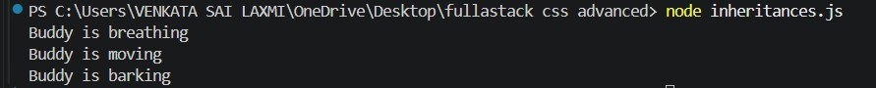

3.Hirarcheal Inheritance :
class Bird { constructor(name) { this.name = name;
} fly() { console.log(`${this.name} is flying`);
}
} class Sparrow extends Bird { constructor(name) { super(name);
} chirp() { console.log(`${this.name} is chirping`);
}
} class Eagle extends Bird { constructor(name) { super(name);
} hunt() { console.log(`${this.name} is hunting`);
}
// Method Overriding
fly() { console.log(`${this.name} is soaring high`);
}
}
// Create instances and call methods const sparrow = new Sparrow("Jack"); const eagle = new Eagle("Sky");
// Sparrow methods sparrow.fly(); // Jack is flying (from Bird) sparrow.chirp(); // Jack is chirping (from Sparrow) console.log(); // Empty line
// Eagle methods eagle.fly(); // Sky is soaring high (overridden) eagle.hunt(); // Sky is hunting (from Eagle)
Output :
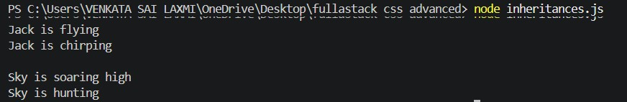

4.Multiple Inheritance :
// Mixin 1 const CanSwim = {
swim() { console.log(`${this.name} is swimming`);
}, dive() { console.log(`${this.name} is diving`);
}
};
// Mixin 2 const CanFly = { fly() { console.log(`${this.name} is flying`);
}, land() { console.log(`${this.name} is landing`);
}
};
// Mixin 3 const CanWalk = {
walk() { console.log(`${this.name} is walking`);
}, run() { console.log(`${this.name} is running`);
}
};
// Class class Duck { constructor(name) { this.name = name;
} quack() { console.log(`${this.name} says Quack!`);
}
}
// Apply multiple mixins
Object.assign(Duck.prototype, CanSwim, CanFly, CanWalk); const duck = new Duck("Donald"); duck.swim(); // Donald is swimming duck.fly(); // Donald is flying duck.walk(); // Donald is walking duck.quack(); // Donald says Quack!

Output :
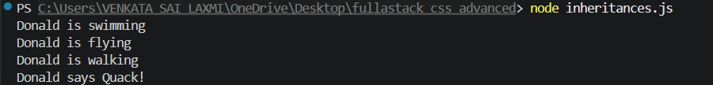
5.Hybrid Inheritance :
#Using multilevel + multiple class Animal { constructor(name) { this.name = name;
} eat() { console.log(`${this.name} is eating`);
}
} class Bird extends Animal {
chirp() { console.log(`${this.name} is chirping`);
}
} class FlyingBird extends Bird {
fly() { console.log(`${this.name} is flying`);
}
}
#MIXINS (For Multiple Inheritance) const CanSwim = {
swim() { console.log(`${this.name} is swimming`);
}
};
const CanHunt = {
hunt() { console.log(`${this.name} is hunting`);
}
}; class Duck extends FlyingBird { constructor(name) { super(name);
} quack() { console.log(`${this.name} says Quack!`);
}
}
// Applying mixins
Object.assign(Duck.prototype, CanSwim, CanHunt); const duck = new Duck("Donald");
duck.eat(); duck.chirp(); duck.fly(); duck.swim(); duck.hunt(); duck.quack();
Output :
